The original Figure

Figure 1. RPA primer optimization. Every two lines of primer sets are the same, the front line is the NDRV standard plasmid DNA and the latter line as a blank control. M: DL2000 marker. Lanes 1–2: NDRV-RPA-1F/R primer; lanes 3–4, NDRV-RPA-2F/R primer; 5–6, NDRV-RPA-3F/R primer.

Figure 2. Optimization of RPA assay components. (A) RPA reaction temperature; M: DL2000 marker. Lanes 1–7: 33 ℃, 35 ℃, 37 ℃, 39 ℃, 41℃ and 43℃, and the negative control;

Figure 2. Optimization of RPA assay components. (C) Optimal primer concentration screening. M: DL2000 marker. Lanes 1-6: 0.32 μM, 0.36 μM, 0.4 μM, 0.44 μM, 0.48 μM and the negative control.

Figure 3. The specificity, sensitivity and repeatability of the RPA. (A) RPA specificity test; M: DL2000 marker. Lanes 1–12: NDRV, MDRV, ARV, DHAV-Ⅰ, DHAV-Ⅱ, NDV, DTMUV, DPV, MPV, IBDV and IBV, and ddH₂O.
Figure 2. Optimization of RPA assay components. (B) Optimization of the RPA reaction time; M: DL2000 marker. Lanes 1–6: the RPA reaction incubated for 5,10, 20, 30, 40 min and negative control, respectively;

Figure 3. The specificity, sensitivity and repeatability of the RPA. (B) Sensitivity of the RT-RPA (B); M: DL2000 marker. 10-fold gradient dilution of the DNA samples (10⁻¹–10⁻¹⁰, lanes 1–10). Lane 11: negative control. (D) Repeatability of the RPA assay. M: DL2000 marker. Lanes 1-3: NDRV standard plasmid DNA, Lanes 4: the negative control.

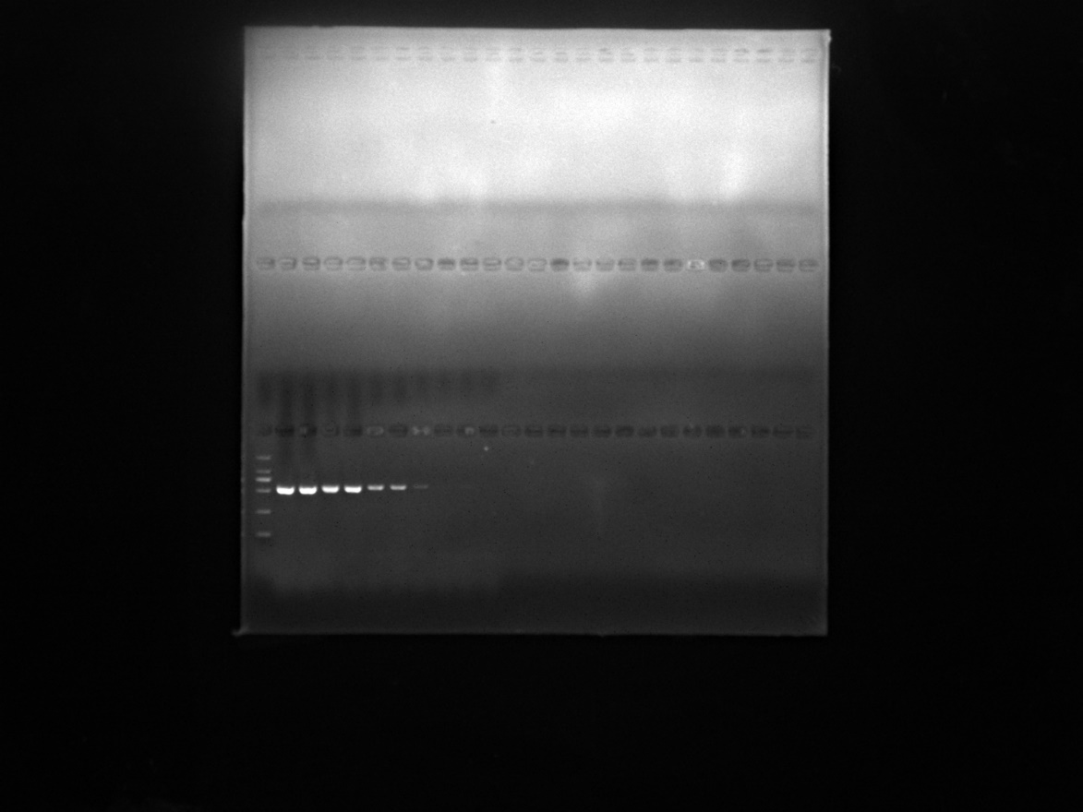
Figure 3. The specificity, sensitivity and repeatability of the RPA. (B) Sensitivity of the RT-PCR (C); M: DL2000 marker. 10-fold gradient dilution of the DNA samples (10⁻¹–10⁻¹⁰, lanes 1–10). Lane 11: negative control.

Figure 4. Visualization of RPA products under ultraviolet light. Aliquots (5 μl) of the RT-RPA products were analyzed by 2% agarose gel electrophoresis (A) and SYBR Green I staining (B). M: DL2000 marker. Lanes 1–11: the RT-RPA reactions incubated for 1, 3, 5, 7, 10, 15, 20, 25, 30, 40 min and negative control, respectively.

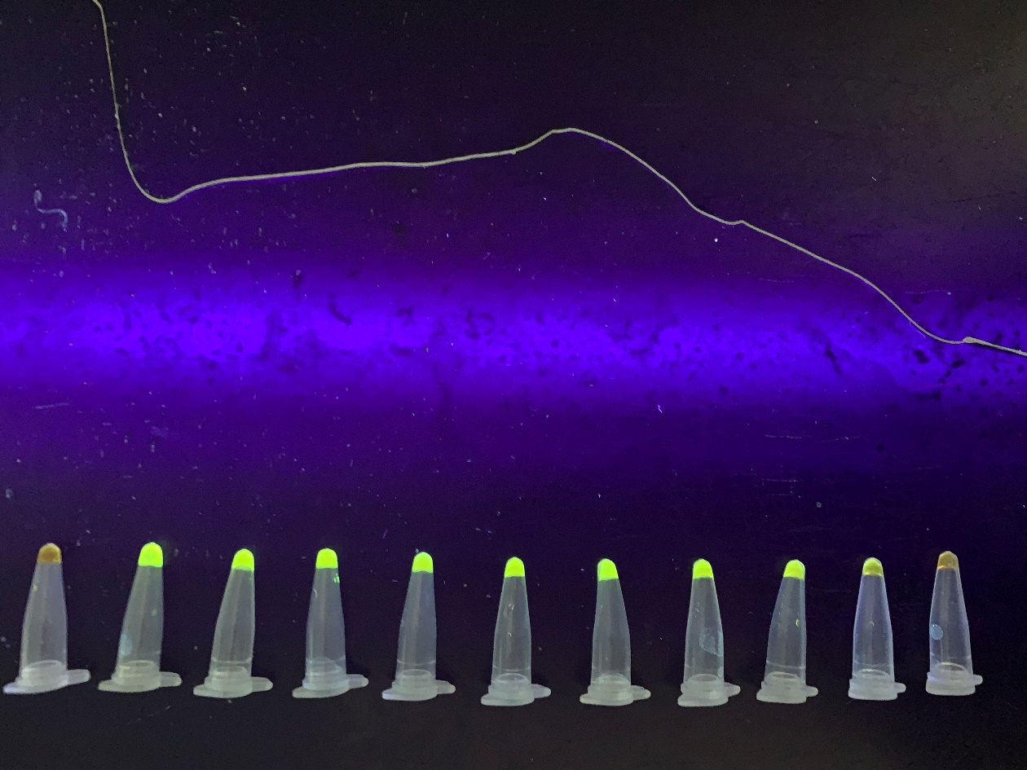
Figure 4. Visualization of RPA products under ultraviolet light. Aliquots (5 μl) of the RT-RPA products were analyzed by SYBR Green I staining (B). M: DL2000 marker. Lanes 1–11: the RT-RPA reactions incubated for 1, 3, 5, 7, 10, 15, 20, 25, 30, 40 min and negative control, respectively.


Figure 5. Detection of NDRV in field-collected and artificially inoculated samples by RT-RPA. M: DL2000 marker. Lanes 1–8: field-collected samples; Lanes 9–16: artificially inoculated samples. Lanes 17–20: the samples obtained from healthy ducklings. Lanes 21: the negative control.

