Extended Data Figures 1-6 and Extended Data Tables 1 & 2

Mukherjee, U. et al.
New constraints on the final stages of the last deglaciation from high-resolution sea-level observations
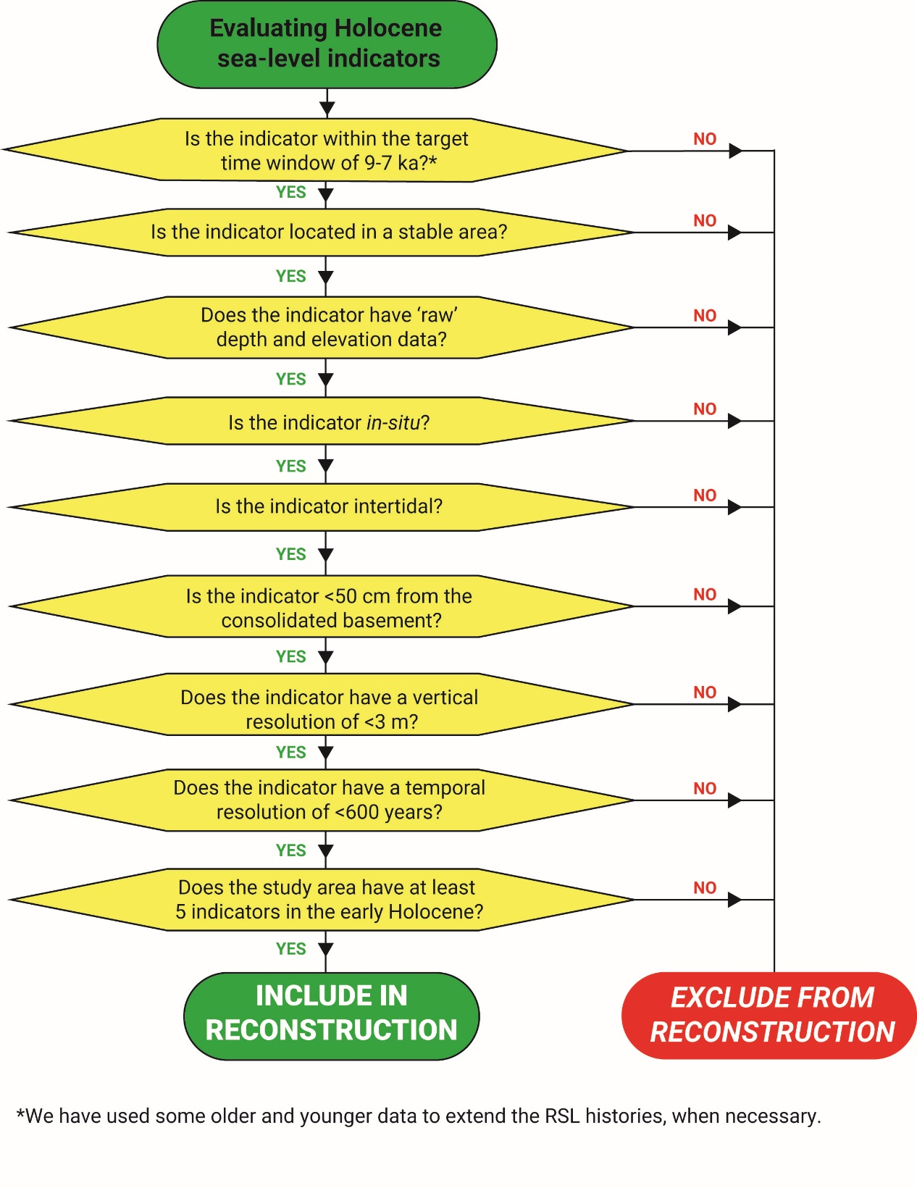
Extended Data Figure 1. Relative sea-level (RSL) data selection procedure. Flowchart outlining the criteria and order used to evaluate global RSL data for potential inclusion in this study.

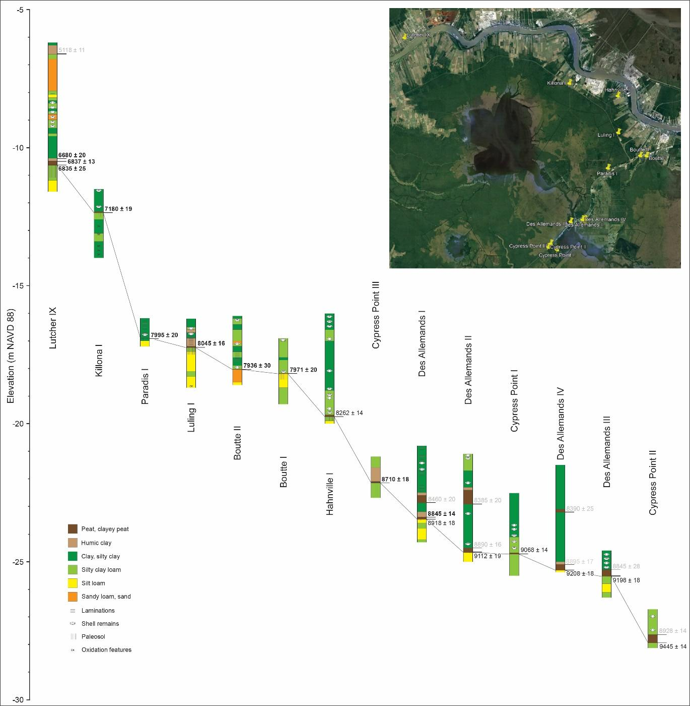
Extended Data Figure 2. Cross section with 14 cores used for the new relative sea-level (RSL) record from the Mississippi Delta. Correlation line represents the top of the paleosol that overlies the Pleistocene basement. Ages are weighted means of multiple ¹⁴C samples from a given stratigraphic level in most cases. Ages in black are associated with sea-level index points (bold) or upper limiting data points (not bold); ages in grey cannot be linked to paleo-RSL due to unsuitable paleoenvironmental conditions, post-depositional sediment compaction, or both.

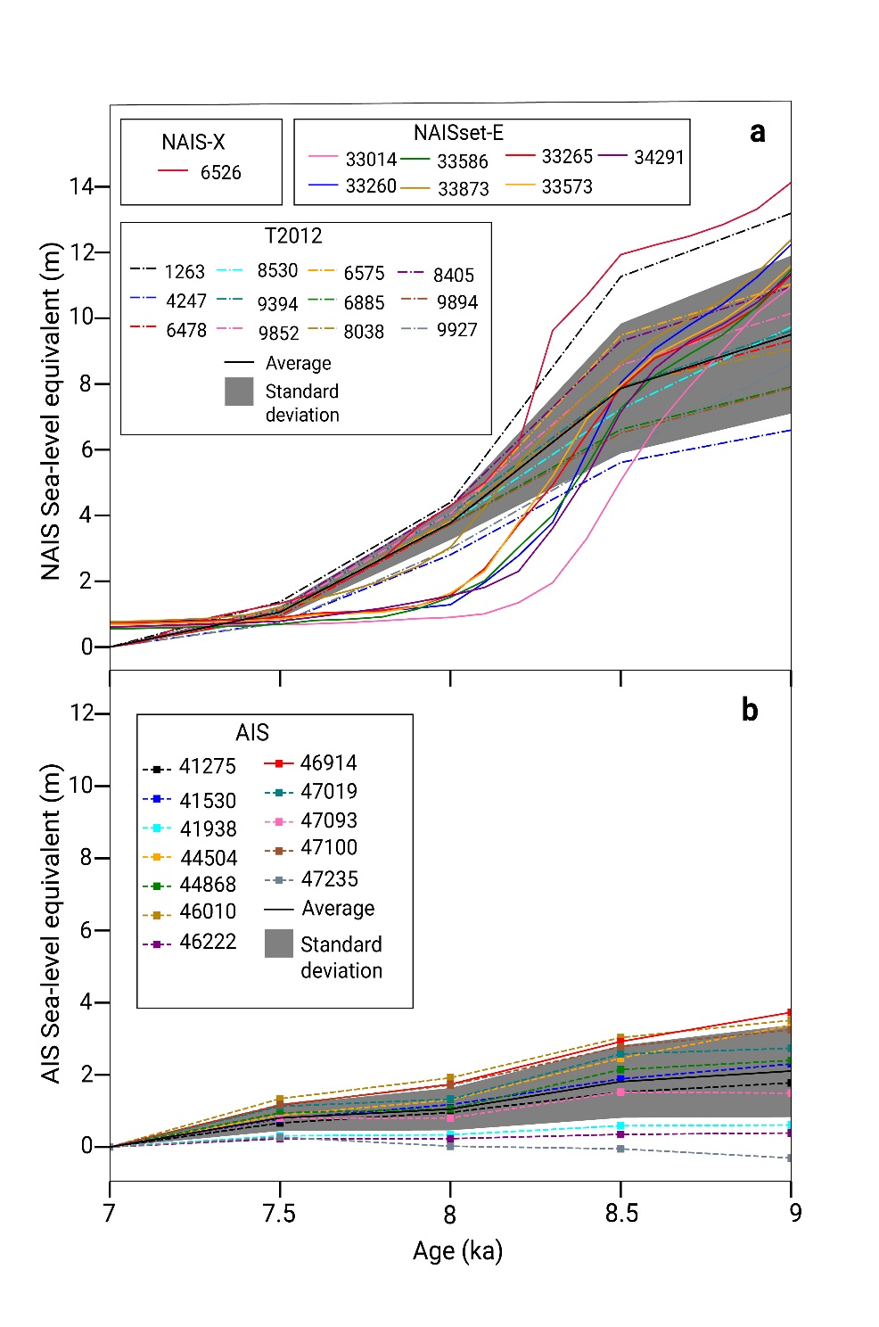
Extended Data Figure 3. Sea-level equivalent for North American and Antarctic ice models used in this study. a, North American ice sheets models showing the three sets of models – T2012, NAISset-E (GLAC3B, LT et al., in prep) and NAIS-X (GLAC2A, LT et al., in prep) b, Antarctic ice sheet model ensemble – AIS (BL et al., submitted). The model numbers provided here can be cross-referenced against the runIDs used in the corresponding publications and data repositories with details of the ice model ensembles discussed here.

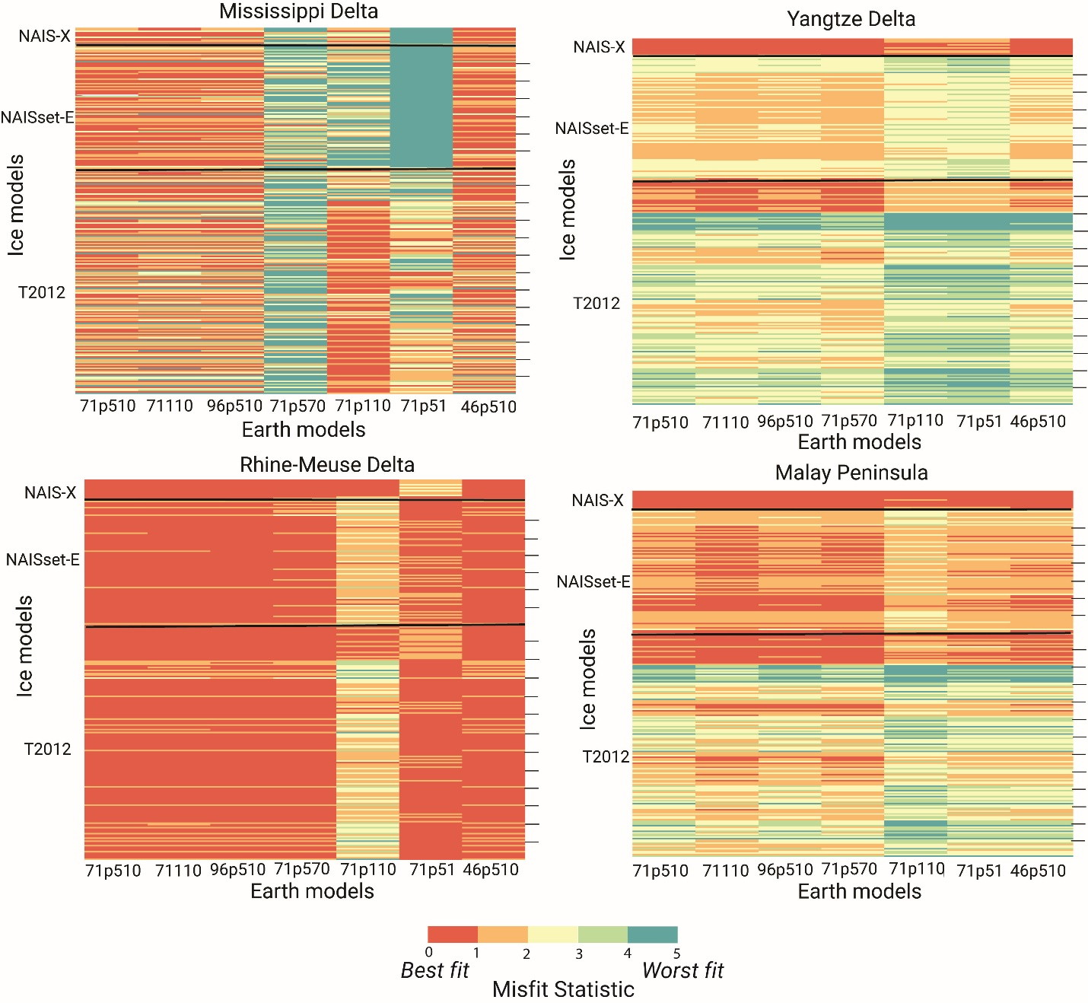
Extended Data Figure 4. Data-model misfit calculation based on 1764 different Earth and ice model configurations for the four study areas. Each GIA model run is colored by its misfit statistic (ϕ(M)) value. The 7 Earth models are plotted along the x-axis; the various combinations of ice models (see Methods) are plotted along the y-axis. Each tick mark along the y-axis indicates one NAIS ice model (belonging to NAIS-X, NAISset-E and T2012 ensemble as annotated along the y-axis) combined with the 12 different AIS models.

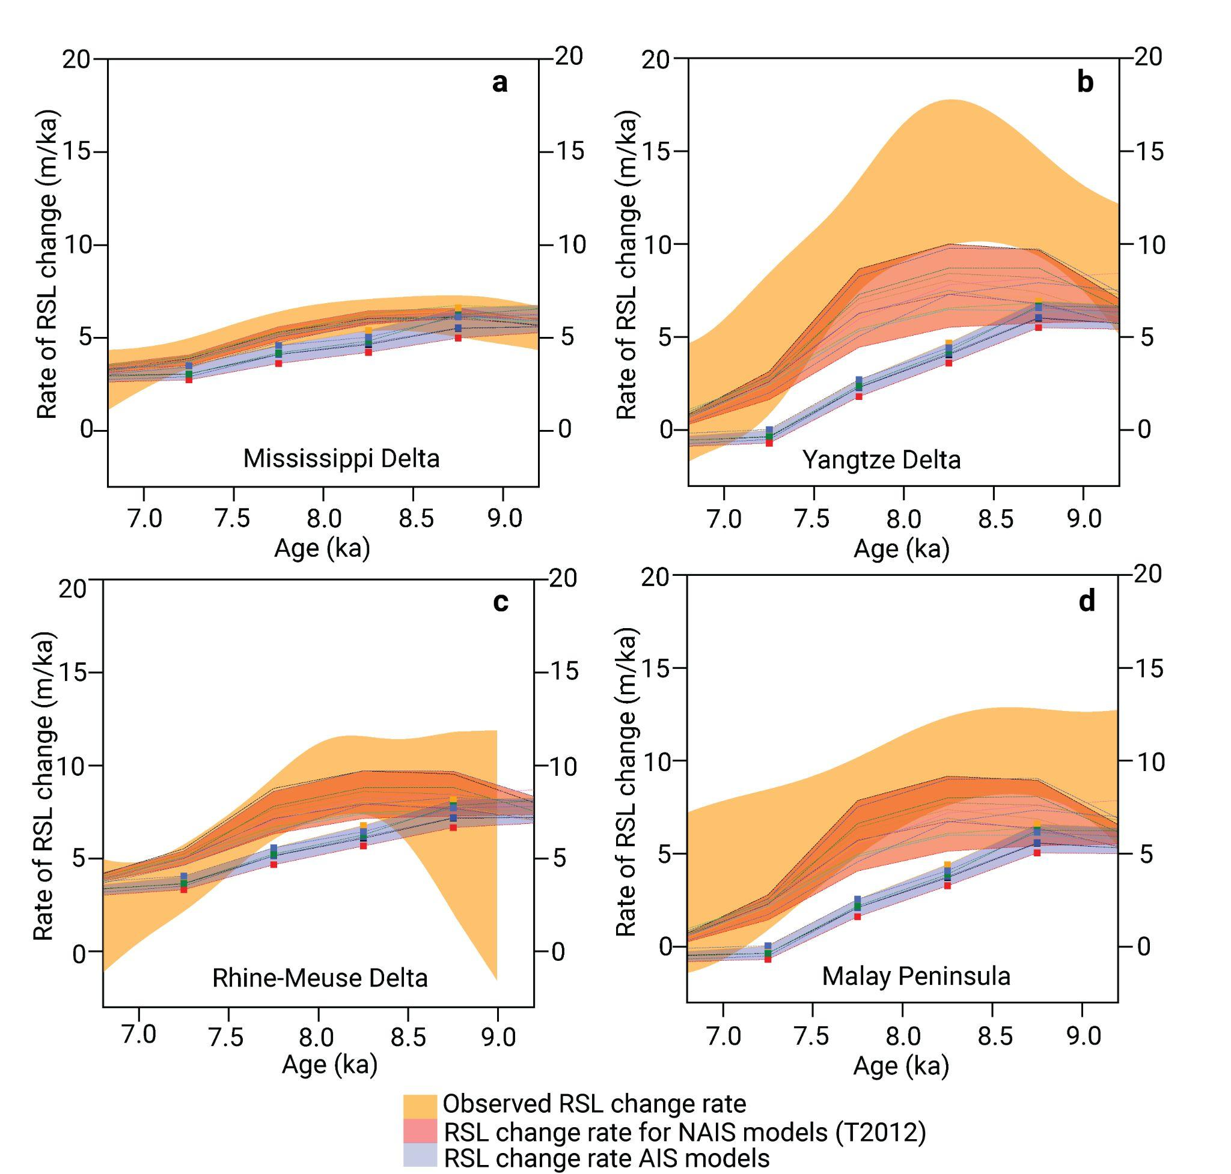
Extended Data Fig. 5. Comparison of the North American and Antarctic signals in the four study areas. a, Mississippi Delta, b, Yangtze Delta, c, Rhine-Meuse Delta, d, Malay Peninsula. The modelled rates of relative sea-level change are calculated using only NAIS from the T2012 ensemble (red envelope) and AIS (BL et al., submitted) (purple envelope) ice models.

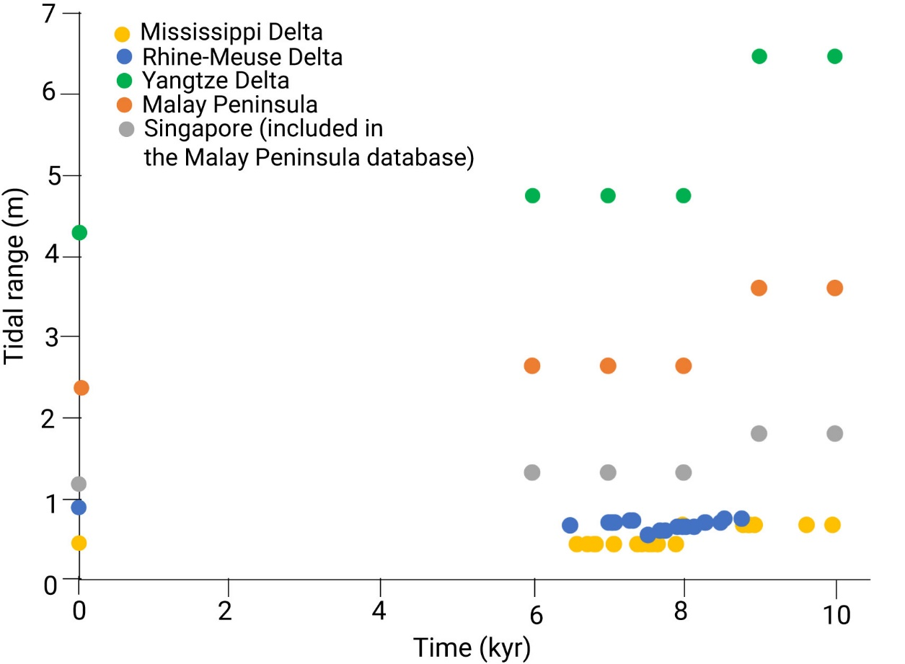

Extended Data Figure 6. Holocene tidal range change in the four study areas. The modern data are from Admiralty Tide Tables, older data from paleotidal models. In the Mississippi Delta and the Rhine-Meuse Delta the paleo-indicative range (IR) of samples older than 8 ka have been calculated by increasing the present-day IR by a factor of 1.5. In the absence of detailed paleotidal modeling and paleo-tidal range reconstruction studies in the Yangtze Delta and Malay Peninsula (including Singapore), for RSL samples older than 8 ka, we have increased the present-day IR by a factor of 50% to calculate the paleo-IR and by a factor of 10% for samples younger than 8 ka.

Extended Data Table 1. Radiocarbon data.

Sample Name | UTM coordinates¹ |  | Surface elevation  (m) | Depth below surface  (m) | Stratigraphic position | Dated  material | Age  (¹⁴C yr BP) | UCIAMS number
 | E | N
Lutcher IX-1a | 720900 | 3324660 | 3.1 | 13.60-13.62 | Basal peat (center) | 2 charcoal fragments | 6900 ± 25 | 159370
Lutcher IX-1b | 720900 | 3324660 | 3.1 | 13.60-13.62 | Basal peat (center) | 6 charcoal fragments | 6840 ± 25 | 159371
Lutcher IX-1c | 720900 | 3324660 | 3.1 | 13.60-13.62 | Basal peat (center) | 12 Scirpus spp. achene fragments | 6795 ± 20 | 159372
Lutcher IX-2a | 720900 | 3324660 | 3.1 | 9.70-9.73 | Intercalated peat (base) | 3 charcoal fragments | 5115 ± 15 | 187166
Lutcher IX-2b | 720900 | 3324660 | 3.1 | 9.70-9.73 | Intercalated peat (base) | 3 charcoal fragments | 5120 ± 15 | 187167
Lutcher IX-3 | 720900 | 3324660 | 3.1 | 13.50-13.52 | Basal peat (top) | several charcoal fragments | 6680 ± 20 | 187168
Lutcher IX-4 | 720880 | 3324660 | 3.1 | 13.72-13.74 | Basal peat (base) | several charcoal fragments | 6835 ± 25 | 187169
Killona I-1a | 742690 | 3319500 | 1.0 | 13.35-13.37 | Basal peat (base) | 3 charcoal fragments | 7180 ± 25 | 159373
Killona I-1b | 742690 | 3319500 | 1.0 | 13.35-13.37 | Basal peat (base) | 6 charcoal fragments | 7180 ± 30 | 159374
Boutte I-1g² | 753040 | 3310340 | 0.0 | 18.18-18.20 | Basal peat (base) | >15 charcoal fragments | 7965 ± 45 | 137480
Boutte I-1h² | 753040 | 3310340 | 0.0 | 18.18-18.20 | Basal peat (base) | >15 charcoal fragments | 7995 ± 35 | 137473
Boutte I-1i² | 753040 | 3310340 | 0.0 | 18.18-18.20 | Basal peat (base) | 4 Scirpus spp. achenes | 7955 ± 30 | 137474
Boutte II-1g² | 752220 | 3310350 | 0.7 | 18.72-18.74 | Basal peat (base) | >15 charcoal fragments | 8080 ± 350 | 137475
Boutte II-1h² | 752220 | 3310350 | 0.7 | 18.72-18.74 | Basal peat (base) | 3 charcoal fragments | 8100 ± 230 | 137476
Boutte II-1i² | 752220 | 3310350 | 0.7 | 18.72-18.74 | Basal peat (base) | 3 Scirpus spp. achenes | 7930 ± 30 | 137477
Boutte II-1j² | 752220 | 3310350 | 0.7 | 18.72-18.74 | Basal peat (base) | 15 unidentified seeds | 8240 ± 490 | 137478
Boutte II-1k² | 752220 | 3310350 | 0.7 | 18.72-18.74 | Basal peat (base) | 1 unidentified seed | 8340 ± 570 | 137479
Luling I-1a | 749260 | 3313270 | 1.2 | 18.43-18.45 | Basal peat (base) | 2 charcoal fragments | 8045 ± 20 | 159376
Luling I-1b | 749260 | 3313270 | 1.2 | 18.43-18.45 | Basal peat (base) | 6 charcoal fragments | 8045 ± 25 | 159377
Hahnville I-1a | 749060 | 3318040 | 1.8 | 21.53-21.55 | Basal peat (base) | 3 charcoal fragments | 8260 ± 20 | 159378
Hahnville I-1b | 749060 | 3318040 | 1.8 | 21.53-21.55 | Basal peat (base) | 1 charcoal fragment | 8405 ± 20⁴ | 159379
Hahnville I-1c | 749060 | 3318040 | 1.8 | 21.53-21.55 | Basal peat (base) | 1 wood fragment | 8255 ± 25 | 173658
Hahnville I-1d | 749060 | 3318040 | 1.8 | 21.53-21.55 | Basal peat (base) | 1 wood fragment | 8275 ± 30 | 173659
Paradis I-1 | 748030 | 3308600 | 0.5 | 17.42-17.44 | Paleosol (top) | 1 charcoal fragment | 7995 ± 20 | 159375
Des Allemands I-1a | 745210 | 3301460 | -0.8 | 22.65-22.67 | Basal peat (base) | 1 charcoal fragment | 8905 ± 25 | 159380
Des Allemands I-1b | 745210 | 3301460 | -0.8 | 22.65-22.67 | Basal peat (base) | 1 charcoal fragment | 8930 ± 25 | 159381
Des Allemands I-2a | 745210 | 3301460 | -0.8 | 22.58-22.59 | Basal peat (top) | 3 wood fragments | 8835 ± 20 | 190604
Des Allemands I-2b | 745210 | 3301460 | -0.8 | 22.58-22.59 | Basal peat (top) | 6 wood fragments | 8855 ± 20 | 190605
Des Allemands I-3 | 745210 | 3301460 | -0.8 | 22.05-22.07 | Intercalated peat (base) | 3 Scirpus spp. achenes, 3 wood fragments | 8460 ± 20 | 187176
Des Allemands II-1a | 745170 | 3301860 | -1.3 | 23.34-22.37 | Basal peat (base) | 3 charcoal fragments | 8940 ± 25⁴ | 159382
Des Allemands II-1b | 745170 | 3301860 | -1.3 | 23.34-22.37 | Basal peat (base) | 1 charcoal fragment | 9150 ± 30 | 159383
Des Allemands II-1c | 745170 | 3301860 | -1.3 | 23.34-22.37 | Basal peat (base) | 1 wood fragment | 8875 ± 25⁴ | 173662
Des Allemands II-1d | 745170 | 3301860 | -1.3 | 23.34-22.37 | Basal peat (base) | 1 wood fragment | 9085 ± 25 | 173663
Des Allemands II-2a | 745170 | 3301860 | -1.3 | 23.20-23.21 | Basal peat (top) | 1 wood fragment | 8890 ± 25 | 190606
Des Allemands II-2b | 745170 | 3301860 | -1.3 | 23.20-23.21 | Basal peat (top) | 1 wood fragment | 8890 ± 20 | 190607
Des Allemands II-3 | 745170 | 3301850 | -1.3 | 21.50-21.52 | Intercalated peat (base) | 3 Scirpus spp. achenes, 3 wood fragments | 8385 ± 20 | 187177
Des Allemands III-1a | 743330 | 3301510 | -0.6 | 24.90-24.93 | Basal peat (base) | 1 charcoal fragment | 9215 ± 25 | 159384
Des Allemands III-1b | 743330 | 3301510 | -0.6 | 24.90-24.93 | Basal peat (base) | 3 charcoal fragments | 9180 ± 25 | 159385
Des Allemands III-2a | 743330 | 3301510 | -0.6 | 24.69-24.70 | Basal peat (top) | 3 wood fragments | 8810 ± 80 | 173660
Des Allemands III-2b | 743330 | 3301510 | -0.6 | 24.69-24.70 | Basal peat (top) | 7 wood fragments | 8850 ± 30 | 173661
Des Allemands IV-1a | 744870 | 3301810 | -0.7 | 24.60-24.62 | Basal peat (base) | 3 wood fragments | 9205 ± 20 | 190608
Des Allemands IV-1b | 744870 | 3301810 | -0.7 | 24.60-24.62 | Basal peat (base) | 7 wood fragments | 9210 ± 20 | 190609
Des Allemands IV-2a | 744870 | 3301810 | -0.7 | 24.41-24.42 | Basal peat (top) | 1 wood fragment | 8885 ± 30 | 190610
Des Allemands IV-2b | 744870 | 3301810 | -0.7 | 24.41-24.42 | Basal peat (top) | 1 wood fragment | 8900 ± 20 | 190611
Des Allemands IV-3 | 744870 | 3301810 | -0.7 | 22.46-22.48 | Intercalated peat (base) | 3 wood fragments, 2 Scirpus spp. achenes | 8390 ± 25 | 190612
Cypress Point I-1a | 741655 | 3297815 | 0.09 | 24.80-24.82 | Basal peat (base) | 1 wood fragment | 9010 ± 20 | 190602
Cypress Point I-1b | 741655 | 3297815 | 0.09 | 24.80-24.82 | Basal peat (base) | 2 wood fragments | 9125 ± 20 | 190603
Cypress Point II-1a | 740450 | 3298105 | 0.37 | 28.30-28.31 | Basal peat (base) | 1 wood fragment | 9470 ± 20 | 187170
Cypress Point II-1b | 740450 | 3298105 | 0.37 | 28.30-28.31 | Basal peat (base) | 2 wood fragments | 9420 ± 20 | 187171
Cypress Point II-2a | 740450 | 3298105 | 0.37 | 28.01-28.02 | Basal peat (top) | 1 wood fragment | 8935 ± 20 | 187172
Cypress Point II-2b | 740450 | 3298105 | 0.37 | 28.01-28.02 | Basal peat (top) | 3 wood fragments | 8920 ± 20 | 187173
Cypress Point III-1a | 740795 | 3298575 | -0.39 | 21.76-21.77 | Basal peat (base) | 5 wood fragments | 8690 ± 25 | 187174
Cypress Point III-1b | 740795 | 3298575 | -0.39 | 21.76-21.77 | Basal peat (base) | 8 wood fragments | 8730 ± 25 | 187175
1. UTM zone 15R with reference to NAD83 (for site Lutcher IX with reference to NAD27).
2. First published by ref. 21.
4. Rejected.

Extended Data Table 2. Earth model parameters adopted for the glacial isostatic adjustment modelling.
