Table 4. Major volatile compounds profile (GC-MS) in fresh and vacuum concentrated karonda juice
Runs | Major compounds
Runs | Ⅰ | Ⅱ | Ⅲ | Ⅳ | Ⅴ
Fresh juice | Tetrahydrofuran (21.76%)  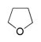 | 3-Hydroxy-3-methylvaleric acid (12.66%)  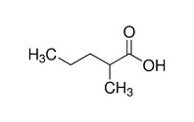 | 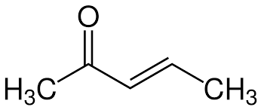  3-Penten -2-one (11.97%) | Hydroperoxide (5.14%)  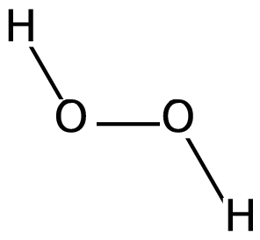 | Octane (4.54%)  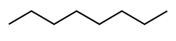
1 | Oxirane (15.42%)  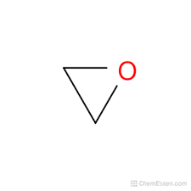 | 3-Hydroxy-3-methylvaleric acid (9.04%) | Cyclopentane (8.07%)  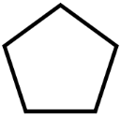 | n-Hexadecanoic acid (4.42%)  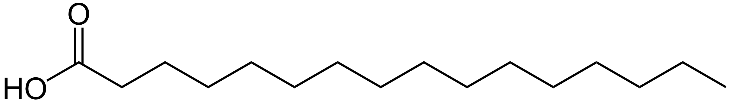 | Hydroperoxide (3.86%)
2 | Tetrahydrofuran (22.76%) | 1-Pentanol (13.47%)  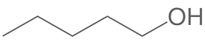 | 3-Hexen-2-one (11.56%)  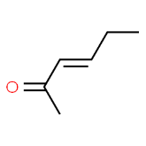 | Hydroperoxide (5.17%) | Octane (5.16%)
3 | Tetrahydrofuran (22.37%) | 3-Hydroxy-3-methylvaleric acid (13.12%) | 3-Hexen-2-one (11.89%) | Hydroperoxide (5.41%) | Octane (4.78%)
4 | Tetrahydrofuran (22.14%) | 3-Hydroxy-3-methylvaleric acid (12.96%)  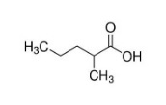 | 3-Penten-2-one (11.92%) | Hydroperoxide (5.13%) | Octane (4.81%)

5 | Tetrahydrofuran (22.31%) | 1-Pentanol (13.01%) | 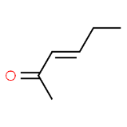  3-Hexen-2-one (12.78%) | Hydroperoxide (4.69%) | Octane (4.53%)
6 | Toluene (50.85%)  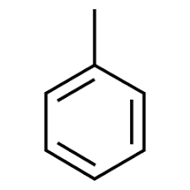 | 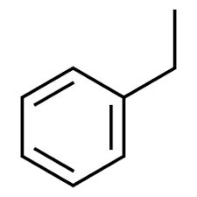  Ethylbenzene (13.24%) | o-Xylene (7.02%)  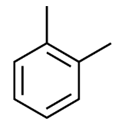 | Tetrahydrofuran (5.94%) | 3-Penten-2-one (3.77%)
7 | Toluene (61.82%) | Ethylbenzene (16.96%) | o-Xylene (12.13%)  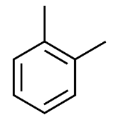 | 2-Pentene (0.99%)  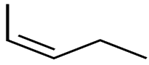 | 3-Hydroxymethylvaleric acid (0.75%)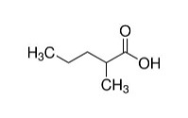
8 | Acetoacetate (24.32%)  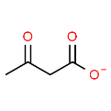 | Sotolone (11.67%)  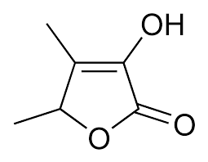 | Acetate (11.49%)  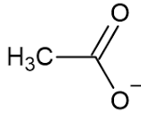 | Methyl isobutyl ketone (4.77%)  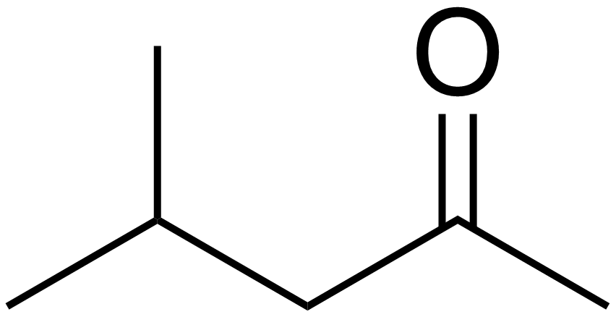 | Nonane (4.00%)  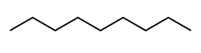
9 | Tetrahydrofuran (22.35%) | 1-Pentanol (13.58%) | 3-Penten-2-one (12.12%) | Hydroperoxide (5.11%) | Octane (4.84%)
10 | Tetrahydrofuran (21.36%) | 3-Hydroxy-3-methylvaleric acid (12.65%)  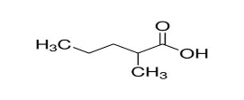 | 3-Penten-2-one (12.48%) | Hydroperoxide (5.2%) | Octane (4.33%)
Table 4. Co

