Supplementary Information
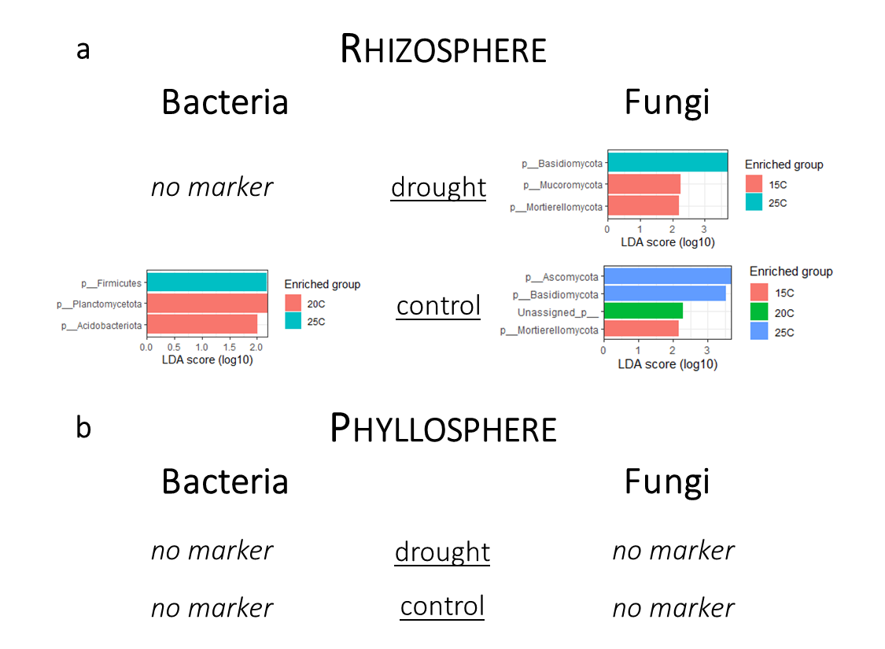
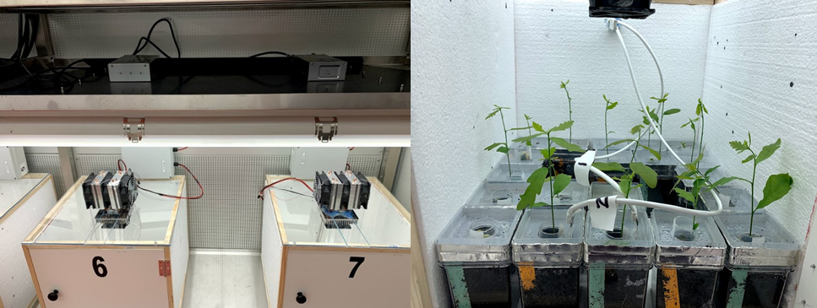
Figure S2: Bacterial (left) and fungal (right) taxa that explain the differences between temperatures at given soil moisture treatment (control and drought) in rhizosphere (a) and phyllosphere (b). Analysis was only conducted on phylum-level; “no marker” = no enriched group was found; 15C: 15 °C, 20C: 20 °C, 25C: 25 °C.
Figure S1: Left: Climate boxes with integrated humidity and temperature sensors. Right: Oak seedlings planted in soil with different soil moisture levels (green – low moisture, orange – high moisture) inside a climate box.

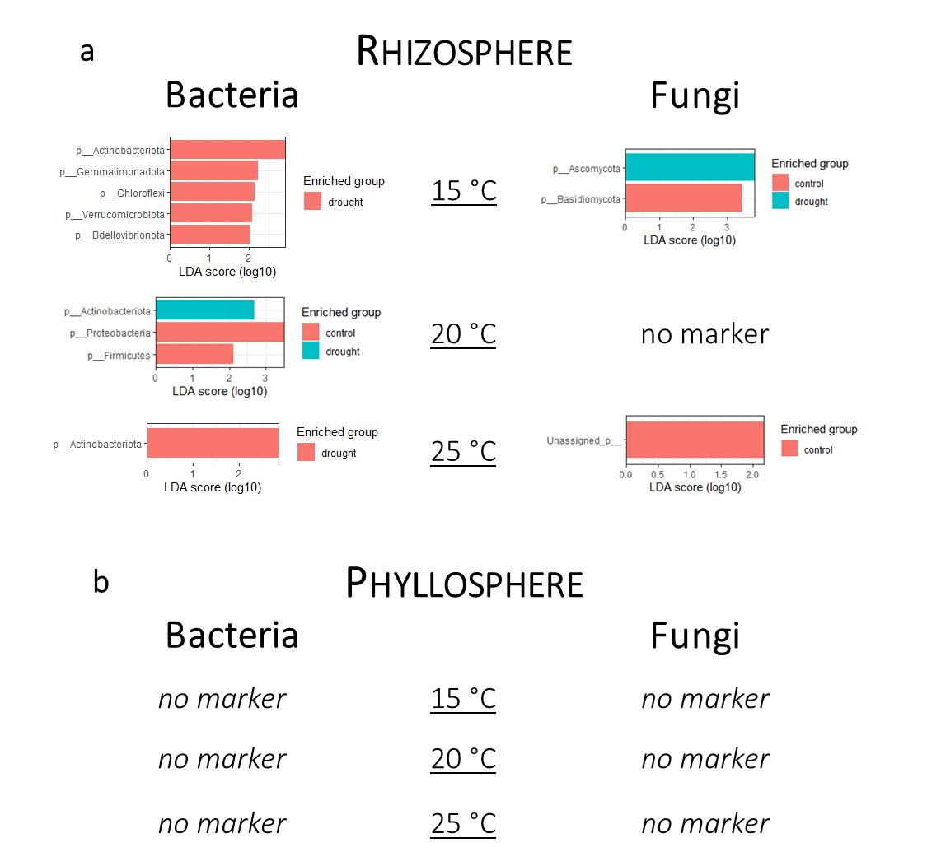
Figure S3: Bacterial (left) and fungal (right) taxa that explain the differences between control and drought treatments at given temperature level in rhizosphere (a) and phyllosphere (b). Analysis was only conducted on phylum-level; “no marker” = no enriched group was found; 15C: 15 °C, 20C: 20 °C, 25C: 25 °C.

The impact of temperature, soil moisture and their interaction on the fungal and bacterial community on rhizosphere and phyllosphere of oak.
Table S1: The impact of temperature, soil moisture, and their interaction on the fungal and bacterial community on rhizosphere and phyllosphere of the oak Quercus robur using linear fixed effect models species richness, Shannon diversity and abundance and testing for significance with the ´Anova´ function (car package). R²-values were calculated with the function ´r.squaredGLMM´ (MuMln package) after running separate linear models for each fixed effect. The bacterial community composition on oak rhizosphere and phyllosphere as modelled using PERMANOVA (absolute count data; function ´adonis2´ from the package vegan). Significant values are indicated in bold.
 |  | Soil Moisture | Temperature | Soil Moisture x  Temperature
Rhizosphere |  | Measure | p | R² | p | R² | p | R²
Rhizosphere | Fungi | Species richness | 0.221 | 0.007 | 0.094 | 0.060 | 0.052
Rhizosphere | Fungi | Shannon diversity | 0.423 | 0.004 | 0.002 | 0.112 | 0.881
Rhizosphere | Fungi | Abundance | 0.030 | 0.102 | 0.019 | 0.119 | 0.020
Rhizosphere | Fungi | Community composition | 0.001 | 0.062 | 0.001 | 0.033 | 0.003 | 0.010
Rhizosphere | Bacteria | Species richness | 0.078 | 0.017 | 0.623 | 0.002 | 0.712
Rhizosphere | Bacteria | Shannon diversity | 0.692 | 0.001 | 0.989 | 0.001 | 0.895
Rhizosphere | Bacteria | Abundance | 0.030 | 0.066 | 0.039 | 0.060 | 0.185
Rhizosphere | Bacteria | Community composition | 0.001 | 0.149 | 0.001 | 0.022 | 0.048 | 0.009
Phyllosphere | Fungi | Species richness | 0.498 | 0.004 | 0.550 | 0.013 | 0.115
Phyllosphere | Fungi | Shannon diversity | 0.138 | 0.024 | 0.520 | 0.008 | 0.238
Phyllosphere | Fungi | Abundance | <0.001 | 0.305 | 0.004 | 0.066 | <0.001
Phyllosphere | Fungi | Community composition | 0.269 | 0.012 | 0.221 | 0.068 | 0.260 | 0.015
Phyllosphere | Bacteria | Species richness | 0.057 | 0.047 | 0.619 | 0.004 | 0.928
Phyllosphere | Bacteria | Shannon diversity | 0.012 | 0.075 | 0.199 | 0.021 | 0.295
Phyllosphere | Bacteria | Abundance | 0.199 | 0.023 | 0.001 | 0.153 | 0.214
Phyllosphere | Bacteria | Community composition | 0.002 | 0.026 | 0.027 | 0.022 | 0.929 | 0.010

Partitioning of the total β-diversity (Jaccard dissimilarity index) between the different treatments into species turnover and change in species numbers for the bacterial and fungal communities on oak phyllosphere and rhizosphere.
Table S2: Partitioning of the total beta diversity (βJAC, Jaccard dissimilarity index) between the different temperature treatments (15 °C – 20 °C, 20 °C – 25 °C, 15 °C – 25 °C) and between the different soil moisture treatments at the specific temperatures (15 °C high – low, 20 °C high - low, 25 °C high – low) into the components of species turnover (βJTU) and change in species numbers (βJNE) for the bacterial and fungal communities on both phyllosphere and rhizosphere.
 |  | Phyllosphere |  |  | Rhizosphere
 | Comparison | βJAC | βJTU | βJNE | βJAC | βJTU | βJNE
Bacteria | 15 °C – 20 °C | 0.9082 | 0.8892 | 0.0190 | 0.5014 | 0.4481 | 0.0533
Bacteria | 20 °C – 25 °C | 0.8722 | 0.8378 | 0.0344 | 0.5111 | 0.4484 | 0.0627
Bacteria | 15 °C – 25 °C | 0.8971 | 0.8366 | 0.0605 | 0.5034 | 0.4943 | 0.0091
Bacteria | 15 °C: high - low | 0.9292 | 0.8300 | 0.0992 | 0.6264 | 0.5761 | 0.0503
Bacteria | 20 °C: high - low | 0.9482 | 0.9207 | 0.0275 | 0.6555 | 0.6493 | 0.0062
Bacteria | 25 °C: high - low | 0.8947 | 0.7349 | 0.1598 | 0.8610 | 0.5280 | 0.0333
Fungi | 15 °C – 20 °C | 0.8856 | 0.8169 | 0.0687 | 0.7292 | 0.6787 | 0.0524
Fungi | 20 °C – 25 °C | 0.8511 | 0.8387 | 0.0124 | 0.7112 | 0.6814 | 0.0298
Fungi | 15 °C – 25 °C | 0.8975 | 0.8526 | 0.0449 | 0.7319 | 0.7117 | 0.0202
Fungi | 15 °C: high - low | 0.8661 | 0.8468 | 0.0193 | 0.7376 | 0.6746 | 0.0630
Fungi | 20 °C: high - low | 0.7381 | 0.4590 | 0.2791 | 0.7335 | 0.7278 | 0.0057
Fungi | 25 °C: high - low | 0.8125 | 0.7731 | 0.0394 | 0.7324 | 0.7117 | 0.0207

