Supplementary Material for Glycemic Comparison Index (GCI): A Retrospective Analysis of its Prognostic Value in ICU Patients with AMI and Diabetes

Table S1 The ICD codes for extracting diagnoses
ICD code | ICD version | Full name
AMI related
41000 | 9 | Acute myocardial infarction of anterolateral wall, episode of care unspecified
41001 | 9 | Acute myocardial infarction of anterolateral wall, initial episode of care
41002 | 9 | Acute myocardial infarction of anterolateral wall, subsequent episode of care
41010 | 9 | Acute myocardial infarction of other anterior wall, episode of care unspecified
41011 | 9 | Acute myocardial infarction of other anterior wall, initial episode of care
41012 | 9 | Acute myocardial infarction of other anterior wall, subsequent episode of care
41020 | 9 | Acute myocardial infarction of inferolateral wall, episode of care unspecified
41021 | 9 | Acute myocardial infarction of inferolateral wall, initial episode of care
41022 | 9 | Acute myocardial infarction of inferolateral wall, subsequent episode of care
41030 | 9 | Acute myocardial infarction of inferoposterior wall, episode of care unspecified
41031 | 9 | Acute myocardial infarction of inferoposterior wall, initial episode of care
41032 | 9 | Acute myocardial infarction of inferoposterior wall, subsequent episode of care
41040 | 9 | Acute myocardial infarction of other inferior wall, episode of care unspecified
41041 | 9 | Acute myocardial infarction of other inferior wall, initial episode of care
41042 | 9 | Acute myocardial infarction of other inferior wall, subsequent episode of care
41050 | 9 | Acute myocardial infarction of other lateral wall, episode of care unspecified
41051 | 9 | Acute myocardial infarction of other lateral wall, initial episode of care
41052 | 9 | Acute myocardial infarction of other lateral wall, subsequent episode of care
41060 | 9 | True posterior wall infarction, episode of care unspecified
41061 | 9 | True posterior wall infarction, initial episode of care
41062 | 9 | True posterior wall infarction, subsequent episode of care
41070 | 9 | Subendocardial infarction, episode of care unspecified
41071 | 9 | Subendocardial infarction, initial episode of care
41072 | 9 | Subendocardial infarction, subsequent episode of care
41080 | 9 | Acute myocardial infarction of other specified sites, episode of care unspecified
41081 | 9 | Acute myocardial infarction of other specified sites, initial episode of care
41082 | 9 | Acute myocardial infarction of other specified sites, subsequent episode of care
41090 | 9 | Acute myocardial infarction of unspecified site, episode of care unspecified
41091 | 9 | Acute myocardial infarction of unspecified site, initial episode of care
41092 | 9 | Acute myocardial infarction of unspecified site, subsequent episode of care
I21 | 10 | Acute myocardial infarction
I210 | 10 | ST elevation (STEMI) myocardial infarction of anterior wall
I2101 | 10 | ST elevation (STEMI) myocardial infarction involving left main coronary artery
I2102 | 10 | ST elevation (STEMI) myocardial infarction involving left anterior descending coronary artery
I2109 | 10 | ST elevation (STEMI) myocardial infarction involving other coronary artery of anterior wall
I211 | 10 | ST elevation (STEMI) myocardial infarction of inferior wall
I2111 | 10 | ST elevation (STEMI) myocardial infarction involving right coronary artery
I2119 | 10 | ST elevation (STEMI) myocardial infarction involving other coronary artery of inferior wall
I212 | 10 | ST elevation (STEMI) myocardial infarction of other sites
I2121 | 10 | ST elevation (STEMI) myocardial infarction involving left circumflex coronary artery
I2129 | 10 | ST elevation (STEMI) myocardial infarction involving other sites
I213 | 10 | ST elevation (STEMI) myocardial infarction of unspecified site
I214 | 10 | Non-ST elevation (NSTEMI) myocardial infarction
I219 | 10 | Acute myocardial infarction, unspecified
I21A | 10 | Other type of myocardial infarction
I21A1 | 10 | Myocardial infarction type 2
I21A9 | 10 | Other myocardial infarction type
I22 | 10 | Subsequent ST elevation (STEMI) and non-ST elevation (NSTEMI) myocardial infarction
I220 | 10 | Subsequent ST elevation (STEMI) myocardial infarction of anterior wall
I221 | 10 | Subsequent ST elevation (STEMI) myocardial infarction of inferior wall
I222 | 10 | Subsequent non-ST elevation (NSTEMI) myocardial infarction
I228 | 10 | Subsequent ST elevation (STEMI) myocardial infarction of other sites
I229 | 10 | Subsequent ST elevation (STEMI) myocardial infarction of unspecified site
Diabetes related
25000 | 9 | Diabetes mellitus without mention of complication, type II or unspecified type, not stated as uncontrolled
25001 | 9 | Diabetes mellitus without mention of complication, type I [juvenile type], not stated as uncontrolled
25002 | 9 | Diabetes mellitus without mention of complication, type II or unspecified type, uncontrolled
25003 | 9 | Diabetes mellitus without mention of complication, type I [juvenile type], uncontrolled
25010 | 9 | Diabetes with ketoacidosis, type II or unspecified type, not stated as uncontrolled
25011 | 9 | Diabetes with ketoacidosis, type I [juvenile type], not stated as uncontrolled
25012 | 9 | Diabetes with ketoacidosis, type II or unspecified type, uncontrolled
25013 | 9 | Diabetes with ketoacidosis, type I [juvenile type], uncontrolled
25020 | 9 | Diabetes with hyperosmolarity, type II or unspecified type, not stated as uncontrolled
25021 | 9 | Diabetes with hyperosmolarity, type I [juvenile type], not stated as uncontrolled
25022 | 9 | Diabetes with hyperosmolarity, type II or unspecified type, uncontrolled
25023 | 9 | Diabetes with hyperosmolarity, type I [juvenile type], uncontrolled
25030 | 9 | Diabetes with other coma, type II or unspecified type, not stated as uncontrolled
25031 | 9 | Diabetes with other coma, type I [juvenile type], not stated as uncontrolled
25032 | 9 | Diabetes with other coma, type II or unspecified type, uncontrolled
25033 | 9 | Diabetes with other coma, type I [juvenile type], uncontrolled
25080 | 9 | Diabetes with other specified manifestations, type II or unspecified type, not stated as uncontrolled
25081 | 9 | Diabetes with other specified manifestations, type I [juvenile type], not stated as uncontrolled
25082 | 9 | Diabetes with other specified manifestations, type II or unspecified type, uncontrolled
25083 | 9 | Diabetes with other specified manifestations, type I [juvenile type], uncontrolled
25090 | 9 | Diabetes with unspecified complication, type II or unspecified type, not stated as uncontrolled
25091 | 9 | Diabetes with unspecified complication, type I [juvenile type], not stated as uncontrolled
25092 | 9 | Diabetes with unspecified complication, type II or unspecified type, uncontrolled
25093 | 9 | Diabetes with unspecified complication, type I [juvenile type], uncontrolled
E101 | 10 | Type 1 diabetes mellitus with ketoacidosis
E1010 | 10 | Type 1 diabetes mellitus with ketoacidosis without coma
E1011 | 10 | Type 1 diabetes mellitus with ketoacidosis with coma
E106 | 10 | Type 1 diabetes mellitus with other specified complications
E1061 | 10 | Type 1 diabetes mellitus with diabetic arthropathy
E10610 | 10 | Type 1 diabetes mellitus with diabetic neuropathic arthropathy
E10618 | 10 | Type 1 diabetes mellitus with other diabetic arthropathy
E1062 | 10 | Type 1 diabetes mellitus with skin complications
E10620 | 10 | Type 1 diabetes mellitus with diabetic dermatitis
E10621 | 10 | Type 1 diabetes mellitus with foot ulcer
E10622 | 10 | Type 1 diabetes mellitus with other skin ulcer
E10628 | 10 | Type 1 diabetes mellitus with other skin complications
E1063 | 10 | Type 1 diabetes mellitus with oral complications
E10630 | 10 | Type 1 diabetes mellitus with periodontal disease
E10638 | 10 | Type 1 diabetes mellitus with other oral complications
E1064 | 10 | Type 1 diabetes mellitus with hypoglycemia
E10641 | 10 | Type 1 diabetes mellitus with hypoglycemia with coma
E10649 | 10 | Type 1 diabetes mellitus with hypoglycemia without coma
E1065 | 10 | Type 1 diabetes mellitus with hyperglycemia
E1069 | 10 | Type 1 diabetes mellitus with other specified complication
E108 | 10 | Type 1 diabetes mellitus with unspecified complications
E109 | 10 | Type 1 diabetes mellitus without complications
E110 | 10 | Type 2 diabetes mellitus with hyperosmolarity
E1100 | 10 | Type 2 diabetes mellitus with hyperosmolarity without nonketotic hyperglycemic-hyperosmolar coma (NKHHC)
E1101 | 10 | Type 2 diabetes mellitus with hyperosmolarity with coma
E111 | 10 | Type 2 diabetes mellitus with ketoacidosis
E1110 | 10 | Type 2 diabetes mellitus with ketoacidosis without coma
E1111 | 10 | Type 2 diabetes mellitus with ketoacidosis with coma
E116 | 10 | Type 2 diabetes mellitus with other specified complications
E1161 | 10 | Type 2 diabetes mellitus with diabetic arthropathy
E11610 | 10 | Type 2 diabetes mellitus with diabetic neuropathic arthropathy
E11618 | 10 | Type 2 diabetes mellitus with other diabetic arthropathy
E1162 | 10 | Type 2 diabetes mellitus with skin complications
E11620 | 10 | Type 2 diabetes mellitus with diabetic dermatitis
E11621 | 10 | Type 2 diabetes mellitus with foot ulcer
E11622 | 10 | Type 2 diabetes mellitus with other skin ulcer
E11628 | 10 | Type 2 diabetes mellitus with other skin complications
E1163 | 10 | Type 2 diabetes mellitus with oral complications
E11630 | 10 | Type 2 diabetes mellitus with periodontal disease
E11638 | 10 | Type 2 diabetes mellitus with other oral complications
E1164 | 10 | Type 2 diabetes mellitus with hypoglycemia
E11641 | 10 | Type 2 diabetes mellitus with hypoglycemia with coma
E11649 | 10 | Type 2 diabetes mellitus with hypoglycemia without coma
E1165 | 10 | Type 2 diabetes mellitus with hyperglycemia
E1169 | 10 | Type 2 diabetes mellitus with other specified complication
E118 | 10 | Type 2 diabetes mellitus with unspecified complications
E119 | 10 | Type 2 diabetes mellitus without complications
E130 | 10 | Other specified diabetes mellitus with hyperosmolarity
E1300 | 10 | Other specified diabetes mellitus with hyperosmolarity without nonketotic hyperglycemic-hyperosmolar coma (NKHHC)
E1301 | 10 | Other specified diabetes mellitus with hyperosmolarity with coma
E131 | 10 | Other specified diabetes mellitus with ketoacidosis
E1310 | 10 | Other specified diabetes mellitus with ketoacidosis without coma
E1311 | 10 | Other specified diabetes mellitus with ketoacidosis with coma
E136 | 10 | Other specified diabetes mellitus with other specified complications
E1361 | 10 | Other specified diabetes mellitus with diabetic arthropathy
E13610 | 10 | Other specified diabetes mellitus with diabetic neuropathic arthropathy
E13618 | 10 | Other specified diabetes mellitus with other diabetic arthropathy
E1362 | 10 | Other specified diabetes mellitus with skin complications
E13620 | 10 | Other specified diabetes mellitus with diabetic dermatitis
E13621 | 10 | Other specified diabetes mellitus with foot ulcer
E13622 | 10 | Other specified diabetes mellitus with other skin ulcer
E13628 | 10 | Other specified diabetes mellitus with other skin complications
E1363 | 10 | Other specified diabetes mellitus with oral complications
E13630 | 10 | Other specified diabetes mellitus with periodontal disease
E13638 | 10 | Other specified diabetes mellitus with other oral complications
E1364 | 10 | Other specified diabetes mellitus with hypoglycemia
E13641 | 10 | Other specified diabetes mellitus with hypoglycemia with coma
E13649 | 10 | Other specified diabetes mellitus with hypoglycemia without coma
E1365 | 10 | Other specified diabetes mellitus with hyperglycemia
E1369 | 10 | Other specified diabetes mellitus with other specified complication
E138 | 10 | Other specified diabetes mellitus with unspecified complications
E139 | 10 | Other specified diabetes mellitus without complications

Table S2 Cox proportional hazard ratios (HRs) for 1-year all-cause mortality
 | HRs（95%CI）
 | Model1 | Model2 | Model3 | Model4
Low GCI | 0.94(0.60-1.46)  (P=0.770) | 1.10(0.71-1.73)  (P=0.667) | 1.09(0.69-0.70)  (P=0.722) | 1.07(0.68-1.68)  (P=0.771)
Medium GCI | Ref | Ref | Ref | Ref
High GCI | 2.21(1.51-3.24)  (P<0.001) | 1.78(1.21-2.63)  (P=0.003) | 1.63(1.10-2.42)  (P=0.015) | 1.57(1.05-2.34)  (P=0.028)
CI: Confidence interval; GCI: Glycemic Comparison Index; HR: Hazard ratio.
Model 1: Unadjusted model.
Model 2: Adjusted for PCI, CABG, and cancer.
Model 3: Adjusted for APSIII scores, congestive heart failure, PCI, CABG, cancer.
Model 4: Adjusted for CABG, APTT, urine output, gender, age, hematocrit, hemoglobin, ventilation, cerebrovascular disease, cancer, and APSIII scores.

Table S3 Secondary Outcomes Analysis with GCI Group
Secondary Endpoint | Model Variables Included | GCI Group | OR/Estimate | 95% CI | P-value
ICU Free Days within 28 days | CABG, APTT, Urine output, RDW, Hematocrit, Hemoglobin, Anion gap, BUN, creatinine, Mechanical ventilation, Cerebrovascular disease, Chronic pulmonary disease, Cancer, APSIII | Low GCI | -0.53 | -3.57-0.56 | 0.48
ICU Free Days within 28 days |  | Medium GCI | Ref
ICU Free Days within 28 days |  | High GCI | -2.07 | -2.01-0.94 | 0.007
Hypoglycemia Incidence | PCI, Potassium, Hemoglobin, BUN, Mechanical ventilation, APSIII | Low GCI | 1.86 | 1.22-2.86 | 0.004
Hypoglycemia Incidence |  | Medium GCI | Ref
Hypoglycemia Incidence |  | High GCI | 0.38 | 0.24-0.61 | <0.001
Hospital Mortality | CABG, Urine output, RDW, Potassium, Anion gap, Creatinine, Mechanical ventilation, Cerebrovascular disease, Cancer, APSIII | Low GCI | 0.81 | 0.33-1.95 | 0.65
Hospital Mortality |  | Medium GCI | Ref
Hospital Mortality |  | High GCI | 1.68 | 0.82-3.60 | 0.17

Table S4 Subgroup analysis of GCI and 1-yaer all-cause mortality

Subgroups | Q1 |  | Q2 | Q3 |  | P for interaction
 | HR (95%CI) | P |  | HR (95%CI) | P
Gender
Male (n=402) | 1.15(0.64-2.04) | 0.64 | Ref | 3.11(1.89-5.11) | <0.001 | 0.07
Female (n=220) | 0.67(0.34-1.36) | 0.27 | Ref | 1.22(0.66-2.28) | 0.51 | 0.07
Age
<70y (n=300) | 1.34(0.65-2.78) | 0.43 | Ref | 2.63(1.30-5.32) | 0.007 | 0.52
≥70y (n=322) | 0.79(0.44-1.40) | 0.41 | Ref | 1.86(1.18-2.95) | 0.007 | 0.52
HbA1c level
<7%(n=276) | 1.82(0.77-4.33) | 0.17 | Ref | 2.62(1.56-4.43) | <0.001 | 0.25
≥7%(n=322) | 0.75(0.43-1.32) | 0.32 | Ref | 1.70(0.93-3.12) | 0.09 | 0.25
CABG
Yes (n=338) | 0.87(0.42-1.80) | 0.70 | Ref | 1.77(0.83-3.37) | 0.14 | 0.57
No (n=284) | 1.32(0.76-2.33) | 0.32 | Ref | 1.74(1.10-2.74) | 0.02 | 0.57
vasoactive medications in first 24h
Yes (n=342) | 0.93(0.50-1.72) | 0.81 | Ref | 2.77 (1.62-4.74) | <0.001 | 0.26
No (n=280) | 0.97(0.51-1.83) | 0.91 | Ref | 1.72(0.99-2.99) | 0.05 | 0.26
Congestive heart failure
Yes (n=377) | 0.97(0.57-1.66) | 0.90 | Ref | 1.73(1.10-2.74) | 0.02 | 0.16
No (n=245) | 0.89(0.41-1.95) | 0.77 | Ref | 3.25(1.63-6.49) | <0.001 | 0.16

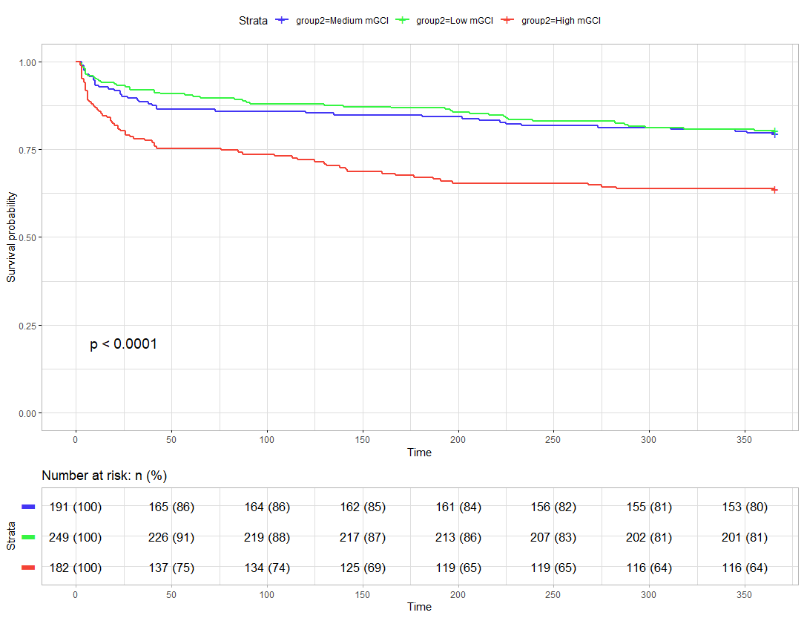
Figure S1 Sensitivity Analysis of Kaplan–Meier survival analysis curves for 1-year all-cause mortality
mGCI: median-based Glycemic Comparison Index

