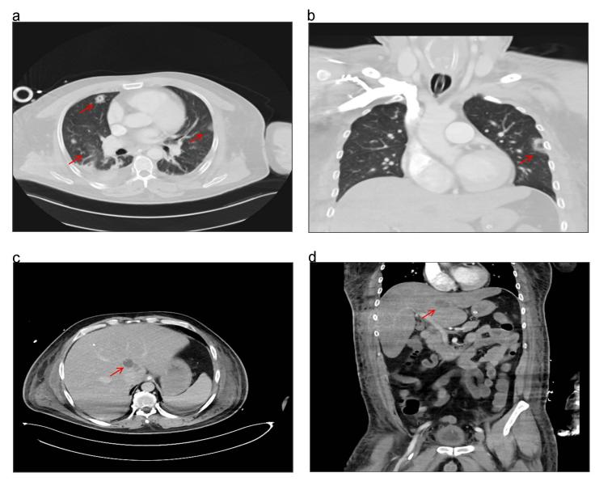
Fig. S1 (a b) Contrast-enhanced Chest CT demonstrated that increased local infection (red arrow). (c d) Abdominal CT 3 days after admission revealed a 3.3cm×2.1cm × 2.2cm low density area in the caudate lobe (red arrow).
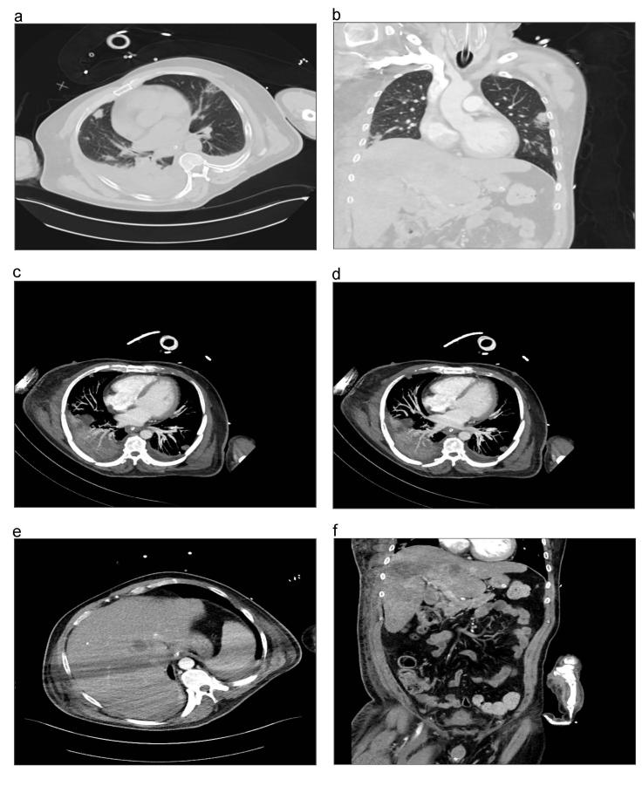
Fig. S2 CT imaging finding after received antibiotics for 15 days, (a b) Chest CT demonstrated that revealed resolution of the lung infection (red arrow). (c d) the improved CTA examination suggested no pulmonary embolism . (e f) Abdominal CT scan revealed infection focus was smaller than before (red arrow).
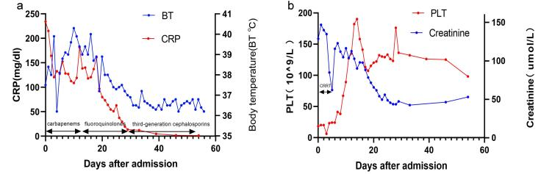
Fig. S3 Clinical course after admission. (a b) Change of the number of platelets, level of creatinine and CRP after admission.

