Supplementary Information
Design of Magnetic κ-Carrageenan-Collagen Bioinks for 3D Bioprinting

Duarte Almeida1,2,†, Freya Küppers1,2,†, Afonso Gusmão1,2, Ana C. Manjua3, Catarina F.R. Ferreira1,2, Carla A.M. Portugal4, João C. Silva1,2, Paola Sanjuan-Alberte1,2,*, Frederico Castelo Ferreira1,2,*
1 Department of Bioengineering and iBB-Institute for Bioengineering and Biosciences, Instituto Superior Técnico, Universidade de Lisboa, Av. Rovisco Pais, 1049-001 Lisbon, Portugal
2 Associate Laboratory i4HB—Institute for Health and Bioeconomy, Instituto Superior Técnico, Universidade de Lisboa, Av. Rovisco Pais, 1049-001 Lisbon, Portugal
3 Biosensors and Devices Lab, Biomedical Engineering Department, Institute for Complex Molecular Systems, Eindhoven Artificial Intelligence Systems Institute, Eindhoven University of Technology, Eindhoven, 5600 MB, The Netherlands
4 LAQV-REQUIMTE, Department of Chemistry, NOVA School of Science and Technology, Universidade Nova de Lisboa, Campus da Caparica, 2829-516 Caparica, Portugal
† Shared first authorship
* Corresponding authors: paola.alberte@tecnico.ulisboa.pt, frederico.ferreira@tecnico.ulisboa.pt

Table S1: Printing parameters of Pronterface used for the printing of 6K2C1MNP MSC-laden ink in the tube formation assay.

Length | 5.0
Speed | 15.0
Print speed | 100%
Print flow | 10%
Temperature | 23ºC

Table S2: Mechanical and printability data of various formulations, whose performance led to the choosing of the four formulations presented in the main manuscript.
Formulation (% w/w) | Young’s modulus (kPa) | Printability at day 1 (-) | Printability at day 8 (-) | Uniformity (-) | Printing fidelity (-)
0.8 % κc + 0.5% MNPs | 17.81 ± 5.51 | 0.92 ± 0.14 | 1.16 ± 0.27 | 1.04 ± 0.03 | 1.11 ± 0.05
0.8 % κc + 1.0% MNPs | 21.55 ± 10.89 | 0.99 ± 0.24 | 1.16 ± 0.25 | 1.06 ± 0.06 | 1.26 ± 0.07
1.0% κc | 24.69 ± 0.47 | 0.93 ± 0.12 | 1.03 ± 0.16 | 1.14 ± 0.13 | 1.15 ± 0.02
1.0 % κc + 0.5% MNPs | 25.56 ± 5.39 | 0.92 ± 0.12 | 1.04 ± 0.16 | 1.12 ± 0.09 | 1.15 ± 0.05
1.0 % κc + 1.0% MNPs | 27.68 ± 4.38 | 0.95 ± 0.17 | 1.04 ± 0.19 | 1.10 ± 0.10 | 1.15 ± 0.03
0.75% κc + 0.2% collagen | 10.58 ± 2.99 | 1.00 ± 0.27 | 1.30 ± 0.56 | 1.02 ± 0.01 | 1.23 ± 0.20
0.75% κc + 0.2% collagen + 0.5% MNP | 22.94 ± 3.12 | 1.00 ± 0.13 | 1.01 ± 0.12 | 1.04 ± 0.03 | 1.14 ± 0.04
0.75% κc + 0.2% collagen + 1.0% MNP | 19.37 ± 4.27 | 0.92 ± 0.10 | 0.88 ± 0.09 | 1.06 ± 0.04 | 1.16 ± 0.03

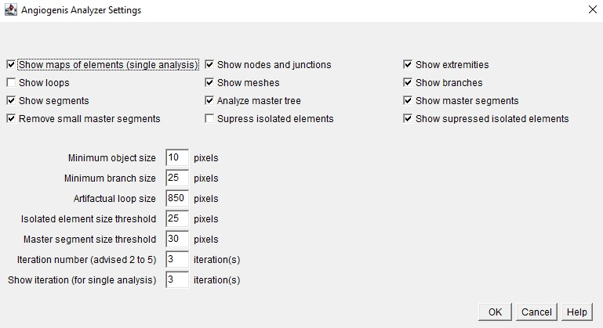
Figure S1: Angiogenesis Analyzer settings used to perform the assessment of the number of branches and branch points of the bright-field images of HUVECs prior to magnetic field stimulation.

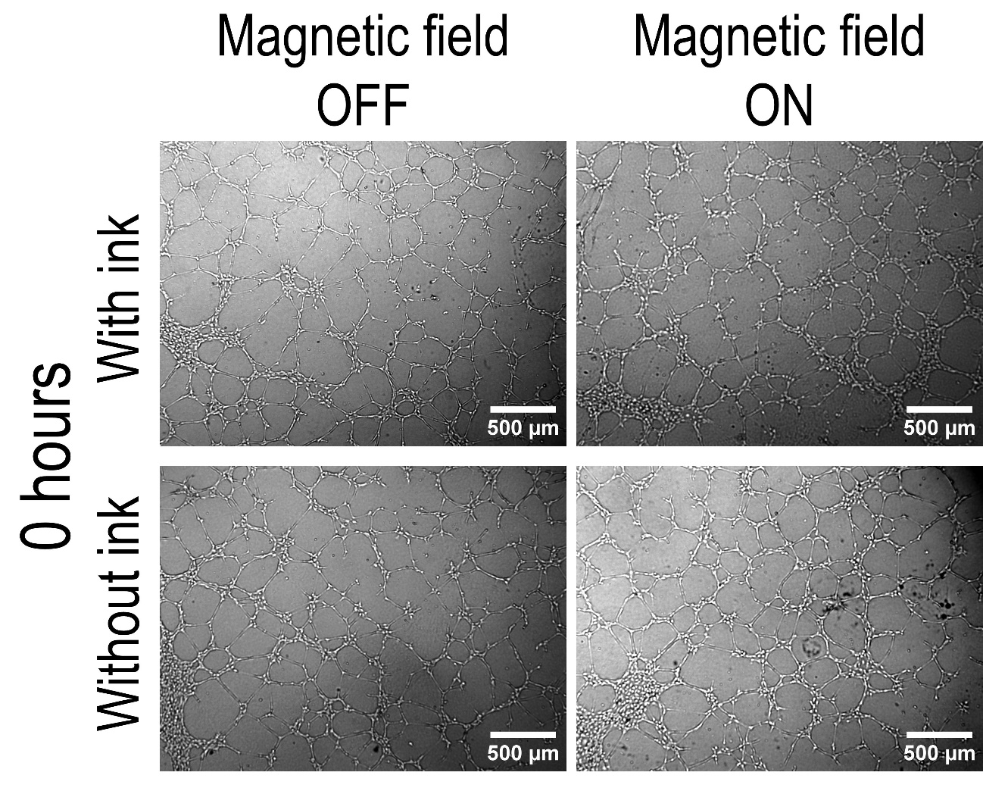
Figure S2: Bright-field images of the cultured HUVECs prior to magnetic field stimulation.

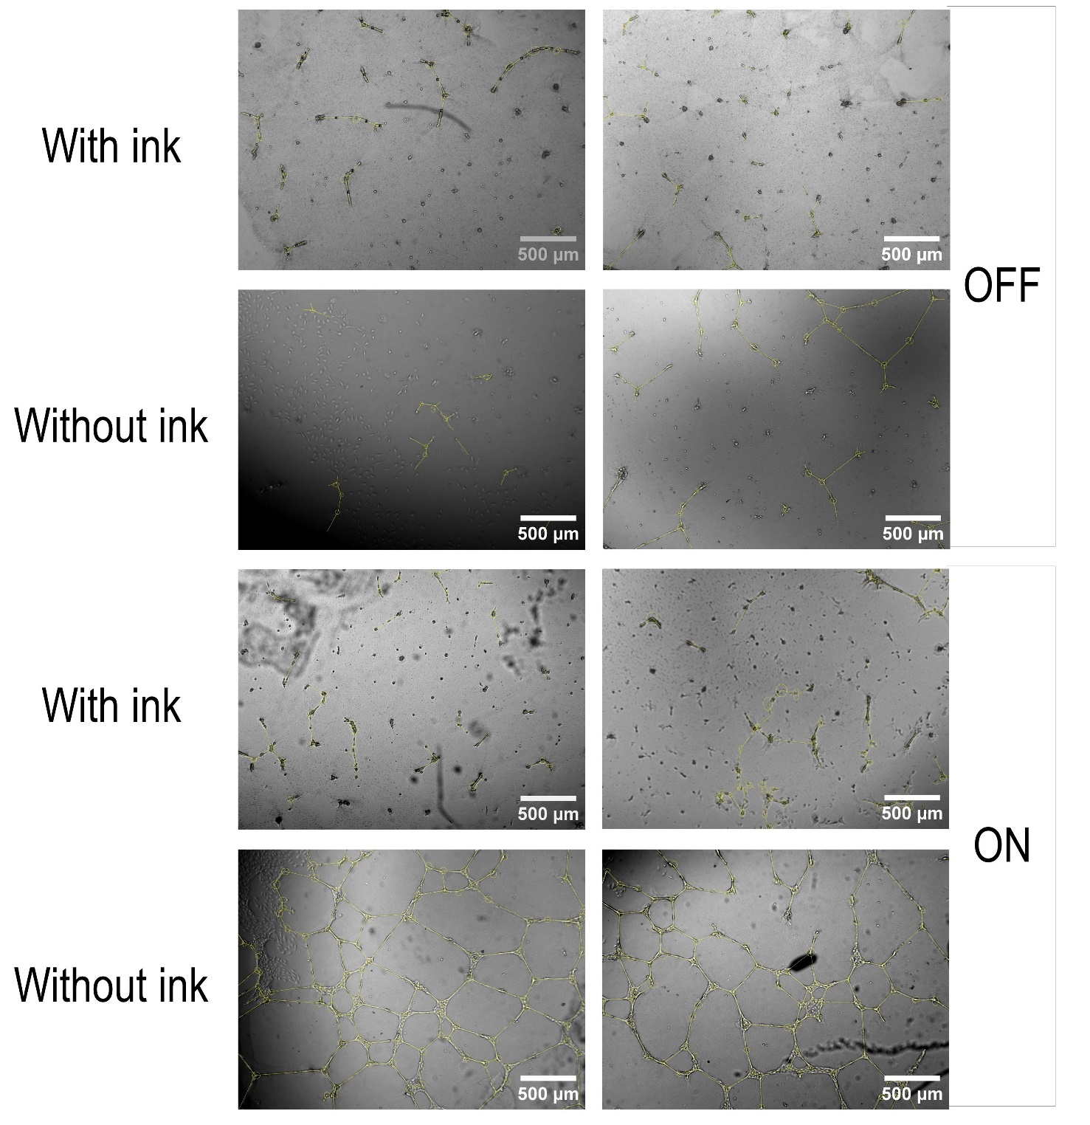
Figure S3: Results of the analyses of the images taken at timepoint 24h. Yellow lines represent tubes and yellow circles represent branch points connecting two or more tubes.

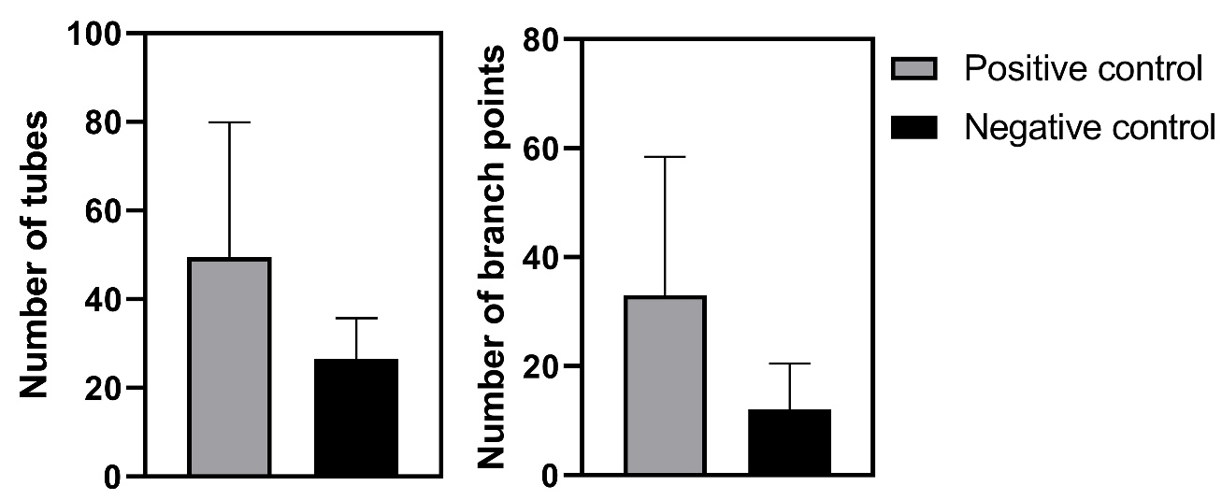
Figure S4: Number of tubes and branch points measured in the condition where HUVECs were cultured without the ink’s effect.

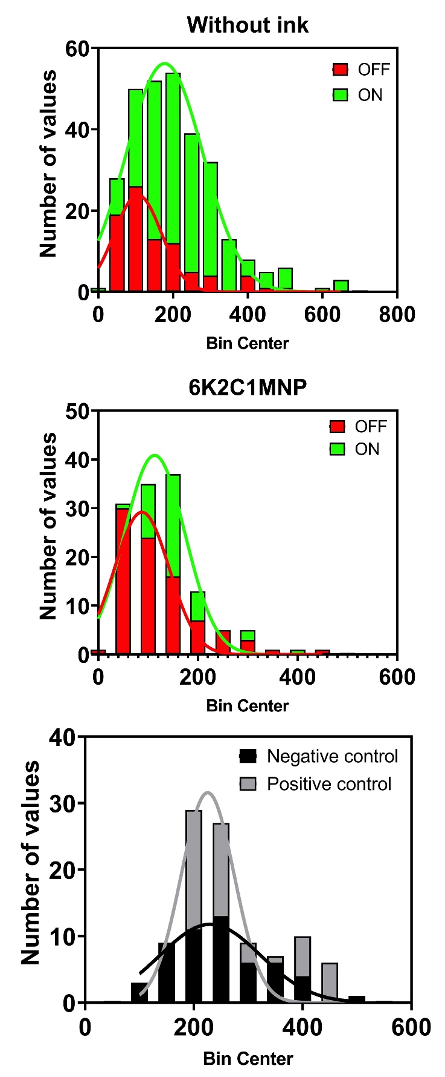
Figure S5: Histogram and fitting Gaussian curve of the distribution of tube lengths for the conditions without ink (top), with ink (middle) and controls (bottom).

Video S1: Experimental setup of the magnetic responsiveness assessment, showing the 6K2C1MNP hydrogel being attracted to the magnet.
Video S2: Magnetic responsiveness of the 3D printed magnetic structure, showing a slight inflection of its inner part towards the magnet when it is approached.

