SUPPLEMENTARY INFORMATION

Causal relationship between immune cells and Osteonecrosis: a bidirectional Mendelian randomization study

_{Supplementary Table 1 :} Results of Mendelian randomization analysis of osteonecrosis on immunophenotypes
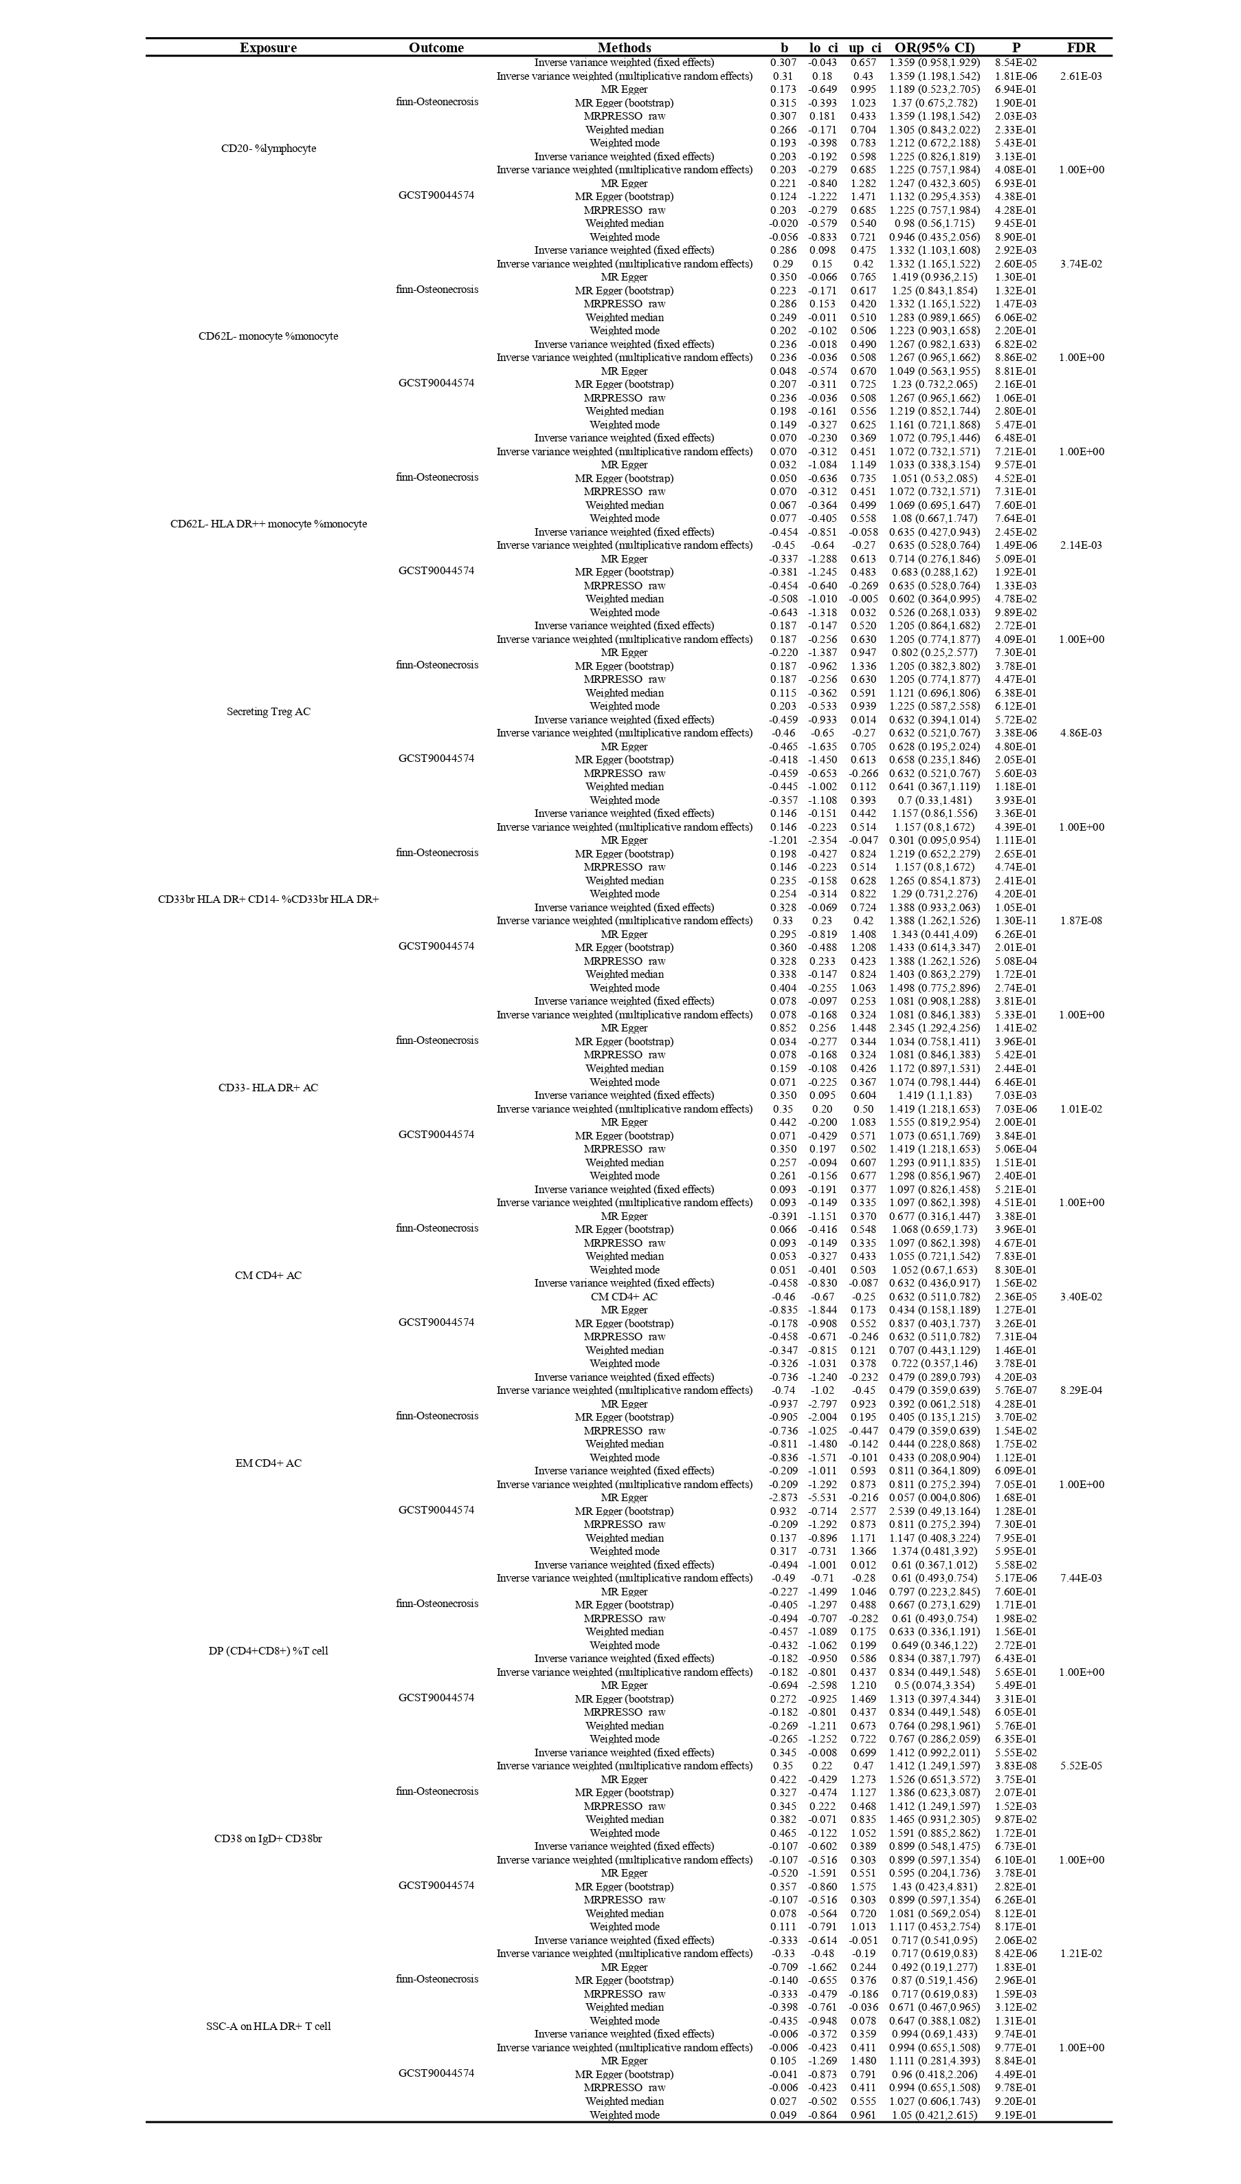

_{Supplementary Table 2 :} MR-Egger and MR_PRESSO of the results of Mendelian randomization analysis of immunophenotypes on osteonecrosis
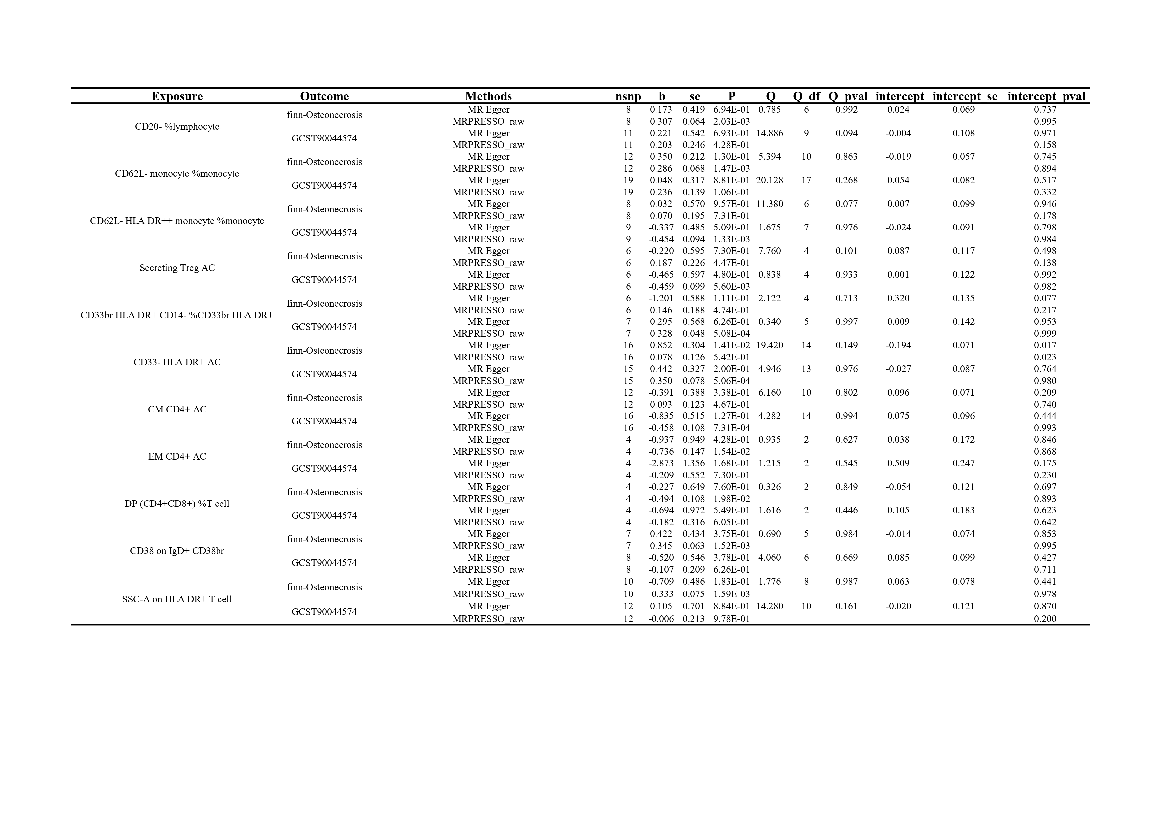

_{Supplementary Table 3 :} Results of Mendelian randomization analysis of immunophenotypes on osteonecrosis
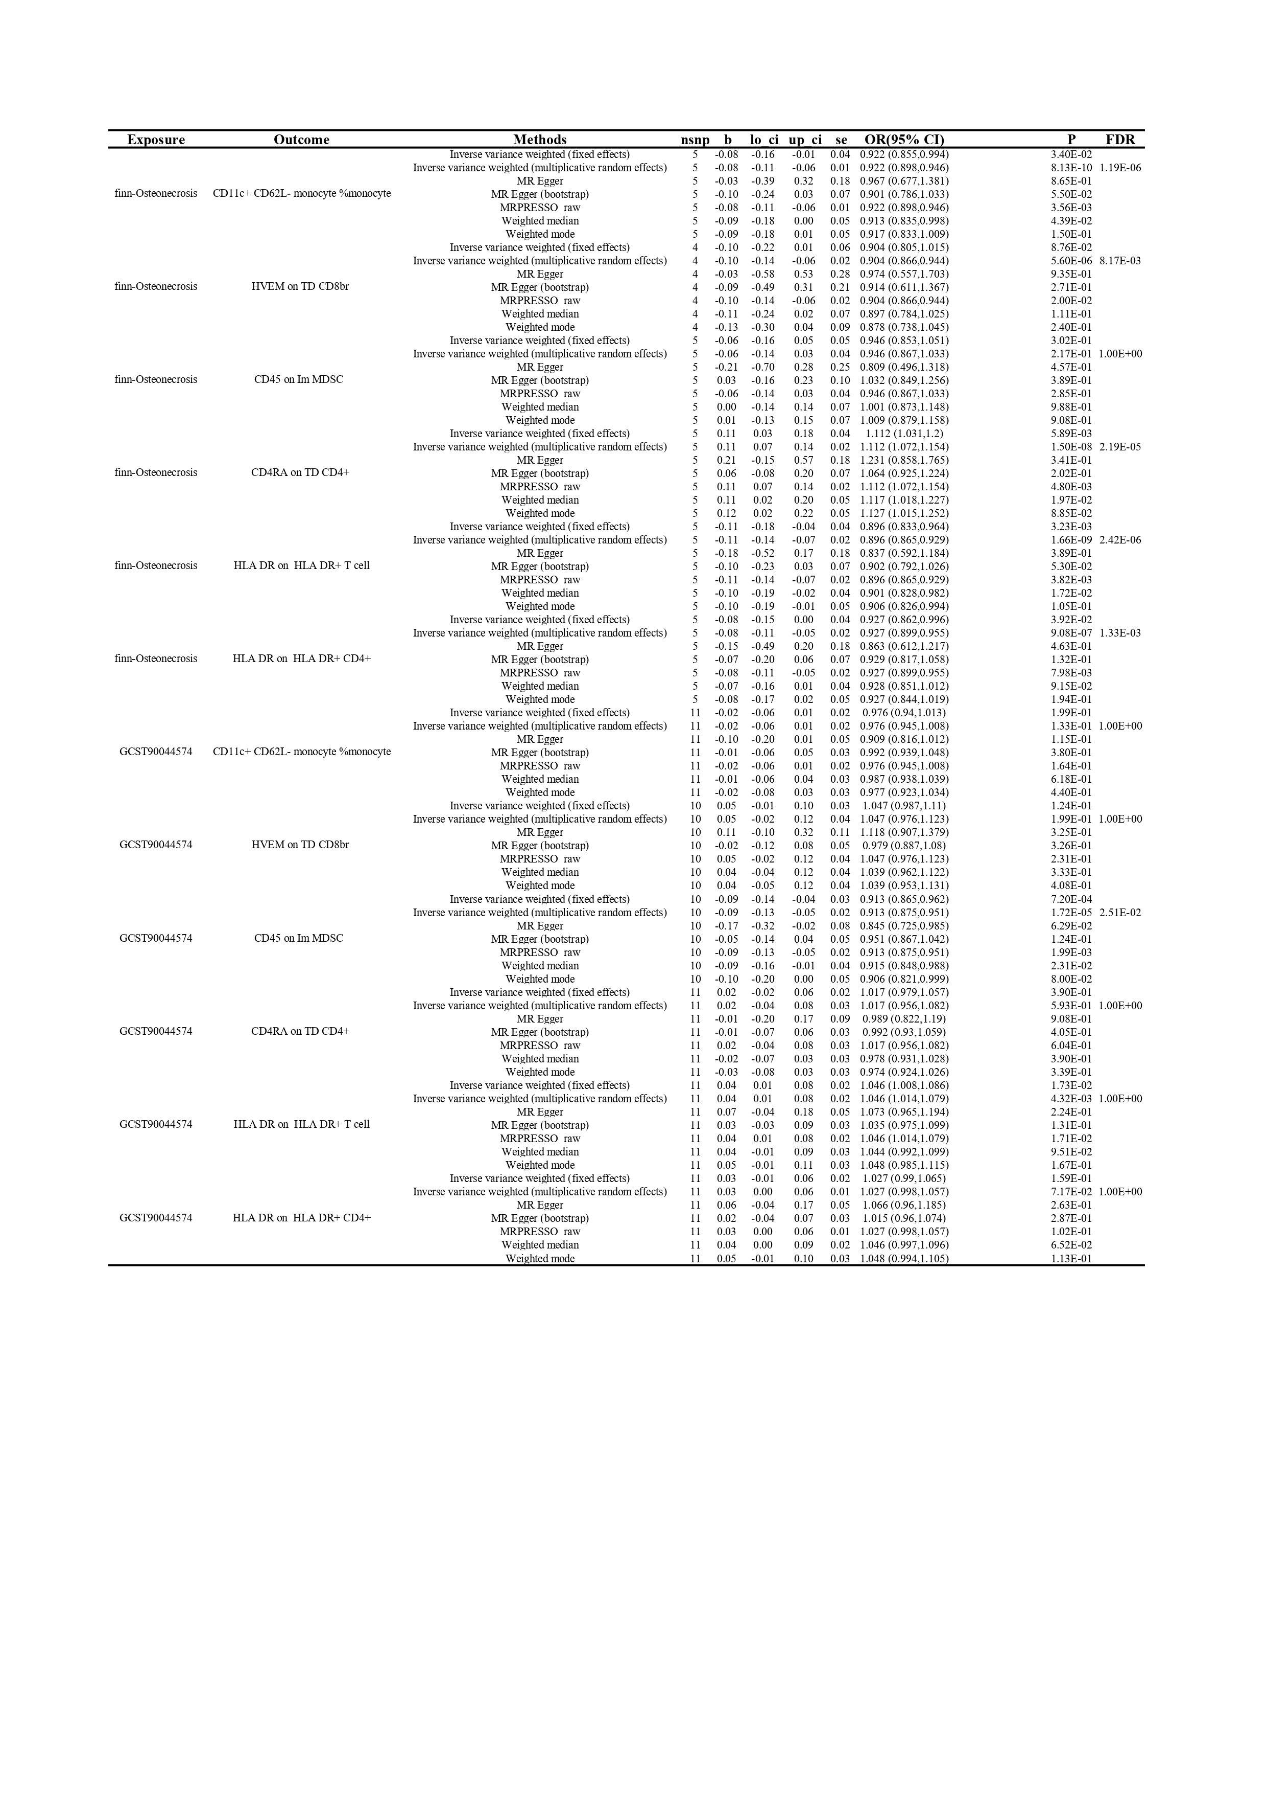
_{Supplementary Table 4 :} MR-Egger and MR_PRESSO of the results of Mendelian randomization analysis of osteonecrosis on immunophenotypes
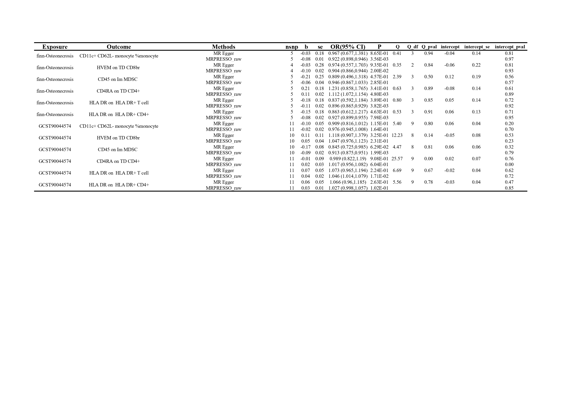

_{Supplementary figure 1：}Meta-analysis of the Causal Effects of Immune Phenotypes on Osteonecrosis
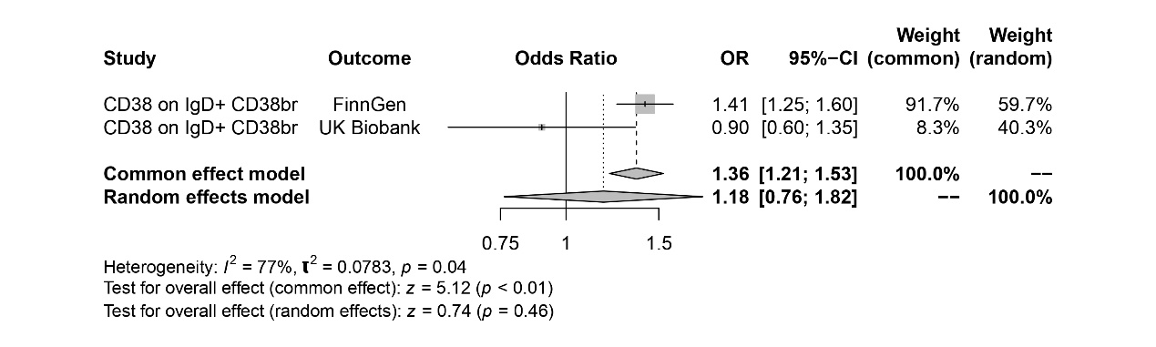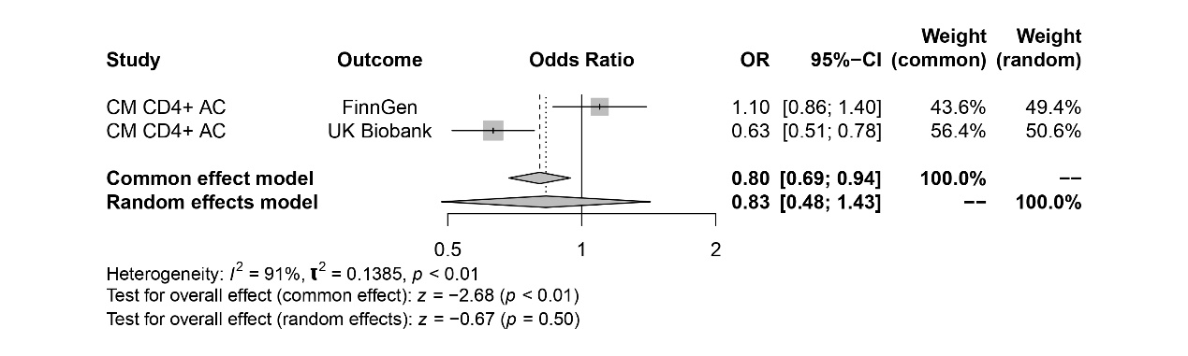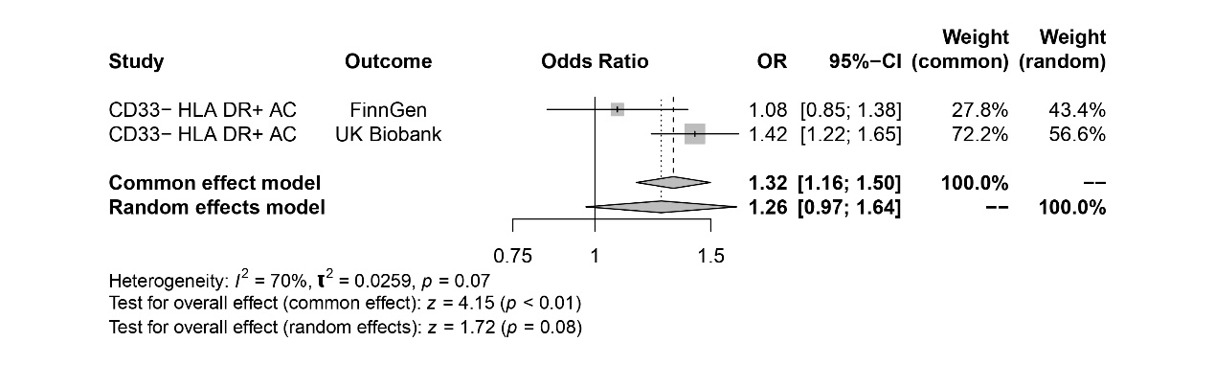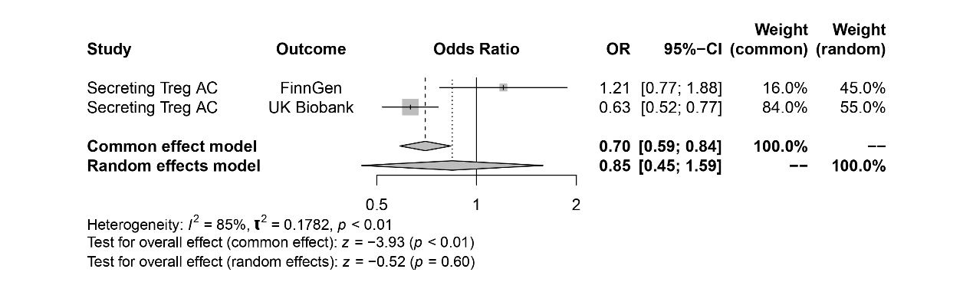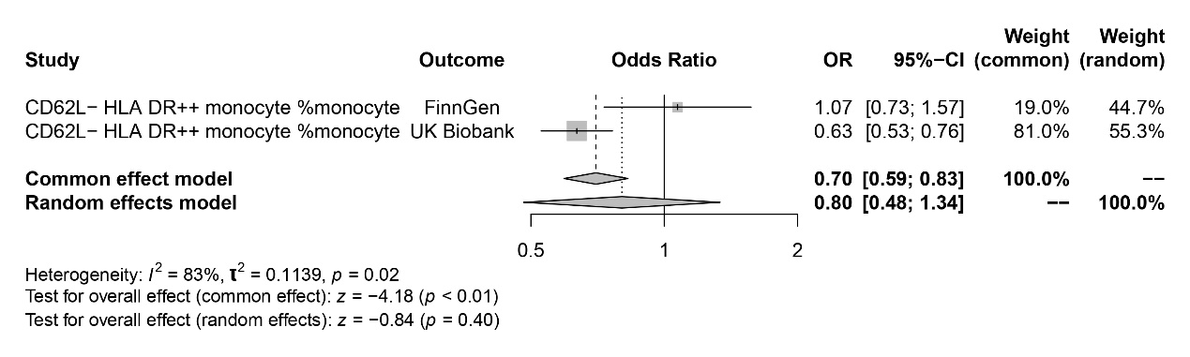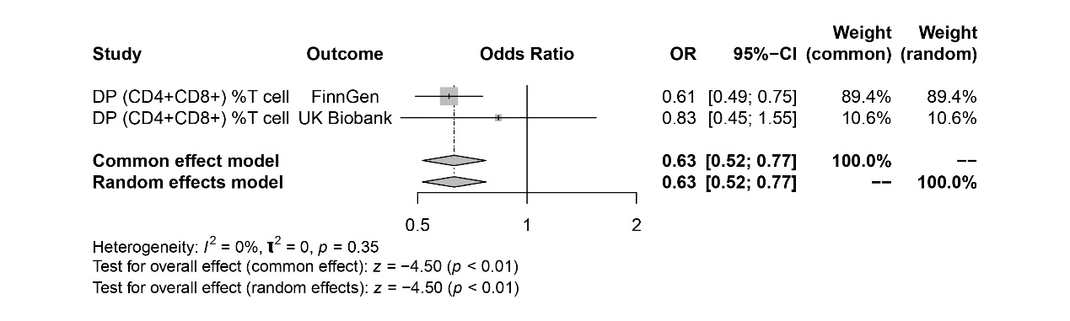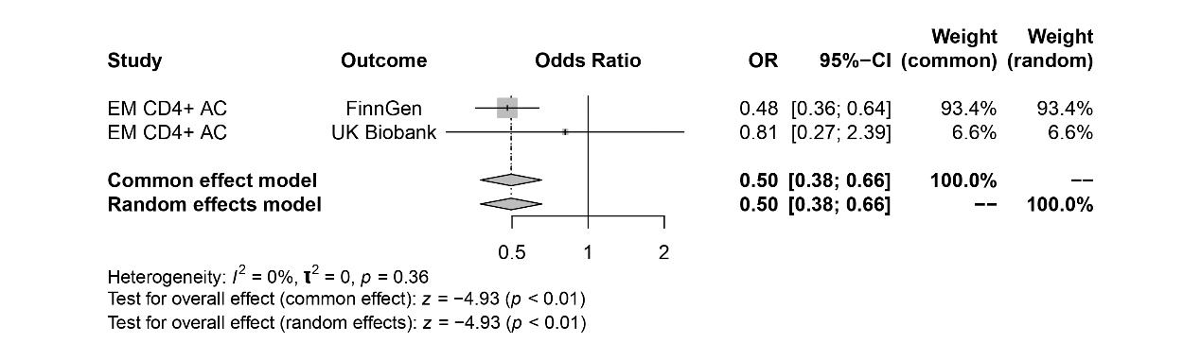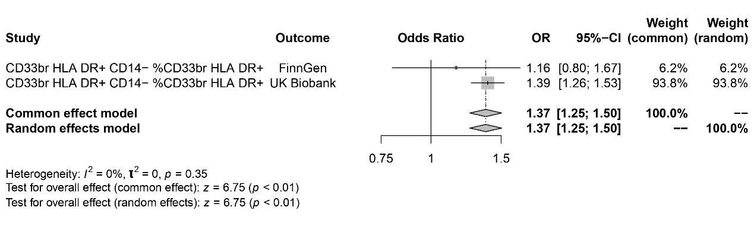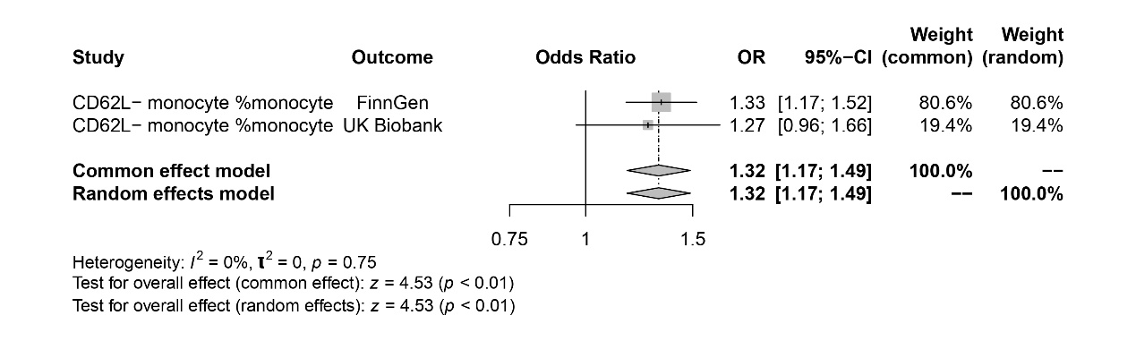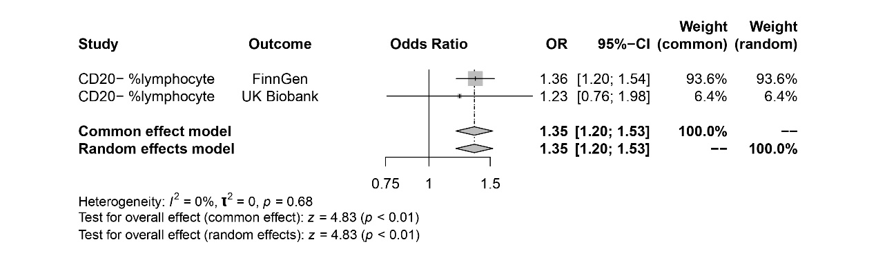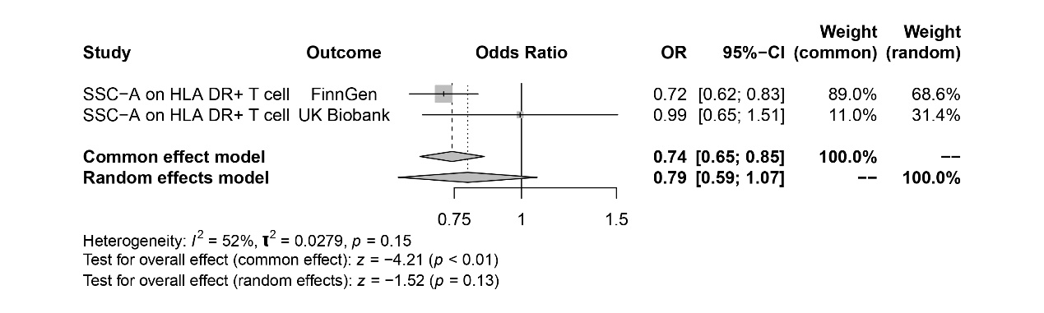

Supplementary figure 2：Scatter plot and funnel plot (CD20- %lymphocyte cell, left FinnGen, right UK Biobank)

Supplementary figure 3：Least-one-out validation chart (CD20- %lymphocyte cell, left FinnGen, right UK Biobank)

Supplementary figure 4：Scatter plot and funnel plot (CD62L- monocyte % monocytes, left FinnGen, right UK Biobank)

Supplementary figure 5 ：Least-one-out validation chart (CD62L- monocyte % monocytes, left FinnGen, right UK Biobank)

Supplementary figure 6 ：Scatter plot and funnel plot (CD33br HLA DR+ CD14- % CD33br HLA DR+, left FinnGen, right UK Biobank)

Supplementary figure 7 ：Least-one-out validation chart (CD33br HLA DR+ CD14- % CD33br HLA DR+, left FinnGen, right UK Biobank)

Supplementary figure 8 ：Scatter plot and funnel plot (EM CD4+ activated cells, left FinnGen, right UK Biobank)

Supplementary figure 9 ：Least-one-out validation chart (EM CD4+ activated cells, left FinnGen, right UK Biobank)

Supplementary figure 10 ：Scatter plot and funnel plot (DP (CD4+CD8+) % T cells, left FinnGen, right UK Biobank)

Supplementary figure 11 ：Least-one-out validation chart (DP (CD4+CD8+) % T cells, left FinnGen, right UK Biobank)
_{Supplementary figure 12：}Meta-analysis of the Causal Effects of Osteonecrosis on Immune Phenotypes
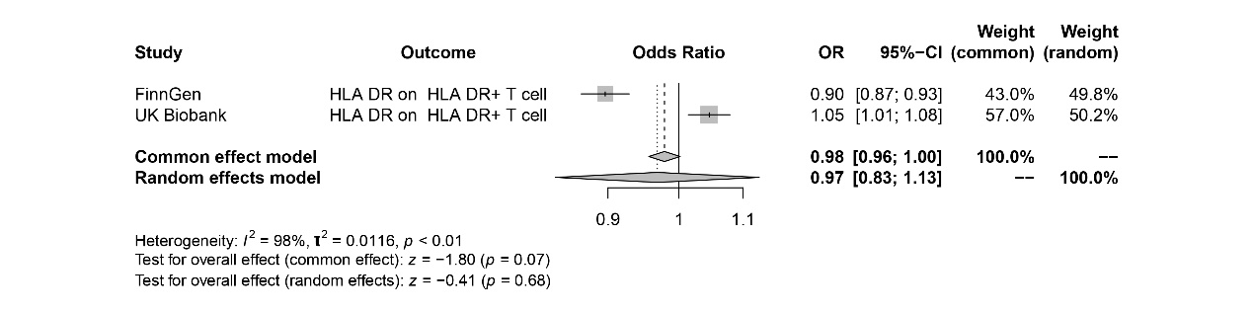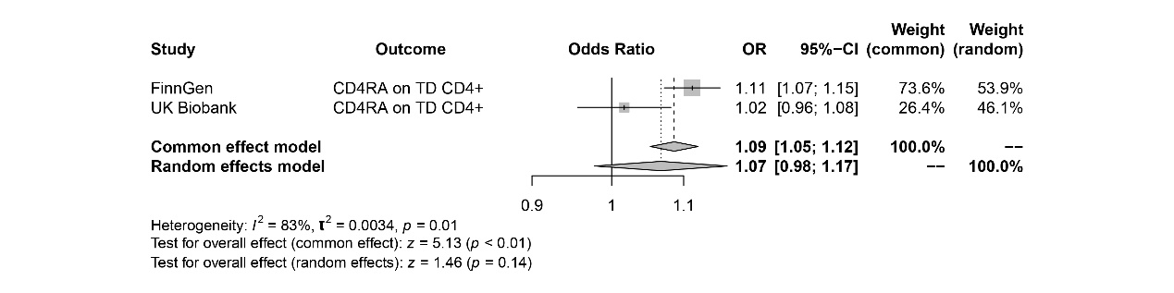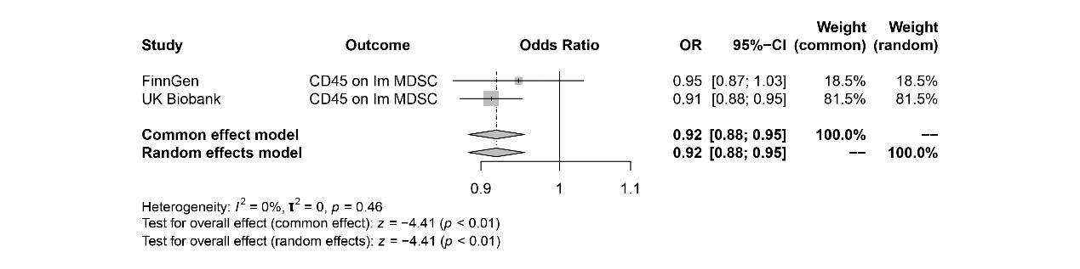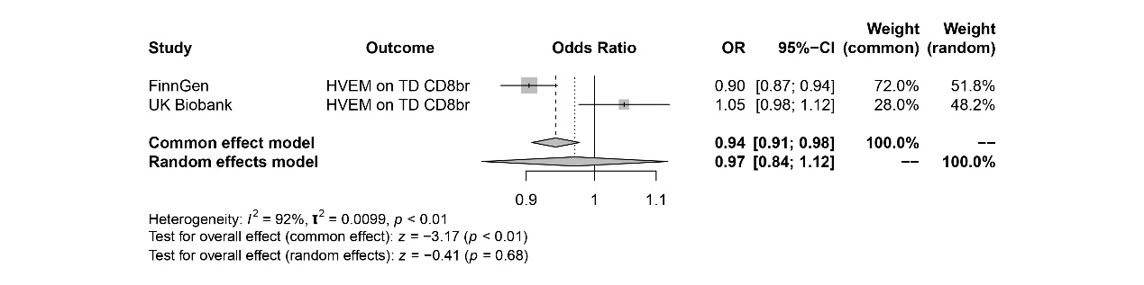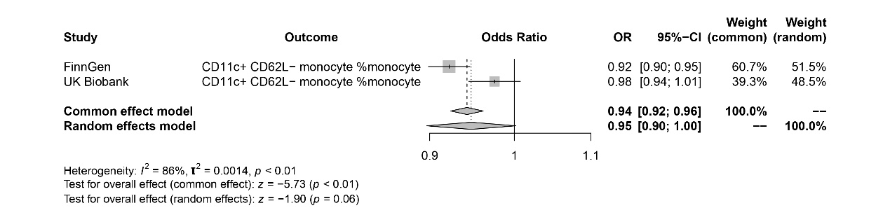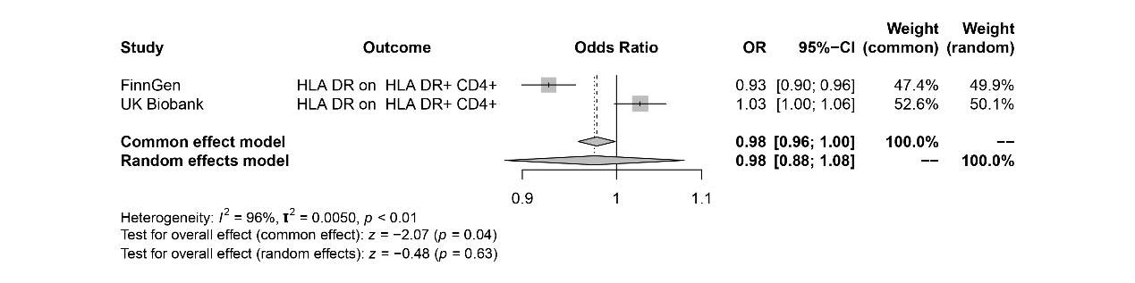

Supplementary figure 13 ：Scatter plot and funnel plot (CD45 on Im MDSC, left FinnGen, right UK Biobank)

Supplementary figure 14 ：Least-one-out validation chart (CD45 on Im MDSC, left FinnGen, right UK Biobank)

