Supplementary material
Supplementary material 1: Consultation types and categories in Danish general practice
Consultation type (service number Danish name) | Face-to-face | Phone | E-mail | Home visit | Chronic care review
Consultation (0101 Konsultation) | X
Annual chronic care consultation (0120 Årsstatus/årskontrol) |  |  |  |  | X
Consultation by telephone (0201 Telefonkonsultation) |  | X
Planned consultation by telephone (0204 Aftalt telefonkonsultation) |  | X
Social medicine telephone consultation (3201 Socialmedicinsk telefonkonsultation) |  | X
Assessment of patients at nursing home  (0124 Lægefaglig vurdering af patienter på kommunal akutfunktion/akutteam) |  |  |  | X
Consultation by e-mail (0105 E-konsultation) |  |  | X
Consultation with municipality services by e-mail (0127 E-konsultation med kommunen) |  |  | X
Consultation by video (0125 Videokonsultation) | X
Video conference (0126 Videokonference) | X
Talk therapy (6101 Samtaleterapi) | X
Home-vist (04*1 Sygebesøg *dækker alle sygebesøg uanset 3. tal i koden) |  |  |  | X
Preventive home-visit (0121 Opsøgende hjemmebesøg) |  |  |  |  | X
§2 services | Face-to-face | Phone | E-mail | Home visit | Chronic care review
Home-visit after hospital admission, Capital region (4250 Opfølgende hjemmebesøg) |  |  |  | X
Annual dementia consultation, Capital region (4282 Kontrol demens (årlig)) |  |  |  |  | X
Communication with municipality acute functions, Capital region (4469 Kommunikation med kommunal akutfunktion) |  |  |  | X
Home-visit after hospital admission, Region of Southern Denmark (4176 Opfølgende hjemmebesøg) |  |  |  | X
Consultation after hospital admission in the clinic, Region of Southern Denmark (4676 Opfølgning efter indlæggelse) | X
Prevention of acute hospitalisation or non-beneficial rehospitalisation, Region of Southern Denmark (4442-4448 Forebyggelse af akutte indlæggelser eller uhensigtsmæssigt genindlæggelser) |  |  |  | X
Crisis counseling, Region of Southern Denmark (4609 Krisesamtale) | X
Course of talk therapy, Region of Southern Denmark (4610 Samtaleterapiforløb) | X
Home-visit after hospital admission, Central region (4213 Opfølgende hjemmebesøg) |  |  |  | X
Home-visit for terminal patient, Central region (4801 Terminalydelsen) |  |  |  | X
Assessment of patients by acute team, Central region (4449 Akutfunktion) |  |  |  | X
Temporary COVID-19 services | Face-to-face | Phone | E-mail | Home visit | Chronic care review
Consultation by video (4436 Videokonsultation) | X
Laboratory test results by telephone if indicated (4483 Telefonisk kontakt til patienter om prøvesvar, såfremt det er fagligt indiceret) |  | X
Negative laboratory test results by e-mail if indicated (4484 Svarafgivelse på e-mail til patienter med negativt prøvesvar, hvor det er fagligt indiceret) |  |  | X
Renumeration code for service 0101 or 0120 provided by telephone according to national agreement (1002 Corona-registreringsydelse til ydelser som er aftalt kan udføres telefonisk) |  | X
Renumeration code for service 0120 or 6101 provided by video according to national agreement (1003 Corona-registreringsydelse til ydelser som er aftalt kan udføres på video) | X
Only consultations provided ≥1000 times in a year in the population was included.

Supplementary material 2: Definition of variables
Variable | Categories | Groups
(I) Patient health factors:
Age | 5-year intervals from 75-100+, ordinal categorical | 6
Sex | Dichotomised | 2
Multimorbidity | Divided into no multimorbidity (score ≤0), lowest middle, and highest tertile. | 4
Ethnicity | Danish, other western background (EU, USA, Canada, New Zealand, or Australia), and other. | 3
Polypharmacy | Calculated as redeeming more than 5 different prescription drugs (on fourth level of ATC code) during the last 120 days and categorised into four groups 0, 1-4, 5-9, and 10+ unique prescription drugs. Excluding antibiotics (J01 & P01BA01). | 4
Level of home healthcare services | Divided into five categories: None, lowest, middle, and highest tertile, and nursing home resident. The tertiles was based on allocated time per week by the municipality in minutes. | 5
(II) Patient geographic factors:
Rural or urban district | Dichotomised into urban and rural. Rural defined as less than 200 inhabitants in a community and more than 200 meters between houses. | 2
Travel distance from home address to the general practice | Categorised based on the renumeration structure for home visits (<4km, 4-20km, and >=21km) | 3
Travel distance to appointed emergency department | <10km, 10-25km, and >25km | 3
(III) Patient socioeconomic factors:
Cohabitation | Divided into single or cohabitating | 2
Household income | Divided by number of cohabitants in the household and split into quintiles for the study population and used as ordinal categorical values | 5
Household wealth | Divided by number of cohabitants in the household and split into quintiles for the study population and used as ordinal categorical values | 5
(IV) practice factors:
Number of GPs | Divided into: Solo, 2-3, 4-5 and 5+ | 4
Age | Divided into tertiles | 3
Gender | Mean gender of GPs divided into quintiles (0-20%, 20-40%, 40-60%, 60-80%, 80-100% female) | 5
Seniority | Divided into tertiles | 3
 | Total categories: | 59

Supplementary material 3: Adjustment models (2021)
Models | (I) Patient health factors |  | (II) Patient Geographic factors |  | (III) Patient Socioeconomic Factors |  | (IV) Practice factors
 | IRR | CI 95% | IRR | CI 95% | IRR | CI 95% | IRR | CI 95%
Patient health factors
Age
75-79 | 1.00 | Reference | 1.00 | Reference | 1.00 | Reference | 1.00 | Reference
80-84 | 1.07 | (1.06;1.07) | 1.06 | (1.06;1.06) | 1.07 | (1.06;1.07) | 1.07 | (1.06;1.07)
85-90 | 1.11 | (1.10;1.11) | 1.09 | (1.09;1.09) | 1.10 | (1.10;1.10) | 1.10 | (1.10;1.10)
90-94 | 1.14 | (1.13;1.14) | 1.10 | (1.10;1.11) | 1.11 | (1.11;1.12) | 1.11 | (1.11;1.12)
95-99 | 1.15 | (1.15;1.16) | 1.10 | (1.10;1.11) | 1.11 | (1.11;1.12) | 1.11 | (1.11;1.12)
100+ | 1.16 | (1.14;1.17) | 1.07 | (1.05;1.09) | 1.08 | (1.06;1.10) | 1.08 | (1.06;1.10)
Sex
Male | 1.00 | Reference | 1.00 | Reference | 1.00 | Reference | 1.00 | Reference
Female | 1.07 | (1.07;1.07) | 1.08 | (1.08;1.09) | 1.09 | (1.09;1.09) | 1.09 | (1.09;1.09)
Nordic Multimorbidity Index
No multimorbidity | 1.00 | Reference | 1.00 | Reference | 1.00 | Reference | 1.00 | Reference
Lowest tertile | 1.15 | (1.15;1.16) | 1.15 | (1.15;1.15) | 1.15 | (1.15;1.16) | 1.15 | (1.15;1.16)
Middle tertile | 1.24 | (1.24;1.25) | 1.24 | (1.23;1.24) | 1.24 | (1.24;1.24) | 1.24 | (1.23;1.24)
Highest tertile | 1.32 | (1.32;1.33) | 1.29 | (1.28;1.29) | 1.29 | (1.29;1.29) | 1.29 | (1.29;1.29)
Ethnicity
Danish | 1.00 | Reference | 1.00 | Reference | 1.00 | Reference | 1.00 | Reference
Other western | 1.04 | (1.04;1.05) | 1.04 | (1.04;1.05) | 1.04 | (1.04;1.05) | 1.04 | (1.03;1.04)
Other | 0.87 | (0.87;0.88) | 0.87 | (0.86;0.88) | 0.88 | (0.87;0.89) | 0.87 | (0.87;0.88)
Missing ethnicity | 1.16 | (1.08;1.24) | 1.07 | (0.99;1.16) | 1.08 | (1.00;1.17) | 1.07 | (0.99;1.15)
Polypharmacy
0 drugs | 1.00 | Reference | 1.00 | Reference | 1.00 | Reference | 1.00 | Reference
1-4 drugs | 1.39 | (1.38;1.39) | 1.40 | (1.40;1.41) | 1.40 | (1.40;1.41) | 1.40 | (1.40;1.41)
5-9 drugs | 1.74 | (1.73;1.74) | 1.76 | (1.75;1.77) | 1.77 | (1.76;1.78) | 1.77 | (1.76;1.78)
10+ drugs | 2.05 | (2.04;2.06) | 2.09 | (2.08;2.10) | 2.10 | (2.09;2.11) | 2.10 | (2.09;2.11)
Home healthcare service
None | 1.00 | Reference | 1.00 | Reference | 1.00 | Reference | 1.00 | Reference
Lowest tertile | 1.29 | (1.28;1.29) | 1.27 | (1.27;1.28) | 1.28 | (1.28;1.29) | 1.28 | (1.28;1.29)
Middel tertile | 1.43 | (1.43;1.44) | 1.39 | (1.39;1.40) | 1.40 | (1.40;1.41) | 1.40 | (1.40;1.41)
Highest tertile | 1.63 | (1.62;1.63) | 1.53 | (1.53;1.54) | 1.54 | (1.53;1.54) | 1.54 | (1.53;1.54)
Nursing home resident | 1.57 | (1.56;1.57) | 1.47 | (1.46;1.47) | 1.47 | (1.47;1.48) | 1.48 | (1.47;1.48)
Patient geographic factors
District
Urban |  |  | 1.00 | Reference | 1.00 | Reference | 1.00 | Reference
Rural |  |  | 0.95 | (0.95;0.95) | 0.95 | (0.95;0.96) | 0.95 | (0.95;0.96)
Travel distance to general practice
<4km |  |  | 1.00 | Reference | 1.00 | Reference | 1.00 | Reference
4-20 |  |  | 0.98 | (0.97;0.98) | 0.98 | (0.97;0.98) | 0.98 | (0.97;0.98)
>=21km |  |  | 1.01 | (1.01;1.02) | 1.01 | (1.01;1.02) | 0.98 | (0.98;0.99)
Travel distance to emergency department
<10km |  |  | 1.00 | Reference | 1.00 | Reference | 1.00 | Reference
10-25km |  |  | 1.00 | (1.00;1.00) | 1.00 | (1.00;1.00) | 1.01 | (1.00;1.01)
>25km |  |  | 1.00 | (0.99;1.00) | 1.00 | (1.00;1.00) | 1.00 | (1.00;1.00)
Patient socioeconomic factors
Cohabitation
Living alone |  |  |  |  | 1.00 | Reference | 1.00 | Reference
Cohabitating |  |  |  |  | 1.01 | (1.01;1.02) | 1.01 | (1.01;1.02)
Household income
Lowest quintile |  |  |  |  | 1.00 | Reference | 1.00 | Reference
Second lowest quintile |  |  |  |  | 1.02 | (1.01;1.02) | 1.02 | (1.01;1.02)
Middle quintile |  |  |  |  | 1.04 | (1.04;1.05) | 1.04 | (1.04;1.05)
Second highest quintile |  |  |  |  | 1.06 | (1.06;1.06) | 1.06 | (1.05;1.06)
Highest quintile |  |  |  |  | 1.07 | (1.06;1.07) | 1.06 | (1.06;1.07)
Missing income |  |  |  |  | 1.08 | (1.05;1.11) | 1.08 | (1.05;1.11)
Household wealth
Lowest quintile |  |  |  |  | 1.00 | Reference | 1.00 | Reference
Second lowest quintile |  |  |  |  | 1.00 | (0.99;1.00) | 1.00 | (1.00;1.00)
Middle quintile |  |  |  |  | 0.99 | (0.99;0.99) | 0.99 | (0.99;0.99)
Second highest quintile |  |  |  |  | 0.99 | (0.98;0.99) | 0.99 | (0.98;0.99)
Highest quintile |  |  |  |  | 0.99 | (0.98;0.99) | 0.98 | (0.98;0.99)
Missing wealth |  |  |  |  | 1.00 | (1.00;1.00) | 1.00 | (1.00;1.00)
Practice factors
Number of owners
Solo |  |  |  |  |  |  | 1.00 | Reference
2-3 |  |  |  |  |  |  | 0.97 | (0.97;0.97)
4-5 |  |  |  |  |  |  | 0.93 | (0.93;0.93)
5+ |  |  |  |  |  |  | 0.90 | (0.90;0.91)
Missing |  |  |  |  |  |  | 0.93 | (0.91;0.94)
Age
Lowest tertile |  |  |  |  |  |  | 1.00 | Reference
Middle tertile |  |  |  |  |  |  | 1.02 | (1.02;1.02)
Highest tertile |  |  |  |  |  |  | 1.02 | (1.02;1.03)
Missing |  |  |  |  |  |  | 1.08 | (1.06;1.09)
Gender (% female)
0-20 |  |  |  |  |  |  | 1.00 | Reference
20-40 |  |  |  |  |  |  | 1.00 | (1.00;1.01)
40-60 |  |  |  |  |  |  | 1.01 | (1.01;1.02)
60-80 |  |  |  |  |  |  | 1.01 | (1.01;1.01)
80-100 |  |  |  |  |  |  | 1.01 | (1.00;1.01)
Missing |  |  |  |  |  |  | 1.00 | (1.00;1.00)
Seniority
Lowest tertile |  |  |  |  |  |  | 1.00 | Reference
Middle tertile |  |  |  |  |  |  | 0.98 | (0.98;0.98)
Highest tertile |  |  |  |  |  |  | 0.99 | (0.99;1.00)
Missing |  |  |  |  |  |  | 1.00 | (1.00;1.00)
IRR: Incidence rate ratio, CI 95%: 95% Confidence interval.

Supplementary material 4: Subgroup multinomial regression of practices outside control limits (2021)
 | Practices within  control limits |  | Practices >95% upper control limit |  | Practices >99.8% upper control limit |  | Practices <95% lower  control limit |  | Practices <99.8% lower control limit
Consultation type | Crude | Adjusted | Crude | Adjusted | Crude | Adjusted | Crude | Adjusted | Crude | Adjusted
Total | 1553 | 1454 | 38 | 132 | 8 | 91 | ≤5 | 10 | ≤5 | ≤5
Face-to-face | 1568 | 1453 | 22 | 121 | ≤5 | 91 | 6 | 22 | ≤5 | ≤5
Telephone | >1529 | >1439 | 62 | 152 | 8 | 96 | ≤5 | ≤5 | ≤5 | ≤5
E-mail | >1543 | >1458 | 47 | 133 | 15 | 94 | ≤5 | ≤5 | ≤5 | ≤5
Home visit | >1511 | >1455 | 69 | 126 | 22 | 96 | ≤5 | ≤5 | ≤5 | ≤5
Chronic care review | >1537 | >1443 | 40 | 134 | 7 | 96 | ≤5 | ≤5 | ≤5 | ≤5
Association with  Practice factors | RRR | CI 95% | RRR | CI 95% | RRR | CI 95% | RRR | CI 95% | RRR | CI 95%
Number of GPs
Solo | 1 | Reference | 1.00 | Reference | --- | --- | 1.00 | Reference | --- | ---
2-3 | 1 | Reference | 0.47 | (0.20;1.09) | --- | --- | 0.00 | (0.00; ∞) | --- | ---
4-5 | 1 | Reference | 0.17 | (0.03;0.91) | --- | --- | 0.00 | (0.00; ∞) | --- | ---
5+ | 1 | Reference | 0.00 | (0.00; ∞) | --- | --- | 0.00 | (0.00; ∞) | --- | ---
Missing | 1 | Reference | 10.87 | (1.05;112.61) | --- | --- | 0.00 | (0.00; ∞) | --- | ---
Age
Lowest tertile | 1 | Reference | 1.00 | Reference | --- | --- | 1.00 | Reference | --- | ---
Middle tertile | 1 | Reference | 0.34 | (0.12;0.97) | --- | --- | 0.00 | (0.00; ∞) | --- | ---
Highest tertile | 1 | Reference | 0.62 | (0.20;1.98) | --- | --- | 0.11 | (0.00;4.66) | --- | ---
Missing | 1 | Reference | 1.62 | (0.16;16.19) | --- | --- | 53.34 | (0.00; ∞) | --- | ---
Gender % female
0-20% | 1 | Reference | 1.00 | Reference | --- | --- | 1.00 | Reference | --- | ---
20-40% | 1 | Reference | 0.65 | (0.07;5.68) | --- | --- | 6305877.58 | (0.00; ∞) | --- | ---
40-60% | 1 | Reference | 1.66 | (0.53;5.21) | --- | --- | 0.24 | (0.00; ∞) | --- | ---
60-80% | 1 | Reference | 0.64 | (0.12;3.42) | --- | --- | 0.31 | (0.00; ∞) | --- | ---
80-100% | 1 | Reference | 1.12 | (0.60;2.08) | --- | --- | 0.37 | (0.07;2.01) | --- | ---
Missing | 1 | Reference | 1.00 | Collinear | --- | --- | 1.00 | Collinear | --- | ---
Seniority
Lowest tertile | 1 | Reference | 1.00 | Reference | --- | --- | 1.00 | Reference | --- | ---
Middle tertile | 1 | Reference | 1.21 | (0.49;2.98) | --- | --- | 1.34 | (0.13;13.37) | --- | ---
Highest tertile | 1 | Reference | 0.95 | (0.30;3.27) | --- | --- | 2.90 | (0.06;133.86) | --- | ---
Missing | 1 | Reference | 1.00 | Collinear | --- | --- | 1.00 | Collinear | --- | ---
RRR: Relative risk ratio, CI 95%: 95% Confidence interval, --- Omitted from the analysis due to small numbers

Supplementary material 5: Variation between practices: Heatmap-infused funnel plots of crude and adjusted rates for specific consultation types (2021)
Face to face
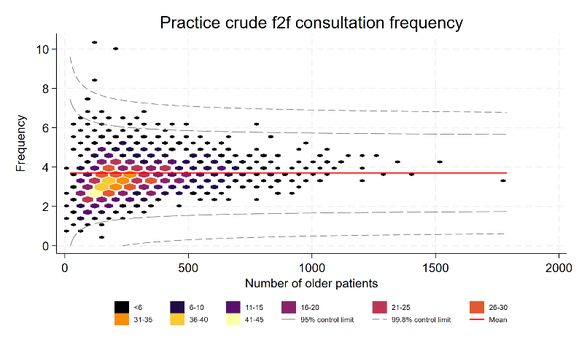 | 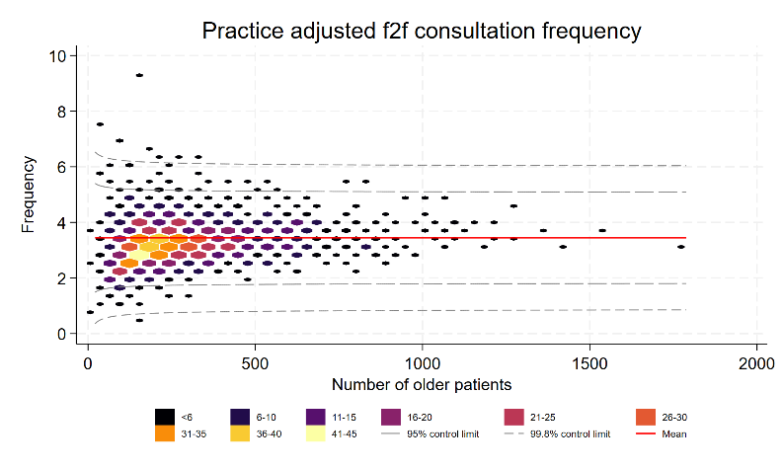
Telephone
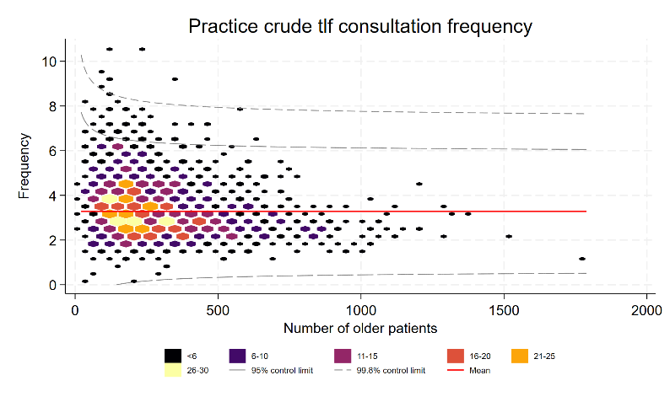 | 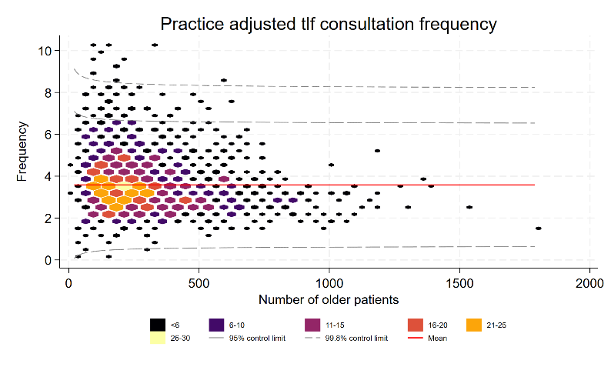
E-mail
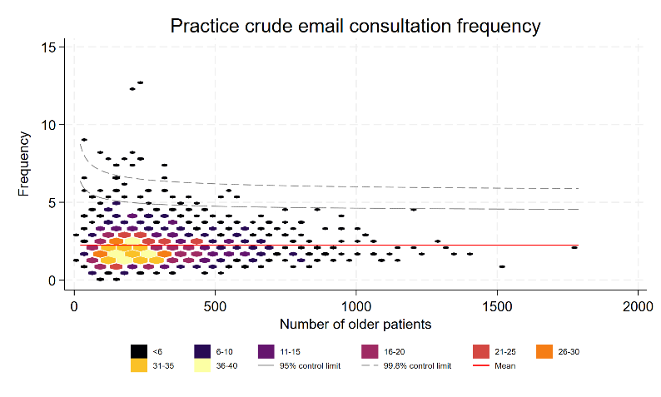 | 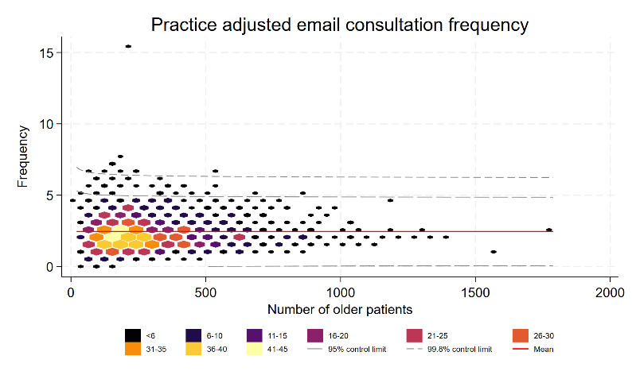
Home visit
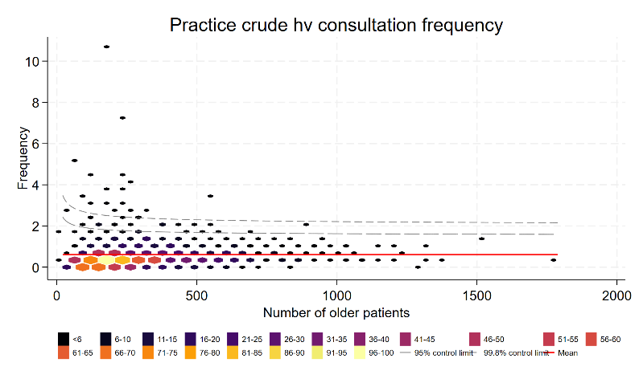 | 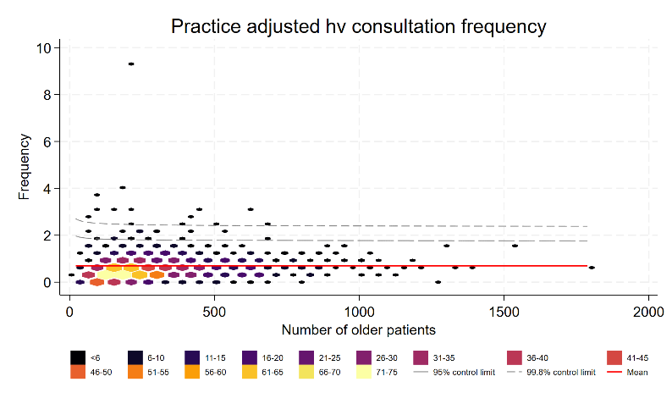
Chronic care review
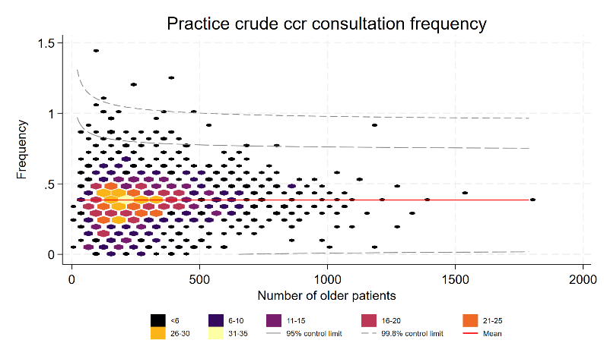 | 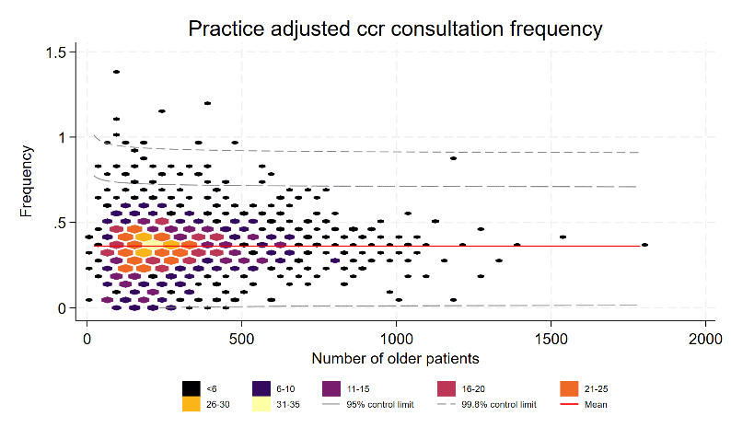

Supplementary material 6: Sensitivity analysis of time listed with the general practice (2017-2021)
 | 2017 |  |  |  | 2018 |  |  |  | 2019 |  |  |  | 2020 |  |  |  | 2021
Years listed with the general practice | all | 0-1 | 2-5 | 5+ | all | 0-1 | 2-5 | 5+ | all | 0-1 | 2-5 | 5+ | all | 0-1 | 2-5 | 5+ | all | 0-1 | 2-5 | 5+
n | 468,679 | 28,635 | 100,008 | 340,036 | 488,743 | 39,457 | 103,669 | 345,617 | 512,085 | 41,239 | 114,507 | 356,339 | 540,998 | 42,731 | 120,043 | 378,224 | 569,457 | 38,730 | 130,540 | 400,187
% | 100 | 6.1 | 21.3 | 72.6 | 100 | 8.1 | 21.2 | 70.7 | 100 | 8.1 | 22.4 | 69.6 | 100 | 7.9 | 22.2 | 69.9 | 100 | 6.8 | 22.9 | 70.3
Consultation frequency
Total | 13.42 | 14.12 | 13.72 | 13.27 | 12.51 | 13.81 | 12.66 | 12.31 | 10.95 | 12.79 | 11.24 | 10.65 | 10.88 | 13.49 | 11.41 | 10.41 | 10.22 | 13.09 | 10.80 | 9.76
Face-to-face | 5.90 | 5.63 | 5.69 | 5.99 | 5.44 | 5.02 | 5.27 | 5.54 | 4.61 | 4.37 | 4.46 | 4.69 | 3.59 | 3.67 | 3.41 | 3.63 | 3.70 | 3.85 | 3.53 | 3.74
Telephone | 4.06 | 4.37 | 4.26 | 3.97 | 3.58 | 3.64 | 3.77 | 3.52 | 3.03 | 3.29 | 3.13 | 2.97 | 3.97 | 4.48 | 4.19 | 3.85 | 3.29 | 3.82 | 3.48 | 3.17
E-mail | 2.50 | 3.07 | 2.75 | 2.38 | 2.51 | 3.53 | 2.66 | 2.36 | 2.33 | 3.41 | 2.58 | 2.13 | 2.40 | 3.60 | 2.73 | 2.16 | 2.24 | 3.51 | 2.56 | 2.02
Home visit | .48 | 0.61 | 0.51 | 0.46 | .54 | 1.18 | 0.53 | 0.46 | .55 | 1.28 | 0.64 | 0.44 | 0.60 | 1.41 | 0.75 | 0.46 | 0.61 | 1.49 | 0.85 | 0.45
Chronic care review | .48 | 0.44 | 0.51 | 0.48 | .43 | 0.44 | 0.44 | 0.43 | .42 | 0.44 | 0.43 | 0.42 | 0.32 | 0.34 | 0.32 | 0.31 | 0.38 | 0.42 | 0.38 | 0.38

