β-CPP bioceramics in alginate 3D Scaffolds as a new material for mineralized tissue regeneration

Gabriel C. Pinto^{1,2}, Rodolfo D. Piazza ², Igor P. Mendes Soares³, Caroline Anselmi ⁴, Eduardo T. C. C. e Silva, Carlos¹, A. de Souza Costa⁵, Josimeri Hebling⁴, Nuno J. O. Silva¹, Antônio C. Guastaldi ²

¹CICECO - Aveiro Institute of Materials, University of Aveiro, Portugal
² São Paulo State University (UNESP), Institute of Chemistry, Araraquara, Brazil
³ Department of Dental Materials and Prosthodontics, São Paulo State University (UNESP), School of Dentistry, Araraquara, Brazil.
⁴ Department of Morphology, Orthodontics and Pediatric Dentistry, São Paulo State University (UNESP), School of Dentistry, Araraquara, Brazil.
⁵ Department of Physiology and Pathology, São Paulo State University (UNESP), School of Dentistry, Araraquara, Brazil.

SUPPLEMENTARY INFORMATION

Physicochemical characterization

Fourier-transform infrared spectroscopy (FTIR)

The Absorption Spectrophotometer in the mid-infrared region with Fourier transform - VERTEX 70 from BRUKER with ATR module (through attenuated total reflection (diamond crystal)) was used to obtain information about the composition of the samples in each stage of synthesis of the β-CPP. When collecting the spectra, 64 scans were performed with a resolution of 4 cm⁻¹ in the range of 4000 to 400 cm⁻¹.

Raman spectroscopy

In order to establish information about the structural, molecular properties, the FT RAMAN Bruker MultiRAM, which has Nd-YAG laser at a wavelength of 1064 nm was used. The spectra were obtained from 500-2500 cm⁻¹, with an integration time of 60 seconds.

X-Ray diffraction analysis (XRD)

To identify crystalline phases, present in the sintered samples, the X-ray diffractometer SIEMENS model D5005, Cu Kα radiation (α = 1.5418Å) was used. Measurements were made over a scan range of 5 to 60° (2θ), with a scan speed of 0.01° per second. The Determination of crystallinity index (IC) was made by comparison between the amorphous and crystalline region present in 10 a 60 2θ [1].

Scanning electron microscopy (SEM) and energy dispersive X-ray spectroscopy (EDS)

The SEM and the EDS analysis were performed to the ceramics and the 3D Scaffolds composites, using two microscopes, the JEOL JSM 7500F and the Hitachi SU3800 with a 2.0 kV accelerating voltage and Brucker's 30 mm EDS. This technique was used to analyze the morphological properties of the β-CPP and the 3D Scaffolds, as well as to determine the Ca/P ratio of each ceramic samples obtained.

Thermogravimetry

The thermal behavior of the synthesized 3D Scaffolds was carried out by thermogravimetric analysis on the METTLER TOLEDO SCSTARe System equipment, with a heating rate of 15 °C min⁻¹, in the temperature range of 35 to 800 ºC and in a synthetic air atmosphere. 100µm

Mechanical compression tests

To evaluate the vertical forces exerted and the respective mechanical resistance of the 3D Scaffolds obtained, the mechanical compression tests were carried out by the Instron model 5966 equipment (High Wycombe, Buckinghamshire, United Kingdom). The Scaffolds were submitted a compression range of 0 to 100 N with average dimensions of 16 mm thickness and 2.8mm in diameter.

Swelling and degradation tests

The degree of swelling (SW) was determined by the gravimetric method, which consisted of incubating the different dry of the 3D Scaffolds in a specific solution and monitoring the weight as a function of time. Swelling was studied in PBS and calculated according to Equation 1, where Mt corresponds to the mass of the 3D Scaffold at time “t” and Ms to the mass of the dry scaffold [1].

$$GI= \frac{Mt-Ms}{Ms} x 100$$
Equation 1:

To evaluate the degradation degree of the 3D Scaffolds, triplicate aliquots from each group were separated, weighed, and then also placed in PBS (pH 7.4). After being removed from the medium, these groups were freeze-dried for 24 hours and weighed again to compare the weight, using the initial mass corresponding to 100%. Samples were measured on days 0, 7, 14 and 21.

Response of osteoblastic lineage cells cultured into β-CPP/alginate 3D Scaffolds

Pre-osteoblastic MC3T3-E1 cells were used for the in vitro tests (European Cell Culture Collection, sold by Sigma-Aldrich, Merck, Darmstadt, Germany). Cells were grown up to 80% confluency at 37°C and 5% CO₂ in complete α-MEM culture medium supplemented with 10% fetal bovine serum (FBS), 100 IU/mL penicillin, 100 µg/mL streptomycin, 2 mmol/L glutamine and 0.25 g/mL amphotericin B (all from Gibco, Life Technologies, Grand Island, NY, USA). The cells were cultured by trypsinization (0.25% trypsin, Gibco) until sufficient number. Experiments used cells from passages #23 to #26 for the high viscosity β-CPP/Alginate 3D Scaffolds. The cell-related protocols were not carried out for the groups using a low viscosity matrix due to its high rate of degradation behavior.
The 3D Scaffolds were standardized to 6 mm in diameter and 5 mm in thickness, vacuum disinfected in 70% ethanol (1 h) and washed in sterilized phosphate buffer saline solution (PBS; 0.14 M NaCl, 0. 0017 M KH₂PO₄, 0.003 M KCl, 0.01 M Na₂HPO₄; pH~7.2; three times for 10 min) ¹. The Scaffolds were allocated individually in 24-compartment culture plates (Kasvi, São José dos Pinhais, PR, Brazil) and incubated overnight in 1 mL of complete α-MEM at 37 ºC and 5% CO₂. The following day, the medium was aspirated to culture 5×10⁴ cells in 20 µL of complete medium on each Scaffold.
After cell seeding, the samples were incubated for 30 min at 37 ºC and 5% CO₂ for initial cell adhesion, followed by the addition of 1 mL of complete culture medium. The scaffold-cell sets were incubated at 37 ºC and 5% CO₂ for up to 14 days, with renewal of the complete culture medium every 48h.
Cell viability was assessed after 1, 7, and 14 days of culture. At these periods, cells cultured on scaffolds (n=8) were incubated with alamarBlue reagent (Invitrogen, Life Technologies) in α-MEM medium without FBS (1:10) for 3 h at 37 °C and 5% CO₂. After this period, the fluorescence of 100 µL of the solutions was determined with 560 nm of excitation and 590 nm of emission (Synergy H1, BioTek, Winooski, VT, USA). The high viscosity pure alginate (AlgA) at day 1 was set as the control and the mean absorbance considered 100% cell viability ¹.
The viability and proliferation were also assessed by fluorescence microscopy. Cells were cultured on 3D Scaffolds (n=4) for 1, 7, and 14 days. After the periods, the samples were washed with PBS and incubated with SBF-free α-MEM supplemented with 4 μM ethidium homodimer-1 (EthD-1) and 2 μM calcein AM (live/dead viability/cytotoxicity kit; Invitrogen, Life Technologies). After 30 min of incubation, samples were evaluated in direct fluorescence under 40× magnification (Leica DM 5500B; Leica, Austin, TX, USA) ².
The biomineralization capacity of the high viscosity β-CPP/Alginate 3D Scaffolds was evaluated after 14 days of pre-osteoblast culture on the surface of the 3D Scaffolds (n=8) cultured in osteogenic differentiation medium composed of complete α-MEM supplemented with 5 mM β-glycerophosphate (Santa Cruz Biotechnology Santa Cruz, CA, USA) and 50 μg/mL ascorbic acid (Fisher Chemical, NJ, USA). Cells were fixed with ethanol (70% in water; Sigma-Aldrich) at 4 °C for 1 h and stained with alizarin red solution (40 mM in deionized water, pH~4.2; Sigma-Aldrich) for 15 min under agitation. The background staining was removed after five washes with 1 mL of deionized water. Then, 500 µL of cetylpyridinium chloride solution (10% in PBS; pH~7; Sigma-Aldrich) at 37 °C were used to solubilize the mineralized matrix for 20 min under shaking, and the absorbance of the resulting solution was determined at 570 nm (Synergy H1). Since the analyzed 3D Scaffolds have calcium in their composition, the 3D Scaffolds without cultured cells (n=6) were processed in the same way and used as a discount in the absorbance values ​​for each group. The control sample (AlgA) was considered as 100% mineralized matrix formation ^{1,2}

RESULTS

β-CPP characterization
A floccular morphology with varying sizes was observed in the sintered samples, presented in Figure 1. In addition to the phase change, sintering promoted the expected densification and coalescence of the precursor ceramic crystals, resulting in a modification of the texture and porosity of the biomaterial obtained. The occurrence of this phenomenon was more pronounced in the sample submitted at 1150°C, due to the greater energy used. Since the presence of these pores is necessary for the circulation of physiological fluid through the biomaterial of interest, the β-CPP synthesized shows an attractive morphology as a biomaterial.

Figure 1: SEM of sintered samples. 600°C (A), 750°C (B), 900°C (C) and 1150°C (D).
A
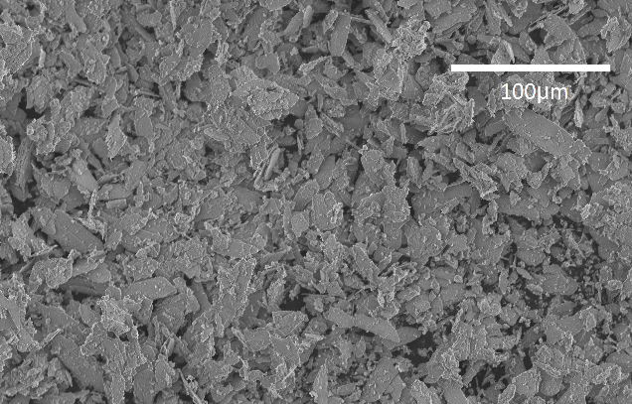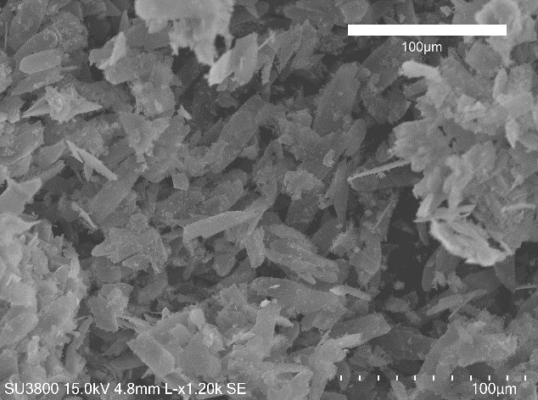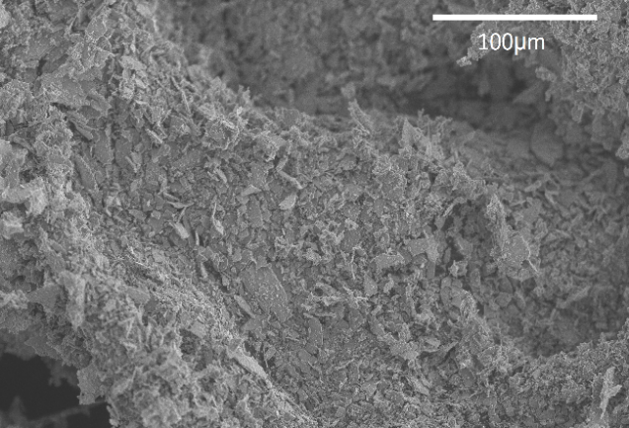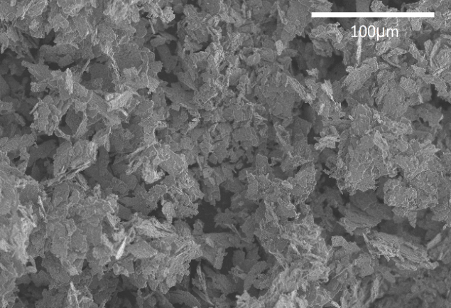
D
B
C

Chemical elements such as oxygen, calcium and phosphorus were observed through EDS analysis, Figure 2. This is another indication of the presence of the main constituents of the calcium phosphates group, which can be found even after sintering treatment at different temperatures.

Figure 2: EDS of the ceramic samples under different sintering temperatures.
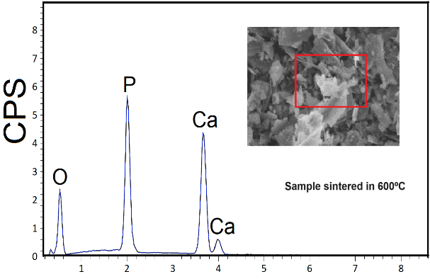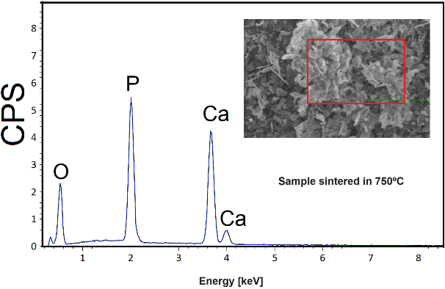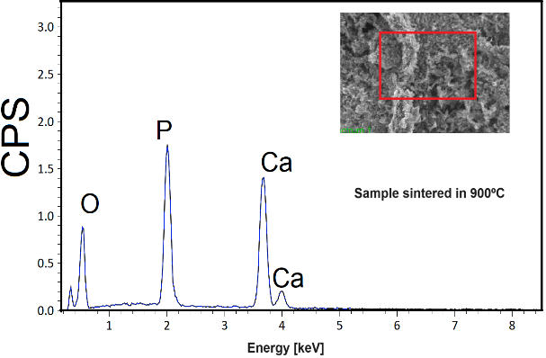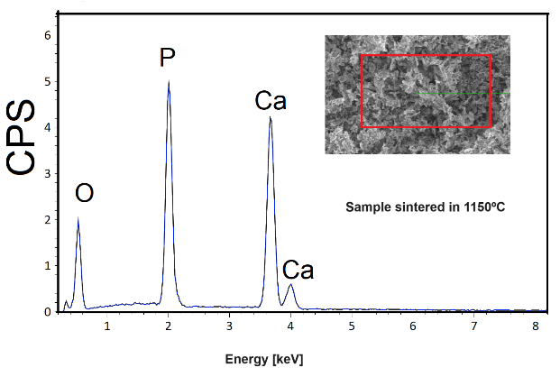

β-CPP/Alginate 3D Scaffolds

Figure 3: shows the chemical mapping of β-CPP/Alginate 3D Scaffolds using the EDS. The main elements found for the 3D scaffolds standards (AlgoA and AlgB) were attributed to the oxygen, chlorine, sodium and calcium, characteristic peaks of the sodium alginate polymeric matrix composition, cross-linked with a calcium chloride saline solution. In the groups with all three groups of different concentrations of β-CPP (1:1, 5:3 and 2:1) were observed the appearance of the signal related to the phosphorus element in the composition, corroborating a detectable amount of β-CPP bioceramic in the 3D structure.

Figure 3: EDS β-CPP/Alginate 3D Scaffolds.
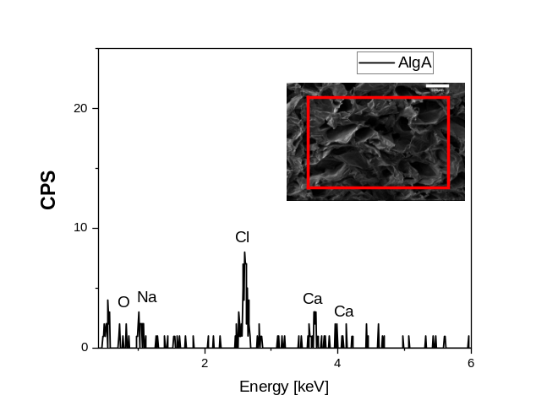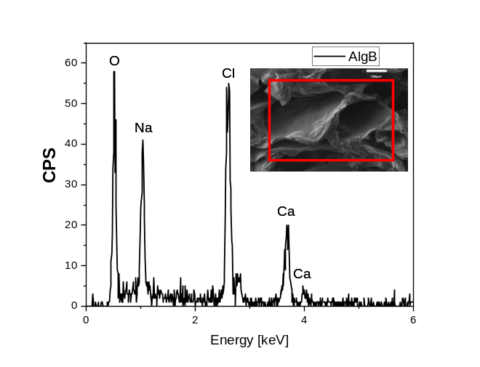
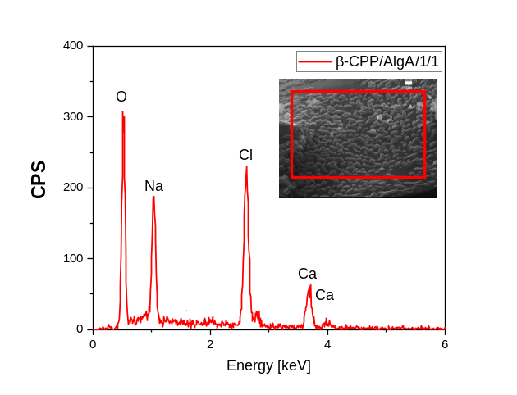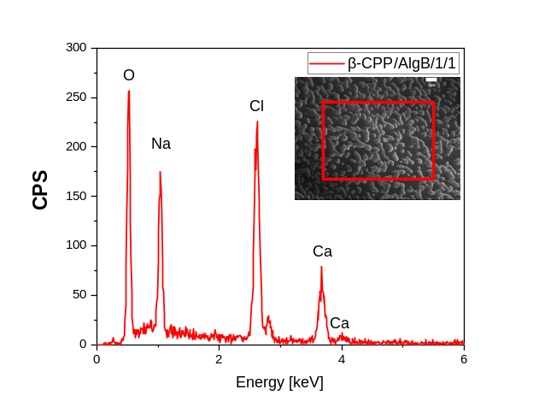
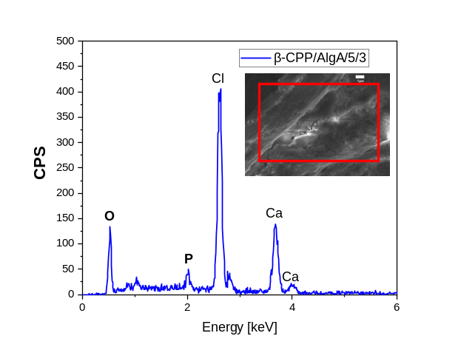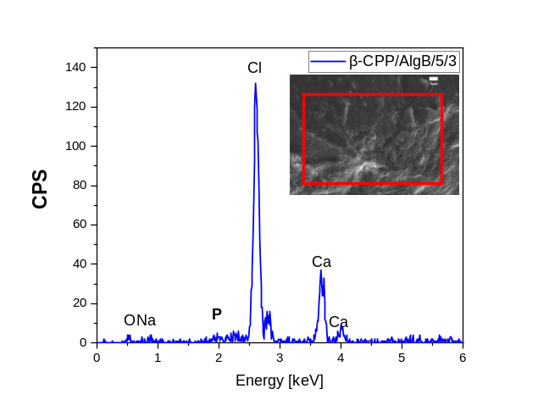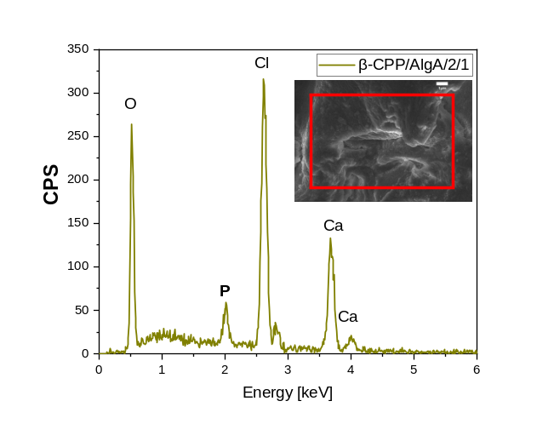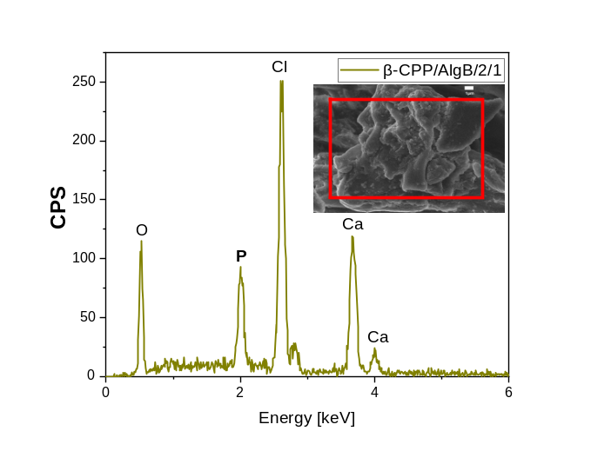

REFERENCES
[1] R. Debone Piazza, J.V. Brandt, C. Carvalho dos Santos, R. Fernando Costa Marques, M. Jafelicci Junior, Gelatin/dextran‐based hydrogel cross‐linked by Diels–Alder click chemistry: the swelling and potassium diclofenac releasing, Med. Devices Sensors. 4 (2021) 1–14. https://doi.org/10.1002/mds3.10151.
[2] M.L. Leite, C. Anselmi, I.P.M. Soares, A.P. Manso, J. Hebling, R.M. Carvalho, C.A. de Souza Costa, Calcium silicate-coated porous chitosan scaffold as a cell-free tissue engineering system for direct pulp capping, Dent. Mater. 38 (2022) 1763–1776. https://doi.org/10.1016/j.dental.2022.09.014.
[3] I.P. Mendes Soares, C. Anselmi, F.A. Kitagawa, R.A. de O. Ribeiro, M.L. Leite, C.A. de Souza Costa, J. Hebling, Nano-hydroxyapatite-incorporated polycaprolactone nanofibrous scaffold as a dentin tissue engineering-based strategy for vital pulp therapy, Dent. Mater. 38 (2022) 960–977. https://doi.org/10.1016/j.dental.2022.03.006.

