Supporting information for

Dissolving microneedle rollers for rapid transdermal drug delivery

Xiao Peng Zhang, Bao Li Zhang, Bo Zhi Chen, Ze Qiang Zhao, Xin Dong Guo*

Beijing Laboratory of Biomedical Materials, College of Materials Science and Engineering, Beijing University of Chemical Technology, Beijing, 100029, P.R. China.
Key Lab of Biomedical Materials of Natural Macromolecules (Beijing University of Chemical Technology), Ministry of Education, Beijing 100029 China.

Corresponding author:
Xin Dong Guo, Beijing Laboratory of Biomedical Materials, College of Materials
Science and Engineering, Beijing University of Chemical Technology, Beijing,
100029, China. E-mail: xdguo@buct.edu.cn.

Figure Caption
Fig. S1. Fabrication process of DMNR and DMNP.
Fig. S2. The seam morphology of DMNR.
Fig. S3. Microscope images of holes left on each layer in Parafilm M® after insertion by DMNR.
Table S1. Geometric parameters of five types of DMNRs
Movie S1. Overview morphology of DMNR with needle height of 600 μm.
Movie S1. The Parafilm M® morphology after DMNR administrated.

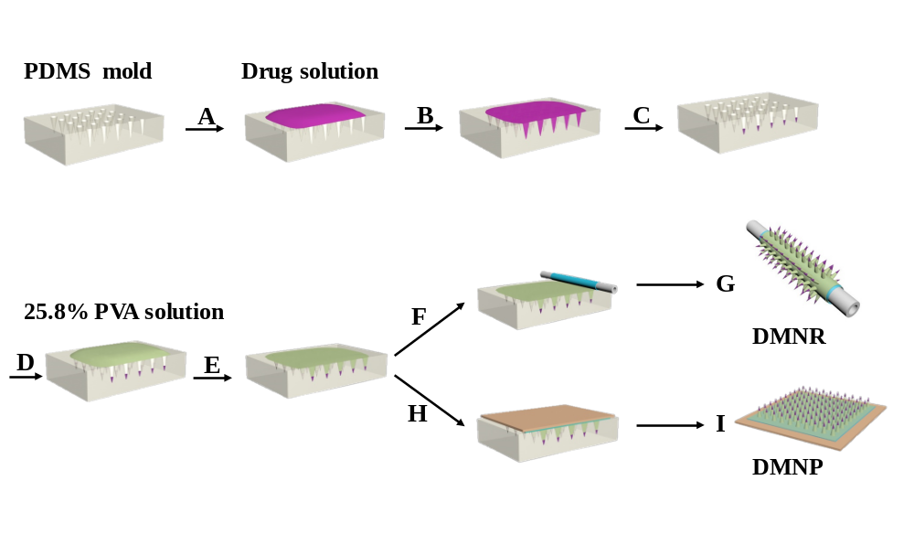
Fig. S1. Fabrication process of DMNR and DMNP. (A) 100 μl drug solution was applied to the PDMS mold under vacuum. (B) Drug solution was filled into the PDMS cavities under vacuum. (C) Residual drug solution was removed from the mold surface and the drug solution loaded in the mold cavities was continued to dry under vacuum for 30 min. (D) 25.8 % PVA/sucrose solution was applied to the drug-loaded mold. (E) PVA/sucrose solution was cast into the PDMS mold under vacuum for 30 min. (F) After drying at room temperature, dissolving microneedle arrays were demolded from the PDMS mold using a roller with double-side tape. (G) Schematic diagram of DMNR. (H) DMN arrays were demolded using a patch with double-side tape. (I) Schematic diagram of DMNP.

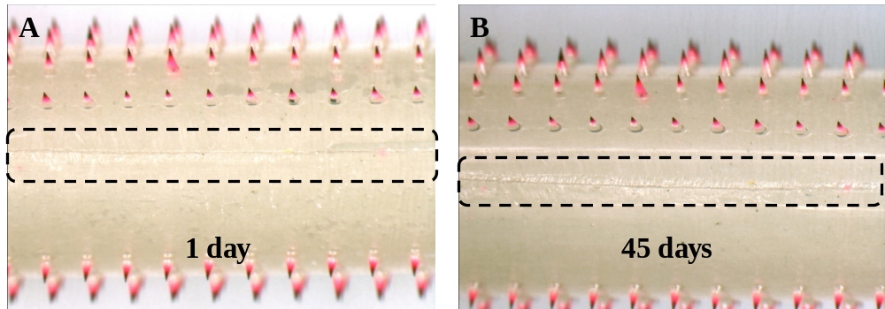
Fig. S2. The seam morphology of DMNR. The seam morphology images of DMNR after being stored for 1 day (A) and 45 days (B) after demolding.

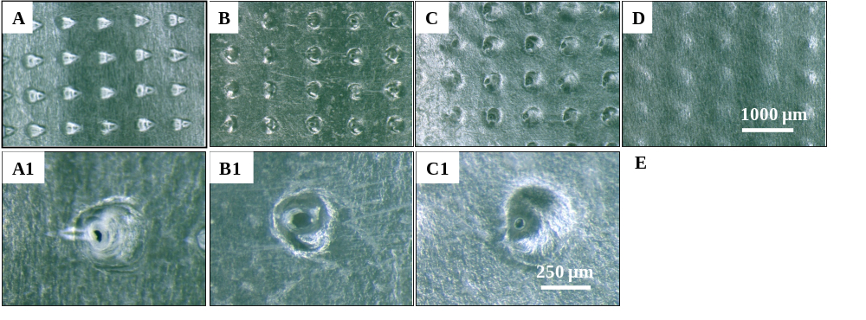
Fig. S3. Microscope images of holes left on each layer in Parafilm M® after insertion by DMNR. (A) First layer, (B) second layer, (C) third layer, (D) fourth layer. (A1), (B1), (C1) are the partially enlarged view of (A), (B), (C), respectively.

Table S1. Geometric parameters of five types of DMNRs
MN Height  (μm) | Tip-to-tip space of MN (μm) | Bottom diameter of MN (μm) | Number of MN | Outer diameter of the roller (mm)
400 | 800 | 350 | 375 | 4
600 | 800 | 350 | 225 | 4
600 | 800 | 350 | 375 | 4
600 | 800 | 350 | 525 | 4
700 | 800 | 350 | 375 | 4

