Real-life use of ropeg-interferon α2b in Polycythemia Vera: patient selection and clinical outcomes

Annals of Hematology
F. Palandri¹, F. Branzanti², M. Venturi^{1,2}, A. Dedola^{1,2}, G. Fontana^{1,2}, M. Loffredo^{1,2}, A. Patuelli^{1,2}, E. Ottaviani¹, M. Bersani¹, M. Reta³, O. Addimanda³, V. Vicennati^{2,4}, N. Vianelli¹, M. Cavo^{1,2}
1) IRCCS Azienda Ospedaliero-Universitaria di Bologna, Istituto di Ematologia “Seràgnoli”, Bologna, Italy
2) Department of Medical and Surgical Sciences (DIMEC), Alma Mater Studiorum University of Bologna, 40138 Bologna, Italy.
3) UO Interaziendale Medicina Interna ad Indirizzo Reumatologico AUSL BO-IRCCS AOUBO, Bologna, Italy
4) Division of Endocrinology and Diabetes Prevention and Care, IRCCS Azienda Ospedaliero-Universitaria di Bologna, Italy
Corresponding Author
Francesca Palandri
IRCCS Azienda Ospedaliero-Universitaria di Bologna
Istituto di Ematologia “Seràgnoli”, Bologna, Italy
Tel +39 051 214 3044
Fax +39 051 636 4037
e-mail: francesca.palandri@unibo.it

Supplemental Figure 1: Patients’ timelines
Suppl. Fig. 1A: Low-risk patients previously treated with an alternative IFN formulation
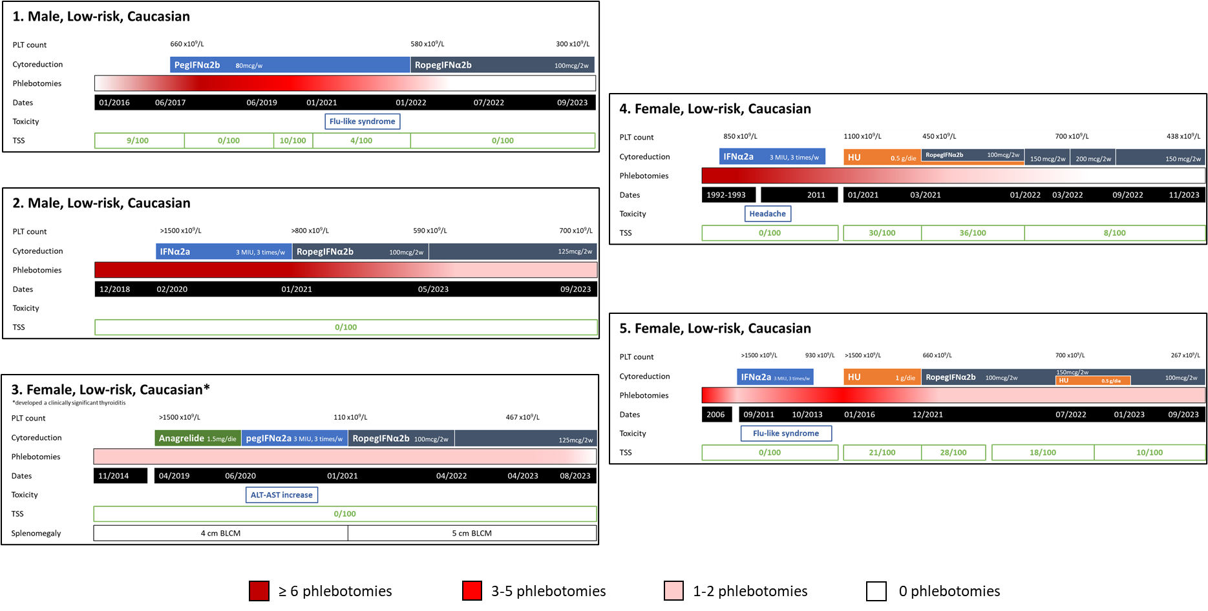

Suppl. Fig. 1B: Low-risk patients non-treated with an alternative IFN formulation
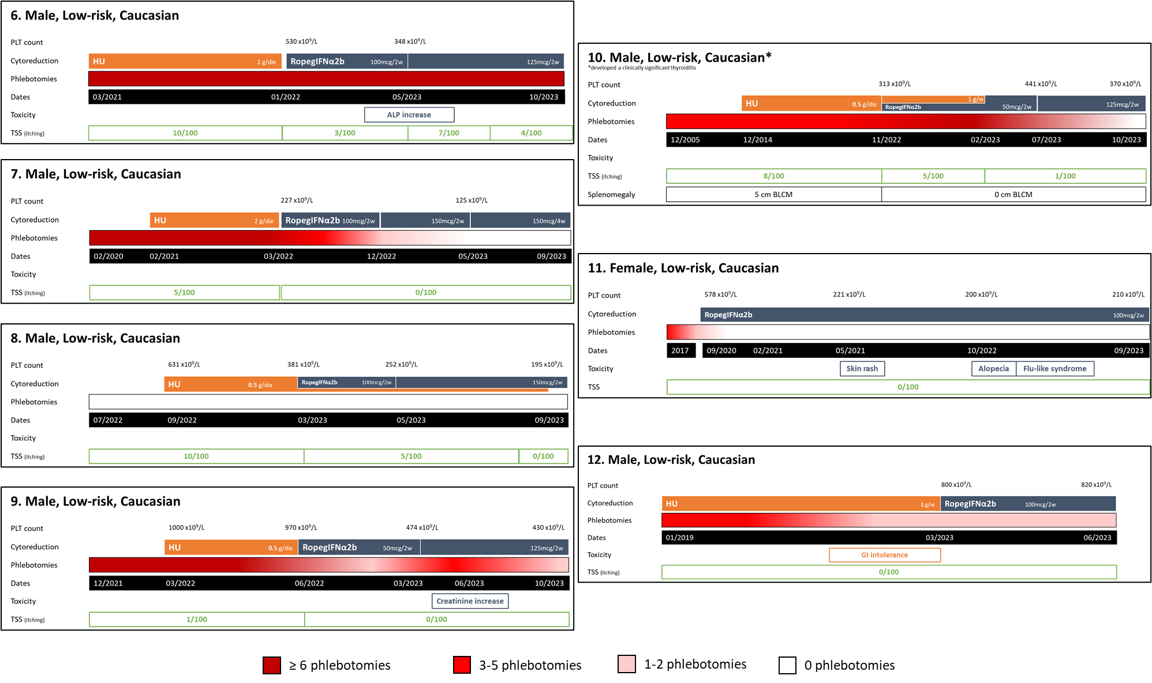
Suppl. Fig. 1C: High-risk patients
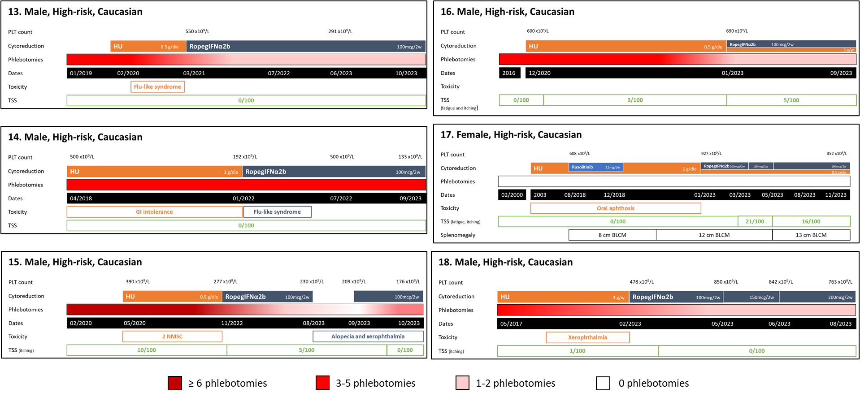
IFN: Interferon; HU: Hydroxyurea; PLT: Platelets; GI: Gastrointestinal; TSS: Total Symptoms Score; PHL: Phlebotomies; w: weekly; 2w: every two weeks.
Overlapping cytoreduction bars represent joint therapies.
Patient 3 was the only one presenting splenomegaly at diagnosis.
Number of phlebotomies are reported over a 6-month period.

