Extended Data
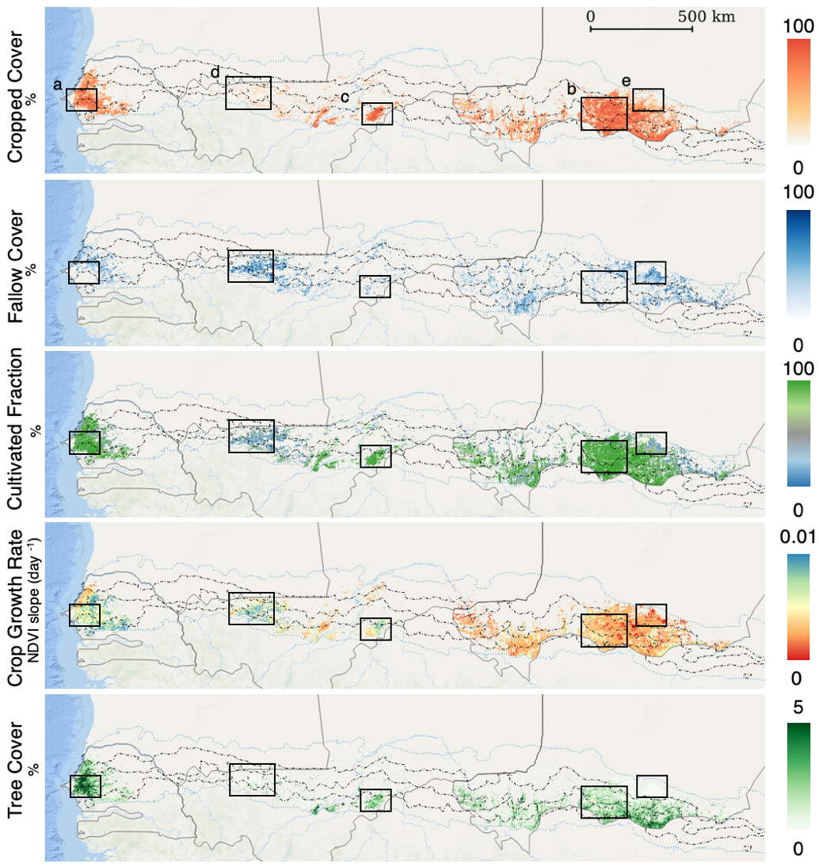
Extended Data Fig. 1 | Cropland characteristics for the full study area aggregated to grid cells of 1x1 km. Crop growth rate and tree cover were extracted only using the pixels within cropped fields. Crop growth rate represents the greenness (NDVI) increase per day.

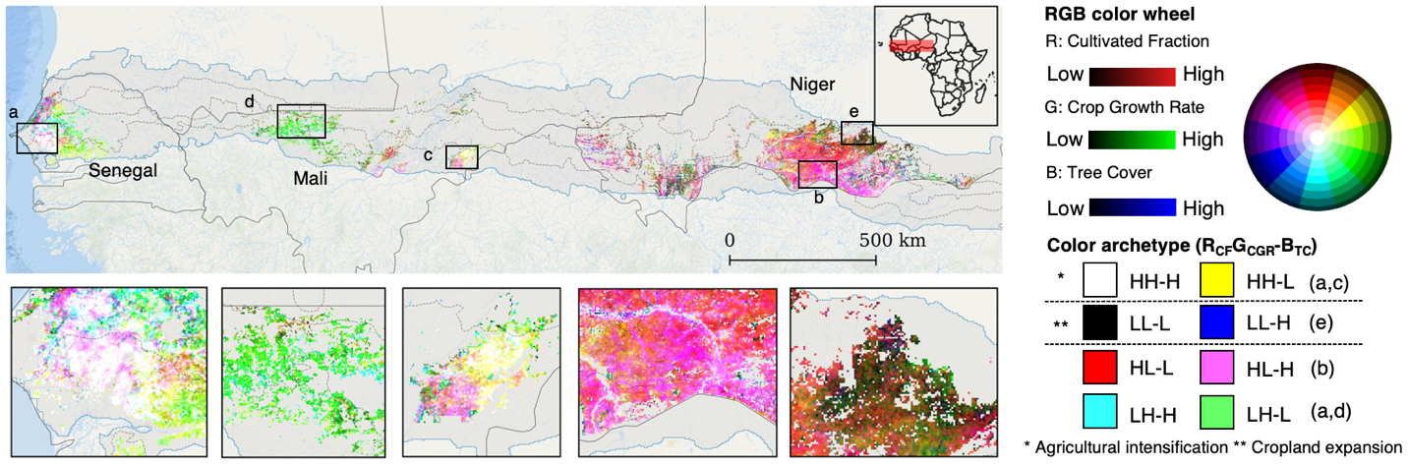
Extended Data Fig. 2 | The combinations of cultivated fraction, crop growth rate and tree cover of cropped fields. Interactions between metrics are illustrated in the R-G-B color space at a 1-km grid cell scale. Each factor was scaled to a unitless range between 0 and 1 using min-max normalization (maximum value is defined as mean + standard deviation, Extended Data Fig. 4). White colors indicate high values of all three indicators. Crop growth rate and tree cover were extracted only for pixels within cropped fields. Crop growth rate represents the maximum NDVI slope per day during the full calendar year 2019. The dark dashed lines are the 300-, 400-, and 500-mm-per-yr rainfall isohyets within the Sahelian zone (200–600-mm yr⁻¹ as mean 1982–2020) shown in dark grey.

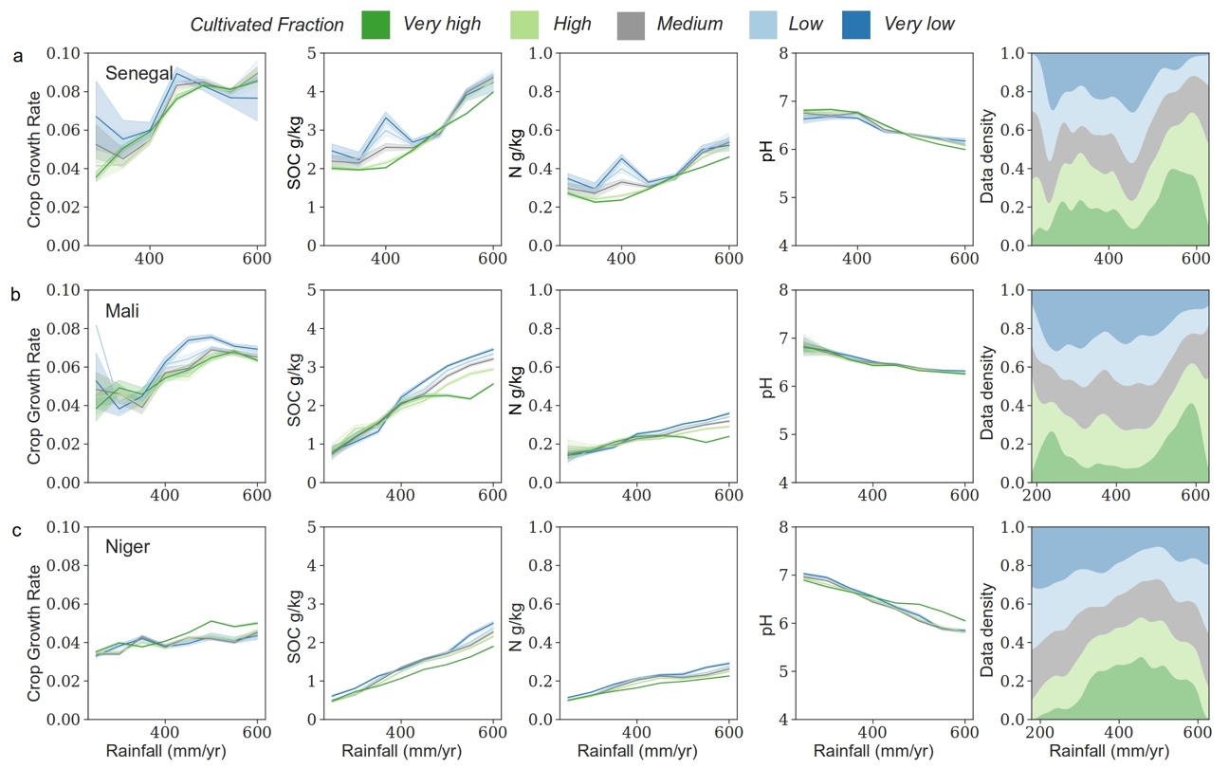
Extended Data Fig. 3 | Individual parameters of soil nutrients. a, Senegal. b, Mali., c, Niger
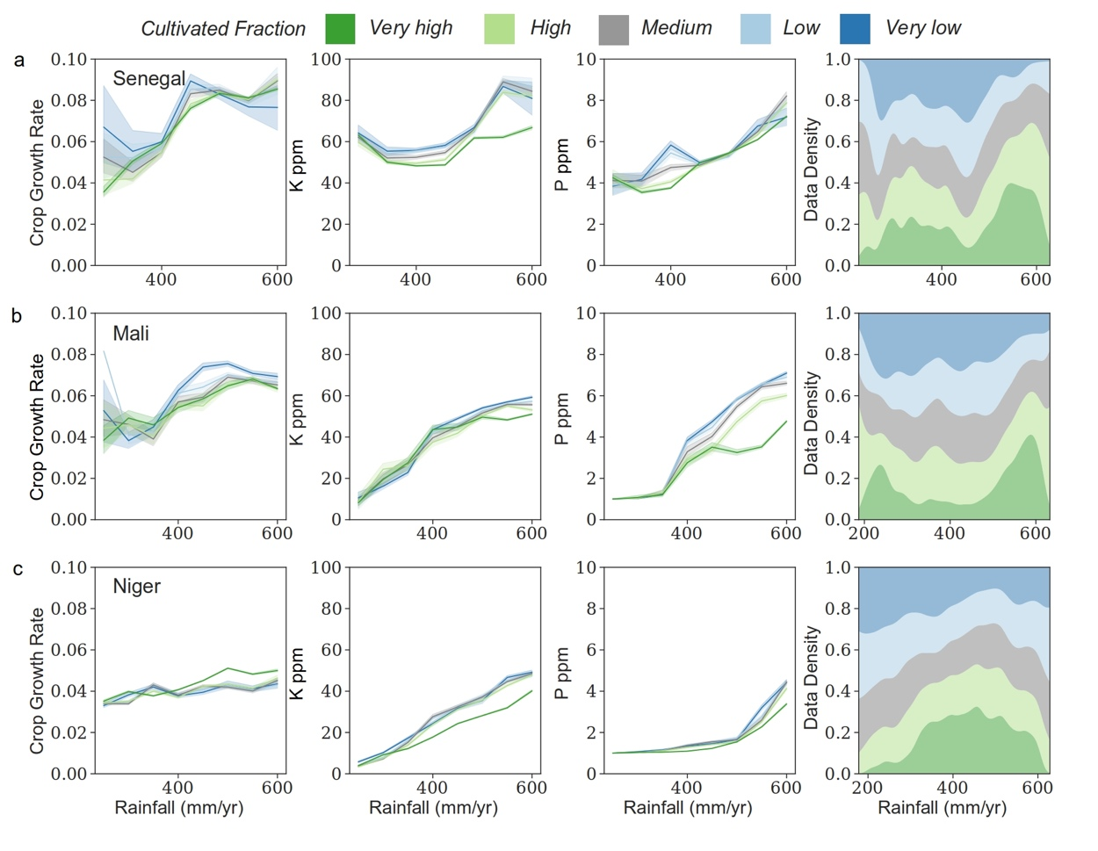
Extended Data Fig. 4 | Individual parameters of soil chemicals. a, Senegal. b, Mali., c, Niger
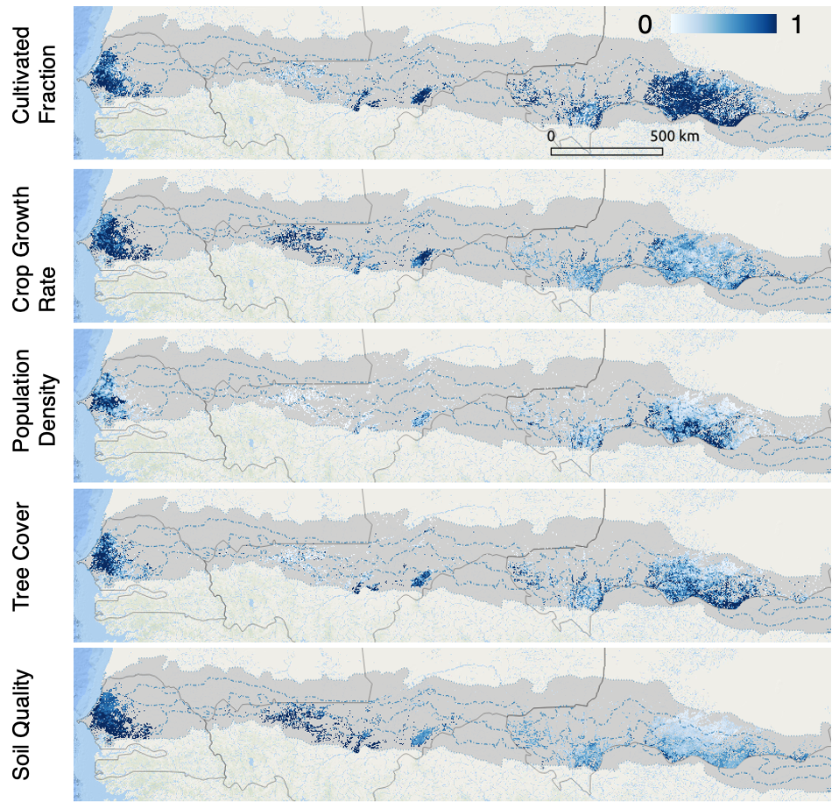
Extended Data Fig. 5 | The 1-km resolution maps of min-max normalized agroecological factors.
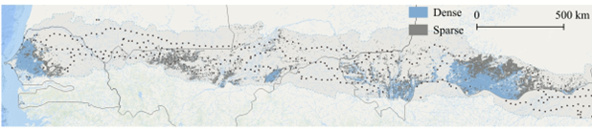
Extended Data Fig. 6 | Spatial distribution of areas with sparse (<50 persons/km²) and dense (>50 persons/km²) human population³⁶.
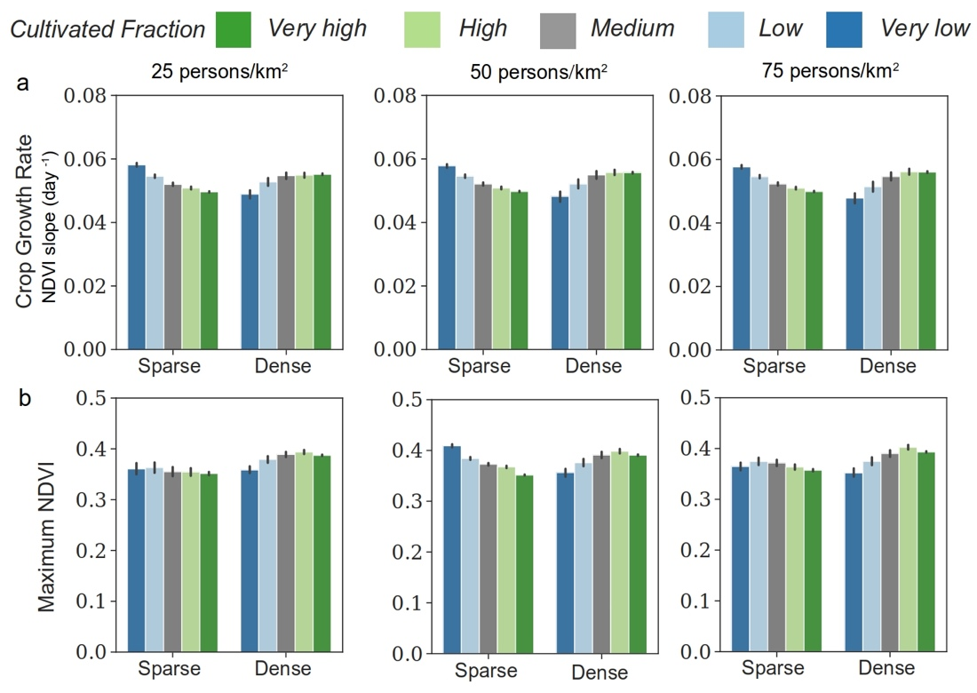
Extended Data Fig. 7 | a, Crop growth rate and cultivated fraction for areas with sparse (<25/50/75 persons/km²) and dense (>25/50/75 persons/km²) human population. b, annual maximum NDVI and cultivated fraction for areas with sparse (<25/50/75 persons/km²) and dense (>25/50/75 persons/km²) human population.
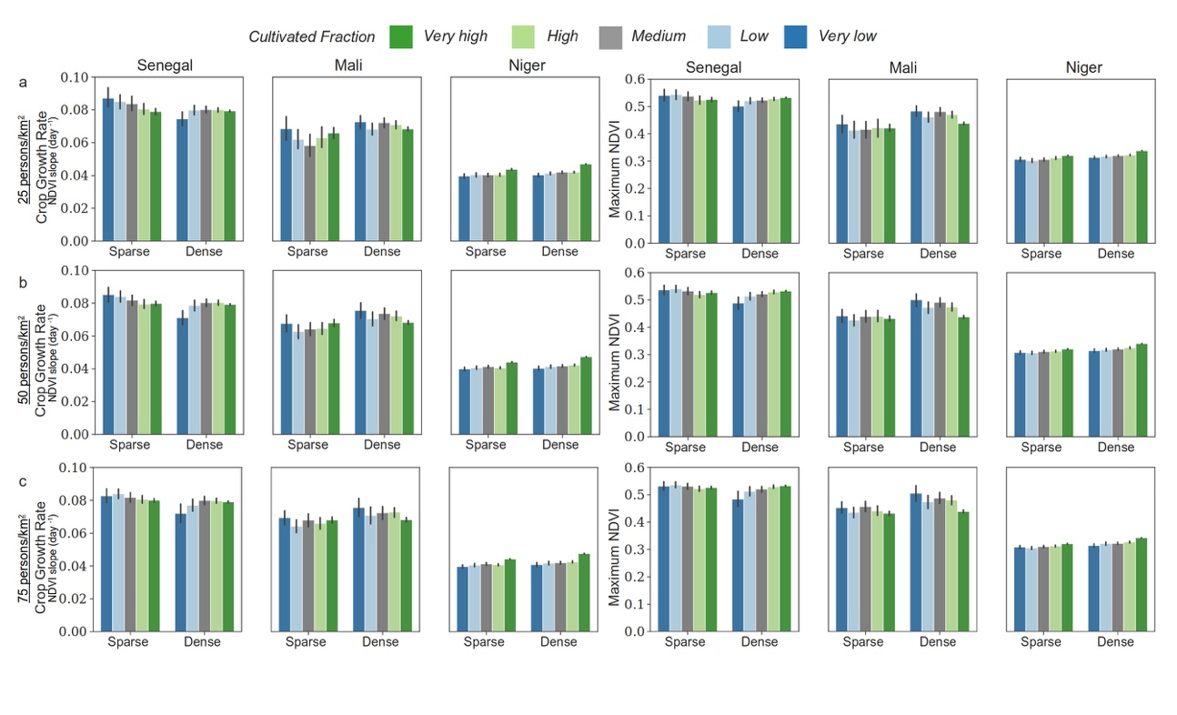
Extended Data Fig. 8 | a, Crop growth rate and cultivated fraction for areas with sparse (<25 persons/km²) and dense (>25 persons/km²) human population, and annual maximum NDVI and cultivated fraction for areas with sparse (<25 persons/km²) and dense (>25 persons/km²) human population. b, with sparse (<50 persons/km²) and dense (>50 persons/km²) human population. c, with sparse (<75 persons/km²) and dense (>75 persons/km²) human population.
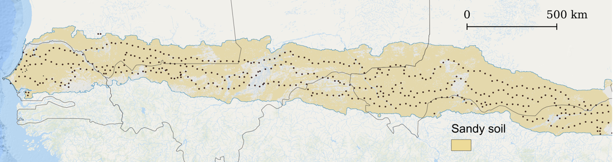
Extended Data Fig. 9 | The extent of sandy soil extracted from soil texture layer³⁹.
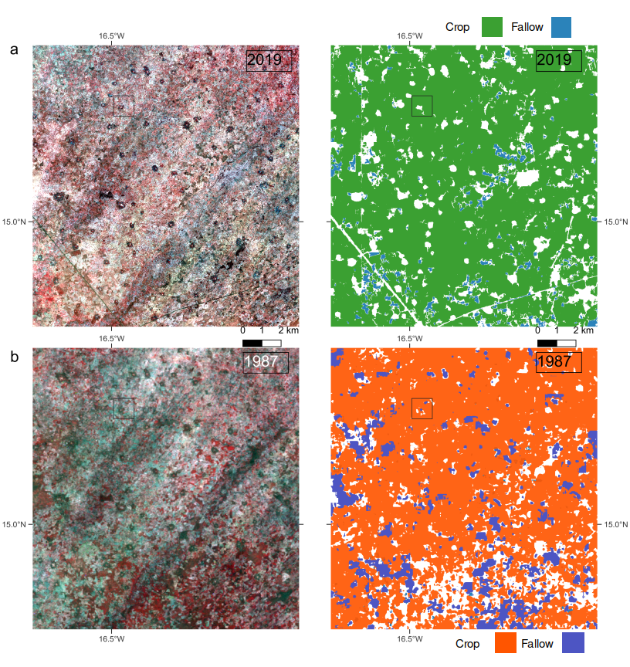
Extended Data Fig. 10 | Visual illustrations of 33 years agricultural landscape changes for an intensified agroforestry region. a, False color composite (R: Near Infrared, G: Red, B: Green) PlanetScope images of agricultural areas in Senegal covering June-November 2019, and the predicted cropped fields and fallows at a spatial resolution of 4.7 m. b, False color composite Landsat images of the same region covering June-November 1987, and the predicted cropped fields and fallows at a spatial resolution of 30 m. The square grid is the 1 x 1 km area shown in Fig. 1a right panel.
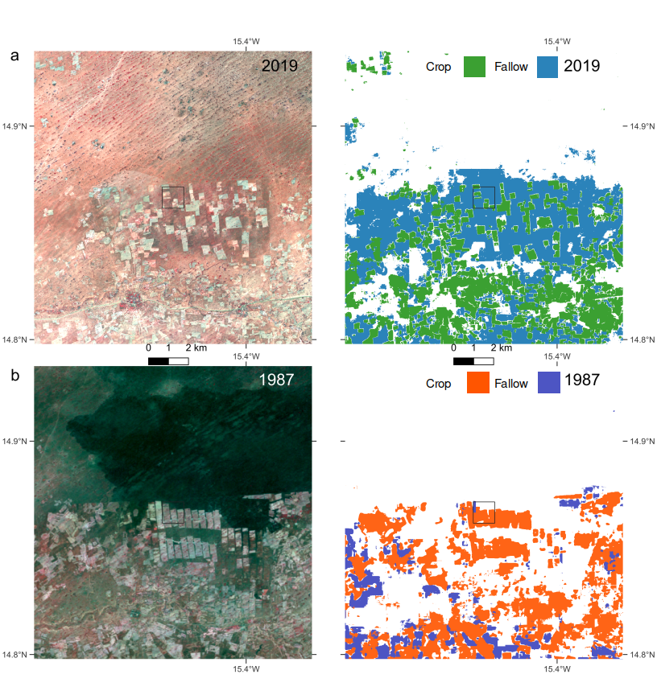
Extended Data Fig. 11 | Visual Illustration of 33 years agricultural landscape changes for a marginal region. a, False color composite (R: Near Infrared, G: Red, B: Green) PlanetScope images of agricultural areas in Senegal covering June-November 2019, and the predicted cropped fields and fallows at a spatial resolution of 4.7 m. b, False color composite Landsat images of the same region covering June-November 1987, and the predicted cropped fields and fallows at a spatial resolution of 30 m. Fallow land / savannas are underestimated for the year 1987. The square grid is the 1 x 1 km area shown in Fig.1a left panel.
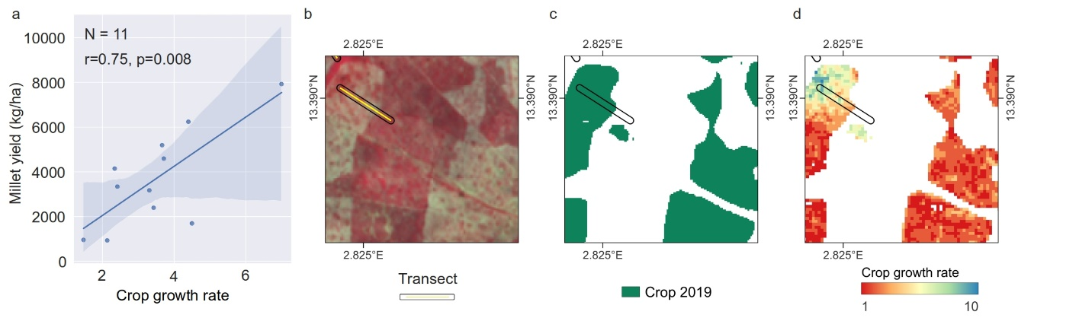Extended Data Fig. 12 | Examining the correlation between millet yield and crop growth rate. a, the correlation coefficient between millet yield measured in the field in 2019 and crop growth rate. b, an illustration of the millet harvest transect overlay on the NICFI image from 2019. c, the prediction for cropped fields in 2019. d, the crop growth rate within these cropped fields.
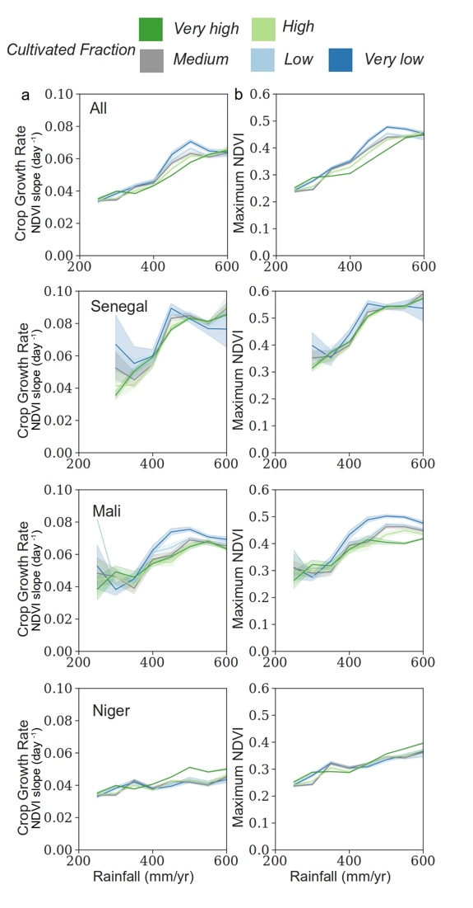
Extended Data Fig. 13 | Annual maximum NDVI in comparison to crop growth rate (same as in Fig. 5) along the rainfall gradient for different classes of cultivated fraction for the Sahel and three countries. Both crop growth rate and annual maximum NDVI are masked by cropped fields and averaged along the 200–600 mm/year rainfall gradient (50 mm steps) at the 95% confidence interval for Senegal, Mali, and Niger.

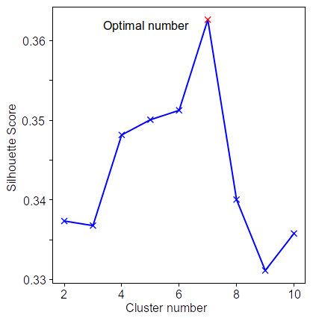
Extended Data Fig. 14 | Silhouette scores for determining the number of clusters.

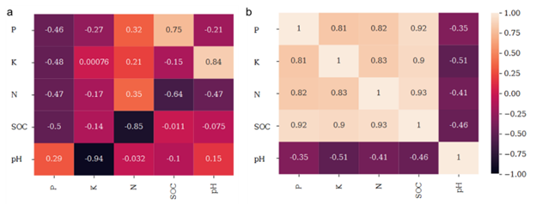
Extended Data Fig. 15 | For soil indicators a, Eigen vectors or factor loading of principal component analyses (PCA). b, Pearson correlation coefficients (R).

Extended Data Table 1 | Model accuracy.
 | Cropped field | Fallow field | Cropland
User’s accuracy | 0.97 | 0.71 | 0.88
Producer’s accuracy | 0.83 | 0.75 | 0.78
f1score | 0.89 | 0.73 | 0.83

Extended Data Table 2 | Spatial cultivated fraction classes for grid cells of 1x1 km.
Very high | High | Medium | Low | Very low
>80% | >60% and <=80% | >40% and <=60% | >20% and <=40% | <=20%

Extended Data Table 3 | Results of principal component analyses (PCA).
 | PC*1 | PC2 | PC3 | PC4 | PC5
Eigenvalues | 3.869 | 0.76 | 0.034 | 0.175 | 0.161
Variance | 0.77 | 0.15 | 0.007 | 0.04 | 0.03
10% highest | -0.49 | -0.67 | -0.52 | -0.44 | -0.36
*PC: principal component

Extended Data Table 4 | Statistics of min-max normalization.
* | CF | CGR | SQI | PD | TC | TE
Mean | 31% | 0.005 | 0.267 | 105.86 | 1.66% | 143
STD | 74% | 0.002 | 0.103 | 77.52 | 1.28% | 296
*CF: cultivated fraction, CGR: crop growth rate, SQI: soil quality index, PD: population density, TC: tree cover, TE: terrain elevation

