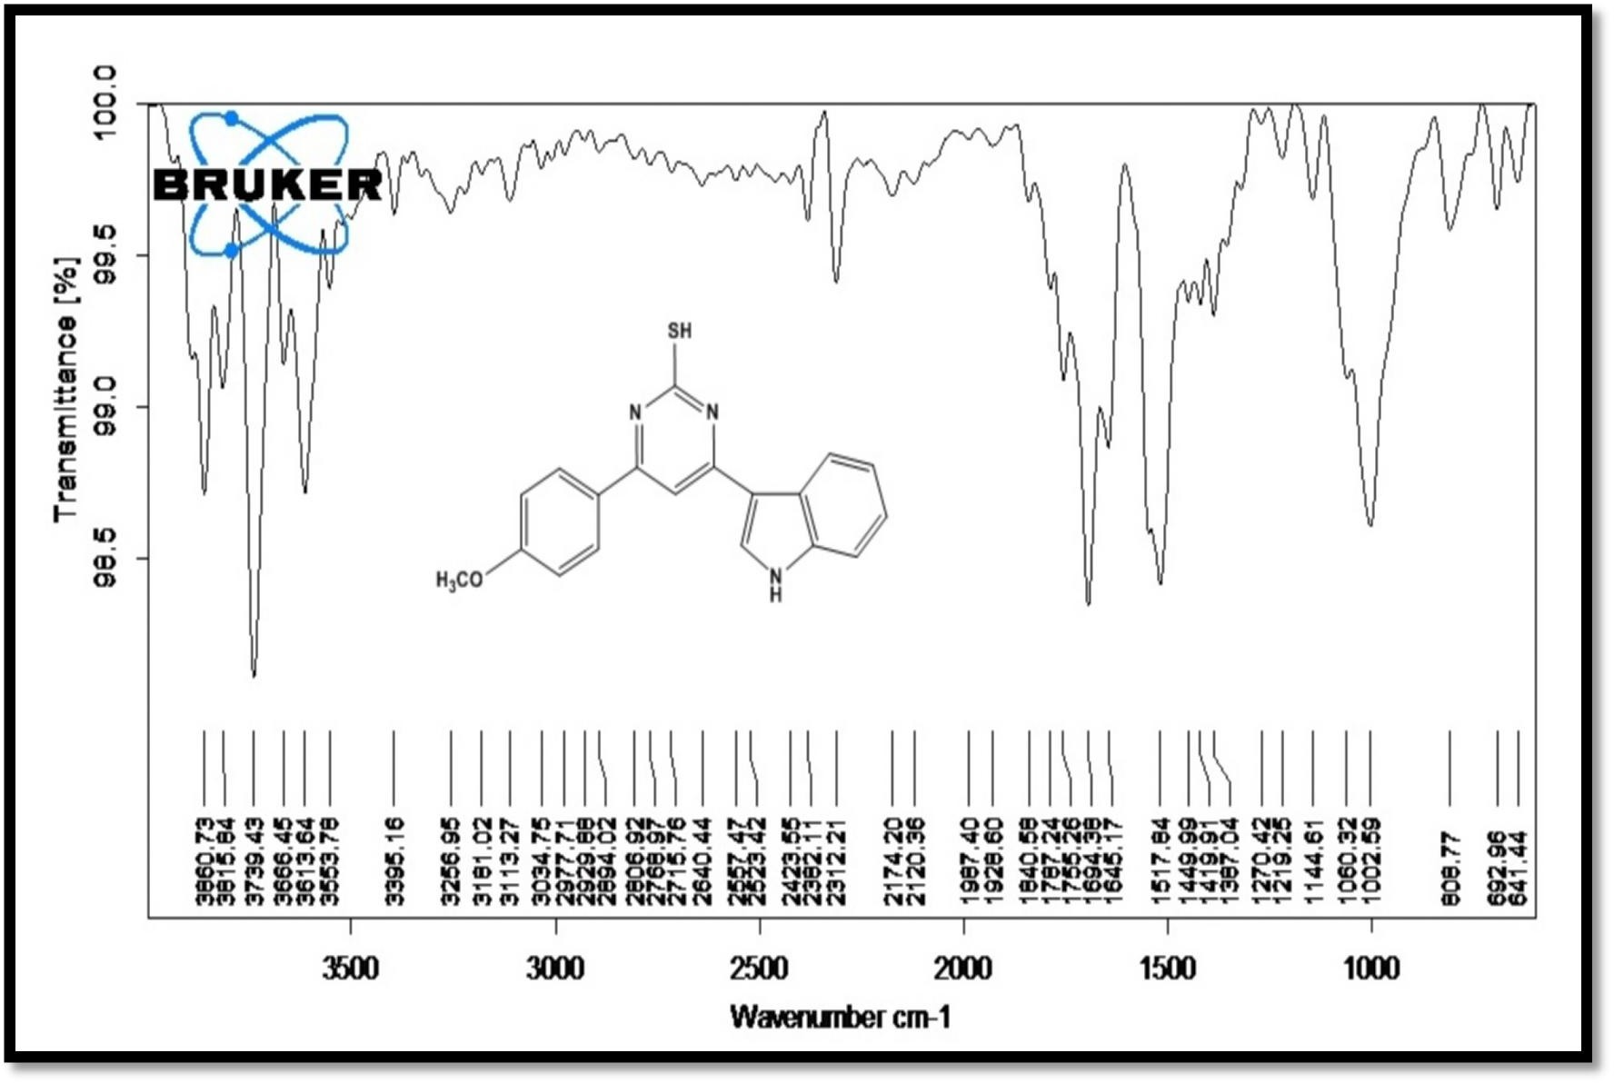IR spectrum of 4-(4-methoxyphenyl)-6-(1H-indol-3-yl)-pyrimidin-2-thiol (4b)

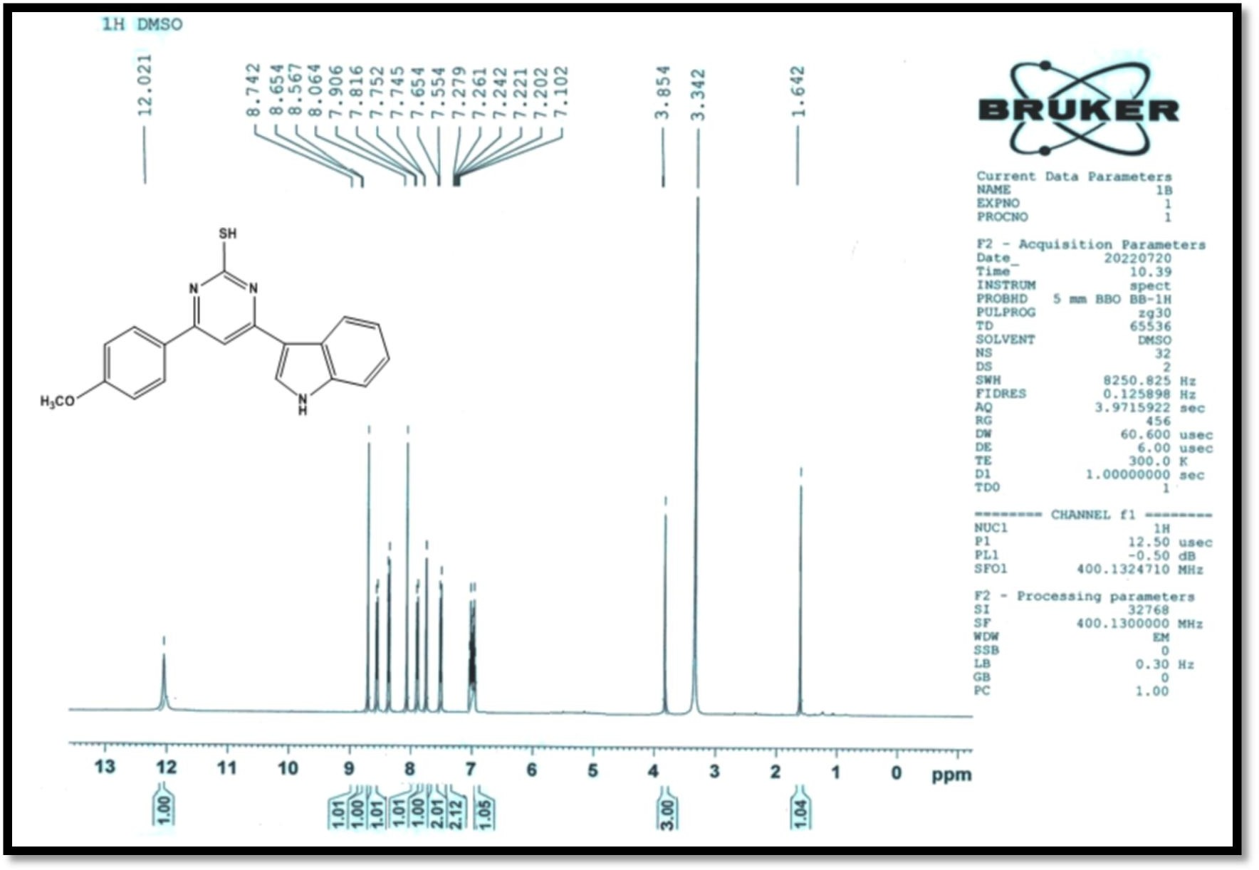

¹H NMR spectrum of 4-(4-methoxyphenyl)-6-(1H-indol-3-yl)-pyrimidin-2-thiol (4b)

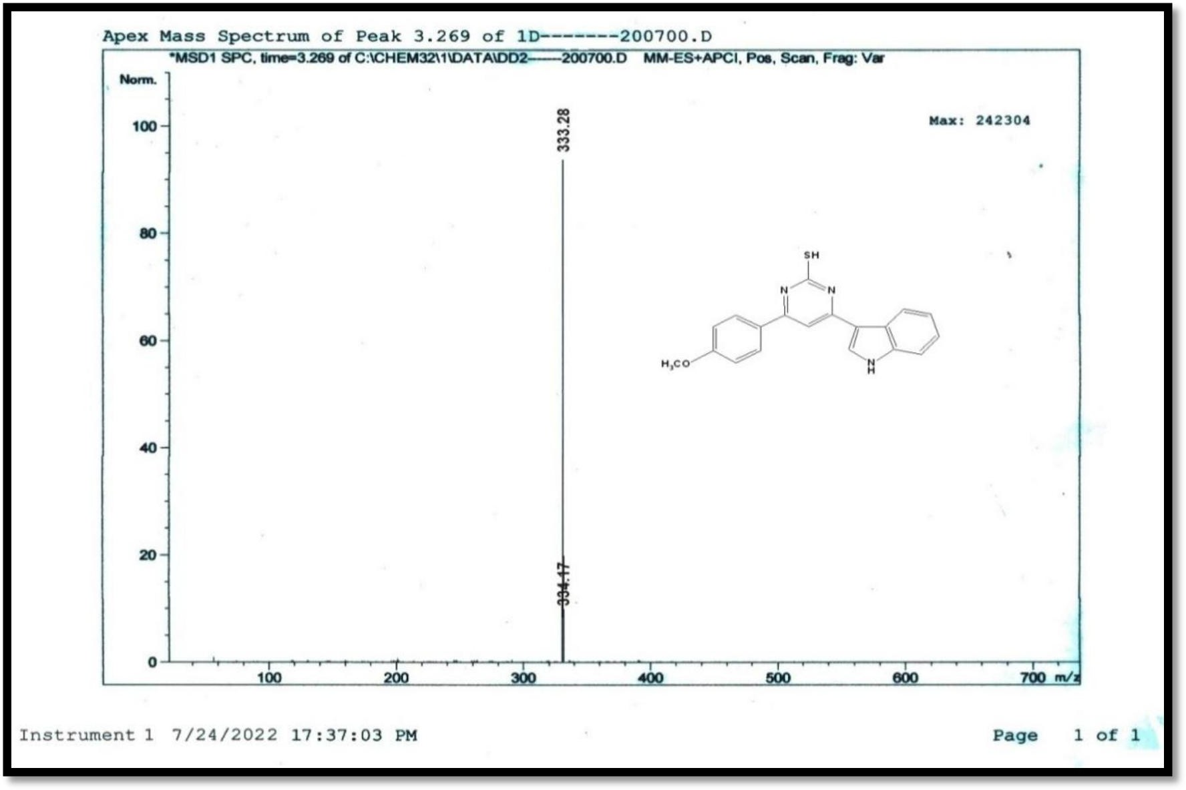

¹Mass spectrum of 4-(4-methoxyphenyl)-6-(1H-indol-3-yl)-pyrimidin-2-thiol (4b)

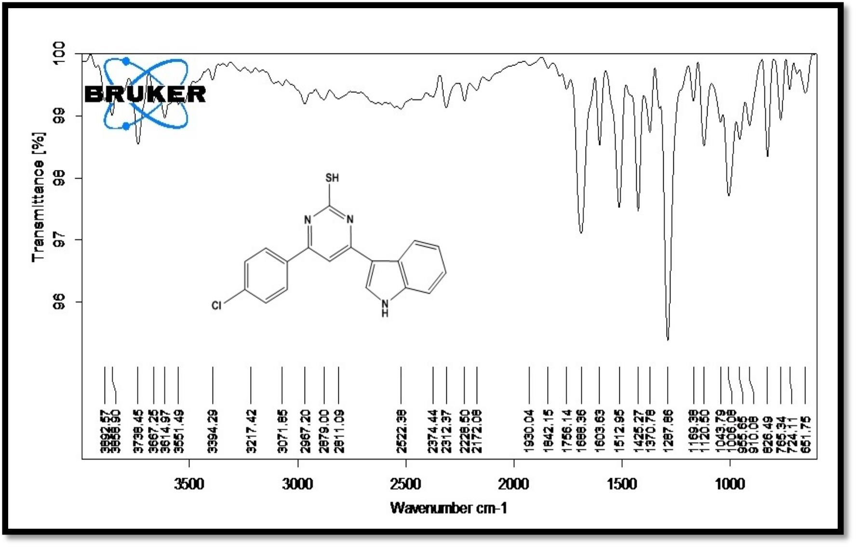
IR spectrum of 4-(4-chlorophenyl)-6-(1H-indol-3-yl)-pyrimidin-2-thio (4d)
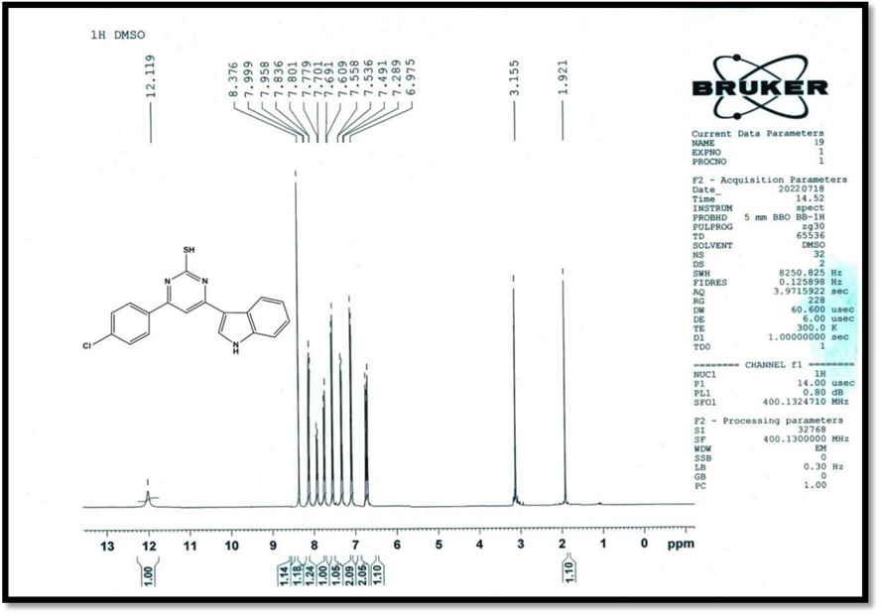

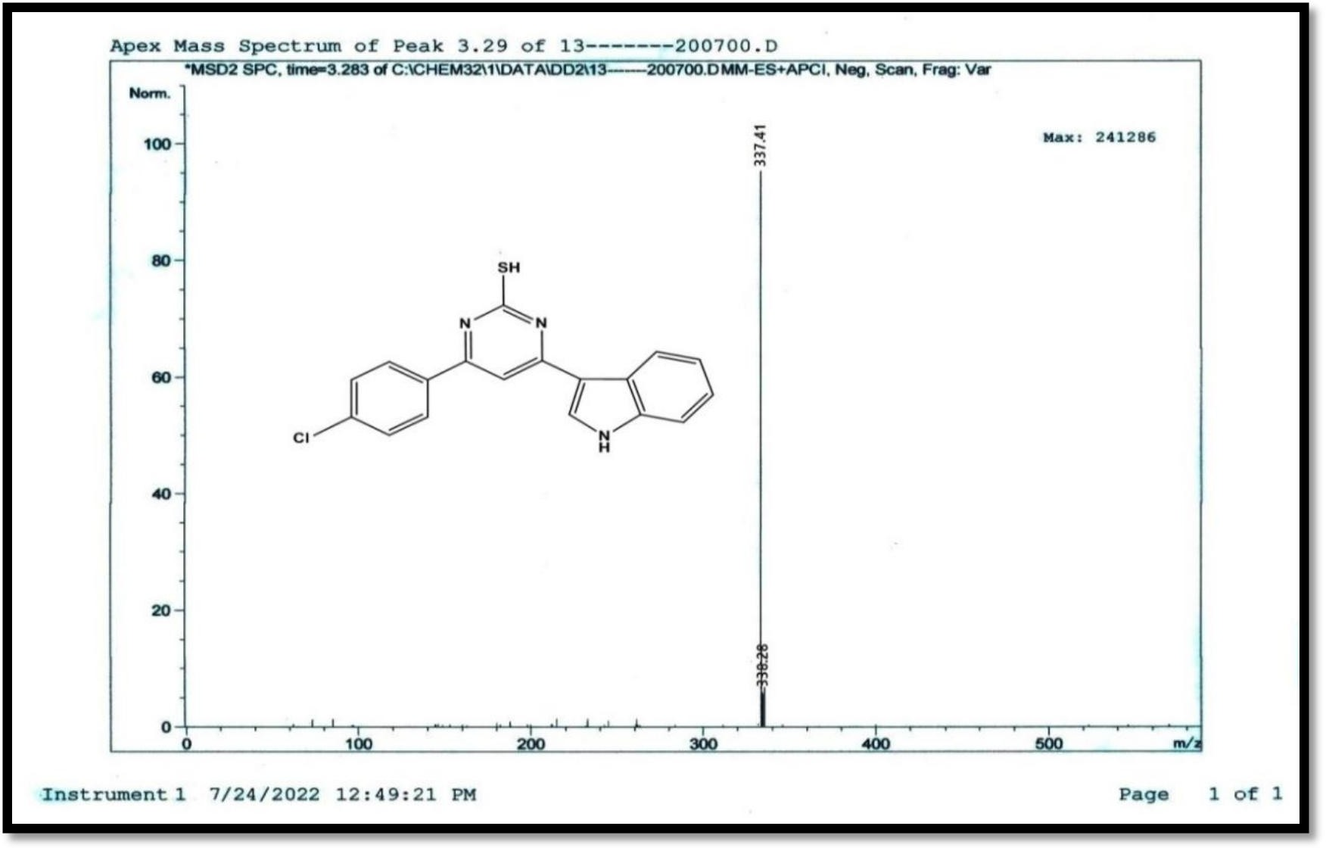
1H-NMR spectrum of 4-(4-chlorophenyl)-6-(1H-indol-3-yl)-pyrimidin-2- thiol (4d)

Mass spectrum of 4-(4-chlorophenyl)-6-(1H-indol-3-yl)-pyrimidin-2-thiol (4d)

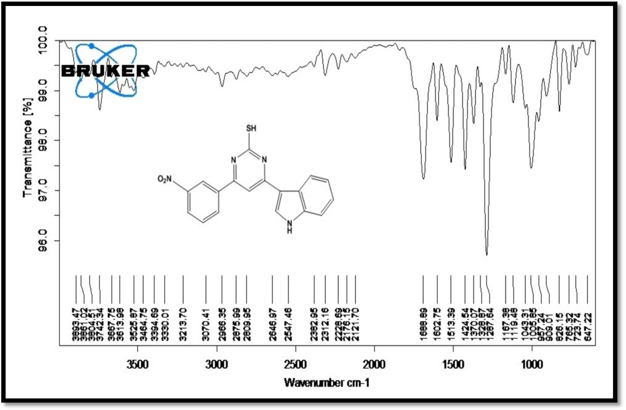

IR spectrum of 4-(3-nitrophenyl)-6-(1H-indol-3-yl)-pyrimidin-2-thiol (4f)

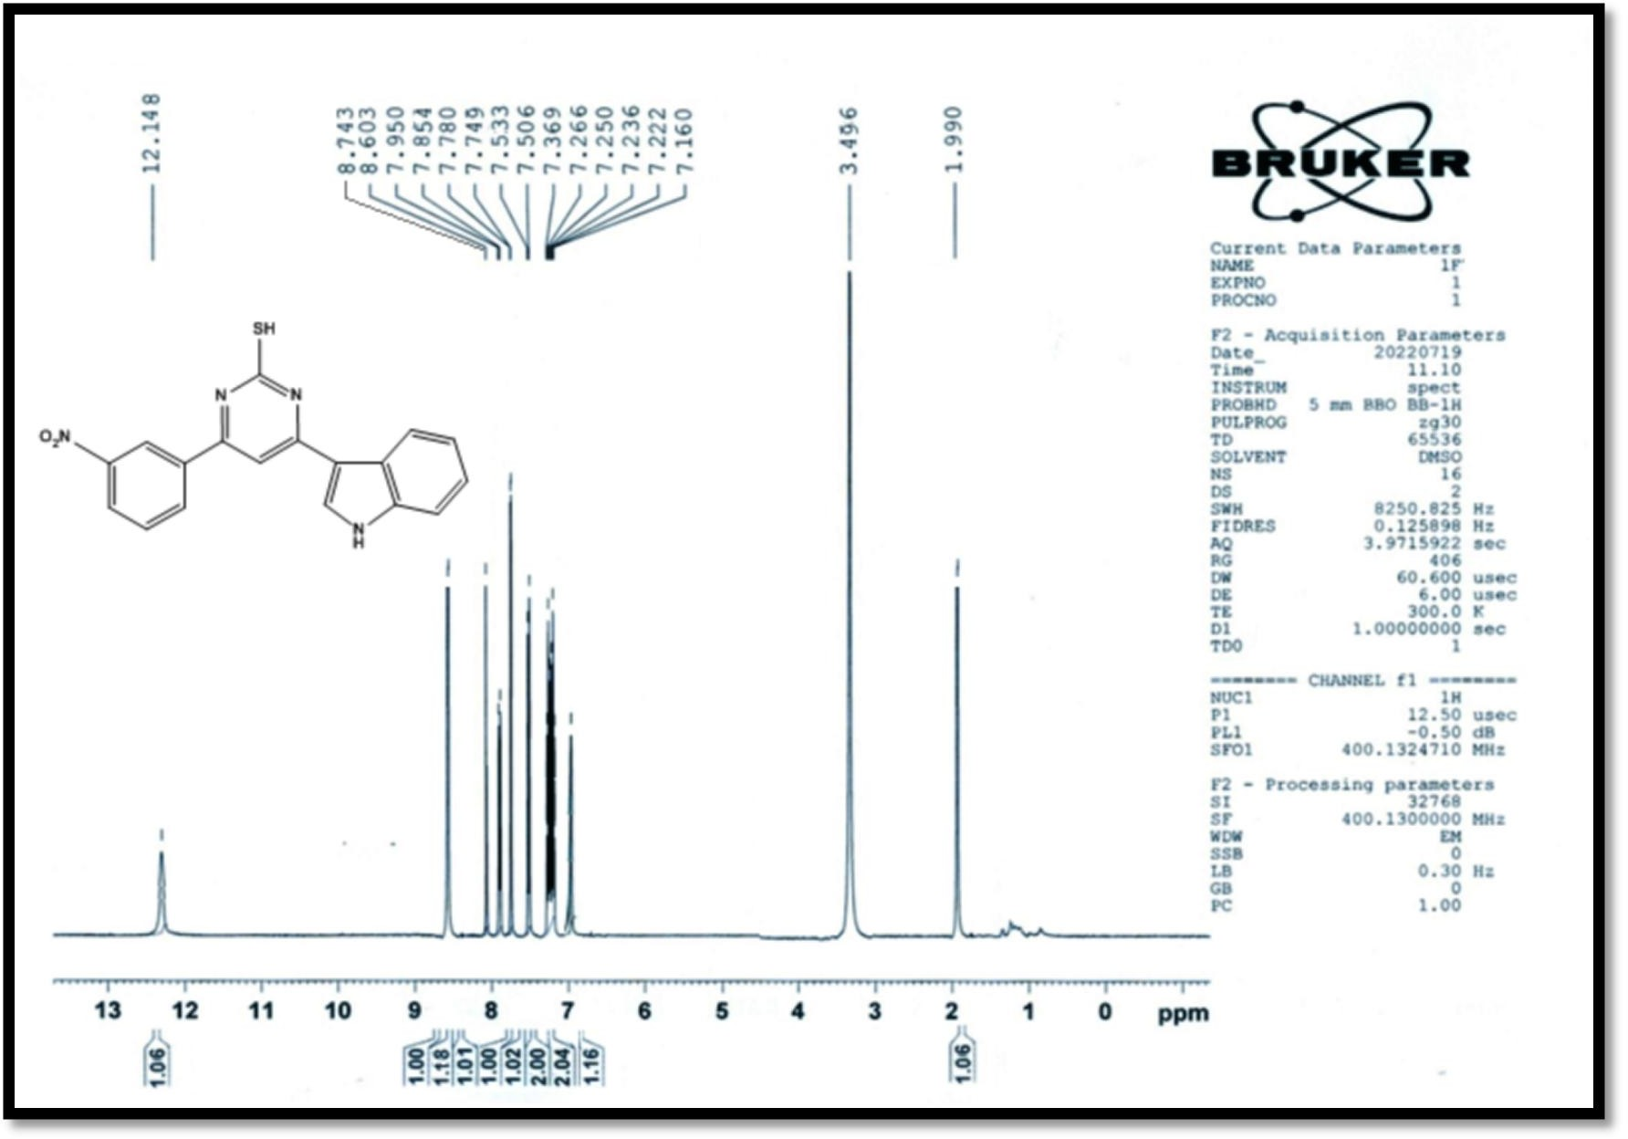

¹H NMR spectrum of 4-(3-nitro phenyl)-6-(1H-indol-3-yl)-pyrimidin-2-thiol (4f)

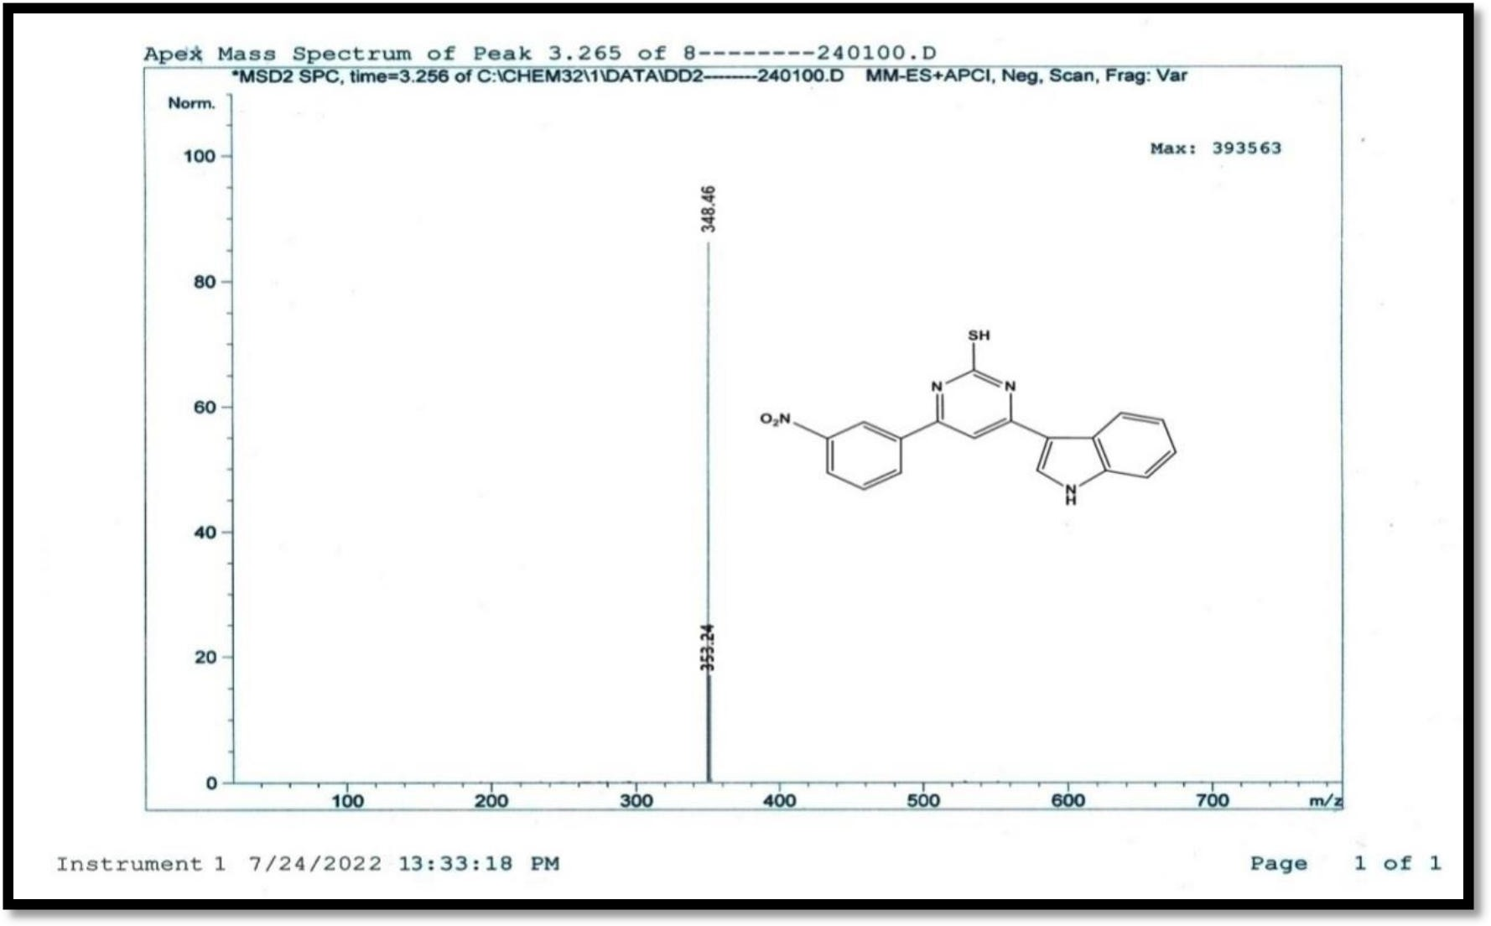
Mass spectrum of 4-(3-nitro phenyl)-6-(1H-indol-3-yl)-pyrimidin-2-thiol (4f)

