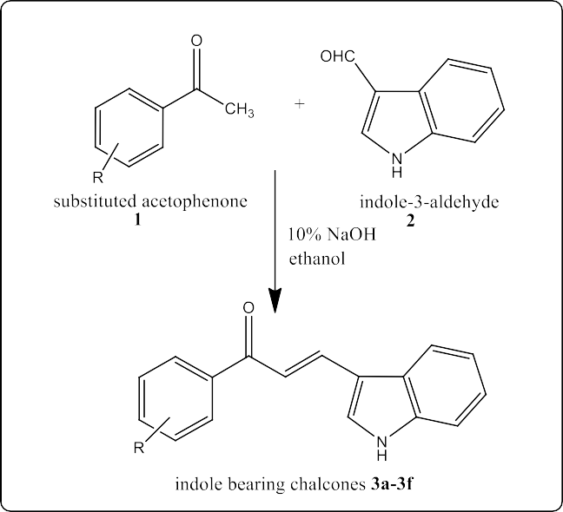

S
Scheme 1: Indole bearing Chalcones 3a-3f
R=
3a: 4-0H
3b: 4-0CH₃
3c: 4-NH₂
3d: 4-Cl
3e: 4-Br
3f: 3-NO₂

