Supplementary for
Unraveling the Associations Between Voice Pitch and Major Depressive Disorder: A Multisite Genetic Study
The Supplementary contained the following contents:
- Supplemental Text
- Supplemental Figures S1-S16
- Supplemental Tables S1-S14 (in a separate MS Excel file)

Supplementary Text

Methods

Interview protocol
All subjects were interviewed using a computerized assessment system. Interviewers were postgraduate medical students, junior psychiatrists, or senior nurses, trained by the CONVERGE team for a minimum of 1 week. Interviews were recorded and the research team listened to at least two interviews from each interviewer to identify any errors in the way questions were asked and answers were interpreted. The interview protocol acquired the following assessments for psychopathology: i) CIDI (WHO 1997) section of MDD expanded to include a “deep” assessment of the DSM-IV A criteria for MDD, symptoms of DSM-IV melancholia, Beck’s cognitive triad (helplessness, hopefulness, and worthlessness), and irritability/anxiety; ii) CIDI section on dysthymia; iii) sections from interviews in the Virginia Adult Twin Study of Psychiatric and Substance Use Disorders (VATSPSUD) ¹ for generalized anxiety disorder, panic, and five phobia subtypes (agoraphobia and social, situational, animal, and blood injury phobias), (iv) brief assessments of premenstrual syndrome and postnatal depression ^{2,3}, and (v) assessments of smoking/nicotine dependence (Heatherton et al., 1991) (alcohol and substance abuse were virtually absent in this study, so it was not assessed). Additionally, four key environmental exposures known to be strongly associated with the risk of MDD were assessed in cases and controls: i) child sexual abuse; ii) parent-child relationships; iii) social support; and iv) stressful live events. Neuroticism was assessed using the full 23-item Eysenck personality questionnaire N scale. Family history of MDD was individually assessed in parents and full siblings using the Family History Research Diagnostic Criteria. In each case, measures used are those developed, field-tested, and validated in the VATSPSUD studies ³.
The interview protocol in the replication study largely mirrored that used in the CONVERGE study, with a few additional elements. Firstly, all subjects took part in a 16-item, self-administered questionnaire assessing the severity of depression-related symptoms on a five-point distress scale over the past 30 days (subscales for depression in symptom checklist, SCL) ⁴, providing a more immediate assessment of their depressive state. Secondly, case subjects were asked to give details about their life history, specifically focusing on the occurrence of stressful events prior to their episodes of depression.

DNA Sequencing and Genotype imputation
The CONVERGE study used low-coverage sequencing to genotype the sample. DNA was extracted from saliva samples using the Oragene protocol. Sequencing reads obtained from Illumina Hiseq machines were aligned to Genome Reference Consortium Human Build 37 patch release 5 (GRCh37.p5) with Stampy (v1.0.17)⁵ using default parameters after filtering out reads containing adaptor sequences or consisting of more than 50% poor quality bases. The aligned reads were indexed, and PCR duplicates were marked for removal. Base quality score recalibration (BQSR) was performed on the BAM files using the Genome Analysis Toolkit (GATK) ⁶, with known SNPs and INDELs masked. Whole-genome sequences were acquired to a mean depth of 1.73 (95% confidence intervals (CIs) 0.7–4.3) per individual, from which 32,781,340 SNP sites were identified.
Variant discovery and genotyping were conducted using the GATK's UnifiedGenotyper, targeting polymorphic SNPs in the 1000 Genomes Project Phase 1 East Asian reference panel. The dbSNP v137 rsids were used to fill in the variant ID column of the output variant call format (VCF) files. A sensitivity threshold of 90% to SNPs in the 1000G Phase1 ASN panel was applied for SNP selection for imputation. This gave a total of 21,356,798 (9,053,391 known in 1000 Genomes Phase 1 ASN Panel and 11,486,024 novel) biallelic SNPs identified from all chromosomes and unassembled contigs. Genotype likelihoods were calculated using SNPtools ⁷. The imputation process was conducted using BEAGLE software ⁸.

Voice Data Preprocessing
Of the initial subjects recruited in CONVERGE, 8,322 subjects have interview recordings (Figure 1). To obtain the subjects’ utterances, a group of undergraduates listened to the recordings to identify any voice segments from the subjects with a duration >2 seconds. Audio samples were excluded where the noise was so prominent that the content of the subject's speech could not be understood, which yielded 7,654 subjects with available segments. All segments from the same subject were concatenated in the order in which they occur in the interview and down sampled to 8 kHz. Two postgraduate psychological students listened to all the segments to ensure that no speech voice other than the subjects was included in the segments.
The preprocessing procedure in the replication study was the same as in CONVERGE. Of the initially recruited 1,301 participants (551 cases), 1,189 subjects (including 490 cases) had available voice segments (Figure 1). All segments from the same subject were concatenated into one, to extract voice features for replicating the association between voice and MDD and identifying the voice features associated with SCL. The speech segments in the replication study were further annotated to indicate the specific question that prompted each spoken response (For example, questions listed in Table S12). This additional level of data analysis was introduced to better understand the relationship between the interview content and the participants' speech patterns. We additionally extracted the same voice features on the non-concatenated segments corresponding to a single question for a sensitivity analysis, which we referred to as, the single-item analysis (described below).

Voice Feature extraction
The process to calculate the pitch (Fundamental frequency, F0) and its dynamics is as follows:
- F0 Calculation: given an audio segment, a time series of the F0 values was computed⁹ and subsequently smoothed. F0 captures the statical information at the time-point, reflecting the rate of vocal fold vibration and approximates the voice pitch ⁹.
- Delta regression coefficients: the first-order delta regression coefficients (differential values, ΔF0) were computed on the time series of F0 values, using a context window size of 2. ΔF0 captures the dynamical information, reflecting the speed of pitch change.
- Derived features: A group of statistical/functionals was applied to the F0 and ΔF0 time series to extract 83 derived features, capturing the long-term temporal information of the speech. These statistical/functionals included maximum/minimum, mean, quartiles, range, inter quartile range, relative position (time point) for the first maximum/minimum value, time ratio for upper/lower range, linear regression coefficients, quadratic regression coefficients, linear predictive coding coefficients, etc. All these 83 features are described in¹⁰.

Feature selection process to remove redundant features
From the COMPARE16 feature set, we obtained 83 F0/ΔF0-based features. We excluded one feature, the minimal length for F0 >0 because the values of this feature were the same for almost all subjects. They were forced to the frame size unit, according to ¹⁰.
Next, given that many of the features were highly correlated (for example, the arithmetic and root-quadratic mean of F0) (Figure S16), we implemented a feature selection process to remove redundant features. We first calculated the pairwise Pearson correlation for each voice feature pair and ranked the voice features from high to low according to their sum of squared correlation r values with all other features. We then retained the first (leading) feature and excluded all other features that had an absolute r value >0.5 with the leading one. This process was repeated, each time keeping the next leading feature remaining in the list and excluding its correlates.
The above procedure resulted in a set of 30 F0/ΔF0-based features (Table S3) that were representative of the original 82 features and not highly correlated with each other.

Reference
1. Kendler, K. S. & Prescott, C. A. Genes, Environment, and Psychopathology: Understanding the Causes of Psychiatric and Substance Use Disorders. (Guilford Press, 2007).
2. Cox, J. L., Holden, J. M. & Sagovsky, R. Detection of postnatal depression: development of the 10-item Edinburgh Postnatal Depression Scale. Br. J. Psychiatry 150, 782–786 (1987).
3. Kendler, K. et al. Genetic and environmental factors in the aetiology of menstrual, premenstrual and neurotic symptoms: a population-based twin study. Psychol. Med. 22, 85–100 (1992).
4. Derogatis, L. R. SCL-90: an outpatient psychiatric rating scale-preliminary report. Psychopharmacol Bull 9, 13–28 (1973).
5. Lunter, G. & Goodson, M. Stampy: a statistical algorithm for sensitive and fast mapping of Illumina sequence reads. Genome Res. 21, 936–939 (2011).
6. McKenna, A. et al. The Genome Analysis Toolkit: a MapReduce framework for analyzing next-generation DNA sequencing data. Genome Res. 20, 1297–1303 (2010).
7. Wang, Y., Lu, J., Yu, J., Gibbs, R. A. & Yu, F. An integrative variant analysis pipeline for accurate genotype/haplotype inference in population NGS data. Genome Res. 23, 833–842 (2013).
8. Browning, S. R. & Browning, B. L. Rapid and Accurate Haplotype Phasing and Missing-Data Inference for Whole-Genome Association Studies By Use of Localized Haplotype Clustering. Am. J. Hum. Genet. 81, 1084–1097 (2007).
9. Hermes, D. J. Measurement of pitch by subharmonic summation. J. Acoust. Soc. Am. 83, 257–264 (1988).
10. Eyben, F. Real-Time Speech and Music Classification by Large Audio Feature Space Extraction. (Springer, 2015).

Supplemental Figures
Figure S1. QQ plot for initial naive estimation of associations between voice F0/ΔF0 features and MDD.
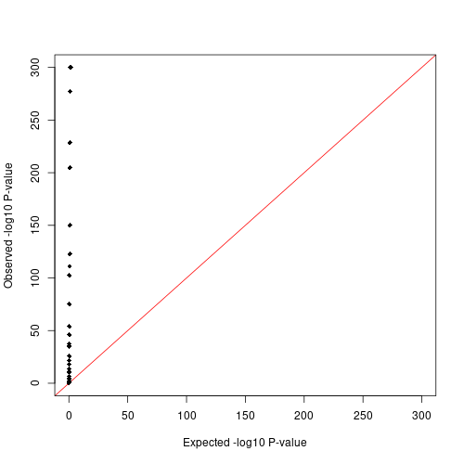

Figure S2. QQ plot for two-stage meta-analysis of associations between voice F0/ΔF0 features and MDD.
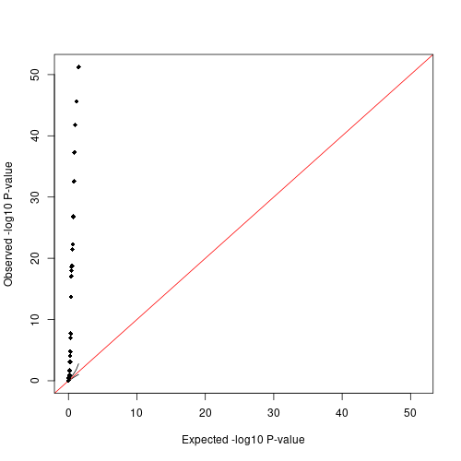
Figure S3. The distribution of the ΔF0 features in CONVERGE.
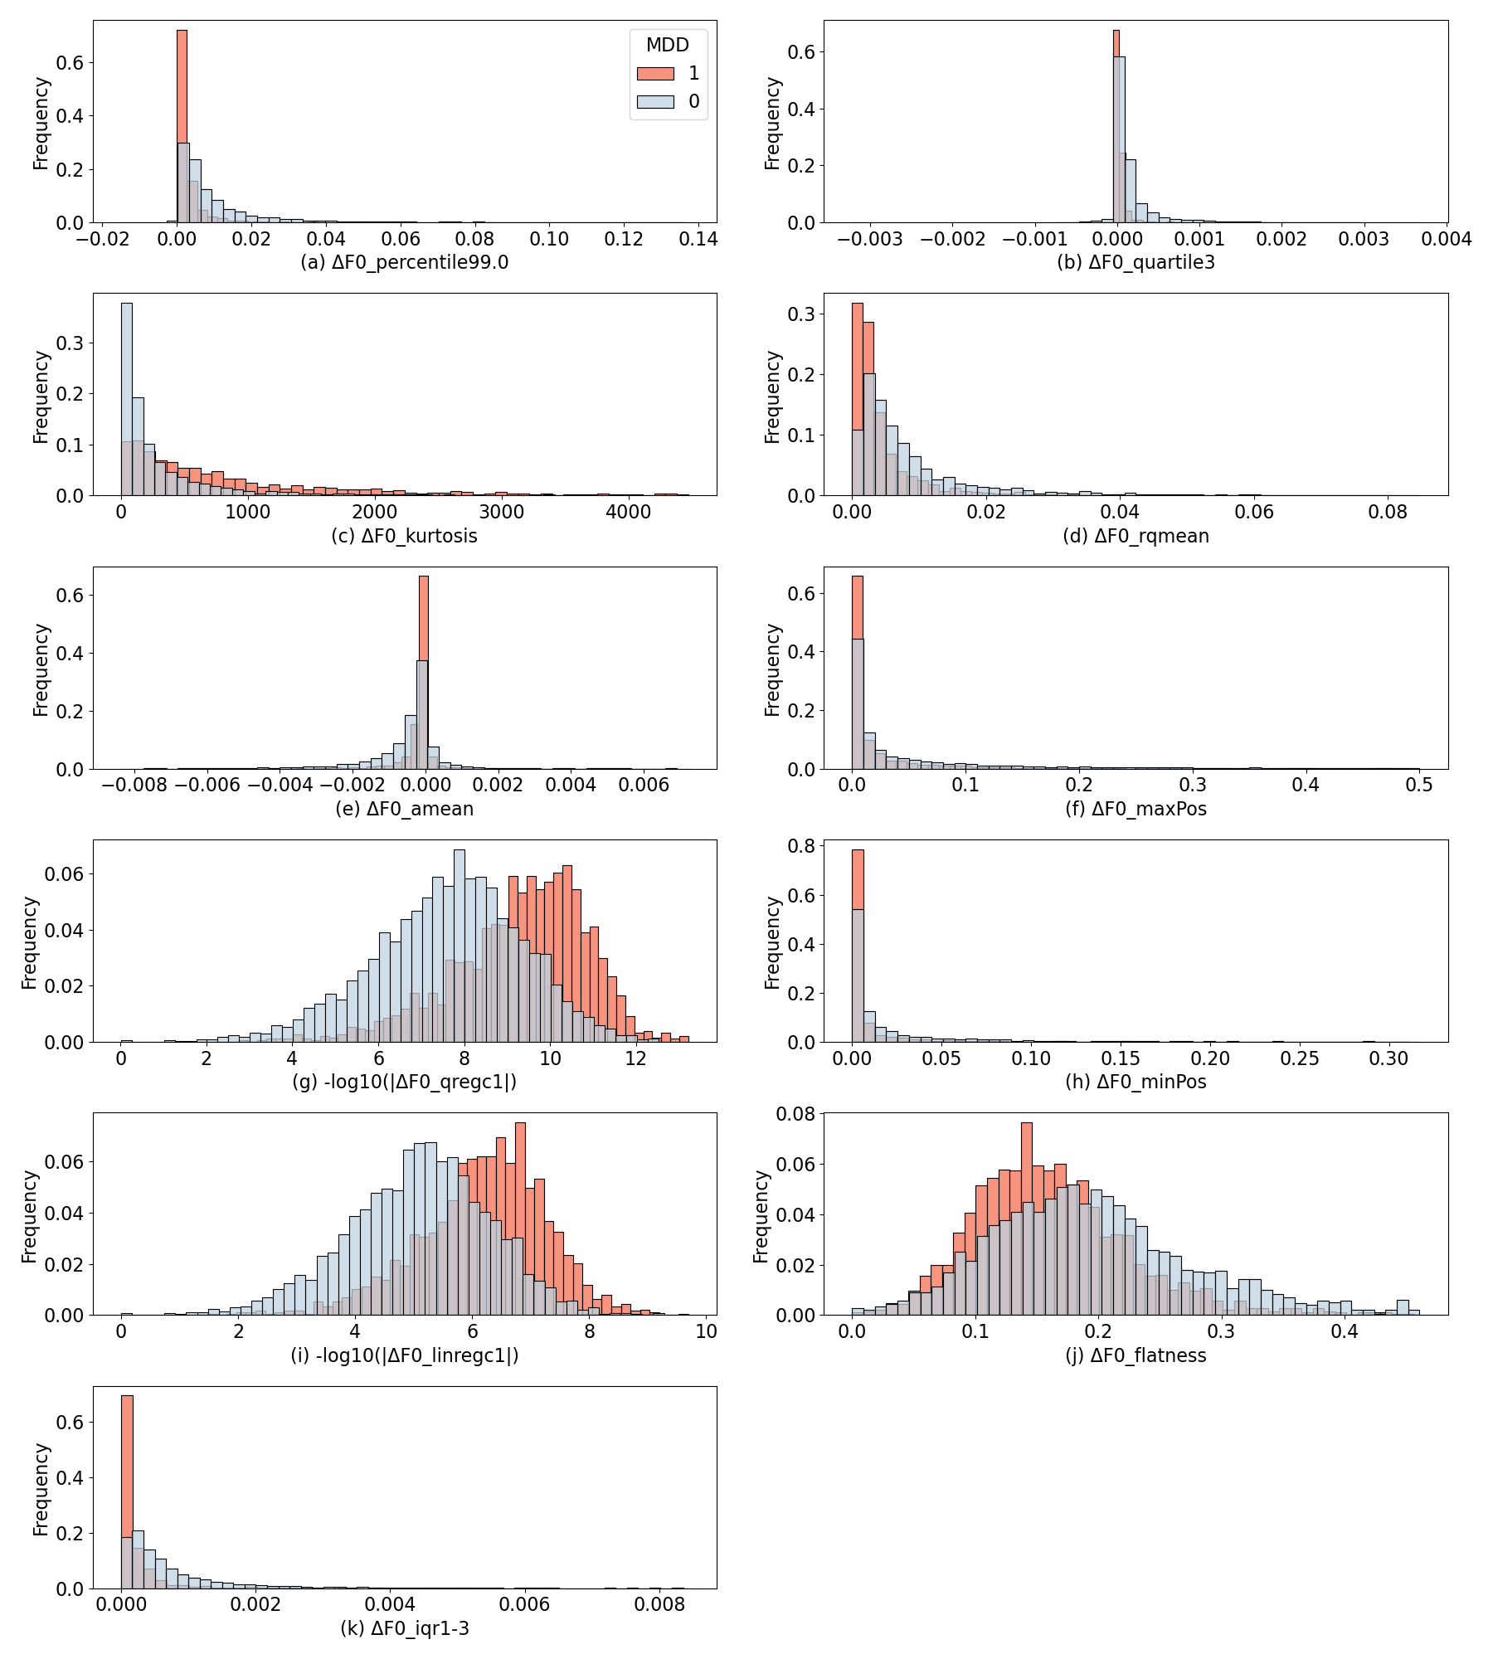

Figure S4. The distribution of the F0 features in CONVERGE.
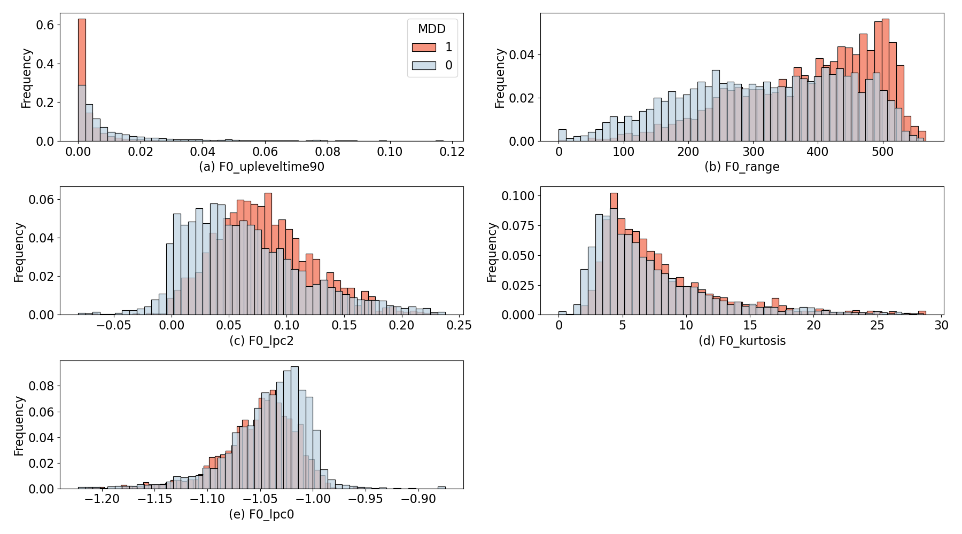

Figure S5 Manhattan Plot for ΔF0_iqr1-3
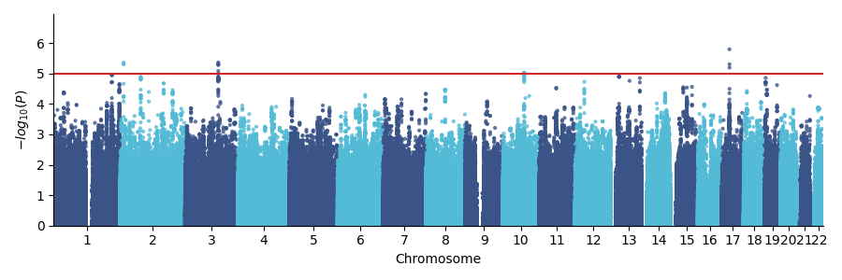
Figure S6 QQ Plot for ΔF0_iqr1-3
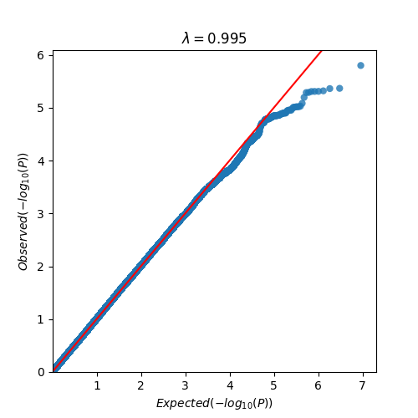

Figure S7 Manhattan Plot for F0_kurtosis
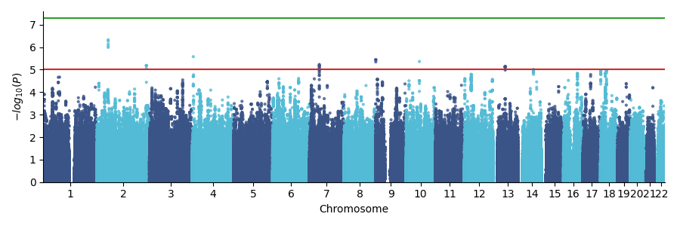
Figure S8 QQ Plot for F0_kurtosis
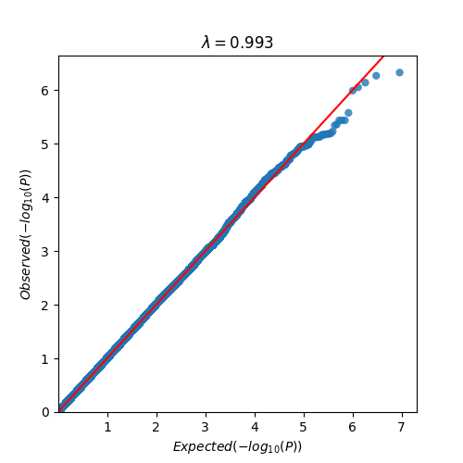

Figure S9 Manhattan Plot for ΔF0_kurtosis
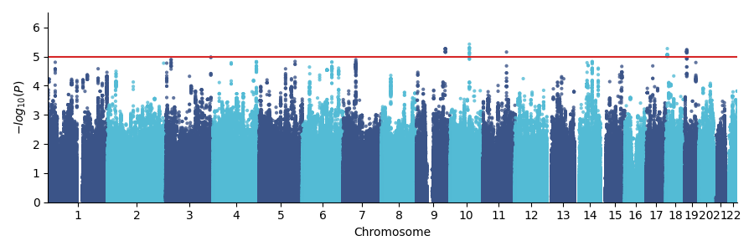
Figure S10 QQ Plot for ΔF0_kurtosis
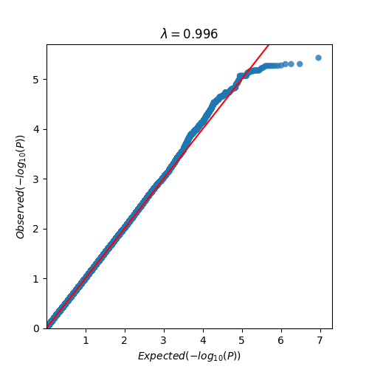

Figure S11 Manhattan Plot for ΔF0_percentile99.0
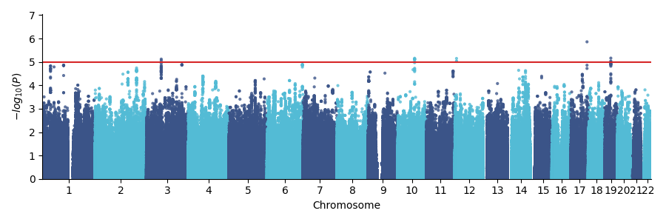

Figure S12 QQ Plot forΔF0_percentile99.0
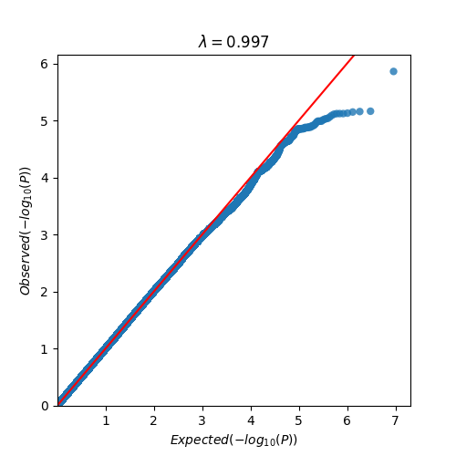

Figure S13 The distribution of Symptom Checklist scores.
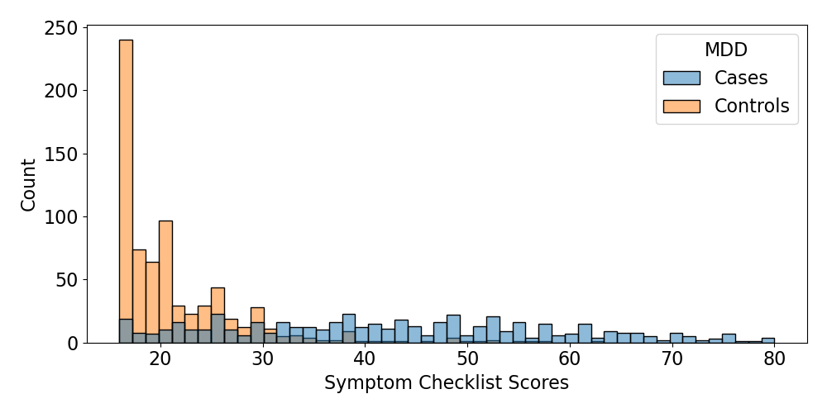

Figure S14. Classification performance with different maximum durations of segments.
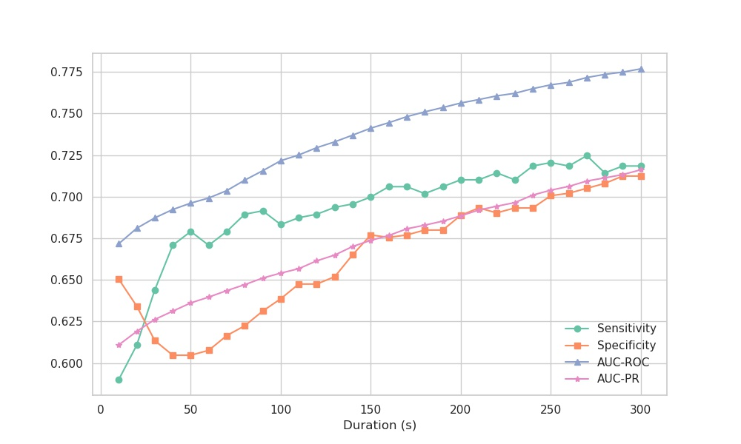

Figure S15. Estimated beta coefficients with 95% confidence interval from associations between 16 voice F0/ΔF0 features and MDD. Estimations were conducted using the two-stage meta-analysis method on four corpora: CONVERGE, replication, single-segment about weight (D10) from replication, and single-segment about birthday (D2.A) from replication.
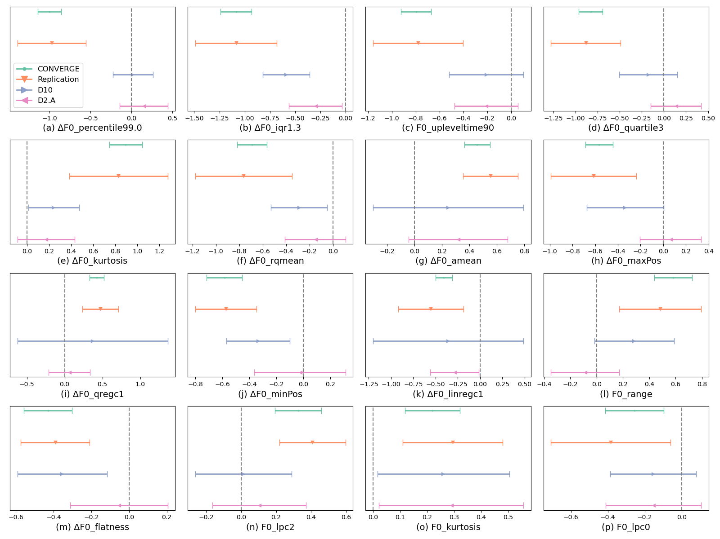

Figure S16. Heatmap of the correlation r-values between the leading features and excluded features. The x-axis is the 52 excluded voice features because of their high correlation with the 30 leading features (y-axis).
