Supplementary Figure Legends
Supplementary Figure 1: Direct acyclic graph (DAG) for the association between
the peripheral eosinophil count (PEC) and ESRD
Supplementary Figure 2: Kaplan-Meier survival curves for Q4 (highest PEC)
compared with Q1 (lowest PEC)

Supplementary Figure 1_DAG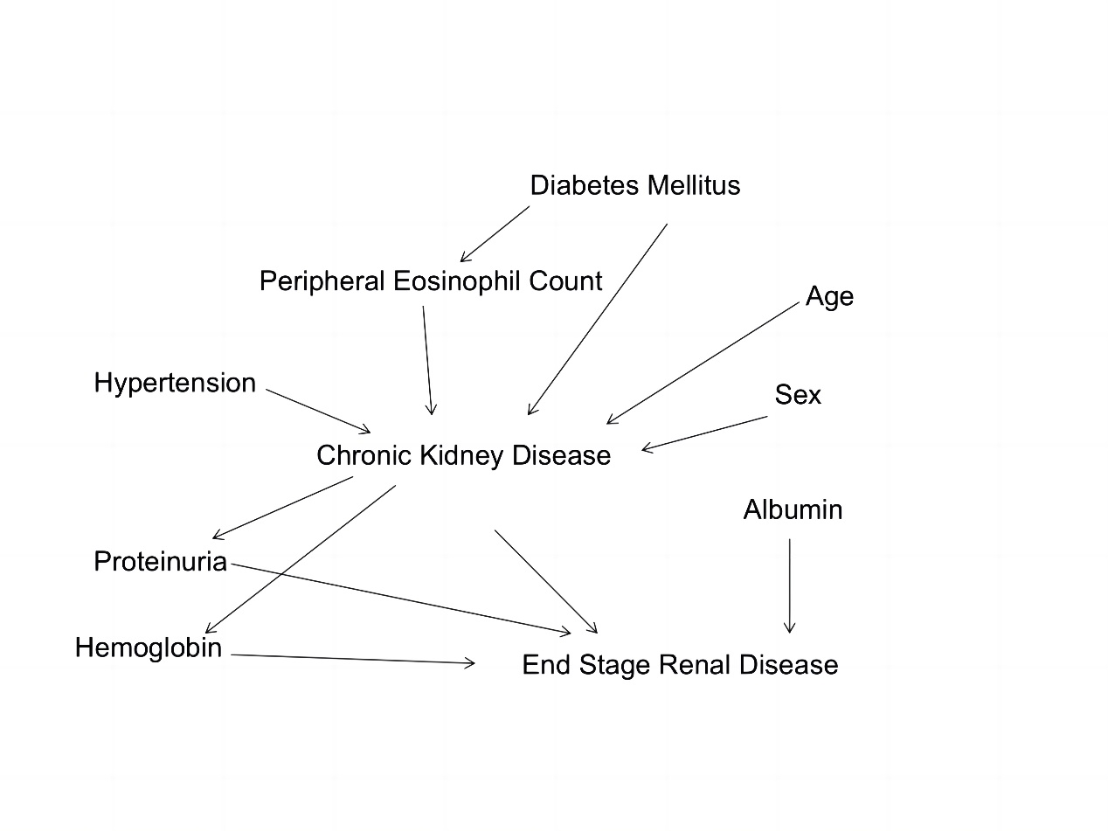

Supplementary Figure 2 KM curve
