Supplementary Information

Beyond Predictions: An Interpretable Machine Learning Approach for Battery Performance Forecasting
Jieun Kim^{1†}, Injun Choi^{2†}, Ju Seong Kim¹, H Hwang², Inchul Park^{1*}
^{1*}Secondary Battery Materials Lab, POSCO NEXT Hub, 100 Songdogwahak-ro, Yeonsu-gu, Incheon, 21985, Republic of Korea.
²Convergence Innovation Research Laboratory, Research Institute of Industrial Science & Technology, 67 Cheongam-ro, Nam-gu, Pohang-si, Gyeongsangbuk-do, 37673, Republic of Korea.
*Corresponding author(s). E-mail(s): inchul@posco-inc.com;
Contributing authors: jekim427@posco-inc.com; surung9898@rist.re.kr;
†These authors contributed equally to this work.

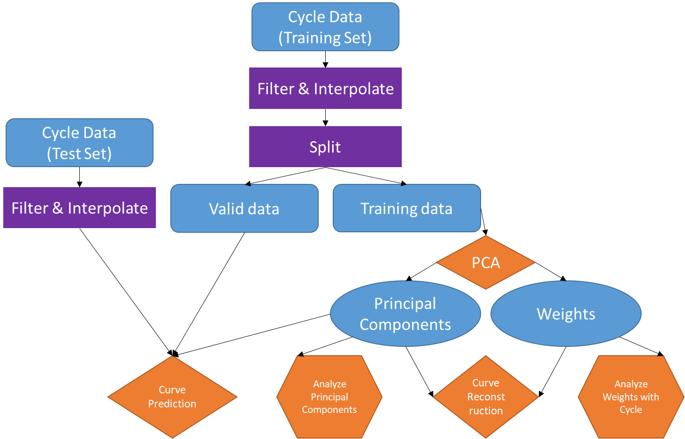
Figure S1. Flowchart of this research

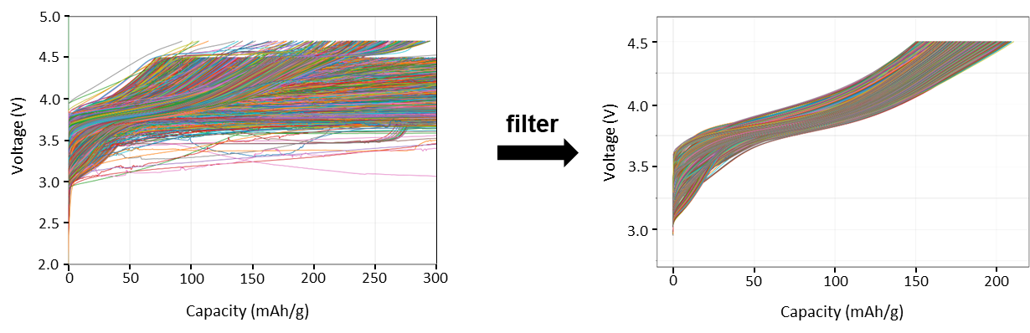
Figure S2. The charge curve dataset before and after filtering from LRLO used for PCA in this study

Supplementary Section 1 (Table S1, Figure S3, 4)
The accuracy as a function of the number of PCA components is shown in Figure S3 and Table S1 for components ranging from n=1 to 10. With only one component, the average RMSE was 2.7 mAh/g, and the upper 95% confidence interval of the RMSE reached 5.2 mAh/g. This is an error of more than 2% for a typical capacity of 200 mAh/g. As the number of components increases, there is a consistent decrease in RMSE. Utilizing 4 components results in RMSE of 0.45 mAh/g. When the component count increases to 7, we observe a improvement in precision, as evidenced by the average RMSE declining to 0.16 mAh/g. Upon expanding the number of components to 10, the average RMSE further decreases to below 0.1 mAh/g. Moreover, in 95% of instances, the RMSE remains below 0.14 mAh/g. However, such high accuracy may indicate the possibility of overfitting, which could potentially reduce the prediction accuracy. Therefore, by measuring the prediction accuracy on a new test set, we confirmed that 7 principal components best describe the electrochemical characteristics of LRLO materials, and this number was chosen for use (see Table S2).

Figure S3. Accuracy plot of reconstructed curve by the number of PCA components

Table S1. Accuracy of reconstructed curve by the number of PCA components
Number of components | RMSE
Number of components | mean | median | 25% | 75% | 90% | 95%
1 | 2.7017 | 2.4857 | 1.7290 | 3.4121 | 4.5449 | 5.1568
2 | 1.4088 | 1.2768 | 0.8706 | 1.8383 | 2.3914 | 2.6575
3 | 0.8757 | 0.7692 | 0.5280 | 1.0661 | 1.5176 | 1.9395
4 | 0.4469 | 0.4021 | 0.2720 | 0.5630 | 0.7556 | 0.8818
5 | 0.3201 | 0.2837 | 0.1893 | 0.3920 | 0.5223 | 0.6628
6 | 0.2301 | 0.1973 | 0.1425 | 0.2807 | 0.3874 | 0.4521
7 | 0.1644 | 0.1401 | 0.1069 | 0.1997 | 0.2680 | 0.3197
8 | 0.1278 | 0.1064 | 0.0844 | 0.1485 | 0.2158 | 0.2591
9 | 0.1011 | 0.0890 | 0.0694 | 0.1163 | 0.1584 | 0.1925
10 | 0.0772 | 0.0689 | 0.0537 | 0.0911 | 0.1177 | 0.1399

Figure S4. (a) Reconstructed dQ/dV curve. (b) dQ/dV curve for each component. (c)-(d) Enlarged images corresponding to the box of a.

Supplementary Section 2 (Figure S5 - 9)
The Pearson correlation coefficients for all data were measured from the PCA coefficients, capacity, and average voltage across all cycles in the training dataset. To understand how the correlation coefficient changes with cell aging, the correlation coefficients of the PCA weights, capacity, and average voltage were measured specifically for data from certain cycle numbers within the training dataset.
Figure S7 shows the correlation coefficient matrices for all data and specifically for the 10th, 20th, 30th, 40th, and 50th cycles. It was observed that there is no significant difference in the composition of the correlation coefficient matrix between the total cycle data and the individual cycle data. PC1 consistently shows a very high correlation with capacity, exceeding 0.95, regardless of the cycle. Although PC1 and average voltage have a strong correlation over all cycles with a coefficient of 0.86, it is lower compared to the correlation with capacity. Since the correlation between capacity and average voltage is high at 0.67, this likely contributes to the strong correlation between PC1 and average voltage. PC2 has a relatively high but weak correlation of 0.44 with average voltage compared to capacity. Further principal components, starting with PC3, show inconsistently low correlations. Figures S8 and S9 illustrate the cyclewise relationship between the 1st and 2nd principal components and capacity and average voltage, respectively. These relationships appear to be consistent, almost independent of the number of cycles.

Figure S5. Interpretability of components

Figure S6. Relationship between the first principal component and (a) capacity for all cycles and average voltage for (b) all cycles, (c) fresh cells and (d) aged cycles.

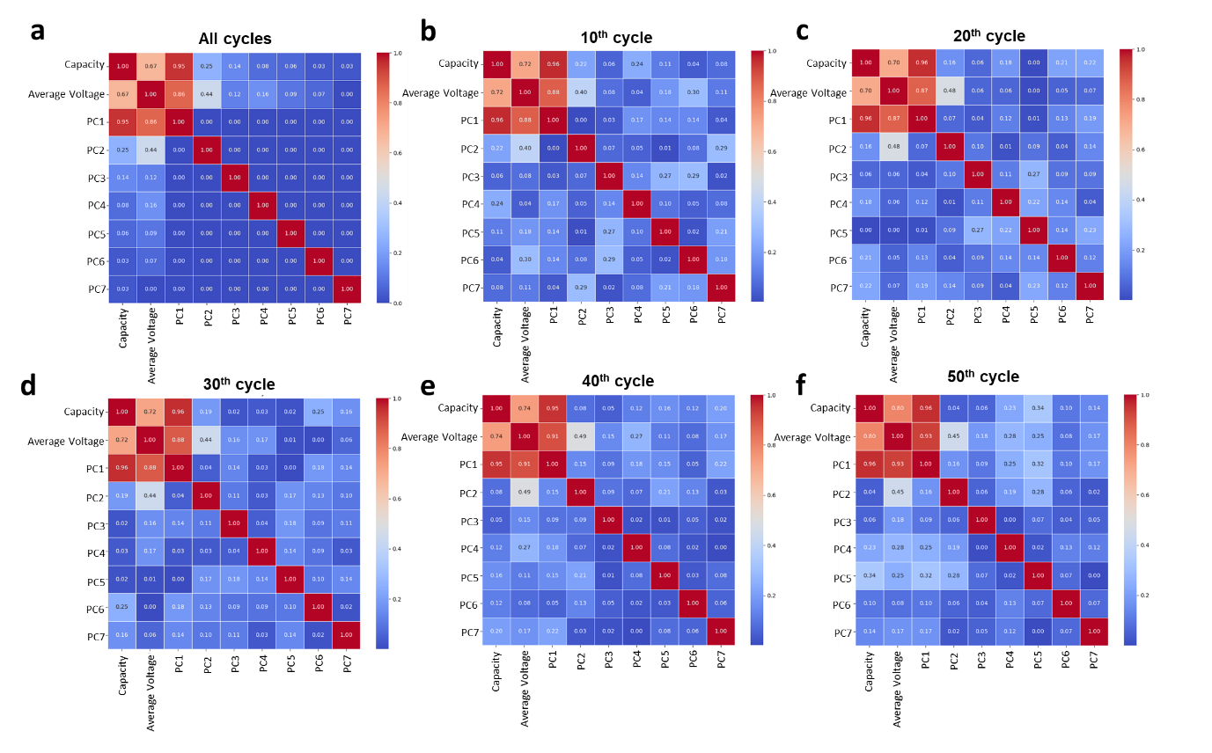
Figure S7. Correlation matrix between PCA components and battery performance for (a) all cycles, (b) 10th, (c) 20th, (d) 30th, (e) 40th and (f) 50th cycle.

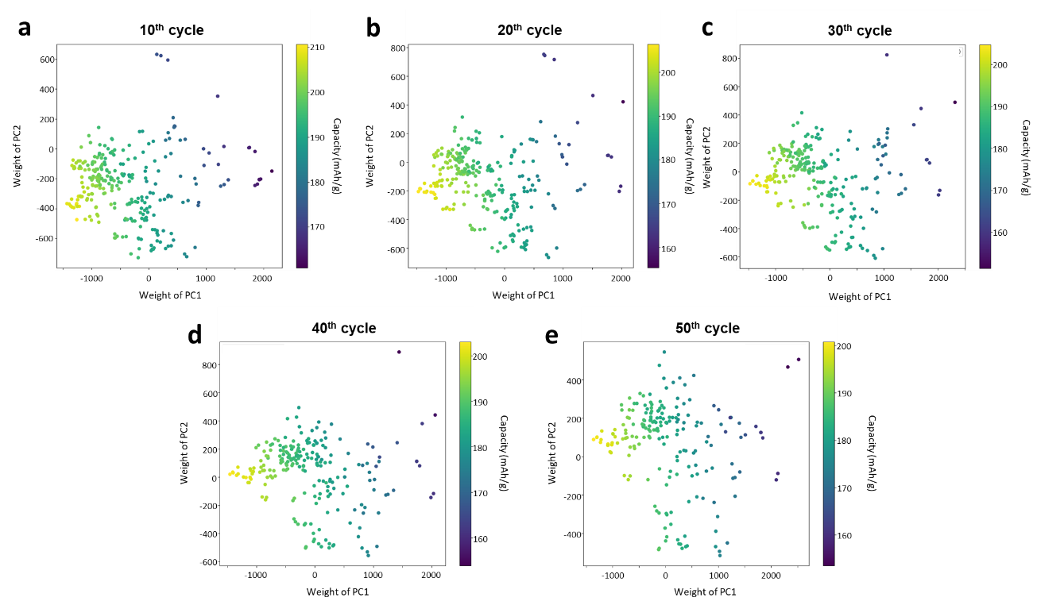
Figure S8. Relationship between the principal components and capacity for (a) 10th, (b) 20th, (c) 30th, (d) 40th and (e) 50th cycle.

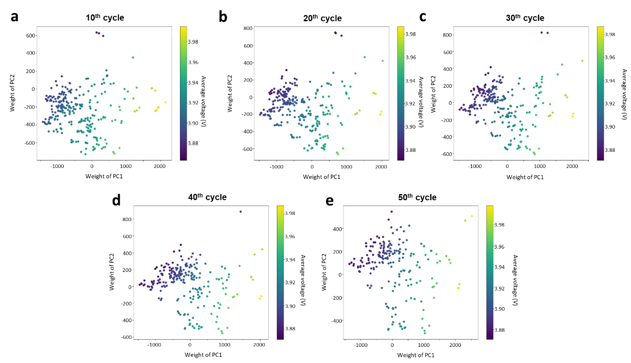
Figure S9. Relationship between the principal components and average voltage for (a) 10th, (b) 20th, (c) 30th, (d) 40th and (e) 50th cycle.

Figure S10. (a) Degradation behavior of LRLO (Case II). (b) Voltage retention with degradation. (c) Differential charge curve with degradation.

Figure S11. (a) Degradation behavior of LRLO (Case III). (b) Voltage retention with degradation. (c) Differential charge curve with degradation.

Figure S12. (a) Degradation behavior of LRLO (Case IV). (b) Capacity retention and (c) Voltage retention with degradation. (d) Differential charge curve with degradation.
Table S2. Accuracy of predicted curve by the number of PCA components
Number of components | RMSE
Number of components | mean | median | 25% | 75% | 90% | 95%
1 | 6.4055 | 5.2005 | 3.5205 | 7.4131 | 12.4517 | 18.3536
2 | 3.2406 | 2.2046 | 1.2691 | 3.4555 | 9.4899 | 11.1451
3 | 2.9558 | 1.5360 | 0.9043 | 2.6254 | 10.6347 | 12.6155
4 | 2.7954 | 2.1429 | 1.0992 | 4.1307 | 6.1842 | 7.2780
5 | 2.7943 | 2.1235 | 1.1597 | 4.3097 | 5.5248 | 6.8018
6 | 2.5411 | 1.6633 | 0.9691 | 3.4374 | 5.8958 | 7.4763
7 | 2.3895 | 1.6813 | 1.0225 | 3.2946 | 5.1526 | 6.3071
8 | 3.1350 | 2.7585 | 1.6229 | 4.1508 | 6.0397 | 7.0650
9 | 3.5915 | 3.2580 | 2.0245 | 4.9959 | 6.3477 | 7.1838
10 | 3.5231 | 2.9068 | 1.9773 | 4.7201 | 6.8535 | 7.9810

Figure S13. Charge curve prediction: examples (bad case)

Table S 3. Accuracy of reconstructed curve of test set based on PCA components obtained from tain set
Number of components | RMSE
Number of components | mean | median | 25% | 75% | 90% | 95%
7 | 0.3836 | 0.2472 | 0.1891 | 0.3367 | 1.1388 | 1.4650

Figure S14. Charge curve prediction outside Applicability Domain for all cells.

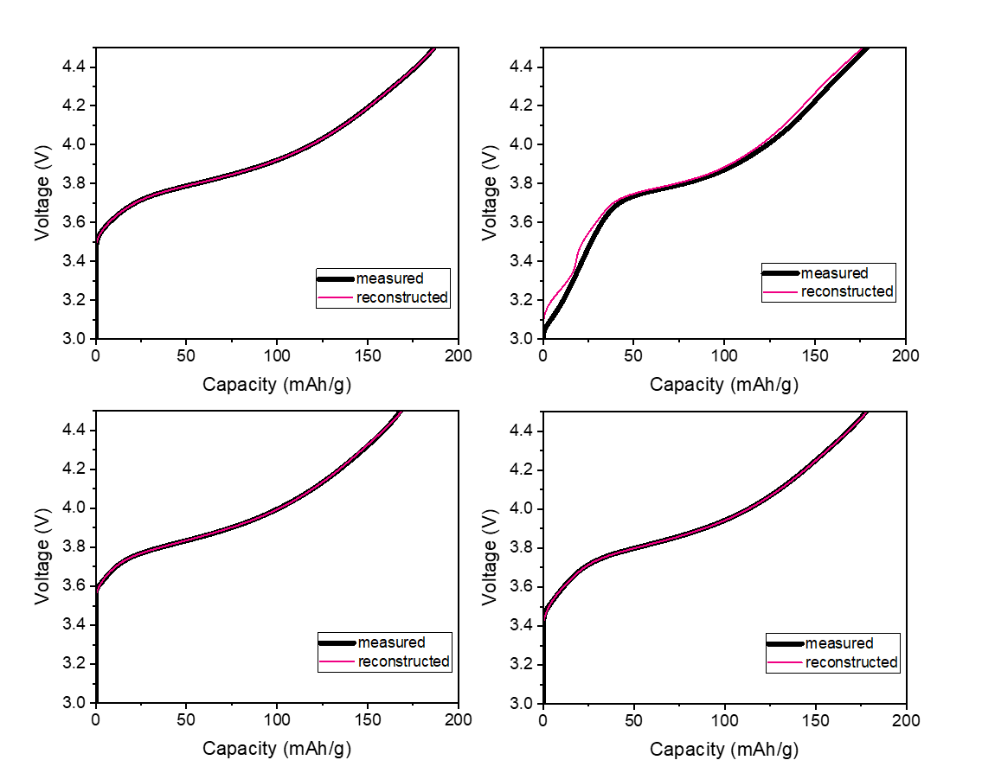
Figure S 15. Reconstructed charge curves of train set based on PCA components obtained from train set.

Supplementary Section 3 (Figure S16 - 17)
We extended Principal Component Analysis (PCA) to include the test dataset in addition to the training dataset. We used the same approach for PCA as described in the Methods section, with the only difference being the addition of the test dataset to the original training set.
The new PCA components derived from the combined dataset of the training and test sets are shown in Figure S16. These components are essentially identical to those obtained from the training set alone, as shown in Figure 1c.
Figure S17 illustrates the relationship between the new 1st Principal Components from the PCA (which now includes both training and test sets) and two key variables: Capacity and Average Voltage. This relationship shows the same trends as observed in Figure S5, indicating consistent correlations and patterns even when the test dataset is included in the PCA.

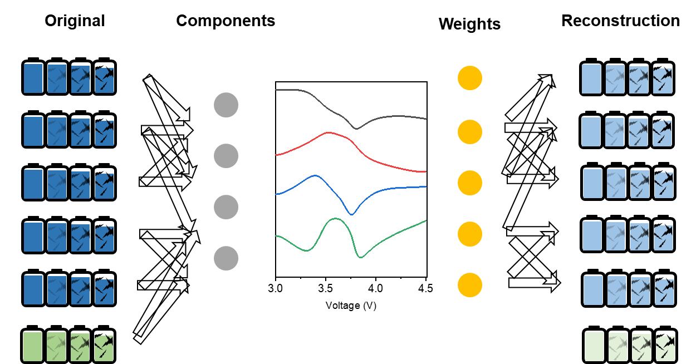
Figure S16. New PCA components derived from the combined dataset of training and test sets.

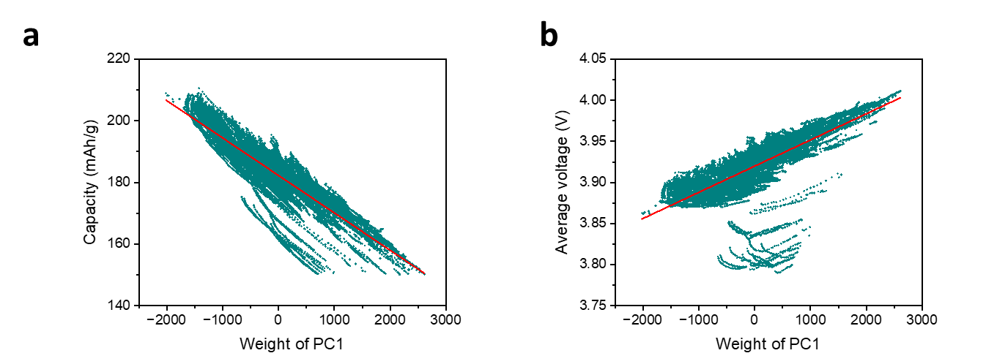
Figure S17. (a) PC1 – capacity curve and (b) PC1 – average voltage including test set that contains data outside of AD

