Supplementary Data
Supplementary Table 1. Gene/Genome Genebank accession numbers used in this study.
Taxonomy | Isolate/Strain | GenBank No. | ITS | ERG11 | D1/D2 | Genome
[Candida] mucifera | 17G1312 | PP204071.1 | P
[Candida] mucifera | 80408 | OR761613.1 | P
[Candida] mucifera | CBS 7409 | NR_130678.1 | P
Trichomonascus apis | CBS 10922 | NR_155939.1 | P
Trichomonascus petasosporus | CBS 9602 | NR_155940.1 | P
Trichomonascus vanleenenianus | CBS 14902 | NR_168170.1 | P
[Sporothrix] fungorum | CBS 259.70 | NR_145318.1 | P
Trichomonascus ciferrii | CBS 5295 | NR_111160.1 | P
[Candida] allociferrii | NBRC 10194 | LC158134.1 | P
[Candida] mucifera | 17G1312 | PP204302.1 |  | P
Candida albicans | SC5314 | XP_716761.1 |  | P
Trichomonascus ciferrii | CBS 4856 | PP213130.1 |  | P
[Candida] mucifera | 17G1312 | PP230918.1 |  |  | P
Trichomonascus ciferrii | NRRL Y-10943 | NG_042436.1 |  |  | P
[Candida] mucifera | 17G1312 | GCA_036871495.1 |  |  |  | 
Trichomonascus ciferrii | NRRL Y-10943 | GCA_030573635.1 |  |  |  | P
Trichomonascus ciferrii | CBS 4856 | GCA_008704605.1 |  |  |  | P

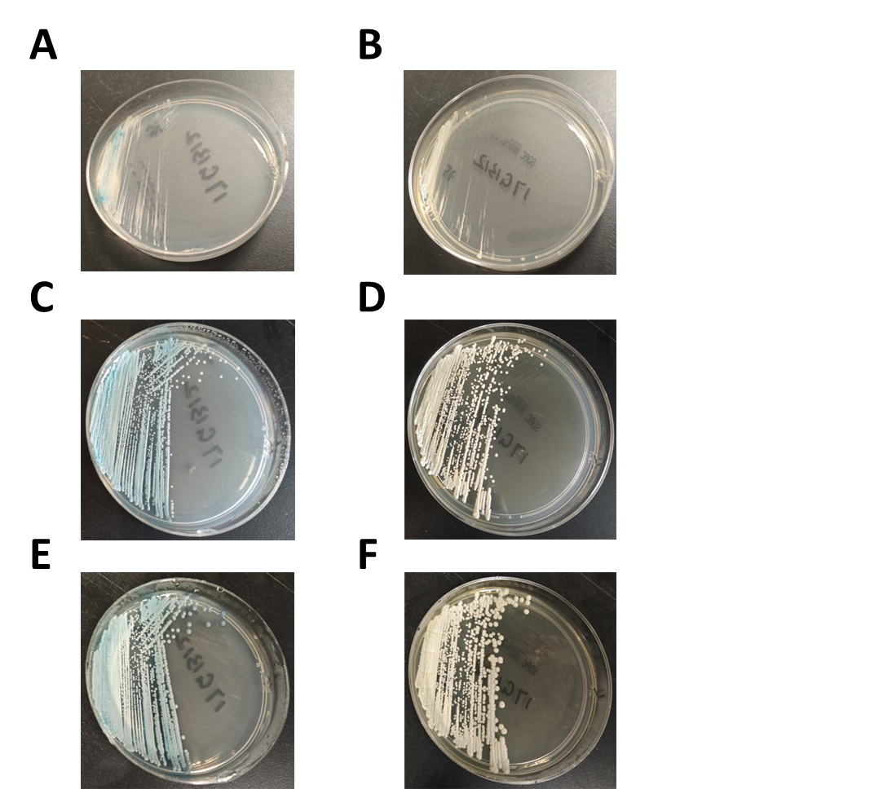
Supplementary Figure 1. Candida mucifera colonies were observed after incubation at 35°C in ambient air. On Sabouraud dextrose medium, pale yellow yeast colonies were observed after 1 day (A), 3 days (C), and 5 days (E) of incubation. On Candida chromogenic medium, blue-green yeast colonies were observed after 1 day (B), 3 days (D), and 5 days (F) of incubation.

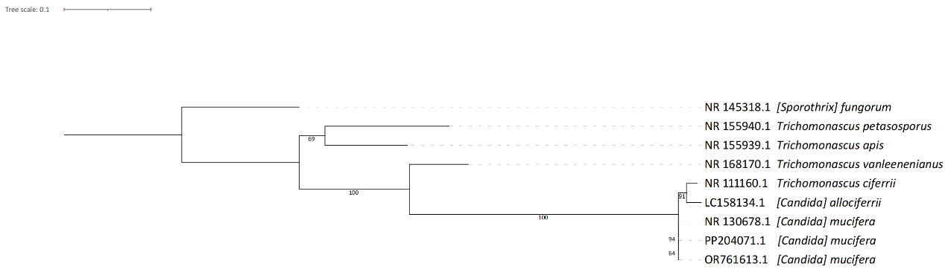
Supplementary Figure 2. The maximum likelihood tree for species within the Trichomonascus genus was constructed based on the internal transcribed spacer (ITS) region. ITS region sequences from different species were aligned using MAFFT v7.52 [1], and the phylogenetic tree was built using IQTREE v2.2.6 [2]. The best-fit model, TPM2u+F+I, was selected according to the Bayesian information criterion [3]. Branch supports were assessed through 1000 bootstrap resamplings [4]. No outgroups were added, and we employed midpoint rooting to obtain the final tree.

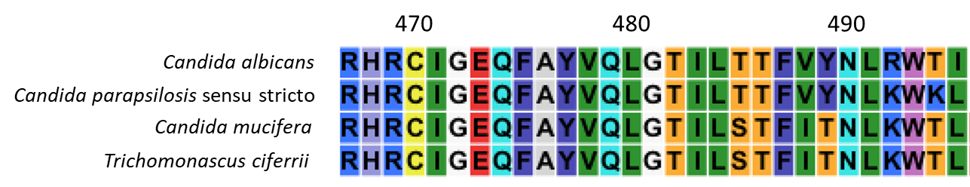
Supplementary Figure 3. The alignment results of the Erg11p region of Candida mucifera. To confirm the correspondence of isoleucine at position 488 in Erg11p of Candida albicans to the corresponding residue in C. mucifera Erg11p, we included Erg11p sequences from Candida parapsilosis sensu stricto and Trichomonascus ciferrii to aid in the alignment.

References
1. Katoh K, Rozewicki J, Yamada KD. MAFFT online service: multiple sequence alignment, interactive sequence choice and visualization. Brief Bioinform. 2019;20(4):1160-6.
2. Nguyen LT, Schmidt HA, von Haeseler A, Minh BQ. IQ-TREE: A Fast and Effective Stochastic Algorithm for Estimating Maximum-Likelihood Phylogenies. MOLECULAR BIOLOGY AND EVOLUTION. 2015;32(1):268-74.
3. Chernomor O, von Haeseler A, Minh BQ. Terrace Aware Data Structure for Phylogenomic Inference from Supermatrices. Syst Biol. 2016;65(6):997-1008.
4. Hoang DT, Chernomor O, von Haeseler A, Minh BQ, Vinh LS. UFBoot2: Improving the Ultrafast Bootstrap Approximation. Mol Biol Evol. 2018;35(2):518-22.

