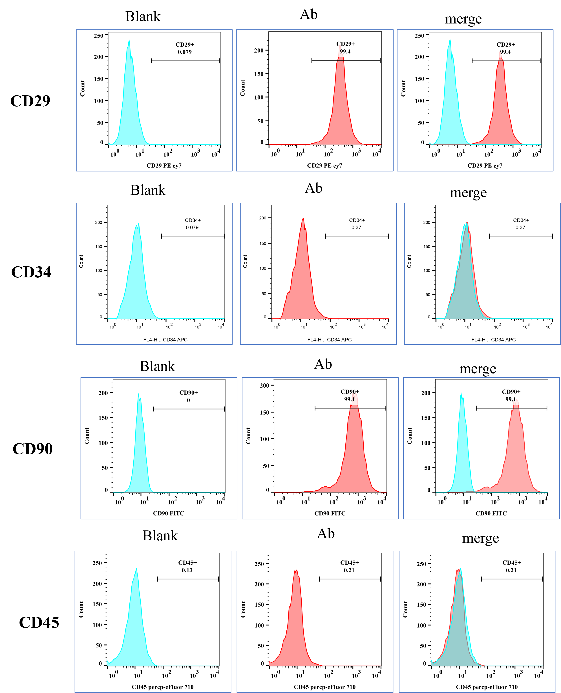
Fig.S1 Identification of BMSCs. The expression of BMSCs-related markers in isotype cells.

