Table 1. The visual aids and key points and principles of health literacy applied
Topics | Example slides | Key points and principles of health literacy applied
1. Introduction to research and trials | 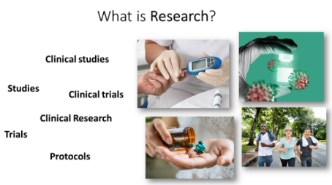 | ● Define ‘research’ and introduce similar terms   Explain the meaning of research, different types of research, behavioral research in clinical trials using simple, plain language   Use pictures and examples
2. Introduction to randomization | 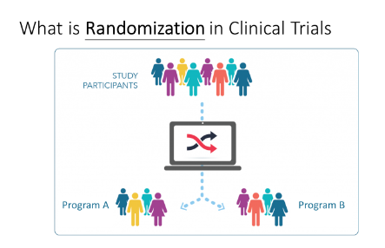 | ● Explain the rationale behind randomization   Visualize the process   Avoid academic and medical jargon
3. An overview of the program | 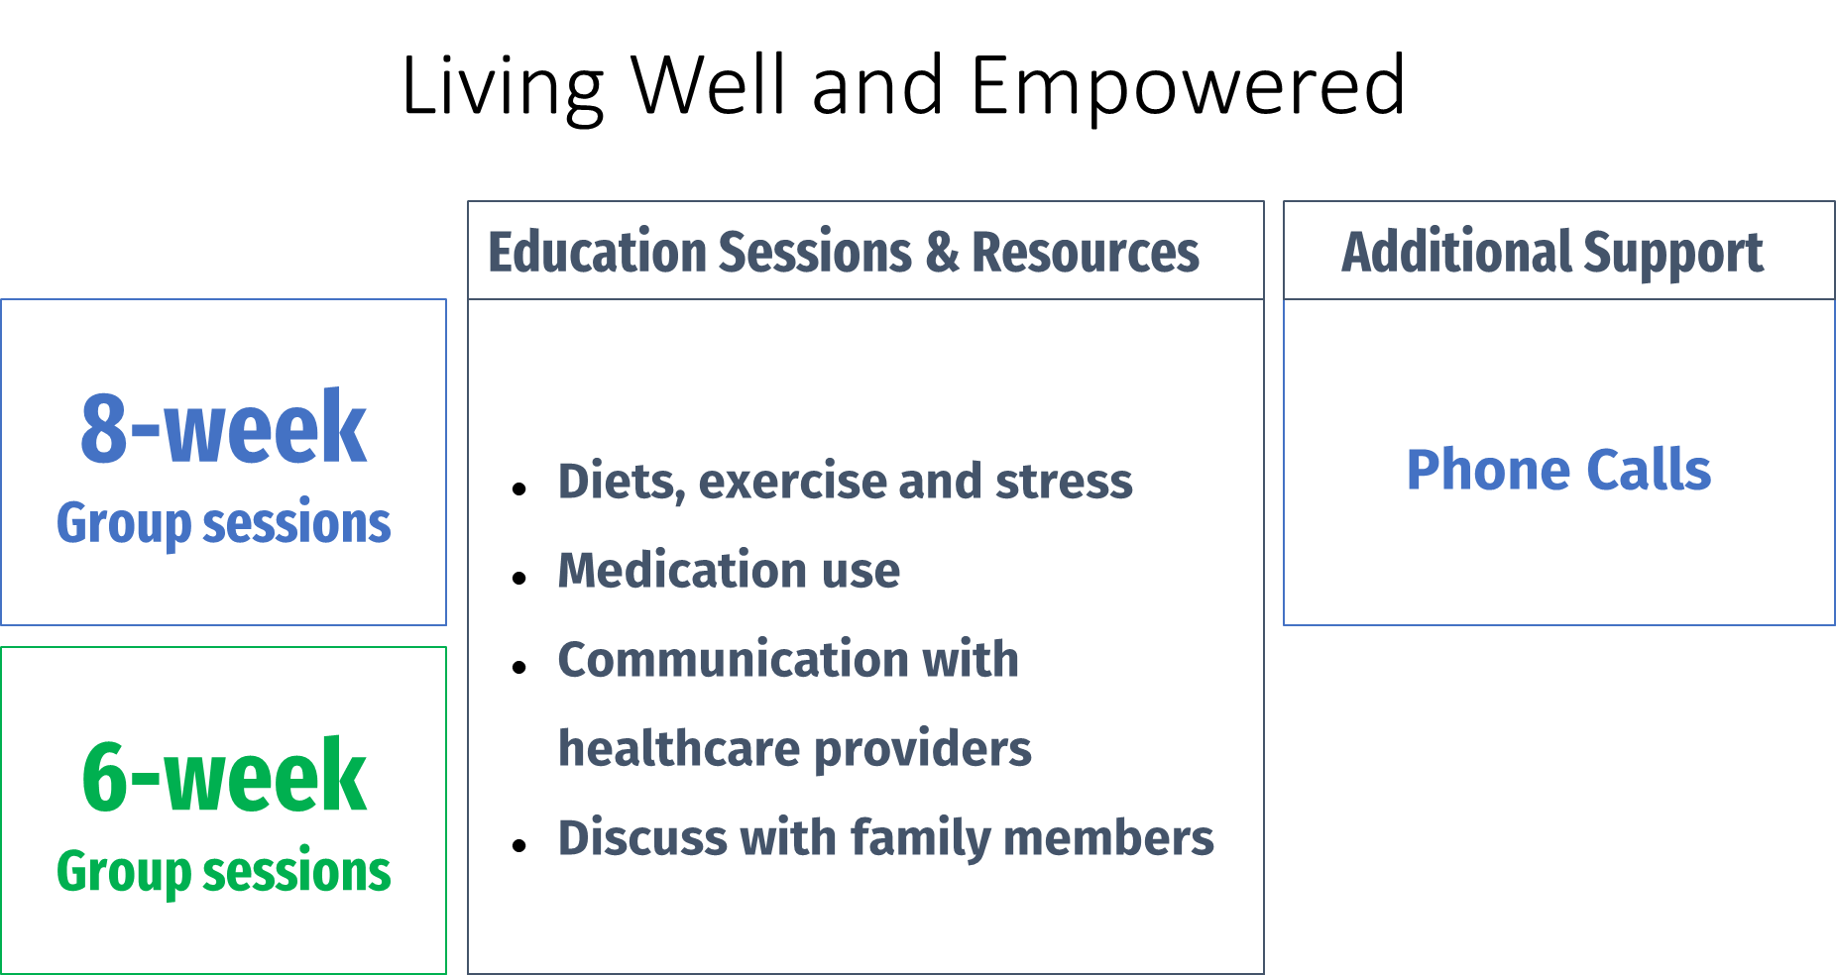 | ● Account for cultural considerations   Informative headings, and sections shaded with different colors to break up content.   Numbers in numeric form   Provide an overview of the two arms in the study   Neutrally explain the similarities and differences between trial arms
4. The study timeline and expectation | 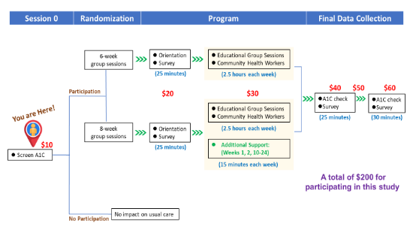 | ● Use a pictorial roadmap to visualize the study timeline, including study assessments, time involved, and payment/incentive schedule   Clear design by retaining the study timeline structure and adding a layer of information each time
5. Explanation of scientific rationale for completing assessments | 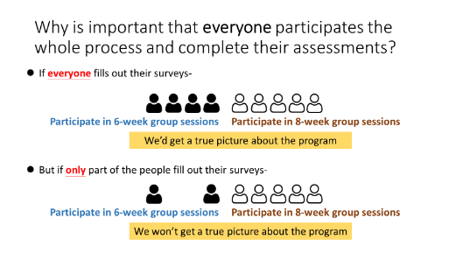 | ● Use an infographic to explain the scientific rationale for a “true” picture, provide transparency and value of their contribution   Use the trial arms as an example
6. Small group discussions to diffuse ambivalence | 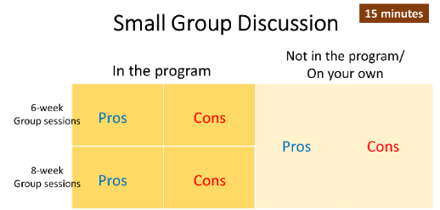 | ● Ask open-ended questions to encourage participant engagement   Visualize different scenarios of trial participation to avoid confusion   Interactive discussion to ensure understanding of the study information and create a safe space to express concerns

