Supporting information

Instrumentation
Powder X-ray diffraction (PXRD) spectra were obtained using a PAN analytical X-PRT PRO instrument with a CuKα radiation having λ=1.5406 Ǻ. The morphology of the photocatalysts was analyzed by Field-Emission Scanning Electron Microscopy (FE-SEM) using Model JSM6100 (Jeol) with Image Analyser instrument scanning (SEM, Hitachi S4800). Brunauer-Emmett-Teller (BET) specific surface area was obtained by nitrogen adsorption-desorption isotherm analysis using SMART Instruments, SMART SORB 93 model after degassing at 150 °C for 3 hours. Fourier transform infrared spectra (FT-IR) were recorded in the range 400–4000 cm⁻¹ (Agilent ATR model) to understand the bonding present in the coordination complex. The stability of the photocatalyts was determined by measuring the zeta potential using Malvern Zetasizer (Zetasizer Ver. 7.11). Absorbance of samples was measured with UV Spectrophotometer (Agilent Pro). Degradation products and metabolites were characterized using gas chromatograph interfaced with mass selective detector (Perkin Elmer-Clarus 500). GC was fitted with an Elite-5 capillary column (Crossbond 5% diphenyl and 95% dimethyl polysiloxane; 30 mL× 0.32 mm i.d.× 0.25 µm film thickness, Perkin Elmer™ instrument, Shelton, CT, USA). Helium was used as both the carrier (1 mL min⁻¹) and the make-up gas (40 mL min⁻¹). The injector in the splitless mode at 250 ⁰C was used. The transfer line temperature was set at 280 ⁰C and oven temperature was programmed from 60 ⁰C (2 min hold) to 300 ⁰C at the rate of 10 ⁰C min⁻¹ (5 min hold). The injected volume and scan time were 2 µL and 0.2 s, respectively. Chromatographic data was acquired by recording the full scan mass spectra in the range m/z 50–500. Mass spectra corresponding to identify chromatographic peaks were interpreted directly according to the fragments. Chromatographic data acquisition and processing were carried out with Turbo mass software.

Details of Langmuir, Freundlich, Temkin, Sip and D-R isotherms used in present study
Adsorption data through Langmuir adsorption isotherms were calculated through graph of Ce/Xe v/s Ce of the solute. Which were calculated by fitting the adsorption data into the equation:
$$\frac{C_{e}}{X_{e}}= \frac{1}{k_{L}X_{m}}+\frac{C_{e}}{X_{m}}$$
or
$$\frac{1}{X_{e}}=\frac{1}{C_{e}}\left(\frac{1}{k_{L}X_{m}}\right)+ \frac{1}{X_{m}}$$
X_{e}was calculated through the equation:
$$X_{e}= \frac{\left(Ci-Ce\right)×Volofsolution\left(mL\right)×Molecularweightofadsorbent}{Amountofcatalyst (mg)}$$
Fruendlich Isotherm.
A typical graph of Xe v/s Ce of the solute was a straight line.
$Xe= Kf+ Ce1/n$and linear form is $\log{Xe}=\log{Kf}+ \frac{1}{n}logCe$
Where C_{e} is the equilibrium concentration of the dye solution; X_{e} is the amount of dye adsorbed per gram weight of adsorbent; Kf is the Freundlich adsorption constant (mg/g); n is adsorption intensity.
Temkin Isotherm:
$$Xe=\frac{RT}{b}\ln{A}+ \frac{RT}{b}\ln{Ce}$$
Where B=RT/b constant related to heat of sorption (J/mol) obtained from the Temkin plot (qeVslnCe); A (slope) = Temkin isotherm equilibrium binding constant (L/g); b (intercept) = Temkin isotherm constant; R =universal gas constant (8.314 J∙mol−1∙K−1) T = Temperature at 298, 308 and 318 K.
As C_{e}values were very low, the lnC_{e}values were coming out to be negative.Therefore, Temkin isotherm (X_{e} v/s lnC_{e}) was not plotted for present study.

Dubinin-Radushkevich (D-R) isotherm:
$$\ln{Xe}=\ln{Xm-βε2}$$
$$ε=RTln⁡\left(1+\frac{1}{Ce}\right)$$
Where X_{m} is maximum adsorption capacity (mg/g) obtained from intercept; β (mol²/J²) is a activity coefficient constant related to sorption energy and obtained from slop;ε is Polanyi potential. D-R was plotted between lnXeVs ε²
Sips Isotherm
It is plotted between 1/Xe ×10⁻² (g/mg) and (1/Ce) ×10⁻⁸ L/mg; where (1/mg) and (mg/g) are the Sips equilibrium constant and maximum adsorption capacity values obtained from the slope and the intercept of the plot. The Sips isotherm equation is characterized by the dimensionless heterogeneity factor ‘n’ which can also be employed to describe the system’s heterogeneity when is between 0 and 1.

$$\frac{1}{X_{e}}=\frac{1}{XmKs}\left(\frac{1}{Ce}\right)1/n+ \frac{1}{X_{m}}$$
Equation used for calculation Band Gap Energy values
The band gap energy was determined by fitting the reflectance data into the direct transition equation
(αhʋ) ² =A(hʋ-Eg)
; where A is a constant, Eg is the energy gap, ʋ is the frequency of incident radiation, h is Planck’s constant, α is the optical absorption coefficient and exponent 2 is the number characterizing the direct transition process. Plotting (αhʋ)² as a function of photon energy as shown in figure 3S, upon extrapolating the linear portion of the curve to absorption equal to zero gives the value of the band gap energy

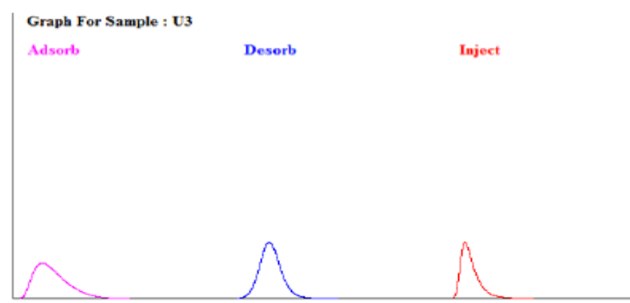
35.68 m²g⁻¹

a)
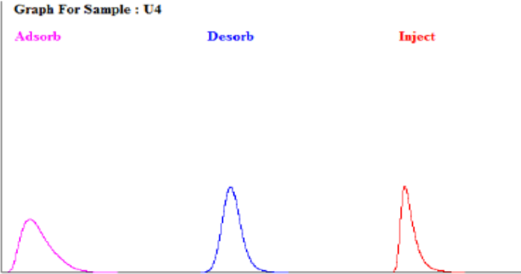
30.63 m²g⁻¹

b)
12.25 m²g⁻¹

c)
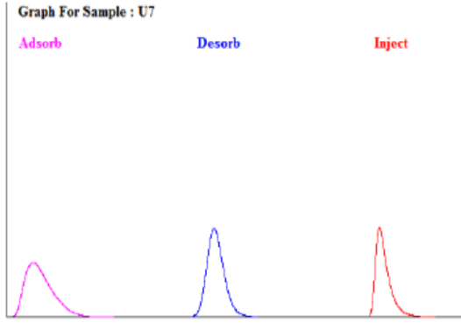
Figure 1S. BET of (a) CuFe₂O₄ (b) CuMn₂O₄ (c) MnZn₂O₄ nanocomposites

b)
a)
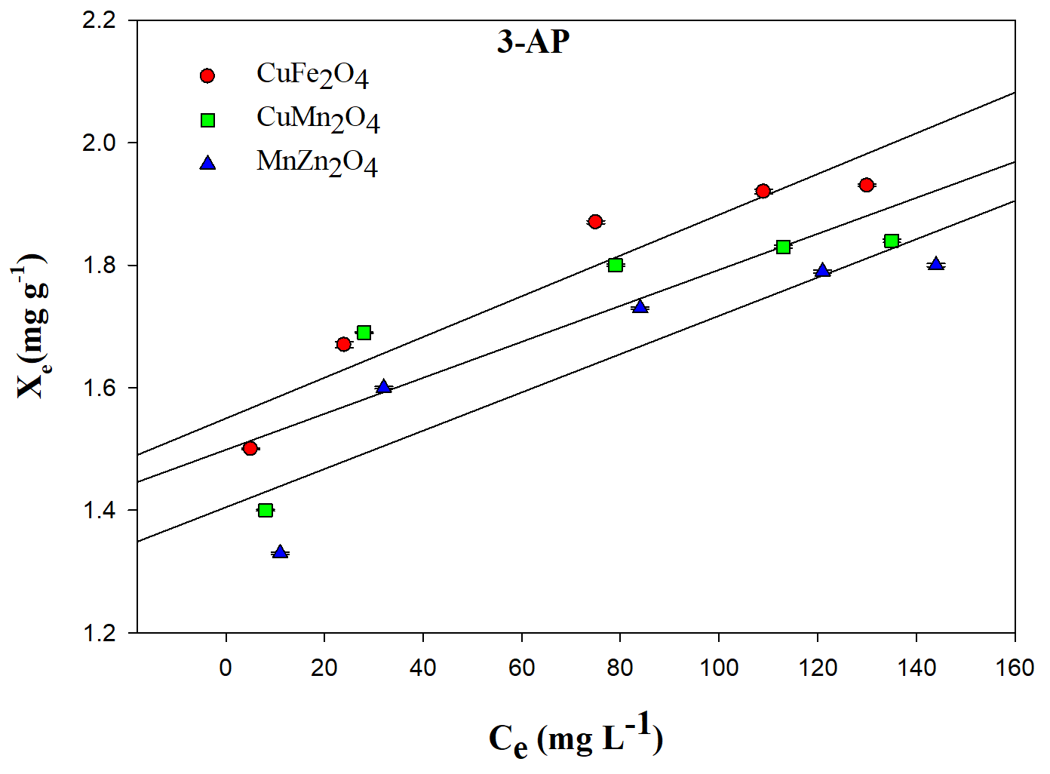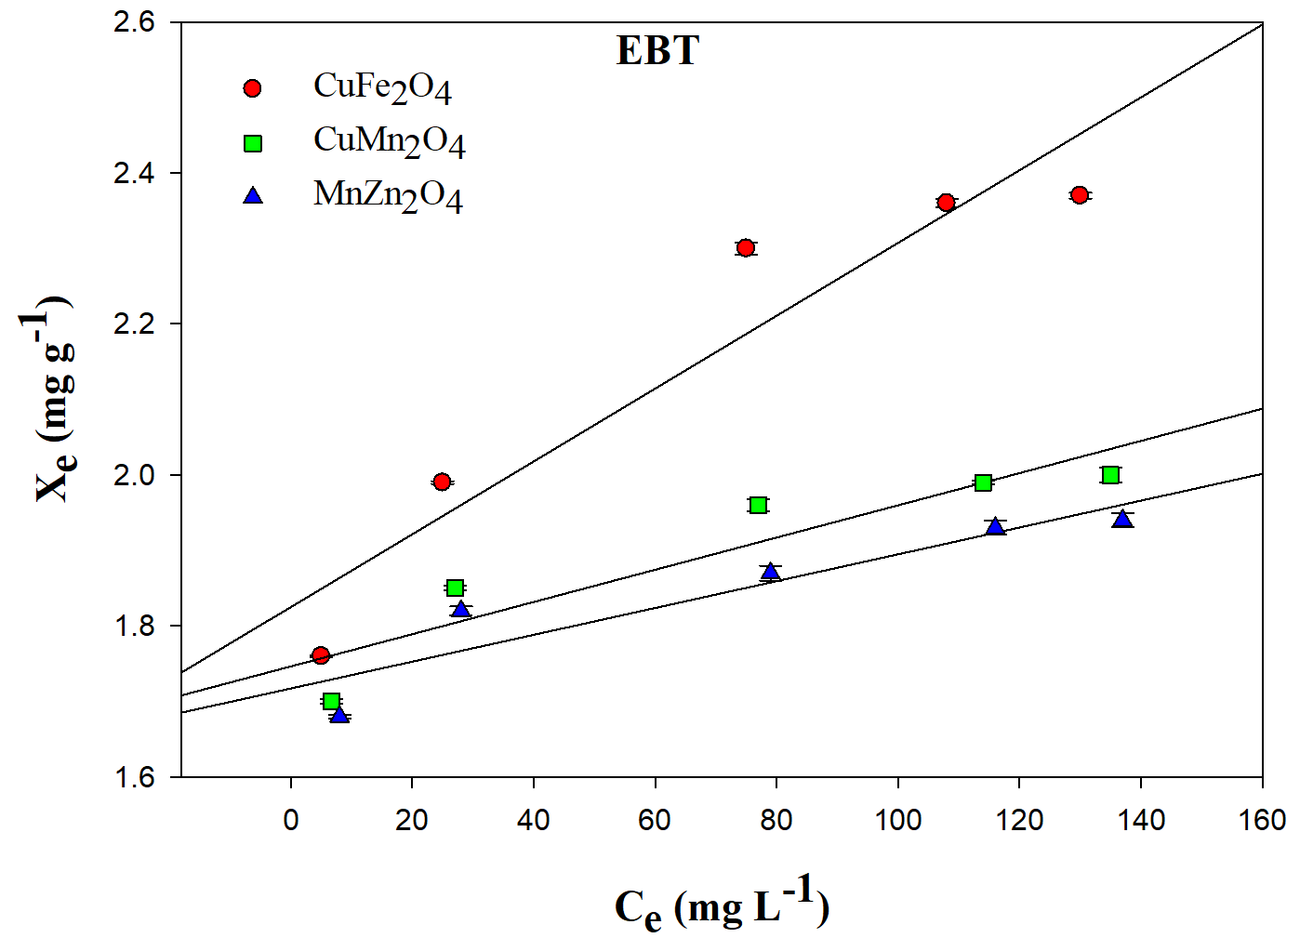
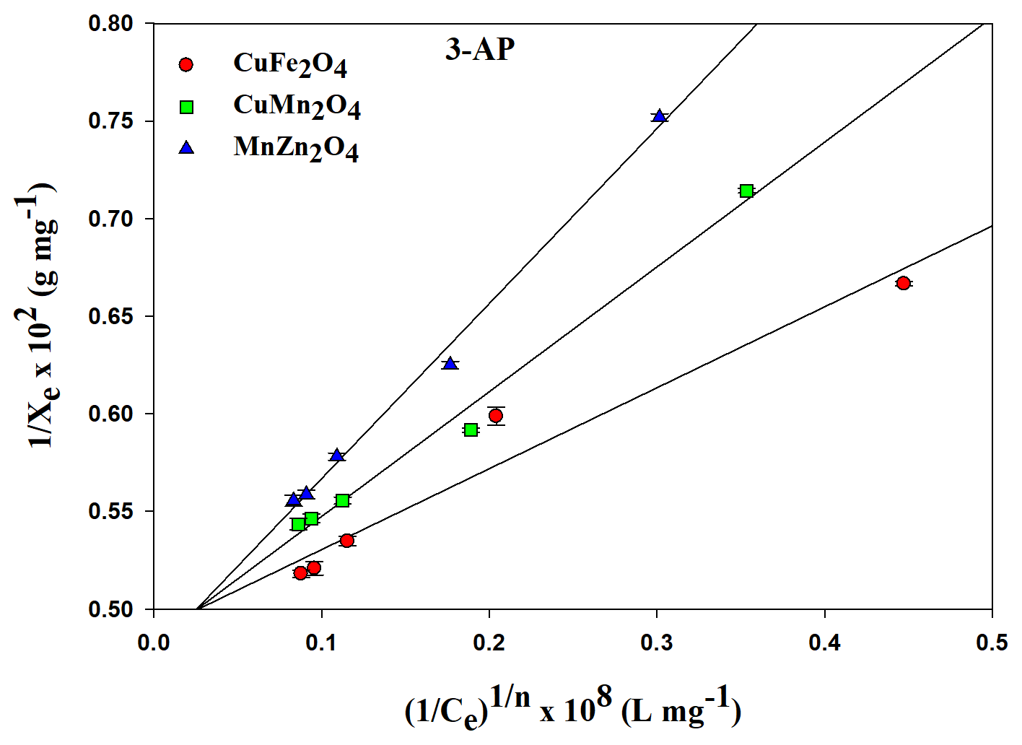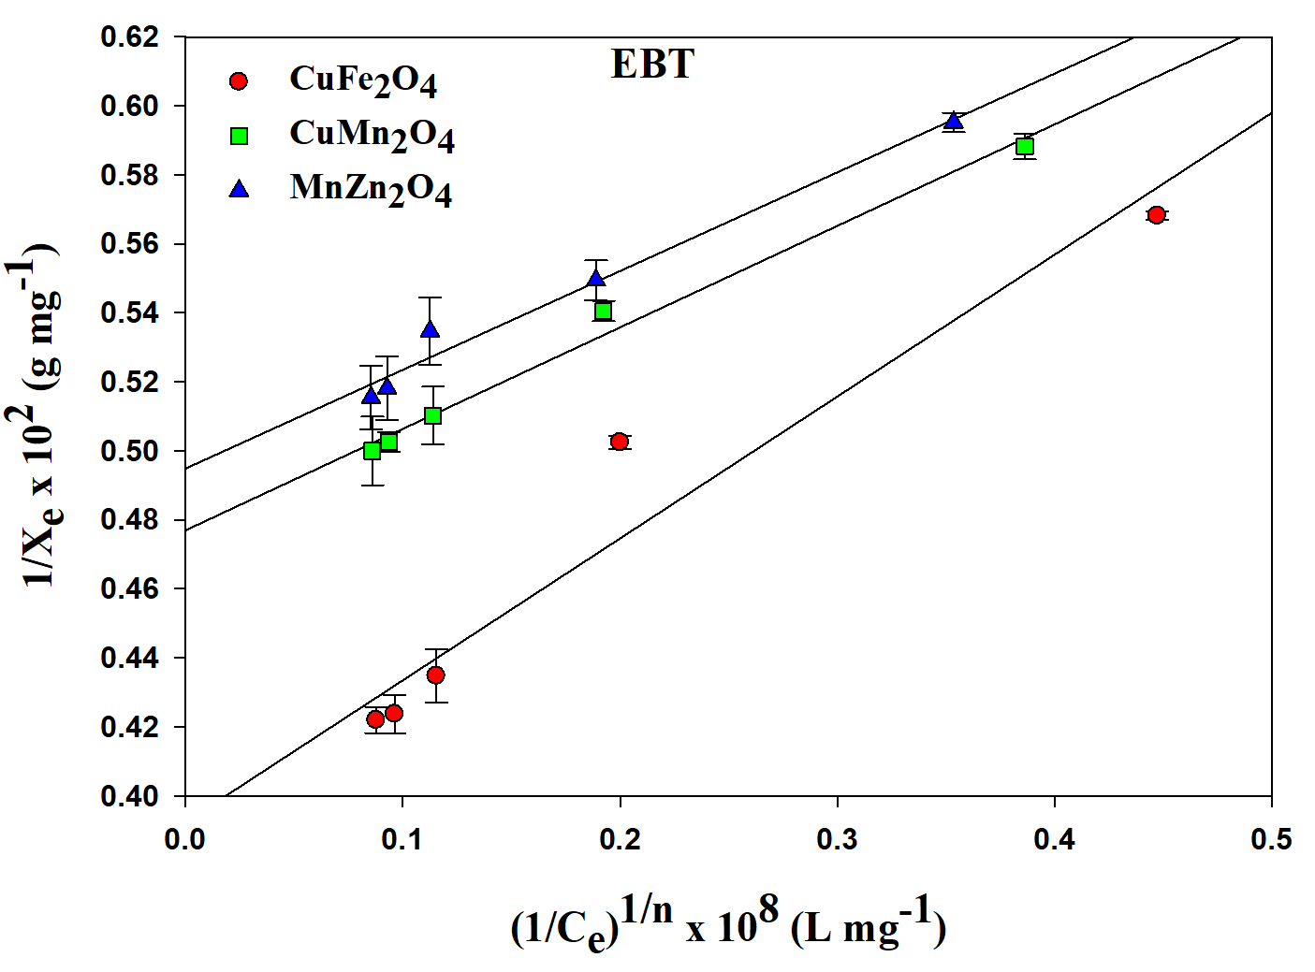
c)
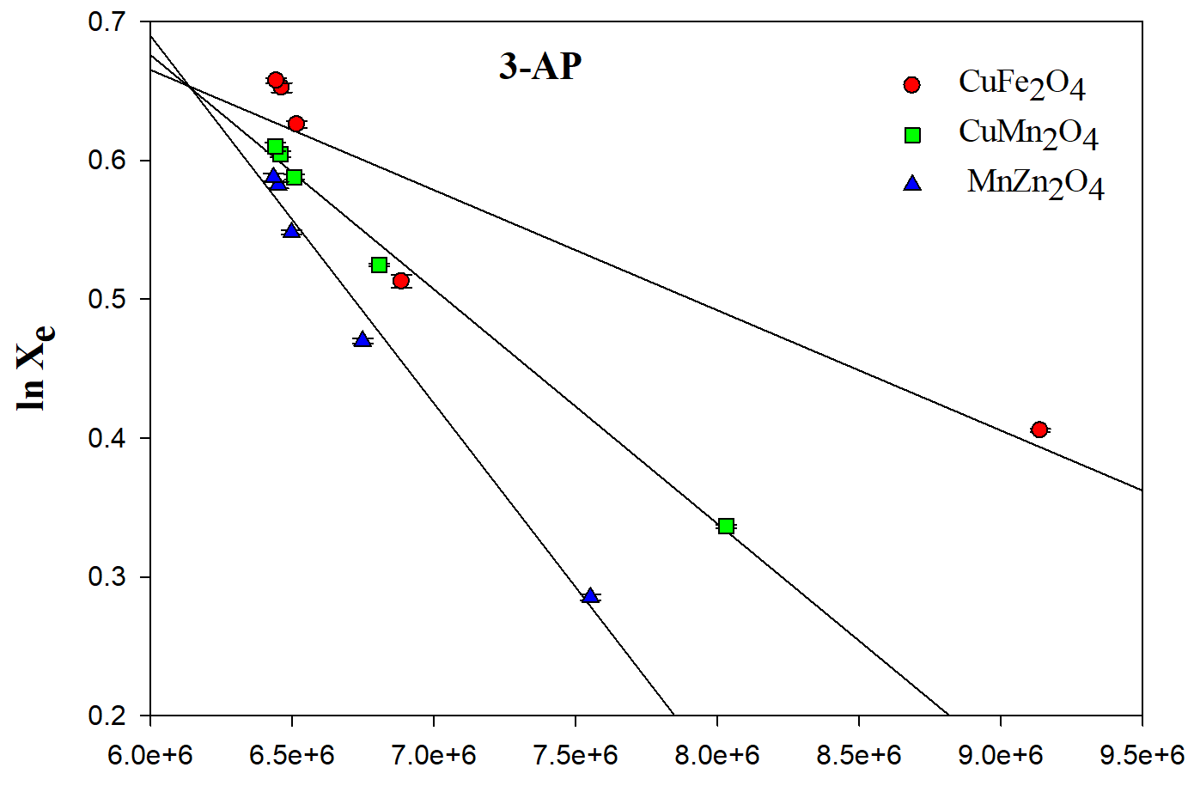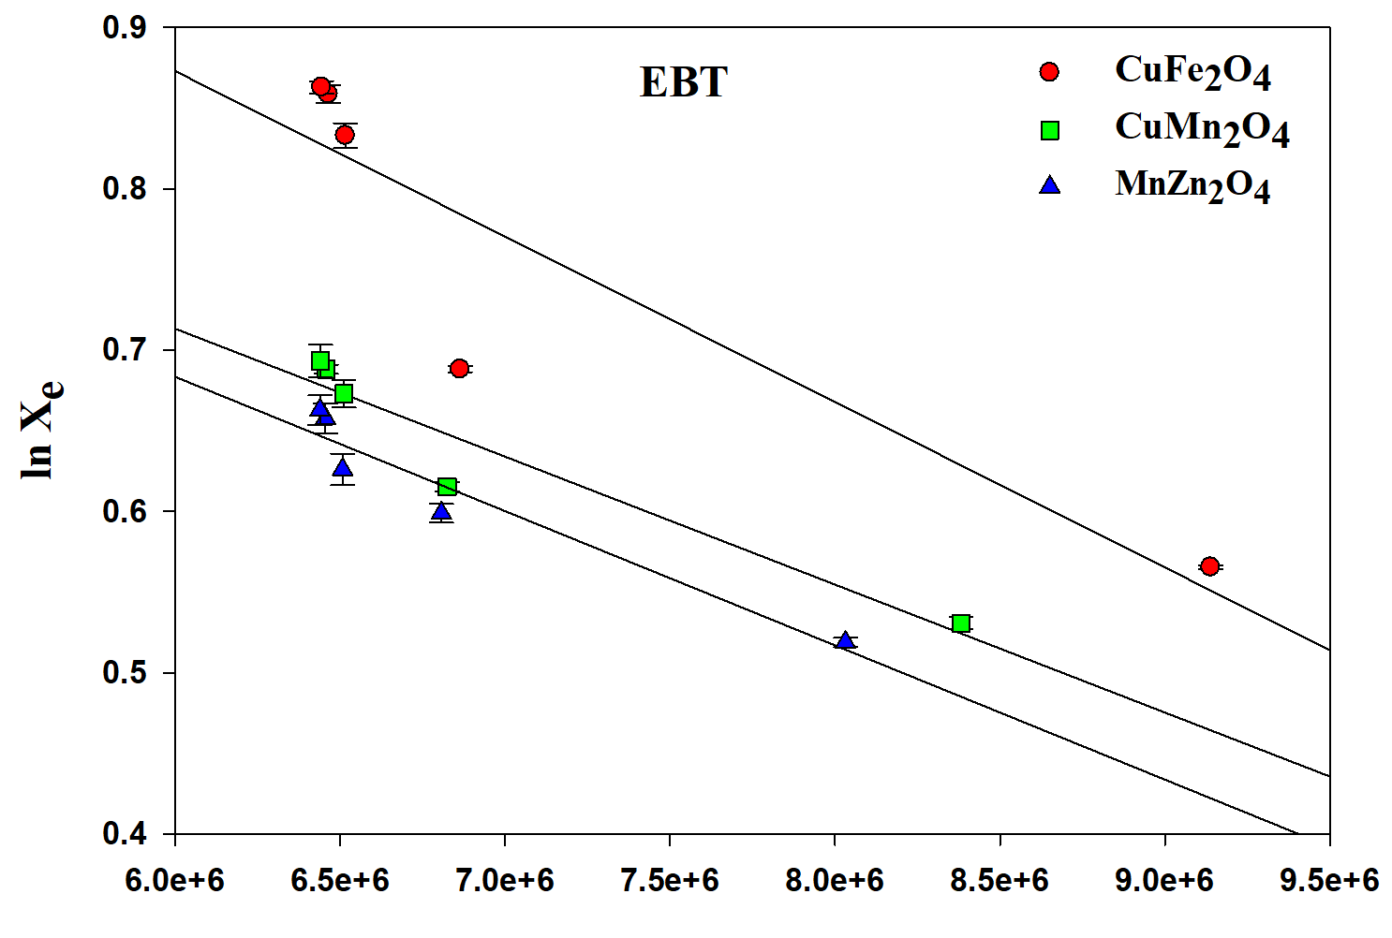
Figure 2S. (a) Freundlich, (b) Sips isotherms and (c) DRK for EBT and 3-AP adsorption. Note: Triplicate experiments (n=3) were evaluated for estimation of error bar.

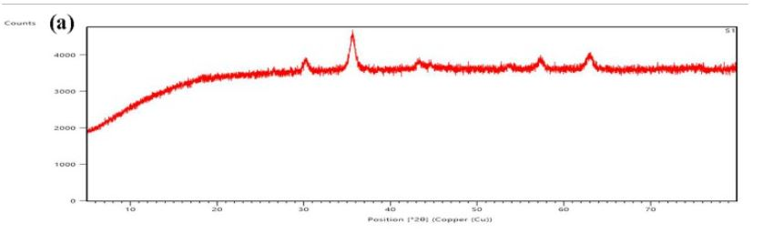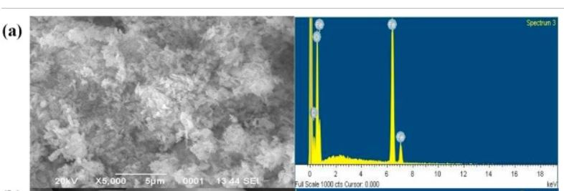
b)
a)
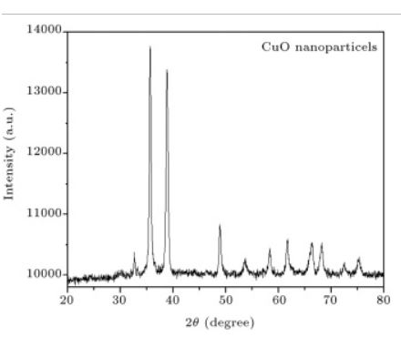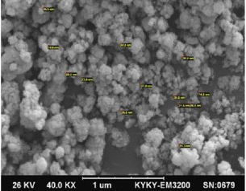
c)
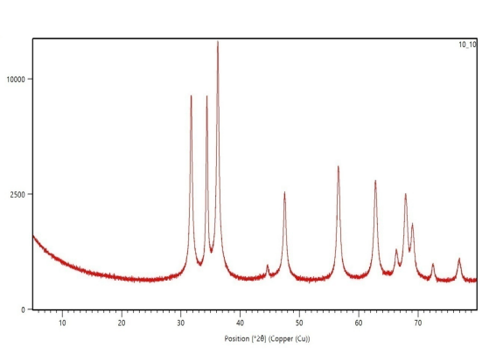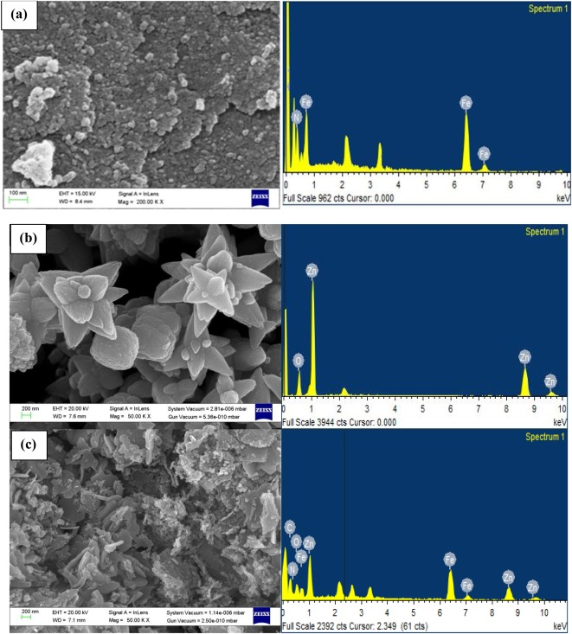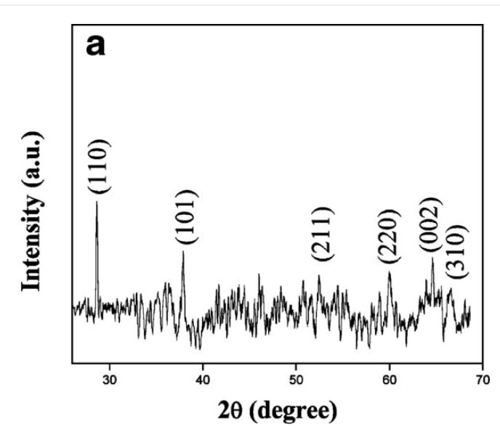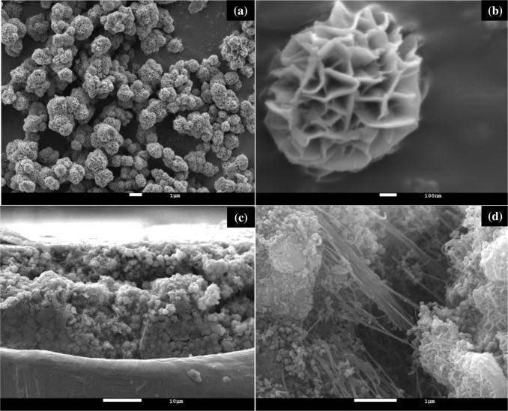
d)
Figure 3S. PXRD and FE-SEM of (a) Fe₂O₃ (b) CuO (c) ZnO (d) MnO₂

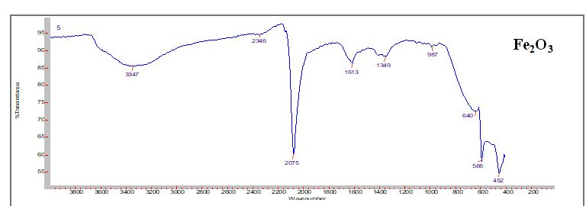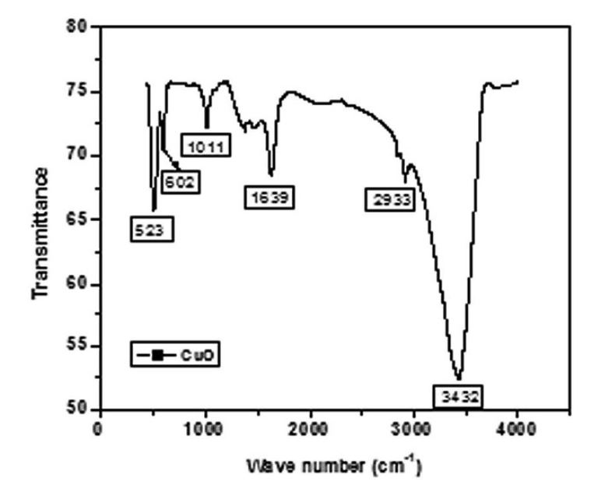
(a) a)

(b)
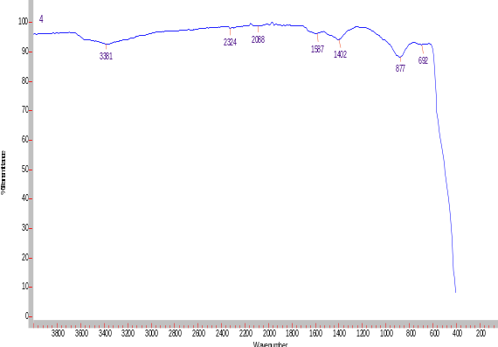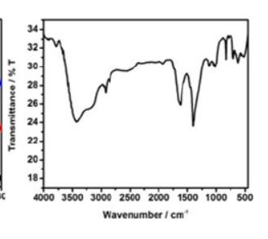
(d)
(c)
Figure 4S FT-IR spectra of (a) Fe₂O₃ (b) CuO (c) ZnO (d) MnO₂ nanoparticle

Table 1S. Comparison of different isotherms on the basis of R² and p values for EBT and 3-AP adsorption
Langmuir  3-AP EBT |  |  |  |  | Sips  3-AP EBT
Catalyst  CuFe₂O₄  CuMn₂O₄  MnZn₂O₄ | R²  0.95  0.98  0.99 | p  0.021  0.030  0.030 | R²  0.92  0.95  0.97 | p  0.022  0.025  0.012 | R²  0.86  0.81  0.83 | p  0.004  0.005  0.002 | R²  0.86  0.85  0.88 | p  0.006  0.005  0.001
DRK  3-AP EBT |  |  |  |  | Freundlich  3-AP EBT
Catalyst  CuFe₂O₄  CuMn₂O₄  MnZn₂O₄ | R²  0.78  0.99  0.98 | p  0.021  0.002  0.007 | R²  0.82  0.92  0.93 | p  0.032  0.003  0.002 | R²  0.86  0.74  0.81 | p  0.013  0.059  0.035 | R²  0.89  0.85  0.86 | p  0.014  0.025  0.024

