The PDF file includes
Supplementary Methods 2
Supplementary Fig. 1 | Electrophoresis image of IONPs and IO@LNPs 8
Supplementary Fig. 2 | Stability of IONPs and IO@LNPs 9
Supplementary Fig. 3 | MRI phantom test of empty LNPs 10
Supplementary Fig. 4 | R₂ map of IO@LNPs with different IONP concentration 11
Supplementary Fig. 5 | Size distribution of IO@LNP/DiD 12
Supplementary Fig. 6 | CLSM images of intracellular IO@LNPs 13
Supplementary Fig. 7 | Organ distribution of IO@LNPs 14
Supplementary Fig. 8 | The relative image intensity of MR contrast effect by IO@LNP derived from in vivo T2-weighted MR images. 15
Supplementary Fig. 9 | A Bio-TEM image for a PBS-treated sample. 16
Supplementary Table 1 | MRI sequence parameters on Fig. 2a,b 17
Supplementary Table 2 | MRI sequence parameters on Fig. 2c,d 18
Supplementary Table 3 | MRI sequence parameters on Supplementary Fig. 4 19
Supplementary Table 4 | MRI sequence parameters on Fig. 3b-e 20
Supplementary Reference 21

Supplementary Methods

Chemicals
Anhydrous ethanol (C₂H₆O), anhydrous sodium acetate (CH₃COONa), acetic acid (CH₃COOH), ferric chloride hexahydrate (FeCl₃∙6H₂O), trisodium citrate dihydrate (Na₃Cit∙2H₂O), diethylene glycol (DEG), 1,2-distearoyl-sn-glycero-3-phosphocholine (DSPC), 1,2-di-O-octadecenyl-3-trimethylammonium propane (DOTMA), cholesterol, 1,1'-dioctadecyl-3,3,3',3'-tetramethylindodicarbocyanine 4-chlorobenzenesulfonate salt (DiD), Triton X-100, Hoechst 33342 solution and low melting agarose were purchased from Sigma-Aldrich (Missouri, USA). 1,2-distearoyl-sn-glycero-3-phosphoethanolamine-N-[methoxy(polyethylene glycol)-5000] (mPEG-DSPE) was purchased from Creative PEGWorks (North Carolina, USA). 1,1′-dioctadecyl-3,3,3′,3′-tetramethylindotricarbocyanine iodide (DiR) was purchased from MedChemExpress (New Jersey, USA). 20X phosphate buffered saline (PBS) solution was purchased from BYLABS (California, USA). 10X Tris-borate-EDTA (TBE) buffer was purchased from Thermo Fisher Scientific (Massachusetts, USA). Roswell Park Memorial Institute (RPMI) 1640 medium was purchased from WELGENE (Gyeongsan, Korea). Dulbecco’s phosphate buffered saline (DPBS) and fetal bovine serum characterized was purchased from Cytiva (Utah, USA). Antibiotics-Antimycotics (100X) and 0.5% Trypsin-EDTA (10X) was purchased from Gibco (New York, USA). 4% paraformaldehyde (PFA) were purchased from Biosesang (Seongnam, South Korea).
Reagents (sodium cacodylate buffer, glutaraldehyde, uranyl acetate and Spurr's Resin) for Karnovsky’s Fixative of Bio-TEM samples were provided from National Instrumentation Center for Environmental Management (NICEM).

Physicochemical characterization of IONPs and IO@LNPs
The Fourier transform infrared (FTIR) spectrum of IONPs was obtained from the Platinum attenuated total reflection FTIR (ATR-FTIR) spectrometer (Bruker, Germany). A vibrating sample magnetometer (VSM) test was performed to identify a superparamagnetic property of IONPs using VSM-7410 (Lake shore, USA). The size of IONPs was verified using LIBRA 120 Energy-Filtering transmission electron microscope (EF-TEM) (Carl Zeiss, Germany). The TEM imaging of empty LNPs and IO@LNPs was performed using Talos L120S cryo-EM (FEI, Czech) to visually confirm that IONPs were loaded in IO@LNPs. In addition, size distribution, a polydispersity index (PDI) and the zeta potentials of nanoparticles (IONPs, IO@LNPs and Empty LNPs) were measured on Zetasizer Nano ZS (Malvern, UK).

Stability test of IONPs and IO@LNPs
To indirectly assess the stability of the particles, IONPs and IO@LNPs were incubated with various solvents (deionized water, PBS and RPMI medium) at room temperature, and the hydrodynamic size based on dynamic light scattering (DLS) was monitored over a period (0 hr to 1 week) by Zetasizer Nano ZS.

Gel electrophoresis of IONPs and IO@LNPs
Electrophoresis device (Allsheng, China) was used to further confirm surface charge and encapsulation of IONPs into LNPs based on the result of zeta potential. The samples containing IONPs (8 ug in each well) were loaded in 1% agarose gel. Then, an electrophoresis was performed with 1X TBE buffer at 100 V and the gel image was obtained.

Cell culture and confocal imaging
4T1 cells were maintained at 37 °C in a humidified 5% CO₂ incubator in Roswell Park Memorial Institute (RPMI) medium containing 10% FBS and 1% antibiotics-antimycotics. The cells were seeded in confocal dish (SPL Life Sciences, Korea) at a seeding density of 7 x 10⁴ cells per dish using EVE automatic cell counter (NanoEnTek, Korea) and incubated overnight. IO@LNP/DiD was treated on the dish, and the cells were incubated for different time (0, 20, 40, 60 and 80 min) at 37 °C. Hoechst 33342 fluorescent dye (0.5 μl per dish) was used for staining nuclei. The cells were washed with DPBS to remove the remaining IO@LNPs that were not absorbed by the cells and observed under a A1R confocal laser scanning microscope system (Nikon instruments, Japan).

Measurement of intracellular uptake efficiency for in-vitro MRI
In in-vitro MRI experiments, intracellular fluorescence intensities of DiD fluorescence from IO@LNP/DiD were measured by a Synergy H1 microplate reader (BioTek, USA). The fluorescence intensity of the supernatant media collected in each media-changing step was divided by the initial fluorescence intensity of media containing IO@LNP/DiD. The uptake efficiency was calculated as follows:
$$Uptake Efficiency \left(\%\right)= 1- \frac{{FLU}_{supernatant}}{{FLU}_{particle} }$$

Interpretation of MR signal
Determination of R₁ and R₂ values and acquisition of parametric images were performed with pMRI software (www.parametricmri.com, USA). In the inversion recovery spin echo (IRSE) sequence, longitudinal magnetization intensity $I_{z}$ was determined as follow¹:
$$I_{z}=M_{z}^{0}\left[1-2\exp\left\{-\frac{TI}{T_{1}}\right\}+\exp\left\{-\frac{TR}{T_{1}}\right\}\right] \\ R_{1}=R_{1,0}+r_{1}C=\frac{1}{T_{1}}$$
in which $R_{1}$ is T₁ relaxation rate (s⁻¹), $R_{1,0}$ is T₁ relaxation rate (s⁻¹) in the absence of IONPs, $r_{1}$ is T₁ relaxation rate per IONP concentration (s⁻¹ [mg/ml]⁻¹), $C$ is the concentration (mg/ml), $TI$ is inversion time (s), and $TR$ is repetition time (s). In inversion recovery fast low angle shot (IR FLASH), R₁ can be illustrated in a similar way to IRSE, but the flip angle was additionally considered, which was eight degrees in this study.
In multi-echo spin-echo sequence (MEMS), transverse magnetization intensity $I_{xy}$ was determined as follow:
$$I_{xy}=M_{xy}^{0}\exp\left\{-\frac{TE}{T2}\right\} \\ R_{2}=R_{2,0}+r_{2}C=\frac{1}{T_{2}}$$
in which R₂ is T₂ relaxation rate (s⁻¹), R_{2,0} is T₂ relaxation rate (s⁻¹) in the absence of IONPs, $r_{2}$ is T₂ relaxation rate per IONP concentration (s⁻¹ [mg/ml]⁻¹), C is IONP concentration (mg/ml), TE is echo time (s). In addition, the α value is defined with the following:
$$α=\frac{r_{2}}{r_{1}}.$$
It is well known that as the size of magnetic materials grows, their magnetic moment also increases². This can be measured by a bigger R₂ value which increases proportionally to the squared magnetic moment as follows:
$$R_{2}=\frac{α}{d_{NP}D}γ^{2}μ^{2}C_{NP}J\left(ω, τ_{D}\right)$$
where d_{NP} is the diameter of nanoparticles, D is the diffusion coefficient, μ is the magnetic moment of nanoparticles, γ is the gyromagnetic ratio of water proton, C_{NP} is the concentration of nanoparticles, and J(ω, τ_{D}) is spectral density function. It is a supporting theory to explain that clustered magnetic particles show higher R₂ values and monodispersed particles show smaller R₂ values, even if the total iron concentration is the same³.
When the proportion of loaded IONPs among total IONPs is defined as $θ$, the efficiency of the endosomal escape ∂θ / ∂t can be calculated with the following chain rule:
$$\frac{dr_{2}}{dt}=\frac{∂r_{2}}{∂θ} × \frac{∂θ}{∂t}.$$
In this study, it was found that the r₂ value of loaded IONPs did not much depend on the IONP-to-lipid ratio (w/w). This implies:
$$\frac{∂^{2}r_{2}}{∂θ^{2}}=0 ⇔ \frac{∂r_{2}}{∂θ}=r_{2, loaded}-r_{2, free}$$
where $r_{2}$ is the T₂ relaxation rate per IONP concentration and $θ$ is the proportion of loaded IONPs among total IONPs.
Theoretically, decomposition and/or exocytosis ratio (η) as well as endosomal escape efficiency can be estimated, using ultrasmall IONPs which can be used as T₁ and T₂ dual-mode contrast agents.
$$r_{1}\left(t\right)=θr_{1, loaded}+\left(1-η\right)\left(1- θ\right)r_{1, free}\begin{matrix} \\ \\ \end{matrix} \\ r_{2}\left(t\right)= θr_{2, loaded}+\left(1-η\right)\left(1- θ\right)r_{2, free}\begin{matrix} \\ \\ \end{matrix} \\ ∴ \left(\begin{matrix}\frac{dr_{1}\left(t\right)}{dt} \\ \frac{dr_{2}\left(t\right)}{dt}\end{matrix}\right)= \left(\begin{matrix}r_{1, loaded} & r_{1, free} \\ r_{2, loaded} & r_{2, free}\end{matrix}\right)\left(\begin{matrix}\frac{dθ}{dt} \\ -\left(1-η\right)\frac{dθ}{dt}\end{matrix}\right)$$

The calculation of endosomal escape efficiency
The endosomal escape efficiency 𝜕θ/𝜕t was calculated with the following calculations:

$$\frac{∂θ}{∂t}= \frac{1}{C\left(r_{2, loaded}-r_{2, free}\right)}\frac{dR_{2}}{dt}=0.93 \%/{min}$$

$${\left.\frac{∂θ}{∂t}\right|}_{early}= \frac{1}{C\left(r_{2, loaded}-r_{2, free}\right)}{\left.\frac{dR_{2}}{dt}\right|}_{40-80 min}=1.98 \%/{min}$$

where $θ$ is the proportion of loaded IONPs among total IONPs, ${dR_{2}}/{dt}$ is 0.17 s⁻¹/min, ${\left.{dR_{2}}/{dt}\right|}_{early}$ is 0.37 s⁻¹/min, $r_{2, loaded}$ (the r₂ value for IO@LNP) is 5.69 s⁻¹[mg/ml]⁻¹, $r_{2, free}$ (the r₂ value for dispersed IONP that were not loaded in LNP) is 2.70 s⁻¹[mg/ml]⁻¹, and $C$ is average IONP concentration in cells, which is 6.27 mg/ml. The reason why we calculated the early endosomal escape efficiency focusing on the range of 40–80 min is that we supposed different phases were involved in the range of 80–120 min, which was further illustrated in the Discussion.

In-vivo MRI
BALB/c mouse was injected intramuscularly with IO@LNPs through its right hindlimb (1.90 mg IONP / kg mouse). Then, T2-weighted images were acquired by 7.0 T MRI scanner longitudinally with the following time points: pre-injection and post-injection (0, 1, 2, 3 h). Also, the MR sequence for T2-weighted images was FSE26 (batch size: 0; echo spacing: 15; gating mode: 2; averages: 4; no discards: 0; samples: 256; 3D slab thk: 80%; TE: 45 ms; TR: 3000 ms; PE order: 0; echo train: 7; fat saturation: Yes; gate after TR: No; navigator: Yes; post ETL crusher: No). The images were quantitatively evaluated against the neighboring tissue where the MR contrast effect was not observed.
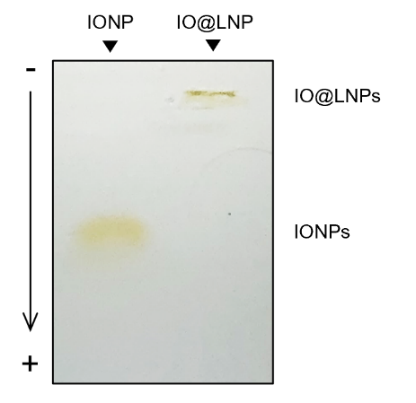

Supplementary Fig. 1 | Electrophoresis image of IONPs and IO@LNPs. The electrophoretic mobility of IO@LNPs in comparison to that of IONPs has shown that the negatively charged IONPs were encapsulated into positively charged LNPs in the mixture of IONPs and empty LNPs.

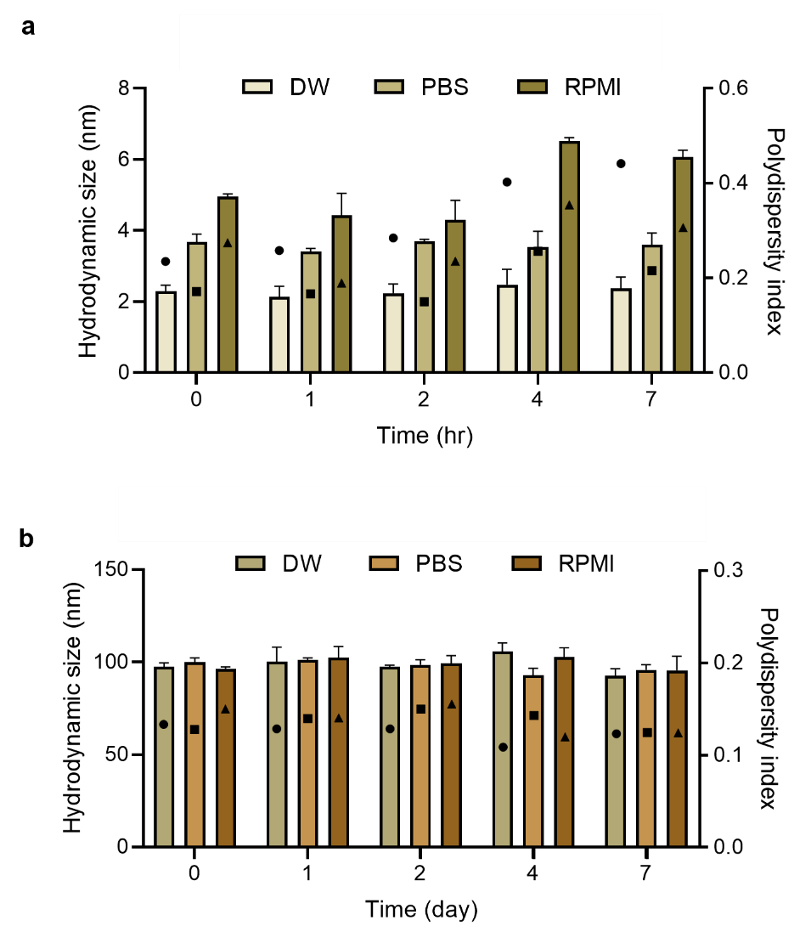

Supplementary Fig. 2 | Stability of IONPs and IO@LNPs. a,b, IONP (a) and IO@LNP (b) stability of based on size (diameter) distribution and PDI in various solvents (DW, PBS, and RPMI growth medium) according to time measured by DLS. RPMI 1640 growth medium contained 10% FBS and 1% antibiotics-antimycotics. Error bars were represented as the mean ± standard error of the mean (SEM).

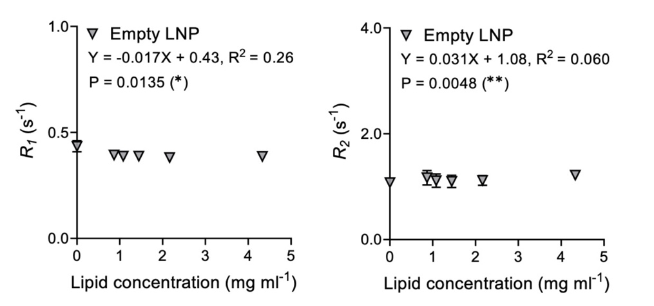

Supplementary Fig. 3 | MRI phantom test of empty LNPs. The lipids that constitute the LNPs exhibited marginal signal in r₁ and r₂. All the samples were dissolved in saline. ∗, P<0.05; ∗∗, P<0.01; ∗∗∗, P<0.001 (F-test among all the groups)

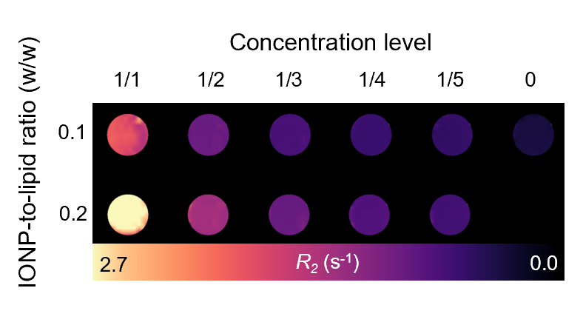

Supplementary Fig. 4 | R₂ map of IO@LNPs with different IONP concentration. R₂ map image of IO@LNPs according to the IONP-to-lipid ratio (0.1 and 0.2 w/w). The samples were prepared by serial dilution from 1/1 (0.22 mg IONP and 2.2 mg lipid per ml for 0.1 w/w; 0.43 mg IONP and 2.2 mg lipid per ml for 0.2 w/w) to 1/5. All the samples were dissolved in saline. Saline samples were marked as 0. Interestingly, the R₂ per IONP concentration (r₂) was not significantly dependent on the ratio of IONP-to-lipid.

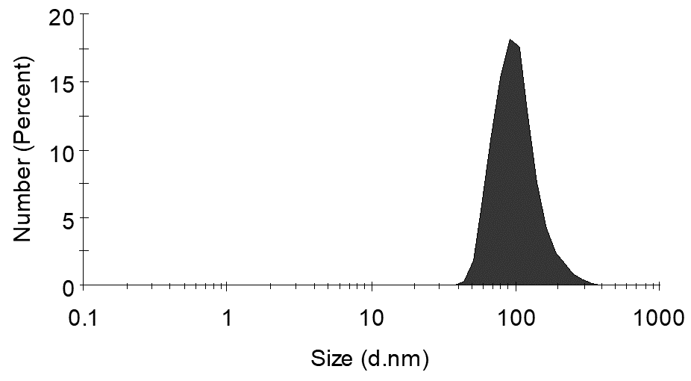

Supplementary Fig. 5 | Size distribution of IO@LNP/DiD. To evaluate the intracellular uptake of IO@LNPs, they were labeled with lipophilic fluorescence (DiD) dyes (See Methods). IO@LNP/DiD has the hydrodynamic size of 105.2 ± 41.21 nm and PDI of 0.155.

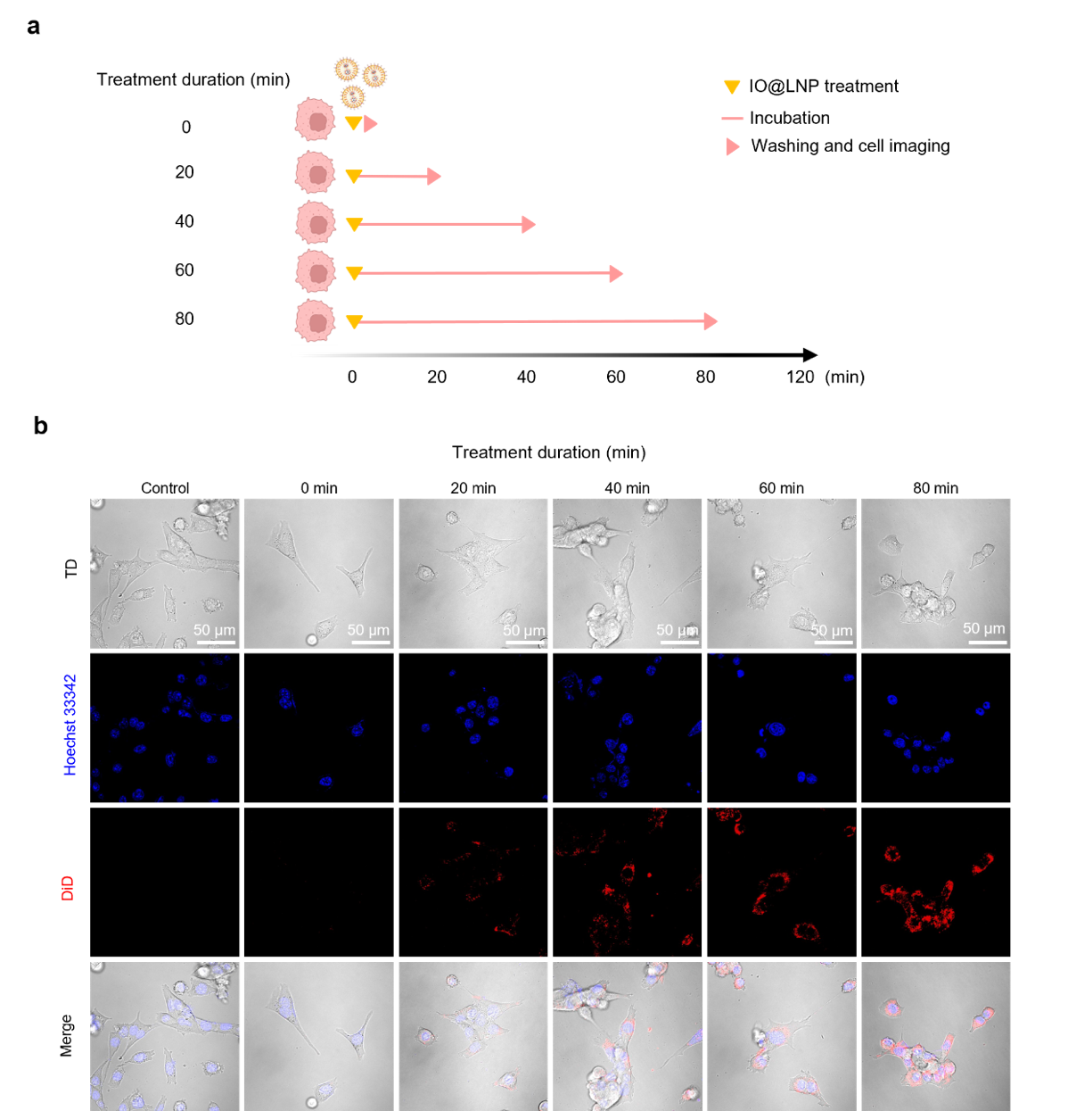

Supplementary Fig. 6 | CLSM images of intracellular IO@LNPs. a, Experimental schedule to determine the timing for observable endosomal escape of IO@LNPs. Cells were incubated with IO@LNP/DiD (yellow), washed after different incubation durations (pink) and then imaged with a confocal laser scanning microscopy (CLSM). b, Fluorescent images showing intracellular uptake of IO@LNPs. Nuclei were stained with Hoechst 33342 (blue) and the intracellular localization of LNPs were demonstrated by DiD (red). The images showed the gradual internalization of IO@LNPs inside the cytoplasm. From 40 min after the start of incubation, LNPs were distributed in the cytoplasm, which implies that endosomal escape is in progress.

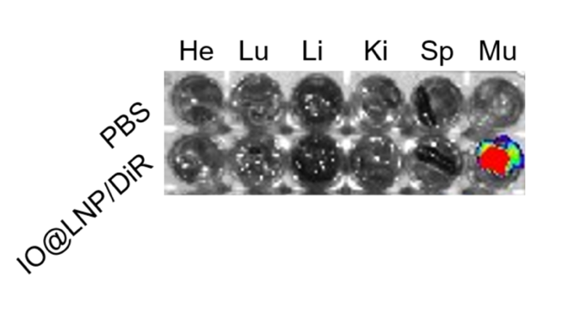

Supplementary Fig. 7 | Organ distribution of IO@LNPs. BALB/c mice (n ≥ 3) injected with IO@LNP/DiR were sacrificed, and their heart (He), lung (Lu), liver (Li), kidney (Ki), spleen (Sp) and muscle (Mu) were imaged using In Vivo Imaging System (IVIS) Spectrum. Excluding the muscles, the other organs showed no fluorescent signals, like those of PBS-injected mice.

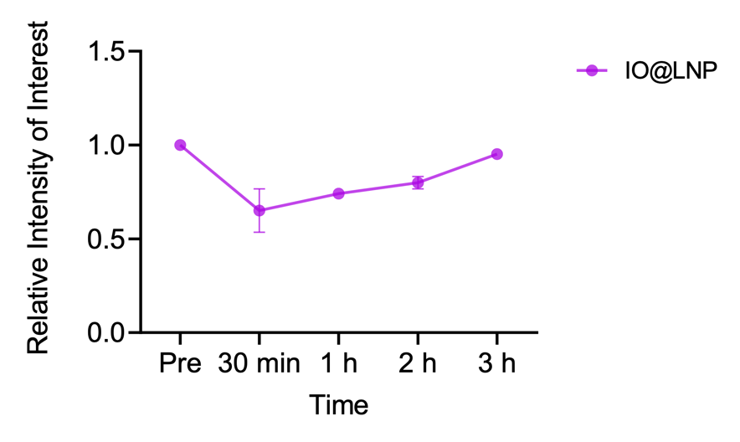
Supplementary Fig. 8 | The relative image intensity of MR contrast effect by IO@LNP derived from in vivo T2-weighted MR images. After multiple acquisition of T2-weighted images of mice (n=3), the relative intensity values of dark regions by IO@LNPs were calculated by dividing the image intensity of tissues where MR contrast effect is observed by those without such effect. As a result, the MR contrast effect of loaded IONPs is strongest immediately after injection and diminishes rapidly within a few hours.

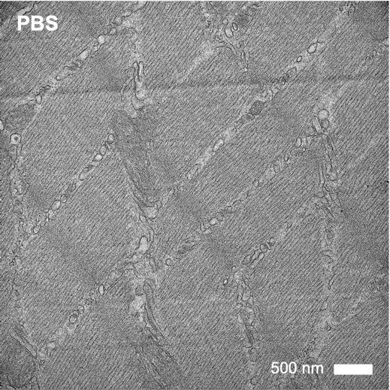

Supplementary Fig. 9 | A Bio-TEM image for a PBS-treated sample.

Supplementary Table 1 | MRI sequence parameters on Fig. 2a,b.
 | R₁ map | R₂ map
Sequence | FLASH | MEMS
FOV (mm) | 30 × 52.5 | 35 × 52.5
Matrix | 128 × 128 | 128 × 128
Slice Thickness (mm) | 2.0 | 2.0
TR (ms) | 8 | 5000
TE (ms) | 0 | 9 ~ 2700
TI (ms) | 20 ~ 4804 | -
Average | 1 | 2
Echo | 300 | 300
Fat Saturation | No | No
Scan Time (min) | 16 | 22

Supplementary Table 2 | MRI sequence parameters on Fig. 2c,d.
 | R₁ map | R₂ map
Sequence | FLASH | MEMS
FOV (mm) | 30 × 52.5 | 35 × 52.5
Matrix | 128 × 128 | 128 × 128
Slice Thickness (mm) | 0.8 | 0.8
TR (ms) | 8 | 5000
TE (ms) | 0 | 9 ~ 2700
TI (ms) | 28 ~ 4812 | -
Average | 1 | 2
Echo | 300 | 300
Fat Saturation | No | No
Scan Time (min) | 16 | 21

Supplementary Table 3 | MRI sequence parameters on Supplementary Fig. 4.
 | R₂ map
Sequence | MEMS
FOV (mm) | 65
Matrix | 128 × 128
Slice Thickness (mm) | 2.0
TR (ms) | 5000
TE (ms) | 9 ~ 2700
TI (ms) | -
Average | 2
Echo | 300
Fat Saturation | No
Scan Time (min) | 22

Supplementary Table 4 | MRI sequence parameters on Fig. 3b-e.
 | R₁ map | R₂ map
Sequence | FLASH | MEMS
FOV (mm) | 40 × 65 | 40 × 65
Matrix | 128 × 128 | 128 × 128
Slice Thickness (mm) | 0.5 | 0.5
TR (ms) | 8 | 5000
TE (ms) | 0 | 9 ~ 2700
TI (ms) | 28 ~ 4804 | -
Average | 1 | 2
Echo | 300 | 300
Fat Saturation | No | No
Scan Time (min) | 16 | 22

Supplementary Reference
1. Alipour A, et al. A new class of cubic SPIONs as a dual-mode T1 and T2 contrast agent for MRI. Magn Reson Imaging 49, 16-24 (2018).

2. Huang J, et al. Effects of nanoparticle size on cellular uptake and liver MRI with polyvinylpyrrolidone-coated iron oxide nanoparticles. ACS Nano 4, 7151-7160 (2010).

3. Ma D, et al. Redox-Sensitive Clustered Ultrasmall Iron Oxide Nanoparticles for Switchable T(2)/T(1)-Weighted Magnetic Resonance Imaging Applications. Bioconjug Chem 31, 352-359 (2020).

