Fig.S1
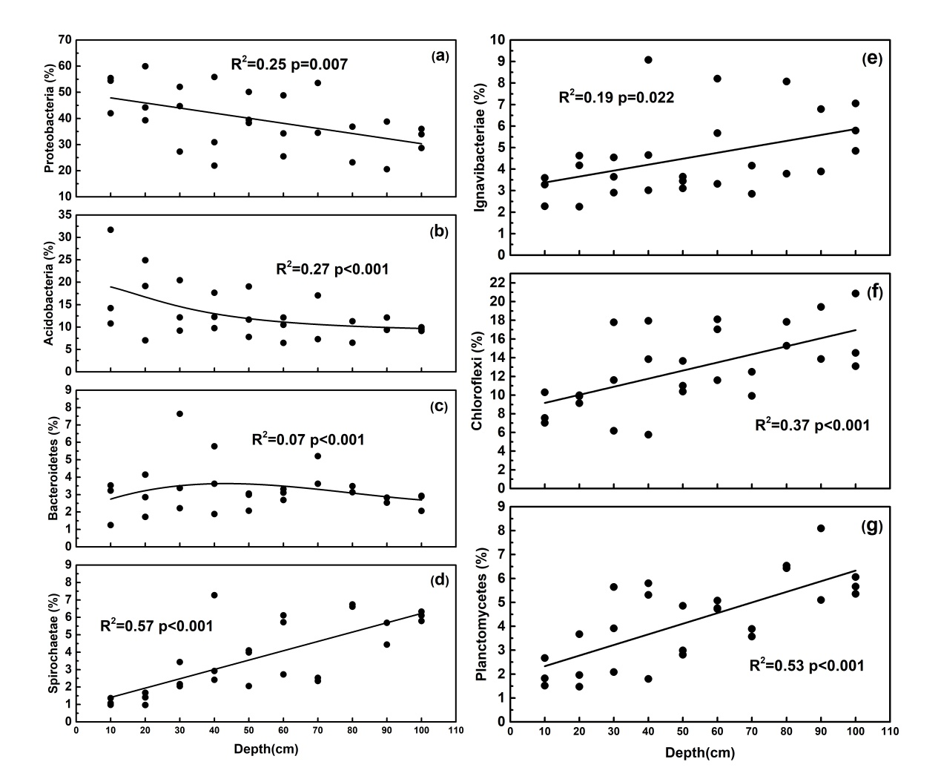

Fig.S2
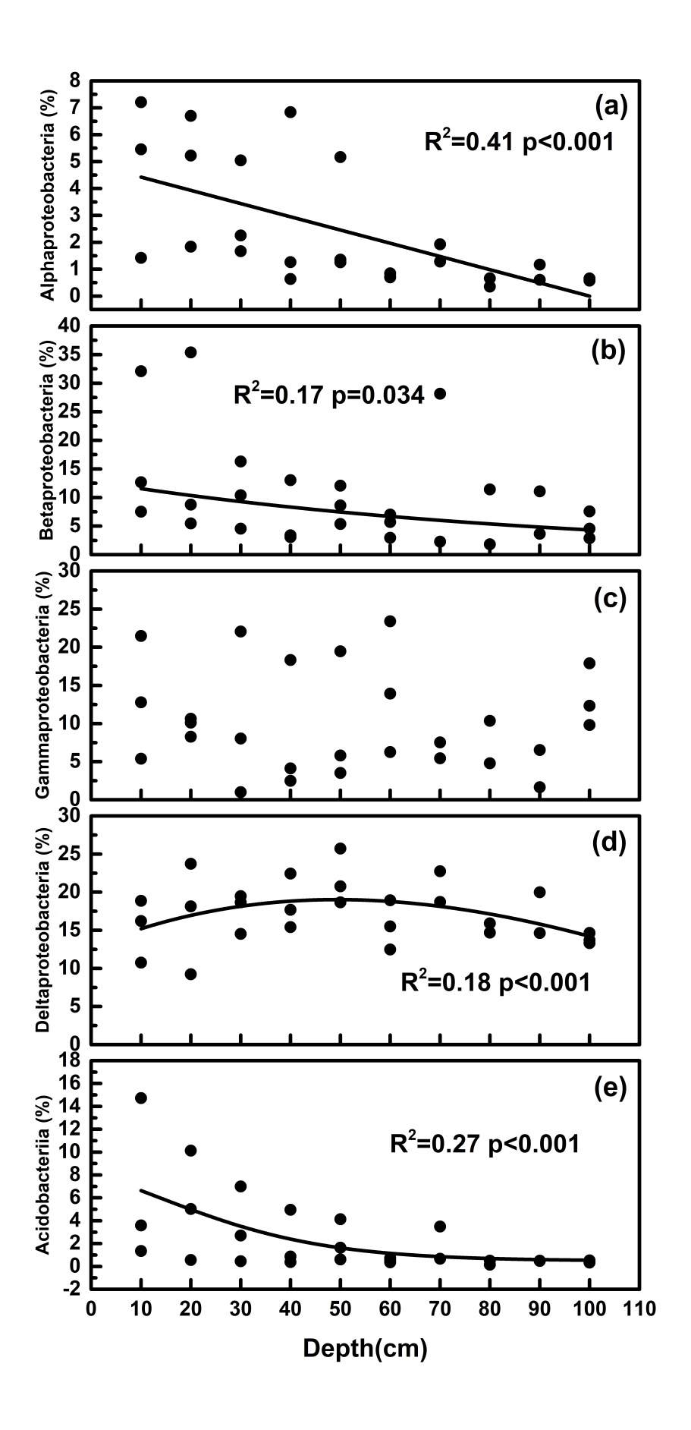

Fig.S3 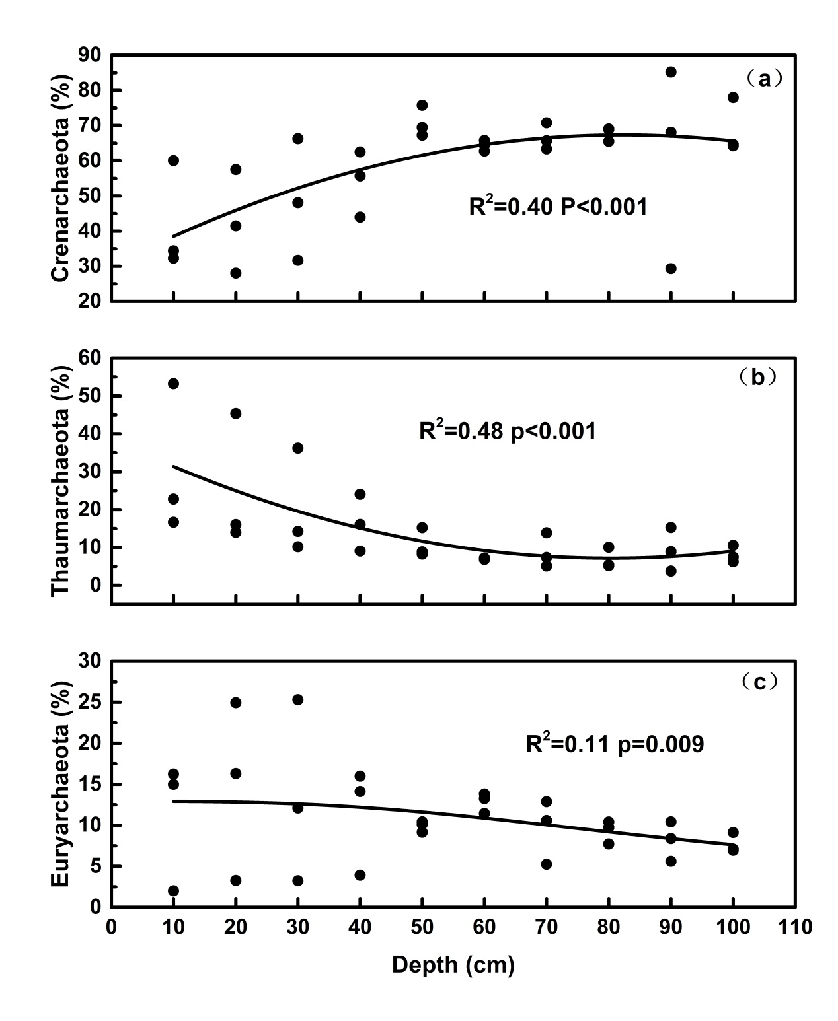

Table S1
 | Proteobacteria (phylum) |  |  | Betaproteobacteria (Class)
Depth (cm) | Methylocystaceae (Family) | Methylococcaceae (Family) | Beijerinckiaceae (Family) | Nitrosomonadaceae(Family)
0-10 | 0.158±0.055 | 0.105±0.006 | 0.049±0.018 | 1.29±0.61
10-20 | 0.11±0.044 | 0.103±0.048 | 0.067±0.023 | 1.49±0.49
20-30 | 0.057±0.018 | 0.024±0.000 | 0.023±0.004 | 0.83±0.28
30-40 | 0.049±0.033 | 0.037±0.014 | 0.055±0.049 | 0.81±0.52
40-50 | 0.052±0.006 | 0.038±0.012 | 0.043±0.021 | 1.08±0.64
50-60 | 0.037±0.013 | 0.024±0.008 | 0.016±0.007 | 0.18±0.02
60-70 | 0.056±0.049 | 0.055±0.043 | 0.011±0.006 | 0.46±0.13
70-80 | 0.01±0.006 | 0.012±0.009 | 0.002±0.002 | 0.05±0.03
80-90 | 0.009±0.007 | 0.026±0.013 | 0.007±0.005 | 0.19±0.14
90-100 | 0.015±0.008 | 0.014±0.003 | 0.011±0.002 | 0.17±0.04

