1. Synthesis
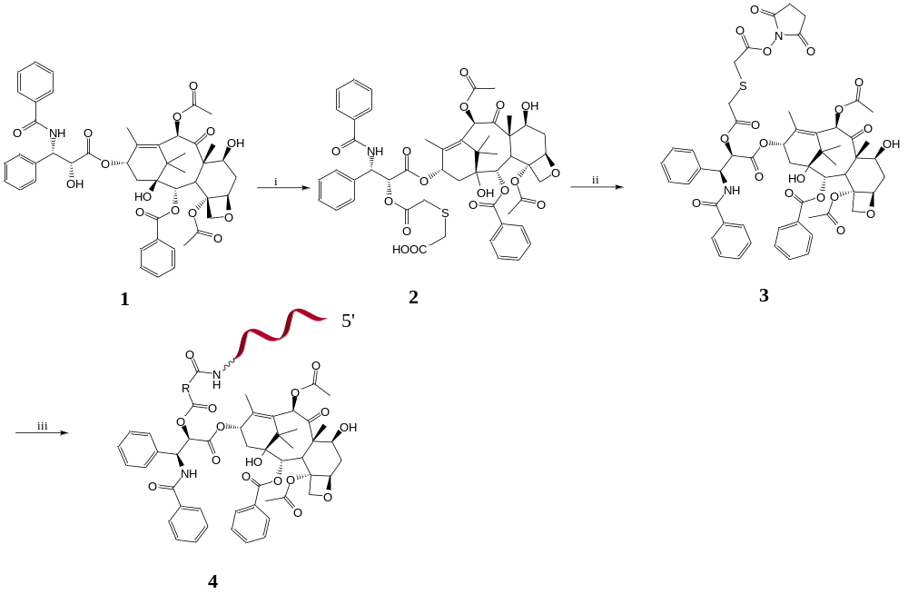
Scheme S1. Preparation of thioether bridged AS1411-PTX conjugates. Note for reagents and conditions: (i) 1,4-oxathiane-2,6-dione, Py, THF; (ii) NHS, Py, THF; (iii) Amino-DNA, NaHCO₃, H₂O, DMF. Compound 4 indicated ASP.

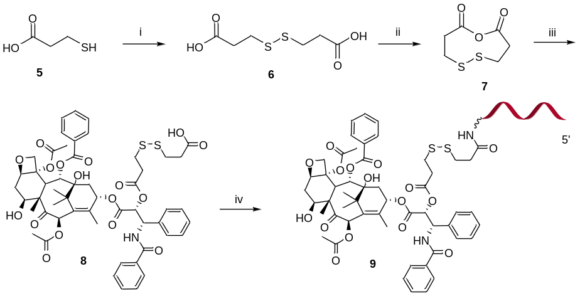

Scheme S2. Preparation of disulfide bridged AS1411-PTX conjugates. Note for reagents and conditions: (i) I₂, MeOH, TEA; (ii) AcCl, 65 °C reflux; (iii) PTX, Py; (iv) Amino-DNA, PB buffer (pH=8.0), DMF. Compound 9 indicated ASSP.

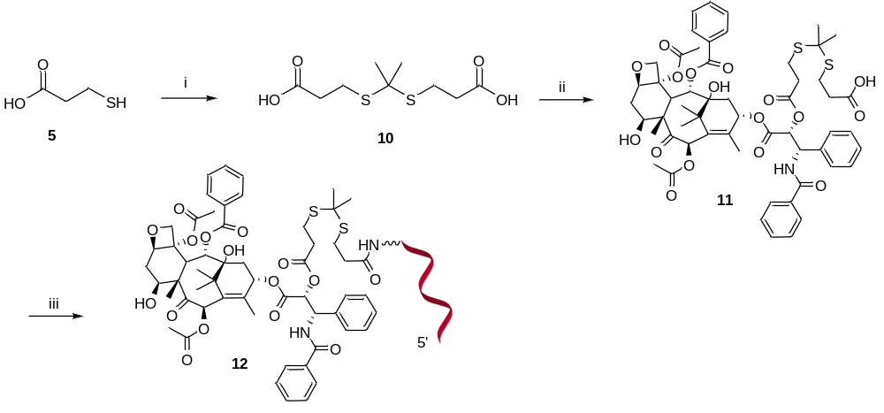
Scheme S3. Preparation of thioketal bridged AS1411-PTX conjugates. Note for reagents and conditions: (i) H₂SO₄, acetone; (ii) PTX, DCC, DMAP, DMF; (iii) Amino-DNA, DCC, HBTU, DIPEA, H₂O, DMF. Compound 12 indicated ATKP.

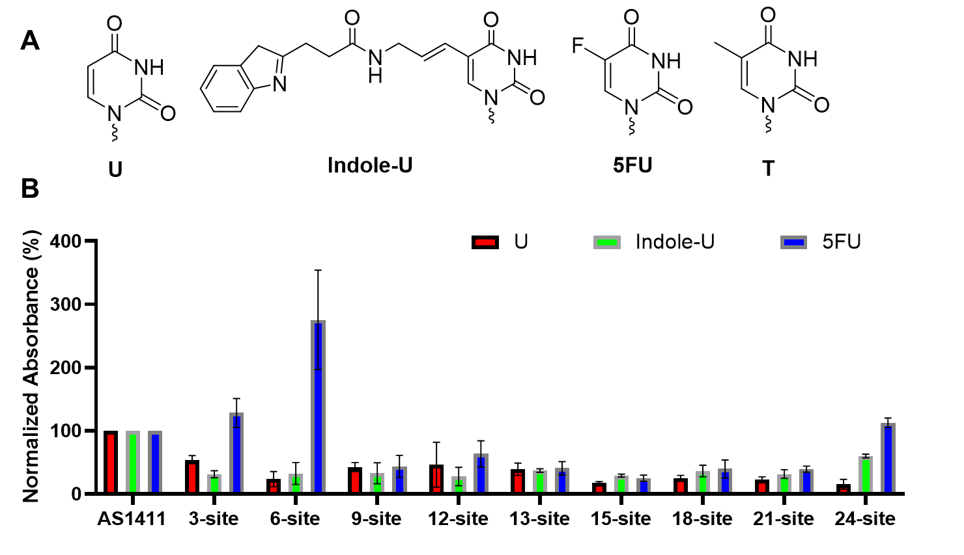
Figure S1. (A) The chemical structures used in aptamers. U represented uridine. Indole-U represented 5-indole-uridine. 5FU represented 5-fluoro-uridine. T represented naturally unmodified thymidine. (B) The binding ability of the 5FU modified AS1411s to nucleolin. The X-axis ordered in the modified sites (counting from 5'-terminus). The Y-axis was the normalized absorbance at 450 nm, which represented the binding ability of the modified AS1411s to nucleolin protein. The absorbance of unmodified AS1411 was treated as 100%. The data were presented as the means ± standard deviation from at least three replicates.

Figure S2. The binding affinity of modified aptamers to nucleolin. FA represented c modified AS1411 at site 6. T represented T-riched oligomer (negative control sequence). FT represented 5FU modified T-riched oligomer at site 6. TSP represented T-riched oligomer-paclitaxel conjugate with thioether linker. RU represented resonance units. NA represented that the calculated K_{d} value was not available. The concentrations of the ApDCs and aptamers ranged from 0.156 µM to 10 µM.

Table S1. MS-identification of aptamer-drug conjugates
Name | Chemical Formula | Molecular  Weight | Exact Mass  [M] | Found  [M]
ASP | C₃₁₈H₃₉₁N₁₀₅O₁₈₃P₂₆S | 9449.5 | 9444.7 | 9446.6
ASSP | C₃₂₀H₃₉₅N₁₀₅O₁₈₃P₂₆S₂ | 9509.6 | 9504.7 | 9507.0
ATKP | C₃₂₃H₄₀₁N₁₀₅O₁₈₃P₂₆S₂ | 9551.7 | 9546.8 | 9547.5
TSP | C₃₁₈H₄₀₈N₅₄O₂₀₀P₂₆S | 9024.3 | 9019.6 | 9017.8
FTSP | C₃₁₇H₄₀₅N₅₄O₂₀₀P₂₆SF | 9028.2 | 9023.6 | 9023.3
FASP | C₃₁₇H₃₈₈N₁₀₅O₁₈₃P₂₆SF | 9453.4 | 9448.7 | 9448.4
Cy5-ASP | C₃₅₇H₄₄₄N₁₀₈O₁₈₇P₂₇S | 10108.3 | 10103.1 | 10100.9
Cy5-FASP | C₃₅₆H₄₄₁N₁₀₈O₁₈₇P₂₇SF | 10112.3 | 10107.1 | 10104.4

Table S2. The sequences of chemically modified aptamer used in the study
Name | Sequence (5’-3’)
AS1411 | GGT GGT GGT GGT TGT GGT GGT GGT GG
3-site | GGX GGT GGT GGT TGT GGT GGT GGT GG
6-site | GGT GGX GGT GGT TGT GGT GGT GGT GG
9-site | GGT GGT GGX GGT TGT GGT GGT GGT GG
12-site | GGT GGT GGT GGX TGT GGT GGT GGT GG
13-site | GGT GGT GGT GGT XGT GGT GGT GGT GG
15-site | GGT GGT GGT GGT TGX GGT GGT GGT GG
18-site | GGT GGT GGT GGT TGT GGX GGT GGT GG
21-site | GGT GGT GGT GGT TGT GGT GGX GGT GG
24-site | GGT GGT GGT GGT TGT GGT GGT GGX GG
1 | GGF GGT GGT GGT TGT GGT GGT GGT GG
2 | GGT GGF GGT GGT TGT GGT GGT GGT GG
3 | GGT GGT GGF GGT TGT GGT GGT GGT GG
4 | GGT GGT GGT GGT TGT GGF GGT GGT GG
5 | GGT GGT GGT GGT TGT GGT GGT GGF GG
6 | GGF GGF GGT GGT TGT GGT GGT GGT GG
7 | GGF GGT GGF GGT TGT GGT GGT GGT GG
8 | GGF GGT GGT GGT TGT GGF GGT GGT GG
9 | GGF GGT GGT GGT TGT GGT GGT GGF GG
10 | GGT GGF GGF GGT TGT GGT GGT GGT GG
11 | GGT GGF GGT GGT TGT GGF GGT GGT GG
12 | GGT GGF GGT GGT TGT GGT GGT GGF GG
13 | GGT GGT GGF GGT TGT GGF GGT GGT GG
14 | GGT GGT GGF GGT TGT GGT GGT GGF GG
15 | GGT GGT GGT GGT TGT GGF GGT GGF GG
16 | GGF GGF GGF GGT TGT GGT GGT GGT GG
17 | GGF GGF GGT GGT TGT GGF GGT GGT GG
18 | GGF GGF GGT GGT TGT GGT GGT GGF GG
19 | GGF GGT GGF GGT TGT GGF GGT GGT GG
20 | GGF GGT GGF GGT TGT GGT GGT GGF GG
21 | GGF GGT GGT GGT TGT GGF GGT GGF GG
22 | GGT GGF GGF GGT TGT GGF GGT GGT GG
23 | GGT GGF GGF GGT TGT GGT GGT GGF GG
24 | GGT GGF GGT GGT TGT GGF GGT GGF GG
25 | GGT GGT GGF GGT TGT GGF GGT GGF GG
26 | GGF GGF GGF GGT TGT GGF GGT GGT GG
27 | GGF GGF GGF GGT TGT GGT GGT GGF GG
28 | GGF GGF GGT GGT TGT GGF GGT GGF GG
29 | GGF GGT GGF GGT TGT GGF GGT GGF GG
30 | GGT GGF GGF GGT TGT GGF GGT GGF GG
31 | GGF GGF GGF GGT TGT GGF GGT GGF GG
Note: T represented naturally unmodified 2'-deoxythymidine; G represented naturally unmodified 2'- deoxyguanosine; X represents either 5-indole-2'-deoxyuridine (Indole-dU), fluorouracil (5FU) or 2'-deoxyuridine (dU); F represents fluorouracil (5FU)

2. Experimental Section
Synthesis of compound 2: To a mixture suspension of 1,4-oxathiane-2,6-dione (397 mg, 3.006 mmol) in CH₂Cl₂ (5 mL), Py was added (242 μL, 3.006 mmol) and stirred for 5 min. Then, addition of PTX (2.176 g, 2.548 mmol) in anhydrous CH₂Cl₂ (20 mL) was performed, and stirred at room temperature for 4 days. The mixture was concentrated under reduced pressure, following co-evaporated with toluene three times to remove the Py. Thereafter, the residue was chromatographed on silica gel (PE/EA=1/1) to give the compound 2 (1.807 g, 72%) as a white solid. 2-((2-(((1S,2R)-1-benzamido-3-(((2aR,4S,4aS,6R,9S,11S,12S,12bS)-6,12b-diacetoxy-12-(benzoyloxy)-4,11-dihydroxy-4a,8,13,13-tetramethyl-5-oxo-2a,3,4,4a,5,6,9,10,11,12,12a,12b-dodecahydro-1H-7,11-methanocyclodeca[3,4]benzo[1,2-b]oxet-9-yl)oxy)-3-oxo-1-phenylpropan-2-yl)oxy)-2-oxoethyl)thio)acetic acid: MS (ESI) m/z for C₅₁H₅₄NO₁₇S⁻ [M-H]⁻, Calculated 984.3118, Found 984.3153; ¹H NMR (400 MHz, MeOD) δ 8.02 (dd, J = 8.2, 6.8 Hz, 2H), 7.74 (dd, J = 5.3, 3.2 Hz, 2H), 7.60 – 7.55 (m, 1H), 7.49 (t, J = 7.5 Hz, 2H), 7.44 – 7.38 (m, 3H), 7.37 – 7.31 (m, 4H), 7.17 (t, J = 7.3 Hz, 1H), 6.35 (d, J = 4.5 Hz, 1H), 5.99 (t, J = 8.6 Hz, 1H), 5.77 (d, J = 6.1 Hz, 1H), 5.54 (d, J = 7.3 Hz, 1H), 5.41 (d, J = 6.1 Hz, 1H), 4.93 – 4.87 (m, 1H), 4.25 (dd, J = 11.0, 6.7 Hz, 1H), 4.09 (s, 2H), 3.72 (d, J = 7.2 Hz, 1H), 3.56 – 3.35 (m, 3H), 3.30 – 3.24 (m, 1H), 3.16 (d, J = 15.0 Hz, 1H), 2.43 – 2.24 (m, 4H), 2.15 – 2.03 (m, 4H), 1.85 – 1.65 (m, 5H), 1.55 (s, 3H), 1.04 (d, J = 3.5 Hz, 6H); ¹³C NMR (101 MHz, MeOD) δ 205.24, 171.33, 170.24, 167.71, 142.40, 138.37, 135.48, 134.90, 134.66, 132.93, 131.34, 130.14, 129.97 – 129.47, 128.87 – 128.4, 85.93, 82.28, 79.04, 77.49, 76.85, 76.51, 76.28, 73.07, 72.33, 59.24, 55.24, 47.92, 44.62, 37.55, 36.45, 33.68, 26.97, 23.35, 22.43, 20.84, 14.99, 10.50. Peak overlapping was observed.

Synthesis of compound 3: To a mixture solution of compound 2 (1.2 g, 1.218 mmol) and NHS (147 mg, 1.279 mmol) in anhydrous THF (30 mL), DCC (276 mg, 1.34 mmol) was added and stirred at room temperature for 3 days. The mixture was filtered, and the filtrate was concentrated in acuum to give the crude solid. Finally, the residue was recrystallized from diethyl ether (100 mL) being cooled to 4 °C, affording white solid (1.18 g) after evaporated to dryness. No further operation was performed. 2aR,4S,4aS,6R,9S,11S,12S,12bS)-9-(((2R,3S)-3-benzamido-2-(2-((2-((2,5-dioxopyrrolidin-1-yl)oxy)-2-oxoethyl)thio)acetoxy)-3-phenylpropanoyl)oxy)-12-(benzoyloxy)-4,11-dihydroxy-4a,8,13,13-tetramethyl-5-oxo-3,4,4a,5,6,9,10,11,12,12a-decahydro-1H-7,11-methanocyclodeca[3,4]benzo[1,2-b]oxete-6,12b(2aH)-diyl diacetate: MS (ESI) m/z for C₅₅H₅₇N₂O₁₉S⁻ [M-H]⁻, Calculated 1081.3282, Found 1081.3203.

Synthesis of compound 4: To a solution of 3′-amino DNA (100 nmol) in NaHCO₃ buffer (50 mM, 0.1 mL), compound 3 (3 µmol) in DMF (0.2 mL) was added to the solution and stirred (800 rpm) for 2 h at 30 °C. The reaction mixture was quenched by the addition of the TEAA (2 M, 0.1 mL). The solvent was removed in vacuo, and the solid residue was re-dissolved in ddH₂O (1 mL). Afterwards, the mixture was purified using high-performance liquid chromatography (Agilent 1260). Phase A was CAN, and phase B was TEAA (50 mM). The gradient was run from 5% to 60% of phase A in 30 minutes for the Xbride ®Oligonucleotide BEH C18 OBDTM Prep Column (2.5 μm, 10 mm×50 mm) at a flow rate of 1.2 mL·min⁻¹ with ambient column temperature. The purified ApDCs were desalted by using a Sephadex G25 column to afford compound 4/5. The samples were further lyophilized to dryness for storage, and confirmed by ESI MS analyses.

Synthesis of compound 6: To a solution of compound 5 (2.3 g, 21.7 mmol) in methanol (30 mL) being cooled to 0 °C, Iodine (5.634 g, 11.1 mmol) in methanol (30 mL) was added dropwise to the stirred solution for 2 hours. TLC analysis showed the complete consumption of compound 6. The reaction mixture was quenched by the addition of the saturated aqueous Na₂S₂O₃, and the pH was adjusted to around 4 by progressively adding solid NaHCO₃. Afterwards, the mixture was filtered and concentrated, chromatographed on silica gel (DCM/MeOH=30/1) to give the compound 7 (2.012 g, 87%) as a white solid. 3,3’-disulfanediyldipropionic acid: MS (ESI) m/z for C₆H₉O₄S₂⁻ [M-H]⁻, Calculated 208.9948, Found 208.9964; ¹H NMR (400 MHz, MeOD) δ 2.92 (t, J = 7.0 Hz, 4H), 2.71 (t, J = 7.0 Hz, 4H). ¹³C NMR (101 MHz, MeOD) δ 175.36, 34.76, 34.30.

Synthesis of compound 8: A round-bottom flask was charged with compound 6 (0.211 g, 1.005 mmol) and acetylchloride (5 mL). Then, the mixture under nitrogen was heated to 65 °C under reflux for 2 hours, to afford crude compound 7. No further purification was performed. 1,5,6-oxadithionane-2,9-dione: MS (ESI) m/z for C₆H₉O₃S₂⁺ [M+H]⁺, Calculated 192.9988, Found 192.9990.
All crude compound 7 and PTX (854 mg, 1 mmol) were dissolved in anhydrous DCM (20 mL). Then, Py (0.282 mL, 3.5 mmol) was added dropwise to the mixture, and stirred at room temperature for 2 days. The solvent was removed in vacuo, and the solid residue was re-dissolved in DCM (20 mL). Afterwards, the residue was chromatographed on silica gel (DCM/MeOH=20/1~3/1) to yield the compound 9 (648 mg, 62%) as a white solid. 3-((3-(((1S,2R)-1-benzamido-3-(((2aR,4S,4aS,6R,9S,11S,12S,12bS)-6,12b-diacetoxy-12-(benzoyloxy)-4,11-dihydroxy-4a,8,13,13-tetramethyl-5-oxo-2a,3,4,4a,5,6,9,10,11,12,12a,12b-dodecahydro-1H-7,11-methanocyclodeca[3,4]benzo[1,2-b]oxet-9-yl)oxy)-3-oxo-1-phenylpropan-2-yl)oxy)-3-oxopropyl)disulfanyl)propanoic acid: MS (ESI) m/z for C₅₃H₅₈NO₁₇S₂⁻ [M-H]⁻, Calculated 1044.3152, Found 1044.3238; ¹H NMR (400 MHz, MeOD) δ 8.02 (dd, J = 8.2, 6.8 Hz, 2H), 7.74 (dd, J = 5.3, 3.2 Hz, 2H), 7.60 – 7.55 (m, 1H), 7.49 (t, J = 7.5 Hz, 2H), 7.44 – 7.38 (m, 3H), 7.37 – 7.31 (m, 4H), 7.17 (t, J = 7.3 Hz, 1H), 6.35 (d, J = 4.5 Hz, 1H), 5.99 (t, J = 8.6 Hz, 1H), 5.77 (d, J = 6.1 Hz, 1H), 5.54 (d, J = 7.3 Hz, 1H), 5.41 (d, J = 6.1 Hz, 1H), 4.93 – 4.87 (m, 1H), 4.25 (dd, J = 11.0, 6.7 Hz, 1H), 4.09 (s, 2H), 3.72 (d, J = 7.2 Hz, 1H), 3.56 – 3.35 (m, 3H), 3.30 – 3.24 (m, 1H), 3.16 (d, J = 15.0 Hz, 1H), 2.43 – 2.24 (m, 4H), 2.15 – 2.03 (m, 4H), 1.85 – 1.65 (m, 5H), 1.55 (s, 3H), 1.04 (d, J = 3.5 Hz, 6H); ¹³C NMR (101 MHz, MeOD) δ 205.19, 172.60, 171.63, 171.31, 170.61, 170.34, 167.66, 142.38, 138.29, 135.54, 134.87, 134.64, 132.95, 131.32, 130.14, 129.68, 128.67, 85.92, 82.28, 79.03, 77.47, 76.84, 76.16, 73.02, 72.33, 59.23, 55.24, 49.90, 47.93, 44.61, 37.56, 36.43, 35.58, 34.78, 34.47, 33.71, 26.96, 23.35, 22.43, 20.85, 15.02, 10.51. Peak overlapping was observed.

Synthesis of compound 9: To a solution of 3′-amino DNA (100 nmol) in PB buffer (50 mM, 0.1 mL), compound 10 (3 µmol) in DMF (0.2 mL) was added to the solution and stirred (800 rpm) for 2 h at 30 °C. The reaction mixture was quenched by the addition of the TEAA (2M, 0.1 mL). The solvent was removed in vacuo, and the solid residue was re-dissolved in ddH₂O (1 mL). Afterwards, the mixture was purified using high-performance liquid chromatography (Agilent 1260). Phase A was CAN, and phase B was TEAA (50 mM). The gradient was run from 5% to 60% of phase A in 30 minutes for the Xbride ®Oligonucleotide BEH C18 OBDTM Prep Column (2.5 μm, 10 mm×50 mm) at a flow rate of 1.2 mL·min⁻¹ with ambient column temperature. The purified ApDCs were desalted by using a Sephadex G25 column to afford compound 11/12. The samples were further lyophilized to dryness for storage, and confirmed by ESI MS analyses.

Synthesis of compound 10: To a solution of compound 5 (3.412 g, 32.2 mmol) in acetone (20 mL) being cooled to 0 °C, sulfuric acid (1.882 g, 19.2 mmol) was added dropwise to the stirred mixture for 2 hours. Then, the mixture was diluted with ddH₂O (200 mL), and the pH was adjusted to 5 by progressively adding aqueous NaOH. Thereafter, the mixture was evaporated to remove the acetone, and the aqueous layer was extracted with ethyl acetate (100 mL×3). Finally, the crude product was chromatographed on silica gel (n-hexane/EA=4/1) under reduced pressure to yield the compound 13 (2.313 g, 57%) as a white solid. 3,3’-(propane-2,2-diylbis(sulfanediyl))dipropionic acid: MS (ESI) m/z for C₉H₁₅O₄S₂⁻ [M-H]⁻, Calculated 251.0417, Found 251.0448; ¹H NMR (400 MHz, MeOD) δ 2.76 (dd, J = 9.0, 5.4 Hz, 4H), 2.49 (t, J = 7.1 Hz, 4H), 1.49 (s, 6H); ¹³C NMR (101 MHz, MeOD) δ 56.97, 35.33, 31.31, 26.33.

Synthesis of compound 11: A round-bottom flask was charged with compound 10 (0.433 g, 1.718 mmol) and PTX (1.547 g, 1.812 mmol) in DMF (20 mL). DCC (355 mg, 1.722 mmol) and a catalytic amount of DMAP were added into the solution. The mixture was left standing overnight at room temperature. The mixture was filtered, evaporated, and chromatographed on silica gel (DCM/MeOH=50/1~30/1) to yield the compound 11 (1.064 g, 57%) as a white solid. (3S,4R)-4-((((2aR,4S,4aS,6R,9S,11S,12S,12bS)-6,12b-diacetoxy-12-(benzoyloxy)-4,11-dihydroxy-4a,8,13,13-tetramethyl-5-oxo-2a,3,4,4a,5,6,9,10,11,12,12a,12b-dodecahydro-1H-7,11-methanocyclodeca[3,4]benzo[1,2-b]oxet-9-yl)oxy)carbonyl)-10,10-dimethyl-1,6-dioxo-1,3-diphenyl-5-oxa-9,11-dithia-2-azatetradecan-14-oic acid: MS (ESI) m/z for C₅₆H₆₄NO₁₇S₂⁻ [M-H]⁻, Calculated 1086.3621, Found 1086.3747; ¹H NMR (400 MHz, MeOD) δ 8.05 – 7.98 (m, 2H), 7.71 (dd, J = 5.2, 3.3 Hz, 2H), 7.57 (td, J = 7.0, 3.2 Hz, 1H), 7.39 (dddd, J = 23.6, 15.3, 11.1, 4.7 Hz, 9H), 7.17 (t, J = 7.3 Hz, 1H), 6.35 (s, 1H), 5.97 (t, J = 8.7 Hz, 1H), 5.77 (d, J = 6.5 Hz, 1H), 5.53 (d, J = 7.2 Hz, 1H), 5.43 (d, J = 6.5 Hz, 1H), 4.93 – 4.87 (m, 1H), 4.24 (dd, J = 10.9, 6.7 Hz, 1H), 4.09 (s, 2H), 3.71 (d, J = 7.2 Hz, 1H), 2.71 (t, J = 6.8 Hz, 2H), 2.61 (t, J = 6.6 Hz, 2H), 2.41 – 2.28 (m, 4H), 2.13 – 2.00 (m, 8H), 1.82 (d, J = 0.8 Hz, 3H), 1.77 – 1.65 (m, 2H), 1.55 (s, 3H), 1.34 (s, 3H), 1.24 – 1.07 (m, 3H), 1.06 – 0.99 (m, 6H); ¹³C NMR (101 MHz, MeOD) δ 205.19, 172.86, 171.66, 171.34, 170.41, 170.35, 167.68, 142.36, 138.36, 135.51, 134.94, 132.95, 131.44, 131.25, 130.16, 129.76, 129.60, 128.75, 128.72, 85.91, 82.29, 79.07, 76.82, 76.28, 76.03, 73.02, 31.19, 30.70, 26.15, 23.38, 22.41, 20.84, 15.08, 10.48. Peak overlapping was observed.

Synthesis of compound 12: The compound 11 (3 µmol), DCC (3 µmol) and HBTU (3 µmol) in DMF (0.4 mL) was added to the solution and stirred for 10 min. After being cooled to 0 °C, a solution of 5′/3′-amino DNA (100 nmol) and DIPEA (3 µmol) in ddH₂O (0.1 mL) was added dropwise into the mixture and stirred (800 rpm) for 4 h at 30 °C.The reaction mixture was quenched by the addition of the TEAA (2 M, 0.1 mL). The solvent was removed in vacuo, and the solid residue was re-dissolved in ddH₂O (1 mL). Afterwards, the mixture was purified using high-performance liquid chromatography (Agilent 1260). Phase A was ACN, and phase B was TEAA (50 mM). The gradient was run from 5% to 60% of phase A in 30 minutes for the Xbride ®Oligonucleotide BEH C18 OBDTM Prep Column (2.5 μm, 10 mm×50 mm) at a flow rate of 1.2 mL·min⁻¹ with ambient column temperature. The purified ApDCs were desalted by using a Sephadex G25 column to afford compound 12. The samples were further lyophilized to dryness for storage, and confirmed by ESI MS analyses.

Attachment Figures
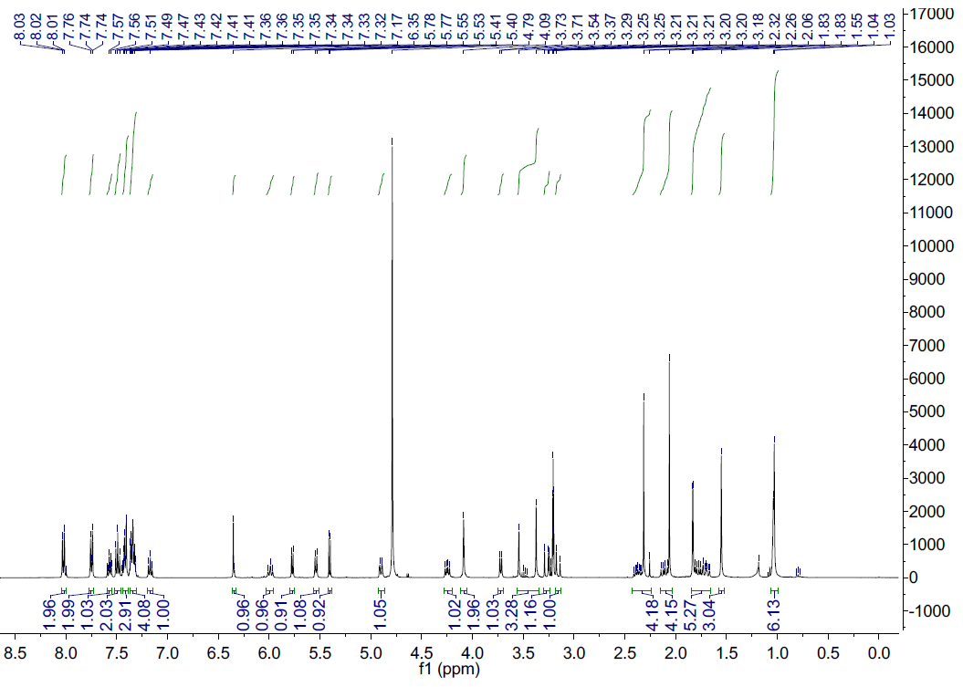
¹H-NMR spectra of compound 2

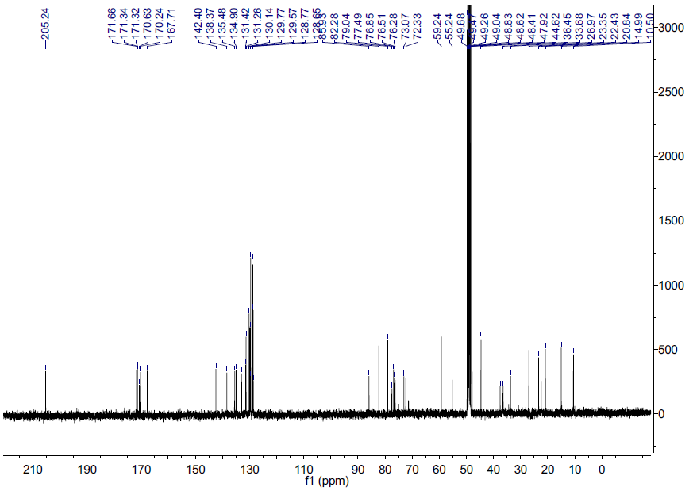
¹³C-NMR spectra of compound 2

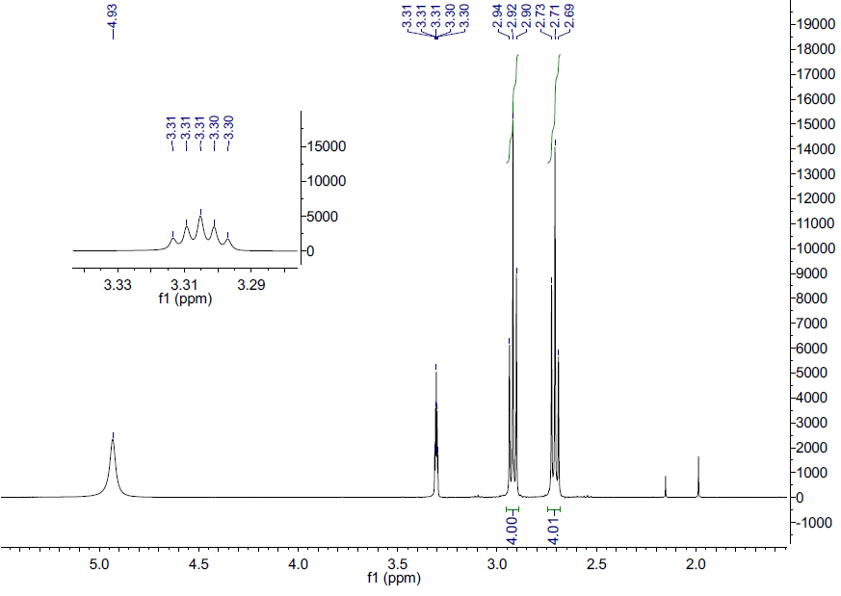
¹H-NMR spectra of compound 6

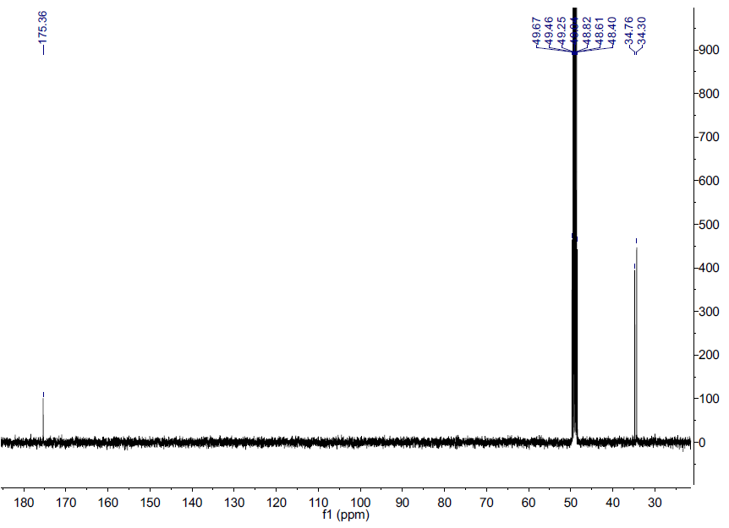
¹³C-NMR spectra of compound 6

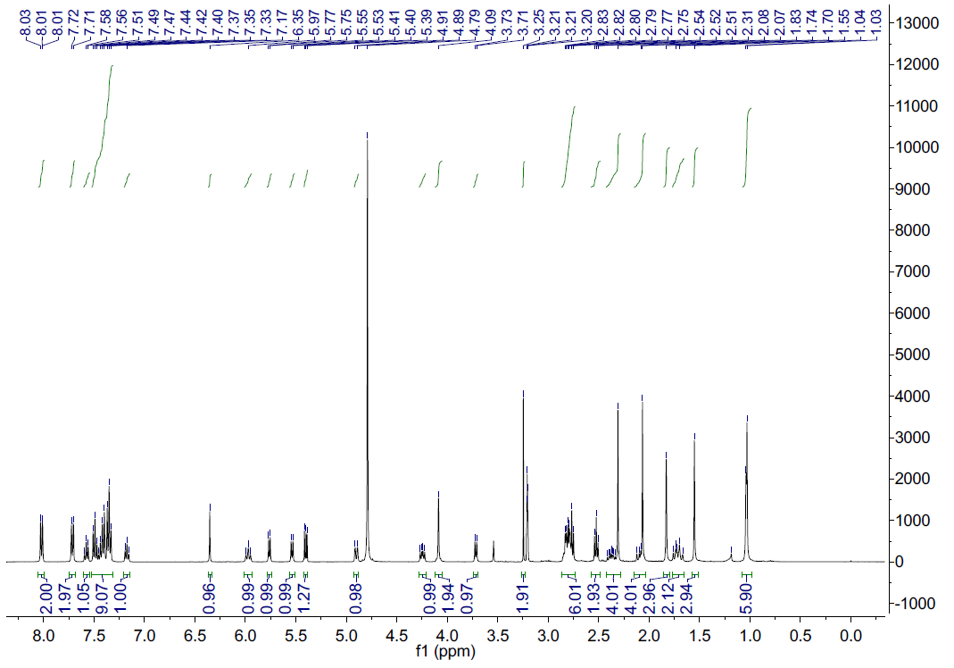
¹H-NMR spectra of compound 8

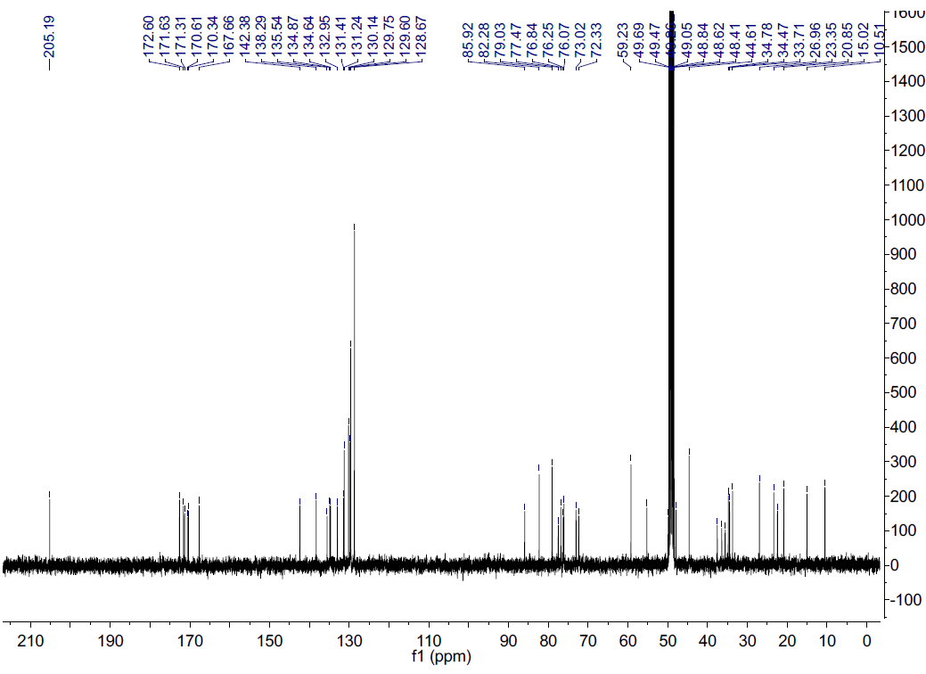
¹³C-NMR spectra of compound 8

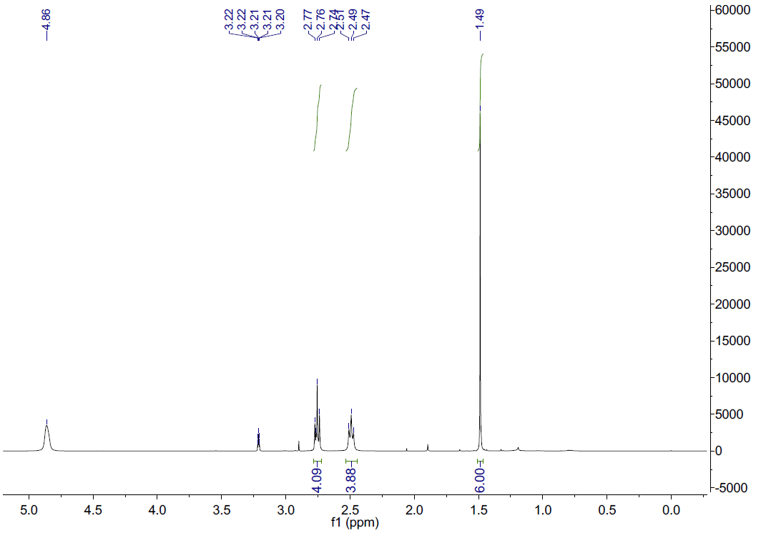
¹H-NMR spectra of compound 10

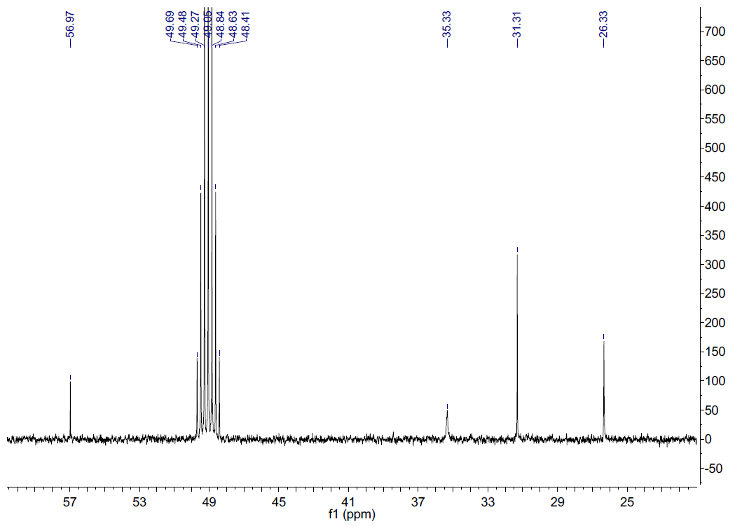
¹³C-NMR spectra of compound 10

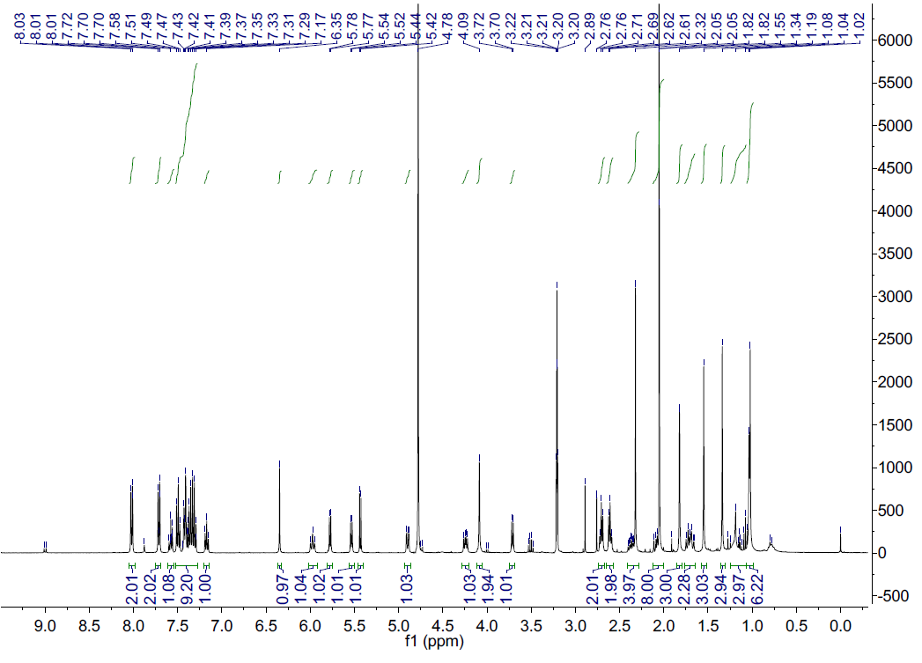
¹H-NMR spectra of compound 11

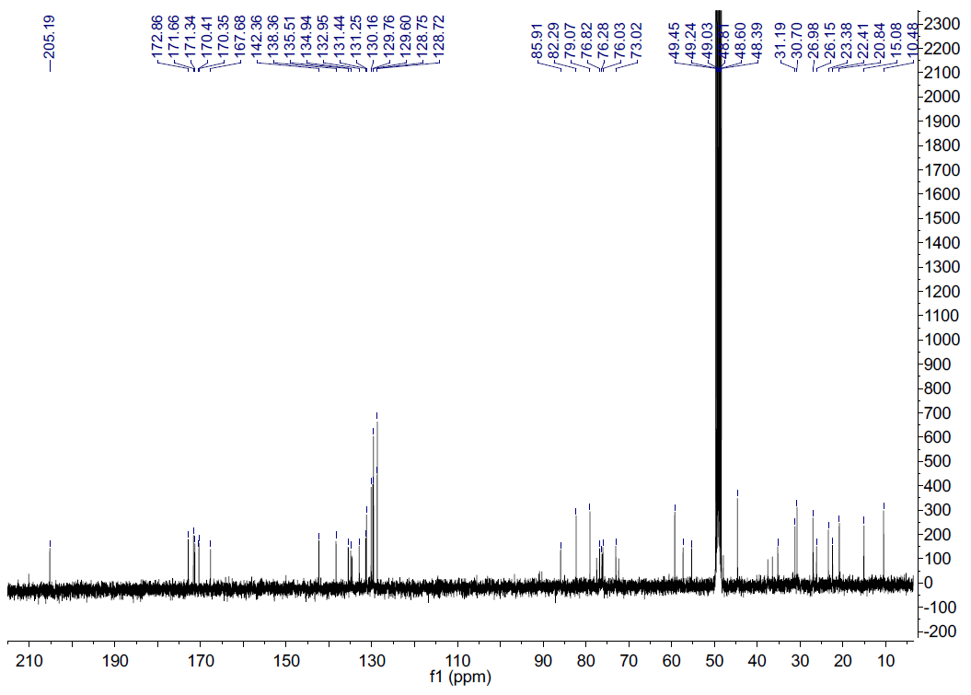
¹³C-NMR spectra of compound 11

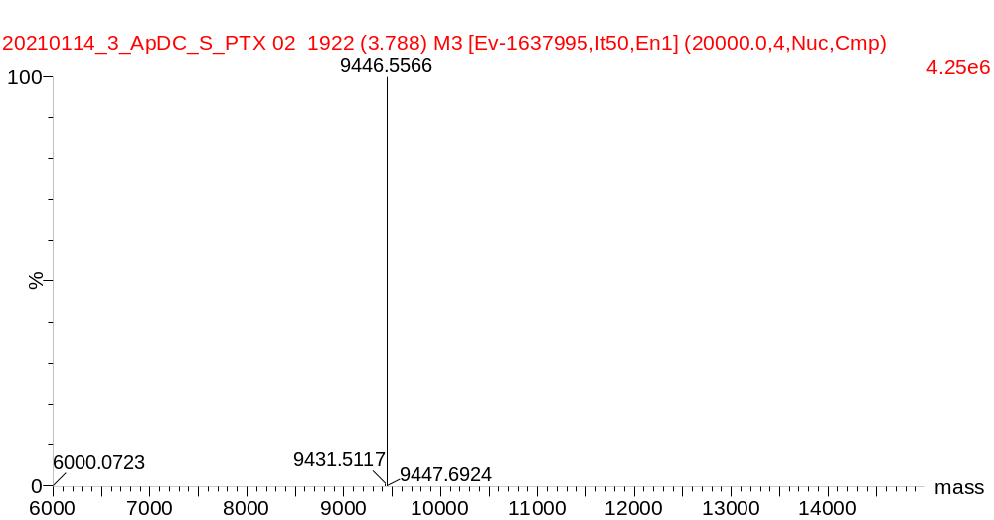
MS spectra of ASP

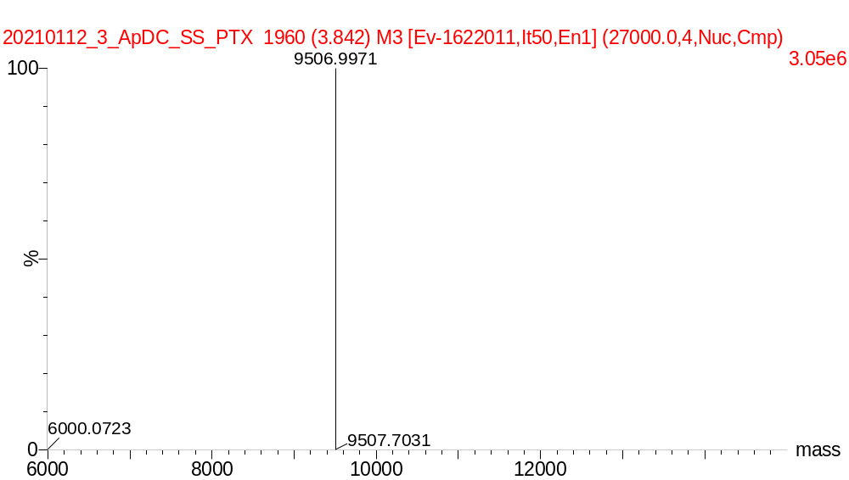
MS spectra of ASSP

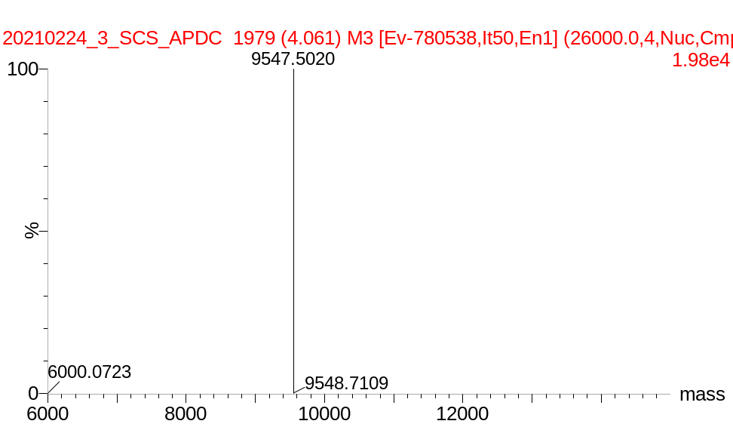
MS spectra of ATKP

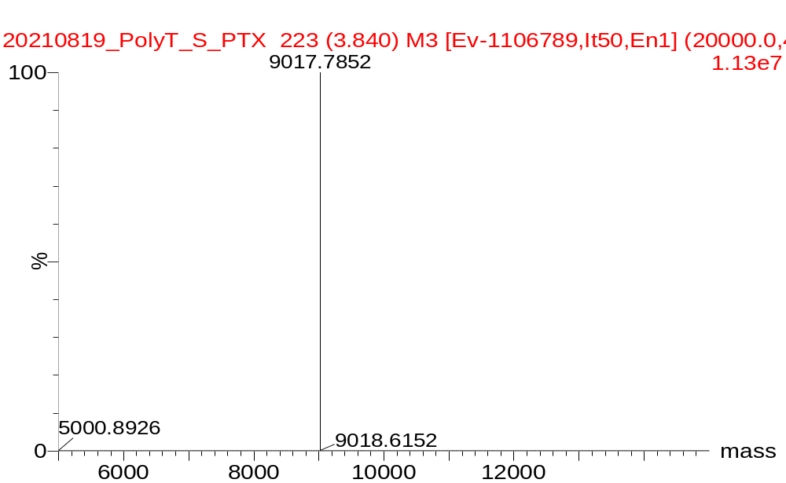
MS spectra of TSP

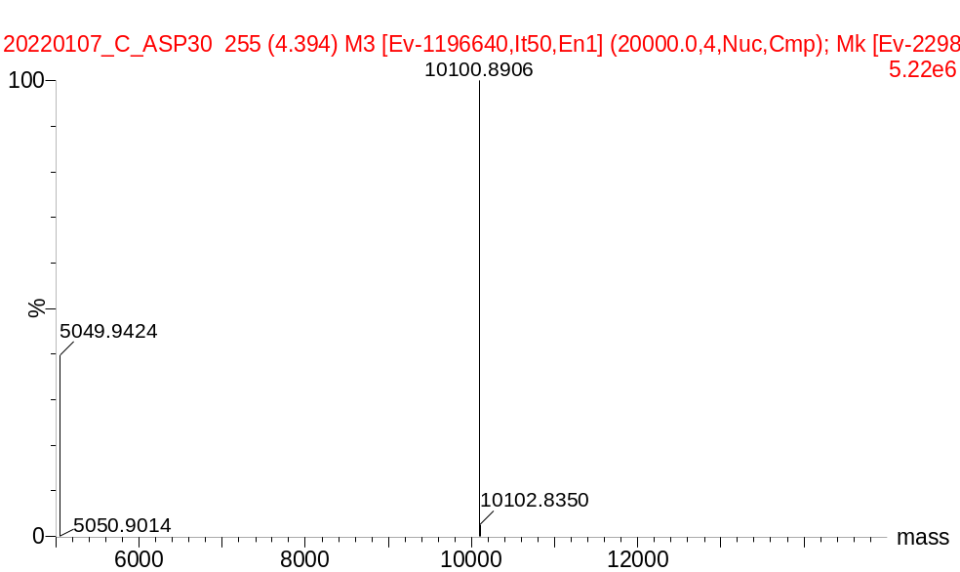
MS spectra of ASP

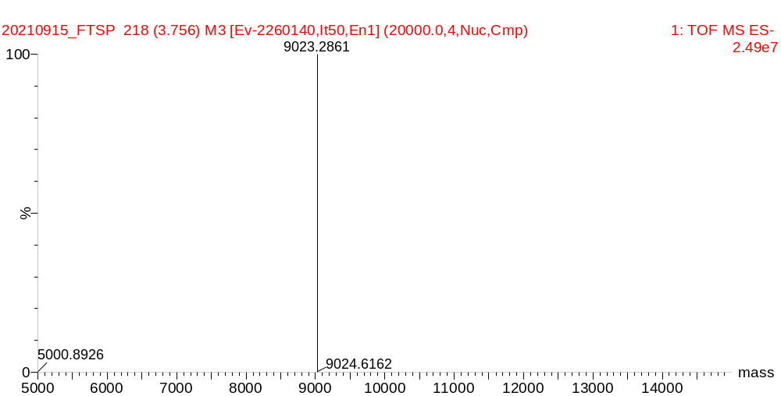
MS spectra of FTSP

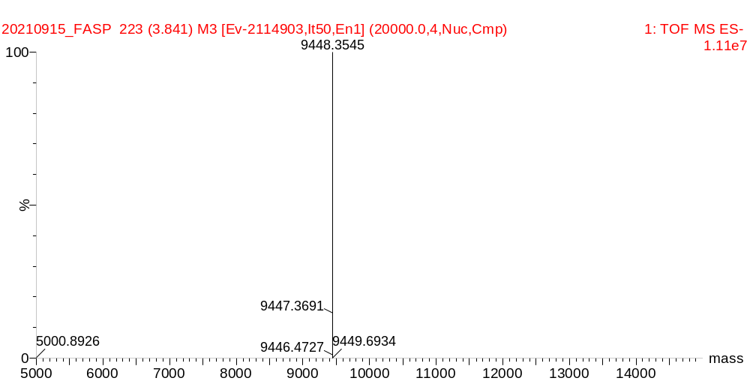
MS spectra of FASP

MS spectra of Cy5-ASP

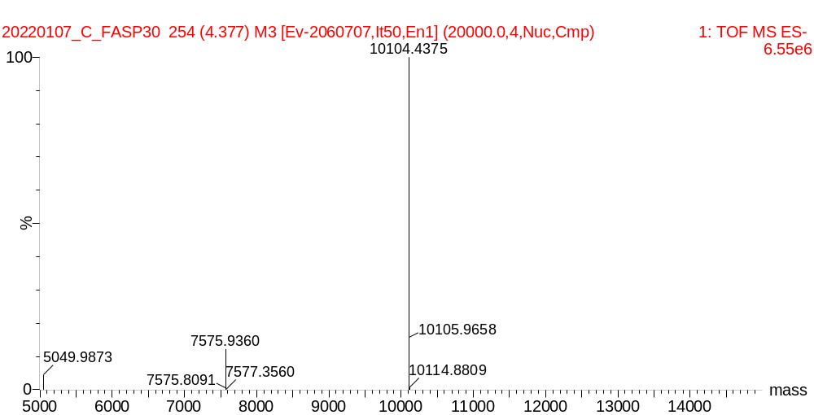
MS spectra of Cy5-FASP

