Supporting Information
Ultrahigh thermal stability and piezoelectricity of lead-free piezoceramics through mimicking PZT’s MPB structure
Lihui, Xu^{1,#}, Jinfeng Lin^{1,#}, Yuxuan Yang^{2,#}, Zhihao Zhao², Xiaoming Shi³, Guanglong Ge¹, Jin Qian¹, Cheng Shi¹, Guohui Li¹, Simin Wang¹, Yang Zhang², Bo Shen^{1,}, Zhengqian Fu⁴, Houbing Huang^{5,}, Haijun Wu^{2,}, Jiwei Zhai^{1,}

¹School of Materials Science and Engineering, Tongji University, Shanghai 201804, China. ²State Key Laboratory for Mechanical Behavior of Materials, Xi'an Jiaotong University, Xi'an 710049, P. R. China. ³Department of Physics, University of Science and Technology Beijing, Beijing 100083, China. ⁴Chinese Acad Sci, Shanghai Inst Ceram, State Key Lab High Performance Ceram & Superfine, Shanghai 200050, China. ⁵School of Materials Science and Engineering, Beijing Institute of Technology, Beijing 100081, China. #These authors contributed equally. E-mail: shenbo@tongji.edu.cn (B. Shen); hbhuang@bit.edu.cn (H. Huan); wuhaijunnavy@xjtu.edu.cn (H. Wu); apzhai@tongji.edu.cn (J. Zhai);

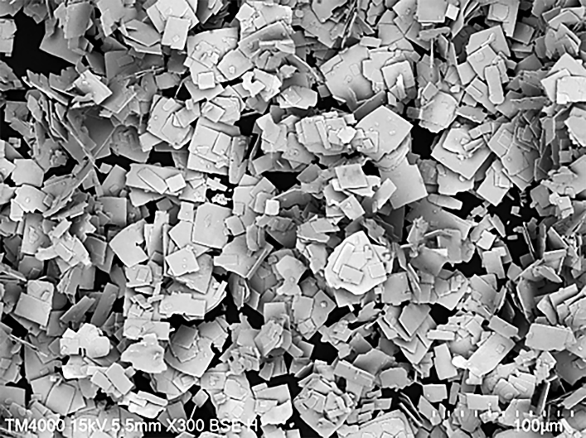
Figure S1. The SEM of the NN platelet template.

Figure S2. a) The surface SEM images of the 3T ceramics. b, c) Cross section SEM images of the 3T ceramics. d) The surface SEM images of the 3R ceramics.

Figure S3. EDS diagram of the main elements in 3T ceramics.

Figure S4 EBSD inverse pole diagram testing along the direction perpendicular to the casting direction of 3T ceramics.

Figure S5. a) Temperature-dependent dielectric constant (ε_{r}-T) curves at high temperature of the xR ceramics. b) The XRD patterns of the xR ceramics.

Figure S6. The XRD patterns of the xT ceramics.

Figure S7. Temperature-dependent dielectric constant (ε_{r}-T) curves at low temperature of the xT ceramics.

Figure S8. In-situ variable temperature Raman spectrum of 1T and 3T ceramics.

Figure S9. a) P-E hysteresis loops of the xT ceramics at room temperature. b) P-E hysteresis loops of the xR ceramics at room temperature.

Figure S10. a) Unipolar S-E strain curves of the xT ceramics. b) d₃₃ values of the random and textured ceramics.

Figure S11. The comprehensive performance comparison of the 3T ceramics with other Pb/Pb-free piezoceramics, including the d₃₃ value and Curie temperature.
Figure S12. f) In-situ variable electric fields XRD for the 3T ceramics.

Figure S13. a) TEM images for the 3T ceramics. b) TEM images for the 3R ceramics.

Figure S14. In-situ variable temperature P-E loops for the 3T ceramics.

Figure S15. a) Peak fitting of the in-situ variable temperature XRD for the 3T ceramics after poled. b) Peak fitting statistical chart.

