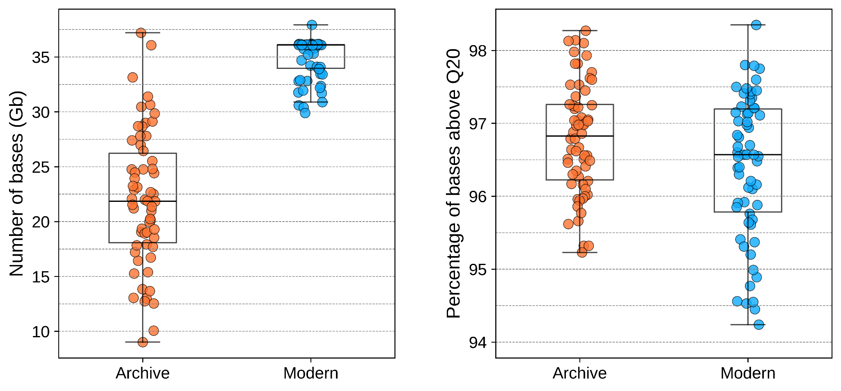 Supplementary fig. 1. Number of bases across herbarium archives and modern samples. The number of bases per individual and the percentage of high-quality bases (Q>20) after the removal of sequencing adapters and of low-quality reads.

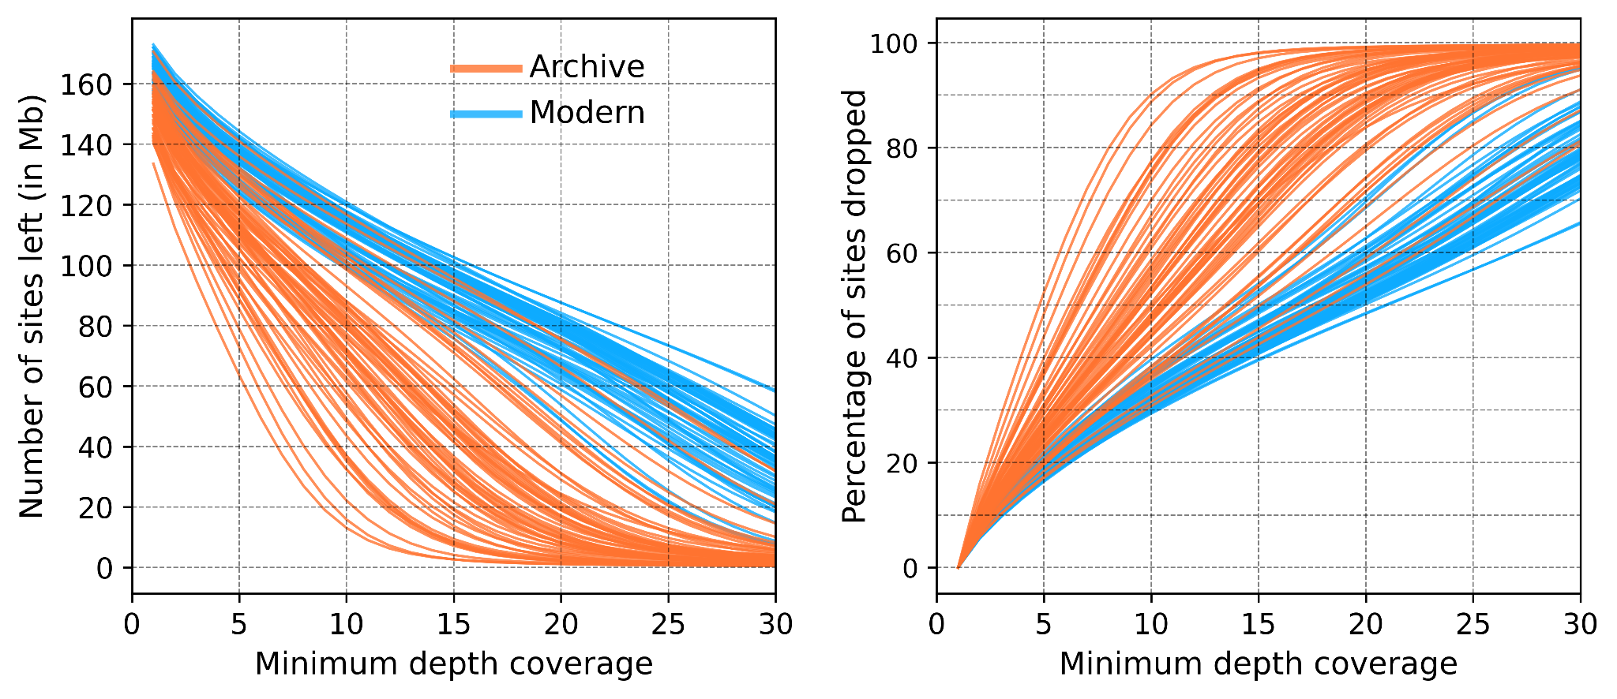 Supplementary fig. 2. Effects of minimum depth-coverage on the amount of data.
The number of high-quality sites remaining and the percentage of high-quality sites dropped after removal of sites below a minimum depth-coverage.

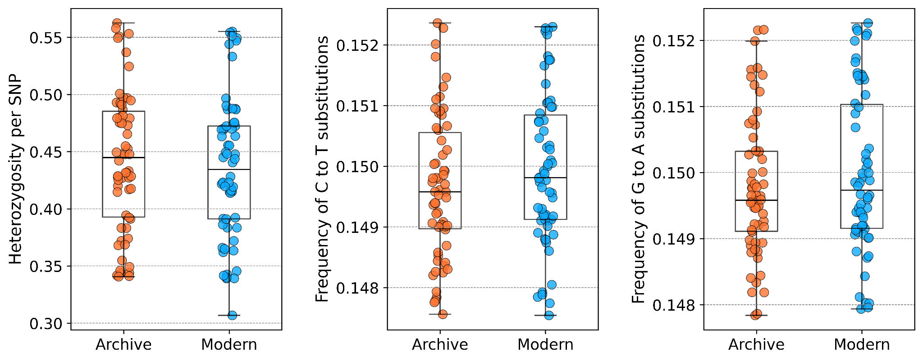

Supplementary fig. 3. Heterozygosity rate and frequency of substitutions across individuals.
The heterozygosity rate is calculated by dividing the heterozygous sites by the total number of quality-filtered SNPs for each individual. The frequency of C to T and G to A substitutions is calculated by dividing the number of the respective substitution by the total number of quality-filtered SNPs for each individual.

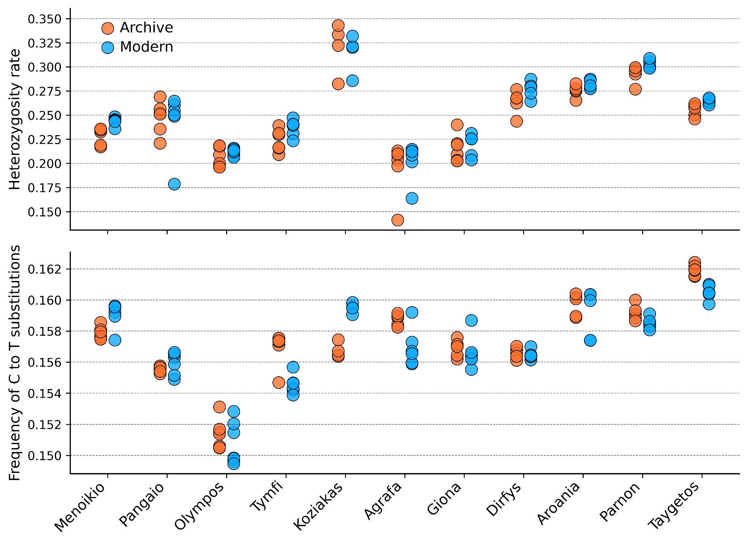 Supplementary fig. 4. Heterozygosity rate and frequency of C to T substitutions across individuals and populations.
For each population a maximum of 10% missing genotypes per site was allowed. Heterozygosity rate is calculated by dividing the number of heterozygous sites by the total number of called sites for each individual. The frequency of C to T substitutions is calculated by dividing the number of C to T substitutions by the total number of substitutions for each individual.

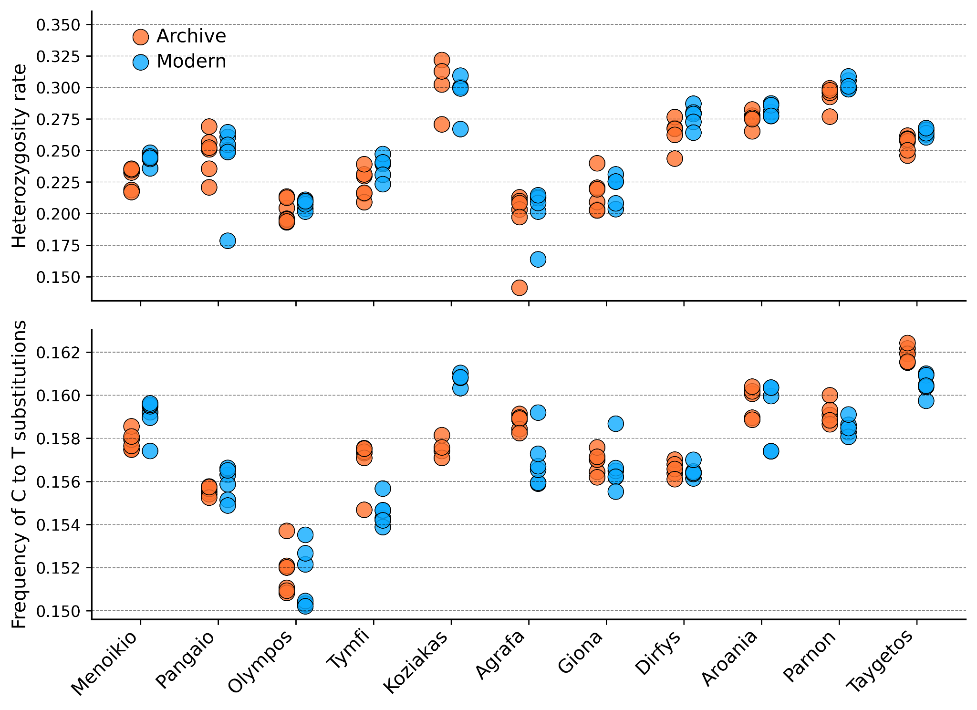 Supplementary fig. 5. Heterozygosity rate and frequency of C to T substitutions across individuals and populations.
For each population a maximum of 15% missing genotypes per site was allowed. Heterozygosity rate is calculated by dividing the number of heterozygous sites by the total number of called sites for each individual. The frequency of C to T substitutions is calculated by dividing the number of C to T substitutions by the total number of substitutions for each individual.

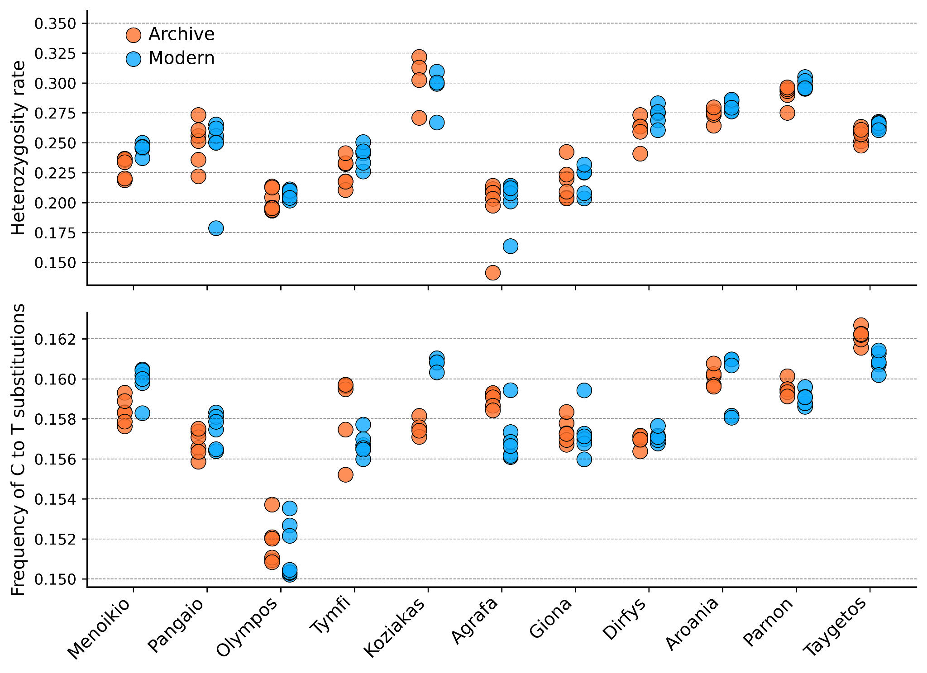 Supplementary fig. S6. Heterozygosity rate and frequency of C to T substitutions across individuals and populations.
For each population a maximum of 20% missing genotypes per site was allowed. Heterozygosity rate is calculated by dividing the number of heterozygous sites by the total number of called sites for each individual. The frequency of C to T substitutions is calculated by dividing the number of C to T substitutions by the total number of substitutions for each individual.

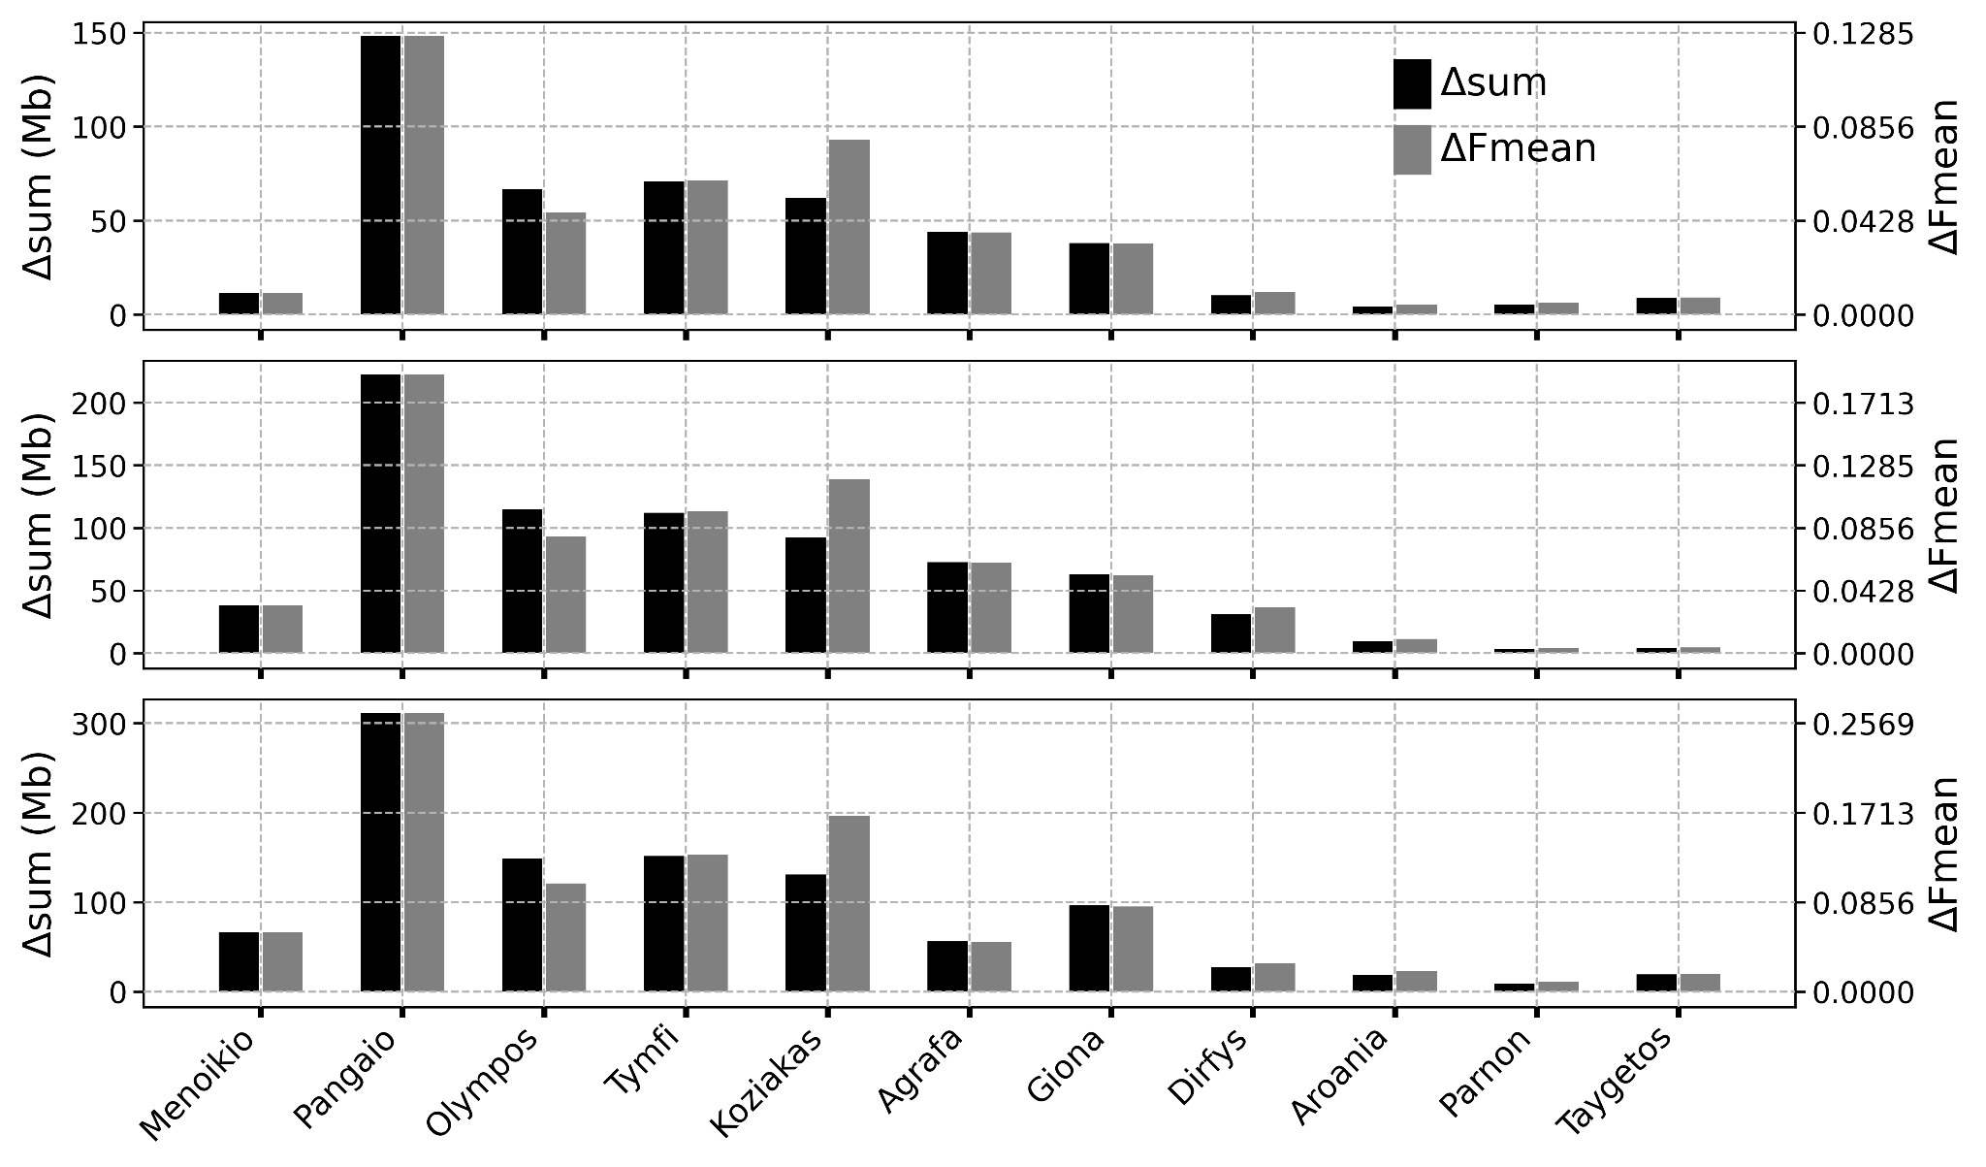 Supplementary fig. S7. Delta estimators of temporal genomic change for a minimum ROH length of 500 kb.
From top to bottom row the maximum allowed number of heterozygous sites for ROH calculations was set to one, two, and three respectively.

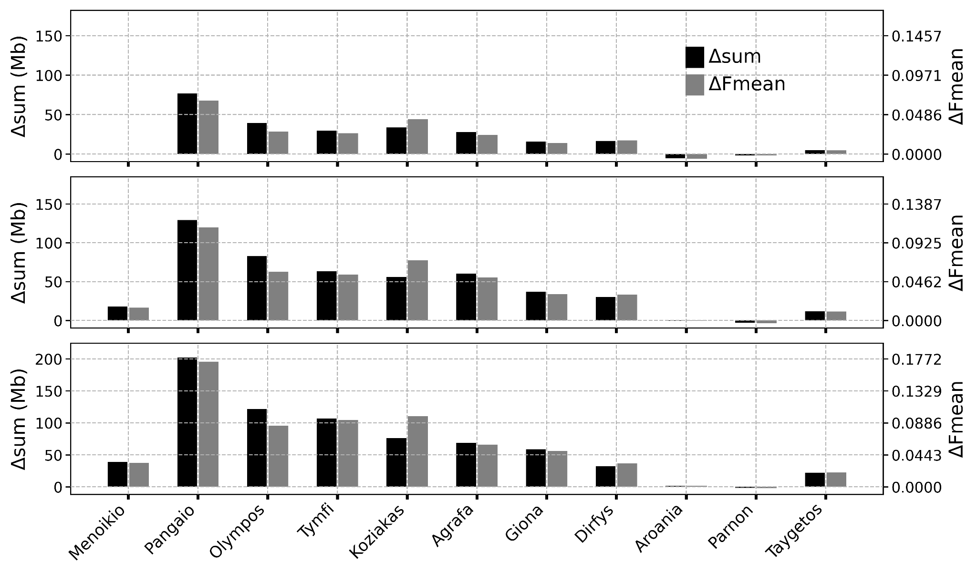 Supplementary fig. 8. Delta estimators of temporal genomic change for a minimum ROH length of 700 kb.
From top to bottom row the maximum allowed number of heterozygous sites for ROH calculations was set to one, two, and three respectively.

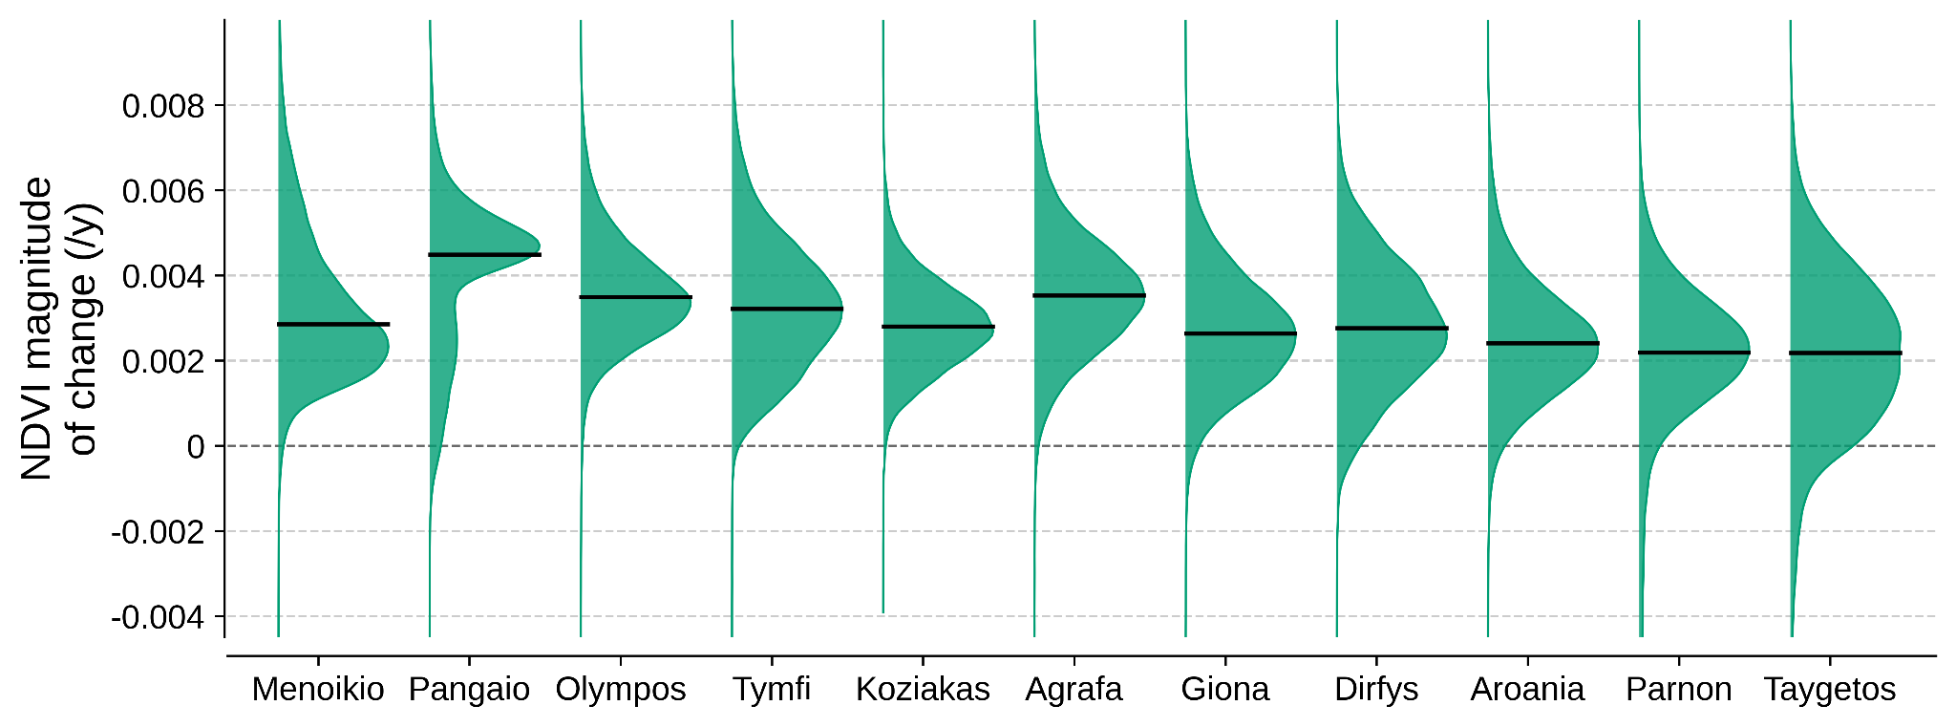 Supplementary fig. 9. The distribution of NDVI magnitudes of change across mountains.
The distributions include values of 30m pixels (grid cells) within the elevation belt that encompasses the montane and subalpine habitats of ironwort in each mountain. Black solid lines indicate the median values.

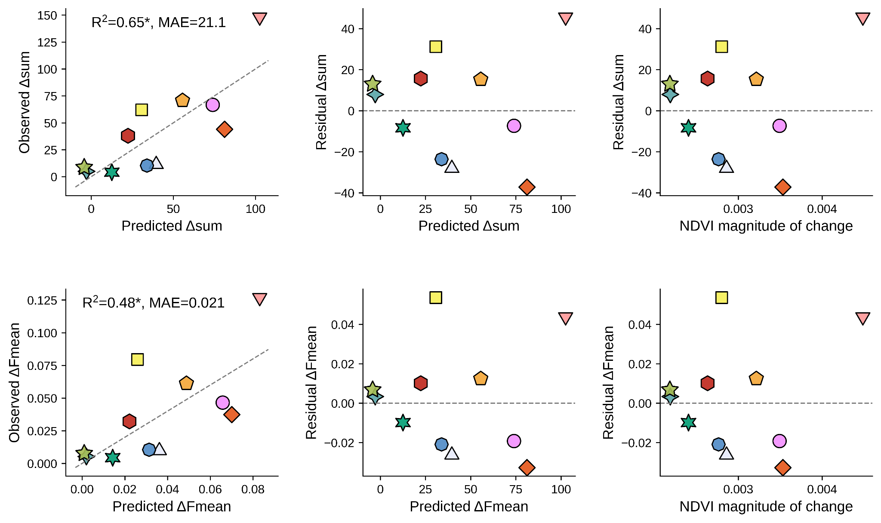 Supplementary fig. 10. Predictions of genomic erosion.
Linear regressions between predicted and observed accumulation of ROHs, and the distribution of residuals with regard to predicted values and NDVI magnitude of change (the predictor). Predictions for each population were generated using the jackknife procedure. A threshold of maximum one allowed heterozygous site per ROH was used and a minimum ROH length of 500 kb was considered. The top row shows the predictions for Δsum while the bottom row for ΔFmean. The asterisk after the R squared value indicates p<0.05. MAE=Mean Absolute Error.

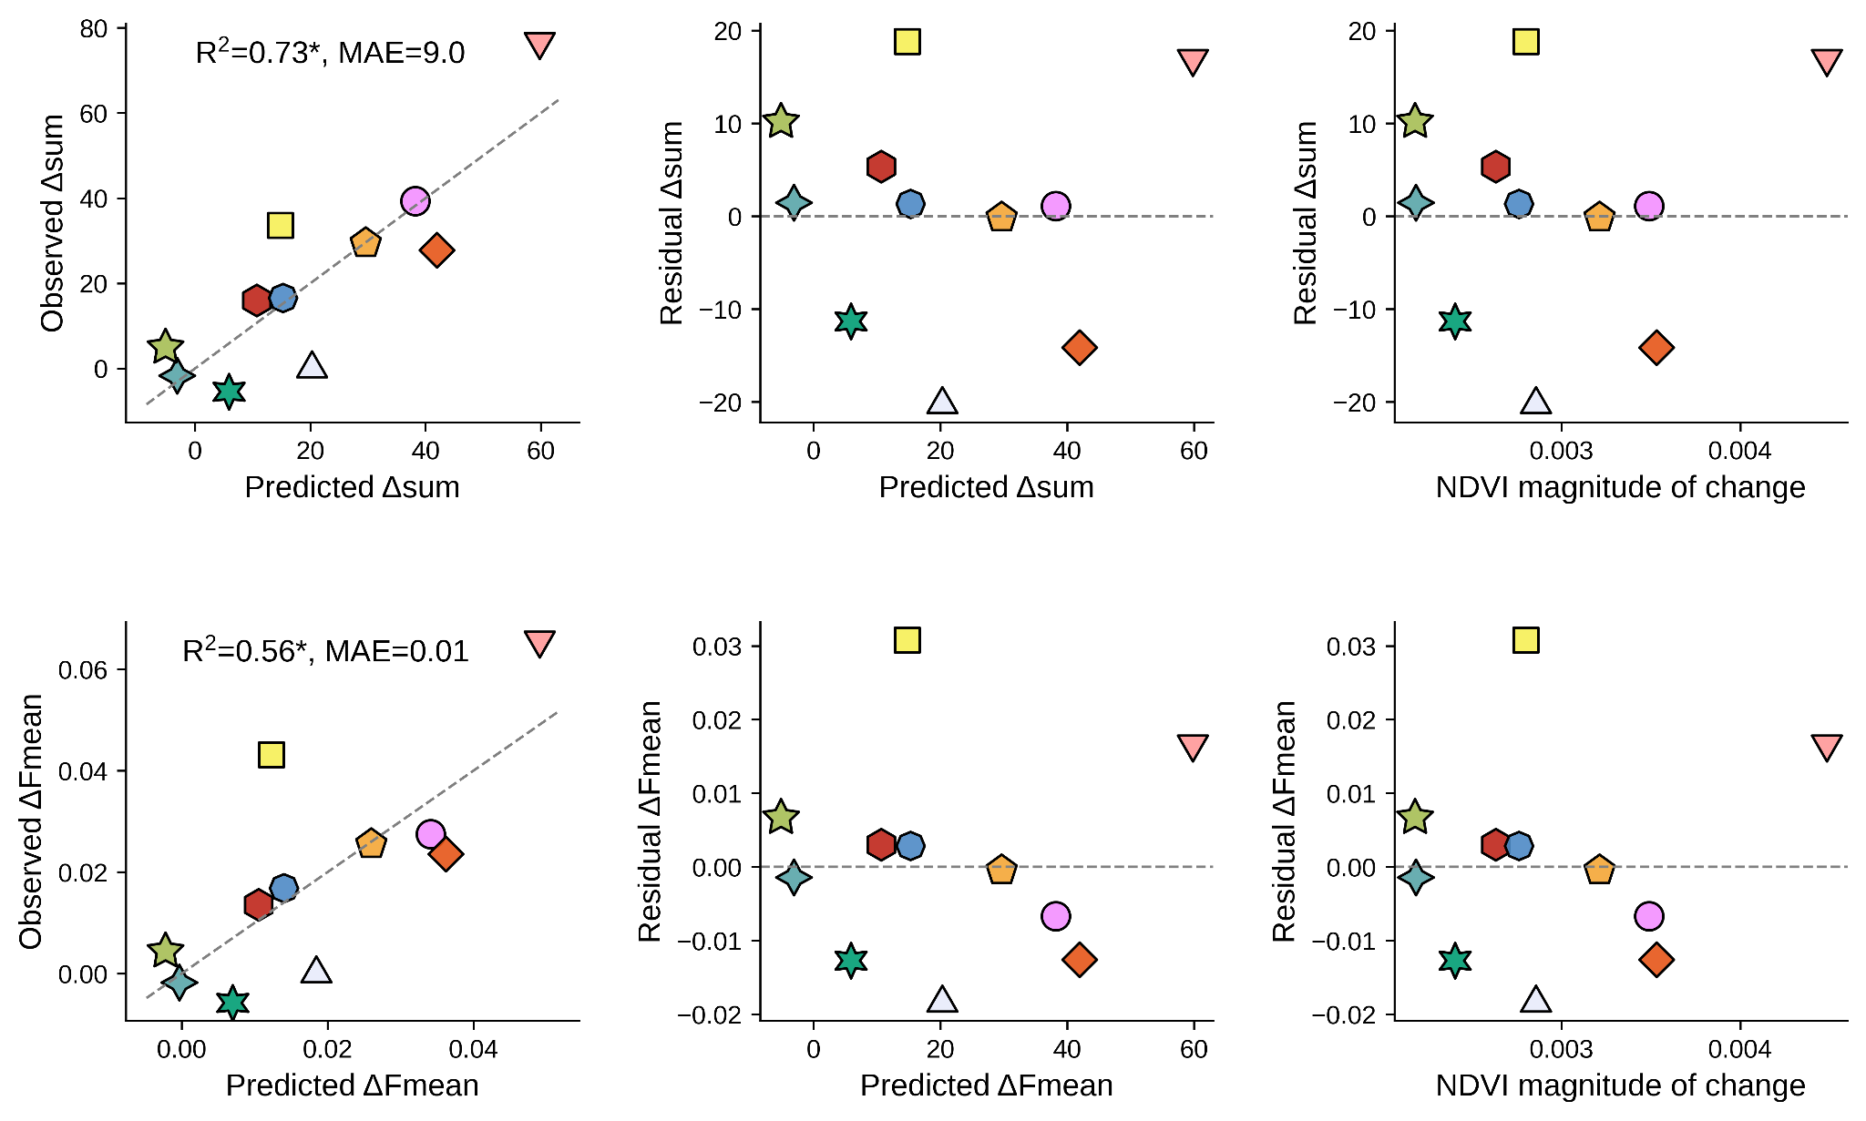 Supplementary fig. 11. Predictions of genomic erosion.
Linear regressions between predicted and observed accumulation of ROHs, and the distribution of residuals with regard to predicted values and NDVI magnitude of change (the predictor). Predictions for each population were generated using the jackknife procedure. A threshold of maximum one allowed heterozygous site per ROH was used and a minimum ROH length of 700 kb was considered. The top row shows the predictions for Δsum while the bottom row for ΔFmean. The asterisk after the R squared value indicates p<0.05. MAE=Mean Absolute Error.

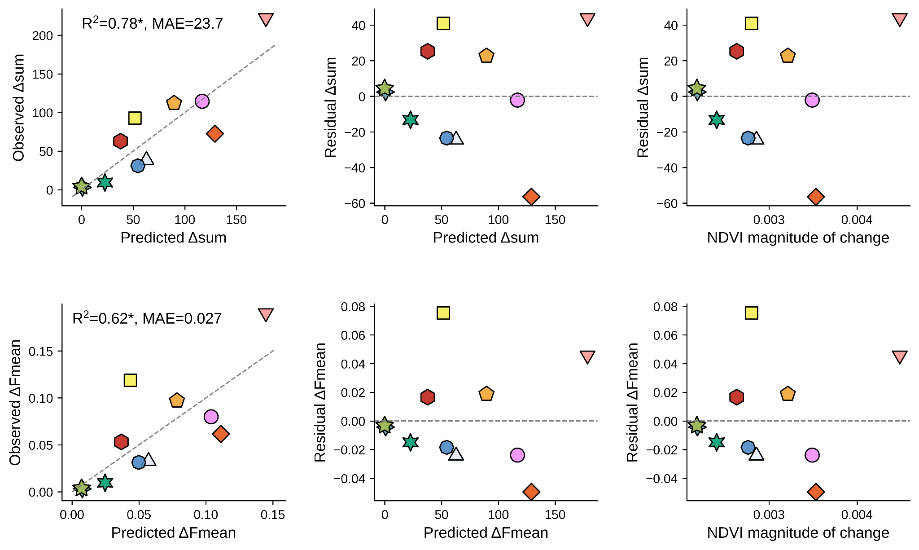 Supplementary fig. 12. Predictions of genomic erosion.
Linear regressions between predicted and observed accumulation of ROHs, and the distribution of residuals with regard to predicted values and NDVI magnitude of change (the predictor). Predictions for each population were generated using the jackknife procedure. A threshold of maximum two allowed heterozygous sites per ROH was used and a minimum ROH length of 500 kb was considered. The top row shows the predictions for Δsum while the bottom row for ΔFmean. The asterisk after the R squared value indicates p<0.05. MAE=Mean Absolute Error.

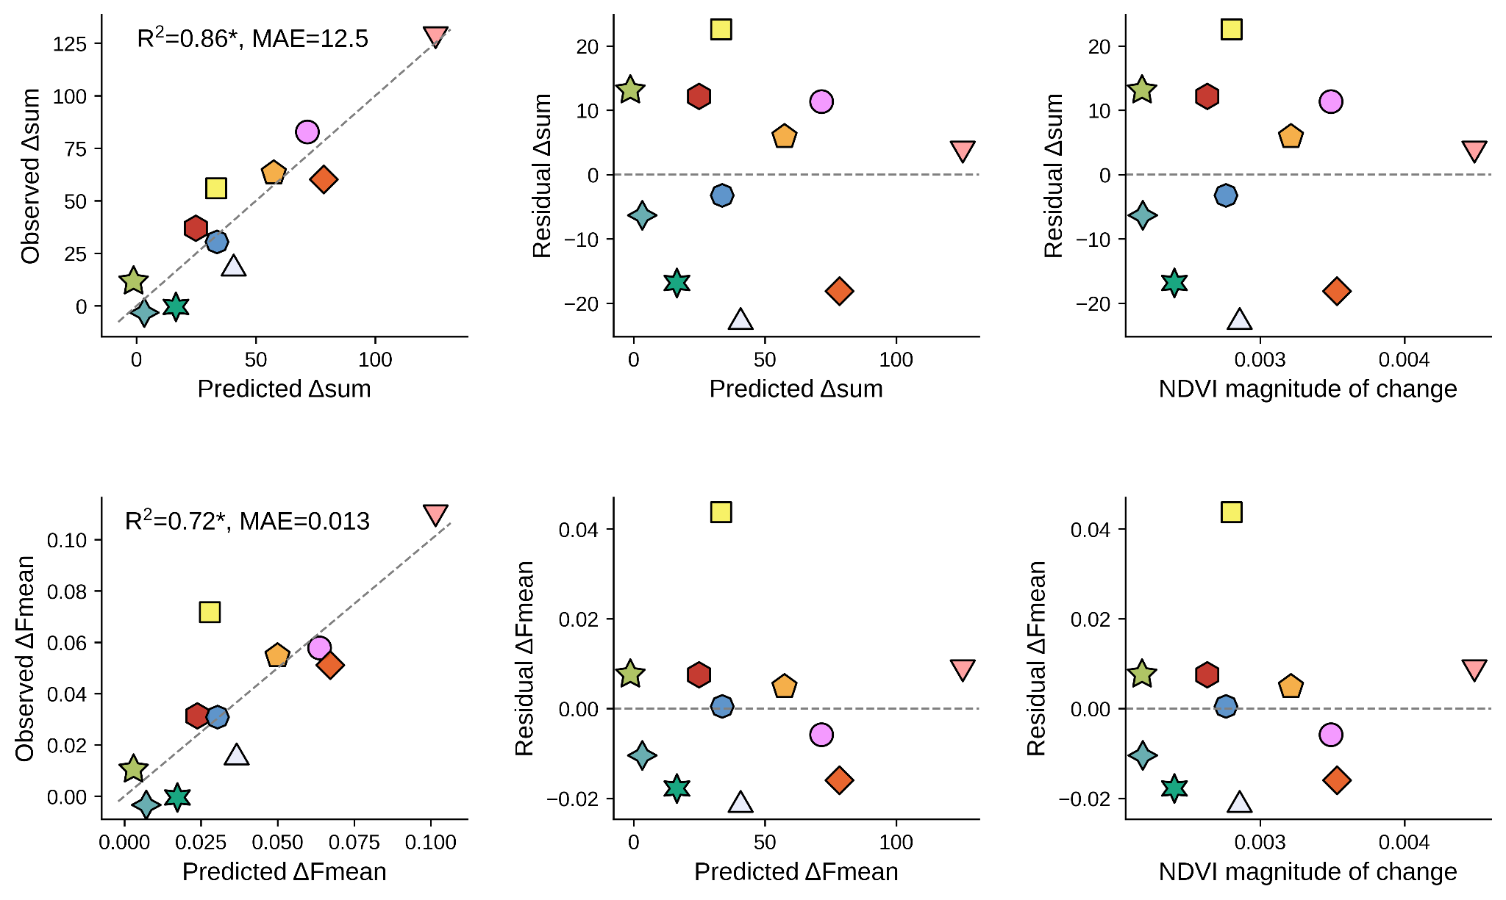 Supplementary fig. 13. Predictions of genomic erosion.
Linear regressions between predicted and observed accumulation of ROHs, and the distribution of residuals with regard to predicted values and NDVI magnitude of change (the predictor). Predictions for each population were generated using the jackknife procedure. A threshold of maximum two allowed heterozygous sites per ROH was used and a minimum ROH length of 700 kb was considered. The top row shows the predictions for Δsum while the bottom row for ΔFmean. The asterisk after the R squared value indicates p<0.05. MAE=Mean Absolute Error. These estimates were used in the main text.

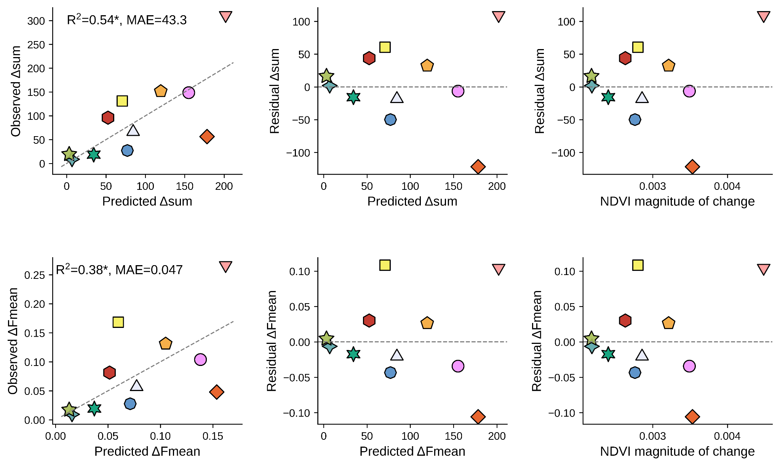 Supplementary fig. 14. Predictions of genomic erosion.
Linear regressions between predicted and observed accumulation of ROHs, and the distribution of residuals with regard to predicted values and NDVI magnitude of change (the predictor). Predictions for each population were generated using the jackknife procedure. A threshold of maximum three allowed heterozygous sites per ROH was used and a minimum ROH length of 500 kb was considered. The top row shows the predictions for Δsum while the bottom row for ΔFmean. The asterisk after the R squared value indicates p<0.05. MAE=Mean Absolute Error.

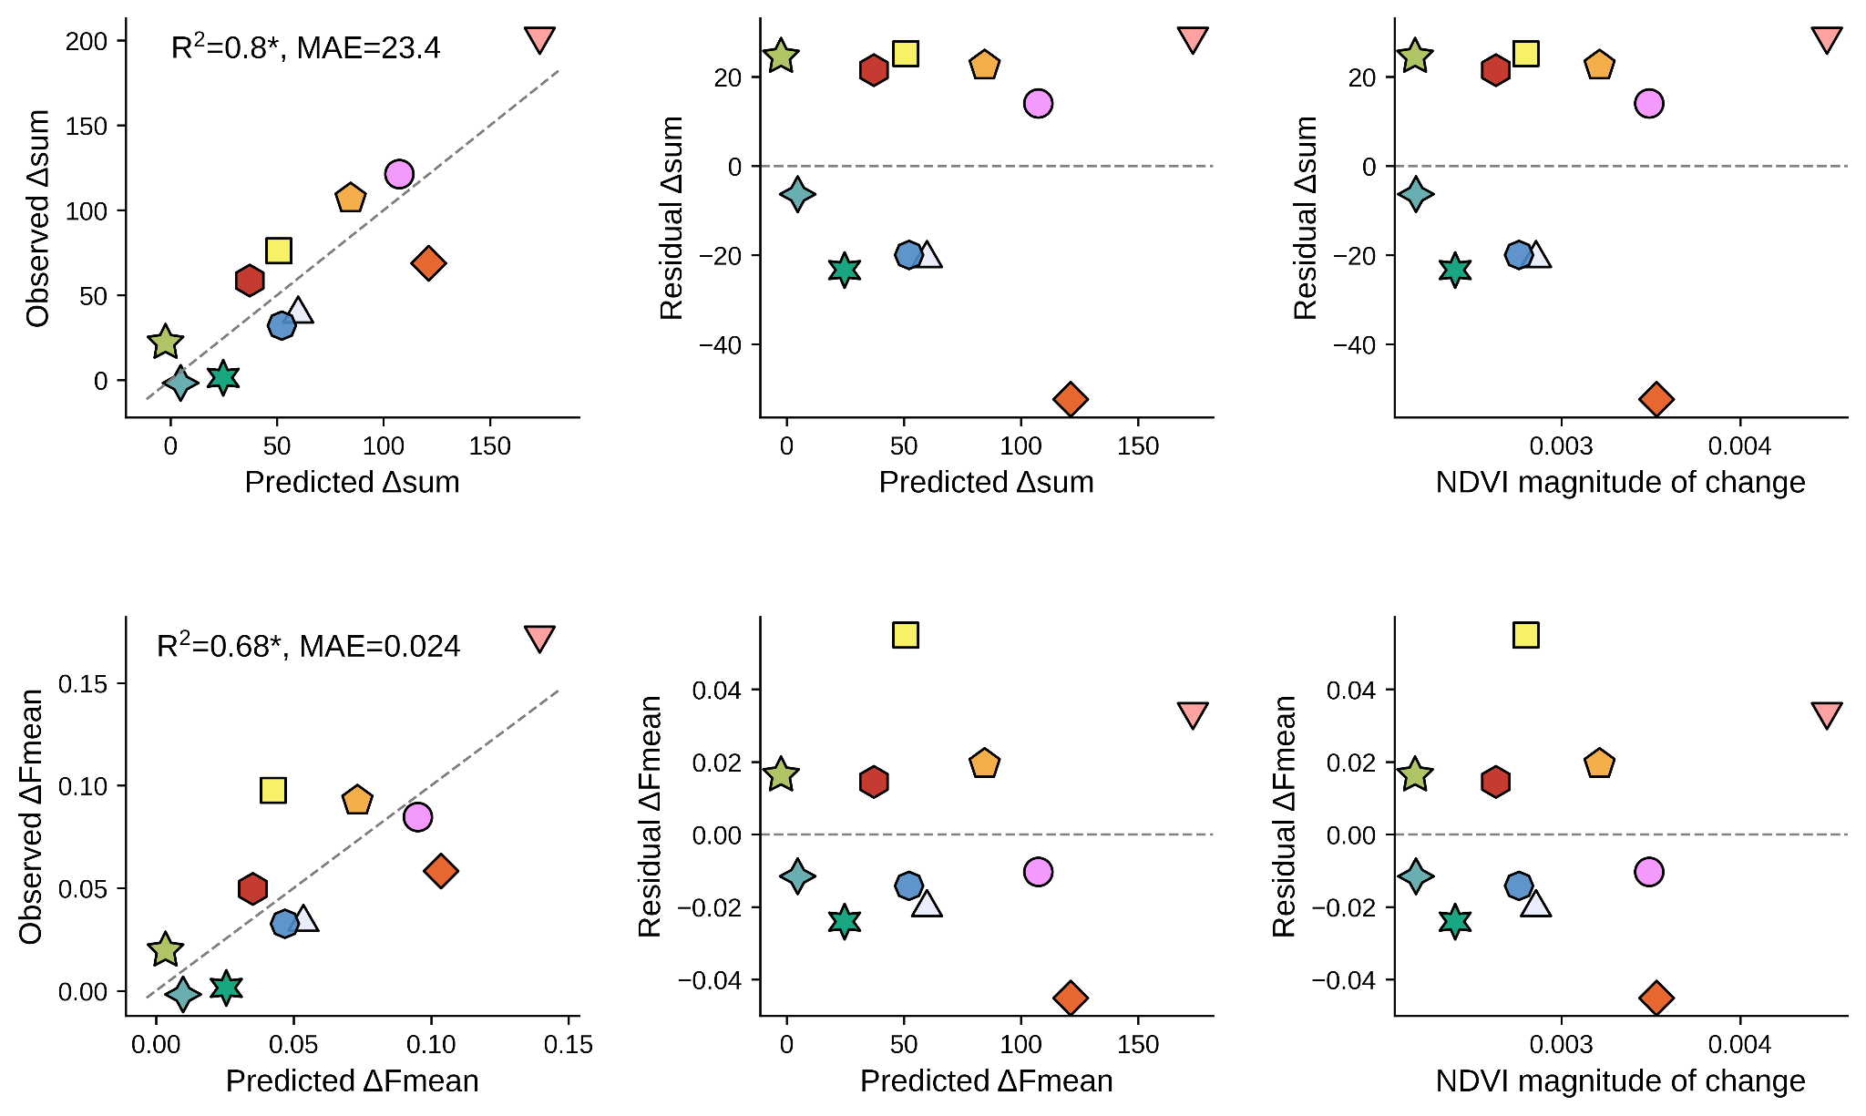 Supplementary fig. 15. Predictions of genomic erosion.
Linear regressions between predicted and observed accumulation of ROHs, and the distribution of residuals with regard to predicted values and NDVI magnitude of change (the predictor). Predictions for each population were generated using the jackknife procedure. A threshold of maximum three allowed heterozygous sites per ROH was used and a minimum ROH length of 700 kb was considered. The top row shows the predictions for Δsum while the bottom row for ΔFmean. The asterisk after the R squared value indicates p<0.05. MAE=Mean Absolute Error.

Supplementary Table 1. Herbarium archive and modern sample information.
Individual codes and sequencing IDs in parentheses, collection date, and locality description (longitude and latitudes for modern samples) are provided for each mountain. Herbaria codes: ATH (Goulandris Natural History Museum), CP (University of Copenhagen), LD (Lund University)
Archived samples |  |  | Modern samples
Herbarium code (Sequencing ID) | Collection date | Locality description | Code  (Sequencing ID) | Collection  date | Lon | Lat | Elevation
S. scardica
Menoikio
ATH13037 (h49) | 19/6/1956 | From Grekika Kalivia to Karpa, 1900m | MEN16 (s49) | 12/8/2020 | 23.71566 | 41.16697 | 1842
CP16153a (h50) | 20/7/1978 | Above Mikropolis, 1550-1850m | MEN44 (s50) | 26/4/2021 | 23.76713 | 41.19709 | 1671
CP16153b (h51) | 20/7/1978 | Above Mikropolis, 1550-1850m | MEN46 (s51) | 26/4/2021 | 23.76646 | 41.19784 | 1711
CP18619b (h52) | 5/7/1981 | NNE of the summit, by end of forest road ascending from the village of Mikropolis (14 km from the village), 1500-1600m, Grassy subalpine meadows. | MEN52 (s52) | 26/4/2021 | 23.76518 | 41.19582 | 1719
CP18619c (h53) | 5/7/1981 | NNE of the summit, by end of forest road ascending from the village of Mikropolis (14 km from the village), 1500-1600m, Grassy subalpine meadows. | MEN54 (s53) | 26/4/2021 | 23.76593 | 41.19510 | 1672
CP18619a (h63) | 5/7/1981 | NNE of the summit, by end of forest road ascending from the village of Mikropolis (14 km from the village), 1500-1600m, Grassy subalpine meadows. | MEN48 (s63) | 26/4/2021 | 23.76570 | 41.19791 | 1724
Pangaio
ATH13034 (h44) | 30/8/1959 | Mati. 1830m | PAN03 (s44) | 14/6/2020 | 24.08935 | 40.91332 | 1921
CP15328a (h45) | 28/7/1977 | Towards Trikorfo summit, 1600m, Alpine grasslands | PAN06 (s45) | 14/8/2020 | 24.08859 | 40.93816 | 1454
CP15328b (h46) | 28/7/1977 | Towards Trikorfo summit, 1600m, Alpine grasslands | PAN15 (s46) | 14/8/2020 | 24.09072 | 40.93407 | 1608
ATH42198a (h47) | 28/7/1977 | Trikorfos, 1600m | PAN25 (s47) | 14/8/2020 | 24.08883 | 40.92451 | 1860
ATH42198b (h48) | 28/7/1977 | Trikorfos, 1600m | PAN27 (s48) | 14/8/2020 | 24.08237 | 40.92541 | 1740
CP107a (h62) | 12/7/1977 | N part of the summit area, Place called Lofkes, 1600-1700m, Rocky alpine grassland | PAN28 (s62) | 14/8/2020 | 24.08633 | 40.93326 | 1515
Olympos
ATH40754a (h36) | 28/7/1978 | N of the refuge "Spilios Agapitos". Apostolidis ravine, 2050-2150, sandy stony ground | OLY19 (s36) | 7/8/2020 | 22.37681 | 40.08224 | 1803
ATH40754b (h37) | 28/7/1978 | N of the refuge "Spilios Agapitos". Apostolidis ravine, 2050-2150, sandy stony ground | OLY22 (s38) | 7/8/2020 | 22.37422 | 40.08211 | 1921
ATH5776a (h38) | 1/8/1968 | E side of Mt. Olymbos, in ravine SE and below the refuge A "Spilios Agapitos", 2000-2100m, steep rocky slides, screes and gravel at the bottom of the ravine | OLY25 (s39) | 7/8/2020 | 22.37347 | 40.08285 | 1991
ATH5777a (h39) | 1/8/1968 | E side of Mt. Olymbos, "Apostolidis" ravine, N of the refugeA "Spilios Agapitos", 2050-2150m, rocky slopes, screes and gravel at the bottom of the ravine | OLY26 (s40) | 7/8/2020 | 22.37289 | 40.08250 | 1997
CP9408a (h41) | 17/8/1975 | Surroundings of Hellenic Alpine Club Refuge A, 2000-2150m, Pinus heldreichii woodland and limestone ravines | OLY27 (s41) | 7/8/2020 | 22.37247 | 40.08098 | 2025
CP9408b (h42) | 17/8/1975 | Surroundings of Hellenic Alpine Club Refuge A, 2000-2150m, Pinus heldreichii woodland and limestone ravines | OLY28 (s42) | 7/8/2020 | 22.37221 | 40.08089 | 2040
CP12328 (h43) | 5/8/1978 | E side, Mavrolongos valley between Prionia and Refuge A, 1600m, Open, rocky places in Pinus nigra/heldreichii woodland | OLY29 (s43) | 7/8/2020 | 22.37200 | 40.08081 | 2062
S. raeseri
Tymfi
ATH5793 (h31) | 7/7/1979 | W part of Mt. Timfi (Gamila), around the EOS Katafigion 4 km ENE of the village "Mikron Papingon", 1850-1900m | TYM04 (s31) | 31/7/2020 | 20.75465 | 39.97616 | 1568
ATH43546a (h32) | 7/7/1979 | N Pindhos, W part of Mt. Timfi (Gamila), 4-4,5 km ENE of the village "Mikron Papingon", N of the EOS Katafigion along the ridge to Koutsomitros summit, 1850-2000m, dry alpine pastures with rocky outcrops and E facingrocky slopes. | TYM09 (s32) | 31/7/2020 | 20.76759 | 39.97846 | 1900
ATH43546b (h33) | 7/7/1979 | N Pindhos, W part of Mt. Timfi (Gamila), 4-4,5 km ENE of the village "Mikron Papingon", N of the EOS Katafigion along the ridge to Koutsomitros summit, 1850-2000m, dry alpine pastures with rocky outcrops and E facingrocky slopes. | TYM11 (s33) | 31/7/2020 | 20.76709 | 39.98079 | 1936
ATH42114a (h34) | 23/7/1977 | Around refuge EOS, 1800m | TYM16 (s34) | 31/7/2020 | 20.76893 | 39.97990 | 1894
ATH42114b (h61) | 23/7/1977 | Around refuge EOS, 1800m | TYM26 (s35) | 1/8/2020 | 20.77082 | 39.979428 | 1811
CP15458 (h35) | 7/7/1979 | W part around the EOS katafygion, above the village of Mikro Papigon, 1900-2050, subalpine meadows and rocks | TYM24 (s61) | 1/8/2020 | 20.77201 | 39.97868 | 1784
Koziakas
LD1462898 (h21) | 7/7/1972 | 5 km NE of Pertouli, rocky S slope, NW of the E.M.O.T. cabin, 1750-1900m | KOZ01 (s21) | 22/7/2020 | 21.52694 | 39.54616 | 1591
LD1462658 (h22) | 7/7/1972 | 5 km NE of Pertouli, rocky S slope, NW of the E.M.O.T. cabin, 1750-1900m | KOZ04 (s22) | 22/7/2020 | 21.52674 | 39.54754 | 1609
LD1463033 (h23) | 28/61971 | 11 km NW of Pili (near Elati), dry limestone cliffs, 1800m | KOZ08 (s23) | 22/7/2020 | 21.53623 | 39.54705 | 1863
LD1426427 (h24) | 7/8/1974 | 6 km E of Pertoulion, dry W-slope slope with Juniperus and Eryngium, some rocks, 1750-1850m | KOZ13 (s24) | 22/7/2020 | 21.53519 | 39.54685 | 1854
Agrafa
LD1463798 (h25) | 22/6/1971 | Mt Mazur, 3 km ESE of Argidea, W-facing slope with small cliffs, 1750-1800m | AGR07 (s25) | 24/7/2020 | 21.56210 | 39.30997 | 1985
LD1426487 (h26) | 13/7/1974 | Mt Karava, 3 km NW of Vlasion, dry and grazed SE slope below the top, 2050-2150m | AGR12 (s26) | 24/7/2020 | 21.55218 | 39.31359 | 1891
LD1463018 (h27) | 14/6/1971 | Mt Kazarma, 4 km NE of Vlasion, W-facing slope scree with small cliffs, 1800m | AGR16 (s27) | 25/7/2020 | 21.62585 | 39.31549 | 1792
LD1462778 (h28) | 14/7/1974 | Mt. Kazarma, 4.5 km NNE of Vlasion, rocks and ledges facing NW, 1760m | AGR18 (s28) | 25/7/2020 | 21.62624 | 39.31873 | 1772
LD1462838 (h29) | 15/7/1974 | Mt Voutsikaki, 4.5 km ESE of Vlasion, rocks and dry E-slope near the top, 2100m | AGR25 (s29) | 25/7/2020 | 21.63139 | 39.28009 | 2084
LD1462718 (h30) | 15/7/1974 | Mt Voutsikaki, 4.5 km ESE of Vlasion, rocks and dry E-slope near the top, 2100m | AGR28 (s30) | 25/7/2020 | 21.63204 | 39.28072 | 2058
Giona
ATH44501a (h16) | 12/8/1980 | NE of the summit, 2100-2200m, E facing scree and rocks | GIO25 (s16) | 11/7/2020 | 22.25662 | 38.64787 | 2295
ATH44501b (h17) | 12/8/1980 | NE of the summit, 2100-2200m, E facing scree and rocks | GIO28 (s17) | 11/7/2020 | 22.25874 | 38.64927 | 2170
CP918a (h18) | 12/8/1980 | NE of the summit, 2100-2200m, E facing scree and rocks | GIO29 (s18) | 11/7/2020 | 22.26000 | 38.64975 | 2095
CP918c (h19) | 12/8/1980 | NE of the summit, 2100-2200m, E facing scree and rocks | GIO30 (s19) | 11/7/2020 | 22.26049 | 38.65026 | 2057
CP918b (h20) | 12/8/1980 | NE of the summit, 2100-2200m, E facing scree and rocks | GIO31 (s20) | 11/7/2020 | 22.26074 | 38.65101 | 2027
LD1426187 (h60) | 17/8/1973 | 3 km E of Sikea, small limestone cliffs and gravel facing E, 2425m | GIO24 (s60) | 11/7/2020 | 22.25276 | 38.64202 | 2385
S. euboea
Dirfys
ATH46727 (h11) | 15/7/1980 | W-facing slope, 1500m | DIR20 (s12) | 18/7/2020 | 23.85761 | 38.62157 | 990
ATH5788a (h12) | 28/9/1968 | Summit area of Mt. Dhirfis, from the EOS refuge 1150m up to the peak 1740m, open stony-rocky limestone slopes and dry meadows | DIR21 (s13) | 18/7/2020 | 23.85820 | 38.62211 | 978
LD1497680 (h14) | 19/7/1966 | 6-7 km NE of the village of Steni (NE of Khalkis), rocks and rocky slope facing W, 930m | DIR23 (s14) | 18/7/2020 | 23.85097 | 38.61795 | 1158
LD1497740 (h15) | 19/7/1966 | 6-7 km NE of the village of Steni (NE of Khalkis), rocks and rocky slope facing W, 930m | DIR26 (s15) | 18/7/2020 | 23.85225 | 38.61925 | 1157
ATH5788c (h59) | 28/9/1968 | Summit area of Mt. Dhirfis, from the EOS refuge 1150m up to the peak 1740m, open stony-rocky limestone slopes and dry meadows | DIR24 (s59) | 18/7/2020 | 23.85161 | 38.61859 | 1137
S. clandestina
Aroania
ATH46714a (h54) | 31/7/1980 | 3.5 km. SW of the village Zaroukla, on a N-S lined ridge, 1600-1700m, small cliffs, rocky or stony ground, W-facing slope | ARO02 (s54) | 13/7/2021 | 22.25267 | 37.93630 | 1540
ATH46714b (h55) | 31/7/1980 | 3.5 km. SW of the village Zaroukla, on a N-S lined ridge, 1600-1700m, small cliffs, rocky or stony ground, W-facing slope | ARO06 (s55) | 13/7/2021 | 22.25310 | 37.93752 | 1565
ATH46714c (h56) | 31/7/1980 | 3.5 km. SW of the village Zaroukla, on a N-S lined ridge, 1600-1700m, small cliffs, rocky or stony ground, W-facing slope | ARO16 (s56) | 13/7/2021 | 22.25200 | 37.94288 | 1639
LD1120302 (h57) | 9/9/1970 | 3.5 km SW of Zarouchla. NE-facing ravine, 1480-1570m | ARO25 (s57) | 13/7/2021 | 22.24888 | 37.94702 | 1737
LD1120842 (h58) | 2/8/1968 | 3.5 km SSW of Zaroukla, calcareous mountain ridge, cliffs and splinters, 1700-1800m | ARO38 (s58) | 13/7/2021 | 22.24722 | 37.94243 | 1766
Parnon
ATH16571b (h6) | 5/7/1971 | S. of the plateau "Profitis Ilias", on woody slopes of Megali Tourla summit, 1500-1600m, Dry rocky limestone ground with Abies trees, on both sides of a big ravine | PRN87 (s6) | 5/6/2021 | 22.60916 | 37.26768 | 1525
ATH23891 (h7) | 32/7/1971 | S. of the plateau "Profitis Ilias", on woody slopes of Megali Tourla summit, 1700-1900m | PRN92 (s7) | 5/6/2021 | 22.60947 | 37.27189 | 1620
LD1101985 (h8) | 9/6/1969 | Megala Tourla, 3 km W of Kastanitsa, 1650m | PRN95 (s8) | 5/6/2021 | 22.60783 | 37.27545 | 1673
LD1128625 (h9) | 6/9/1970 | Megala Tourla, 3.5 km W of Kastanitsa, slopes and ridge with stones and gravel, 1500-1550m | PRN110 (s9) | 5/6/2021 | 22.61058 | 37.28267 | 1732
CP13306a (h10) | 13/7/1971 | Megali Tourla, 1700-1900m | PRN128 (s10) | 5/6/2021 | 22.60956 | 37.27857 | 1754
Taygetos
ATH44482a (h1) | 19/7/1980 | 1 km NE of the summit of Prof. Elias, along the path from the refuge to the summit, 1800-2000m, stony grassland | TAY70 (s1) | 2/6/2021 | 22.36343 | 36.95421 | 1705
ATH46699a (h2) | 19/7/1980 | 1 km NE of the summit of Prof. Elias, along the path from the refuge to the summit, 1800-2000m, stony grassland | TAY76 (s2) | 2/6/2021 | 22.36127 | 36.955819 | 1772
CP631b (h3) | 19/7/1980 | 1 KM NE of the summit of Prof. Elias, along the path from refuge to the summit, 1800-2000m, stony grassland | TAY81 (s3) | 2/6/2021 | 22.36059 | 36.95835 | 1833
LD1101865 (h4) | 2/7/1969 | 1.5 km SE of Prof. Elias, E-facing slope, 1620-1770m | TAY90 (s4) | 2/6/2021 | 22.35547 | 36.96020 | 2097
LD1101767 (h5) | 13/9/1970 | 1 km NE of Profitis Elias, rocky NE-facing slopes, 1800-2130m | TAY101 (s5) | 2/6/2021 | 22.36661 | 36.95020 | 1584
CP631a (h64) | 19/7/1980 | 1 KM NE of the summit of Prof. Elias, along the path from refuge to the summit, 1800-2000m, stony grassland | TAY83 (s64) | 2/6/2021 | 22.35940 | 36.95861 | 1872

Supplementary Table 2. Genome assembly steps.
After each step the total number of sequences, the total genome length, the N50 score, and BUSCO statistics are provided. The embryophyta_odb10 (1’614 genes) database was used for the estimation of completeness and duplication.
Genome assembly step | Number of sequences | Total length (Gb) | N50 (Mb) | Busco completeness and duplication (%)
CANU v2.2 | 4,346 | 1.268 | 0.99 | 98.8, 39.4
Purge Haplotigs v1.1.2 | 2,287 | 1.151 | 1.33 | 98.8, 34.7
Pseudohaploid | 1,601 | 1.073 | 1.55 | 98.7, 25.2
SALSA v2.3 | 1,015 | 1’074 | 4.62 | 98.7, 25.3
SSPACE-LongRead v1.1 | 879 | 1’074 | 4.98 | 98.7, 25.3
SSPACE Standard v3.0 | 828 | 1’074 | 4.98 | 98.7, 25.3
SALSA v2.3 | 800 | 1’074 | 6.5 | 98.7, 25.2
SSPACE Standard v3.0 | 728 | 1’074 | 7.2 | 98.7, 25.3

Supplementary Table 3. Total number of called sites and number of retained SNPs across different missing genotype thresholds.
The total number of called sites represents the utilized genome size after the exclusion of repetitive regions and low-quality reads. The number of high-quality SNPs per population under different missing genotype thresholds per population is provided.
Population | All sites (utilized genome size) | Number of SNPs (10%) | Number of SNPs (15%) | Number of SNPs (20%)
Menoikio | 194,767,543 | 1,563,626 | 1,563,626 | 1,731,366
Pangaio | 194,608,706 | 1,364,269 | 1,364,269 | 1,572,317
Olympos | 204,551,260 | 2,015,080 | 2,275,944 | 2,275,944
Tymfi | 192,534,721 | 1,578,030 | 1,578,030 | 1,800,988
Koziakas | 194,856,321 | 1,288,370 | 1,634,459 | 1,634,459
Agrafa | 196,252,777 | 2,378,546 | 2,378,546 | 2,543,772
Giona | 196,827,550 | 2,183,521 | 2,183,521 | 2,402,402
Dirfys | 197,297,379 | 1,832,571 | 1,832,571 | 2,008,126
Aroania | 190,852,886 | 1,670,617 | 1,670,617 | 1,927,230
Parnon | 188,693,001 | 1,690,179 | 1,690,179 | 1,865,642
Taygetos | 186,388,176 | 1,992,306 | 1,992,306 | 2,146,364

Supplementary Table 4. Number of retrieved satellite images across populations and sensors.
The total number of images retrieved for the years 1984 to 2022 and for the months April to September.
Mountain | Landsat 4  LT04 | Landsat 5  LT05 | Landsat 7  LE07 | Landsat 8  LC08 | Landsat 9  LC09
Menoikio | 16 | 712 | 617 | 329 | 34
Pangaio | 9 | 561 | 485 | 220 | 22
Olympos | 6 | 230 | 231 | 109 | 12
Tymfi | 4 | 226 | 229 | 114 | 11
Koziakas | 13 | 691 | 602 | 342 | 34
Agrafa | 9 | 509 | 402 | 341 | 34
Giona | 12 | 471 | 418 | 334 | 34
Dirfys | 10 | 454 | 414 | 149 | 20
Aroania | 10 | 702 | 629 | 333 | 35
Parnon | 4 | 434 | 411 | 220 | 23
Taygetos | 6 | 706 | 607 | 333 | 34

Supplementary Table 5. Correction parameters for harmonizing Landsat imagery across sensors.
Slope and intercept of the linear regression that was used to harmonize the Normalized Difference Vegetation Index (NDVI) between Landsat 4,5,7,8, and 9 satellite sensors across mountains.
 | Landsat 4 & 5 to Landsat 7 |  | Landsat 8 and 9 to Landsat 7
Mountain | Intercept | Slope | Intercept | Slope
Menoikio | 0.018 | 0.99 | -0.053 | 1.016
Pangaio | 0.209 | 0.601 | -0.018 | 0.949
Olympos | 0.055 | 0.929 | -0.022 | 0.984
Tymfi | 0.023 | 1.011 | -0.006 | 0.956
Koziakas | 0.065 | 0.929 | -0.018 | 0.979
Agrafa | 0.032 | 0.974 | -0.026 | 0.985
Giona | 0.044 | 0.958 | -0.022 | 0.979
Dirfys | 0.045 | 0.961 | -0.015 | 0.947
Aroania | 0.034 | 0.989 | -0.025 | 0.981
Parnon | 0.03 | 1 | -0.018 | 0.97
Taygetos | 0.059 | 0.95 | -0.028 | 0.994

Supplementary Table 6. Jackknife estimates of model parameters.
The bias-corrected intercept (a) and slope (b) were estimated for three different thresholds of maximum allowed heterozygous sites for ROH calculation.
 | ROHs > 500Kb |  |  |  | ROHs > 700Kb
 | Δsum |  | ΔFmean |  | Δsum |  | ΔFmean
Allowed  heterozygosity | $$\hat{a}$$ | $$\hat{b}$$ | $$\hat{a}$$ | $$\hat{b}$$ | $$\hat{a}$$ | $$\hat{b}$$ | $$\hat{a}$$ | $$\hat{b}$$
1 | -142.91 | 63,403 | -0.12 | 52.7 | -78.35 | 34,032.2 | -0.06 | 28.4
2 | -209.78 | 94,925.5 | -0.17 | 78.9 | -119.4 | 55,299.9 | -0.1 | 45.9
3 | -282.97 | 128,947.1 | -0.23 | 106.9 | -185.83 | 85,553.1 | -0.15 | 71.3

