Excised | Postoperative  Complication
n=66;  47,5% | n=13;  19,7%
n=33;  23,7% | n=6;  18,6%
n=22;  15.8% | n=0; 0%  (p=0,03)
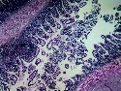
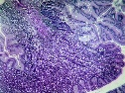
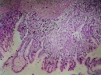
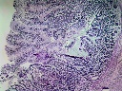
Base HM n=0; 0%

No HM n=73; 60,3%
Entire HM n=5; 10,4%

Tip HM n=11; 22,9%

Mid HM n=32; 66,7%

Simple
Diverticulectomy
Wedge
Resection
Segmental
Resection
TOTAL EXCİSED (n=121)
n=117
Length of MD (p=0,01 r=0,31) | 3,2±1,6 cm | 4,0 ± 1,3 cm | 3,6±1,2 cm | 2,3±1,2 cm

