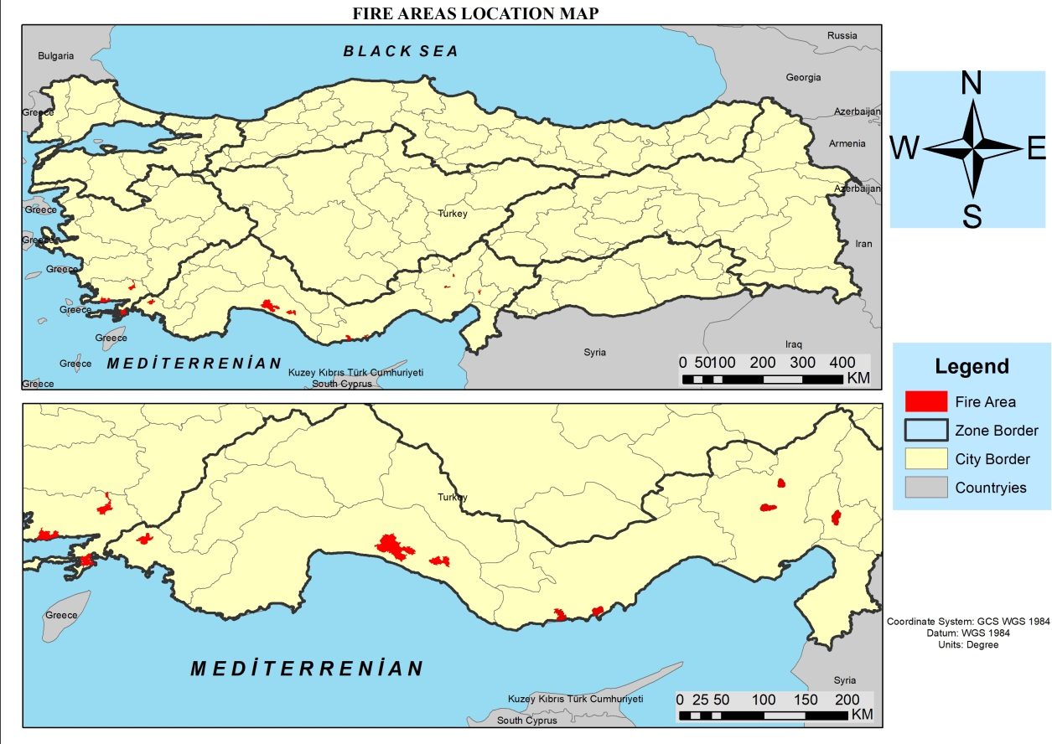
Map-1: Fire areas location
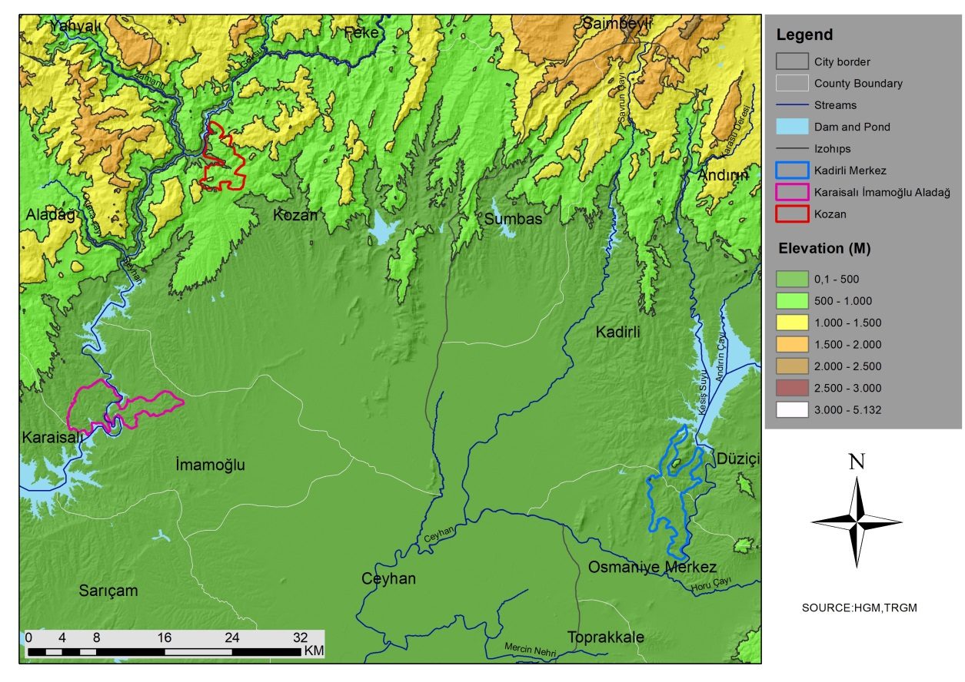
Map-2: Elevation step map of the fire area in Adana and Osmaniye

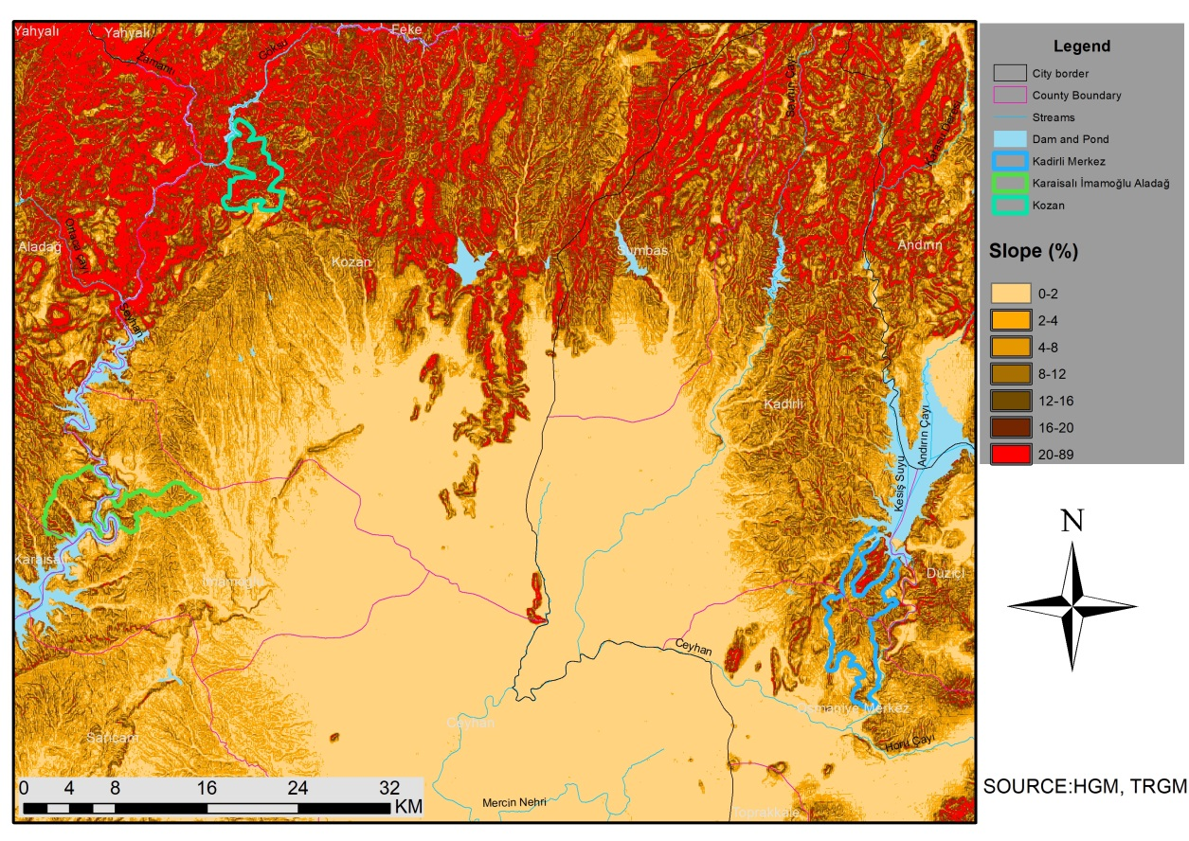
Map-3: Slope map of the fire area in Adana and Osmaniye

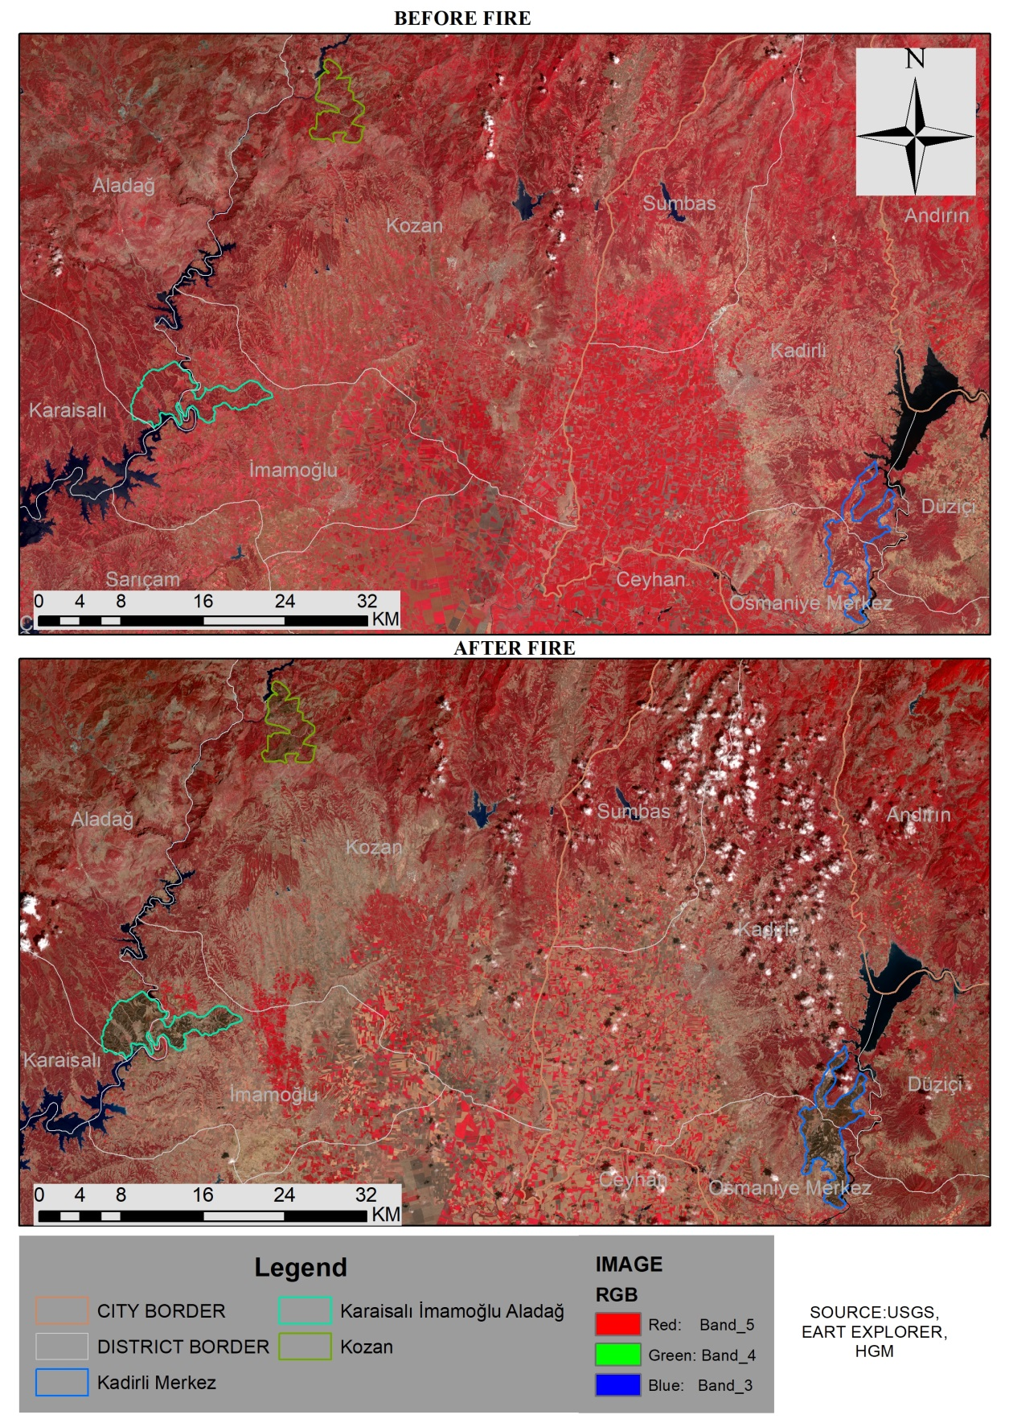

Map-4: Plant density map of pre-fire and post-fire multispectral camera recordings in Adana and Osmaniye

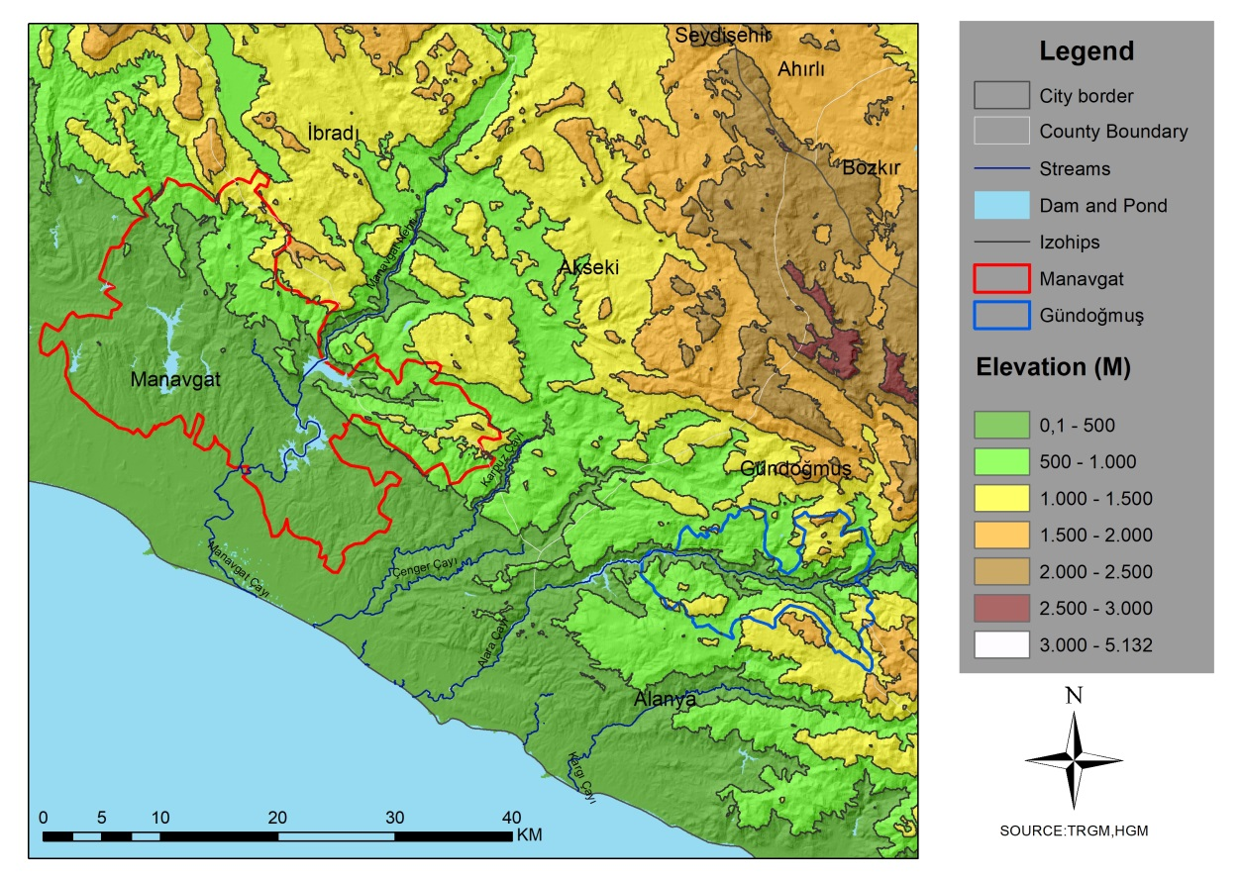
Map-5: step map of the fire area in Antalya

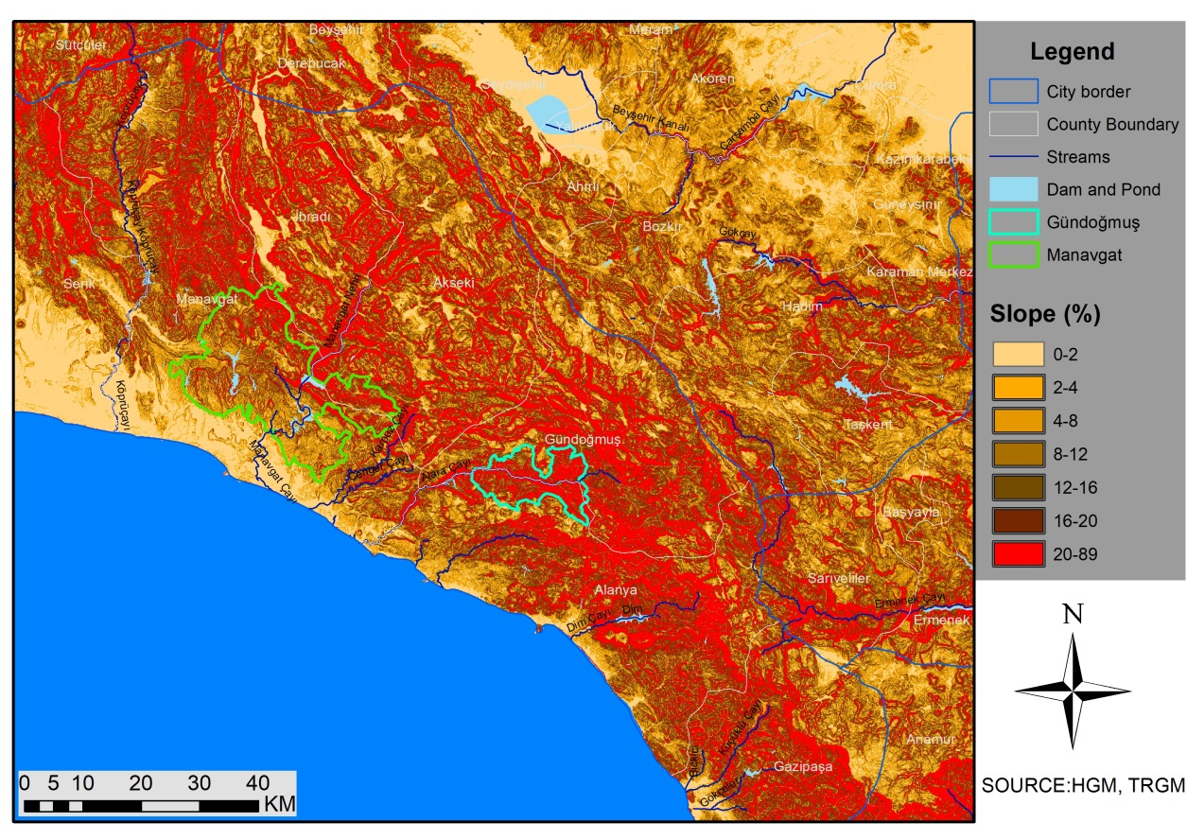
Map-6: Slope map of the fire area in Antalya

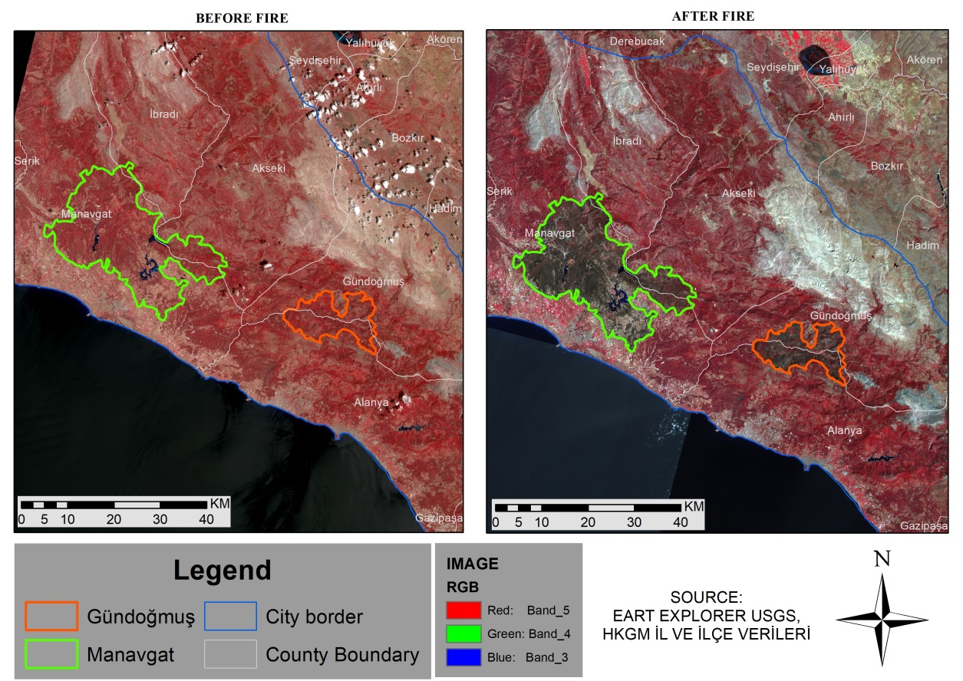
Map-7: Multispectral camera recordings before and after the fire in Antalya

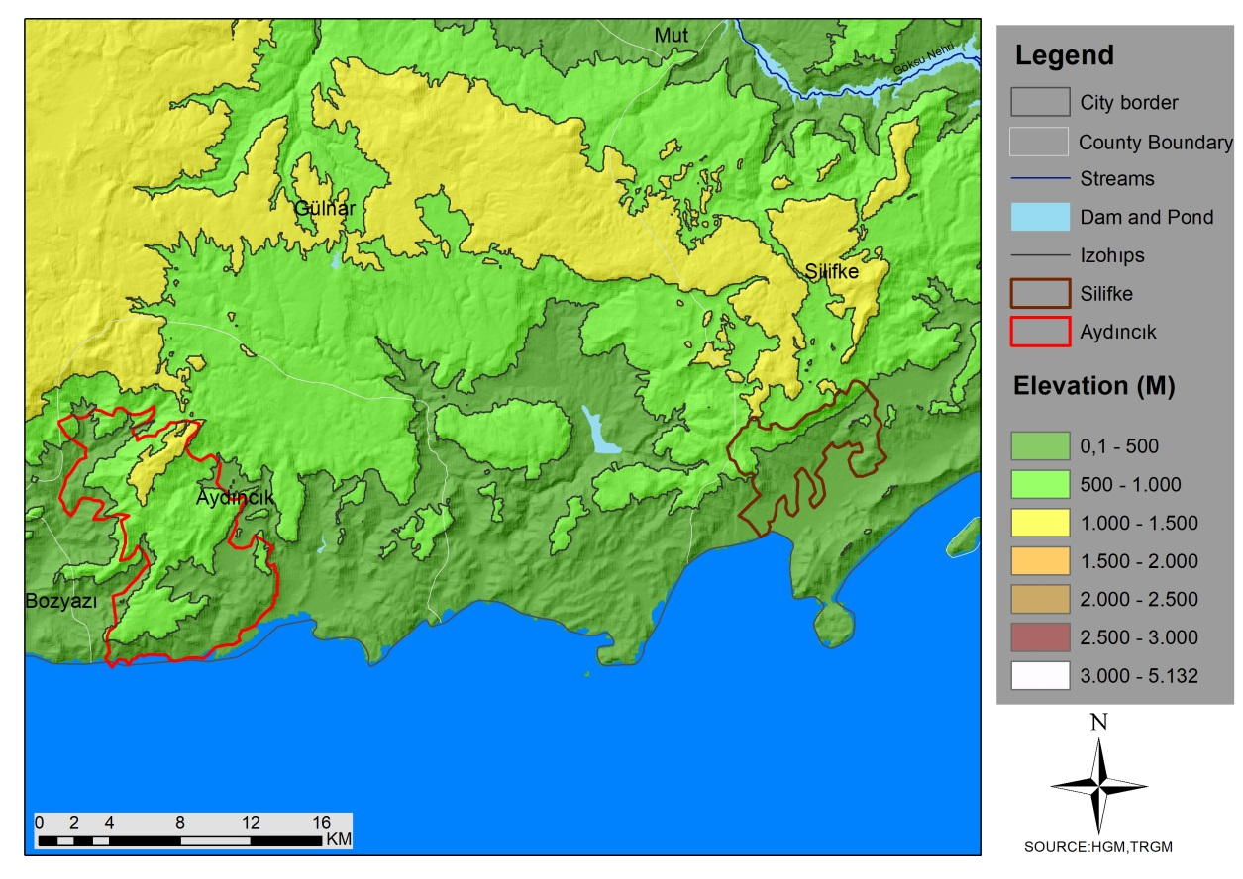
Map-8: Elevation step map of the fire area in Mersin

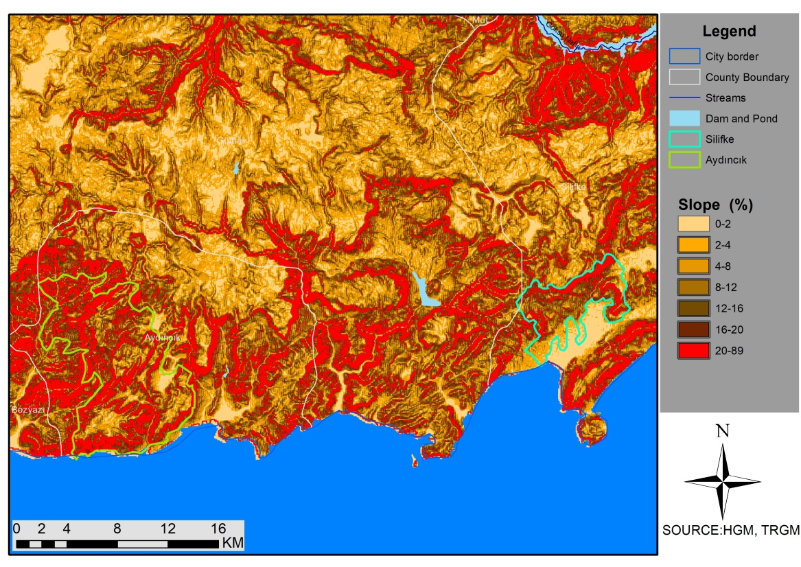
Map-9: Slope map of the fire area in Mersin

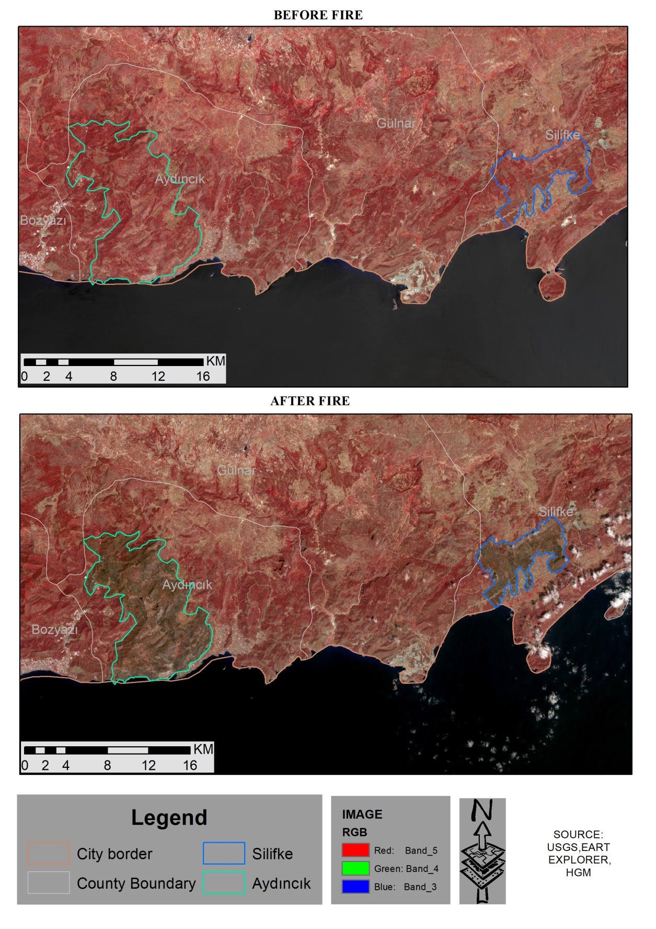
Map-10: Multispectral camera recordings before and after the fire in Mersin

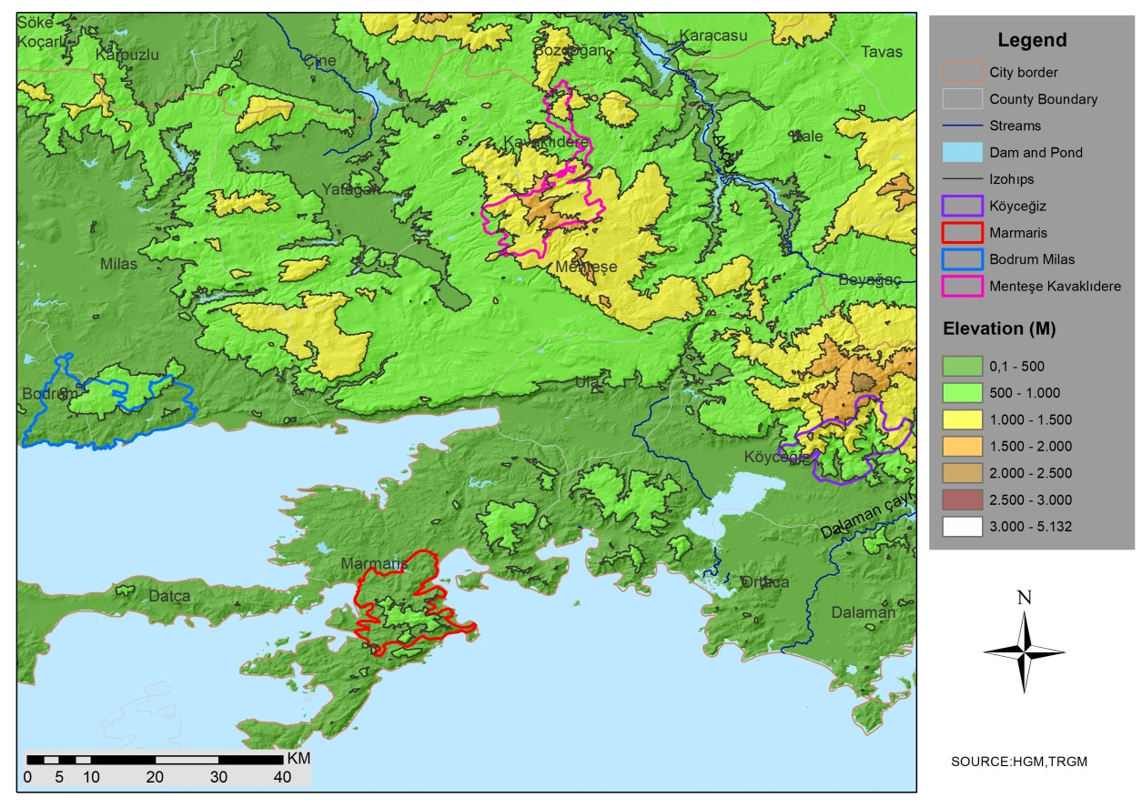
Map-11: Elevation step map of the fire area in Muğla

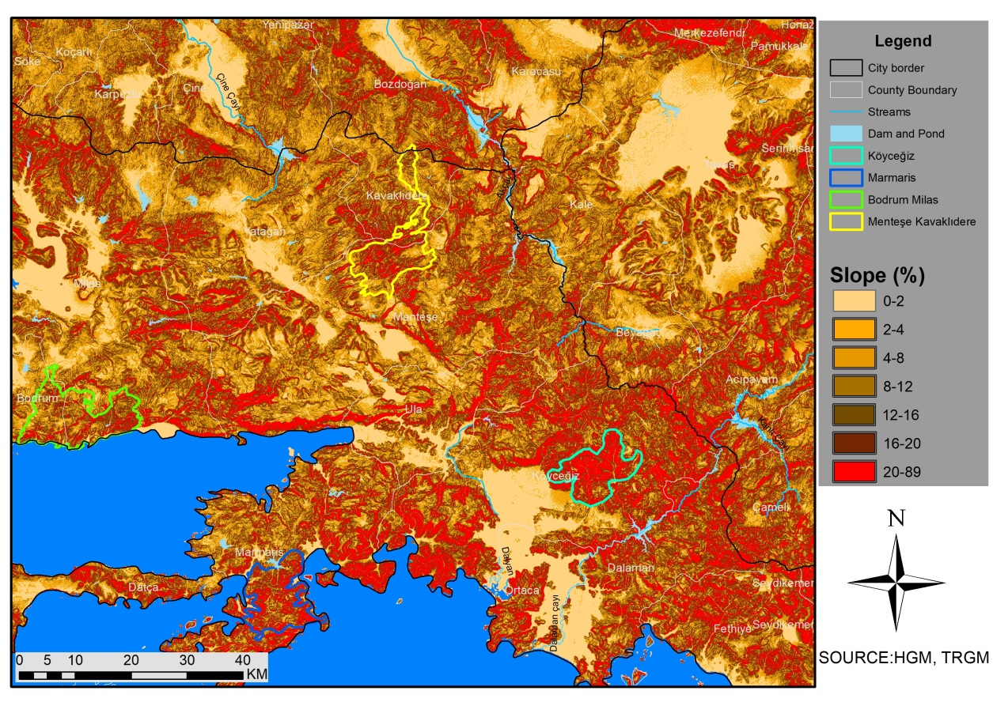
Map-12: Slope map of the fire area in Muğla

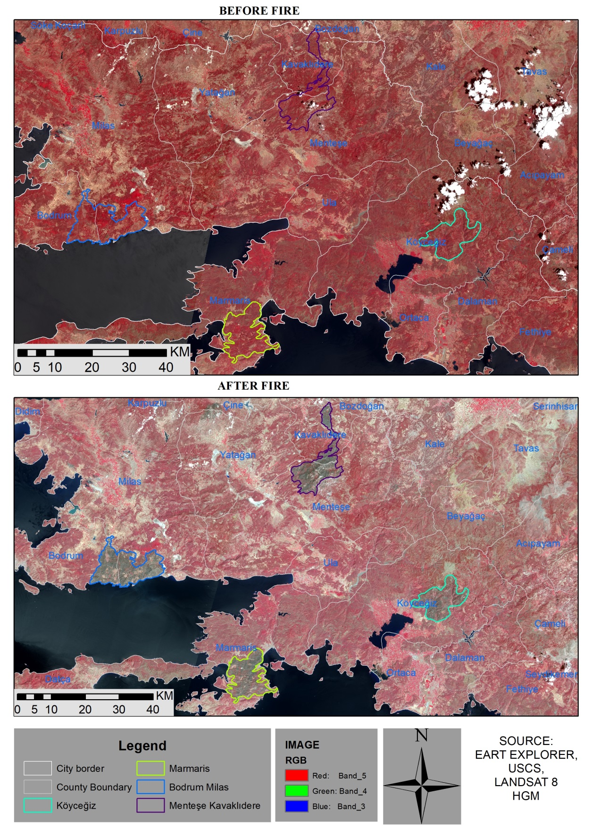
Map-13: Plant density map of pre-fire and post-fire multispectral camera recordings in Muğla

