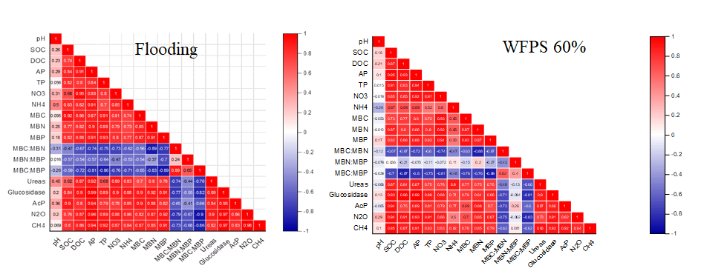
Fig. S1. Analysis of Pearson's correlations for variables in 60% WFPS and flooded soils

Fig. S2. Relationships among methane (CH₄) and nitrous oxide (N₂O) and dissolve organic carbon (DOC), microbial biomass carbon (MBC) and soil pH

Fig. S3. Relationships among methane (CH₄) and nitrous oxide (N₂O) and urease, glycosidase and acid phosphatese

