Appendices

Further evidence
We present here some further evidence on BNLD. Figures from 12 to 17 show the maps of backward and forward bilateral for automotive of Germany, the US and China. The specific bilateral rela- tionships we referred to in the paper here emerge clearly. Then we present the density distribution in 2014 disaggregated by subsystem (Figure 18), normalized within the range [0,1].
Figure 19 shows the correlation between BNLD normalized by [0,1] and labour productivity. This is in line with our conjecture that BNLD multiplier indicator could be used to assess a weak positioning in the international division of labour eventually detrimental for sectoral performances. These scatter plots refer to 2005 as an example and observations are plotted by highlighting different sectoral belonging. We have removed China, Brazil, Indonesia, India, Mexico, Cyprus, Malta, Russia and Luxembourg which are either outliers or developing countries that we exclude from the preferred econometric estimation.
We also plot the time dynamics of BNLD for each sector from Italy, Germany, the US and China (see Figures 20 to 23).
Table A alternatively shows the change in BNLD for the period 2000-2014. We account for sec- toral heterogeneity and classify countries with respect to an upward or downward trend. The former entails an increasing (net) dependence, the latter a decreasing one. In the upward column we find in the majority of cases advanced countries and some emerging and developing economies mainly belonging to Eastern Europe, while the downward column is usually characterized by emerging and developing economies, with some exceptions. Concerning sectors, the majority of them registers more countries in the upward column, with the exception of Furniture and other manufacturing, Repair and installation of machinery and equipment. Lastly, we provide correlation matrix (Table 5) and descriptive statistics (Table 6) of the variables used in the econometric analysis.

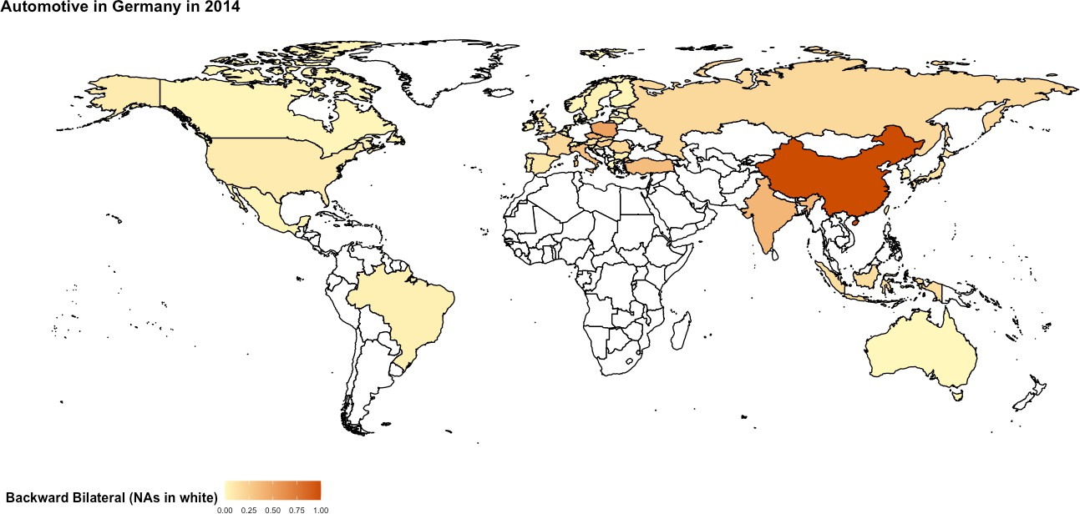

Figure 12: Backward Bilateral: employees activated in 2014 in the (43-1) WIOD countries in order to produce 1 mn USD of final commodity of German automotive subsystem.

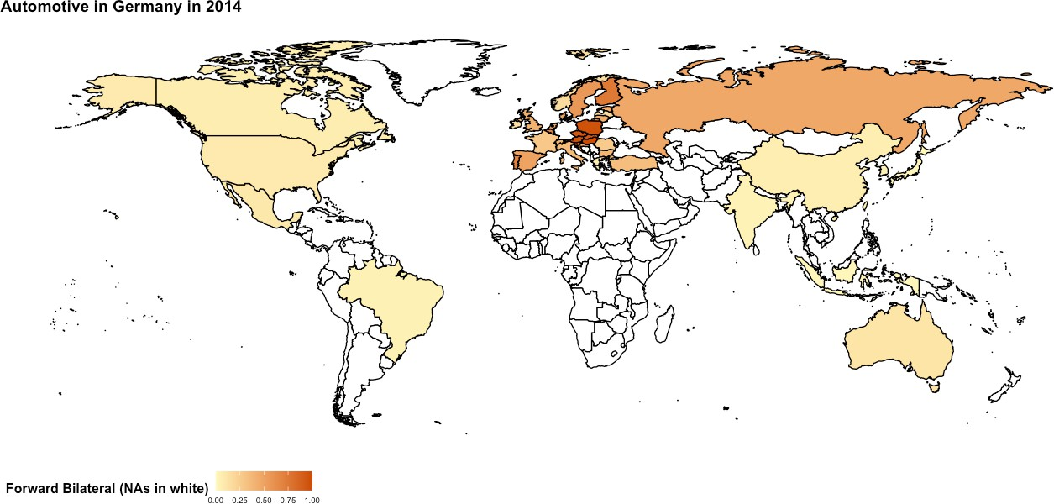

Figure 13: Forward Bilateral: employees provided in 2014 to the (43-1) WIOD countries by Ger- man automotive industry in order to produce 1 mn USD of the various final commodities in the subsystems in the world.

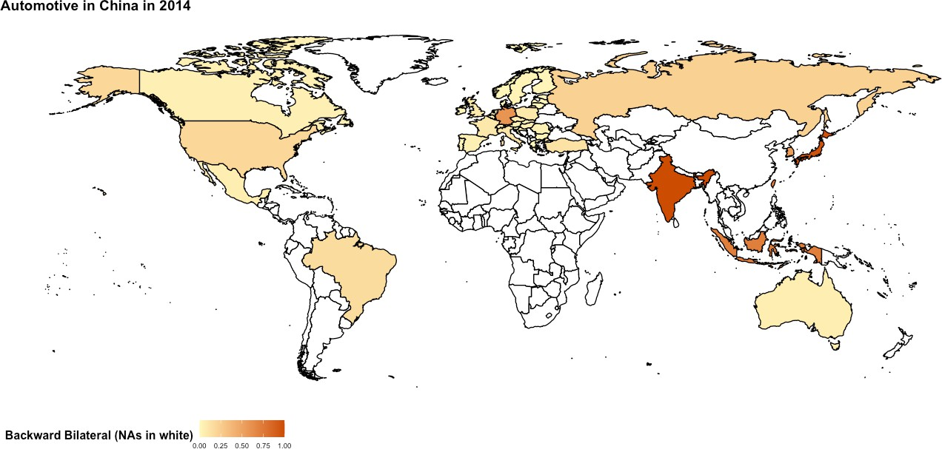

Figure 14: Backward Bilateral: employees activated in 2014 in the (43-1) WIOD countries in order to produce 1 mn USD of final commodity of Chinese automotive subsystem.

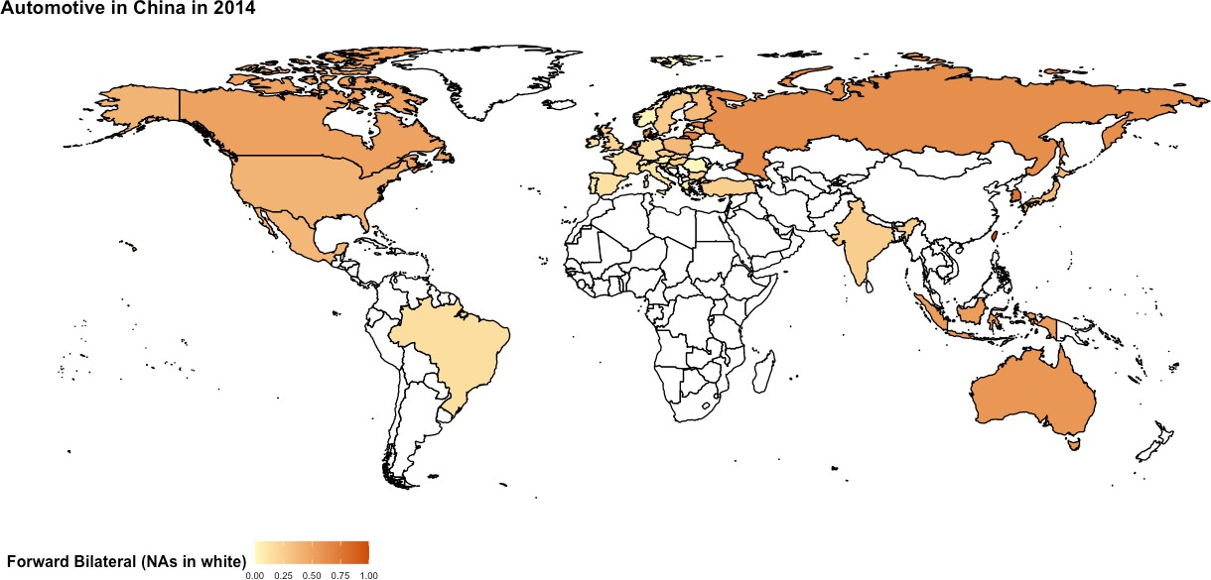

Figure 15: Forward Bilateral: employees provided in 2014 to the (43-1) WIOD countries by Chi- nese automotive industry in order to produce 1 mn USD of the various final commodities in the subsystems in the world.

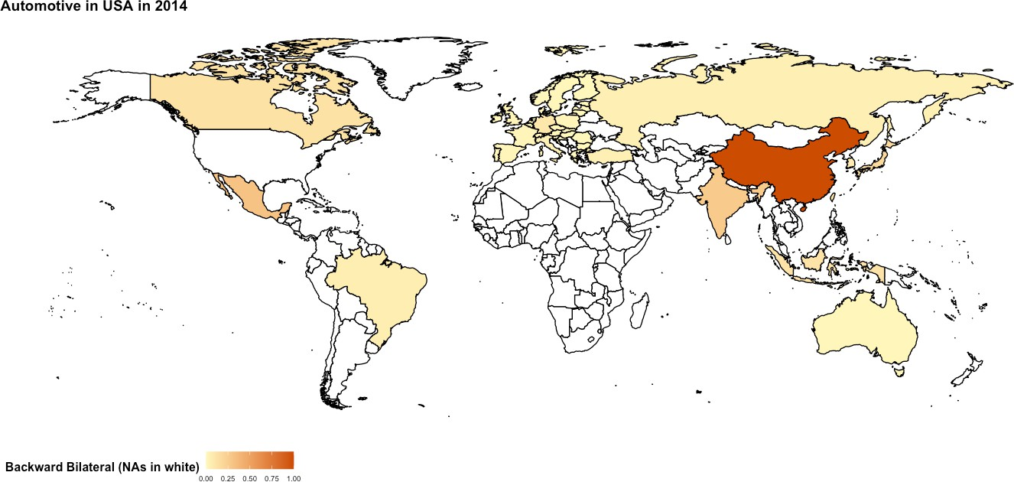

Figure 16: Backward Bilateral: employees activated in 2014 in the (43-1) WIOD countries in order to produce 1 mn USD of final commodity of US automotive subsystem.

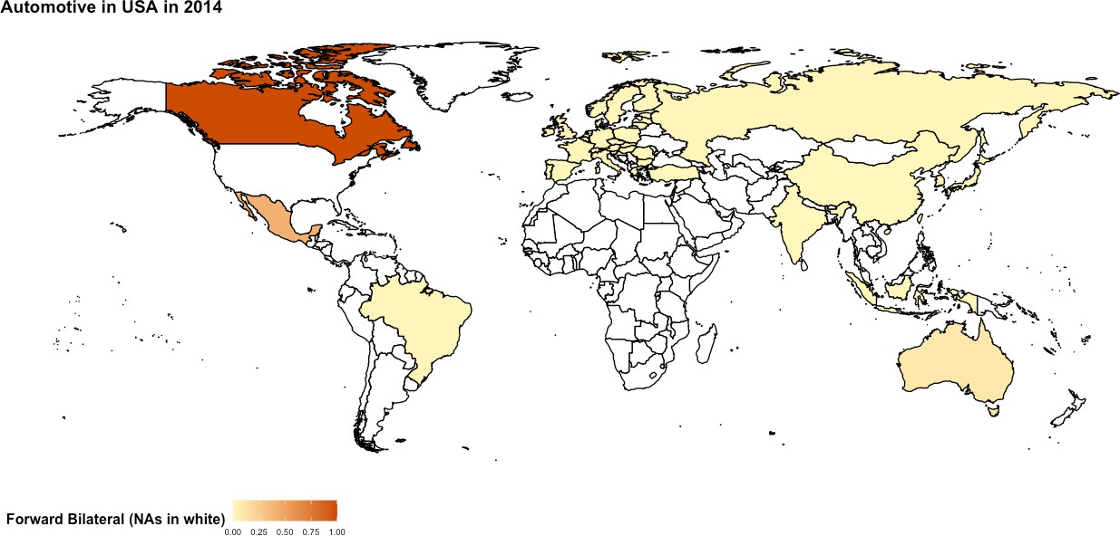

Figure 17: Forward Bilateral: employees provided in 2014 to the (43-1) WIOD countries by US automotive industry in order to produce 1 mn USD of the various final commodities in the subsys- tems in the world.

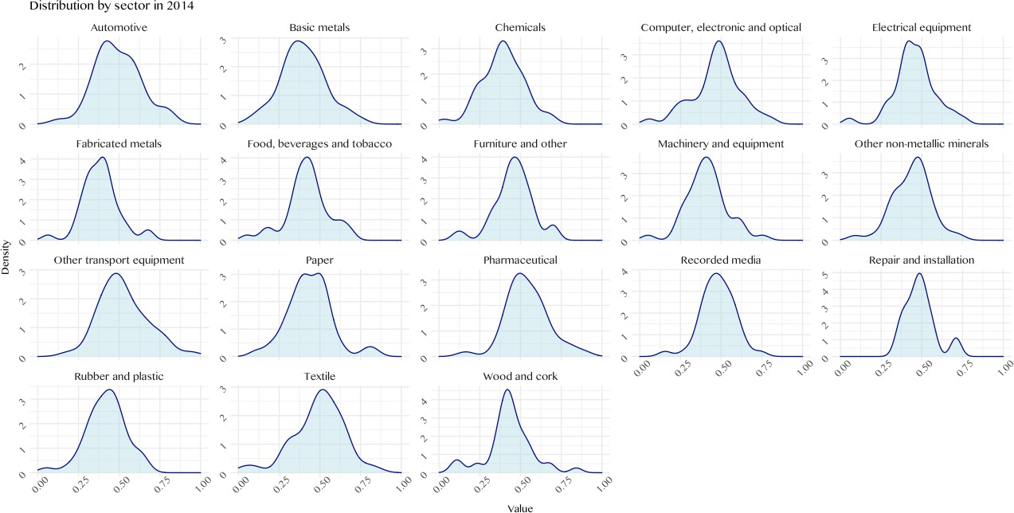
Figure 18: BNLD density distribution in 2014 for BNLD normalized in [0,1].

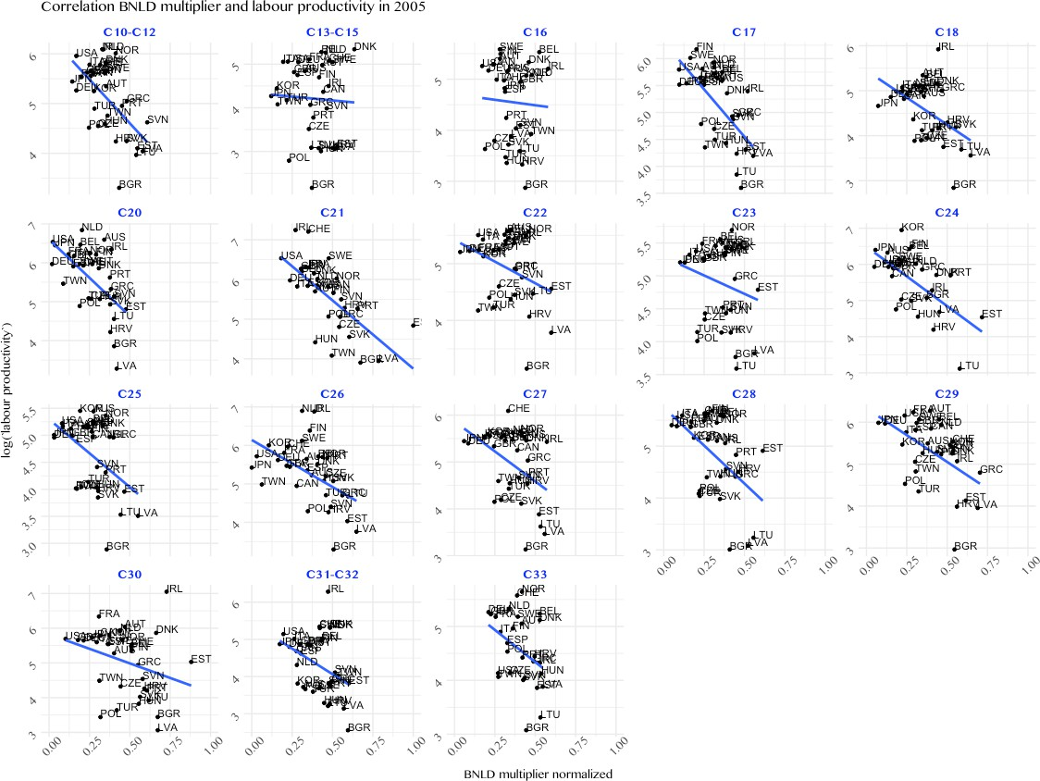
Figure 19: Scatter plot BNLD [0,1] and labour productivity by industry code in 2005

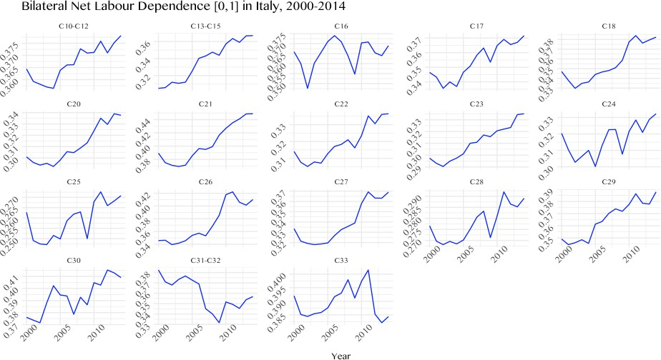
Figure 20: Trend in BNLD normalized [0,1] for Italy.

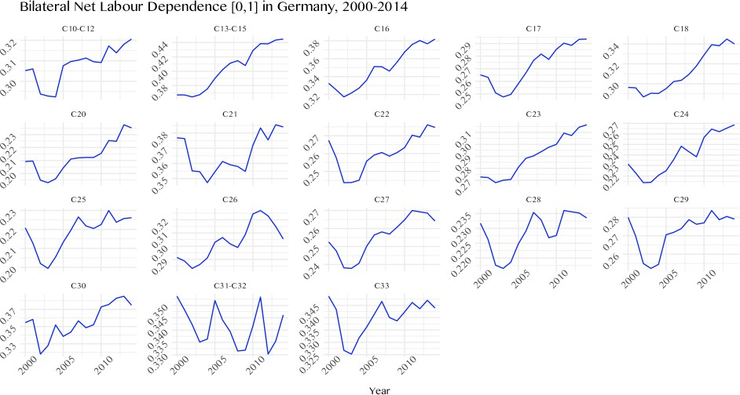
Figure 21: Trend in BNLD normalized [0,1] for Germany.

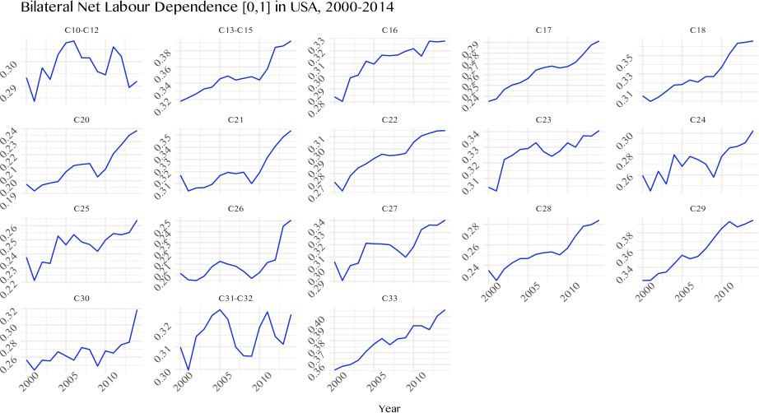
Figure 22: Trend in BNLD normalized [0,1] for the US.

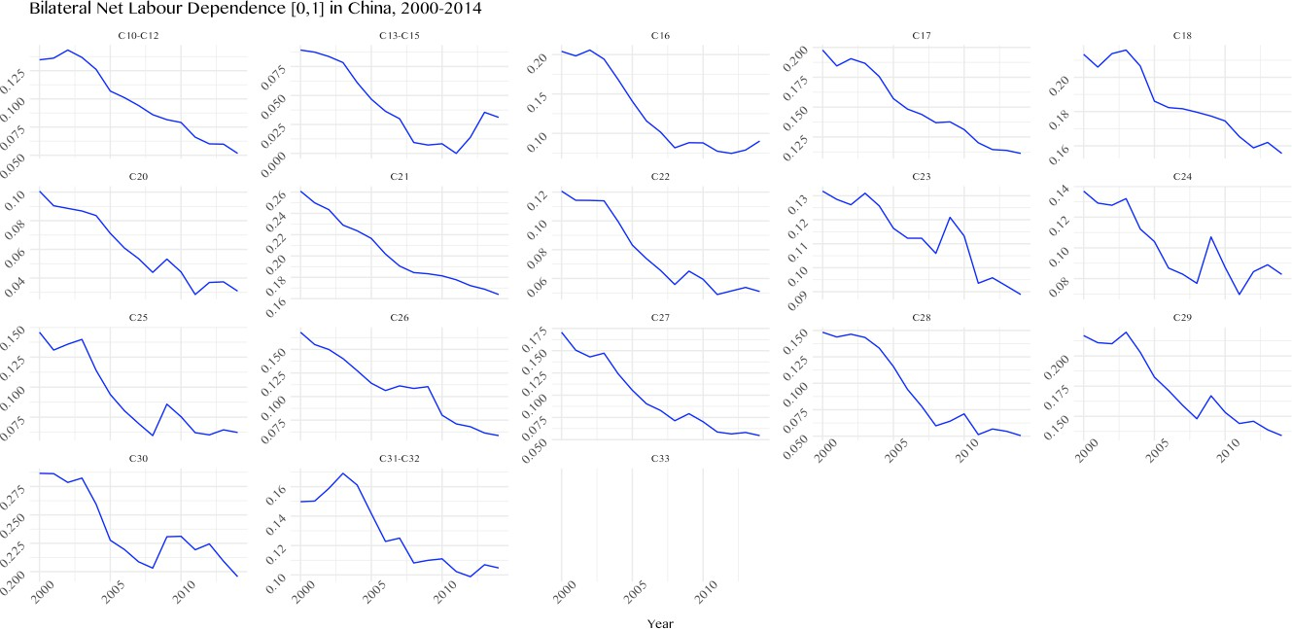

Figure 23: Trend in BNLD normalized [0,1] for China. Data for sector C33 are missing.

Table 4: Change for all countries in net labour dependence between 2000 and 2014, by sector. The correspondence between country codes and names can be found in Tables 12 and 13
 | Change in ∆BNLD₂₀₀₀₋₂₀₁₄
Sectors | UPWARD  (More net dependent) | DOWNWARD  (Less net dependent)
Food, beverages and to- bacco: | AUS, AUT, BEL, CAN, CHE, CZE, DEU, DNK, EST, FIN, FRA, GBR, HRV, HUN, IND, ITA, JPN, LTU, NLD, NOR, POL, ROU, RUS, SVK,  SVN, SWE, TUR | BGR, BRA, CHN, CYP, ESP, GRC, IDN, IRL, KOR, LUX, LVA, MEX, MLT, PRT, TWN, USA
Textile: | AUS, AUT, BEL, BGR, BRA, CAN, CHE, CYP, CZE, DEU, DNK, ESP,EST, FIN, FRA, GBR, HRV, HUN, IDN, IRL, ITA, JPN, KOR, LTU, LUX, LVA, MEX, MLT, NLD, NOR, POL, PRT, ROU, RUS, SVK, SVN, SWE, TUR, TWN, USA | CHN, IND
Wood and cork: | AUS, AUT, BRA, CAN, CHE, CZE, DEU, DNK, ESP, EST, FIN, FRA, GBR, HRV, HUN, IDN, IRL, ITA, JPN, LUX, MEX, MLT, NLD, NOR, POL, PRT, ROU, RUS, SVN, SWE, USA | BEL, BGR, CHN, CYP, GRC, IND, KOR, LTU, LVA, SVK, TUR, TWN
Paper: | AUS, AUT, BEL, BRA, CAN, CHE, CYP, DEU, DNK, ESP, EST, FIN, FRA, GBR, GRC, HRV, HUN, IND, IRL, ITA, JPN, KOR, LUX, LVA, MEX, MLT, NLD, NOR, POL, PRT, ROU, RUS, SVK, SVN, SWE, TUR, USA | BGR, CHN, CZE, IDN, LTU, TWN
Continued on next page

Table 4: Change for all countries in net labour dependence between 2000 and 2014, by sector. The correspondence between country codes and names can be found in Tables 12 and 13 (Continued)
 |  |  | Change in ∆BNLD₂₀₀₀₋₂₀₁₄
Sectors |  |  | UPWARD  (More net dependent) | DOWNWARD  (Less net dependent)
 |  |  | AUS, AUT, BEL, CAN, CHE,
 |  |  | CYP, CZE, DEU, DNK, ESP,
Printing media: | and | recorded | FIN, FRA, GBR, GRC, HRV, IND, IRL, ITA, JPN, KOR,  LUX, LVA, MEX, NLD, NOR, | BGR,BRA,CHN,EST,HUN, IDN,LTU,MLT,SVK,TWN
 |  |  | POL, PRT, ROU, SVN, SWE,
 |  |  | TUR, USA
Chemicals: |  |  | AUS, AUT, BEL, BRA, CAN, CHE, CZE, DEU, DNK, ESP, EST, FIN, FRA, GBR, GRC, HRV, HUN, IND, IRL, ITA, JPN, KOR, LVA, MEX, NLD, NOR, NOR, POL, ROU, RUS, SVK, SVN, SWE, TUR, TWN, USA | BGR, CHN, CYP, IDN, LTU, LUX, MLT, PRT
Pharmaceutical: |  |  | AUS, AUT, BEL, BRA, CAN, CHE, CZE, DEU, ESP, EST, FIN, FRA, GBR, HRV, HUN, IND, IRL, ITA, JPN, LTU, MEX, MLT, NLD, NOR, ROU, SVK, SVN, SWE, TWN, USA | BGR, CHN, CYP, DNK, GRC, IDN, KOR, LUX, LVA, POL, PRT
Rubber and plastic: |  |  | AUS, AUT, BEL, BRA, CAN, DEU, DNK, ESP, FIN, FRA, GBR, GRC, HRV, IND, IRL, ITA, JPN, KOR, LUX, MEX, NLD, NOR, RUS, SVN, SWE, TWN, USA | BGR, CHE, CHN, CYP, CZE, EST, HUN, IDN, LTU, LVA, MLT, POL, PRT, ROU, SVK, TUR
Continued on next page

Table 4: Change for all countries in net labour dependence between 2000 and 2014, by sector. The correspondence between country codes and names can be found in Tables 12 and 13 (Continued)
 | Change in ∆BNLD₂₀₀₀₋₂₀₁₄
Sectors | UPWARD DOWNWARD  (More net dependent) (Less net dependent)
Non-metallic mineral: | AUS, AUT, BEL, BRA, CAN, CHE, CZE, DEU, DNK, ESP, EST, FIN, FRA, GBR, GRC,  HRV, HUN, IDN, IND, IRL, BGR, CHN, CYP, LTU, LVA, ITA, JPN, KOR, LUX, MEX, TWN  MLT, NLD, NOR, POL, PRT, ROU, RUS, SVK, SVN, SWE, TUR, USA
Basic metals: | AUS, AUT, BEL, BGR, CZE, DEU, DNK, ESP, EST, FIN,  BRA, CAN, CHE, CHN, CYP,  FRA, GBR, HRV, IND, IRL,  GRC, HUN, IDN, KOR, MEX,  ITA, JPN, LTU, LUX, LVA,  PRT, SVK, TWN  MLT, NLD, NOR, POL, ROU,  RUS, SVN, SWE, TUR, USA
Fabricated metal prod- ucts: | AUS, AUT, BEL, BRA, CAN,  BGR, CHE, CHN, CYP, EST,  CZE, DEU, DNK, ESP, FIN,  GRC, HUN, IDN, IND, KOR,  FRA, GBR, HRV, IRL, ITA,  LTU, LVA, NOR, PRT, SVK,  JPN, LUX, MEX, MLT, NLD,  TUR, TWN  POL, ROU, SVN, SWE, USA
Computer, electronic and optical products: | AUS, AUT, BEL, BRA, CAN, CZE, DEU, DNK, ESP, EST, FIN, FRA, GBR, GRC, HRV,  HUN, IDN, IRL, ITA, JPN, BGR, CHE, CHN, CYP, IND, LTU, LUX, LVA, MEX, MLT, KOR, TWN  NLD, NOR, POL, PRT, ROU, RUS, SVK, SVN, SWE, TUR, USA
Continued on next page

Table 4: Change for all countries in net labour dependence between 2000 and 2014, by sector. The correspondence between country codes and names can be found in Tables 12 and 13 (Continued)
 | Change in ∆BNLD₂₀₀₀₋₂₀₁₄
Sectors | UPWARD DOWNWARD  (More net dependent) (Less net dependent)
Electrical equipment: | AUS, AUT, BEL, BRA, CAN, CZE, DEU, DNK, ESP, EST,  FIN, FRA, GBR, GRC, HRV, BGR, CHE, CHN, CYP, HUN, IDN, IRL, ITA, JPN, LTU, IND, KOR, LVA, ROU, SVK,  LUX, LVA, MEX, MLT, NLD, TWN NOR, POL, PRT, SVN, SWE,  TUR, USA
Machinery and equip- ment: | AUS, AUT, BEL, BRA, CAN, CHE, CYP, CZE, DEU, DNK,  ESP, EST, FIN, FRA, GBR, BGR, CHN, GRC, HRV, HUN, IDN, IRL, ITA, JPN, LTU, IND, KOR, MEX, PRT, SVN,  LUX, LVA, MLT, NLD, NOR, TUR, TWN POL, ROU, RUS, SVK, SWE,  USA
Automotive: | AUS, BEL, BRA, CAN, DNK,  ESP, EST, FIN, FRA, GBR, AUT, BGR, CHE, CHN, CYP, GRC, HRV, IRL, ITA, JPN, CZE, DEU, HUN, IDN, IND, LTU, LUX, MEX, MLT, NLD, KOR, LVA, POL, ROU, SVK, NOR, PRT, RUS, SWE, TWN, SVN, TUR  USA
Other transport equip- ment: | AUS, AUT, BEL, BGR, BRA, CAN, CZE, DEU, DNK, ESP,  CHE, CHN, CYP, HRV, HUN,  FIN, FRA, GBR, GRC, IRL,  IDN, IND, JPN, KOR, MEX,  ITA, LTU, LUX, LVA, MLT,  TWN  NLD, NOR, POL, PRT, ROU,  SVK, SVN, SWE, TUR, USA
Continued on next page

Table 4: Change for all countries in net labour dependence between 2000 and 2014, by sector. The correspondence between country codes and names can be found in Tables 12 and 13 (Continued)
 | Change in ∆BNLD₂₀₀₀₋₂₀₁₄
Sectors | UPWARD DOWNWARD  (More net dependent) (Less net dependent)
Furniture and other: | AUT, BEL, BGR, CHE, CHN,  AUS, BRA, CAN, CZE, ESP,  CYP, DEU, DNK, EST, HUN,  FIN, FRA, GBR, GRC, HRV,  IDN, IND, ITA, KOR, LTU,  IRL, JPN, LUX, NLD, NOR,  LVA, MEX, MLT, POL, PRT,  ROU, RUS, SVN, USA  SVK, SWE, TUR, TWN
Repair and installation of m&e: | CHE, CZE, DNK, EST, FIN, AUT, BEL, BGR, CYP, DEU, FRA, GBR, IRL, LTU, MEX, ESP, GRC, HRV, HUN, HUN, MLT, NLD, POL, SVK, SVN, ITA, LUX, LVA, NOR, PRT, SWE, USA ROU, TWN

Variables
LP_{t}
LPt−1 KEt−1 FDt−1 Wt−1
BNLD[0,1]
t−1
Labour productivity (LP) 1.000
Lagged Labour productivity (LP) 0.984 1.000
Lagged Capital per employee (KE) 0.838 0.850 1.000
Lagged Final demand (FD) 0.453 0.465 0.355 1.000
Lagged Average wage (W) 0.870 0.888 0.770 0.427 1.000
Lagged BNLD [0,1] (BNLD^{[0,1]}) -0.285 -0.286 -0.248 -0.591 -0.278 1.000
Spearman rho = 0.236
Table 5: Correlation matrix

Variables | Obs | Mean | Std. Dev. | Min | Max
Labour productivity (LP) | 8818 | 5.015 | .922 | 1.209 | 8.781
Capital per employee (KE) | 8815 | 4.433 | 1.023 | -.161 | 7.45
Final Demand (FD) | 8776 | 7.331 | 2.115 | -1.66 | 13.209
Average Wage (W) | 8818 | 3.37 | .893 | -.078 | 7.187
BNLD [0,1] (BNLD^{[0,1]}) | 9088 | .439 | .099 | .184 | .936

Table 6: Descriptive statistics

Robustness Checks
In this section we provide further robustness checks of the econometric estimation. Table 7 shows estimates with dependent variable in first differences. In Table 8 we control for different lag struc- tures of BNLD, keeping the specification without wages as the preferred one. In Table 9 we use BNLD not normalized in [0,1], while in Table 10 we adopt a sub-sampling technique by first re- ducing the time span (before and after 2007) and then by excluding Southern and Core European countries in one case, and Eastern European ones in the other. Significance and sign of BNLD coefficient are always robust.
Table 7: FE estimation with LP in differences
Dependent variable: country-sector labour productivity in differences(∆LPt)

t−1
FE | FE | FE | FE | FE | FE | FE | FE | FE
(1) | (2) | (3) | (4) | (5) | (6) | (7) | (8) | (9)
BNLD^{[0,1]} -1.032∗∗∗ | -0.867∗∗∗ | -0.895∗∗∗ | -0.746∗∗∗ | -1.052∗∗∗ | -0.728∗∗∗ | -0.732∗∗∗ | -0.744∗∗∗ | -1.001∗∗∗
(0.200) | (0.186) | (0.185) | (0.166) | (0.204) | (0.170) | (0.172) | (0.165) | (0.148)
KEt−1 | -0.153∗∗∗ | -0.143∗∗∗ | -0.0409∗∗∗ |  |  | -0.0478∗∗∗ |  | -0.0875∗∗∗
 | (0.0117) | (0.0113) | (0.0149) |  |  | (0.0158) |  | (0.0183)
FDt−1 |  | -0.0279∗∗∗ | -0.0177∗ | -0.0505∗∗∗ |  |  | -0.0194∗ | -0.0181∗∗
 |  | (0.0104) | (0.0106) | (0.0102) |  |  | (0.0109) | (0.00893)
Wt−1 |  |  | -0.202∗∗∗ |  | -0.241∗∗∗ | -0.198∗∗∗ | -0.239∗∗∗ | -0.101∗∗∗
 |  |  | (0.0224) |  | (0.0149) | (0.0208) | (0.0148) | (0.0294)
Observations 8229 | 8227 | 7945 | 7945 | 7947 | 8229 | 8227 | 7947 | 10036
Time dummies ✓ | ✓ | ✓ | ✓ | ✓ | ✓ | ✓ | ✓ | ✓
LR test (chi2) 143.37 | 555.61 | 49.06 | 284.75 | 162.84 | 820.81 | 295.22 | 693.92
(p-value) (0.000) | (0.000) | (0.000) | (0.000) | (0.000) | (0.000) | (0.000) | (0.000)
Wald test (F) 26.70 | 170.51 | 7.27 | 81.55 | 24.31 | 261.13 | 90.75 | 258.75
(p-value) (0.000) | (0.000) | (0.007) | (0.000) | (0.000) | (0.000) | (0.000) | (0.000)

Notes: Clustered standard errors in parentheses. All variables in log terms. Time dummies included, country-industry fixed effect.∗, ∗∗ and ∗∗∗ denote significance level at 10%, 5% and 1%. Fe (1) to FE (8) excludes developing or small countries and China. FE (9) includes all WIOD countries

Table 8: FE estimation with LP in levels and BNLD with different lags

Dependent variable: country-sector labour productivity in levels (LPt)
 | FE | FE | FE | FE
 | (1) | (2) | (3) | (4)
LPt−1 | 0.718∗∗∗ | 0.709∗∗∗ | 0.680∗∗∗ | 0.638∗∗∗
 | (0.0235) | (0.0269) | (0.0302) | (0.0328)
BNLDt−1 | -0.647∗∗∗ (0.163)
BNLDt−2 |  | -0.647∗∗∗  (0.172)
BNLDt−3 |  |  | -0.558∗∗ (0.266)
BNLDt−4 |  |  |  | -0.358∗∗  (0.178)
log(KE)t−1 | 0.00509 | 0.0000911 | -0.000322 | 0.00790
 | (0.0145) | (0.0173) | (0.0197) | (0.0230)
log(FD)t−1 | 0.0137 | 0.0112 | 0.0170 | 0.0215
 | (0.0116) | (0.0137) | (0.0150) | (0.0169)
Observations | 7945 | 7383 | 6822 | 6260
Notes: Clustered standard errors in parentheses. All variables in log terms. Time dummies included, country-industry fixed effect.∗, ∗∗ and
∗∗∗ denote significance level at 10%, 5% and 1%. Fe (1) to FE (8)
excludes developing or small countries and China. FE (9) includes all
WIOD countries

Table 9: FE estimation with LP in levels and BNLD not normalized

Dependent variable: country-sector labour productivity in levels (LPt)
 | FE | FE | FE | FE | FE | FE | FE | FE | FE
 | (1) | (2) | (3) | (4) | (5) | (6) | (7) | (8) | (9)
log(LP )t−1 | 0.736∗∗∗ | 0.728∗∗∗ | 0.718∗∗∗ | 0.748∗∗∗ | 0.722∗∗∗ | 0.766∗∗∗ | 0.753∗∗∗ | 0.758∗∗∗ | 0.736∗∗∗
 | (0.0152) | (0.0194) | (0.0235) | (0.0296) | (0.0170) | (0.0255) | (0.0259) | (0.0284) | (0.0260)
BNLDt−1 | -0.0385∗∗∗ | -0.0386∗∗∗ | -0.0363∗∗∗ | -0.0350∗∗∗ | -0.0363∗∗∗ | -0.0375∗∗∗ | -0.0373∗∗∗ | -0.0353∗∗∗ | -0.0430∗∗∗
 | (0.00990) | (0.00991) | (0.00913) | (0.00895) | (0.00915) | (0.00982) | (0.00970) | (0.00908) | (0.00739)
log(KE)t−1 |  | 0.0108 | 0.00509 | 0.0233 |  |  | 0.0266∗ |  | -0.000827
 |  | (0.0144) | (0.0145) | (0.0154) |  |  | (0.0151) |  | (0.0137)
log(FD)t−1 |  |  | 0.0137 | 0.0127 | 0.0136 |  |  | 0.0124 | 0.0200∗∗
 |  |  | (0.0116) | (0.0116) | (0.0114) |  |  | (0.0115) | (0.00980)
log(W )t−1 |  |  |  | -0.0677∗∗ |  | -0.0451∗ | -0.0591∗∗ | -0.0548∗∗ | 0.00411
 |  |  |  | (0.0292) |  | (0.0263) | (0.0279) | (0.0272) | (0.0210)
Observations | 8229 | 8227 | 7945 | 7945 | 7947 | 8229 | 8227 | 7947 | 10036
Notes: Clustered standard errors in parentheses. All variables in log terms. Time dummies included, country-industry fixed effect.∗,
∗∗ and ∗∗∗ denote significance level at 10%, 5% and 1%. Fe (1) to FE (8) excludes developing or small countries and China. FE (9) includes all WIOD countries

Table 10: FE estimation with LP in levels and time and country sub-sampling
Dependent variable: country-sector labour productivity in levels (LP_{t})

 | T < 2008  (1) | T > 2007  (2) | NO South-Core EU  (3) | NO East EU  (4)
log(LP )_{t−1} | 0.753∗∗∗ | 0.735∗∗∗ | 0.605∗∗∗ | 0.469∗∗∗
 | (0.0235) | (0.0281) | (0.0400) | (0.0383)

BNLD [0,1]
t−1
-0.749∗∗∗ -0.769∗∗∗ -0.719∗∗ -0.849∗

 | (0.137) | (0.161) | (0.289) | (0.479)
log(KE)_{t−1} | -0.0175 | 0.00890 | 0.0246 | 0.0114
 | (0.0137) | (0.0158) | (0.0289) | (0.0424)
log(FD)_{t−1} | 0.0166∗∗ | 0.0255∗∗ | 0.0108 | 0.0233
 | (0.00715) | (0.0128) | (0.0179) | (0.0210)
Observations | 7066 | 7602 | 3972 | 3973
Notes: Clustered standard errors in parentheses. All variables in log terms. Time dummies included, country-industry fixed effect.∗, ∗∗ and ∗∗∗ denote significance level at 10%, 5% and 1%. In (1) we consider only T lower than 2008, while in (2) only T larger than 2007. (3) and (4) on the contrary drop southern and core European countries and Eastern Europe ones respectively.

Data details

Code | Manufacturing industry descriptions | Pavitt Class
C10-C12 | Manufacture of food products, beverages and tobacco products | SD
C13-C15 | Manufacture of textiles, wearing apparel and leather products | SD
C16 | Manufacture of wood and of products of wood and cork, except furniture | SD
C17 | Manufacture of paper and paper products | SII
C18 | Printing and reproduction of recorded media | SII
C20 | Manufacture of chemicals and chemical products | SB
C21 | Manufacture of basic pharmaceutical products and pharmaceutical preparations | SB
C22 | Manufacture of rubber and plastic products | SII
C23 | Manufacture of other non-metallic mineral products | SII
C24 | Manufacture of basic metals | SII
C25 | Manufacture of fabricated metal products, except machinery and equipment | SD
C26 | Manufacture of computer, electronic and optical products | SB
C27 | Manufacture of electrical equipment | SS
C28 | Manufacture of machinery and equipment n.e.c. | SS
C29 | Manufacture of motor vehicles, trailers and semi-trailers | SII
C30 | Manufacture of other transport equipment | SS
C31-C32 | Manufacture of furniture; other manufacturing | SD
C33 | Repair and installation of machinery and equipment | SS
Table 11: List of 18 manufacturing sectors in 2-digit NACE Rev. 2 classification. Pavitt classes are: Science Based (SB), Specialised Suppliers (SS), Scale and Information Intensive (SII) and Suppliers Dominated (SD)

Country | Code | Country | Code
Australia | AUS | Ireland | IRL
Austria | AUT | Italy | ITA
Belgium | BEL | Japan | JPN
Bulgaria | BGR | South Korea | KOR
Canada | CAN | Lithuania | LTU
Switzerland | CHE | Latvia | LVA
Czech Republic | CZE | The Netherlands | NLD
Germany | DEU | Norway | NOR
Denmark | DNK | Poland | POL
Spain | ESP | Portugal | PRT
Estonia | EST | Romania | ROU
Finland | FIN | Slovakia | SVK
France | FRA | Slovenia | SVN
United Kindom | GBR | Sweden | SWE
Greece | GRC | Turkey | TUR
Croatia | HRV | Taiwan | TWN
Hungary | HUN | United States | USA
Table 12: List of 34 countries used in specifications 1 to 8 in Table 3

Country Code |  | Country | Code
Brazil | BRA | Luxemburg | LUX
China | CHN | Malta | MLT
Cyprus | CYP | Mexico | MEX
Indonesia | IDD | Russia | RUS
India | IND
Table 13: List of 9 outlier countries removed in specifications 1 to 8 but kept in 9 in Table 3.

