Supplementary Information
Xiaoling Yu¹, Wen Zhang³, Zhiping Zhao¹, Chengsong Ye⁴, Shuyan Zhou², Shaogui Wu², Lifen Han¹, Zhaofang Han^{5,6*} and Hanhui Ye^{1*}
Corresponding authors:
Hanhui Ye, E-mail: 15960102808@163.com; Zhaofang Han, E-mail: zhaofang_han@foxmail.com.
This file includes:

Supplementary Figures 1 to 5
Supplementary Tables 1 to 12

Supplementary Figures
Supplementary Figure 1. Distribution of protein-coding genes predicted in 1567D strain.
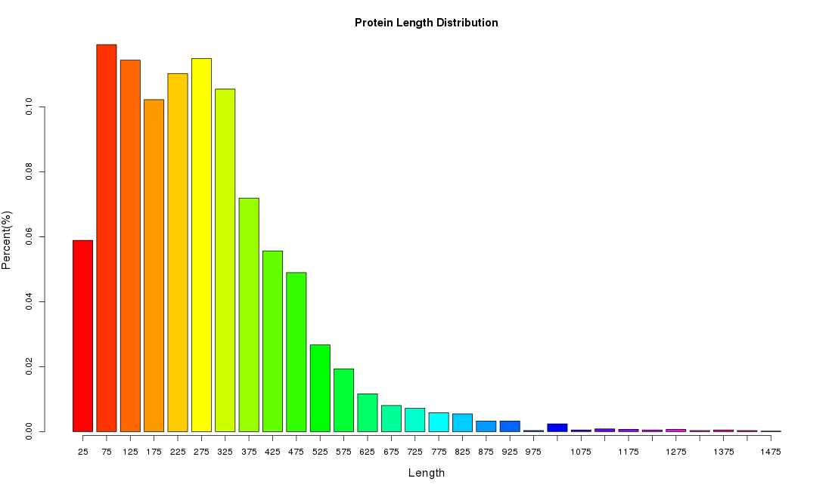

Supplementary Figure 2. COG classification 1567D stain for the carbapenem-resistant K. pneumoniae.
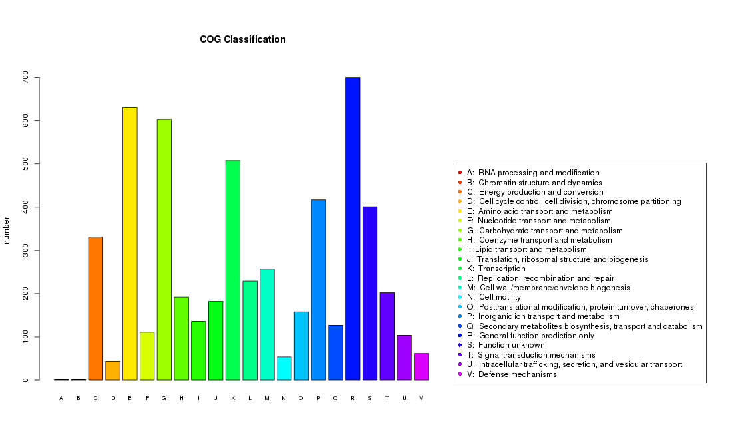

Supplementary Figure 3. Distribution of K. pneumoniae genes annotated in GO term.
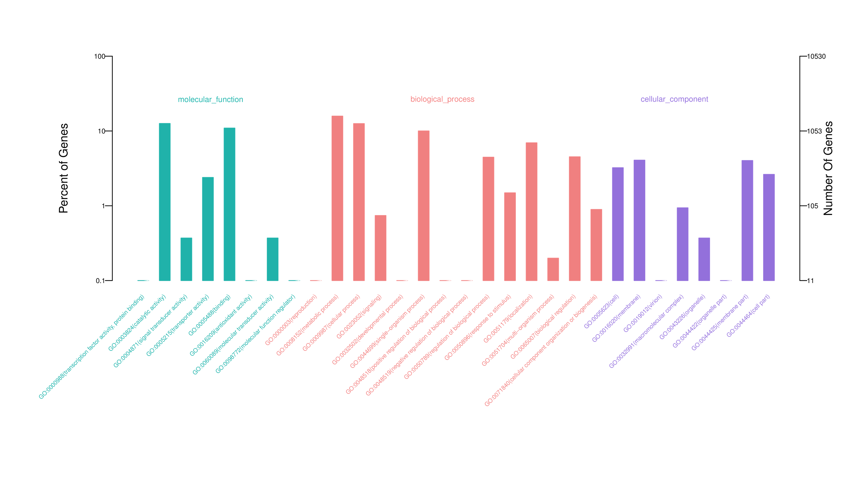

Supplementary Figure 4. Annotation of KEGG pathways in the carbapenem-resistant K. pneumoniae.
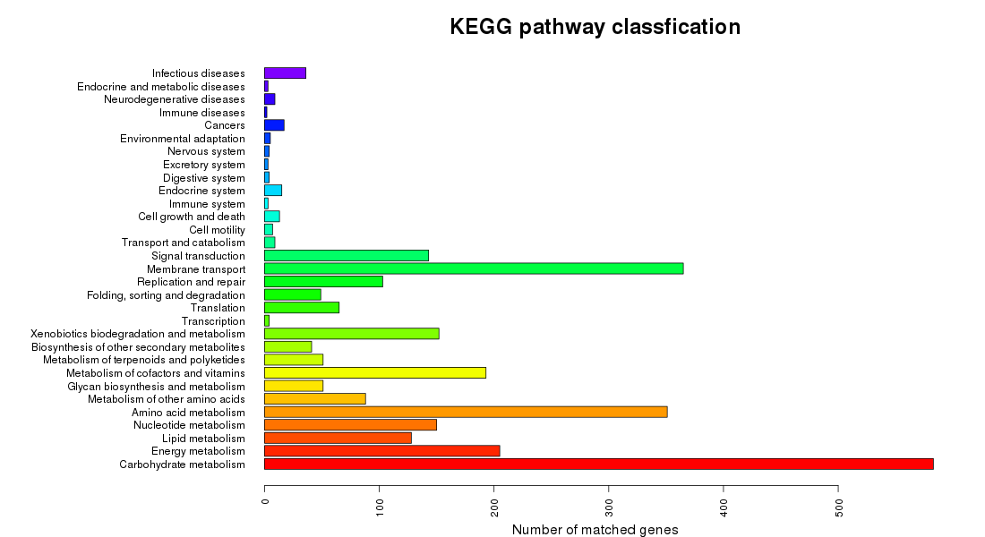

Supplementary Figure 5. Phylogenetic tree assessing the relatedness of the 8 carbapenem-resistant K. pneumoniae strains (red) to the reference genome database (blue).
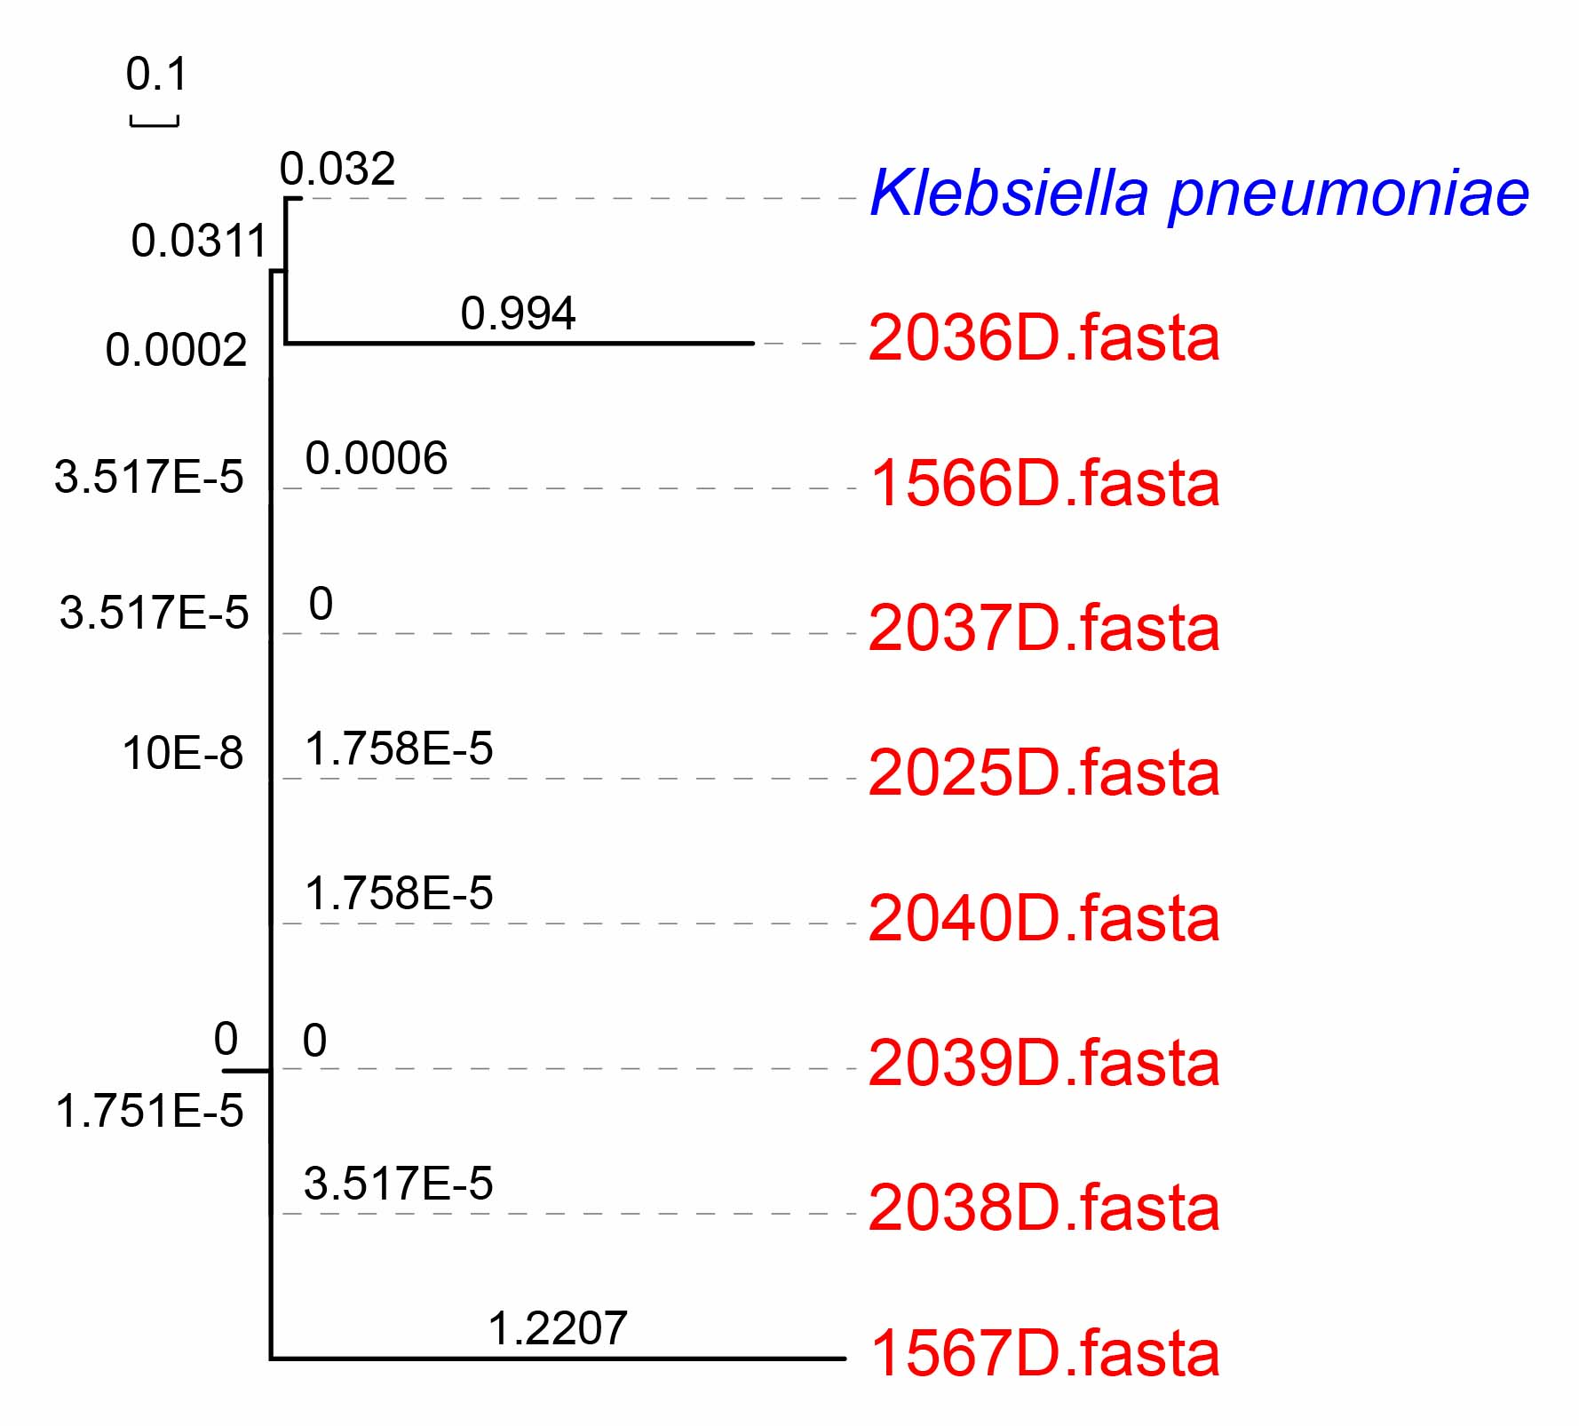

Supplementary Tables
Supplementary Tables 1-8 are in separate Excel files and the table legends are as following:
Supplementary Table 1. Information of strains and patient diagnosis.
Supplementary Table 2. Phenotypes of 1566D, a.k.a., medical records of 1566P.
Supplementary Table 3. Phenotypes of 1567D, a.k.a., medical records of 1567P.
Supplementary Table 4. Phenotypes of 2035D, a.k.a., medical records of 2035P.
Supplementary Table 5. Phenotypes of 2036D, a.k.a., medical records of 2036P.
Supplementary Table 6. Phenotypes of 2037D, a.k.a., medical records of 2037P.
Supplementary Table 7. Phenotypes of 2038D, a.k.a., medical records of 2038P.
Supplementary Table 8. Phenotypes of 2039D, a.k.a., medical records of 2039P.

Supplementary Table 9. Illumina MiSeq sequencing yields.
Sample | Total Reads | Raw Bases | Q20 Bases | Percentage (%)
1566D | 3,743,220 | 1,125,453,384 | 941,700,320 | 83.67
2035D | 4,782,134 | 1,320,197,359 | 1,163,174,482 | 88.11
2036D | 5,856,910 | 1,483,756,319 | 1,311,194,394 | 88.37
2037D | 6,624,804 | 1,657,988,991 | 1,460,537,145 | 88.09
2038D | 5,615,282 | 1,597,685,382 | 1,368,045,328 | 85.63
2039D | 5,641,658 | 1,439,029,823 | 1,263,496,926 | 87.80
2040D | 4,801,236 | 1,220,424,147 | 1,075,399,273 | 88.12

Supplementary Table 10. Oxford Nanopore sequencing yields.
Sample | Total reads | Total bases | Average length | Longest reads length | Reads N50 length
1567D | 414,491 | 7,483,109,230 | 18,054 | 167,316 | 25,890

Supplementary Table 11. Detection and validation of SNPs in seven strains.
Isolates | SNP number | cSNP number | cSNP percent (%) | Validated SNPs | Validation ratio (%)
1566D | 8,499 | 7,336 | 86.3 | 154 | 77.0
2035D | 7,506 | 6,424 | 85.6 | 147 | 73.5
2036D | 33,716 | 28,835 | 85.5 | 152 | 76.0
2037D | 7,488 | 6,399 | 85.5 | 154 | 77.0
2038D | 8,734 | 7,497 | 85.8 | 156 | 78.0
2039D | 8,624 | 7,424 | 86.1 | 155 | 77.5
2040D | 8,880 | 7,636 | 86.0 | 152 | 76.0

Supplementary Table 12. A total of 92 all-variation SNPs in seven strains. Red refers to 40 all-variation loci; Bold stands for 24 strain’s unique SNP loci.
Chromsome | Position | Ref | 1566D | 2035D | 2036D | 2037D | 2038D | 2039D | 2040D
NC_016845.1 | 1066275 | T | C/T | C/T | T | C/T | C/T | C/T | C/T
NC_016845.1 | 1066289 | T | G/T | T/G | G/T | G/T | G/T | G/T | G/T
NC_016845.1 | 1157834 | G | G/T | T/G | G | G | G | G | G
NC_016845.1 | 1309634 | T | G | G | G | G | G | G | G
NC_016845.1 | 1309841 | A | T | A | A/T | T | T | T | T
NC_016845.1 | 1309847 | G | A | A/G | A | A | A | A | A
NC_016845.1 | 1309865 | G | A | A | A | A | A | A | A
NC_016845.1 | 1309889 | C | T | T | T | T | T | T | T
NC_016845.1 | 1311041 | G | C | C | C | C | C | C | C
NC_016845.1 | 1311056 | C | A | A | C | A | A | A | A
NC_016845.1 | 1311080 | G | G | C/G | C | C | C | C | C
NC_016845.1 | 1311134 | G | A | A | A | A | A | A | A
NC_016845.1 | 1311558 | G | T | T | T | T | T | T | T
NC_016845.1 | 1322931 | G | T | T | G | T | T | T | T
NC_016845.1 | 1322970 | A | G | G | G | G | G | G | G
NC_016845.1 | 1323036 | C | T | T | C | T | T | T | T
NC_016845.1 | 1324201 | A | C | C | C | C | C | C | C
NC_016845.1 | 1324306 | C | T | T | T | T | T | T | T
NC_016845.1 | 1324519 | G | A | A | A | A | A | A | A
NC_016845.1 | 1325195 | A | G | G | G | G | G | G | G
NC_016845.1 | 1325197 | C | T | C | T | T | T | T | T
NC_016845.1 | 1325233 | A | G | A | G | G | G | G | G
NC_016845.1 | 1325260 | A | A | A | A | C | C | C/A | C
NC_016845.1 | 3049023 | T | C | C | C | C | C | C | C
NC_016845.1 | 3060510 | T | C | C | C | C | C | C | C
NC_016845.1 | 3060570 | C | T | T | T | T | T | T | T
NC_016845.1 | 3060768 | C | G | G | G | G | G | G | G
NC_016845.1 | 3061023 | C | T | T | T | T | T | T | T
NC_016845.1 | 3074462 | C | T | T | T | T | T | T | T
NC_016845.1 | 3090625 | T | C | C | C | C | C | C | C
NC_016845.1 | 3090874 | A | G | G | G | G | G | G | G
NC_016845.1 | 3091363 | A | G | G | G | G | G | G | G
NC_016845.1 | 3097079 | G | G/A | G/A | G/A | G/A | G/A | G/A | G/A
NC_016845.1 | 3103775 | A | A/G | A/G | G | A | A/G | A | A
NC_016845.1 | 3103779 | T | T | T | G | T | T | T | T
NC_016845.1 | 3121888 | T | T | T | C | T | T | T | T
NC_016845.1 | 3121980 | A | A | A | G | A | A | A | A
NC_016845.1 | 3122814 | C | C/T | T/C | C/T | C | C | C | C
NC_016845.1 | 3122948 | A | A | A | G | A | A | A | A
NC_016845.1 | 3122951 | T | T/C | T/C | C | C/T | C/T | T/C | T/C
NC_016845.1 | 3123167 | G | G | G | A | G | G | G | G
NC_016845.1 | 3123235 | G | G | G | A | G | G | G | G
NC_016845.1 | 3123236 | A | A/T | A/T | T | A/T | A | A | A
NC_016845.1 | 3123266 | G | G | G | A | G | G | G | G
NC_016840.1 | 2673 | A | G | G | G | G | G | G | G
NC_016840.1 | 2677 | C | T | T | T/C | T | T | T | T
NC_016840.1 | 2707 | C | T | T/C | T | T | T | T | T
NC_016840.1 | 2737 | T | G | G | G/T | G | G | G | G
NC_016840.1 | 2812 | T | A | A | A | A | A | A | A
NC_016840.1 | 2896 | C | T | T | T | T | T | T | T
NC_016840.1 | 2905 | C | T/C | T | T/C | C/T | C/T | T/C | T/C
NC_016840.1 | 2932 | C | G | G | G | G | G | G | G
NC_016840.1 | 3013 | C | A | A | A | A | A | A | A
NC_016840.1 | 3070 | C | A | A | A | A | A | A | A
NC_016840.1 | 3094 | A | T | T | T | T | T | T | T
NC_016840.1 | 3120 | A | C | C | C | C | C | C | C
NC_016840.1 | 3223 | G | A | A | A | A | A | A | A
NC_016840.1 | 3244 | G | C | C | C | C | C | C | C
NC_016840.1 | 3250 | C | T/C | T/C | C/T | C/T | T | T | T
NC_016840.1 | 3299 | G | C | C | C | C | C | C | C
NC_016845.1 | 3578729 | A | A/G | A | A | A | A | A | A
NC_016845.1 | 3578759 | T | T/C | T | T | T | T | T | T
NC_016845.1 | 3578876 | T | C/T | T/C | T/C | C/T | C/T | T/C | T/C
NC_016845.1 | 3578930 | T | C/T | T | T/C | C/T | C/T | T | T
NC_016845.1 | 3579029 | T | T | T/G | G/T | G/T | T | T | T
NC_016845.1 | 3579152 | G | A/G | A/G | A | G/A | G/A | G/A | G/A
NC_016845.1 | 3579305 | T | T | T | C/T | T | T | T | T
NC_016845.1 | 3579389 | T | T/G | T/G | G/T | G/T | G/T | G/T | G/T
NC_016845.1 | 3579394 | G | G | G | A | G | G | G | G
NC_016845.1 | 3579425 | G | G/A | G | G/A | G | G | G | G
NC_016845.1 | 3579517 | T | T/C | T/C | T/C | C/T | C/T | T/C | T/C
NC_016845.1 | 4873352 | G | G | G | G/A | G | G | G | G
NC_016845.1 | 5169646 | A | A/G | G | A/G | G | G | G/A | G
NC_016845.1 | 5169731 | G | T/G | G/T | G/T | G/T | G/T | G/T | G/T
NC_016845.1 | 5169737 | A | A/C | C | C | C | A/C | C/A | C/A
NC_016845.1 | 5169743 | A | T/A | A/T | T | A/T | A/T | T/A | T/A
NC_016845.1 | 5169844 | G | T/G | G | T | G | G | G/T | G/T
NC_016845.1 | 5169852 | T | C | C | C | C | C | C | C
NC_016845.1 | 5169857 | T | C/T | C/T | T/C | C/T | T | T | T
NC_016845.1 | 5169860 | G | G/C | G/C | C | C | C/G | G/C | G/C
NC_016845.1 | 5169865 | G | T/G | G | G | G/T | G | G/T | G/T
NC_016845.1 | 5169881 | G | T/G | T | T | T | G/T | G/T | G/T
NC_016845.1 | 5169890 | C | C/A | A | A/C | A | C/A | C/A | C/A
NC_016845.1 | 5169900 | C | T/C | C/T | C/T | C/T | C/T | C/T | C/T
NC_016845.1 | 5169938 | A | A/G | A/G | A/G | A/G | A/G | A/G | A/G
NC_016845.1 | 5169950 | A | C/A | C/A | A/C | A/C | A/C | C/A | C/A
NC_016845.1 | 5169980 | A | C | C | C | C | A/C | C | C/A
NC_016845.1 | 5169989 | A | A/G | G | A/G | G | A/G | A/G | A/G
NC_016845.1 | 5169992 | C | C/G | G | C/G | G | C/G | G/C | G/C
NC_016845.1 | 5170059 | C | C/T | T | T/C | T | C/T | T/C | T/C
NC_016845.1 | 5170096 | G | G | C | G | C | G | G | G
NC_016845.1 | 5170099 | A | G/A | G/A | A/G | G | A/G | G/A | G/A

