Extended Data
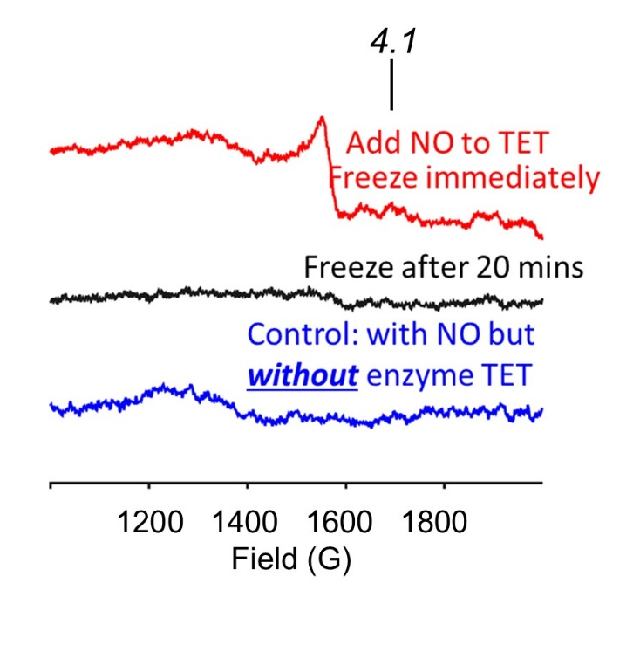
Extended Data Figure 1: The reaction of NO with TET2 does not form a mononitrosyl. Representative X-Band (T = 8K) EPR spectra of full length TET2 protein treated with Sper/NO (100 μM) and all substrates and cofactors for 1 min (red line) and 20 min (black line). Control reaction (blue line) is the complete reaction without TET2 after 20 min, n=3. Spectrum is indicative of a non-Heme NO-bound DNIC.

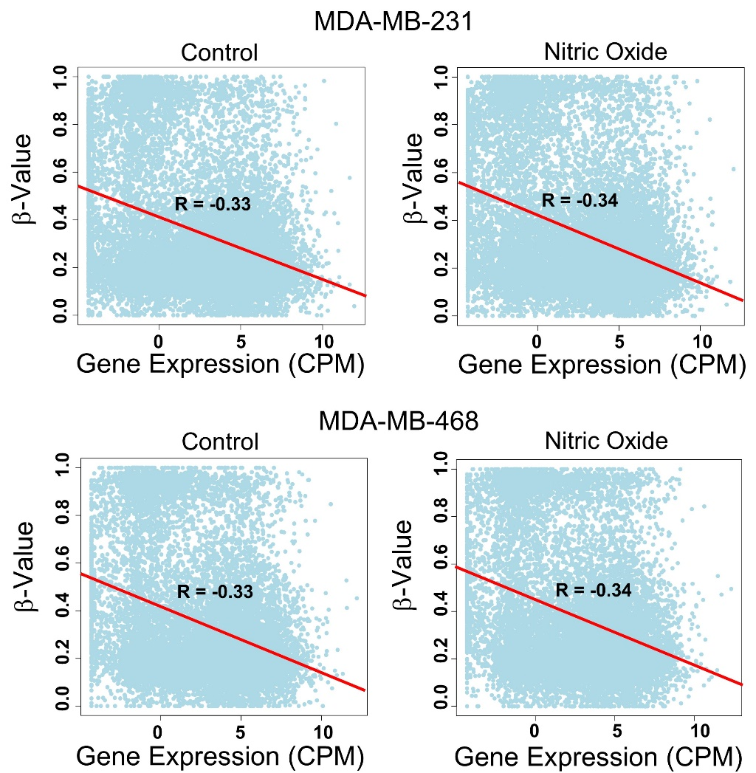

Extended Data Figure 2: NO-mediated increases in 5mC are negatively associated with gene expression in TNBC cells globally. For both control and NO treatment groups there was a clear negative correlation between β-value (5mC) and gene expression (expressed as TMM (trimmed mean of M-values) normalized CPM (counts per million) reads) in both cell types.

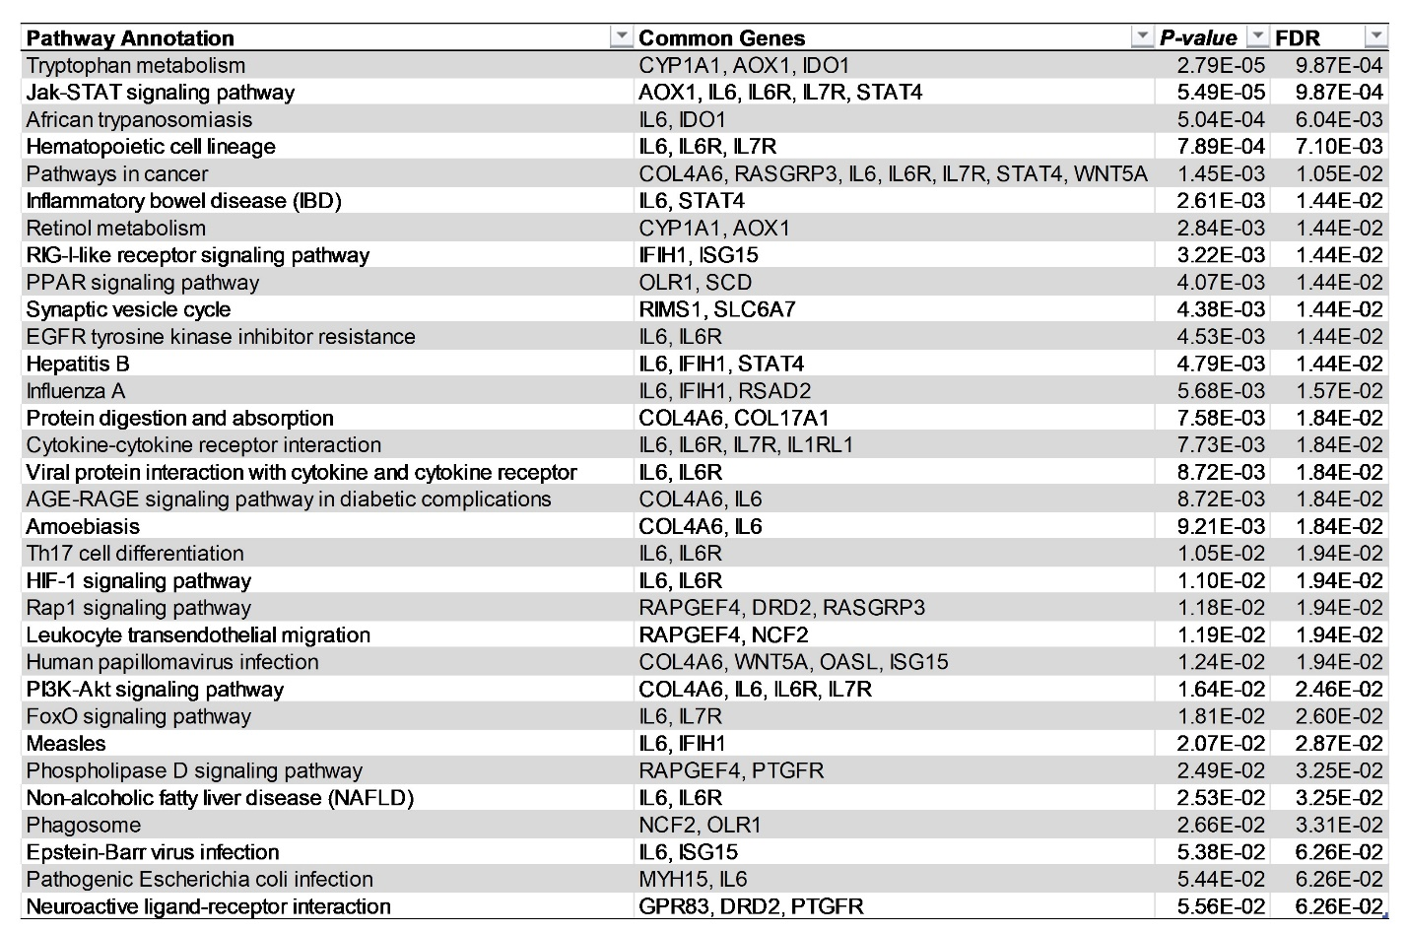

Extended Data Table 1: Gene Set Enrichment Analysis (GSEA) of the 90 differentially expressed genes common to both cell types (|log2FC|>1, FDR < 0.05). KEGG pathways with FDR < 0.05 are shown for 231 and 468 cells.

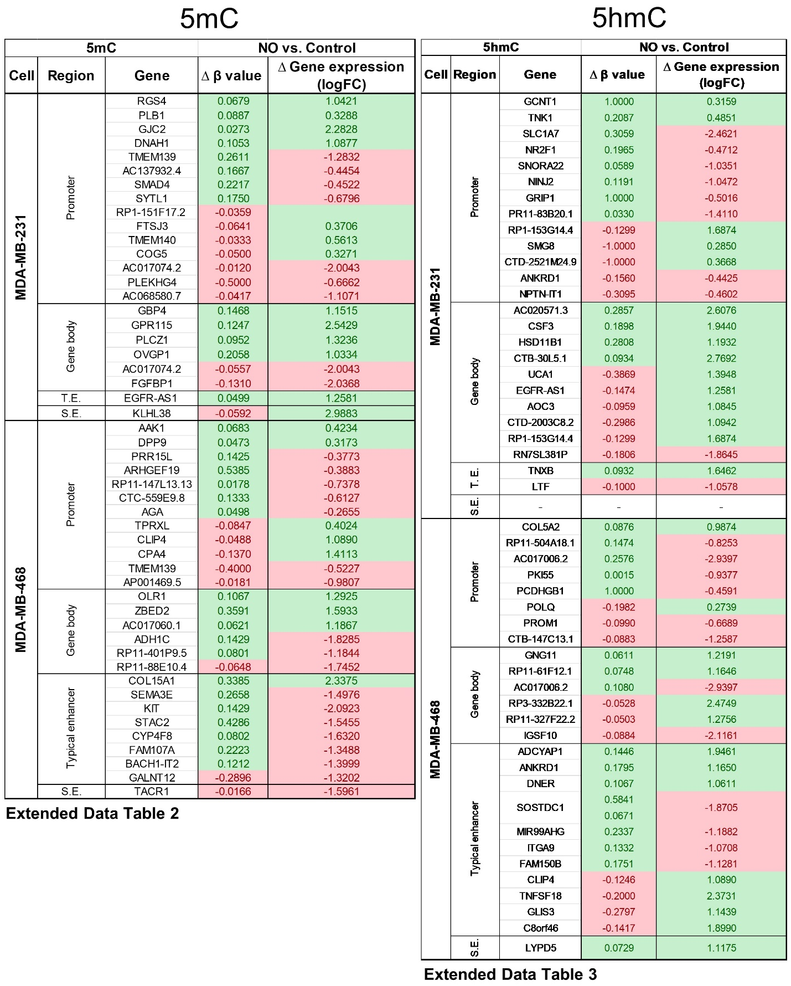

Extended Table 2 & 3: NO-regulated genes and their association with changes in methylation (5mC/5hmC) at specific genomic loci. β-values (5mC or 5hmC) at gene-regulatory loci (as determined by RnBeads) are paired with the expression changes in their associated genes in MDA-MB-231 and MDA-MB-468 cells.

