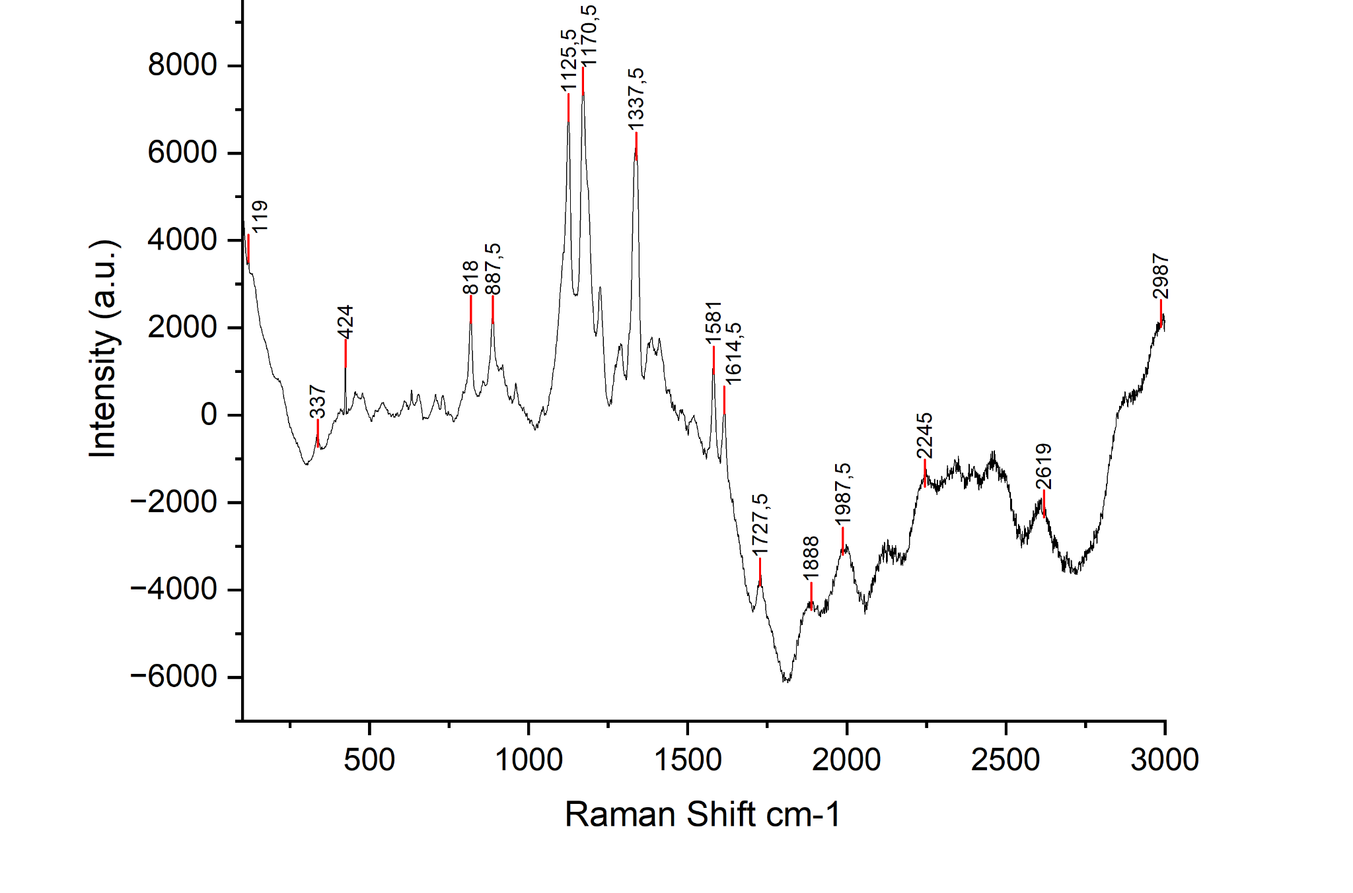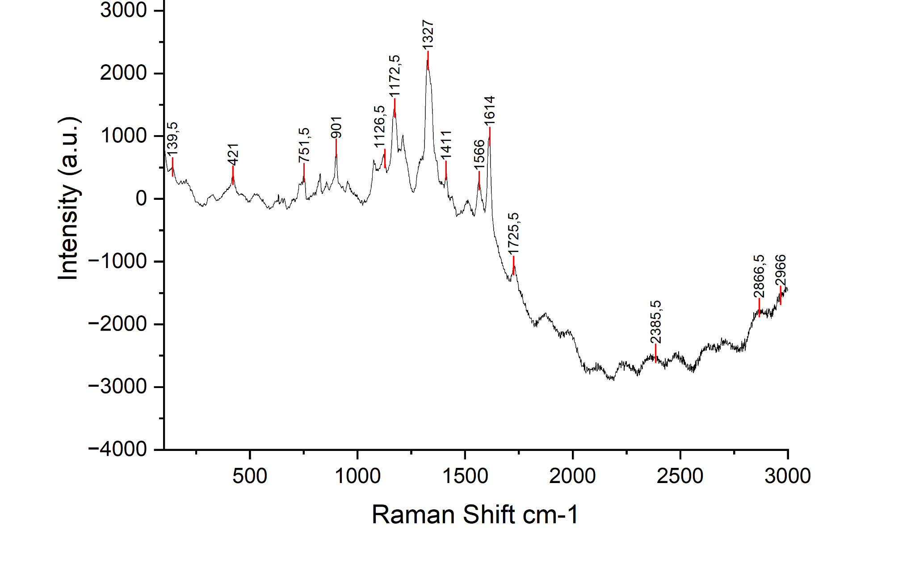
(a) (b)

S1. Raman test result on selected microplastic sample (a) Location 2 (c) Location 4

