Extended Data Table 1 | Multi-dimensional experience sampling (mDES) items used in the current study.
Questions | Label | Low (1) | High (10)
My thoughts were focused on an external task or activity: | Task | Not at all | Completely
My thoughts involved future events: | Future | Not at all | Completely
My thoughts involved past events: | Past | Not at all | Completely
My thoughts involved myself: | Self | Not at all | Completely
My thoughts involved other people: | People | Not at all | Completely
The emotion of my thoughts was: | Emotion | Negative | Positive
My thoughts involved images: | Images | Not at all | Completely
My thoughts were detailed and specific: | Detailed | Not at all | Completely
My thoughts were: | Deliberate | Spontaneous | Deliberate
I was thinking about solutions to problems (or goals): | Problem | Not at all | Completely
My thoughts were intrusive: | Intrusive | Not at all | Completely
My thoughts contained information I already knew (e.g., knowledge or memories): | Knowledge | Not at all | Completely
I was absorbed in the contents of my thoughts: | Absorbing | Not at all | Completely
My thoughts were distracting me from what I was doing: | Distracting | Not at all | Completely
My thoughts involved words: | Words | Not at all | Completely
My thoughts involved sounds: | Sounds | Not at all | Completely
Note. Participants responded using a 1-10 continuous slider scale.
Extended Data Table 2 | Component loadings of the first five components identified via the application of Principal Components Analysis (PCA) to the full 14-task battery mDES data (N observations = 7220, N = 190).
mDES item | PC1 | PC2 | PC3 | PC4 | PC5
Absorbing | 0.29 | -0.06 | 0.20 | -0.14 | -0.11
People | 0.30 | 0.09 | -0.38 | 0.00 | 0.01
Problem | 0.15 | -0.08 | 0.59 | 0.14 | -0.12
Words | 0.25 | -0.05 | -0.03 | 0.03 | 0.62
Sounds | 0.20 | 0.15 | -0.17 | 0.58 | 0.37
Images | 0.20 | -0.04 | -0.21 | 0.42 | -0.56
Past | 0.34 | -0.10 | -0.23 | -0.30 | -0.16
Distracting | 0.21 | 0.49 | 0.10 | -0.10 | -0.01
Task | 0.20 | 0.17 | 0.34 | 0.01 | 0.17
Intrusive | 0.22 | 0.42 | 0.07 | -0.05 | -0.05
Deliberate | 0.13 | -0.42 | 0.24 | 0.13 | 0.14
Detailed | 0.32 | -0.32 | 0.13 | 0.04 | -0.05
Future | 0.26 | 0.20 | 0.16 | 0.27 | -0.22
Emotion | 0.17 | -0.31 | -0.27 | 0.20 | 0.04
Self | 0.30 | 0.14 | -0.16 | -0.31 | 0.07
Knowledge | 0.31 | -0.27 | 0.01 | -0.34 | -0.02
Note. Loadings > 0.3 or < -0.3 are emboldened.

Extended Data Table 3 | Task-averaged mDES coordinates in the 5-d ‘thought-space.’
Task | PC1 | PC2 | PC3 | PC4 | PC5
Easy Math | -0.17 | -0.46 | 0.83 | -0.16 | 0.23
Hard Math | -0.36 | -0.24 | 1.10 | -0.28 | 0.24
Finger Tapping | -0.63 | 0.49 | 0.11 | 0.12 | -0.06
Go/No-Go | -0.77 | 0.52 | 0.25 | 0.10 | -0.25
Friend-Reference | 1.07 | -0.74 | -0.82 | -0.26 | 0.20
Self-Reference | 0.74 | -0.16 | -0.26 | -0.92 | 0.35
Memory | 1.37 | -0.57 | -1.11 | -0.32 | -0.22
Reading | 0.01 | 0.39 | -0.06 | 0.06 | 0.30
Documentary | -0.50 | 0.32 | -0.76 | 0.72 | 0.14
Sci-Fi | -0.25 | 0.37 | -0.72 | 0.54 | 0.24
0-Back | -0.19 | 0.50 | 0.24 | 0.13 | -0.22
1-Back | -0.23 | -0.16 | 0.42 | 0.31 | -0.03
2-Back-Faces | -0.16 | 0.00 | 0.08 | 0.32 | -0.61
2-Back-Scenes | -0.33 | -0.03 | 0.33 | 0.25 | -0.57
Note. Coordinates in ‘thought-space’ represent the dot product between each components’ component loadings and each original mDES observation (i.e., PCA scores). Shown here are the task-averaged PCA scores.

Extended Data Table 4 | Task map coordinates in 5-d ‘brain space.’
Task | Gradient 1 | Gradient 2 | Gradient 3 | Gradient 4 | Gradient 5
Easy Math | -0.02 | 0.14 | 0.08 | -0.07 | -0.06
Hard Math | -0.11 | 0.30 | 0.36 | 0.02 | -0.23
Finger Tapping | -0.09 | -0.20 | 0.22 | 0.02 | 0.16
Go/No-Go | -0.13 | 0.23 | 0.06 | -0.14 | -0.12
Friend-Reference | -0.03 | -0.25 | -0.09 | 0.15 | 0.10
Self-Reference | -0.11 | -0.29 | -0.10 | 0.18 | 0.09
Memory | -0.08 | -0.31 | -0.20 | 0.24 | 0.13
Reading | -0.14 | -0.11 | -0.22 | 0.09 | 0.01
Documentary | 0.01 | -0.02 | -0.36 | -0.02 | 0.24
Sci-Fi | -0.11 | -0.02 | -0.29 | 0.04 | 0.11
0-Back | -0.02 | -0.22 | 0.11 | -0.01 | 0.10
1-Back | -0.07 | 0.01 | 0.36 | -0.03 | -0.01
2-Back-Faces | 0.01 | 0.21 | 0.33 | -0.08 | -0.16
2-Back-Scenes | -0.02 | 0.26 | 0.29 | -0.06 | -0.19
Note. Coordinates in ‘brain space’ represent Spearman rank correlation between each task map and the first five connectivity gradients described in Margulies et al.¹

Extended Data Table 5 | Task-averaged Canonical Correlational Analysis (CCA) summed variates for each dimension of the 4-d ‘state-space.’
Task | CC1 | CC2 | CC3 | CC4
0-Back | 0.53 | -0.28 | -0.09 | -2.56
1-Back | 1.34 | 0.39 | -0.12 | 0.15
2-Back-Faces | 1.07 | 1.03 | -2.07 | -1.13
2-Back-Scenes | 1.13 | 1.23 | -1.62 | -0.17
Sci-Fi | -0.31 | -2.51 | 0.46 | 1.51
Documentary | -0.20 | -3.79 | -2.10 | 1.15
Easy Math | 0.87 | 0.44 | -1.02 | 0.20
Hard Math | 1.19 | 2.33 | 0.31 | 2.46
Finger Tapping | 0.98 | -0.88 | 0.86 | -0.09
Go/No-Go | 2.14 | -0.69 | 1.66 | -0.55
Other-reference | -2.36 | 0.41 | -0.92 | -0.47
Self-reference | -2.03 | 0.95 | 1.48 | -0.13
Reading | -0.64 | -0.34 | 1.73 | -0.11
Memory | -3.15 | 0.39 | -0.34 | 0.19
Note. Most positive and negative scores for each dimension are emboldened.

Extended Data Table 6 | Summary of the 14 task brain map sources, grouped into pairs based on task similarity.
Task | Source | Description
Self-Reference | Murphy et al (2019)² | Participant is shown an adjective and indicates whether the adjective applies to themselves or not.
Other-Reference | Murphy et al (2019)² | Participant is shown an adjective and indicates whether the adjective applies to another person or not.
Go/No-Go | Alam et al (2018)³ | Participant must respond with a button press (‘go’) or ignore (‘no/go’) presented stimuli.
Finger Tapping | Barch et al (2013)⁴ | Participant responds to a stimulus presentation with a button press (right-hand) as soon as it is presented.
Reading | Zhang et al (2022)⁵ | Participant reads sentences presented word by word in the centre of the screen.
Memory | Zhang et al (2022)⁵ | Participant is asked to recall a queued autobiographical memory.
0-Back | Turnbull et al (2019)⁶ | Participant must select whether a shape on the left or right side of the screen matches one in the centre.
1-Back | Turnbull et al (2019)⁶ | Participant must select whether a shape on the left or right side of the screen from the previous trial matches one in the centre.
Easy-Math | Wang et al (2020)⁷ | Participant must select the correct answer to single digit addition problems.
Hard-Math | Wang et al (2020)⁷ | Participant must select the correct answer to double digit addition problems.
Documentary | Van Essen et al (2013)⁸ | Participants watch a short documentary (“Welcome to Bridgeville”) clip.
Sci-Fi | Van Essen et al (2013)⁸ | Participants must watch a Sci-Fi movie (“Inception”) clip.
2-Back: Faces | Barch et al (2013)⁴ | Participant must determine whether a stimulus (face) has been shown 2 trials previously.
2-Back: Scenes | Barch et al (2013)⁴ | Participant must determine whether a stimulus (scene) has been shown 2 trials previously.

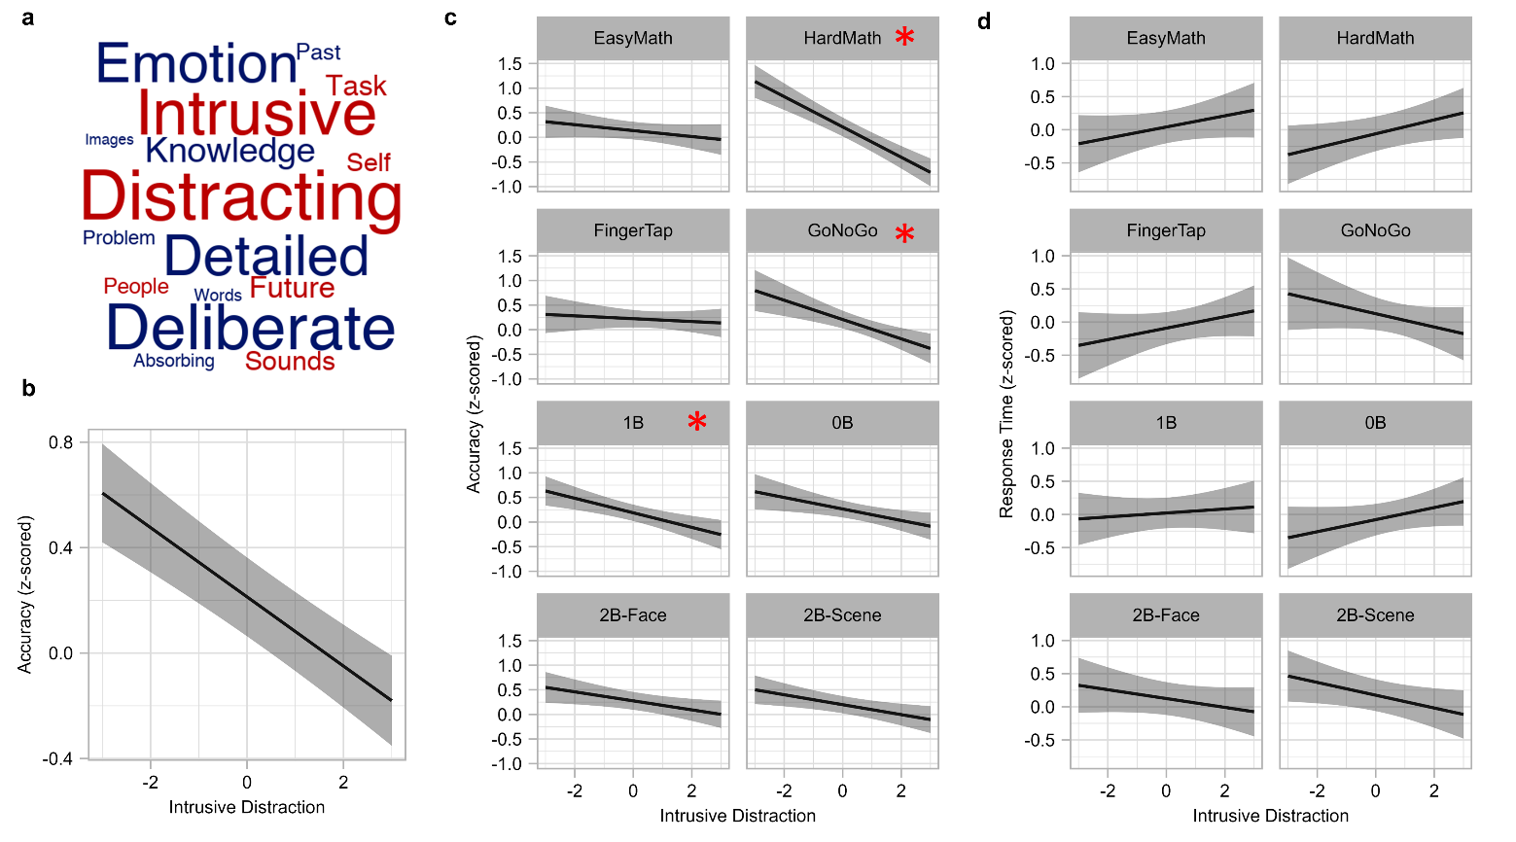
Extended Data Figure 1. Association between task performance metrics and ‘Intrusive Distraction’ dimension of ‘thought-space.’ a) Word cloud representing the ‘Intrusive Distraction’ dimension (each word = experiential feature as assessed via experience sampling, size of word = importance of experiential feature to dimension, color = polarity; red = positive, blue = negative). b) Line plot showing main effect of ‘Intrusive Distraction’ (x-axis) for task accuracy (z-scored within each task separately; y-axis). Error bar = 95% CIs for each predicted value interval. c) Line plots showing interaction between ‘Intrusive Distraction’ (x-axis) and ‘Task’ (facets) for task accuracy (z-scored within each task separately; y-axis). Error bars = 95% CIs for each predicted value interval (unadjusted). Red asterisks indicate which simple slopes are significant when adjusting for 8 estimates (8 tasks). d) Line plots showing interaction between ‘Intrusive Distraction’ (x-axis) and ‘Task’ (facets) for task response time (z-scored within each task separately; y-axis). Error bars = 95% CIs for each predicted value interval (unadjusted).

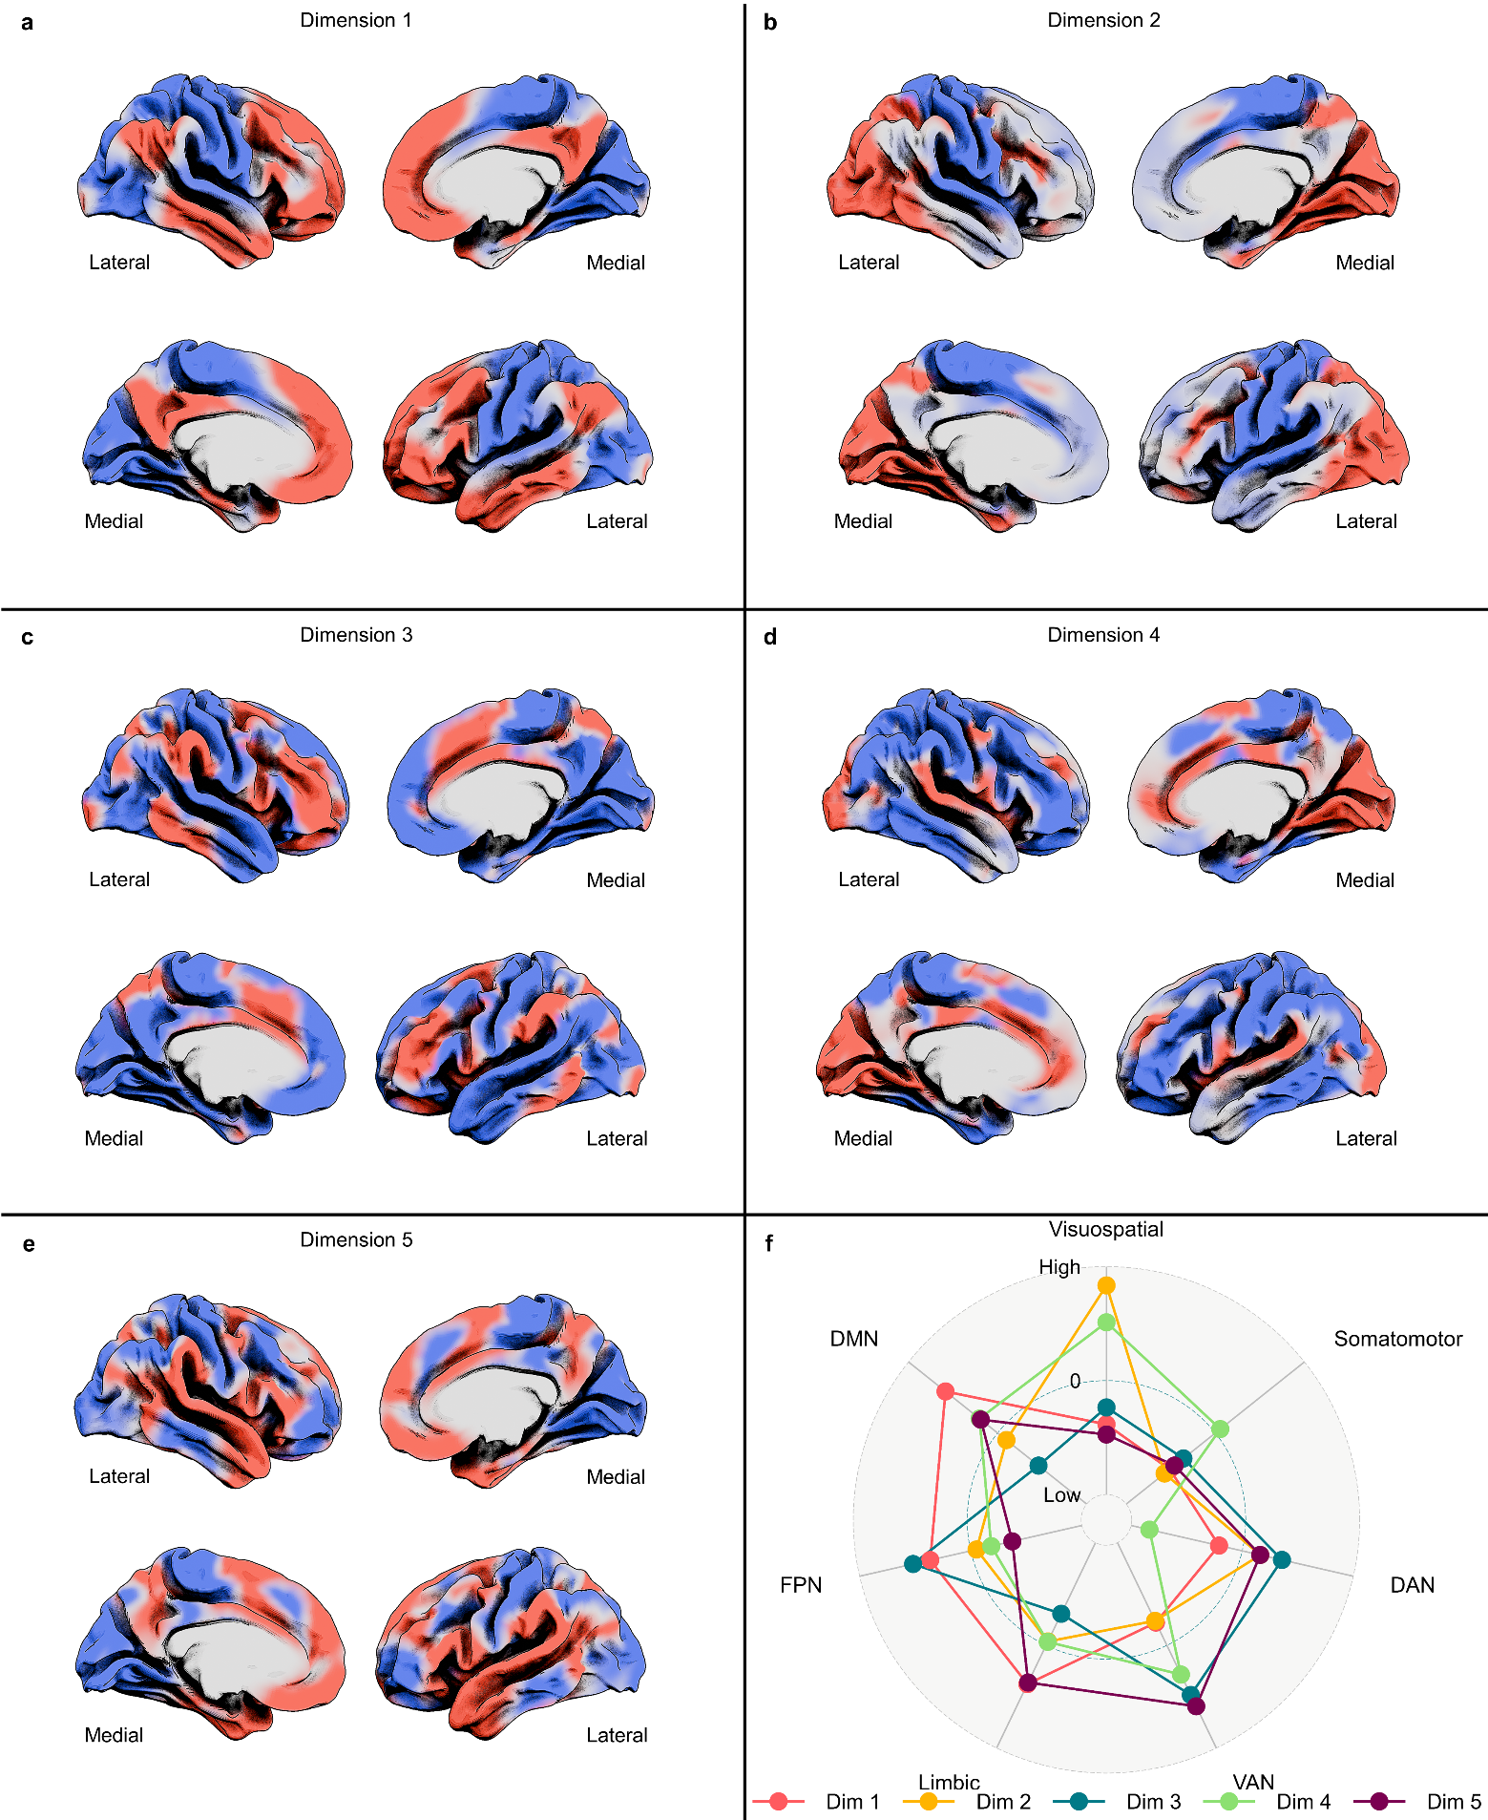
Extended Data Figure 2. Spatial brain maps and network configuration of each connectivity gradient making up the 5-d ‘brain-space’. a-e) spatial maps for gradients 1-5 (top = left hemisphere, bottom = right). Red = Positive, Blue = Negative. f) Radar plot of network configuration of each dimension. Points represent average gradient value in each of the Yeo-7 brain networks⁹. Network-averaged values were z-scored within each gradient prior to plotting. The maximum value (‘High’) is 3 and the minimum value (‘Low’) is -3. Each color represents a different dimension, as shown in the legend at the bottom of the plot (Dim = dimension, DAN = dorsal attention network, VAN = ventral attention network, FPN = fronto-parietal network, DMN = default mode network). Figure adapted from Mckeown et al¹⁰.
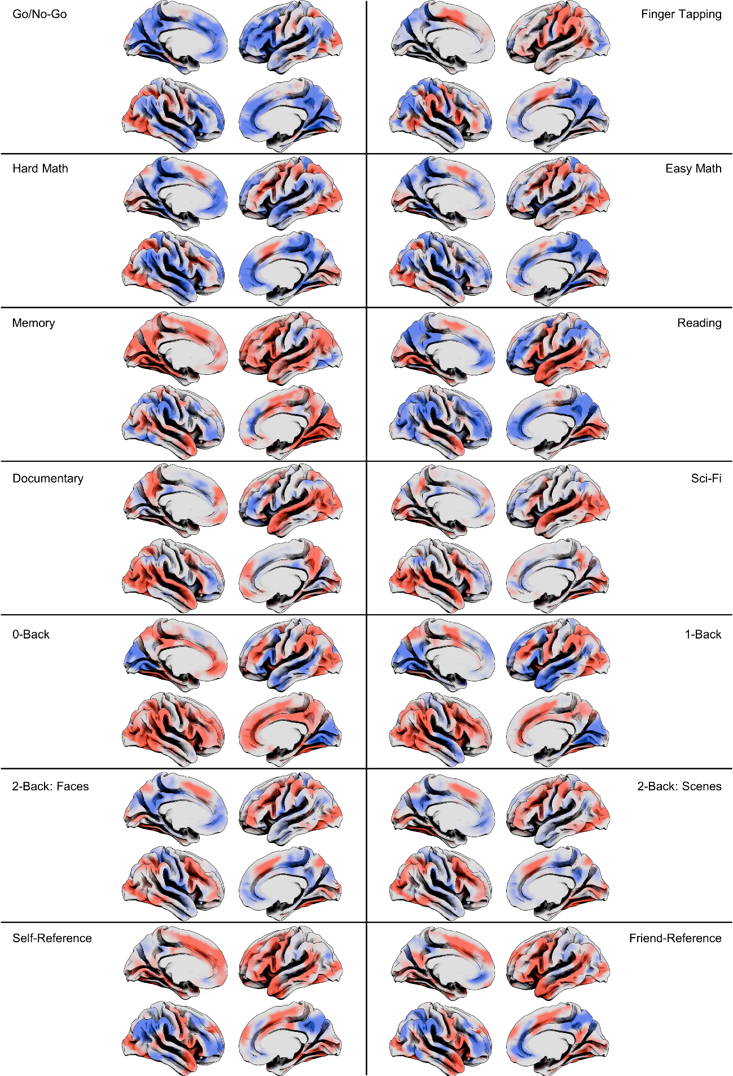
Extended Data Figure 3. Unthresholded group-level task brain maps used in the current study. Each row represents one of the seven pairs, grouped together in terms of task similarity. In each cell, the top row is the left hemisphere (left-hand-side = medial; right-hand-side = lateral), and the bottom row is the right hemisphere (left-hand-side = lateral; right-hand-side = medial). All task maps are z-stat contrast maps (task > baseline).

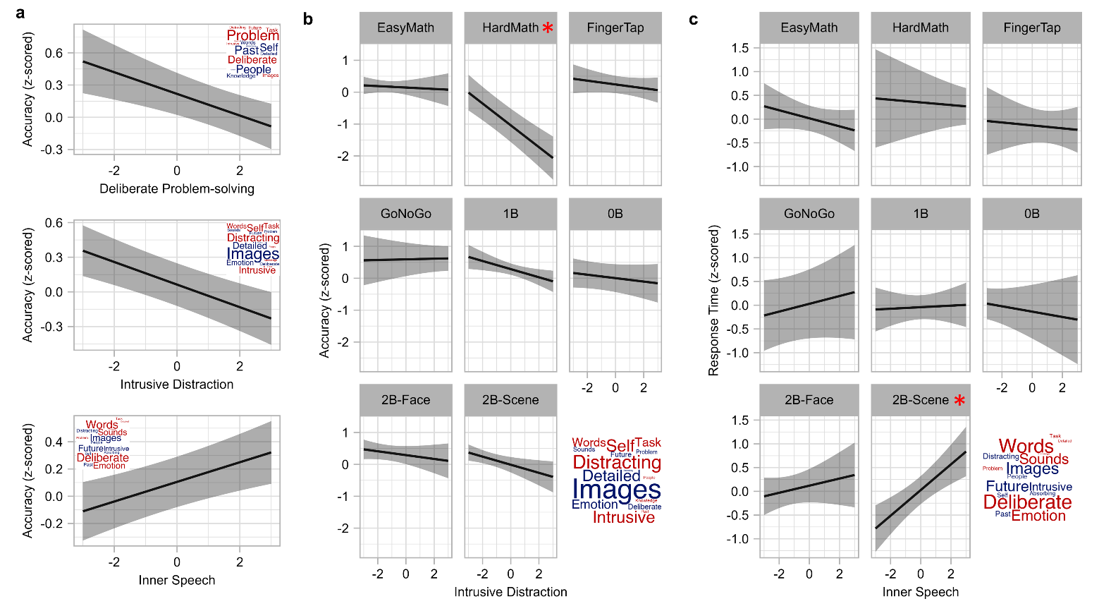
Extended Data Figure 4. Association between task performance metrics and dimensions of CCA ‘state-space.’ a) Significant main effects for task accuracy (‘Deliberate Problem-solving,’ ‘Intrusive Distraction,’ and ‘Inner Speech’) are plotted. Y-axis = z-scored (with each task separately) accuracy, X-axis = CCA dimension (summed variates; see Methods). Word clouds in top corners of each plot represent the X variates of each dimension (size of word = importance of experiential feature to dimension, color = polarity; red = positive, blue = negative). Error bars = 95% CIs for each predicted value interval. b) Faceted plot showing the significant interaction between ‘Intrusive Distraction’ (x-axis) and ‘Task’ for task accuracy (y-axis), with the word cloud representing ‘Intrusive Distraction’ (size of word = importance of experiential feature to dimension, color = polarity; red = positive, blue = negative). Error bars = 95% CIs for each predicted value interval (unadjusted). Red asterisks indicate which task slopes are significant when adjusting for 8 estimates. c) Faceted plot showing the significant interaction between ‘Inner Speech’ (x-axis) and ‘Task’ for task response time (y-axis), with the word cloud representing ‘Inner Speech’ (size of word = importance of experiential feature to dimension, color = polarity; red = positive, blue = negative). Error bars = 95% CIs for each predicted value interval (unadjusted). Red asterisks indicate which task slopes are significant when adjusting for 8 estimates.

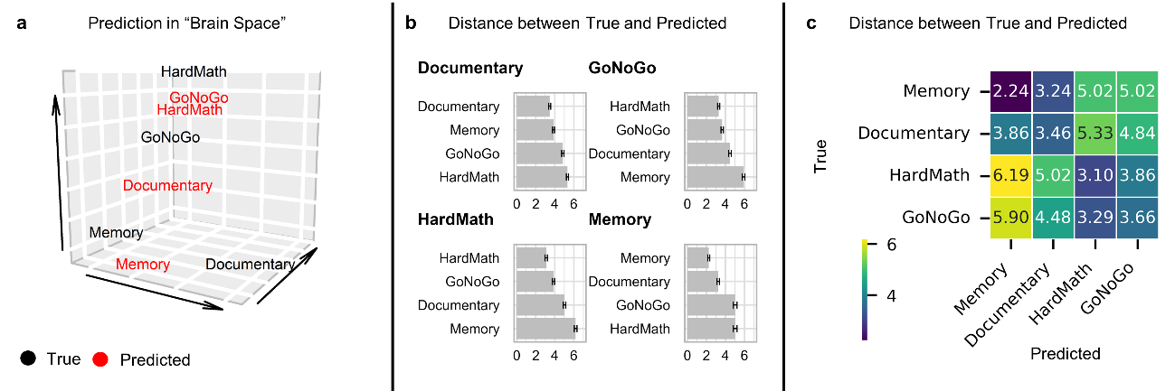
Extended Data Figure 5. Using the 10-task CCA ‘state-space’ to make predictions of brain coordinates in ‘brain-space’ using new experience sampling data in 4 tasks. a) A 3-d scatter plot showing 1) the true locations of the subset of 4 tasks (in black) and 2) the predicted locations (in red) of the subset of 4 tasks in ‘brain-space.’ b) Bar graphs showing the 1) mean of the distribution of distances between the true and predicted coordinates for each task (emboldened title indicates which task), and 2) the mean of the three distributions of distances between the true coordinates for that task and the predicted coordinates for the other three tasks. Error bars = Standard Error, unadjusted. c) Heatmap highlighting that the mean distance between each tasks’ true brain coordinates and brain coordinates (the diagonal) is smaller than the mean distance between each task's true brain coordinates and the other three tasks' predicted brain coordinates.

References
1 Margulies, D. S. et al. Situating the default-mode network along a principal gradient of macroscale cortical organization. Proceedings of the National Academy of Sciences 113, 12574-12579 (2016).
2 Murphy, C. et al. Hello, is that me you are looking for? A re-examination of the role of the DMN in social and self relevant aspects of off-task thought. PloS one 14, e0216182 (2019).
3 Alam, T. G., Murphy, C., Smallwood, J. & Jefferies, E. Meaningful inhibition: Exploring the role of meaning and modality in response inhibition. Neuroimage 181, 108-119 (2018).
4 Barch, D. M. et al. Function in the human connectome: task-fMRI and individual differences in behavior. Neuroimage 80, 169-189 (2013).
5 Zhang, M. et al. Perceptual coupling and decoupling of the default mode network during mind-wandering and reading. Elife 11, e74011 (2022).
6 Turnbull, A. et al. Left dorsolateral prefrontal cortex supports context-dependent prioritisation of off-task thought. Nature communications 10, 3816 (2019).
7 Wang, X., Margulies, D. S., Smallwood, J. & Jefferies, E. A gradient from long-term memory to novel cognition: Transitions through default mode and executive cortex. NeuroImage 220, 117074 (2020).
8 Van Essen, D. C. et al. The WU-Minn human connectome project: an overview. Neuroimage 80, 62-79 (2013).
9 Yeo, B. T. et al. The organization of the human cerebral cortex estimated by intrinsic functional connectivity. Journal of neurophysiology (2011).
10 Mckeown, B. et al. Experience sampling reveals the role that covert goal states play in task-relevant behavior. Scientific Reports 13, 21710 (2023).

