Supplementary information

MATERIALS AND METHODS
Collection and assays of human specimens
Plasma specimens were collected from EV-A71-infected patients with severe symptoms, brainstem encephalitis and brainstem encephalitis combined with pulmonary edema, or mild symptoms, fever, herpangina, or hand-foot-and-mouth disease, and from age-matched healthy control subjects admitted to the National Cheng Kung University Hospital. The Institutional Review Board of National Cheng Kung University Hospital approved the study (HR-99-015). EV-A71 infection was defined as the isolation and typing of the virus from at least 1 site (throat swab, stool, cerebrospinal fluid, or other) with a negative bacterial culture. Brainstem encephalitis was defined as an illness characterized by myoclonus, ataxia, nystagmus, oculomotor palsies, and bulbar palsy in various combinations with or without neuroimaging. Pulmonary edema was defined as respiratory distress with tachycardia, tachypnea, rales, and frothy sputum together with a chest radiograph that showed bilateral pulmonary infiltrates without cardiomegaly. Human plasma samples were subjected to ELISA for the measurement of cytokines IL-10 (2 pg/mL, Biolegend), IL-12 (2 pg/mL, Biolegend), IL-19 (0.648 pg/mL, Abcam), IL-20 (4.2 pg/mL, Abcam), and IFN-γ (1.3 pg/mL, Biolegend).

Mouse cytokine measurement by ELISA
Mouse sera and brain supernatants were subjected to commercially available ELISA (with detection limits and suppliers shown in parentheses) for assays of cytokines IFN-α (12.5 pg/mL, R&D Systems), IFN-β (15.6 pg/mL, PBL Assay Science), IL-1β (4.8 pg/mL, R&D Systems), IL-6 (1.8 pg/mL, R&D Systems), or TNF-α (7.2 pg/mL, R&D Systems)

Antibodies used for flow cytometry
The resulting leukocytes were stained with the antibodies against CD25 (clone PC61.5, eBioscience), CXCR3 (clone CXCR3-173, eBioscience) or Foxp3 (clone MF23, BD Biosciences) on the cell surface, fixed, and permeabilized before staining for intracellular IL-4 (clone 11B11, Biolegend) and analyzed by a flow cytometer.

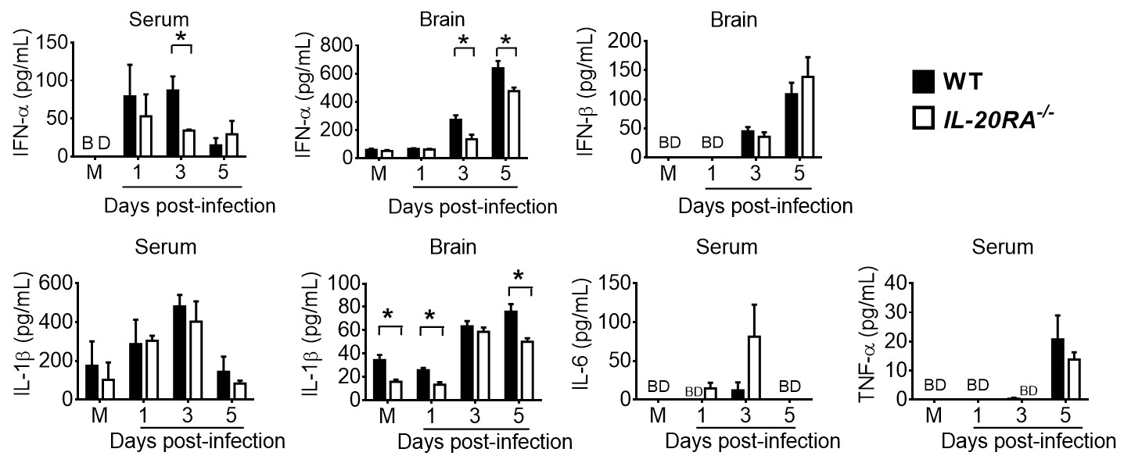

Supplementary Fig. 1 The effects of IL-20RA deficiency on cytokine levels of mice. The sera and brains of mock-infected (M) and infected WT mice and IL-20RA^{-/-} mice were harvested and processed to measure the indicated cytokines by ELISA. Data are means + SEM of ≥3 samples per data point. BD stands for below the detection limit. The serum IFN-β levels and brain IL-6 and TNF-α levels of mock-infected and infected WT mice and IL-20RA^{-/-} mice on 1, 3, and 5 days post-infection were below detection.

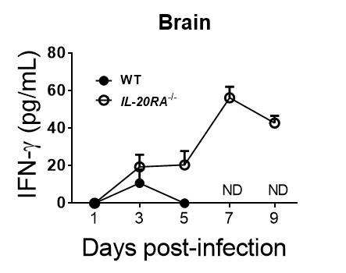

Supplementary Fig. 2 The effect of IL-20RA deficiency on brain IFN-γ levels of infected mice. The brains of infected WT and IL-20RA^{-/-} mice were harvested to measure IFN-γ by ELISA. Data are means + SEM of ≥4 samples per data point. ND stands for not done, because samples were unavailable due to the death of all infected WT mice.
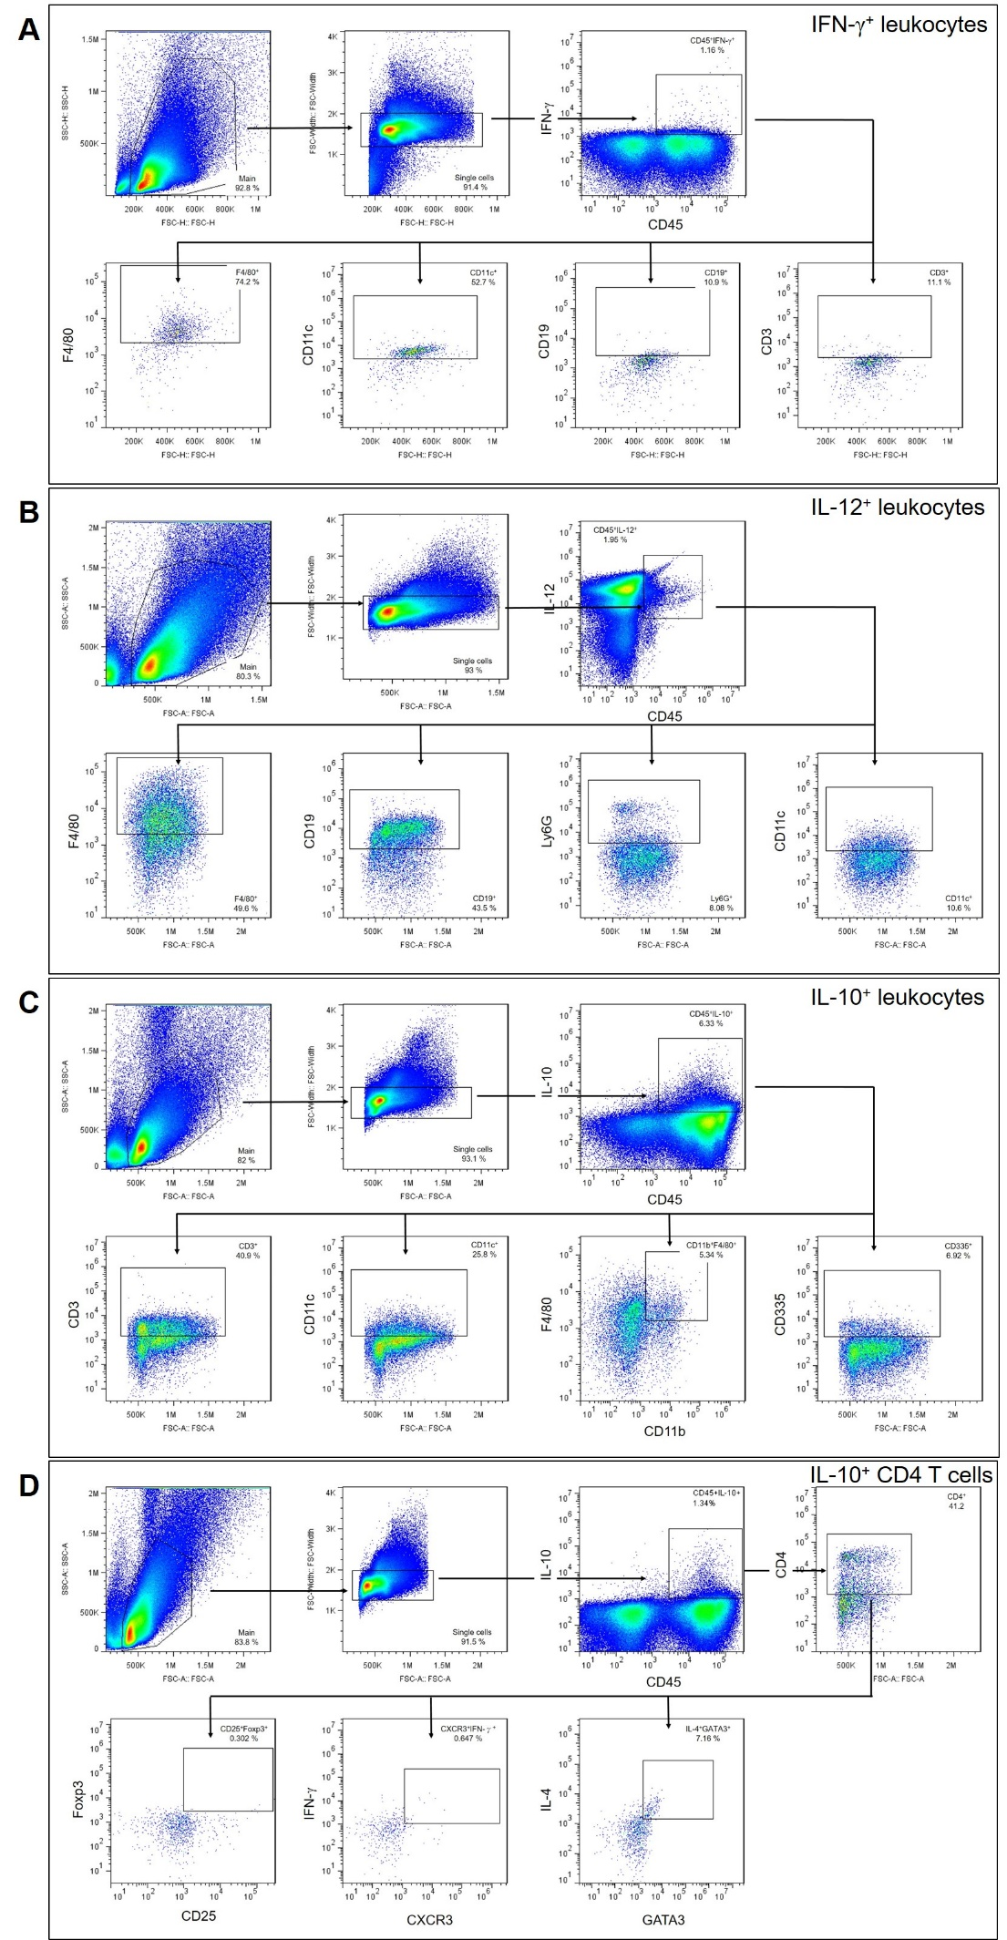

Supplementary Fig. 3 Gating strategy for flow cytometry. Gating strategy for F4/80⁺ macrophages, CD11c⁺ dendritic cells, CD19⁺ B cells, or CD3⁺ T cells of CD45⁺IFN-γ⁺ leukocytes (A), for F4/80⁺ macrophages, CD19⁺ B cells, Ly6G⁺ neutrophils, or CD11c⁺ dendritic cells of IL-12⁺CD45⁺ leukocytes (B), for CD3⁺ T cells, CD11c⁺ dendritic cells, F4/80⁺ macrophages, or CD335⁺ NK cells of IL-10⁺CD45⁺ leukocytes (C), and for Foxp3⁺CD25⁺ Treg cells, IFN-γ⁺CXCR3⁺ Th1 cells, or IL-4⁺GATA3⁺ Th2 cells of CD45⁺IL-10⁺CD4⁺ T cells (D) in mouse splenocytes.

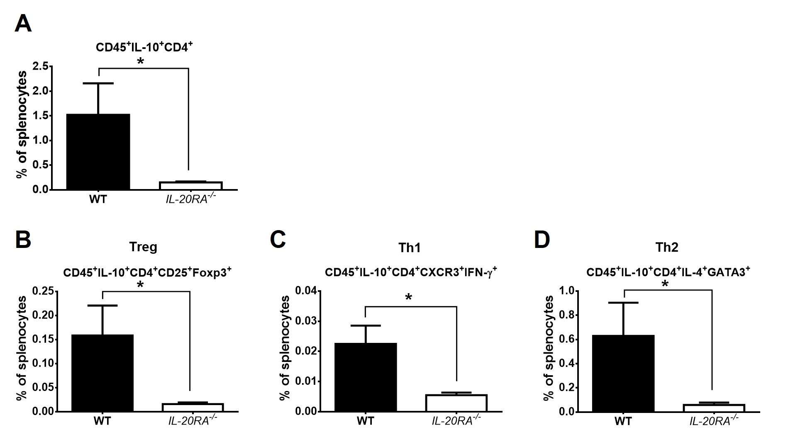

Supplementary Fig. 4 IL-20RA deficiency decreases IL-10-expressing CD4 T cells of EV-A71-infected mice. Splenocytes of infected WT and IL-20RA^{-/-} mice were harvested on day 1 post-infection and stained for the indicated markers to determine the percentages of CD45⁺IL-10⁺CD4⁺ T cells (A) and Treg cells (B), Th1 cells (C), or Th2 cells (D) in CD45⁺IL-10⁺CD4⁺ T cells. Data are means + SE values (error bars) of 6 samples per group. *, P < 0.05, via the Mann-Whitney U test.

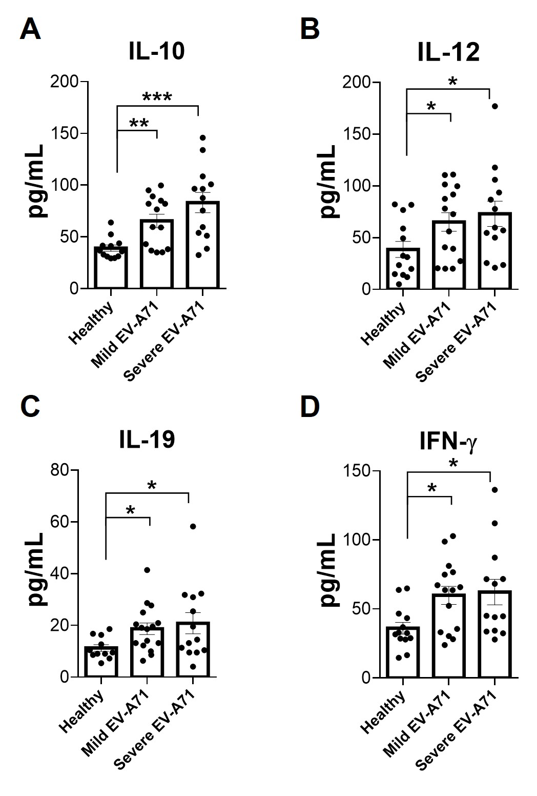
Supplementary Fig. 5 Cytokine levels in the plasma of healthy donors and EV-A71 patients. Plasma samples collected from healthy donors and EV-A71-infected children with mild or severe symptoms were assayed for the indicated cytokines by ELISA. Data show means + SEM of ≥13 samples in each group. *, P < 0.05; **, P < 0.01; and ***, P < 0.001. 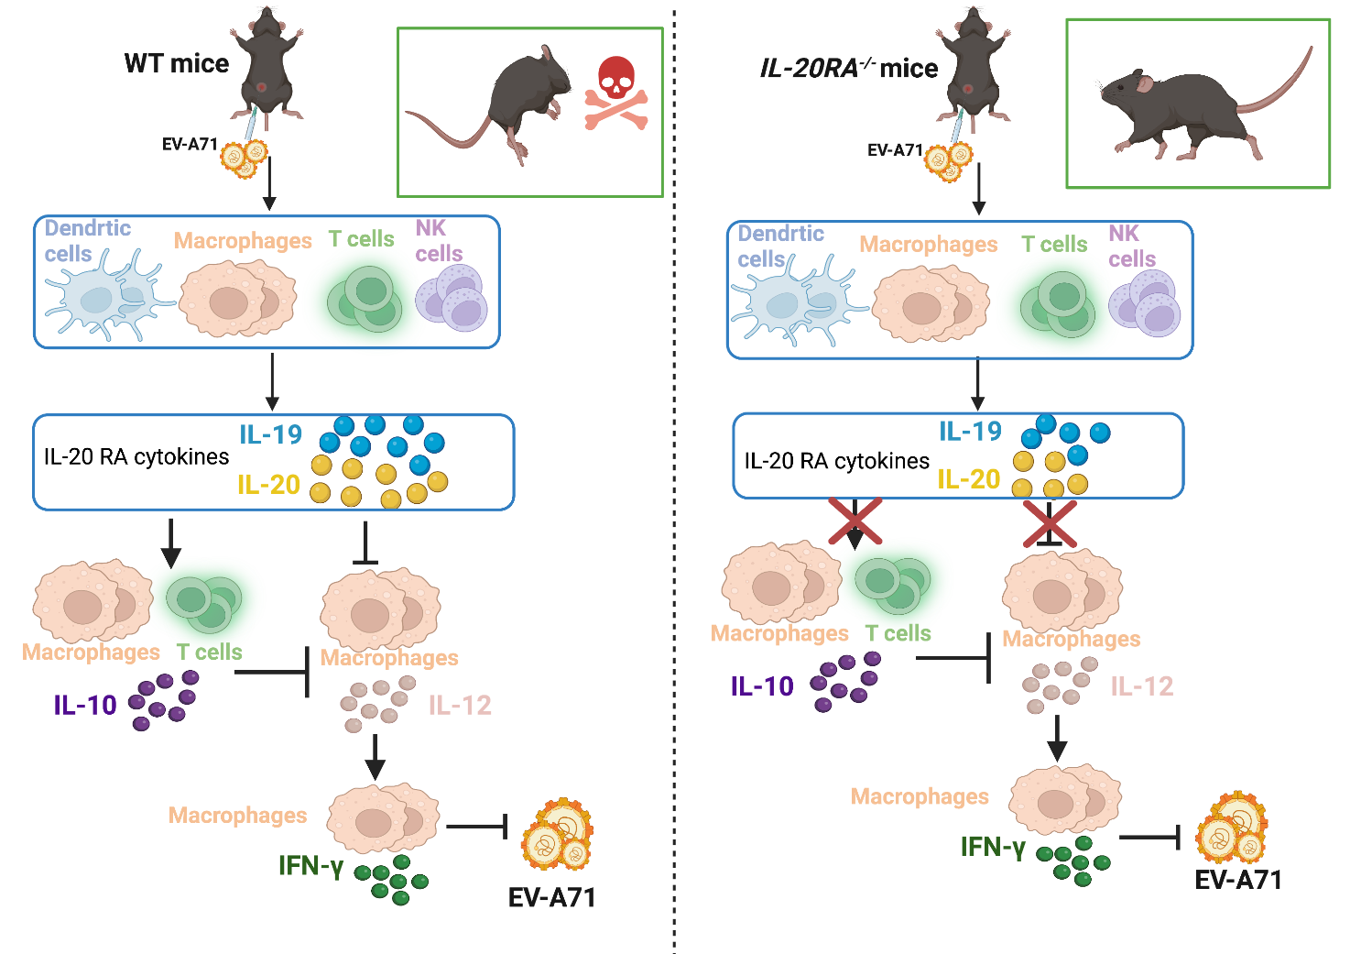

Supplementary Fig. 6 In the periphery of mice, IL-20RA cytokines, IL-19, IL-20, and IL-24 are constitutively expressed, and EV-A71 infection significantly enhances IL-19 and slightly increases IL-20 and IL-24. EV-A71 infection increases T cells to express IL-10 on 1 day post-infection but suppresses macrophages to express IL-12 and the protective cytokine, IFN-γ on 3 and 5 days post-infection, respectively to result in the death of EV-A71-infcted mice.

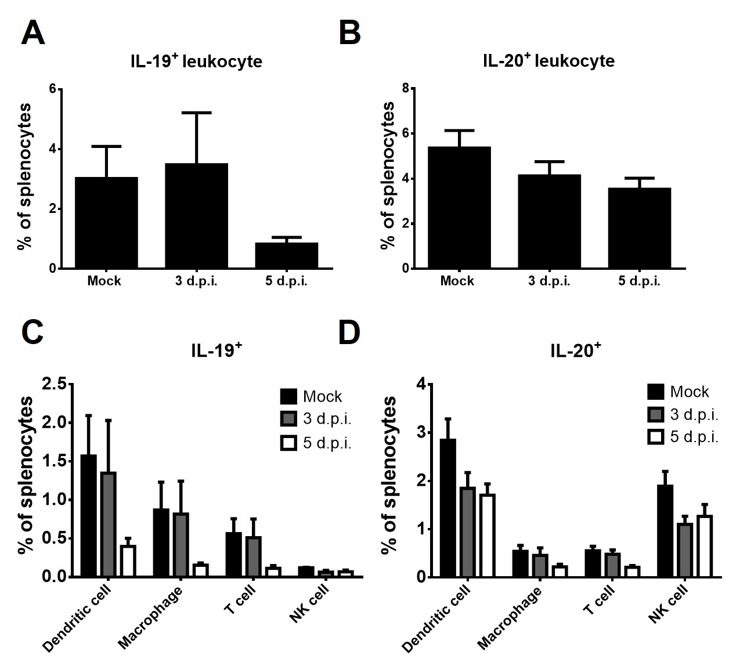
Supplementary Fig. 7 Leukocytes expressing IL-19 or IL-20 in mice. The spleens of mock-infected or infected mice were collected, processed into splenocytes, and stained for IL-19 or IL-20 and leukocyte markers, CD45 plus CD11c (dendritic cells), F4/80 (macrophages), CD3 (T cells), or CD335 (NK cells). The percentage of (A) IL-19⁺ leukocytes, (B) IL-20⁺ leukocytes, (C) IL-19⁺ leukocyte subsets, and (D) IL-20⁺ leukocyte subsets are shown. Data are means + SEM of 3 samples per group.
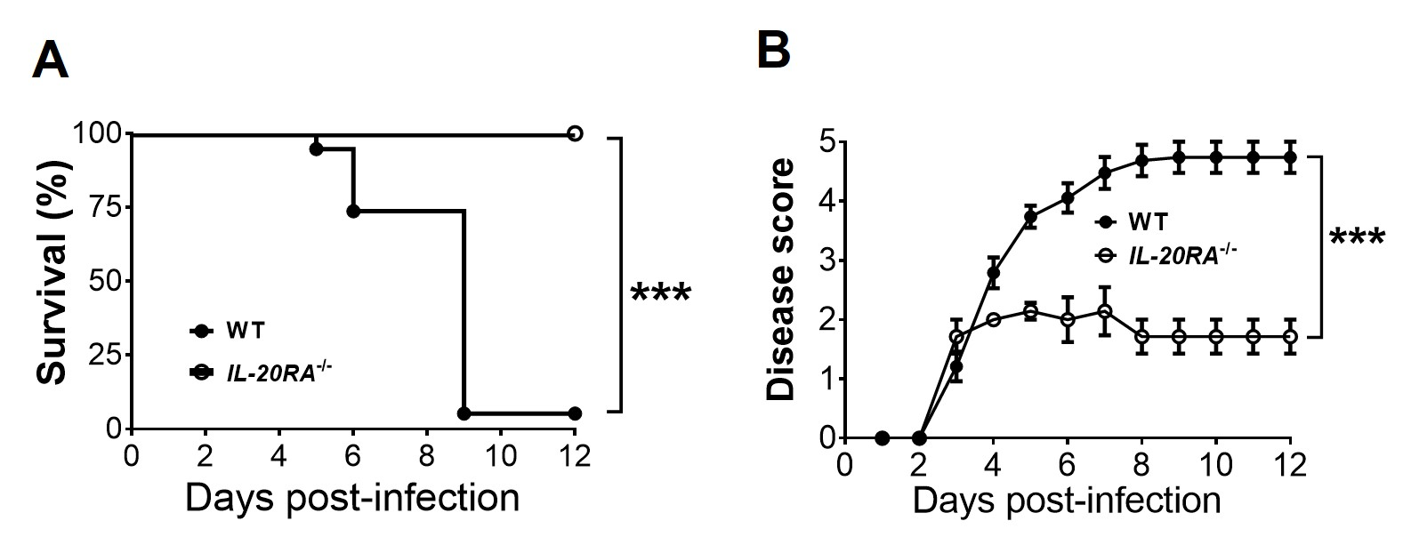

Supplementary Fig. 8 IL-20RA deficiency ameliorates EV-A71 infection in mice. The survival rates (A) and disease scores (B) of WT and IL-20RA^{-/-} mice infected with EV-A71 at the dose of 1 × 10⁵ PFU/mouse are shown (n ≥ 7 per group). ***, P < 0.001.

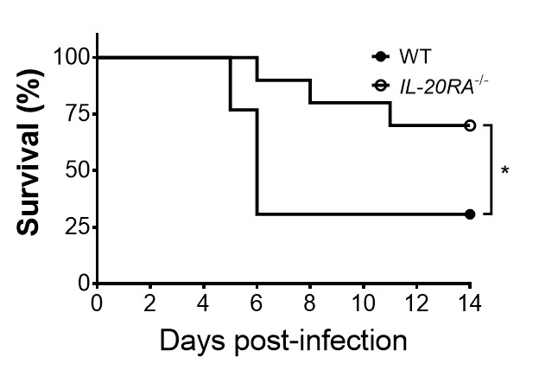

Supplementary Fig. 9 IL-20RA deficiency decreases HSV-1 lethality of mice. The survival rates of 2-week-old WT and IL-20RA^{-/-} mice infected with HSV-1 strain RE by intraperitioneal injection are shown (n ≥ 6 in each group). *, P < 0.05.

