Porous carbon nanosheets from coal tar pitch for zinc ion hybrid capacitor
Feng Weiª*, Qingyun Liuª, Jiadong Zhangª, Ziquan Renª, Linlin Zhang^{b,*}
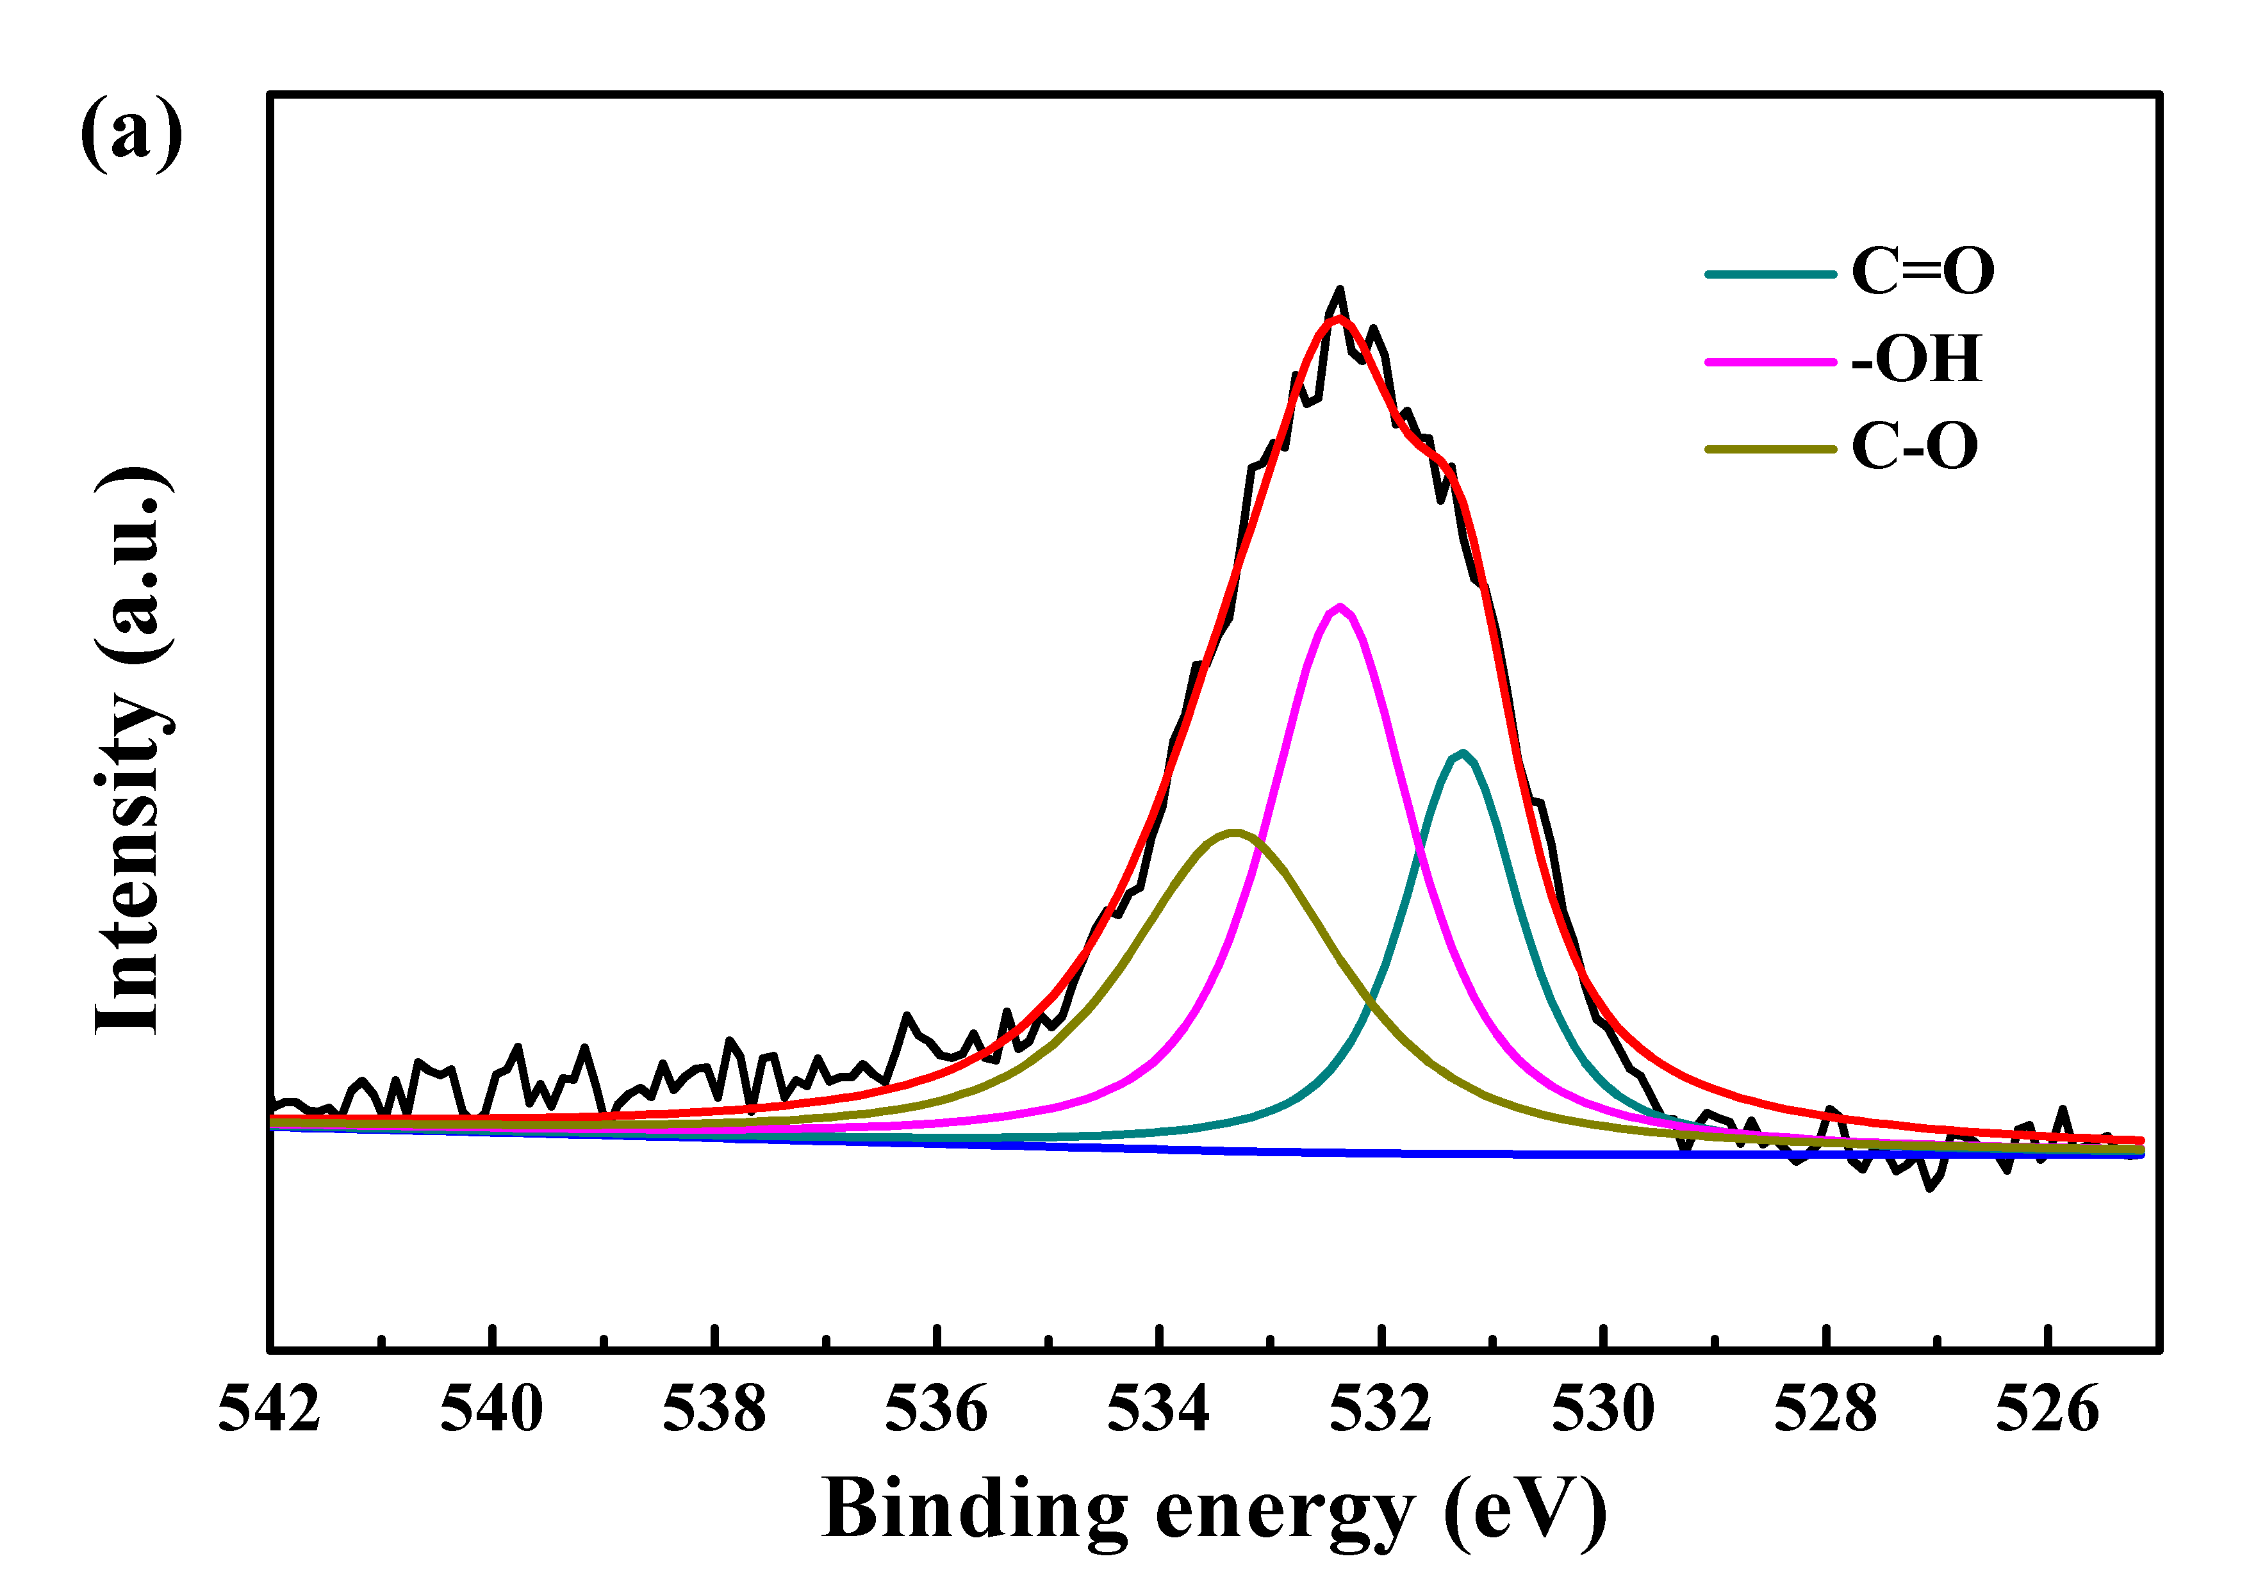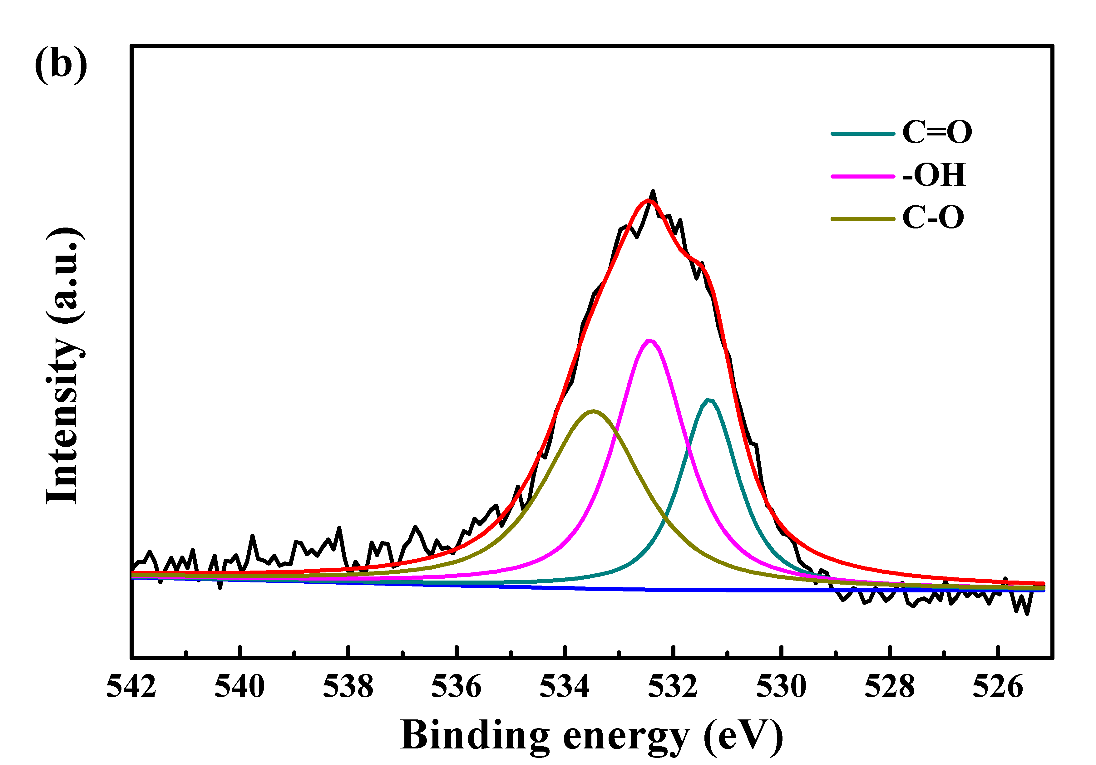
Fig. S1 O1s spectra of (a) PCNS₁ and (b) PCNS₃.
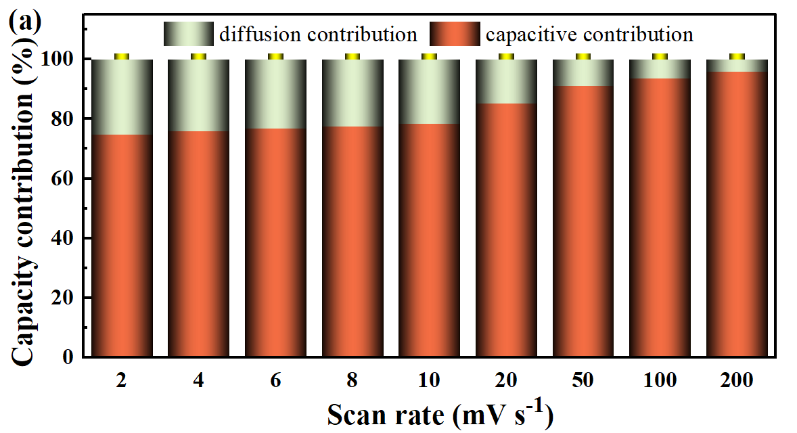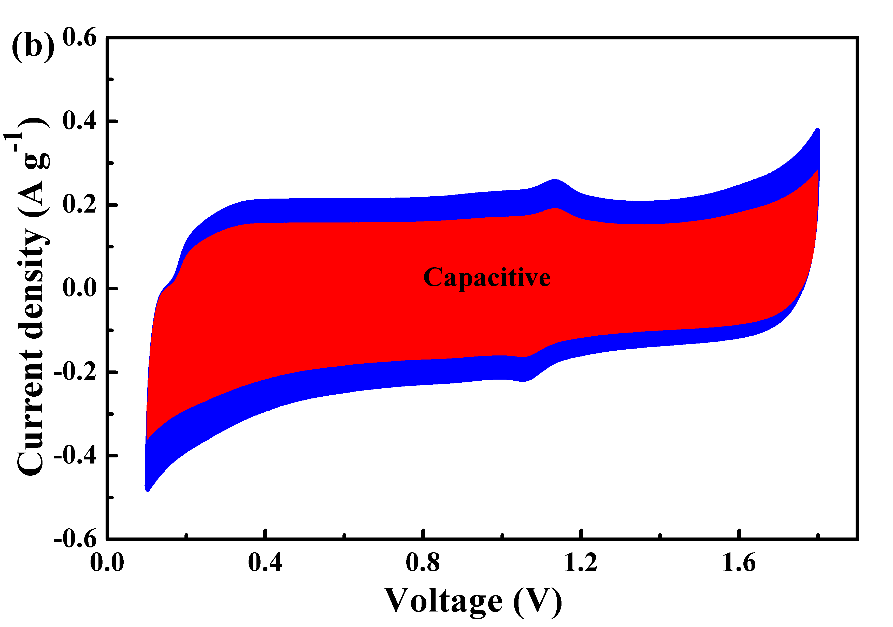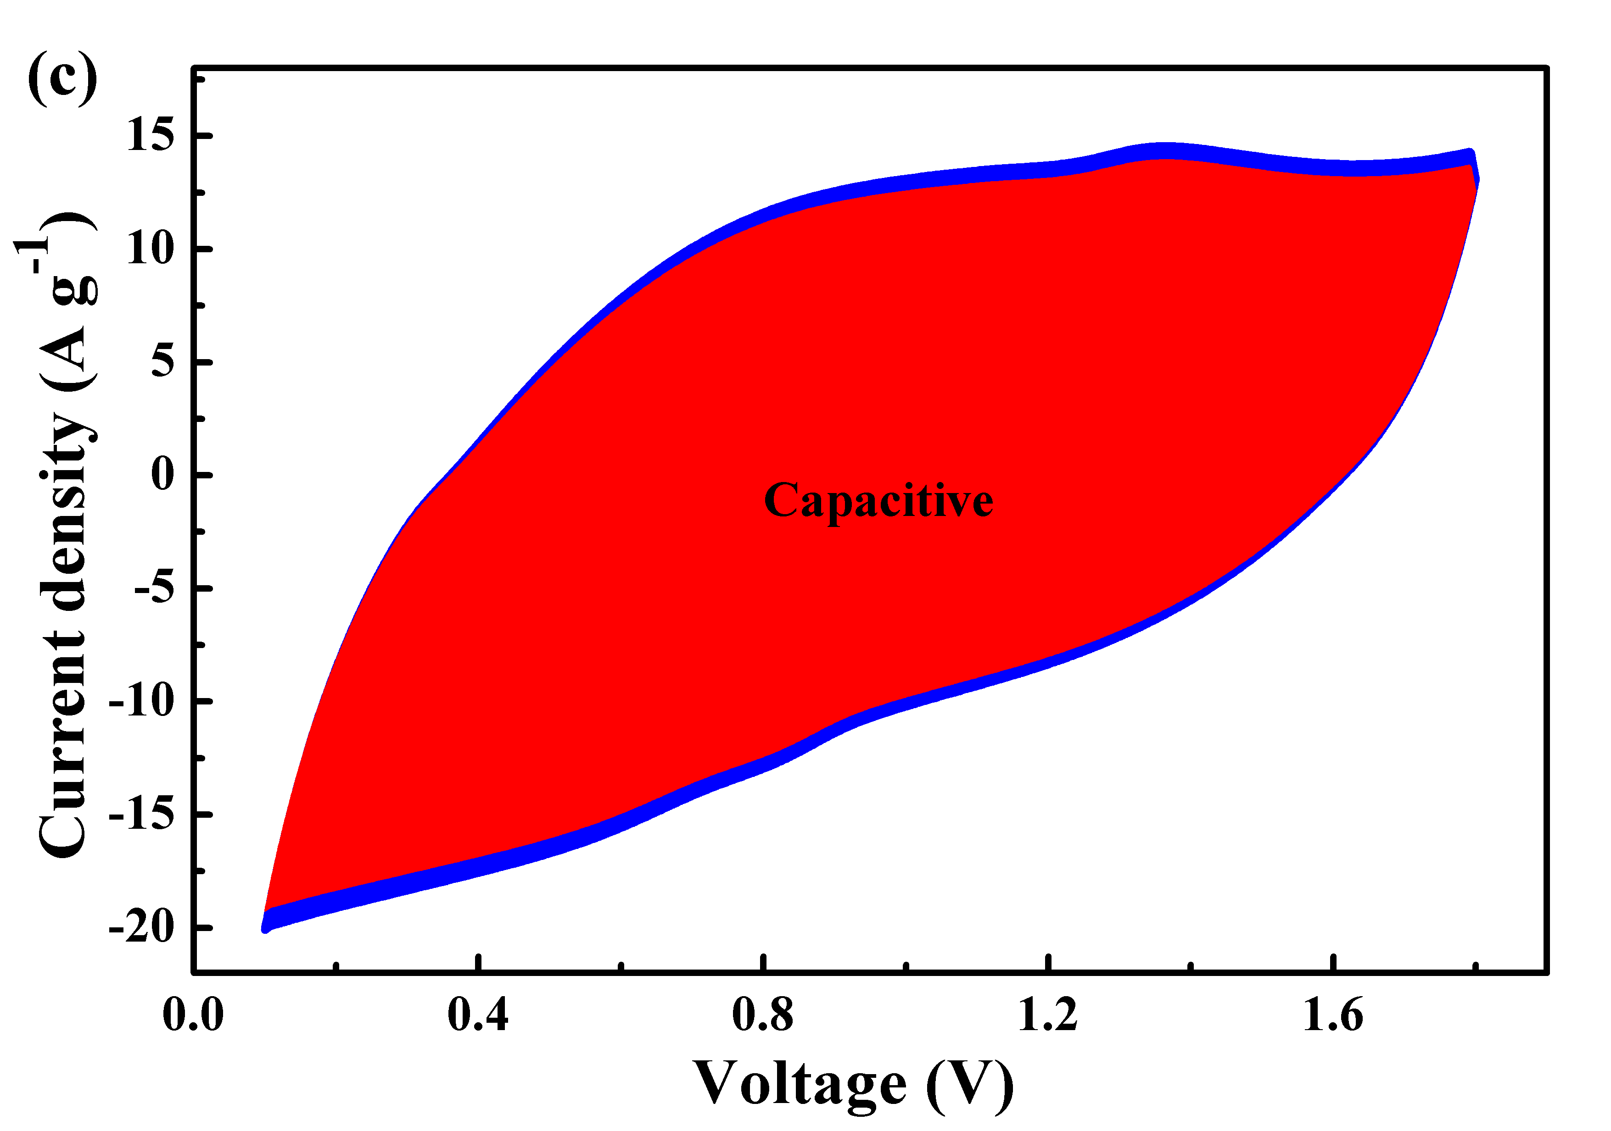
Fig. S2 (a) Capacitive contribution ratio, (e) capacitive contribution at 2 mV s⁻¹ and (f) 100 mV s⁻¹ of Zn‖PCNS₂ ZHC at 1.6 V.

Table S1 The contents of C, O elements in PCNSs.
Samples | C1s  (at.%) | O1s  (at.%) | O1s (at.%)
Samples | C1s  (at.%) | O1s  (at.%) | C=O | C-O | -OH
PCNS₁ | 95.24 | 4.76 | 1.15 | 1.66 | 1.95
PCNS₂ | 93.72 | 6.28 | 1.13 | 3.53 | 1.62
PCNS₃ | 96.84 | 3.16 | 0.74 | 1.20 | 1.22

*Corresponding author. E-mail address: fengw@chzu.edu.cn (F. Wei); 1061701412@qq.com (L.L. Zhang).

