Biomimetic Silk Fibre Assembly: Mimicking Nature's Pultrusion Process
R.O. Moreno-Tortolero,^{a,b*} J. Michalski,ª E. Wells,ª F. Gibb,ª N. Skaer,^{c} R. Walker,^{c} L. Serpell,^{d} C. Holland,^{e} S.A. Davis^{a*}

Electronic Supplementary Information

Materials and Methods

Native-like silk fibroin solution (NL-SF)
Fibroin solutions of 8.5 M LiBr and 20 wt% protein (proprietary protocol) were kindly provided by Orthox Ltd. in 60 mL syringes and stored at 4°C until use. A stock solution of 2 wt% was made for studies requiring diluted solutions by diluting the provided solution with 8.3 M LiBr. As a result, the 20 wt% solutions look clear and free of precipitates, with a distinctive pale-yellow tint and low shear viscosity of 60 ± 3 Pa.s. The stock solutions were dialyzed against Milli-Q water using 12-14 kDa molecular weight cutoff (MWCO) dialysis membranes, with regular medium-to-fresh Milli-Q water changes. LiBr removal was followed by conductivity measurements of the dialysate and contrasted against a conductivity calibration curve, often requiring 3-4 days of dialysis to remove 99.9% of the LiBr salt. After dialysis at 2 wt%, a clear liquid solution with a viscosity similar to that of pure water was obtained. Concentrations were determined gravimetrically by aliquoting approximately 500 µL of the solution and lyophilizing it overnight in a Labconco Freezone 2.5 L freeze-drier. Typically, solutions with concentrations in the range of 5-7 mg/mL were obtained. These concentrations were not arbitrary, as they were chosen after determining the maximum concentration needed from the LiBr solution to generate nonpercolating systems. Serial dilutions of the provided LiBr solution were made, and after dialysis, the physical state was characterized by the eye as liquid-like or gel-like.

Fourier Transform Infrared Spectroscopy (FTIR)
Fibres were analyzed directly using a Perkin Elmer Spectrum One FTIR spectrometer with an attenuated total reflectance (ATR) accessory and supplemented spectrum analyzer software. The analyzed frequency range was from 4000 to 550 cm⁻¹, with a resolution of 2 cm⁻¹ and 50 accumulations.

Optical microscopy
Optical microscopy experiments were conducted using an Olympus BX53 with an SC50 camera attached and a Leica DMI 3000B Fluorescence Optical microscope equipped with a Leica DFC7000 T CCD camera. Dark field and fluorescence experiments were conducted using standard filters within each system.

Confocal laser scanning fluorescence microscopy (CLSFM)
CLSFM characterization was conducted using a Leica SP5-II confocal laser scanning microscope attached to a Leica DMI 6000 inverted epifluorescence microscope. A 5x HCX PL Fluotar lens was used for long working distances.

Scanning electron microscopy (SEM) and energy dispersive X-ray spectroscopy (EDS)
The specimens or samples were placed on aluminum specimen stubs with a conductive carbon sticky tab and then sputter-coated with silver (15 nm thick). The samples were then imaged using a JEOL JSM-IT300 at an acceleration voltage of 15 kV in high current mode for general images and an acceleration voltage of 5 kV in standard current mode for higher resolution images.
For the EDX characterization, an Oxford Instruments X-Max 80 energy dispersive spectrometer was used for scanning electron microscopy (SEM) with a voltage acceleration of 30 kV.

Fibre X-ray diffraction
These experiments were performed using a Rigaku rotating anode (Cu Ka) with a Saturn CCD detector with exposure times of 30–60 s and a specimen-to-detector distance of 50 or 100 mm. Reflections were measured using CLEARER.
Macroscopic fibres were used, wherein these refer to either natural fibres or freshly fabricated biomimetic fibres (within 10 minutes of fabrication). Briefly, approximately 1 cm long fibre bundles were mounted on glass capillary tubes using epoxy-based glue and then mounted directly onto a goniometer head for alignment. Alignment was ensured by monitoring a microscope camera focused on the beam path, and alignment was adjusted for the nominal 0 and 90° orientations. Spectra were acquired at 50 and 100 mm distances at 0 and 90° orientations, respectively, for 30 and 60 s, respectively.

Wilhelmy plate interfacial analysis
Experiments were conducted using a Force Tensiometer (Krüss K100) at room temperature and a flame-treated plain Wilhelmy plate. γ was measured over time to allow for interface equilibration. Each measurement was stopped automatically after the standard deviation of the last 5 points (recorded at 10 s intervals) was < 0.01 mN m-1.

Reeling force measurements
Reeling forces were measured using an analytical microbalance. Briefly, droplets of silk solution were deposited on a Petri dish on the scale, and the instrument was zeroed before pulling the fibres and waiting for a steady state (little to no variation in the measured weight was observed, as determined by variations lower than 10%). The apparent measured mass was then annotated, the experiment was stopped, and the fibres were broken. Before and after spinning, apparent masses were recorded, although no variation was observed. Forces were estimated by calculating the relative force equivalent to the measured mass by multiplying it by the acceleration of gravity. At least 5 experiments were conducted for each reported reeling speed, and the values are presented as the means with their respective standard errors (1.5x).

Dynamic microindentation
The elastic properties of the protein films at the water‒air interface were measured via dynamic microindentation using an FT-MTA03 Micromechanical Testing and Assembly System (FemtoTools AG). Briefly, a standard indentation probe was used to approach the film under microscopic observation at a step size of 5 µm until proximity was observed, but there was no evidence of contact. After this step, the step size was reduced to 1 µm, and the probe was displaced until contact was observed, at which point the probe was moved up by 0.5 µm. The probe then oscillated in a frequency range from 0.1 to 10 Hz and with an amplitude of 1 µm, obtaining the measurements of the elastic (k’) and viscous (k’’) components of the stiffness directly from the instrument without further processing.

Single-fibre tensile testing
Single fibres were collected on lasercut cardboard frames with inner window dimensions of 20 x 10 mm along the longest axis by using double-sided tape. Single fibres were produced by pulling fibres at the given reeling speeds, waiting for steady state of the system, and then, the fibres were collected from the filament connecting the droplet and the collector. Fibre dimaeters were subsequently measured via optical microscopy (Leica DFC7000 T) by taking three randon measurements of each individual fibre and averaging them; the average of each individual fibre was used for calculations of their individual tensile data. Tensile testing was performed using an Autograph universal tester (Shimadzu, Japan) equipped with a 5 N load cell, and the samples were subjected to a drawing speed of 2 mm/min until fibre breakage was observed. The data were calculated as the engineering stress and starins; the force divided by the cross-sectional area and the displacement divided by the fibre length were assumed to be 20 mm. At least three fibres were used for each reeling speed, and the reported values correspond to the mean accompanied by the 1.5x standard error.

Fibre composites

Magnetic fibres.

Doping NLSF Feedstocks
For the bottom-up functionalization of the biomimetic self-assembly process, 1 mL of NLSF and the desired dopant were added in the desired ratio (e.g., 0.8 mL of NLSF and 0.2 mL of 2 mg/ml magnetite nanocrystals).

Synthesis of Magnetite Nanocrystals
One hundred milliliters of ultrapure water was degassed and put under a nitrogen atmosphere; it was heated to 90°C and stirred vigorously. FeCl₂•4H₂O (1.5 g, 7.5 mmol) and FeCl₃ (3.0 g, 18.5 mmol) were added to the water under a positive nitrogen gas flow to yield a red/brown solution. Upon complete dissolution, 10 mL of 25 wt% NH₄OH was added gradually with a syringe. This caused the solution to precipitate and turn black. The solution was left to react further for 30 minutes. The resultant solution was cooled, and the magnetite was isolated through magnetic decantation. The crystals were washed with deionized water several times to remove any remaining chloride ions. The crystals were dried in a vacuum oven at 80°C for 24 hours.

Living E. coli fibres.
BL21 (DE3) cells were obtained from the group of Prof. Imre Berger, and the emerald plasmid Emerald (a version of GFP) was kindly donated by a member of the group. The plasmid architecture is provided in Figure X. Briefly, standard chemically competent BL21 cells were incubated for 10 min with 200 ng of plasmid before being subjected to 45 s at 42°C followed by 2 min at 4°C (water/ice) before being reconstituted using room temperature Luria broth (LB) and cultured in suspension for 2 hours before being plated on standard LB agar supplemented with antibiotics (ampicillin). A primary culture was then made by inoculating 5 ml of LB supplemented with antibiotics; single colonies were removed from the LB-gar plate and cultured overnight. First, primary culture was used to produce fibres by centrifuging the cell suspension at 2000 RCF and resuspending the mixture in auclaved phosphate saline buffer (PBS). Briefly, primary cultures in auclaved PBS were mixed with silk solution at a 1:10 to 1:500 ratio before the fibres were readily removed from the droplets, after which the samples were cultured in LB supplemented with antibiotics and 0.5 mM isopropyl β-d-1-thiogalactopyranoside (IPTG) overnight. The next day, the fibres were briefly washed with PBS, fixed with 10% formaldehyde for 15 min, washed again in PBS and stored in PBS before observation. In the second instance, a secondary culture was used, where 100 mL of LB supplemented with antibiotics was inoculated with 1 mL of primary culture mixture, cultured under shaking until the optical density reached 0.6 (at 600 nm), supplemented with 0.5 mM IPTG and cultured for 2 h before centrifuging the cells and transferring them to PBS to proceed with the method described above and fix the silk-cell composite immediately after production.

Supplementary text
- Description of the new phenomena
These results led to the fortuitous observation of an unreported phenomenon in NLSF systems. When pipetting the diluted samples, independent of pH, it was often possible to observe the formation of solid fibrillar aggregates, which are a few millimeters long. Figure S 1 shows snapshots of the described event captured via dark-field microscopy. These are frames taken from a video recorded while manipulating the solution with a 100 µL pipette tip. Time zero was taken as the moment of touch, and negative time means the time before contact, indicating a clear solution. Upon touching, the solution seems nonwetting and being pushed down (toward the lens), with a deformation similar to indentation (t:0 s). Immediately after pulling the pipette, the solution is drawn, forming a conical shape at which point the collapse of the formed filament, a highly refractive and solid fibre, is observed. This fibre can be continuously pulled, and even a second contact point and nucleation event can occur until the pull force is sufficient to break or detach the origin of the fibre from the pipette tip.
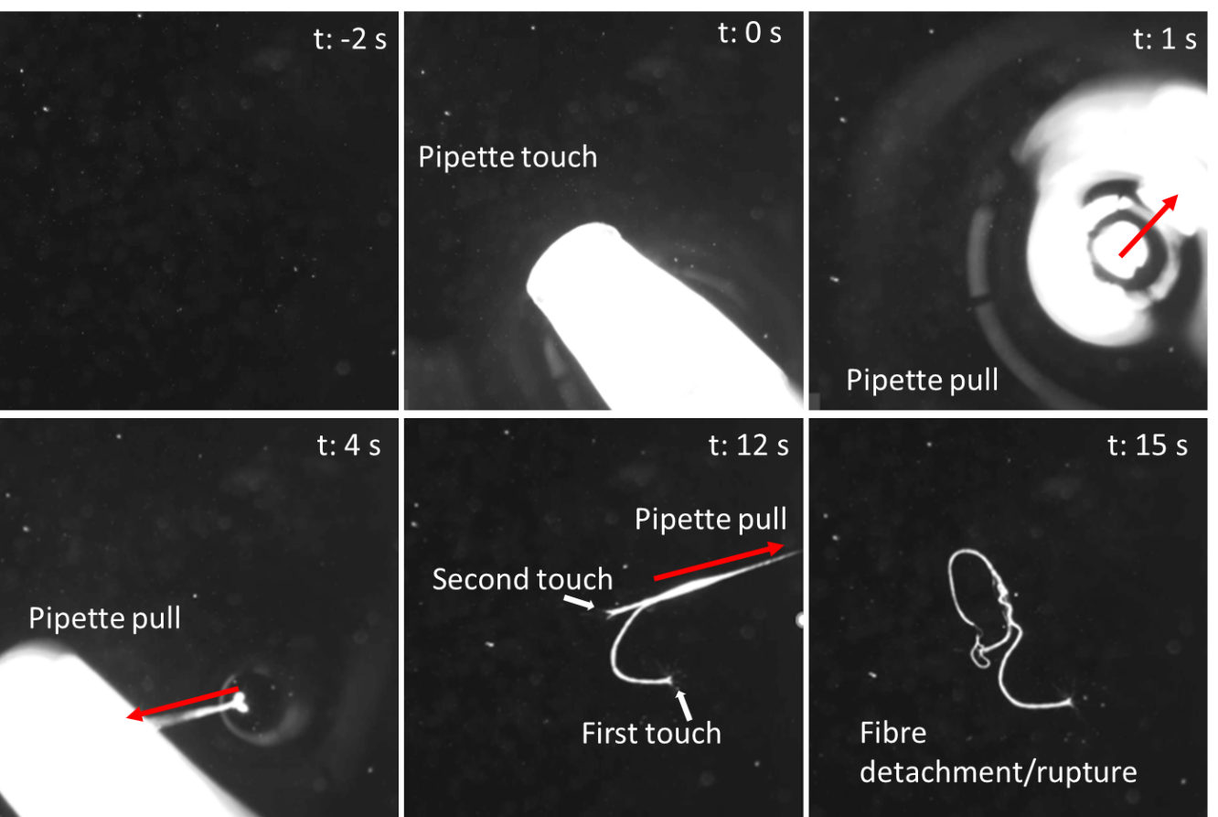
Figure S1. Snapshots obtained from a video taken under optical microscopy using a darkfield filter show the spontaneous formation of a silk-like fibre upon contact of a 100 µl pipette tip with the water/air interface.
Moreover, beyond the formation of a solid, insoluble fibre, the morphology of the formed fibre pointed to a very complex, hierarchical assembly. Clear evidence of hierarchical fibrillar structures was observed, wherein the macroscopic fibre was itself composed of bundles of microscopic fibres, which themselves were composed of bundles of even smaller submicron fibrillar structures (see Figure S 2, A, B and D). Notably, the protein fibres were easily observable through fluorescence microscopy, as they exhibited intrinsic fluorescence in the green, red and blue channels (Figure S 2, C, for fluorescence in green). It is important to note that the submicron fibrils that formed are reminiscent of those observed by us and others.
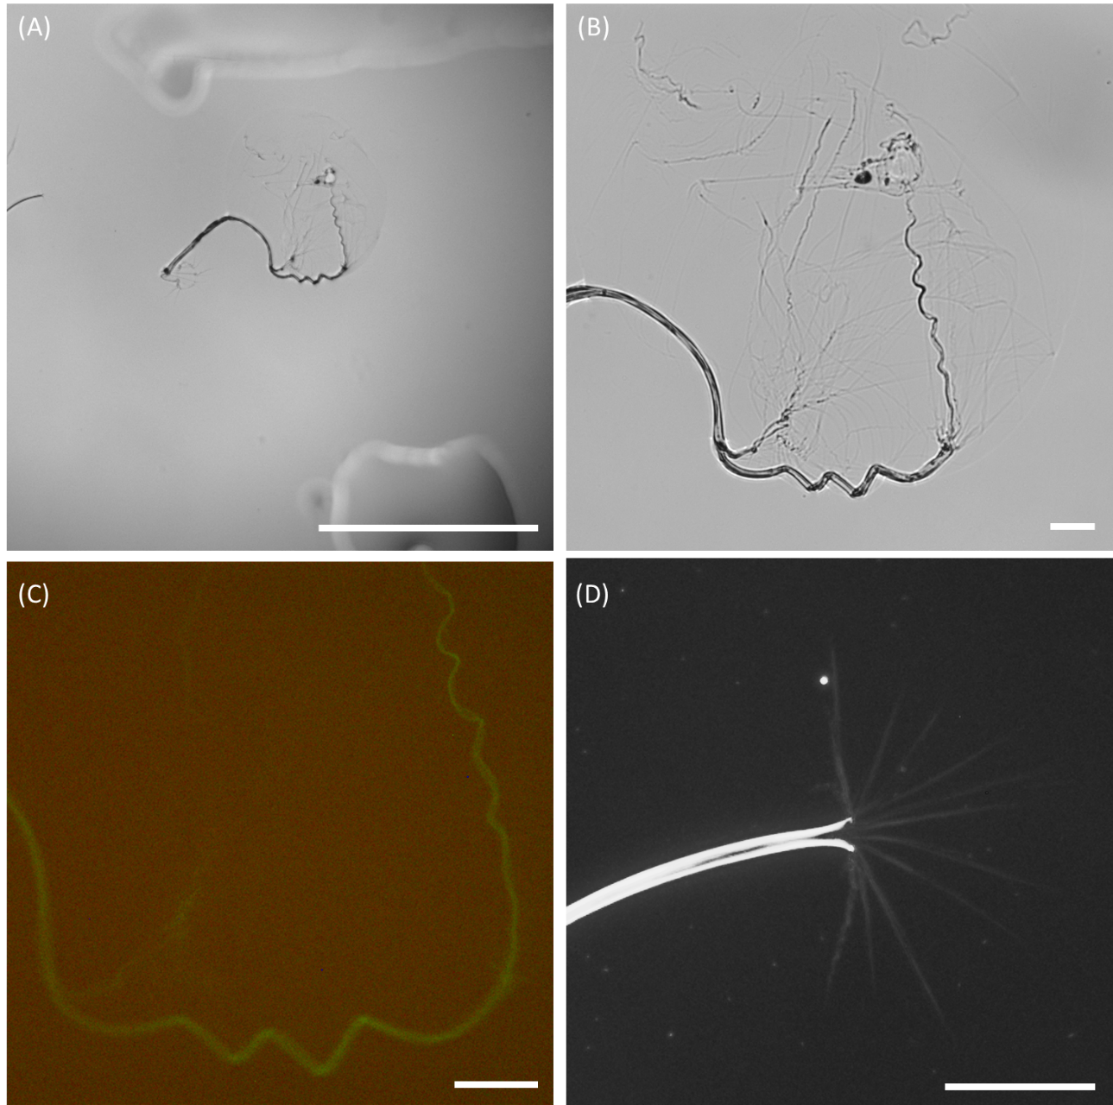
Figure S2. Low-magnification microphotograph of a fibre formed after contact with a pipette tip (A), higher magnification image of the same fibre (B) and its fluorescence image of the formed fibre using intrinsic green fluorescence (C). A higher magnification microphotograph was taken under a dark field of a different fibre, clearly showing that the fully formed fibre spread into microfibrils at the origin of fibre formation (C). The scale bars are 1 mm for (A) and 50 µm for (B-D).

- Interfacial assembly and observations
$${∆γ}_{pH2-pH1}= -\int_{{\overline{A}}_{pH1}}^{{\overline{A}}_{pH2}}{\frac{k_{B}T}{\overline{A^{2}}}}∂\overline{A}$$ | Equation 2
where $\overline{A}$, $k_{B}$, and $T$ represent the average solvent accessible surface area (SASA), variance, Boltzman constant and absolute temperature, respectively. From there, one can then deduce that because $γ_{pH8}<γ_{pH6}$, ${\overline{A}}_{pH8}>{\overline{A}}_{pH6}$. However, this work intends not to discuss the details of the energetics or even the kinetics of protein adsorption at the water/air interface, which is worth exploring in greater depth. However, a key observation was the very rapid initial adsorption of the protein to the interface. Beyond the quasistatic or linear properties of the film, dynamic nonlinear properties seemed to be important. In an attempt to determine early assembly and nonlinear behavior, we used the air bubble technique to measure IFT (data not included). Although these experiments were unsuccessful, due to prominent early bubble detachment, the IFT estimated by the system was in the +200 mN/m range. This observation indicated that the dynamic expansion of the air droplet caused an abrupt increase in the IFT, indicating the solid-like nature of the protein film.
Similarly, inspired by interfacial rheology techniques, a dual-way syringe pump was used to apply sinusoidal flow waves, yet the propensity of the protein to aggregate under shear conditions made the acquisition of repeatable quality data impossible. In general, the surface tension increased as the volume increased. Nonetheless, it was also observed that the increase was somewhat linear with increasing volume, up to a point where the droplet suffered a very rapid decrease in surface tension—observed as an immediate change in the shape of the droplet, as shown in Video 2 and summarized in Figure S4 A. Although it might be tempting to use the Young–Laplace equation to determine the Gibbs elastic modulus of this system, the complexity of this material, with its possible structure, is not necessarily applicable. However, the apparent increase in surface tension with increased deformation suggested a strain hardening effect, with the instantaneous decrease possibly occurring as a whole. These observations are important because they indicate that the protein film is undergoing some degree of orientation and reconfiguration rather than diffusive processes, as in the case of small amphiphiles; i.e., the film is indeed a highly viscoelastic material. Figure S4 B shows a schematic depicting the proposed reorganization process, wherein FibH molecules adsorbed to the water/air interface form a highly viscoelastic film. Nonetheless, the protein's highly flexible and multilinker molecular architecture allows further alignment under isotropic extension when the volume is increased. This approach extends the molecule and expands the registry of stickers. However, the formed network presented a yield, manifested as a sudden drop in surface tension, which could be caused by slips of the lateral interactions or by stretching the solenoid structures. In a similar fashion and inspired by pendant capsule elastometry, a droplet was created, and the volume was retrieved to observe the formation of a neck and the possible appearance of wrinkles. However, no wrinkles were observed, possibly because the wrinkle wavelength was too small. However, the neck of a droplet often collapses into a single highly birefringent filament. Even if very thin, the filaments were able to withstand many times the weight of the droplets. Additionally, the birefringence of the filament increases over time or, if stretched, is indicative of the emergence of an ordered structure, as depicted in Figure S5.

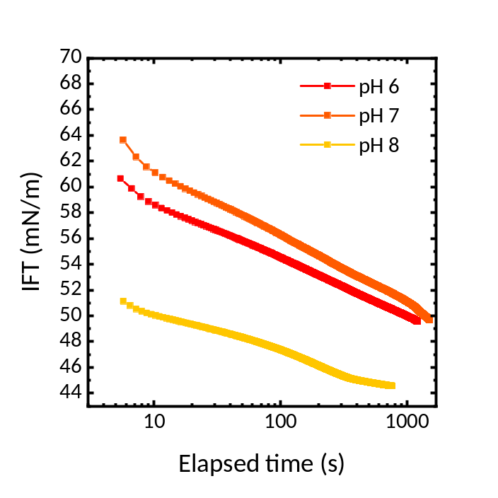
Figure S3. Interfacial surface tension (IFT) against time was measured using a Wilhelmy plate apparatus for buffered samples of NLSF at 6 mg/mL. The curves show a general monotonic decrease in IFT.

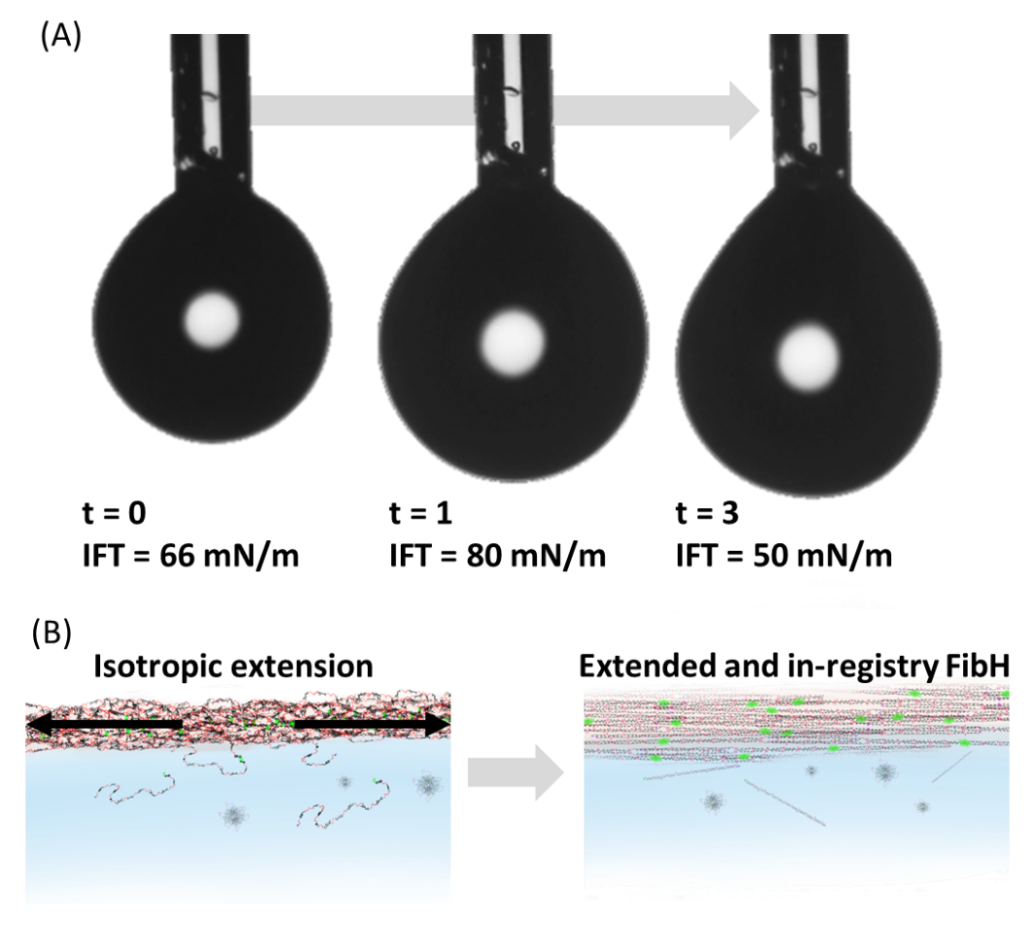
Figure S4. Snapshots were obtained from a video taken during the increased volume of an NLSF pendant droplet showing an initial relatively low IFT followed by an apparent increase in IFT and sudden decrease (A). Scheme illustrating the proposed molecular-scale mechanism of the observed phenomena (B).

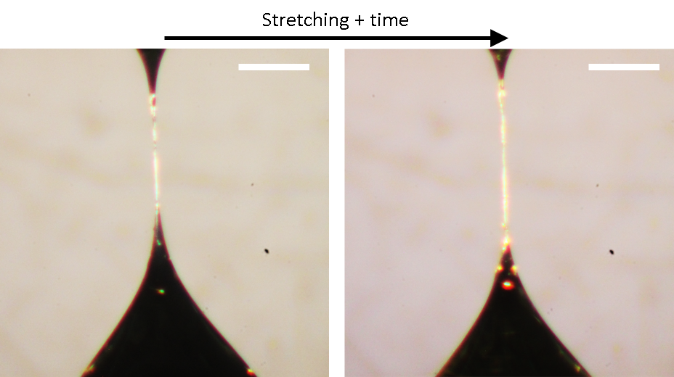
Figure S5. Photograph showing fibre formation at the point of neck collapse as observed under crosspolarizers a short time after collapse (left) and after slight stretching (right), revealing a birefengece increase. The scale bars are 150 µm.
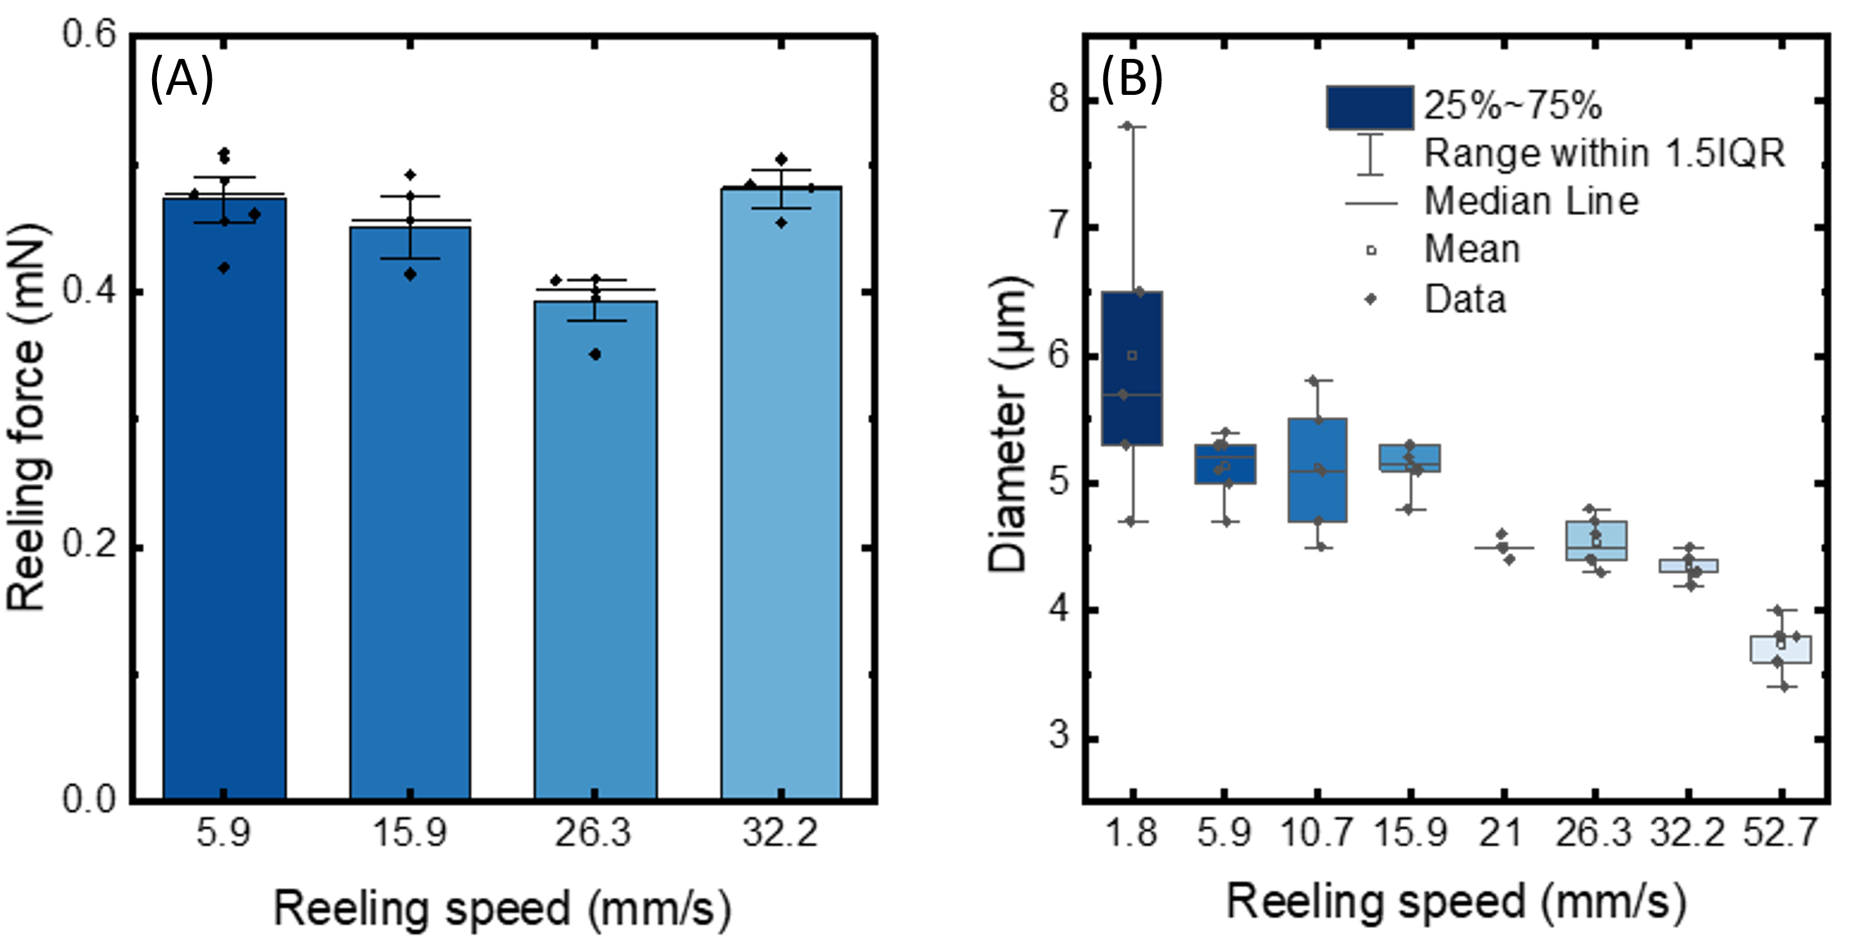
Figure S6. Analysis of the effect of reeling speed on the measured reeling force and fibre diameter. Reeling forces measured as a function of reeling speed (A). Fibre dimeter as a function of reeling speed (B). The data are shown as the means of at least 5 independent measurements.

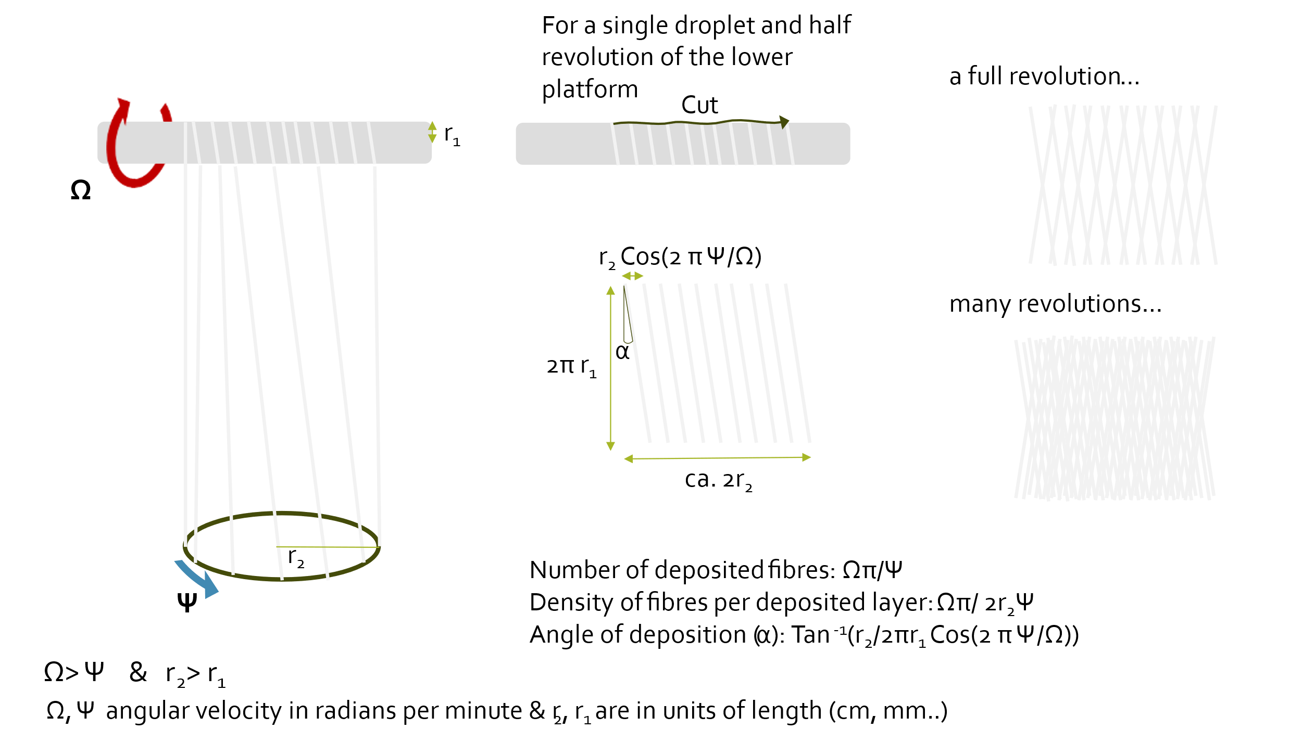
Figure S7. Schematic explanation of the multifibre matte fabrication approach and the effect of relevant fabrication parameters on the overall matte architecture.

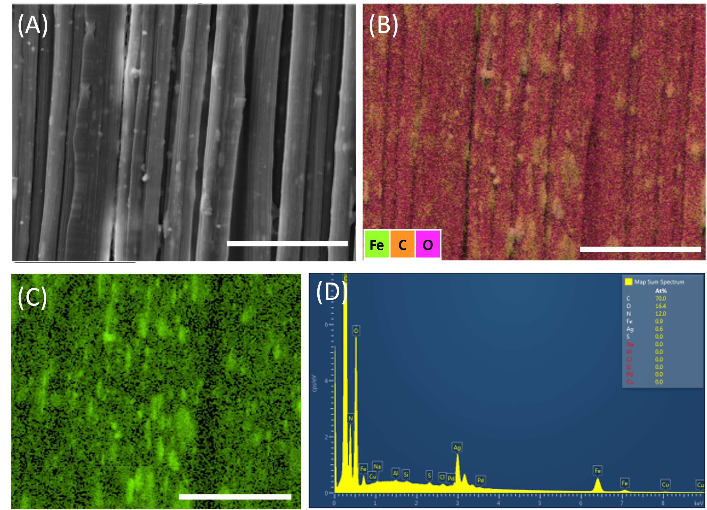
Figure S8. Elemental analysis of the silk-magnetite composite. SEM image of the fabricated composite fibres (A). Composite image obtained via EDX-SEM showing overlapping carbon, oxygen and iron distributions along the fibres (B). Iron distribution alone on the same fibres, showing homogeneously distributed iron along the fibres as well as iron-rich aggregates (C). EDS spectrum showing the elemental composition of the composite fibres, showing the incorporation of iron nanoparticles (D); silver was used to coat the fibres.

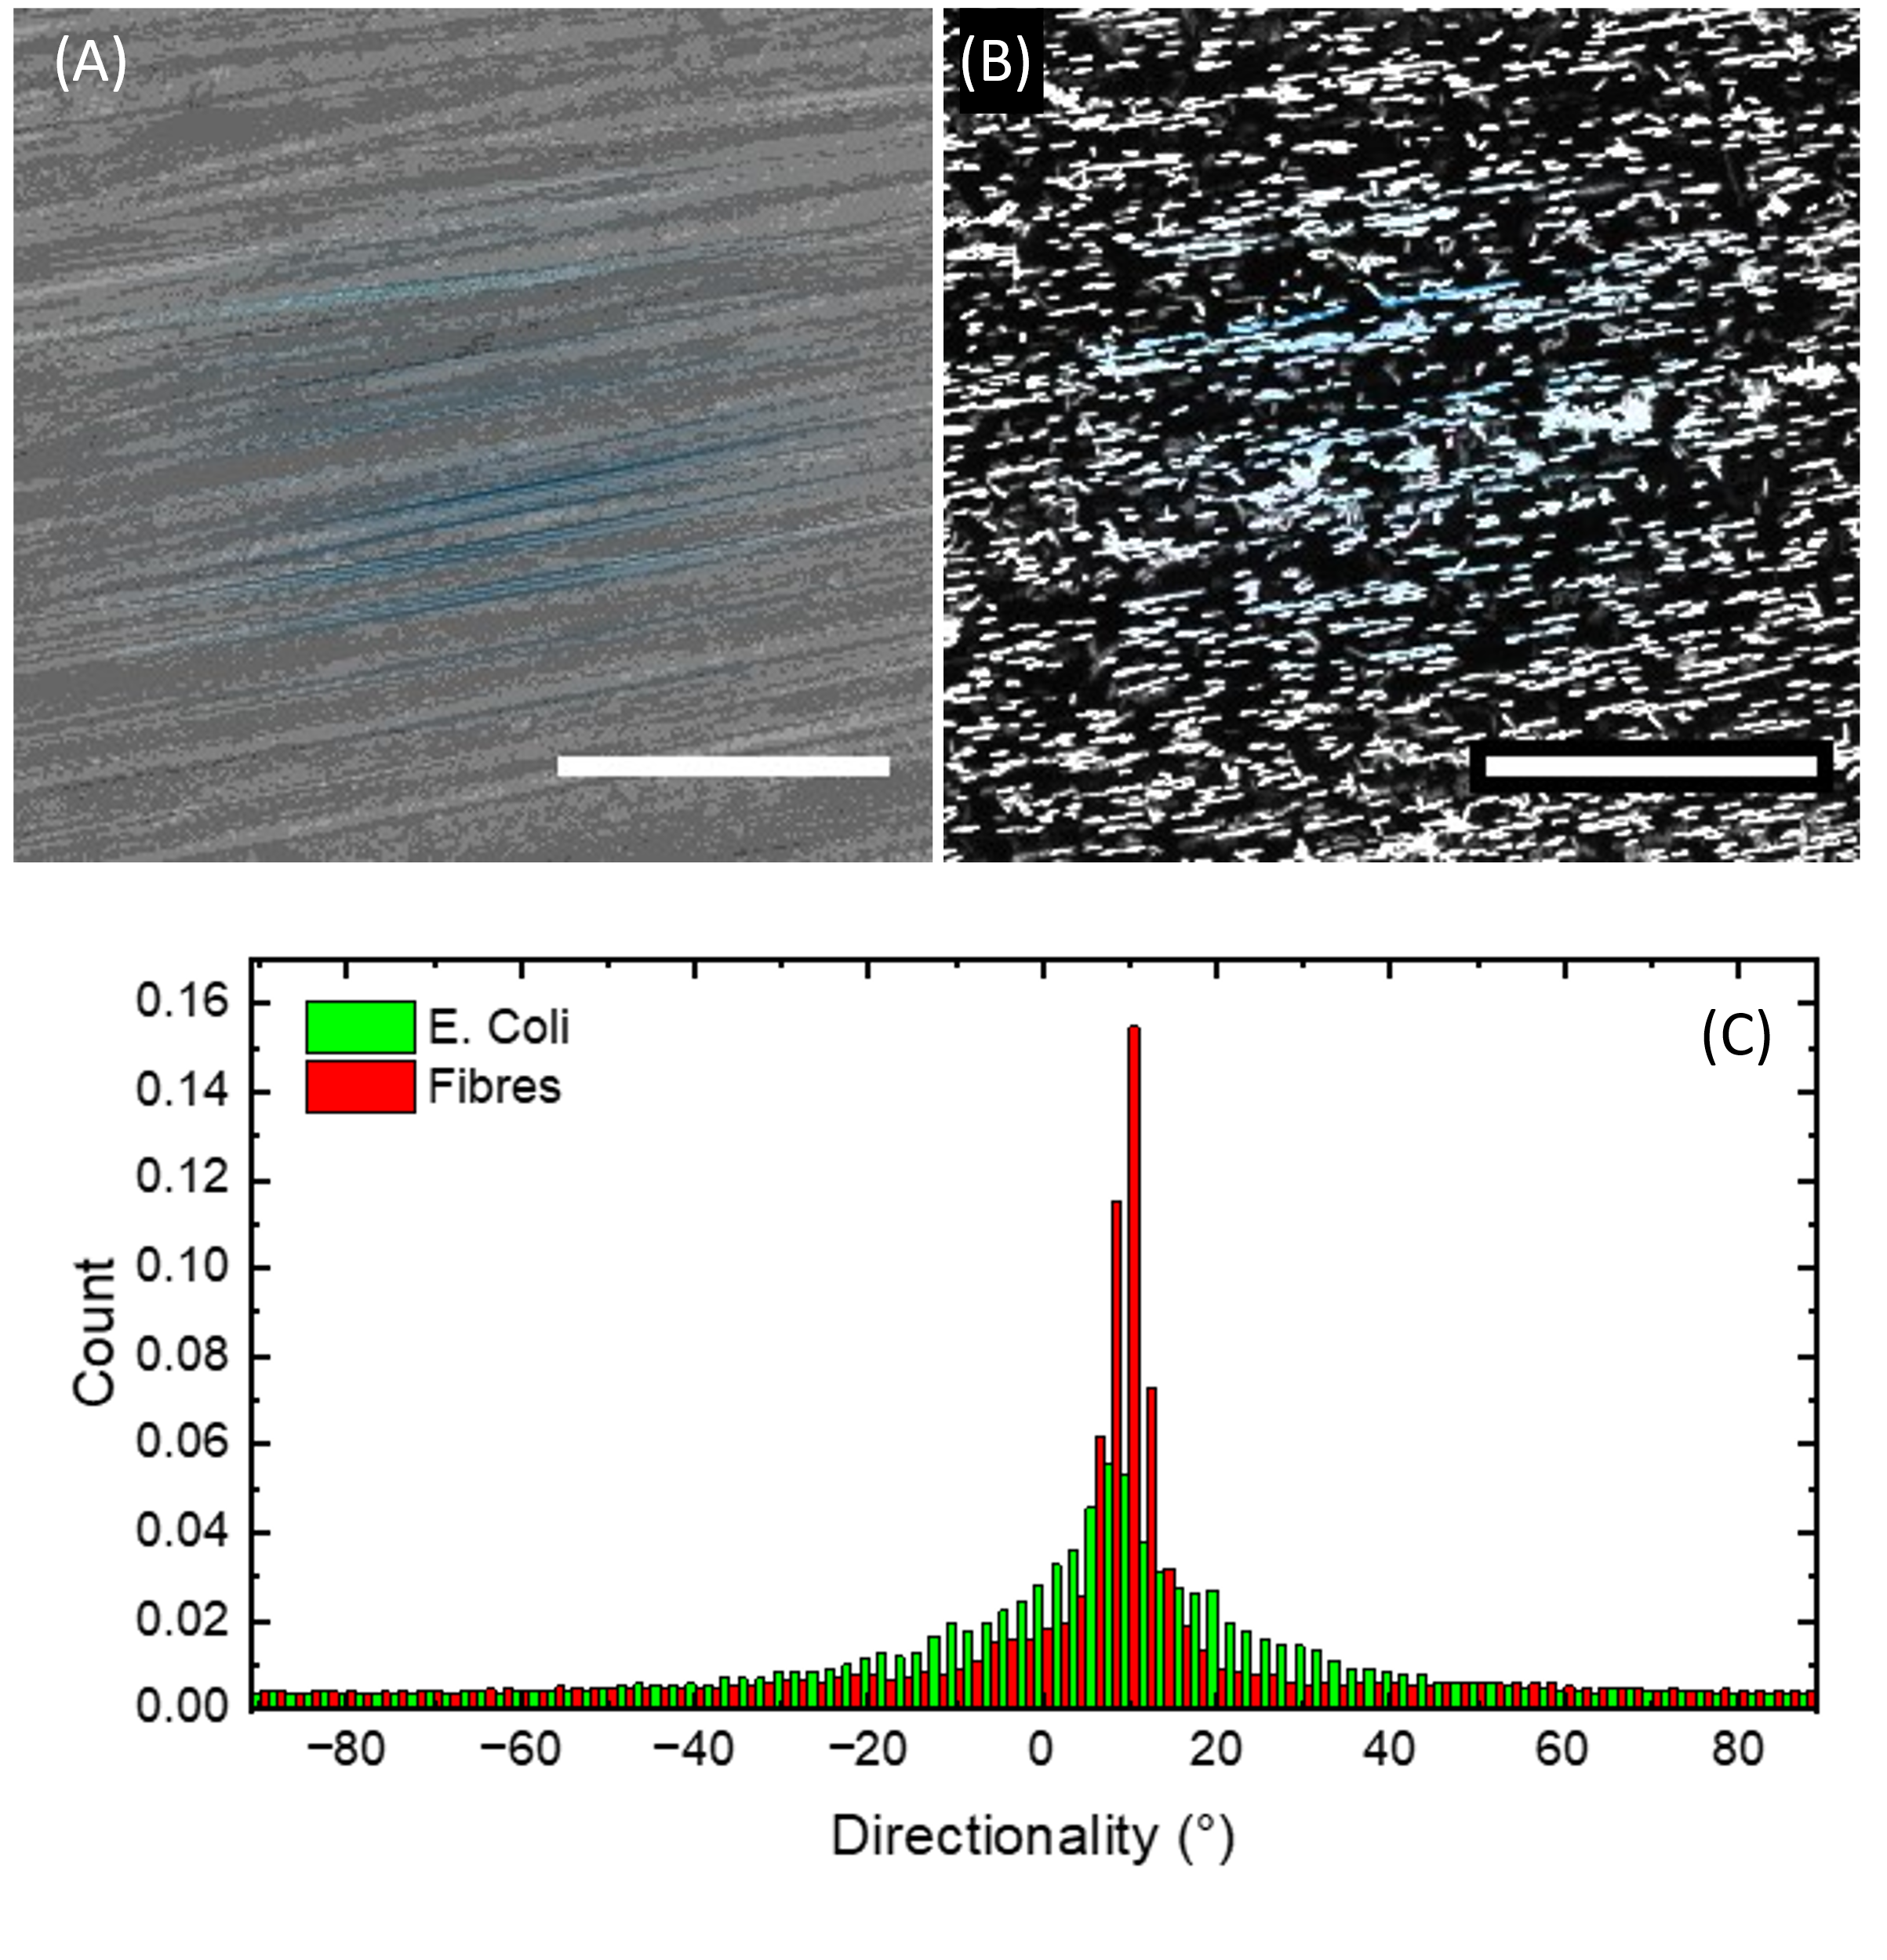
Figure S9. Directionality analysis of the E. coli composite. Directionality analysis of a bright-field image of a bundle of silk-like fibres with coloration indicating strong directionality in the 9-10° direction (A). Directionality analysis of the green fluorescence signal from GFP-transformed E. coli with coloration indicating strong alignment in the 9-10° direction (B). Histograms representing the overall colocalization of the E. coli cells with the direction of the fibres (C).

