Unadjusted model
Results of the twenty case-wise bootstrap network analyses

Table 1. T-test results of the 1rst test
 | FT | VPT | df | t | p-value | d
ASPL | 3.21 | 3.258 | 1998 | 3.894 | <.001 | 0.174
CC | 0.7 | 0.697 | 1998 | -6.299 | <.001 | 0.282
Q | 0.596 | 0.595 | 1998 | -0.859 | 0.39 | 0.038

Table 2. T-test results of the 2nd test
 | FT | VPT | df | t | p-value | d
ASPL | 3.214 | 3.262 | 1998 | 4.034 | <.001 | 0.18
CC | 0.7 | 0.697 | 1998 | -7.3 | <.001 | 0.326
Q | 0.596 | 0.596 | 1998 | -0.301 | 0.763 | 0.013

Table 3. T-test results of the 3rd test
 | FT | VPT | df | t | p-value | d
ASPL | 3.221 | 3.267 | 1998 | 3.671 | <.001 | 0.164
CC | 0.7 | 0.697 | 1998 | -6.003 | <.001 | 0.268
Q | 0.597 | 0.595 | 1998 | -1.459 | 0.145 | 0.065

Table 4. T-test results of the 4th test
 | FT | VPT | df | t | p-value | d
ASPL | 3.217 | 3.264 | 1998 | 3.748 | <.001 | 0.168
CC | 0.700 | 0.697 | 1998 | -5.756 | <.001 | 0.257
Q | 0.596 | 0.596 | 1998 | -0.133 | 0.894 | 0.006

Table 5. T-test results of the 5th test
 | FT | VPT | df | t | p-value | d
ASPL | 3.231 | 3.288 | 1998 | 4.575 | <.001 | 0.205
CC | 0.7 | 0.696 | 1998 | -7.089 | <.001 | 0.317
Q | 0.597 | 0.597 | 1998 | -0.221 | 0.865 | 0.01

Table 6. T-test results of the 6th test
 | FT | VPT | df | t | p-value | d
ASPL | 3.223 | 3.277 | 1998 | 4.558 | <.001 | 0.204
CC | 0.7 | 0.697 | 1998 | -7.934 | <.001 | 0.355
Q | 0.597 | 0.598 | 1998 | 1.124 | 0.261 | 0.05

Table 7. T-test results of the 7th test
 | FT | VPT | df | t | p-value | d
ASPL | 3.22 | 3.271 | 1998 | 4.097 | <.001 | 0.183
CC | 0.7 | 0.697 | 1998 | -6.277 | <.001 | 0.281
Q | 0.596 | 0.597 | 1998 | 0.066 | 0.948 | 0.003

Table 8. T-test results of the 8th test
 | FT | VPT | df | t | p-value | d
ASPL | 3.228 | 3.261 | 1998 | 2.775 | <.001 | 0.124
CC | 0.7 | 0.697 | 1998 | -4.932 | <.001 | 0.221
Q | 0.597 | 0.596 | 1998 | -1.318 | 0.188 | 0.059

Table 9. T-test results of the 9th test
 | FT | VPT | df | t | p-value | d
ASPL | 3.228 | 3.255 | 1998 | 2.214 | 0.027 | 0.099
CC | 0.7 | 0.697 | 1998 | -5.677 | <.001 | 0.254
Q | 0.597 | 0.595 | 1998 | -1.938 | 0.053 | 0.087

Table 10. T-test results of the 10th test
 | FT | VPT | df | t | p-value | d
ASPL | 3.222 | 3.253 | 1998 | 2.519 | 0.012 | 0.113
CC | 0.7 | 0.697 | 1998 | -4.208 | <.001 | 0.188
Q | 0.597 | 0.596 | 1998 | -1.549 | 0.121 | 0.069

Table 11. T-test results of the 11th test
 | FT | VPT | df | t | p-value | d
ASPL | 3.241 | 3.283 | 1998 | 3.295 | 0.001 | 0.147
CC | 0.7 | 0.697 | 1998 | -6.44 | <.001 | 0.288
Q | 0.598 | 0.598 | 1998 | 0.392 | 0.695 | 0.018

Table 12. T-test results of the 12th test
 | FT | VPT | df | t | p-value | d
ASPL | 3.218 | 3.262 | 1998 | 3.429 | <.001 | 0.153
CC | 0.7 | 0.697 | 1998 | -5.779 | <.001 | 0.258
Q | 0.596 | 0.595 | 1998 | -0.662 | 0.508 | 0.03

Table 13. T-test results of the 13th test
 | FT | VPT | df | t | p-value | d
ASPL | 3.217 | 3.253 | 1998 | 2.833 | 0.005 | 0.127
CC | 0.7 | 0.698 | 1998 | -4.56 | <.001 | 0.204
Q | 0.596 | 0.594 | 1998 | -1.815 | 0.07 | 0.081

Table 14. T-test results of the 14th test
 | FT | VPT | df | t | p-value | d
ASPL | 3.22 | 3.253 | 1998 | 2.68 | 0.007 | 0.12
CC | 0.7 | 0.697 | 1998 | -5.016 | <.001 | 0.224
Q | 0.598 | 0.596 | 1998 | -2.092 | 0.037 | 0.094

Table 15. T-test results of the 15th test
 | FT | VPT | df | t | p-value | d
ASPL | 3.228 | 3.266 | 1998 | 3.132 | 0.002 | 0.14
CC | 0.699 | 0.697 | 1998 | -4.348 | <.001 | 0.194
Q | 0.597 | 0.596 | 1998 | -0.544 | 0.587 | 0.024

Table 16. T-test results of the 16th test
 | FT | VPT | df | t | p-value | d
ASPL | 3.22 | 3.263 | 1998 | 3.458 | <.001 | 0.155
CC | 0.7 | 0.697 | 1998 | -5.787 | <.001 | 0.259
Q | 0.597 | 0.596 | 1998 | -0.481 | 0.631 | 0.022

Table 17. T-test results of the 17th test
 | FT | VPT | df | t | p-value | d
ASPL | 3.221 | 3.252 | 1998 | 2.59 | 0.001 | 0.116
CC | 0.7 | 0.698 | 1998 | -4.346 | <.001 | 0.194
Q | 0.597 | 0.595 | 1998 | -1.442 | 0.149 | 0.064

Table 18. T-test results of the 18th test
 | FT | VPT | df | t | p-value | d
ASPL | 3.237 | 3.276 | 1998 | 3.05 | 0.002 | 0.136
CC | 0.7 | 0.697 | 1998 | -5.377 | <.001 | 0.24
Q | 0.599 | 0.598 | 1998 | -1.469 | 0.142 | 0.066
Table 19. T-test results of the 19th test
 | FT | VPT | df | t | p-value | d
ASPL | 3.202 | 3.276 | 1998 | 5.365 | <.001 | 0.24
CC | 0.701 | 0.697 | 1998 | -8.1 | <.001 | 0.362
Q | 0.596 | 0.596 | 1998 | 0.253 | 0.8 | 0.011

Table 20. T-test results of the 20th test
 | FT | VPT | df | t | p-value | d
ASPL | 3.213 | 3.257 | 1998 | 3.561 | <.001 | 0.159
CC | 0.7 | 0.697 | 1998 | -6.609 | <.001 | 0.296
Q | 0.596 | 0.596 | 1998 | -0.411 | 0.681 | 0.018

Fig 2. Bar plot of the twenty bootstrap analyses of the unadjusted model

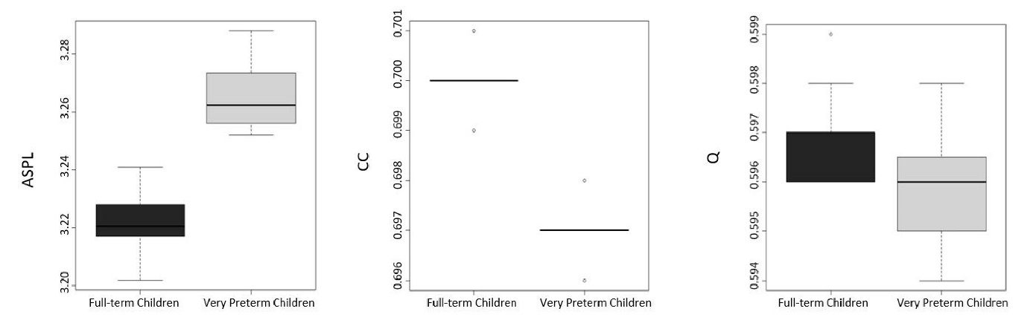
Average of the 20 case-wise bootstrap tests for the 3 coefficients separated by groups. Note. ASPL = Average Shortest Path Length, CC = Clustering Coefficient and Q = Modularity

Adjusted model for the SES and Intelligence
Results of the twenty case-wise bootstrap network analyses.

Table 41. ANCOVA results of the 1rst test
 | FT | VPT | df | F | p-value | η²
ASPL | 3.107 | 3.368 | 1995 | 4.22 | 0.04 | 0.002
CC | 0.705 | 0.692 | 1995 | 6.508 | 0.011 | 0.003
Q | 0.583 | 0.61 | 1995 | 8.302 | 0.004 | 0.004

Table 42. ANCOVA results of the 2nd test
 | FT | VPT | df | F | p-value | η²
ASPL | 3.145 | 3.342 | 1995 | 2.438 | 0.119 | 0.001
CC | 0.707 | 0.69 | 1995 | 10.373 | 0.001 | 0.005
Q | 0.597 | 0.597 | 1995 | 0.005 | 0.942 | 0.000

Table 43. ANCOVA results of the 3rd test
 | FT | VPT | df | F | p-value | η²
ASPL | 3.141 | 3.358 | 1995 | 2.948 | 0.086 | 0.001
CC | 0.703 | 0.693 | 1995 | 3.935 | 0.047 | 0.002
Q | 0.59 | 0.604 | 1995 | 2.159 | 0.142 | 0.001

Table 44. ANCOVA results of the 4th test
 | FT | VPT | df | F | p-value | η²
ASPL | 3.051 | 3.411 | 1995 | 8.128 | 0.004 | 0.004
CC | 0.708 | 0.69 | 1995 | 11.098 | 0.001 | 0.006
Q | 0.575 | 0.616 | 1995 | 17.209 | <.001 | 0.009

Table 45. ANCOVA results of the 5th test
 | FT | VPT | df | F | p-value | η²
ASPL | 3.137 | 3.364 | 1995 | 3.292 | 0.07 | 0.002
CC | 0.704 | 0.693 | 1995 | 5.100 | 0.024 | 0.003
Q | 0.585 | 0.61 | 1995 | 7.862 | 0.005 | 0.004

Table 46. ANCOVA results of the 6th test
 | FT | VPT | df | F | p-value | η²
ASPL | 3.075 | 3.411 | 1995 | 7.314 | 0.007 | 0.004
CC | 0.707 | 0.691 | 1995 | 9.141 | 0.003 | 0.005
Q | 0.591 | 0.602 | 1995 | 1.431 | 0.232 | 0.001

Table 47. ANCOVA results of the 7th test
 | FT | VPT | df | F | p-value | η²
ASPL | 3.163 | 3.347 | 1995 | 2.379 | 0.123 | 0.001
CC | 0.701 | 0.695 | 1995 | 1.296 | 0.255 | 0.001
Q | 0.599 | 0.596 | 1995 | 0.054 | 0.816 | 0.000

Table 48. ANCOVA results of the 8th test
 | FT | VPT | df | F | p-value | η²
ASPL | 3.142 | 3.332 | 1995 | 2.200 | 0.138 | 0.001
CC | 0.701 | 0.697 | 1995 | 0.507 | 0.476 | 0.000
Q | 0.595 | 0.597 | 1995 | 0.027 | 0.869 | 0.000

Table 49. ANCOVA results of the 9th test
 | FT | VPT | df | F | p-value | η²
ASPL | 3.159 | 3.34 | 1995 | 1.963 | 0.161 | 0.001
CC | 0.705 | 0.691 | 1995 | 6.631 | 0.01 | 0.003
Q | 0.594 | 0.599 | 1995 | 0.362 | 0.548 | 0.000

Table 50. ANCOVA results of the 10th test

 | FT | VPT | df | F | p-value | η²
ASPL | 3.238 | 3.259 | 1995 | 0.028 | 0.866 | 0.000
CC | 0.701 | 0.696 | 1995 | 1.069 | 0.301 | 0.001
Q | 0.594 | 0.599 | 1995 | 0.237 | 0.626 | 0.000

Table 51. ANCOVA results of the 11th test
 | FT | VPT | df | F | p-value | η²
ASPL | 3.141 | 3.374 | 1995 | 3.321 | 0.069 | 0.002
CC | 0.704 | 0.693 | 1995 | 4.148 | 0.042 | 0.002
Q | 0.592 | 0.603 | 1995 | 1.357 | 0.244 | 0.001

Table 52. ANCOVA results of the 12th test
 | FT | VPT | df | F | p-value | η²
ASPL | 3.116 | 3.383 | 1995 | 4.373 | 0.037 | 0.002
CC | 0.707 | 0.69 | 1995 | 9.672 | 0.002 | 0.005
Q | 0.586 | 0.608 | 1995 | 5.456 | 0.02 | 0.003

Table 53. ANCOVA results of the 13th test
 | FT | VPT | df | F | p-value | η²
ASPL | 3.067 | 3.415 | 1995 | 7.795 | 0.005 | 0.004
CC | 0.705 | 0.693 | 1995 | 5.159 | 0.023 | 0.003
Q | 0.593 | 0.6 | 1995 | 0.697 | 0.404 | 0.000

Table 54. ANCOVA results of the 14th test
 | FT | VPT | df | F | p-value | η²
ASPL | 3.178 | 3.312 | 1995 | 1.065 | 0.302 | 0.001
CC | 0.7 | 0.697 | 1995 | 0.336 | 0.562 | 0.000
Q | 0.598 | 0.595 | 1995 | 0.086 | 0.77 | 0.000

Table 55. ANCOVA results of the 15th test
 | FT | VPT | df | F | p-value | η²
ASPL | 3.113 | 3.379 | 1995 | 4.131 | 0.042 | 0.002
CC | 0.705 | 0.693 | 1995 | 5.129 | 0.024 | 0.003
Q | 0.588 | 0.605 | 1995 | 2.841 | 0.092 | 0.001

Table 56. ANCOVA results of the 16th test
 | FT | VPT | df | F | p-value | η²
ASPL | 3.19 | 3.276 | 1995 | 0.478 | 0.49 | 0.000
CC | 0.704 | 0.694 | 1995 | 4.317 | 0.038 | 0.002
Q | 0.592 | 0.6 | 1995 | 0.644 | 0.422 | 0.000

Table 57. ANCOVA results of the 17th test
 | FT | VPT | df | F | p-value | η²
ASPL | 3.105 | 3.383 | 1995 | 4.697 | 0.03 | 0.002
CC | 0.706 | 0.691 | 1995 | 8.091 | 0.004 | 0.004
Q | 0.591 | 0.601 | 1995 | 1.275 | 0.259 | 0.001

Table 58. ANCOVA results of the 18th test
 | FT | VPT | df | F | p-value | η²
ASPL | 3.158 | 3.336 | 1995 | 2.041 | 0.153 | 0.001
CC | 0.709 | 0.688 | 1995 | 14.275 | <.001 | 0.007
Q | 0.596 | 0.597 | 1995 | 0.015 | 0.902 | 0.000

Table 59. ANCOVA results of the 19th test
 | FT | VPT | df | F | p-value | η²
ASPL | 3.175 | 3.306 | 1995 | 1.061 | 0.303 | 0.001
CC | 0.704 | 0.693 | 1995 | 4.048 | 0.044 | 0.002
Q | 0.594 | 0.598 | 1995 | 0.108 | 0.742 | 0.000

Table 60. ANCOVA results of the 20th test
 | FT | VPT | df | F | p-value | η²
ASPL | 3.152 | 3.357 | 1995 | 2.525 | 0.112 | 0.001
CC | 0.706 | 0.691 | 1995 | 6.813 | 0.009 | 0.003
Q | 0.589 | 0.605 | 1995 | 2.739 | 0.098 | 0.001

Fig 4. Bar plot of the twenty bootstrap analyses of the model adjusted for SES and non-verbal intelligence

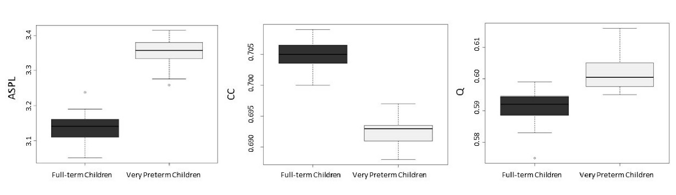
Average of the 20 case-wise bootstrap tests with SES and non-verbal intelligence as covariates for the 3 coefficients separated by groups.

