Table 1 Definitions and measurement of flatfoot parameters
 | Name | Definition | Image
Hindfoot | calcaneofibular distance | The minimum distance of calcaneal and fibula | 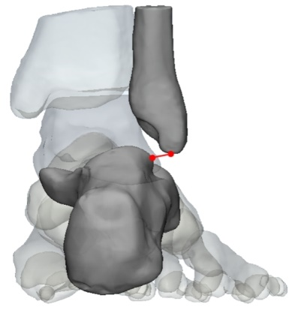
Hindfoot | talofibular distance | The minimum distance of talus and fibula | 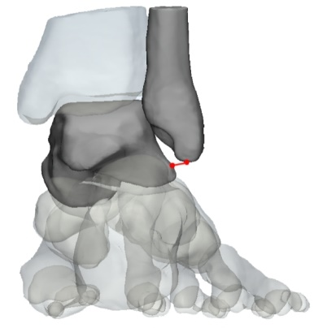
Hindfoot | calcaneal inclination angle, CIA | Angle between the calcaneal inclination axis (i.e., most inferior part of the calcaneus) and the ground, also known as the calcaneal pitch | 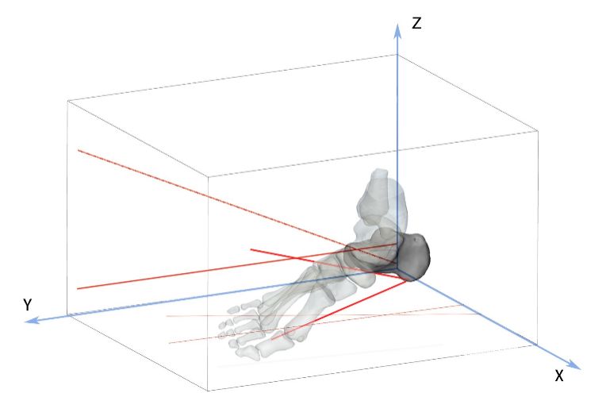
Hindfoot | talocalcaneal angle, TCA | Angle between the long axis of the talus and the longitudinal axis of the rear foot* | 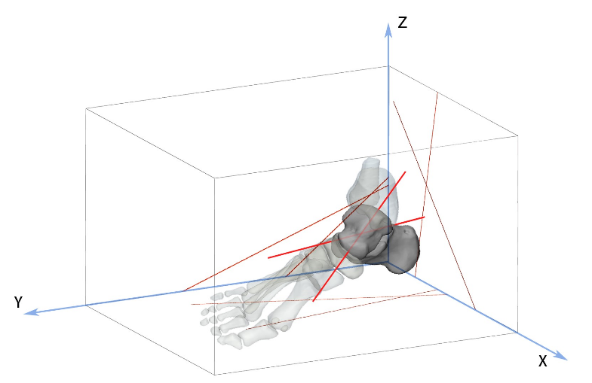
Hindfoot | lateral talocalcaneal angle, LTCA | Angle between the calcaneal axis and the collum tali axis** | 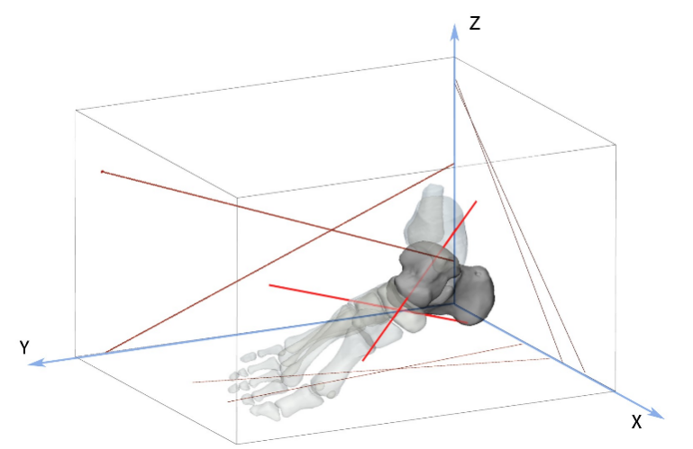
Hindfoot | the angle between the talus and calcaneus, TACA | Angle between the axis of calcaneal and long axis of the talus | 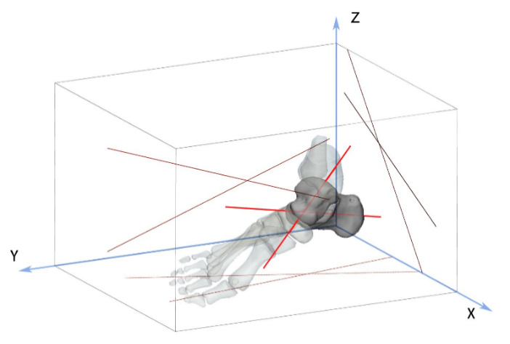
Hindfoot | sinus tarsi volume | a tube or tunnel between the talus and the calcaneus bones | 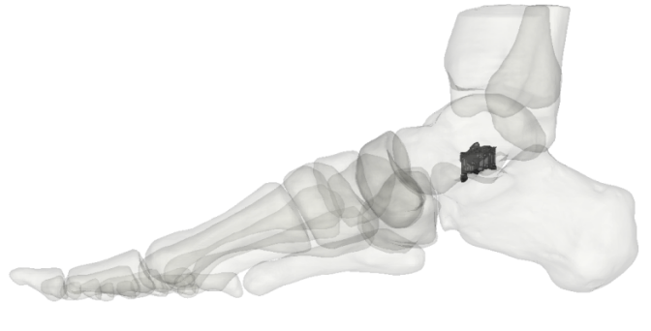
Midfoot | medial column height, MCH | the perpendicular distance between the most inferior aspect of the cuboid and a horizontal line through tuberosity of calcaneus | 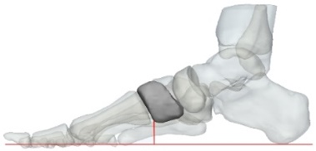
Midfoot | talonavicular coverage angle, TNCA | Angle between the long axis of the calcaneal and the axis of navicular bone | 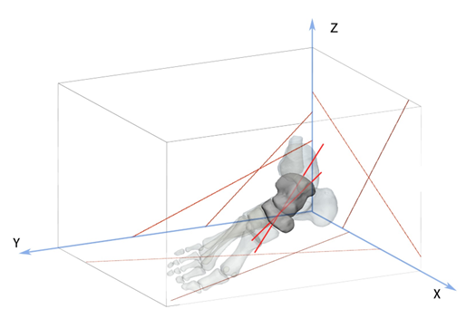
Forefoot | first metatarsal–calcaneal angle， Hibb angle | Angle between the long axis of the calcaneal and the long axis of the 1st metatarsal bone | 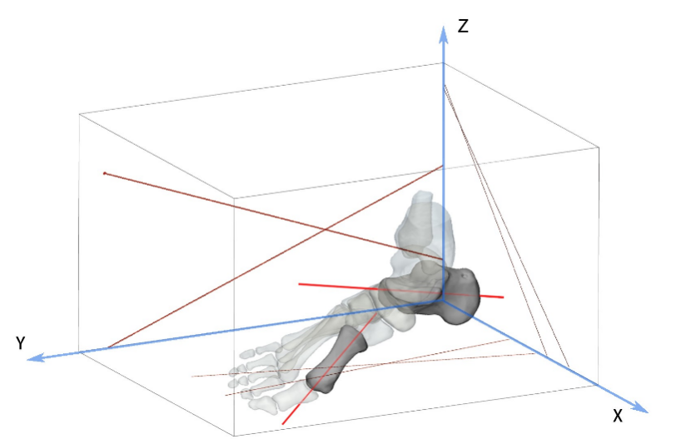
Forefoot | talar first metatarsal angle, Meary’s angle | Angle between the long axis of the talus and the long axis of the 1st metatarsal bone | 