Supplementary Materials for “Quantifying the fraction of precipitation transformed into terrestrial water storage in global river basins”
Yulong Zhong¹, Baoming Tian¹, Hyunglok Kim², Xing Yuan³, Xinyue Liu³, Enda Zhu⁴, Yunlong Wu¹, Lunche Wang¹, Lizhe Wang^{5*}
¹School of Geography and Information Engineering, China University of Geosciences (Wuhan), Wuhan 430078, China.
²School of Earth Sciences and Environmental Engineering, Gwangju Institute of Science and Technology, Gwangju 61005, Republic of Korea.
³School of Hydrology and Water Resources, Nanjing University of Information Science and Technology, Nanjing 210044, China.
⁴State Key Laboratory of Severe Weather & Institute of Artificial Intelligence for Meteorology, Chinese Academy of Meteorological Sciences, Beijing 100081, China.
⁵School of Computer Science, China University of Geosciences, Wuhan 430074, China.
Corresponding author: Lizhe Wang (lizhe.wang@foxmail.com)
These authors contributed equally: Yulong Zhong and Baoming Tian

Supplementary Note 1. Differences of Daily P Products
We study the differences in DF_{P-TWS} from the different P products for several typical basins (Supplementary Fig. 1 and Supplementary Table 3). In Supplementary Fig. 1, there are little differences in daily P between ERA5-Land and ERA5-Single (located on the 1:1 line), which makes the DF_{P-TWS} based on ERA5-Land and ERA5-Single P for the six basins almost indistinguishable as well (Supplementary Table 3). Ogooue (Supplementary Fig. 1a) and Rufiji (Supplementary Fig. 1b) have the most obvious differences in daily P (excluding ERA5-Land vs ERA5-Single) and the most dispersed distribution of points in Supplementary Fig. 1, which results in the largest differences in DF_{P-TWS} (Supplementary Table 3) in these two basins among the six basins. The differences in P (excluding ERA5-Land vs ERA5-Single) decrease in Yangtze (Supplementary Fig. 1c) and Ganges (Supplementary Fig. 1d) compared to Ogooue (Supplementary Fig. 1a) and Rufiji (Supplementary Fig. 1b), with a more concentrated distribution of points, which leads to a decrease in the DF_{P-TWS} difference (Supplementary Table 3). P differences (excluding ERA5-Land vs ERA5-Single) are further reduced in Lake Eyre (Supplementary Fig. 1e) and Murray (Supplementary Fig. 1f), and the distribution of points is the most concentrated among the six basins (Supplementary Fig. 1), resulting in almost no differences in DF_{P-TWS} for the four P products.

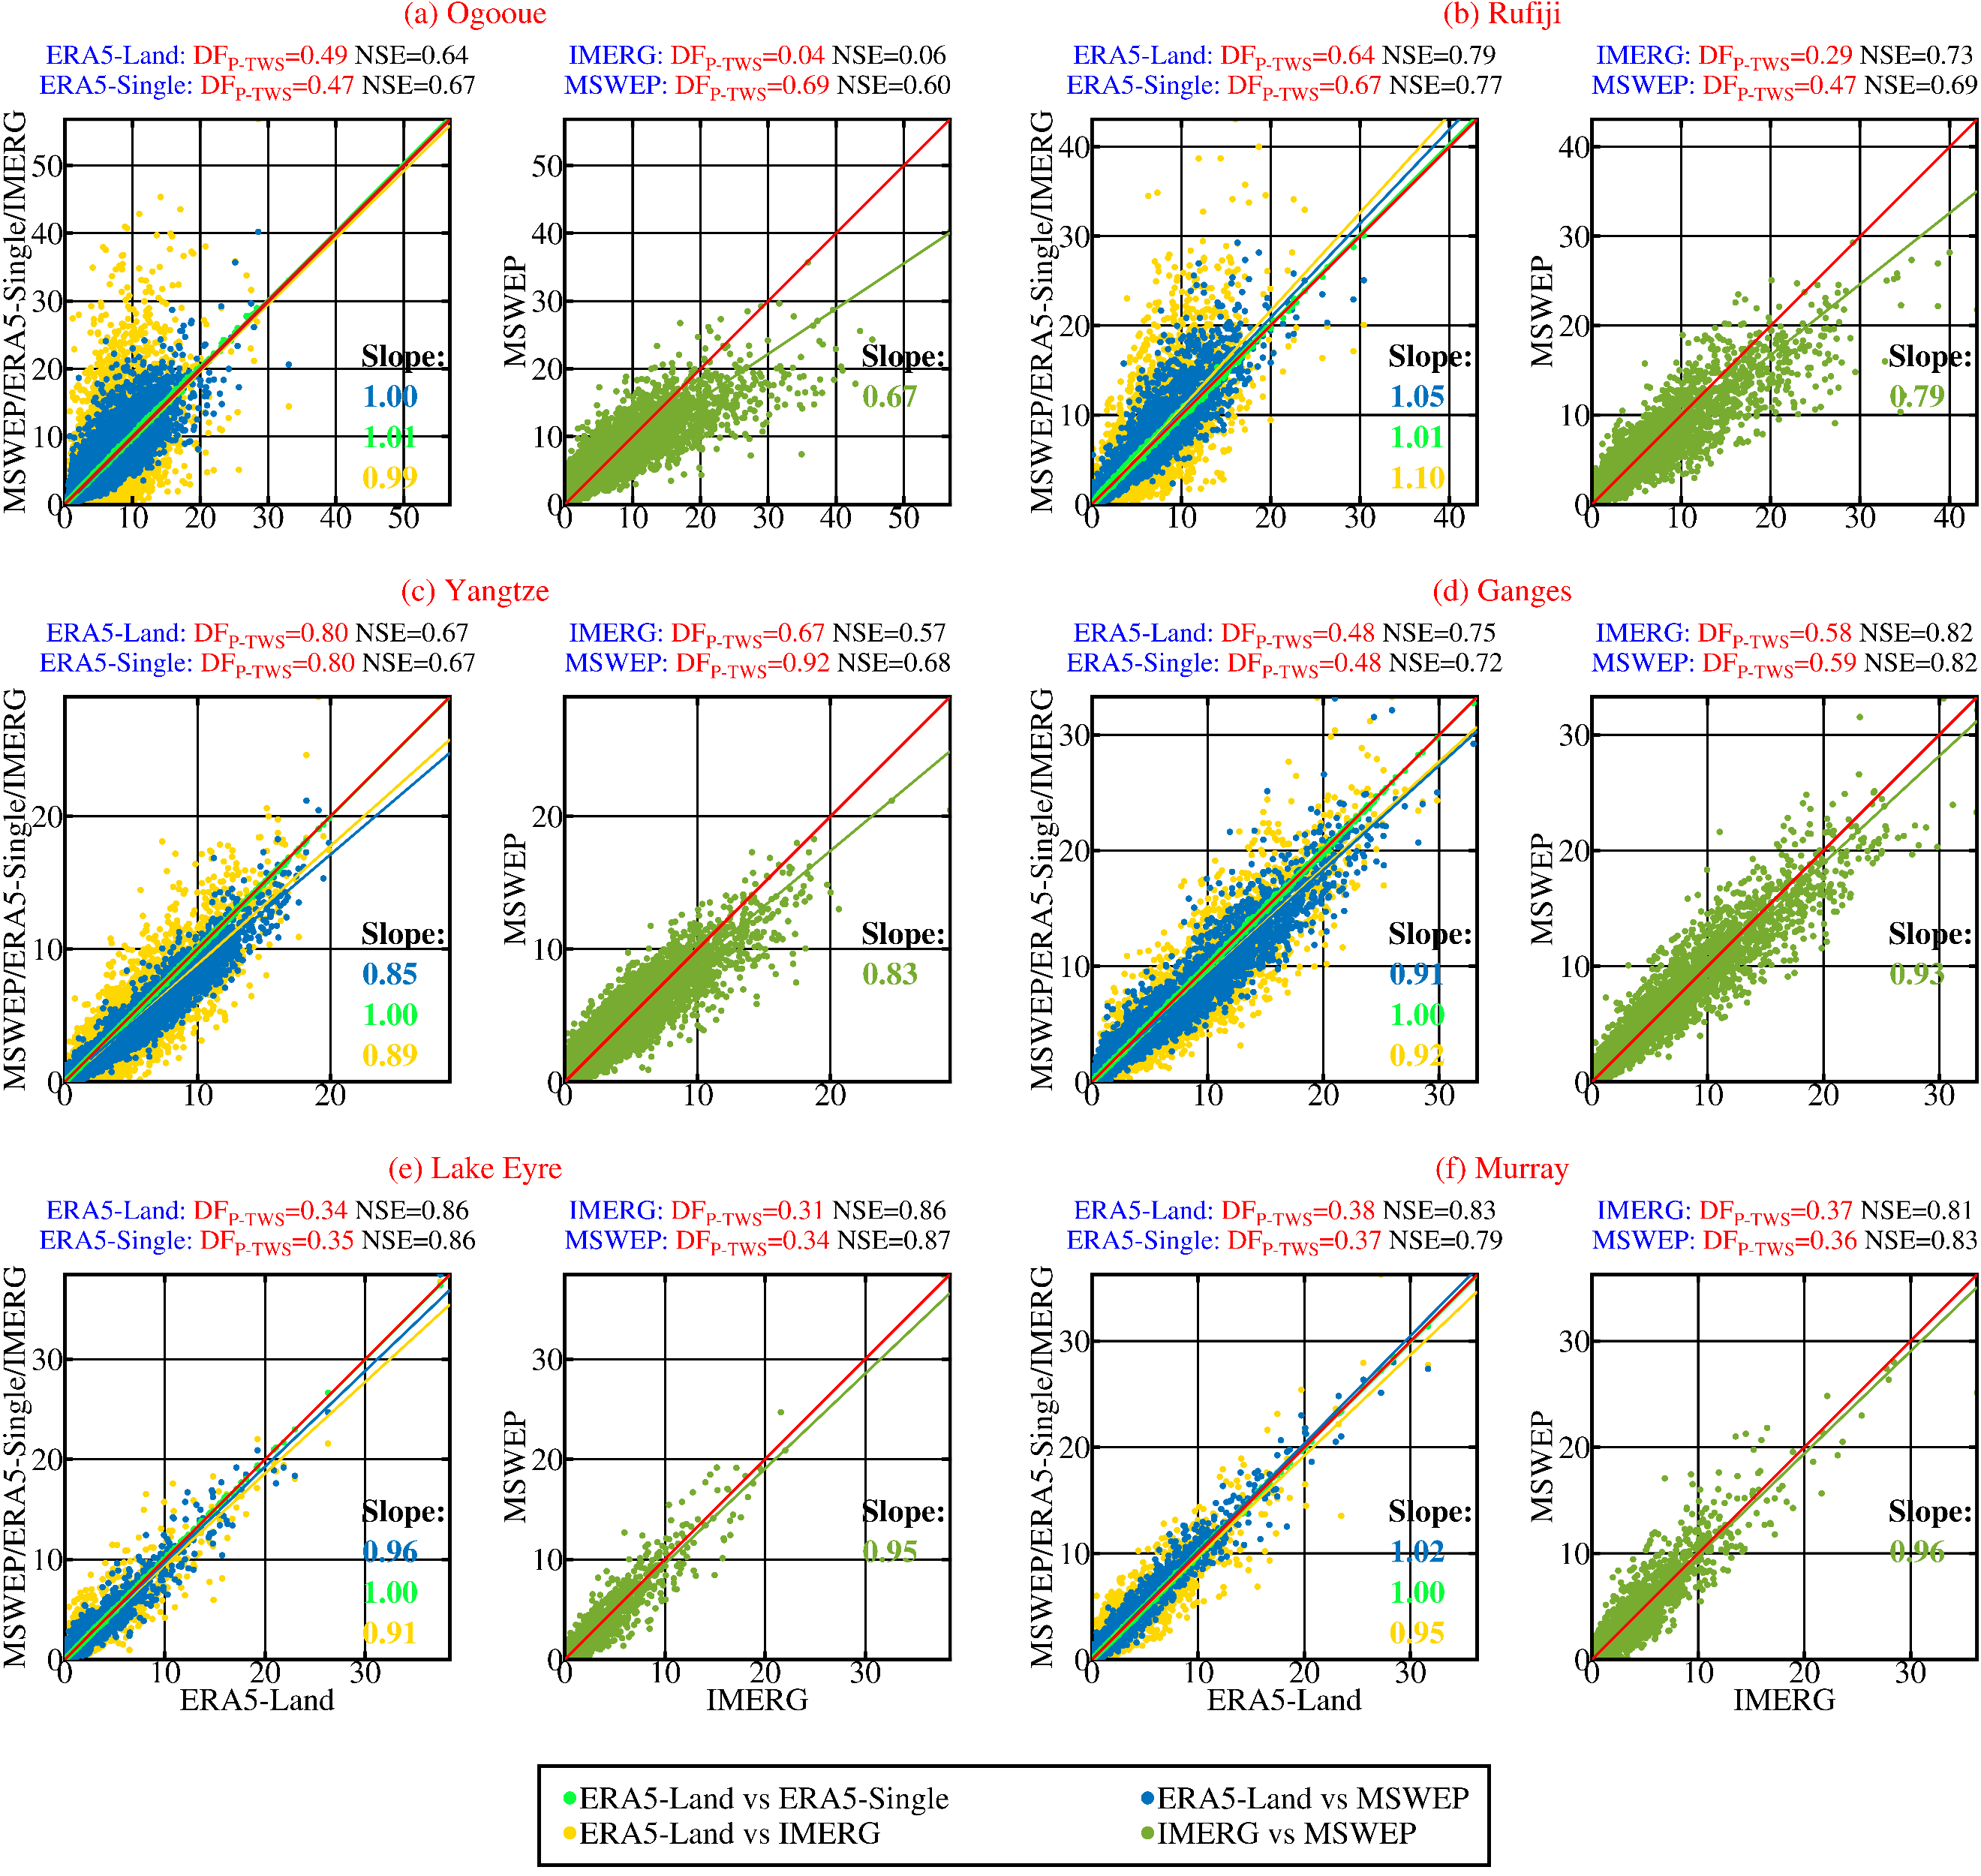

Supplementary Figure 1. Scatter plots of daily P among four P products (ERA5-Land, ERA5-Single, MSWEP, and IMERG) in six basins. The red line is diagonal (1:1 line). The blue, green, yellow, and grass-green lines are linearly fitted lines to the blue (MSWEP vs ERA5-Land), green (ERA5-Single vs ERA5-Land), yellow (IMERG vs ERA5-Land), and grass green (MSWEP vs IMERG) points, respectively.

Supplementary Figure 2. Spatial distribution of STDs for DF_{P-TWS} estimates obtained by the four different P products (ERA5-Land, ERA5-Single, MSWEP, IMERG) in global 121 river basins. It should be noted that there is no DF_{P-TWS} estimate based on IMERG in part of basins, as without continuous IMERG data there.

Supplementary Figure 3. Distribution of 121 basins according to climate zone. Large basins (areas ≥ 500,000 km²) are numbered from 1 to 40 in descending order of their size. The color-coded representation of basins is determined by their respective aridity index (AI, mean annual P divided by mean annual potential ET. The aridity index is available at https://figshare.com/articles/dataset/Global_Aridity_Index_and_Potential_Evapotranspiration_ET0_Climate_Database_v2/7504448/4.

Supplementary Figure 4. The β in Eq. 2 (a) and Eq. 3 (b). Scatter plot of β (Eq. 2 vs Eq. 3) in 121 basins globally (c). The black line is the diagonal (1:1 line). The red line is fitted to these blue points.

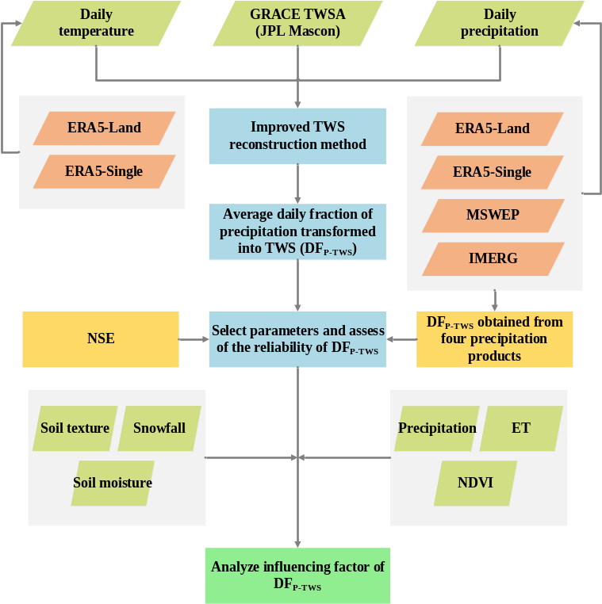

Supplementary Figure 5. Flow chart for this study.

Supplementary Table 1. DF_{P-SSM} (β) estimates calibrated by monthly GLDAS-Noah SSM according to Eq. 4 based on ERA5-Land (P and temperature). River basin IDs are sorted in descending order of their corresponding area (unit: 10⁴ km²).
ID | Basins | Land |  | Area
ID | Basins | β | NSE | Area
1 | Amazon | 0.05 | 0.92 | 596.59
2 | Congo | 0.10 | 0.88 | 370.52
3 | Nile | 0.15 | 0.96 | 335.32
4 | Mississippi | 0.06 | 0.68 | 324.06
5 | Ob | 0.16 | 0.78 | 304.06
6 | Parana | 0.08 | 0.89 | 264.70
7 | Yenisey | 0.06 | 0.59 | 250.57
8 | Chad | 0.18 | 0.91 | 247.10
9 | Lena | 0.07 | 0.46 | 245.36
10 | Amur | 0.07 | 0.24 | 223.90
11 | Niger | 0.22 | 0.96 | 212.30
12 | Mackenzie | 0.11 | 0.65 | 179.56
13 | Yangtze | 0.05 | 0.89 | 174.81
14 | Tarim He | 0.16 | 0.69 | 156.32
15 | Volga | 0.14 | 0.80 | 142.44
16 | Zambezi | 0.08 | 0.89 | 137.81
17 | Aral Sea | 0.25 | 0.88 | 137.25
18 | Lake Eyre | 0.41 | 0.75 | 121.46
19 | Nelson | 0.10 | 0.25 | 110.65
20 | Murray | 0.26 | 0.70 | 105.54
21 | Saint Lawrence | 0.08 | 0.61 | 105.33
22 | Ganges | 0.06 | 0.92 | 100.66
23 | Orange | 0.16 | 0.74 | 97.73
24 | Yellow River | 0.17 | 0.81 | 96.30
25 | Orinoco | 0.04 | 0.85 | 94.14
26 | Shatt Al Arab | 0.29 | 0.89 | 93.56
27 | Indus | 0.10 | 0.75 | 86.50
28 | Yukon | 0.12 | 0.73 | 83.28
29 | Jubba | 0.25 | 0.87 | 79.79
30 | Danube | 0.15 | 0.76 | 79.53
31 | Mekong | 0.07 | 0.90 | 78.38
32 | Tocantins | 0.09 | 0.89 | 77.25
33 | Okavango | 0.11 | 0.81 | 69.22
34 | Rio Grande | 0.21 | 0.59 | 67.39
35 | Columbia | 0.17 | 0.90 | 66.94
36 | Colorado (Colorado River) | 0.30 | 0.78 | 66.11
37 | Kolyma | 0.06 | 0.49 | 65.30
38 | Sao Francisco | 0.09 | 0.87 | 63.72
39 | Brahmaputra | 0.05 | 0.90 | 54.08
40 | Dnieper | 0.18 | 0.73 | 50.98
41 | Senegal | 0.25 | 0.94 | 45.80
42 | Don | 0.24 | 0.81 | 43.77
43 | Rio De La Plata | 0.12 | 0.62 | 42.73
44 | Irrawaddy | 0.04 | 0.89 | 42.29
45 | Lake Balkhash | 0.25 | 0.69 | 41.48
46 | Volta | 0.21 | 0.92 | 41.26
47 | Limpopo | 0.14 | 0.73 | 41.26
48 | Pearl | 0.03 | 0.76 | 41.19
49 | Colorado (Argentina) | 0.18 | 0.65 | 40.09
50 | Hamun | 0.35 | 0.84 | 40.06
51 | Indigirka | 0.06 | 0.20 | 34.12
52 | Parnaiba | 0.11 | 0.90 | 33.30
53 | Pechora | 0.11 | 0.83 | 31.42
54 | Godavari | 0.07 | 0.91 | 31.04
55 | Severnaya Dvina | 0.13 | 0.76 | 30.68
56 | Churchill (Medium) | 0.09 | 0.35 | 30.25
57 | Khatanga | 0.07 | 0.42 | 30.08
58 | Neva | 0.12 | 0.68 | 28.15
59 | Salween | 0.08 | 0.91 | 26.63
60 | Uruguay | 0.06 | 0.58 | 26.61
61 | Magdalena | 0.05 | 0.74 | 26.07
62 | Krishna | 0.08 | 0.88 | 25.88
63 | Thorgay | 0.33 | 0.77 | 24.82
64 | Thelon | 0.11 | 0.43 | 24.49
65 | Yana | 0.10 | -0.06 | 23.34
66 | Fraser | 0.11 | 0.88 | 23.08
67 | Har Us Nuur | 0.18 | 0.58 | 22.90
68 | Liao He | 0.18 | 0.78 | 22.01
69 | Olenek | 0.12 | 0.54 | 21.77
70 | Yongding River | 0.16 | 0.77 | 21.60
71 | Ogooue | 0.09 | 0.82 | 21.52
72 | Ural | 0.23 | 0.80 | 21.10
73 | Vistula | 0.20 | 0.60 | 19.26
74 | Kura | 0.14 | 0.69 | 18.98
75 | Lake Turkana | 0.17 | 0.71 | 18.12
76 | Rufiji | 0.09 | 0.92 | 17.71
77 | Cuvelai | 0.11 | 0.80 | 17.42
78 | Anadyr | 0.05 | 0.59 | 17.21
79 | Huai He | 0.06 | 0.65 | 17.21
80 | Pyasina | 0.06 | 0.53 | 16.96
81 | Ruvuma | 0.08 | 0.91 | 16.41
82 | Rhine | 0.08 | 0.67 | 16.31
83 | Chao Phraya | 0.06 | 0.91 | 15.77
84 | Chuy (Shu) | 0.33 | 0.71 | 15.30
85 | Taz | 0.11 | 0.67 | 15.03
86 | Cuanza | 0.10 | 0.90 | 15.01
87 | Red | 0.04 | 0.85 | 14.80
88 | Melrhir | 0.42 | 0.55 | 14.64
89 | Fitzroy (Pacific Ocean) | 0.09 | 0.67 | 14.09
90 | Elbe | 0.16 | 0.67 | 13.84
91 | Chubut | 0.27 | 0.80 | 13.79
92 | Great Salt Lake | 0.35 | 0.75 | 13.63
93 | Negro (Atlantic Ocean) | 0.16 | 0.79 | 13.61
94 | Caniapiscau | 0.10 | 0.42 | 13.55
95 | Mahanadi | 0.05 | 0.79 | 13.55
96 | Albany | 0.10 | 0.42 | 13.47
97 | Sarysu | 0.40 | 0.78 | 13.41
98 | Santiago | 0.10 | 0.88 | 13.41
99 | Sanaga | 0.12 | 0.90 | 13.36
100 | Burdekin | 0.08 | 0.63 | 13.04
101 | Mar Chiquita | 0.09 | 0.80 | 12.99
102 | Usumacinta | 0.04 | 0.79 | 12.74
103 | Kuskokwim | 0.10 | 0.66 | 12.31
104 | Guir | 0.30 | 0.54 | 12.00
105 | ABHE BAD | 0.28 | 0.83 | 12.00
106 | Hamun-I-Mashkel | 0.37 | 0.71 | 11.89
107 | Oder | 0.18 | 0.62 | 11.88
108 | Brazos | 0.11 | 0.68 | 11.86
109 | Loire | 0.09 | 0.80 | 11.67
110 | Rharsa | 0.31 | 0.53 | 11.44
111 | Lake Gairdner | 0.36 | 0.70 | 11.31
112 | Mobile River | 0.06 | 0.72 | 11.25
113 | Pur | 0.11 | 0.69 | 11.13
114 | Colorado (Texas) | 0.12 | 0.61 | 11.08
115 | Kunene | 0.10 | 0.82 | 10.89
116 | Flinders | 0.16 | 0.72 | 10.78
117 | Moose | 0.10 | 0.54 | 10.77
118 | Hayes | 0.06 | 0.17 | 10.75
119 | Save | 0.08 | 0.79 | 10.26
120 | Severn | 0.06 | 0.02 | 10.12
121 | Victoria | 0.18 | 0.79 | 10.11

Supplementary Table 2. DF_{P-TWS} (β) estimates calibrated by GRACE from Eq. 2 and Eq. 4 based on different P (ERA5-Land, ERA5-Single, MSWEP, and IMERG) and temperature (ERA5-Land and ERA5-Single). ERA5-Land, MSWEP, and IMERG P paired with ERA5-Land temperatures. ERA5-Single P paired with ERA5-Single temperatures. As the coverage of IMERG changes and there are missing values in part of basins, then basins with no missing values within the basins are selected for 2000-2021. River basin IDs are sorted in descending order of their corresponding area (unit: 10⁴ km²).
ID | Basins | Equation 2 |  | Equation 4 |  |  |  |  |  |  |  | Area
ID | Basins | Land |  | Land |  | Single |  | MSWEP |  | IMERG |  | Area
ID | Basins | β | NSE | β | NSE | β | NSE | β | NSE | β | NSE | Area
1 | Amazon | 0.71 | 0.84 | 0.70 | 0.84 | 0.65 | 0.86 | 0.63 | 0.79 | 0.57 | 0.83 | 596.59
2 | Congo | 0.44 | 0.30 | 0.46 | 0.48 | 0.47 | 0.47 | 0.44 | 0.35 | 0.20 | 0.20 | 370.52
3 | Nile | 0.36 | 0.34 | 0.50 | 0.53 | 0.49 | 0.53 | 0.57 | 0.48 | 0.56 | 0.53 | 335.32
4 | Mississippi | 0.56 | 0.85 | 0.58 | 0.86 | 0.58 | 0.86 | 0.60 | 0.85 | 0.53 | 0.82 | 324.06
5 | Ob | 0.70 | 0.85 | 0.77 | 0.84 | 0.77 | 0.84 | 0.91 | 0.84 |  |  | 304.06
6 | Parana | 0.43 | 0.79 | 0.57 | 0.78 | 0.57 | 0.78 | 0.51 | 0.67 | 0.59 | 0.77 | 264.70
7 | Yenisey | 0.97 | 0.68 | 0.97 | 0.68 | 0.97 | 0.69 | 0.96 | 0.63 |  |  | 250.57
8 | Chad | 0.42 | 0.28 | 0.53 | 0.42 | 0.51 | 0.45 | 0.38 | 0.26 | 0.44 | 0.30 | 247.10
9 | Lena | 0.79 | 0.67 | 0.79 | 0.67 | 0.80 | 0.69 | 0.88 | 0.66 |  |  | 245.36
10 | Amur | 0.86 | 0.86 | 0.87 | 0.86 | 0.85 | 0.86 | 0.92 | 0.81 |  |  | 223.90
11 | Niger | 0.47 | 0.27 | 0.46 | 0.27 | 0.48 | 0.28 | 0.52 | 0.24 | 0.47 | 0.34 | 212.30
12 | Mackenzie | 0.81 | 0.74 | 0.98 | 0.74 | 0.98 | 0.73 | 0.96 | 0.57 |  |  | 179.56
13 | Yangtze | 0.80 | 0.67 | 0.80 | 0.67 | 0.80 | 0.67 | 0.92 | 0.68 | 0.67 | 0.57 | 174.81
14 | Tarim He | 0.32 | 0.26 | 0.47 | 0.20 | 0.46 | 0.19 | 0.38 | 0.12 | 0.92 | 0.36 | 156.32
15 | Volga | 0.82 | 0.86 | 0.89 | 0.85 | 0.89 | 0.85 | 0.97 | 0.81 |  |  | 142.44
16 | Zambezi | 0.69 | 0.93 | 0.94 | 0.90 | 0.95 | 0.91 | 0.90 | 0.94 | 0.46 | 0.54 | 137.81
17 | Aral Sea | 0.50 | 0.67 | 0.57 | 0.41 | 0.57 | 0.41 | 0.62 | 0.36 | 0.49 | 0.38 | 137.25
18 | Lake Eyre | 0.32 | 0.88 | 0.34 | 0.86 | 0.35 | 0.86 | 0.34 | 0.87 | 0.31 | 0.86 | 121.46
19 | Nelson | 0.91 | 0.85 | 0.91 | 0.86 | 0.95 | 0.85 | 0.88 | 0.79 | 0.82 | 0.75 | 110.65
20 | Murray | 0.28 | 0.81 | 0.38 | 0.83 | 0.37 | 0.79 | 0.36 | 0.83 | 0.37 | 0.81 | 105.54
21 | Saint Lawrence | 0.59 | 0.83 | 0.70 | 0.79 | 0.68 | 0.81 | 0.80 | 0.83 | 0.67 | 0.76 | 105.33
22 | Ganges | 0.43 | 0.76 | 0.48 | 0.75 | 0.48 | 0.72 | 0.59 | 0.82 | 0.58 | 0.82 | 100.66
23 | Orange | 0.25 | 0.82 | 0.31 | 0.74 | 0.29 | 0.76 | 0.42 | 0.79 | 0.38 | 0.73 | 97.73
24 | Yellow River | 0.39 | 0.68 | 0.56 | 0.50 | 0.57 | 0.52 | 0.36 | 0.33 | 0.50 | 0.44 | 96.30
25 | Orinoco | 0.59 | 0.74 | 0.60 | 0.74 | 0.67 | 0.72 | 0.76 | 0.76 | 0.84 | 0.81 | 94.14
26 | Shatt Al Arab | 0.53 | 0.90 | 0.68 | 0.78 | 0.68 | 0.77 | 0.76 | 0.79 | 0.76 | 0.77 | 93.56
27 | Indus | 0.44 | 0.69 | 0.51 | 0.70 | 0.50 | 0.71 | 0.49 | 0.53 | 0.58 | 0.71 | 86.50
28 | Yukon | 0.88 | 0.49 | 0.88 | 0.49 | 0.89 | 0.48 | 0.87 | 0.37 |  |  | 83.28
29 | Jubba | 0.32 | 0.68 | 0.33 | 0.73 | 0.34 | 0.74 | 0.37 | 0.70 | 0.37 | 0.73 | 79.79
30 | Danube | 0.77 | 0.83 | 0.82 | 0.82 | 0.82 | 0.82 | 0.91 | 0.80 | 0.77 | 0.86 | 79.53
31 | Mekong | 0.77 | 0.65 | 0.76 | 0.66 | 0.87 | 0.67 | 0.73 | 0.59 | 0.83 | 0.68 | 78.38
32 | Tocantins | 0.57 | 0.77 | 0.65 | 0.76 | 0.65 | 0.79 | 0.71 | 0.78 | 0.81 | 0.73 | 77.25
33 | Okavango | 0.35 | 0.84 | 0.38 | 0.74 | 0.39 | 0.73 | 0.72 | 0.89 | 0.39 | 0.69 | 69.22
34 | Rio Grande | 0.33 | 0.71 | 0.41 | 0.68 | 0.42 | 0.69 | 0.42 | 0.71 | 0.36 | 0.67 | 67.39
35 | Columbia | 0.68 | 0.79 | 0.67 | 0.79 | 0.67 | 0.80 | 0.65 | 0.75 | 0.53 | 0.60 | 66.94
36 | Colorado (Colorado River) | 0.39 | 0.74 | 0.47 | 0.54 | 0.50 | 0.53 | 0.47 | 0.48 | 0.29 | 0.41 | 66.11
37 | Kolyma | 0.93 | 0.62 | 0.93 | 0.62 | 0.93 | 0.63 | 0.97 | 0.59 |  |  | 65.30
38 | Sao Francisco | 0.57 | 0.81 | 0.66 | 0.78 | 0.71 | 0.76 | 0.70 | 0.84 | 0.71 | 0.78 | 63.72
39 | Brahmaputra | 0.63 | 0.39 | 0.63 | 0.40 | 0.64 | 0.40 | 0.67 | 0.40 | 0.78 | 0.40 | 54.08
40 | Dnieper | 0.76 | 0.83 | 0.98 | 0.78 | 0.98 | 0.79 | 0.99 | 0.80 | 0.82 | 0.62 | 50.98
41 | Senegal | 0.43 | 0.68 | 0.56 | 0.64 | 0.59 | 0.64 | 0.68 | 0.72 | 0.55 | 0.70 | 45.80
42 | Don | 0.69 | 0.79 | 0.93 | 0.73 | 0.93 | 0.73 | 0.99 | 0.67 | 0.68 | 0.59 | 43.77
43 | Rio De La Plata | 0.55 | 0.87 | 0.59 | 0.86 | 0.59 | 0.86 | 0.53 | 0.84 | 0.43 | 0.78 | 42.73
44 | Irrawaddy | 0.68 | 0.57 | 0.68 | 0.57 | 0.66 | 0.59 | 0.66 | 0.61 | 0.76 | 0.59 | 42.29
45 | Lake Balkhash | 0.38 | 0.66 | 0.52 | 0.54 | 0.54 | 0.55 | 0.33 | 0.33 | 0.43 | 0.65 | 41.48
46 | Volta | 0.41 | 0.37 | 0.45 | 0.26 | 0.46 | 0.20 | 0.73 | 0.69 | 0.56 | 0.52 | 41.26
47 | Limpopo | 0.67 | 0.83 | 0.67 | 0.83 | 0.67 | 0.83 | 0.56 | 0.69 | 0.47 | 0.62 | 41.26
48 | Pearl | 0.54 | 0.65 | 0.54 | 0.65 | 0.49 | 0.67 | 0.69 | 0.80 | 0.61 | 0.63 | 41.19
49 | Colorado (Argentina) | 0.49 | 0.82 | 0.54 | 0.55 | 0.54 | 0.56 | 0.73 | 0.72 | 0.38 | 0.44 | 40.09
50 | Hamun | 0.39 | 0.73 | 0.49 | 0.68 | 0.49 | 0.67 | 0.58 | 0.64 | 0.52 | 0.41 | 40.06
51 | Indigirka | 0.48 | 0.55 | 0.39 | 0.57 | 0.42 | 0.59 | 0.28 | 0.40 |  |  | 34.12
52 | Parnaiba | 0.51 | 0.80 | 0.58 | 0.72 | 0.57 | 0.73 | 0.69 | 0.82 | 0.70 | 0.68 | 33.30
53 | Pechora | 0.91 | 0.62 | 0.91 | 0.62 | 0.91 | 0.62 | 0.95 | 0.59 |  |  | 31.42
54 | Godavari | 0.47 | 0.70 | 0.48 | 0.70 | 0.47 | 0.70 | 0.50 | 0.75 | 0.52 | 0.78 | 31.04
55 | Severnaya Dvina | 0.87 | 0.72 | 0.87 | 0.72 | 0.88 | 0.72 | 0.87 | 0.70 |  |  | 30.68
56 | Churchill (Medium) | 0.75 | 0.75 | 0.79 | 0.74 | 0.80 | 0.73 | 0.40 | 0.40 | 0.67 | 0.56 | 30.25
57 | Khatanga | 0.70 | 0.58 | 0.70 | 0.58 | 0.73 | 0.58 | 0.86 | 0.61 |  |  | 30.08
58 | Neva | 0.85 | 0.87 | 0.86 | 0.87 | 0.87 | 0.87 | 0.93 | 0.87 |  |  | 28.15
59 | Salween | 0.85 | 0.68 | 0.86 | 0.68 | 0.87 | 0.68 | 0.79 | 0.63 | 0.73 | 0.49 | 26.63
60 | Uruguay | 0.80 | 0.86 | 0.80 | 0.86 | 0.79 | 0.86 | 0.70 | 0.82 | 0.59 | 0.87 | 26.61
61 | Magdalena | 0.38 | 0.81 | 0.38 | 0.81 | 0.39 | 0.82 | 0.54 | 0.85 | 0.53 | 0.87 | 26.07
62 | Krishna | 0.56 | 0.81 | 0.54 | 0.82 | 0.53 | 0.81 | 0.53 | 0.81 | 0.49 | 0.79 | 25.88
63 | Thorgay | 0.44 | 0.65 | 0.55 | 0.58 | 0.55 | 0.58 | 0.69 | 0.63 | 0.52 | 0.50 | 24.82
64 | Thelon | 0.83 | 0.67 | 0.82 | 0.67 | 0.84 | 0.67 | 0.45 | 0.45 |  |  | 24.49
65 | Yana | 0.61 | 0.54 | 0.59 | 0.54 | 0.61 | 0.56 | 0.55 | 0.52 |  |  | 23.34
66 | Fraser | 0.85 | 0.56 | 0.89 | 0.56 | 0.90 | 0.57 | 0.81 | 0.43 | 0.88 | 0.59 | 23.08
67 | Har Us Nuur | 0.45 | 0.71 | 0.41 | 0.76 | 0.43 | 0.75 | 0.20 | 0.56 | 0.49 | 0.66 | 22.90
68 | Liao He | 0.58 | 0.72 | 0.57 | 0.72 | 0.60 | 0.74 | 0.55 | 0.71 | 0.56 | 0.73 | 22.01
69 | Olenek | 0.76 | 0.39 | 0.79 | 0.38 | 0.76 | 0.39 | 0.98 | 0.44 |  |  | 21.77
70 | Yongding River | 0.35 | 0.48 | 0.51 | 0.34 | 0.48 | 0.33 | 0.57 | 0.45 | 0.41 | 0.20 | 21.60
71 | Ogooue | 0.56 | 0.62 | 0.49 | 0.64 | 0.47 | 0.67 | 0.69 | 0.60 | 0.04 | 0.06 | 21.52
72 | Ural | 0.67 | 0.81 | 0.76 | 0.78 | 0.76 | 0.78 | 0.80 | 0.76 | 0.48 | 0.72 | 21.10
73 | Vistula | 0.42 | 0.76 | 0.66 | 0.61 | 0.70 | 0.59 | 0.61 | 0.58 | 0.60 | 0.62 | 19.26
74 | Kura | 0.33 | 0.64 | 0.64 | 0.43 | 0.66 | 0.42 | 0.43 | 0.12 | 0.53 | 0.27 | 18.98
75 | Lake Turkana | 0.29 | 0.70 | 0.23 | 0.66 | 0.24 | 0.65 | 0.32 | 0.67 | 0.34 | 0.67 | 18.12
76 | Rufiji | 0.56 | 0.82 | 0.64 | 0.79 | 0.67 | 0.77 | 0.47 | 0.69 | 0.29 | 0.73 | 17.71
77 | Cuvelai | 0.36 | 0.84 | 0.41 | 0.73 | 0.47 | 0.73 | 0.72 | 0.88 | 0.51 | 0.76 | 17.42
78 | Anadyr | 0.82 | 0.47 | 0.82 | 0.47 | 0.84 | 0.50 | 0.90 | 0.45 |  |  | 17.21
79 | Huai He | 0.21 | 0.69 | 0.23 | 0.61 | 0.25 | 0.63 | 0.38 | 0.60 | 0.21 | 0.59 | 17.21
80 | Pyasina | 0.97 | 0.66 | 0.96 | 0.66 | 0.97 | 0.67 | 0.98 | 0.62 |  |  | 16.96
81 | Ruvuma | 0.76 | 0.73 | 0.85 | 0.71 | 0.83 | 0.72 | 0.37 | 0.52 | 0.49 | 0.45 | 16.41
82 | Rhine | 0.50 | 0.74 | 0.51 | 0.74 | 0.51 | 0.75 | 0.50 | 0.72 | 0.41 | 0.69 | 16.31
83 | Chao Phraya | 0.47 | 0.63 | 0.46 | 0.63 | 0.50 | 0.64 | 0.46 | 0.56 | 0.38 | 0.64 | 15.77
84 | Chuy (Shu) | 0.22 | 0.42 | 0.32 | 0.26 | 0.36 | 0.21 | 0.38 | 0.29 | 0.39 | 0.42 | 15.30
85 | Taz | 0.94 | 0.63 | 0.94 | 0.63 | 0.94 | 0.64 | 0.96 | 0.62 |  |  | 15.03
86 | Cuanza | 0.36 | 0.50 | 0.59 | 0.46 | 0.61 | 0.46 | 0.71 | 0.53 | 0.29 | 0.11 | 15.01
87 | Red | 0.68 | 0.70 | 0.67 | 0.70 | 0.74 | 0.70 | 0.68 | 0.71 | 0.64 | 0.64 | 14.80
88 | Melrhir | 0.24 | 0.75 | 0.44 | 0.68 | 0.47 | 0.66 | 0.08 | 0.57 | 0.33 | 0.58 | 14.64
89 | Fitzroy (Pacific Ocean) | 0.23 | 0.85 | 0.28 | 0.82 | 0.27 | 0.83 | 0.31 | 0.85 | 0.28 | 0.84 | 14.09
90 | Elbe | 0.42 | 0.77 | 0.52 | 0.69 | 0.52 | 0.69 | 0.53 | 0.74 | 0.48 | 0.72 | 13.84
91 | Chubut | 0.26 | 0.42 | 0.27 | 0.41 | 0.30 | 0.40 | 0.49 | 0.42 | 0.21 | 0.26 | 13.79
92 | Great Salt Lake | 0.43 | 0.80 | 0.54 | 0.71 | 0.55 | 0.70 | 0.59 | 0.60 | 0.49 | 0.43 | 13.63
93 | Negro (Atlantic Ocean) | 0.73 | 0.75 | 0.70 | 0.76 | 0.68 | 0.76 | 0.95 | 0.78 | 0.62 | 0.66 | 13.61
94 | Caniapiscau | 0.82 | 0.40 | 0.63 | 0.45 | 0.63 | 0.47 | 0.63 | 0.40 | 0.26 | 0.09 | 13.55
95 | Mahanadi | 0.49 | 0.69 | 0.50 | 0.69 | 0.49 | 0.69 | 0.46 | 0.59 | 0.55 | 0.63 | 13.55
96 | Albany | 0.65 | 0.52 | 0.65 | 0.52 | 0.64 | 0.52 | 0.53 | 0.46 | 0.55 | 0.47 | 13.47
97 | Sarysu | 0.20 | 0.51 | 0.41 | 0.36 | 0.41 | 0.36 | 0.42 | 0.32 | 0.30 | 0.34 | 13.41
98 | Santiago | 0.52 | 0.69 | 0.55 | 0.68 | 0.60 | 0.69 | 0.53 | 0.64 | 0.54 | 0.62 | 13.41
99 | Sanaga | 0.34 | 0.24 | 0.41 | 0.25 | 0.47 | 0.26 | 0.52 | 0.33 | 0.51 | 0.18 | 13.36
100 | Burdekin | 0.11 | 0.82 | 0.14 | 0.77 | 0.09 | 0.81 | 0.14 | 0.79 | 0.14 | 0.82 | 13.04
101 | Mar Chiquita | 0.37 | 0.86 | 0.38 | 0.80 | 0.38 | 0.81 | 0.50 | 0.80 | 0.51 | 0.79 | 12.99
102 | Usumacinta | 0.68 | 0.87 | 0.69 | 0.87 | 0.67 | 0.87 | 0.61 | 0.87 | 0.62 | 0.78 | 12.74
103 | Kuskokwim | 0.49 | 0.56 | 0.50 | 0.56 | 0.51 | 0.56 | 0.56 | 0.48 |  |  | 12.31
104 | Guir | 0.22 | 0.69 | 0.38 | 0.54 | 0.38 | 0.54 | 0.34 | 0.51 | 0.25 | 0.53 | 12.00
105 | ABHE BAD | 0.23 | 0.43 | 0.27 | 0.45 | 0.27 | 0.42 | 0.31 | 0.42 | 0.27 | 0.34 | 12.00
106 | Hamun-I-Mashkel | 0.34 | 0.86 | 0.49 | 0.64 | 0.49 | 0.63 | 0.66 | 0.64 | 0.58 | 0.74 | 11.89
107 | Oder | 0.41 | 0.74 | 0.59 | 0.66 | 0.61 | 0.65 | 0.59 | 0.70 | 0.55 | 0.67 | 11.88
108 | Brazos | 0.69 | 0.85 | 0.74 | 0.85 | 0.74 | 0.85 | 0.60 | 0.82 | 0.56 | 0.82 | 11.86
109 | Loire | 0.64 | 0.69 | 0.63 | 0.69 | 0.61 | 0.69 | 0.65 | 0.65 | 0.57 | 0.65 | 11.67
110 | Rharsa | 0.19 | 0.75 | 0.40 | 0.39 | 0.39 | 0.28 | 0.32 | 0.12 | 0.31 | 0.28 | 11.44
111 | Lake Gairdner | 0.22 | 0.75 | 0.26 | 0.59 | 0.26 | 0.59 | 0.25 | 0.50 | 0.23 | 0.49 | 11.31
112 | Mobile River | 0.64 | 0.81 | 0.61 | 0.81 | 0.60 | 0.81 | 0.61 | 0.82 | 0.60 | 0.82 | 11.25
113 | Pur | 0.93 | 0.66 | 0.93 | 0.66 | 0.94 | 0.66 | 0.96 | 0.64 |  |  | 11.13
114 | Colorado (Texas) | 0.43 | 0.79 | 0.53 | 0.77 | 0.52 | 0.78 | 0.46 | 0.77 | 0.43 | 0.80 | 11.08
115 | Kunene | 0.32 | 0.78 | 0.48 | 0.61 | 0.49 | 0.59 | 0.52 | 0.74 | 0.73 | 0.50 | 10.89
116 | Flinders | 0.20 | 0.73 | 0.17 | 0.74 | 0.19 | 0.73 | 0.19 | 0.75 | 0.21 | 0.76 | 10.78
117 | Moose | 0.61 | 0.72 | 0.50 | 0.74 | 0.50 | 0.75 | 0.34 | 0.54 | 0.26 | 0.44 | 10.77
118 | Hayes | 0.27 | 0.60 | 0.28 | 0.60 | 0.29 | 0.58 | 0.33 | 0.58 | 0.34 | 0.61 | 10.75
119 | Save | 0.55 | 0.79 | 0.55 | 0.81 | 0.55 | 0.81 | 0.58 | 0.72 | 0.44 | 0.58 | 10.26
120 | Severn | 0.56 | 0.67 | 0.56 | 0.67 | 0.57 | 0.67 | 0.27 | 0.38 | 0.36 | 0.46 | 10.12
121 | Victoria | 0.48 | 0.75 | 0.52 | 0.74 | 0.53 | 0.73 | 0.73 | 0.80 | 0.61 | 0.78 | 10.11

Supplementary Table 3. Absolute differences in DF_{P-TWS} among four P products in six basins.
Basins | Differences (absolute value) in DF_{P-TWS} for different P products
Basins | ERA5-Land vs ERA5-Single | ERA5-Land vs IMERG | ERA5-Land vs MSWEP | ERA5-Single vs IMERG | ERA5-Single vs MSWEP | IMERG vs MSWEP
Ogooue | 0.02 | 0.45 | 0.20 | 0.43 | 0.22 | 0.65
Rufiji | 0.03 | 0.35 | 0.17 | 0.38 | 0.20 | 0.18
Yangtze | 0.00 | 0.13 | 0.12 | 0.13 | 0.12 | 0.25
Ganges | 0.00 | 0.10 | 0.11 | 0.10 | 0.11 | 0.01
Lake Eyre | 0.01 | 0.03 | 0.00 | 0.04 | 0.01 | 0.03
Murray | 0.01 | 0.01 | 0.02 | 0.00 | 0.01 | 0.01

Supplementary Table 4. STDs of DF_{P-TWS} were obtained by the four P products (ERA5-Land, ERA5-Single, MSWEP, IMERG) in global 121 river basins. River basin IDs are sorted in descending order of their corresponding area (unit: 10⁴ km²).
ID | Basins | STD of DF_{P-TWS} | Area
1 | Amazon | 0.05 | 596.59
2 | Congo | 0.13 | 370.52
3 | Nile | 0.04 | 335.32
4 | Mississippi | 0.03 | 324.06
5 | Ob | 0.08 | 304.06
6 | Parana | 0.03 | 264.70
7 | Yenisey | 0.01 | 250.57
8 | Chad | 0.07 | 247.10
9 | Lena | 0.05 | 245.36
10 | Amur | 0.04 | 223.90
11 | Niger | 0.03 | 212.30
12 | Mackenzie | 0.01 | 179.56
13 | Yangtze | 0.10 | 174.81
14 | Tarim He | 0.25 | 156.32
15 | Volga | 0.05 | 142.44
16 | Zambezi | 0.24 | 137.81
17 | Aral Sea | 0.05 | 137.25
18 | Lake Eyre | 0.02 | 121.46
19 | Nelson | 0.05 | 110.65
20 | Murray | 0.01 | 105.54
21 | Saint Lawrence | 0.06 | 105.33
22 | Ganges | 0.06 | 100.66
23 | Orange | 0.06 | 97.73
24 | Yellow River | 0.10 | 96.30
25 | Orinoco | 0.10 | 94.14
26 | Shatt Al Arab | 0.05 | 93.56
27 | Indus | 0.04 | 86.50
28 | Yukon | 0.01 | 83.28
29 | Jubba | 0.02 | 79.79
30 | Danube | 0.06 | 79.53
31 | Mekong | 0.06 | 78.38
32 | Tocantins | 0.08 | 77.25
33 | Okavango | 0.17 | 69.22
34 | Rio Grande | 0.03 | 67.39
35 | Columbia | 0.07 | 66.94
36 | Colorado (Colorado River) | 0.10 | 66.11
37 | Kolyma | 0.02 | 65.30
38 | Sao Francisco | 0.02 | 63.72
39 | Brahmaputra | 0.07 | 54.08
40 | Dnieper | 0.08 | 50.98
41 | Senegal | 0.06 | 45.80
42 | Don | 0.14 | 43.77
43 | Rio De La Plata | 0.08 | 42.73
44 | Irrawaddy | 0.05 | 42.29
45 | Lake Balkhash | 0.10 | 41.48
46 | Volta | 0.13 | 41.26
47 | Limpopo | 0.10 | 41.26
48 | Pearl | 0.09 | 41.19
49 | Colorado (Argentina) | 0.14 | 40.09
50 | Hamun | 0.04 | 40.06
51 | Indigirka | 0.07 | 34.12
52 | Parnaiba | 0.07 | 33.30
53 | Pechora | 0.02 | 31.42
54 | Godavari | 0.02 | 31.04
55 | Severnaya Dvina | 0.01 | 30.68
56 | Churchill (Medium) | 0.19 | 30.25
57 | Khatanga | 0.09 | 30.08
58 | Neva | 0.04 | 28.15
59 | Salween | 0.07 | 26.63
60 | Uruguay | 0.10 | 26.61
61 | Magdalena | 0.09 | 26.07
62 | Krishna | 0.02 | 25.88
63 | Thorgay | 0.08 | 24.82
64 | Thelon | 0.22 | 24.49
65 | Yana | 0.03 | 23.34
66 | Fraser | 0.04 | 23.08
67 | Har Us Nuur | 0.13 | 22.90
68 | Liao He | 0.02 | 22.01
69 | Olenek | 0.12 | 21.77
70 | Yongding River | 0.07 | 21.60
71 | Ogooue | 0.27 | 21.52
72 | Ural | 0.15 | 21.10
73 | Vistula | 0.05 | 19.26
74 | Kura | 0.11 | 18.98
75 | Lake Turkana | 0.06 | 18.12
76 | Rufiji | 0.18 | 17.71
77 | Cuvelai | 0.13 | 17.42
78 | Anadyr | 0.04 | 17.21
79 | Huai He | 0.08 | 17.21
80 | Pyasina | 0.01 | 16.96
81 | Ruvuma | 0.24 | 16.41
82 | Rhine | 0.05 | 16.31
83 | Chao Phraya | 0.05 | 15.77
84 | Chuy (Shu) | 0.03 | 15.30
85 | Taz | 0.01 | 15.03
86 | Cuanza | 0.18 | 15.01
87 | Red | 0.04 | 14.80
88 | Melrhir | 0.18 | 14.64
89 | Fitzroy (Pacific Ocean) | 0.02 | 14.09
90 | Elbe | 0.02 | 13.84
91 | Chubut | 0.12 | 13.79
92 | Great Salt Lake | 0.04 | 13.63
93 | Negro (Atlantic Ocean) | 0.15 | 13.61
94 | Caniapiscau | 0.19 | 13.55
95 | Mahanadi | 0.04 | 13.55
96 | Albany | 0.06 | 13.47
97 | Sarysu | 0.06 | 13.41
98 | Santiago | 0.03 | 13.41
99 | Sanaga | 0.05 | 13.36
100 | Burdekin | 0.03 | 13.04
101 | Mar Chiquita | 0.07 | 12.99
102 | Usumacinta | 0.04 | 12.74
103 | Kuskokwim | 0.03 | 12.31
104 | Guir | 0.06 | 12.00
105 | ABHE BAD | 0.02 | 12.00
106 | Hamun-I-Mashkel | 0.08 | 11.89
107 | Oder | 0.03 | 11.88
108 | Brazos | 0.09 | 11.86
109 | Loire | 0.03 | 11.67
110 | Rharsa | 0.05 | 11.44
111 | Lake Gairdner | 0.01 | 11.31
112 | Mobile River | 0.01 | 11.25
113 | Pur | 0.02 | 11.13
114 | Colorado (Texas) | 0.05 | 11.08
115 | Kunene | 0.12 | 10.89
116 | Flinders | 0.02 | 10.78
117 | Moose | 0.12 | 10.77
118 | Hayes | 0.03 | 10.75
119 | Save | 0.06 | 10.26
120 | Severn | 0.15 | 10.12
121 | Victoria | 0.10 | 10.11

Supplementary Table 5. A summary of the datasets used in this study.
Dataset | Time | Temporal resolution | Spatial resolution | Access
JPLM RL06_v03 | 2002-2021 | monthly | 0.5° | https://podaac.jpl.nasa.gov/dataset/TELLUS_GRAC-GRFO_MASCON_CRI_GRID_RL06.1_V3
Precipitation (ERA5-Land) | 2000-2021 | hourly | 0.1° | https://cds.climate.copernicus.eu/cdsapp#!/dataset/reanalysis-era5-land?tab=overview
Temperature (ERA5-Land)
Evapotranspiration
(ERA5-Land)
Snowfall
(ERA5-Land)
NDVI | February 2000-December 2021 | monthly | 0.05° | http://doi.org/10.5067/MODIS/MOD13C2.061
GLDAS-Noah (GLDAS-2.1) | 2000-2021 | monthly | 0.25 | https://disc.gsfc.nasa.gov/datasets/GLDAS_NOAH025_M_2.1/summary?keywords=GLDAS
GLDAS-Noah (GLDAS-2.1) | 2000-2021 | 3 hours | 0.25° | https://disc.gsfc.nasa.gov/datasets/GLDAS_NOAH025_3H_2.1/summary?keywords=GLDAS
Soil texture | Second National Soil Census | - | 30″ | http://globalchange.bnu.edu.cn/research/soilw
Precipitation (ERA5-Single) | 2000-2021 | hourly | 0.25° | https://cds.climate.copernicus.eu/cdsapp#!/dataset/reanalysis-era5-single-levels
Temperature (ERA5-Single)
MSWEP | 2000-2021 | daily | 0.1° | http://www.gloh2o.org/mswep/
IMERG | June 2000-September 2021 | daily | 0.1° | https://disc.gsfc.nasa.gov/datasets/GPM_3IMERGDF_06/summary?keywords=IMERG

