Supporting Information

Initiator-free synthesis of interpenetrating polymer networks via Bergman Cyclization

Yue Cai¹, Florian Lehmann², Justus F. Thümmler¹, Dariush Hinderberger², and Wolfgang H. Binder^{1*}

¹ Macromolecular Chemistry, Institute of Chemistry, Faculty of Natural Science II, Martin Luther University Halle-Wittenberg, Von-Danckelmann-Platz 4, 06120 Halle (Saale), Germany
² Physical Chemistry, Institute of Chemistry, Faculty of Natural Science II, Martin-Luther-University Halle-Wittenberg, Von-Danckelmann-Platz 4, 06120 Halle (Saale), Germany
* Correspondence: wolfgang.binder@chemie.uni-halle.de

1. Abbreviations 3
2. Experimental Part 3
2.1. Solvents and Materials 3
2.2. Methods and Instrumentations 3
2.3. Synthesis of (Z)-oct-4-ene-2,6-diyne-1,8-diol 4
2.3.1 Synthesis procedure¹ 4
2.3.2 Copies of ¹H NMR and ESI-ToF MS Spectra 4
2.4 SAXS of PU, PU+EDY, and IPN (PU+PP) 8

Abbreviations
Bergman Cyclization (BC), Enediyne (EDY), Electrospray Ionization Time-of-Flight Mass Spectroscopy (ESI-ToF MS), Differential scanning calorimetry (DSC), Thermogravimetric analysis (TGA), Nuclear magnetic resonance (NMR), Atomic force microscopy (AFM), Infrared (IR), Fourier transformation (FT), N, N-dimethylformamide (DMF), Ethyl acetate (EA), Chloroform (CHCl₃), Deuterated chloroform (CDCl₃), Electron paramagnetic resonance (EPR), Isophorone diisocyanate (IPDI), Polytetrahydrofuran (PTHF).

Experimental Part

Solvents and Materials
Deuterium chloroform (CDCl₃-d) was used as NMR deuterium solvents. Dry solvents were prepared as follows: DMF and toluene were treated with solvent purification systems to remove water and oxygen.
Propargyl alcohol and hexamethylbenzene were purchased from abcr; isophorone diisocyanate, bis(hydroxyl)-telechelic Polytetrahydrofuran (average Mn ~650 g/mol), and chlorotrimethylsilane, cis-1,2-dichloroethylene, tetrakis(triphenylphosphine)-palladium(0) was purchased from Sigma-Aldrich; cuprous iodide and n-butylamine were purchased from Alfa Aesar. All chemicals listed here were used without any purification unless otherwise stated.

Methods and Instrumentations
NMR-spectra were measured on a Varian Gemini 400 spectrometer at 27°C. The ¹H-NMR spectra were recorded at 400 MHz or 500 MHz and for ¹³C-NMR spectroscopy 100 MHz were used. The samples were dissolved in CDCl₃. The NMR spectra were interpreted using MestReNova software (version 9.0.1-13254). Chemical shifts were given in ppm and coupling constants were given in Hz.
ESI-ToF MS measurements were performed using a Bruker Daltonics microTOF. 0.1 mg of samples were dissolved in HPLC grade methanol. All spectra were obtained by means of direct injection with a flow rate of 180 μL h⁻¹ in the negative mode with an acceleration voltage of 4.5 kV.
DSC measurements were done on a Netzsch DSC 204 F1. Samples pieces with a mass of 5 – 10 mg were placed into aluminum crucibles and were heated under nitrogen atmosphere with a heating rate of 5 K·min⁻¹ unless otherwise stated. Evaluation of the measured data was done with Netzsch Proteus Analytic software.
TGA was performed using a TG 209 F3 Tarus by Netzsch. Samples (10 mg) were weighed in an aluminum oxide crucible and heated under nitrogen atmosphere at a heating rate of 10 K/min until a temperature of 600 °C was reached. For data analysis, the software Netzsch Proteus for Thermal Analysis (Version 5.2.1, Netzsch, Selb, Germany) was used.
ATR-FTIR-spectra were measured on a Bruker Tensor VERTEX 70 spectrometer equipped with a Golden Gate Diamond ATR top-plate. For each measurement 32 background scans and 32 sample scans were averaged. The data were analyzed using Opus 6.5 software.
CW EPR spectra were measured using the Miniscope MS 5000 (Magnettech GmbH, Berlin, and Freiberg Instruments, Freiberg, Germany), the MS 5000 temperature controller (Magnettech GmbH, Berlin, Germany) and Freiberg Instruments software. 31 mg of the sample were placed inside the sample tube. The tube was capped with capillary tube sealant (CRITOSEAL® Leica) and placed into the spectrometer. The temperature inside the spectrometer was set to 25 °C (+/- 0.2 °C) and gradually increased to 175 °C in steps of 25 °C. Before starting each measurement, the sample was equilibrated at each temperature for 20 min. A magnetic field sweep of 8 mT centered around 338 mT with a scan time of 60 s, modulation amplitude of 0.05 mT, modulation frequency of 100 kHz and a microwave power of 10 mW were set. Each spectrum is an accumulation of 10 scans and consists of 60.000 data points. The raw spectra were smoothened by applying a gaussian filter. The spectra were convolved with a Gaussian kernel of radius r=500.
Tensile tests were performed using a universal testing machine (Z010, Zwick/Roell) at room temperature and a testing speed of 20 mm/min. Rectangular specimens with a total length of 40 mm, and a width of grip section of 4 mm. Each measurement was repeated at least 3 times. Engineering stress and strain values were calculated based on force and displacement as well as initial specimen dimensions. Cyclic loading and unloading were recorded at a maximum strain of 50%, 100%, 150%, and 200%.
AFM measurements were performed using a Nanosurf CoreAFM (Nanosurf, Liestal, Switzerland) with Tap190AI-G Cantilevers in tapping mode. The samples (thin films) were placed in the carrier and tested at room temperature. Data analysis was accomplished using Gwyddion 2.61 (Czech Metrology Institute, Brno, Czech Republic).

Synthesis of (Z)-oct-4-ene-2,6-diyne-1,8-diol
    - Synthesis procedure¹
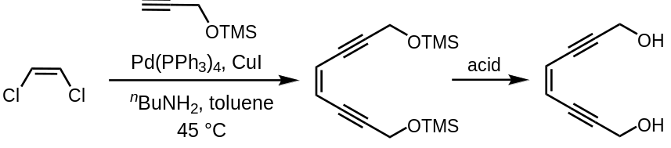
Figure S1 Synthetic route of (Z)-oct-4-ene-2,6-diyne-1,8-diol
O-(trimethylsilyl)- propargyl alcohol (1.0 g, 7.8 mmol), prepared from propargyl alcohol and chlorotrimethylsilane, toluene (10 mL), tetrakis-(triphenylphosphine)palladium(0) (0.258g, 0.2 mmol), cuprous iodide (0.057 g, 0.3 mmol), and n-butylamine (1.1 mL, 11.1 mmol) were mixed under argon in a 100 mL round-bottomed flask. (Z)-1,2-Dichloroethylene (0.25 mL, 3.6 mmol) was added to the mixture. After overnight stirring, the reaction mixture was diluted with ether (50 mL) and filtered. The concentrated filtrate was dissolved then in MeOH (40 mL) containing a few drops of AcOH. Concentration and purification of the product mixture by flash chromatography on silica gel (25% EtOAc in hexanes) afforded (Z)-oct-4-ene-2,6-diyne-1,8-diol. (35%), which was kept in EtOAc: ¹H-NMR (500 MHz, CDCl₃, δ in ppm): ¹H NMR (500 MHz, cdcl₃) δ 5.83 (s, 1H), 4.43 (s, 4H), 1.86 (bs, 2H). ESI-ToF MS: [M+Li]⁺ calculated for C₈H₈O₂Li⁺, 143.068; found, 143.066.

    - Copies of ¹H NMR and ESI-ToF MS Spectra

Figure S2 ¹H NMR spectrum of trimethyl(prop-2-yn-1-yloxy)silane
Figure S3 ¹H NMR spectrum of (Z)-oct-4-ene-2,6-diyne-1,8-diol

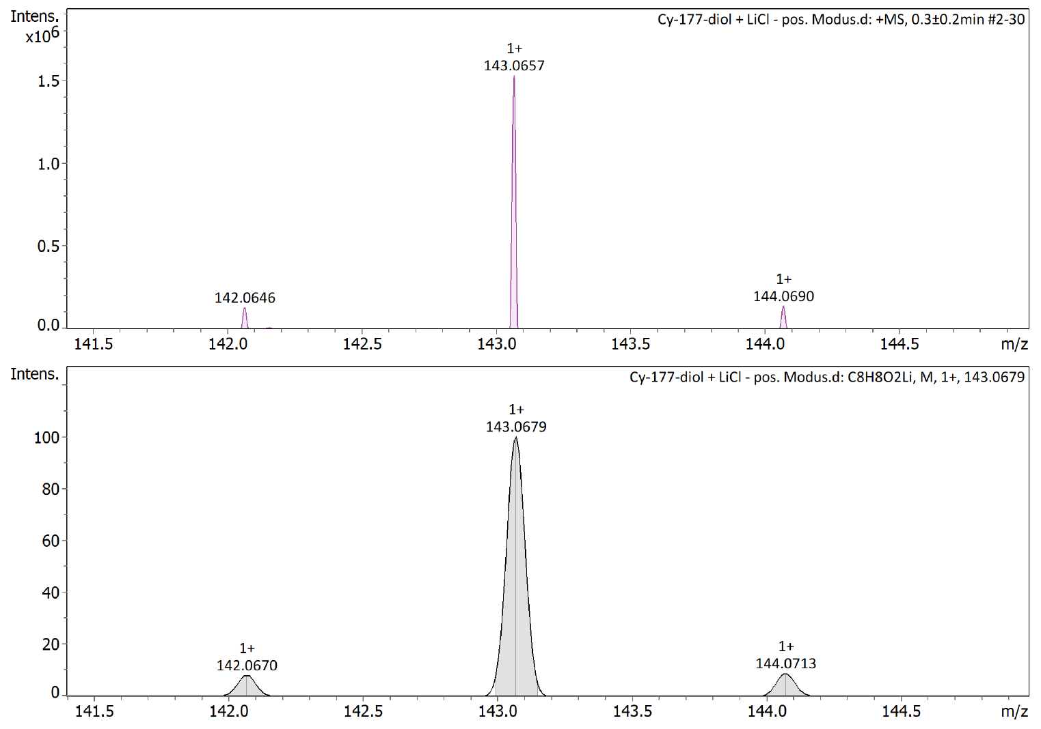
Figure S4 ESI-ToF MS Spectra of (Z)-oct-4-ene-2,6-diyne-1,8-diol

SAXS of PU, PU+EDY, and IPN (PU+PP)
Figure S5 SAXS curves of PU, PU+EDY, and IPN (PU+PP)

1 McPhee, M. M. & Kerwin, S. M. Synthesis and Metal Ion Binding Studies of Enediyne-Containing Crown Ethers. J. Org. Chem. 61, 9385-9393, doi:10.1021/jo961583r (1996).

