Supporting Information
Design, Synthesis and Biological Evaluation of Potent Thiazolidinedione Salicylic Acid Inhibitors Against Glyoxalase-I inhibitors as Potential Anticancer Agents

Banan O. Alomari¹, Lara I. Fakhouri¹*, Nizar A. Al‑Shar’i¹, and Qosay Albalas¹

¹ Department of Medicinal Chemistry and Pharmacognosy, Faculty of Pharmacy, Jordan University of Science and Technology, P.O. Box 3030, Irbid 22110, Jordan

*Corresponding authors, E-mail: lialfakhori@just.edu.jo (Lara I. Fakhouri)
E-mail: nashari@just.edu.jo (Nizar A. Al-Shar’i)

Table of Contents:
¹H NMR spectrum of compound 29a S-4
¹H NMR spectrum of compound 29b S-5
¹H NMR spectrum of compound 29c S-6
¹H NMR spectrum of compound 29d S-7
¹H NMR spectrum of compound 30 S-8
¹H NMR spectrum of compound 31a S-9
¹H NMR spectrum of compound 31b S-10
¹H NMR spectrum of compound 31c S-11
¹H NMR spectrum of compound 31d S-12
¹H NMR spectrum of compound 31e S-13
¹H NMR spectrum of compound 31f S-14
¹H NMR spectrum of compound 1 S-15
¹H NMR spectrum of compound 4 S-16
¹³C NMR spectrum of compound 4 S-17
MS Spectrum of compound 4 S-17
¹H NMR spectrum of compound 5 S-18
¹³C NMR spectrum of compound 5 S-19
MS Spectrum of compound 4 S-19
¹H NMR spectrum of compound 9 S-20
¹³C NMR spectrum of compound 9 S-21
MS Spectrum of compound 9 S-21
¹H NMR spectrum of compound 10 S-22
¹³C NMR spectrum of compound 10 S-23
MS Spectrum of compound 10 S-23
¹H NMR spectrum of compound 18 S-24
¹³C NMR spectrum of compound 18 S-25
MS Spectrum of compound 18 S-25
¹H NMR spectrum of compound 19 S-26
¹³C NMR spectrum of compound 19 S-27
MS Spectrum of compound 19 S-27
¹H NMR spectrum of compound 20 S-28
¹³C NMR spectrum of compound 20 S-29
MS Spectrum of compound 20 S-29
¹H NMR spectrum of compound 21 S-30
¹³C NMR spectrum of compound 21 S-31
MS Spectrum of compound 21 S-31
¹H NMR spectrum of compound 22 S-32
MS Spectrum of compound 22 S-33
¹H NMR spectrum of compound 23 S-34
¹³C NMR spectrum of compound 23 S-35
MS Spectrum of compound 23 S-35
¹H NMR spectrum of compound 24 S-36
¹³C NMR spectrum of compound 24 S-37
MS Spectrum of compound 24 S-37
¹H NMR spectrum of compound 26 S-38
¹³C NMR spectrum of compound 26 S-39
MS Spectrum of compound 26 S-39
¹H NMR spectrum of compound 28 S-40
¹³C NMR spectrum of compound 28 S-41
MS Spectrum of compound 28 S-41

Compound 29a
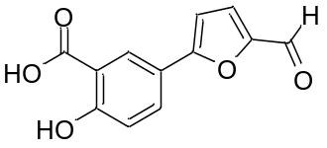
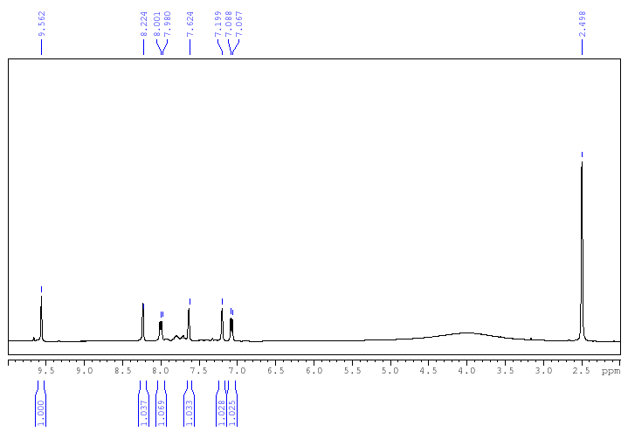

Compound 29b
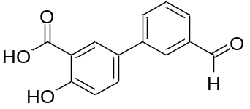
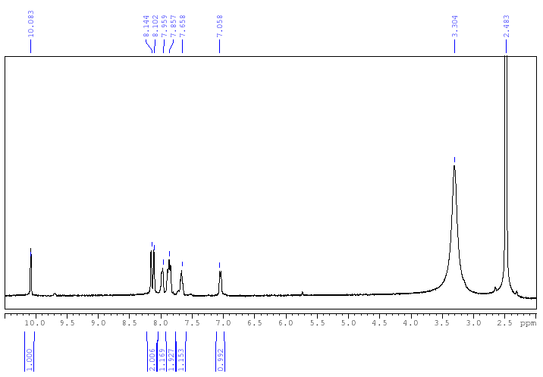

Compound 29c
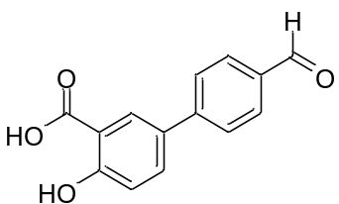
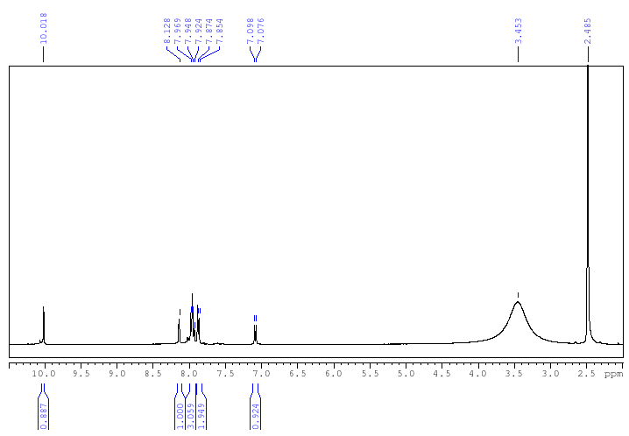

Compound 29d
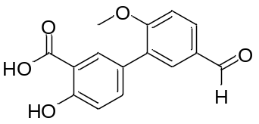
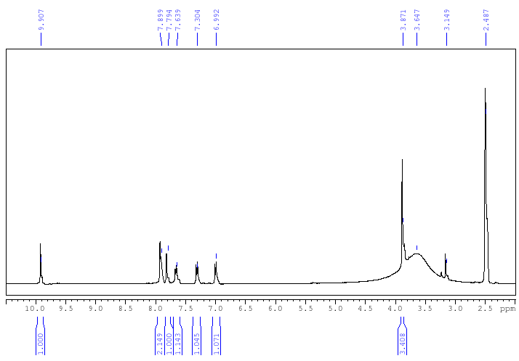

Compound 30
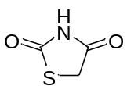
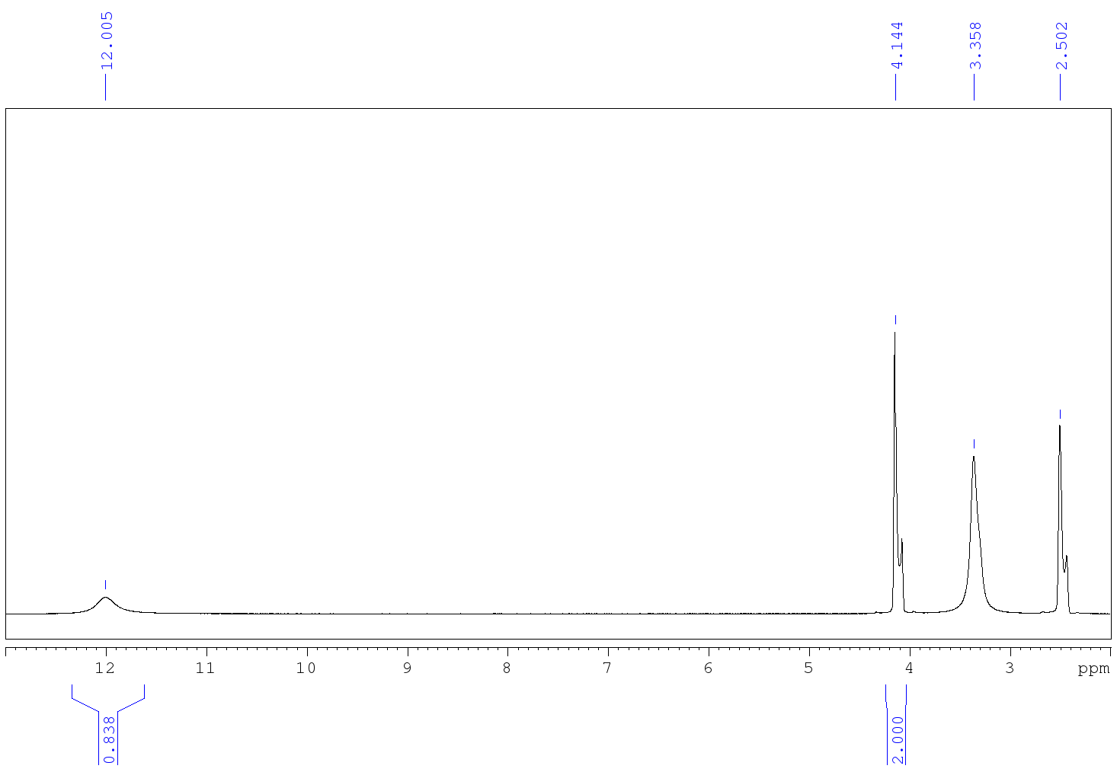

Compound 31a
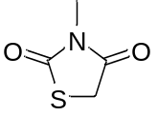
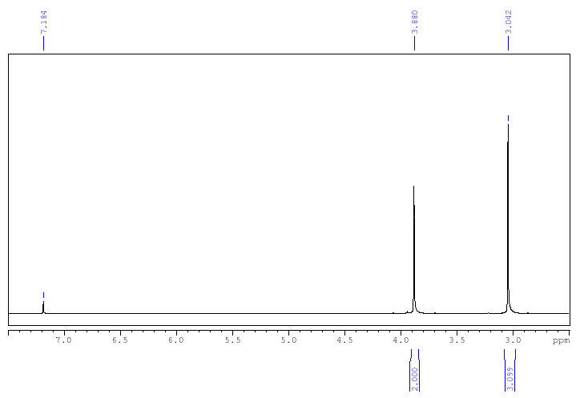

Compound 31b
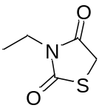
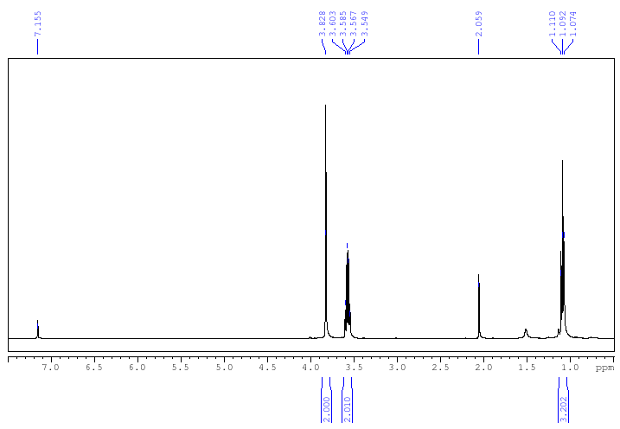

Compound 31c
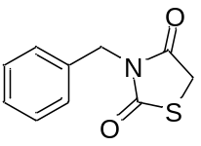
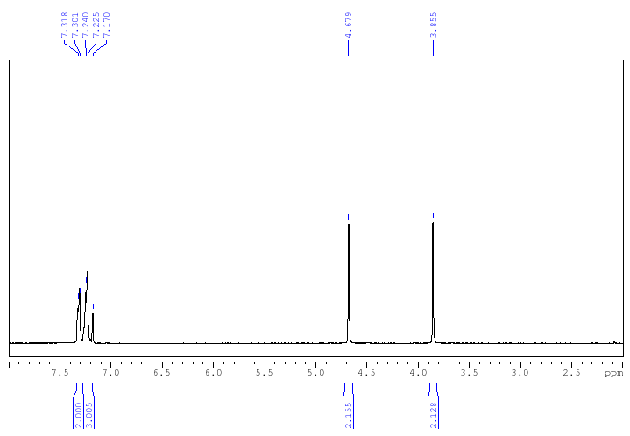

Compound 31d
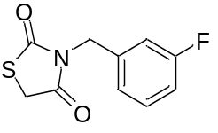
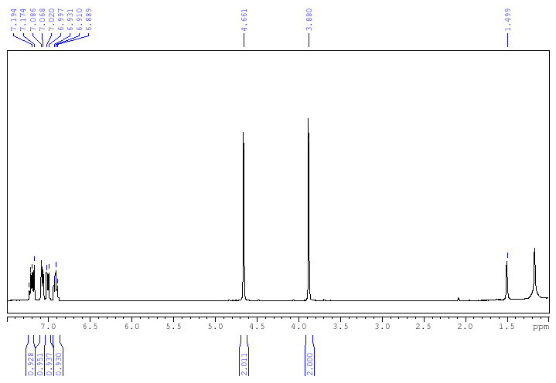

Compound 31e
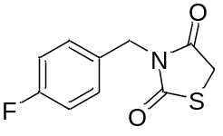
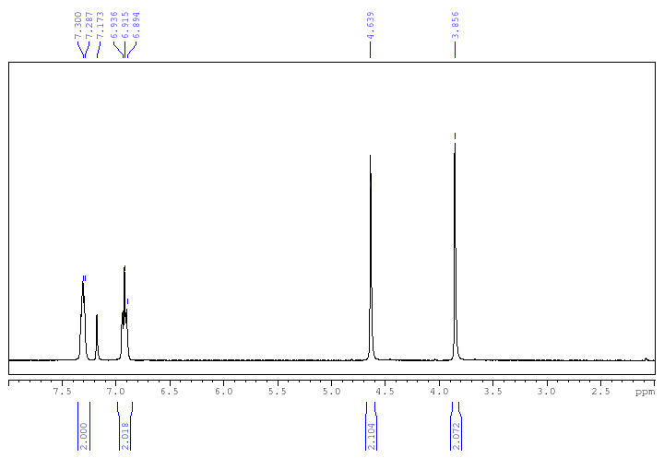

Compound 31f
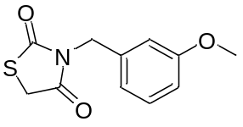
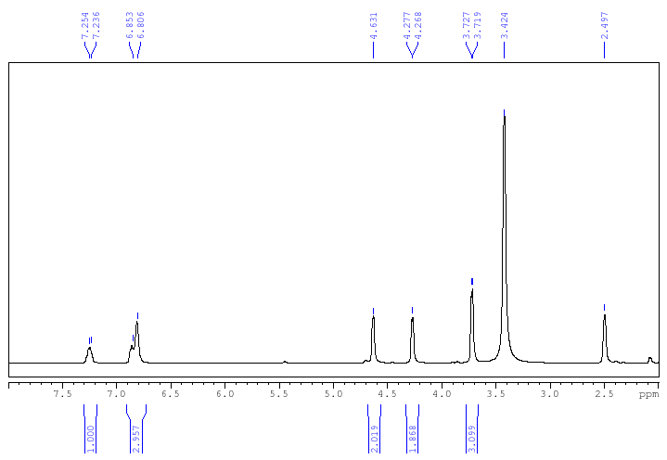

Compound 4
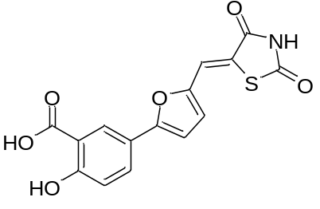
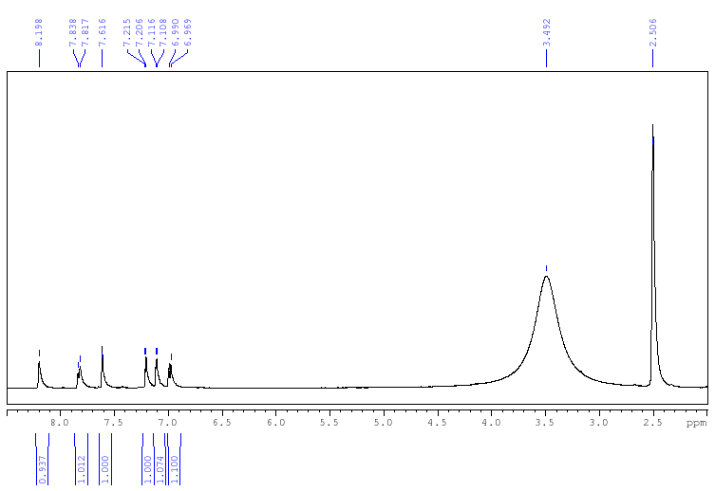

Compound 4
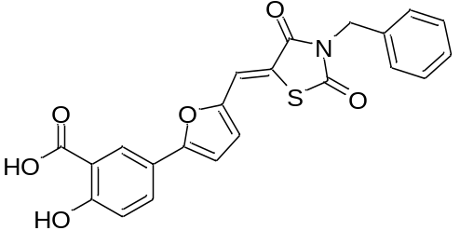
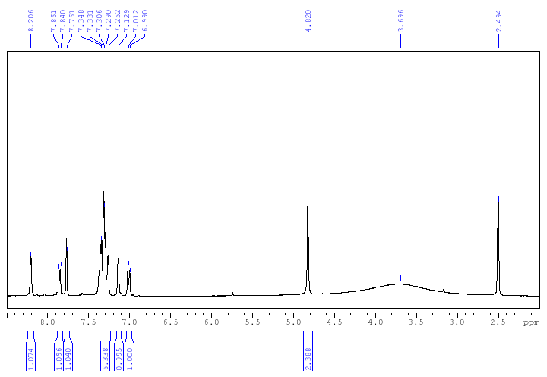

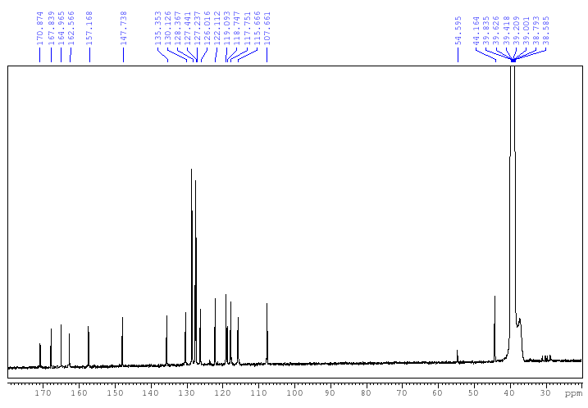

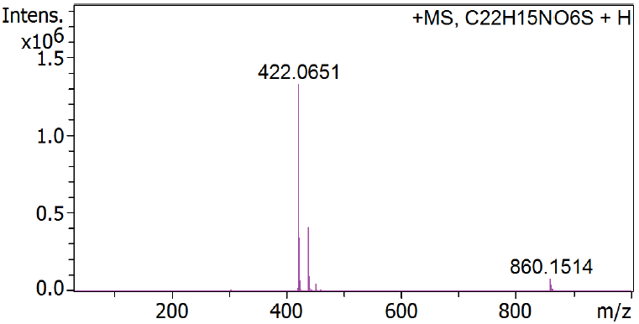

Compound 5
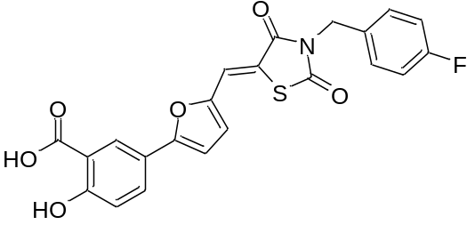
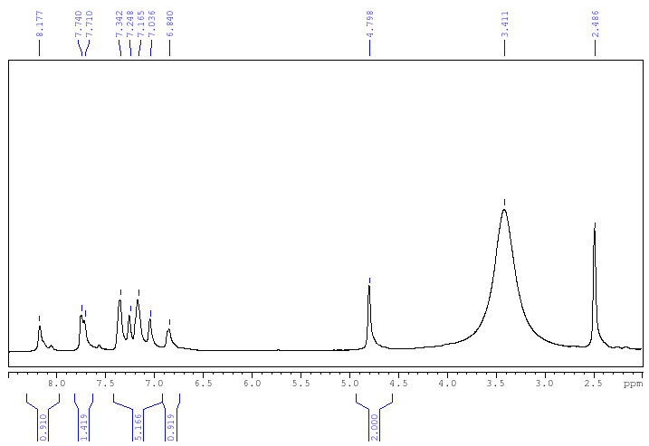

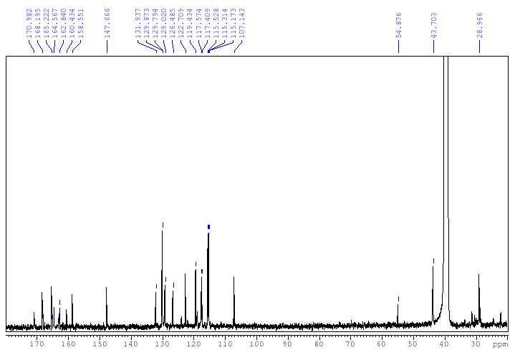
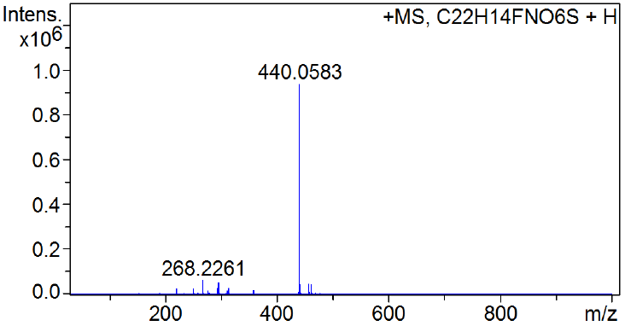

Compound 9
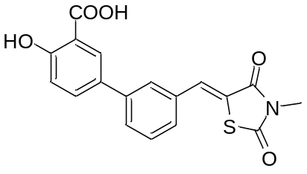
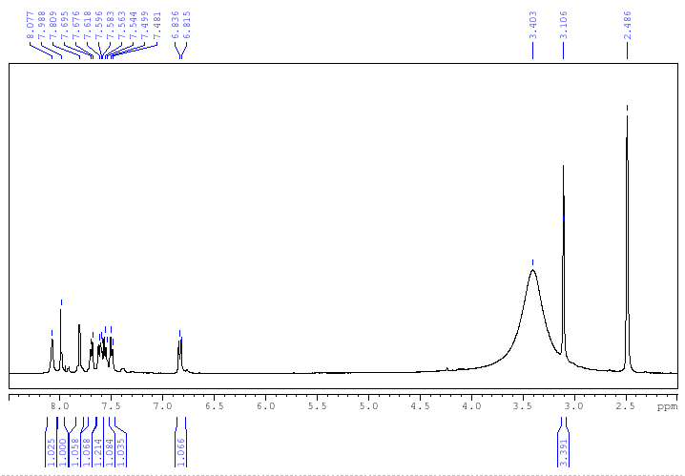

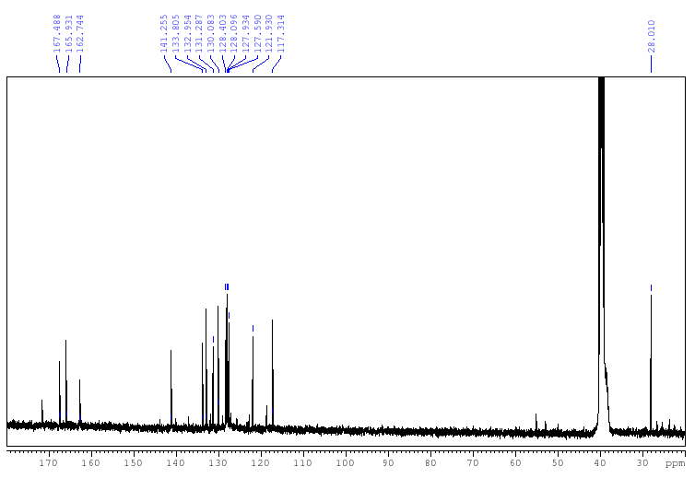
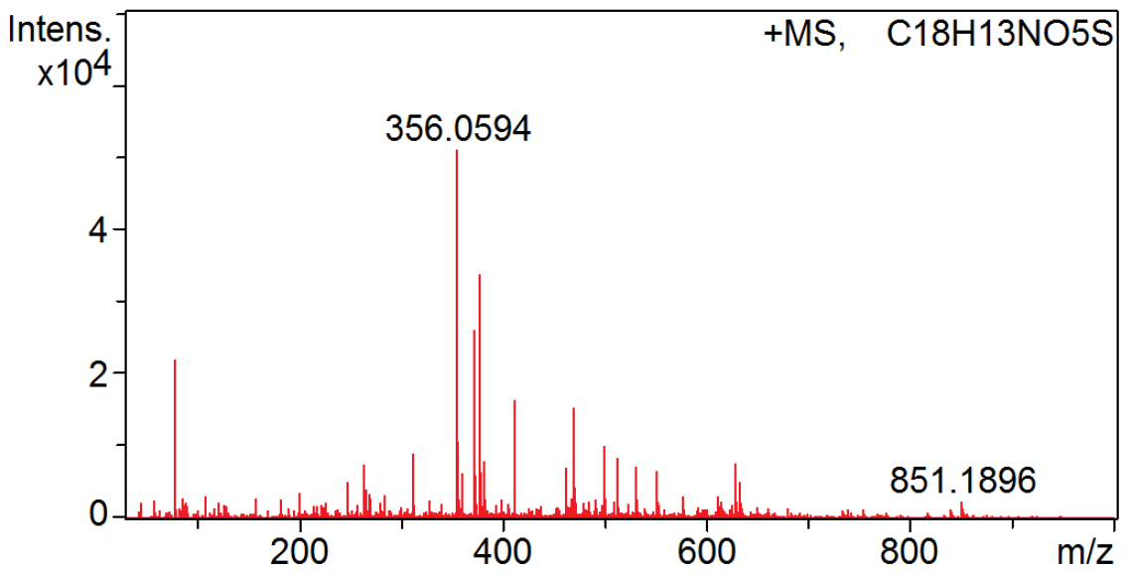

Compound 10
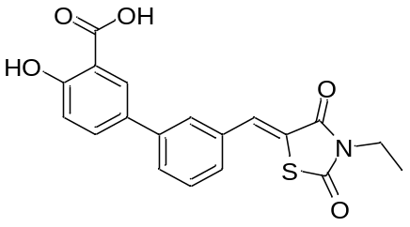
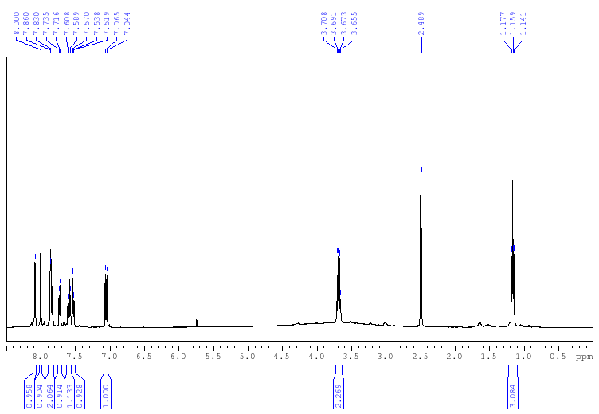 .

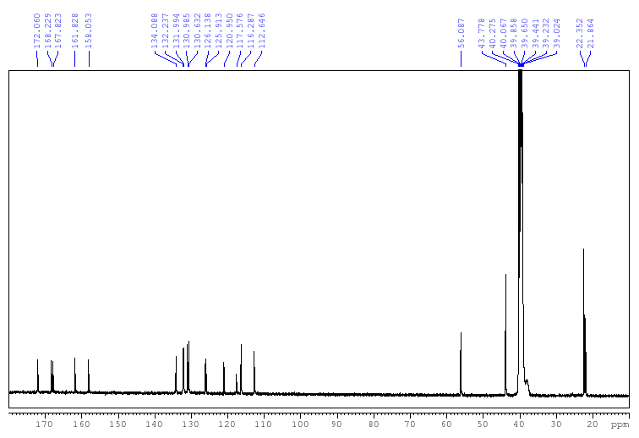
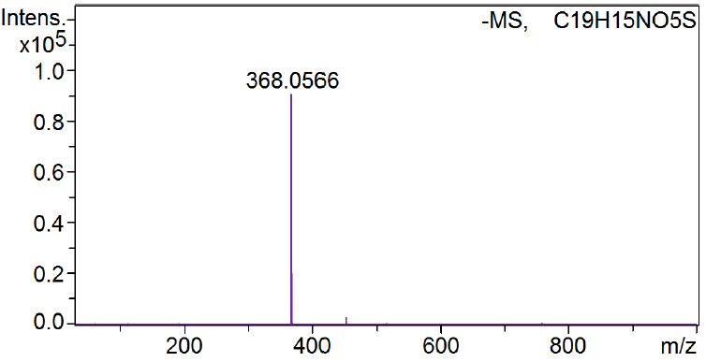

Compound 18
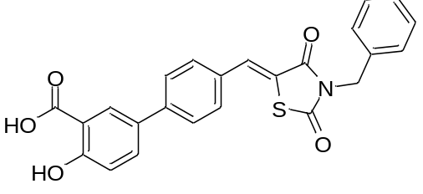
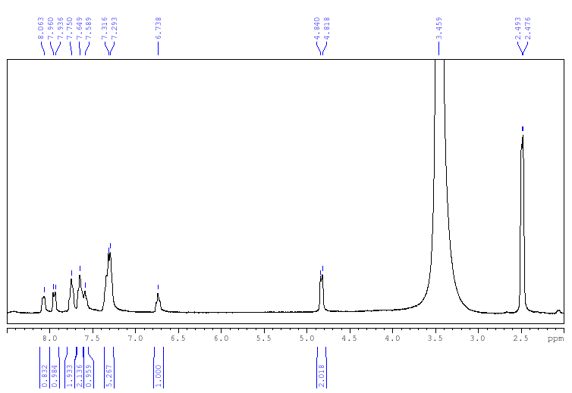

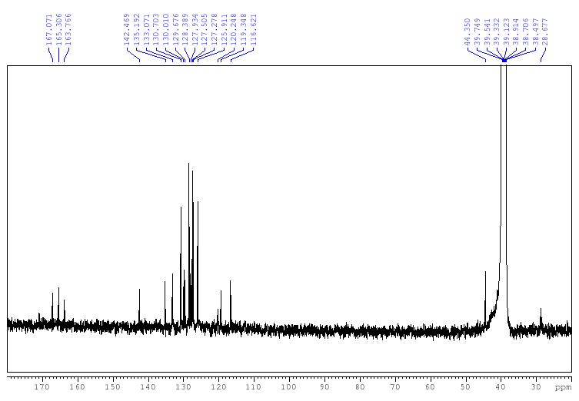
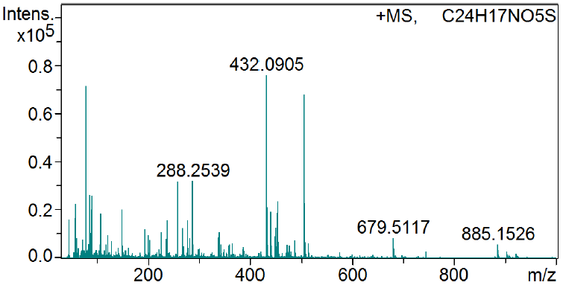

Compound 19
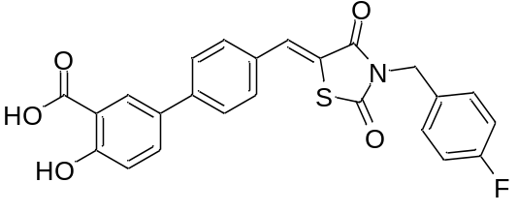
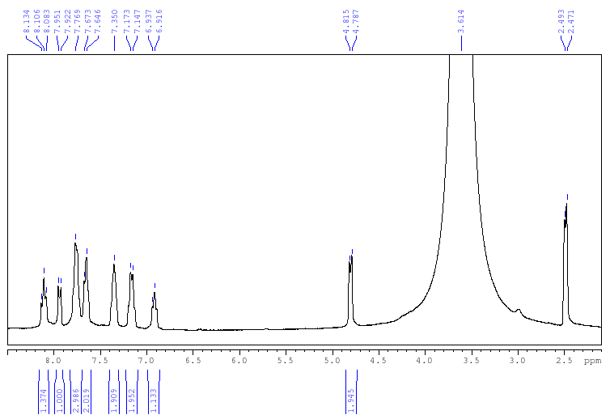
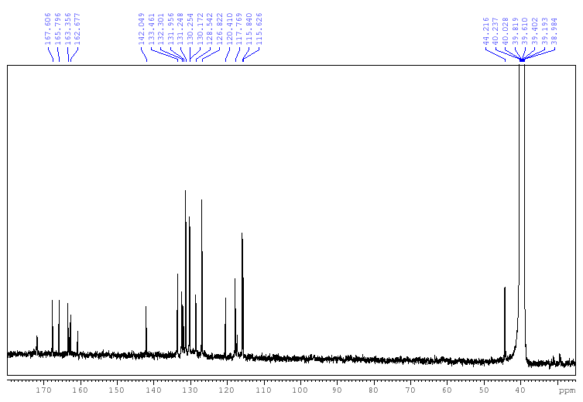
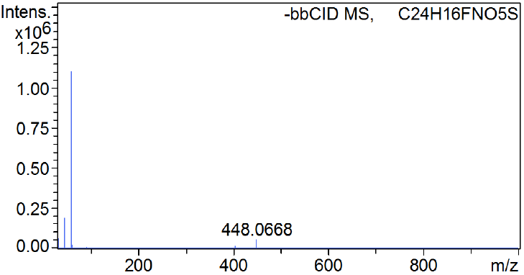

Compound 20
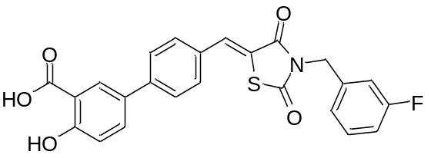
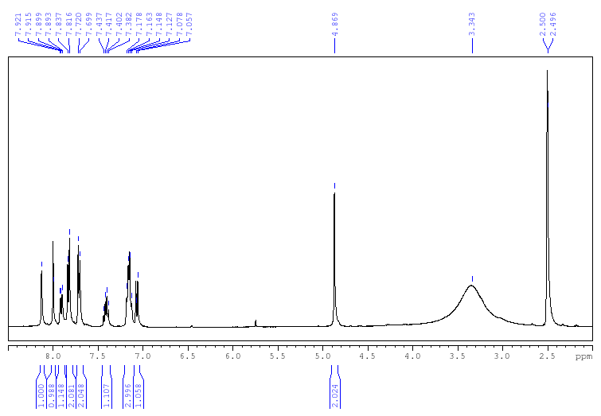

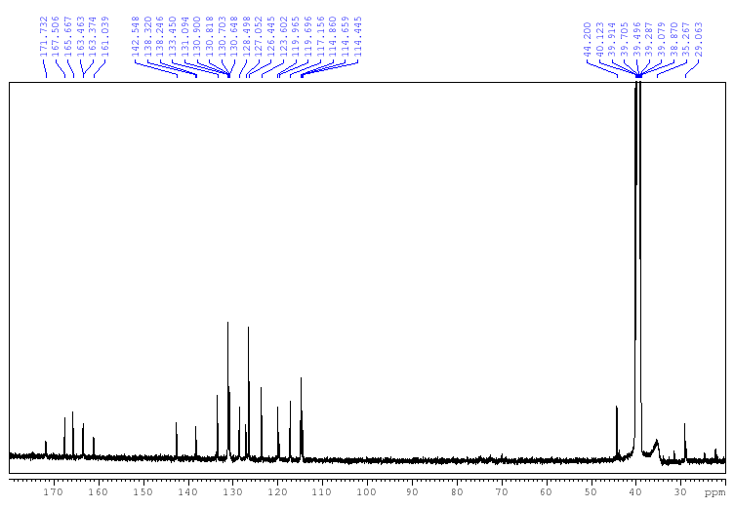
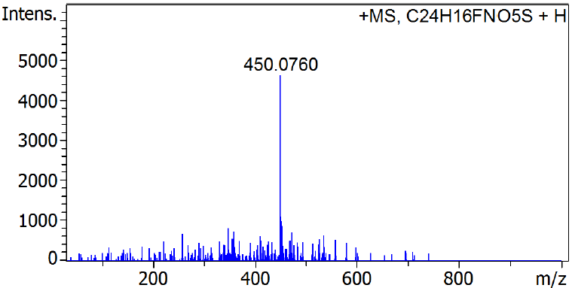

Compound 21
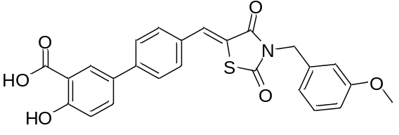
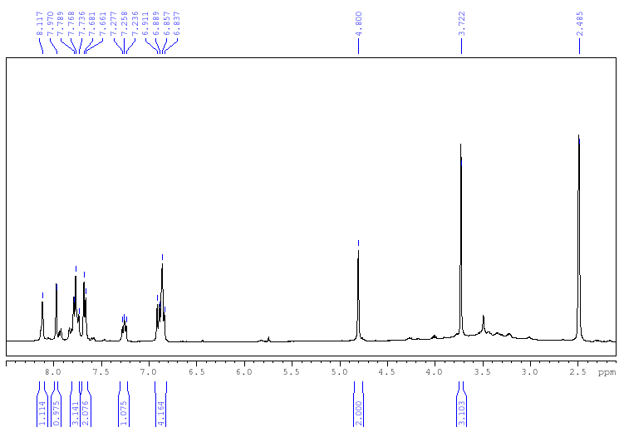

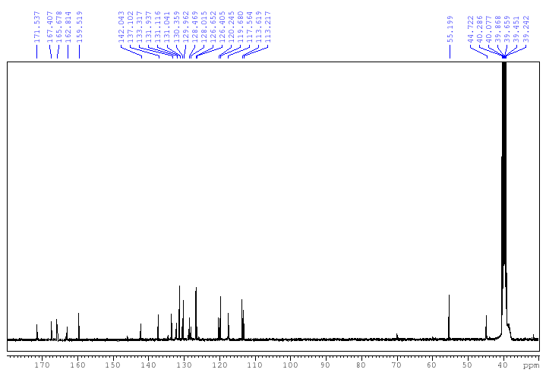
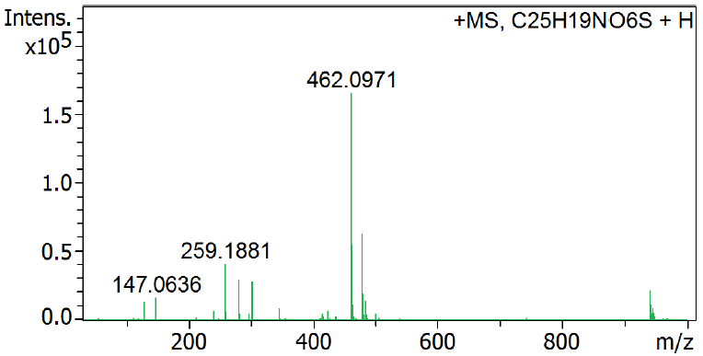

Compound 22
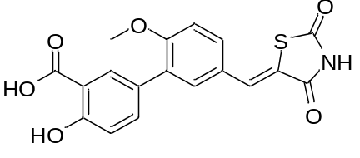
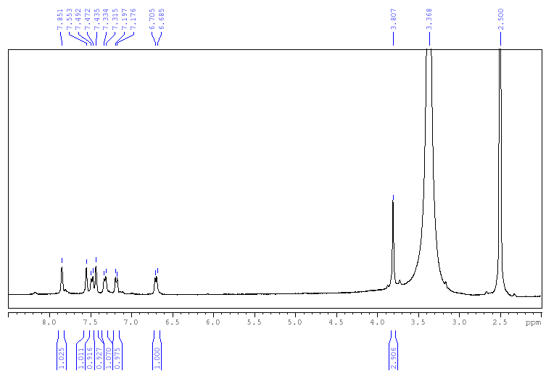
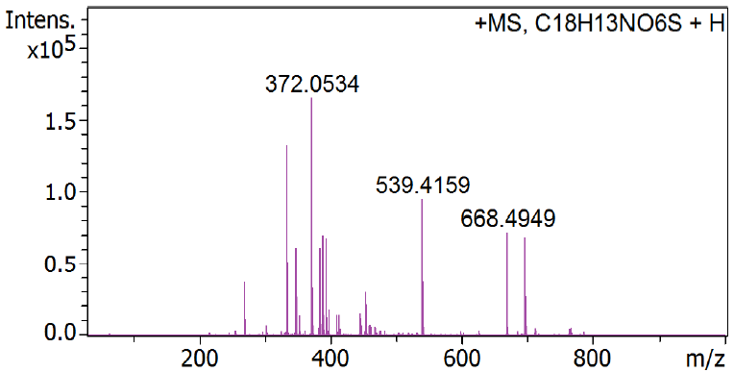

Compound 23
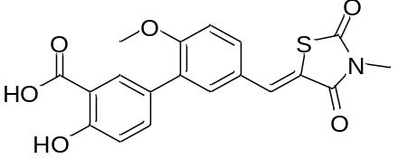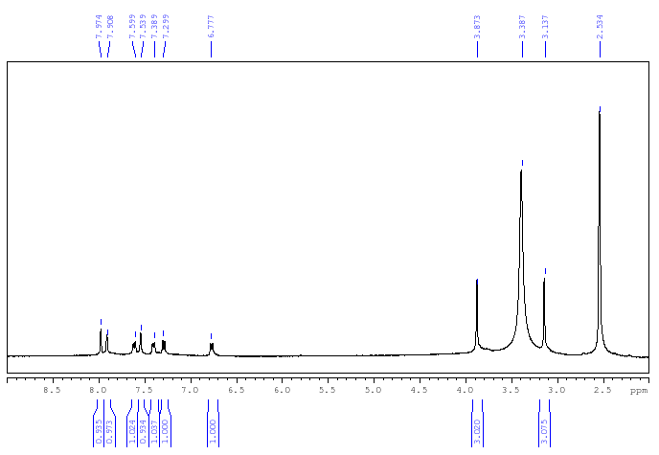

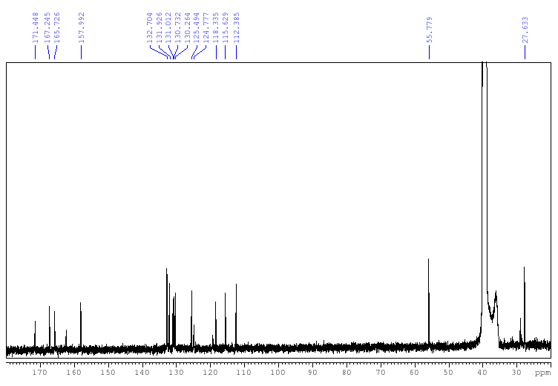
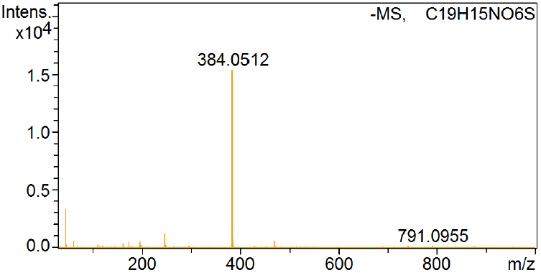

Compound 24
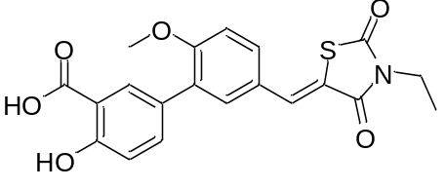
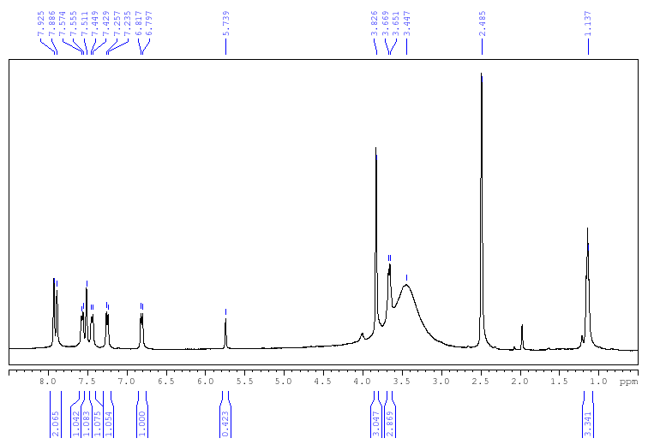

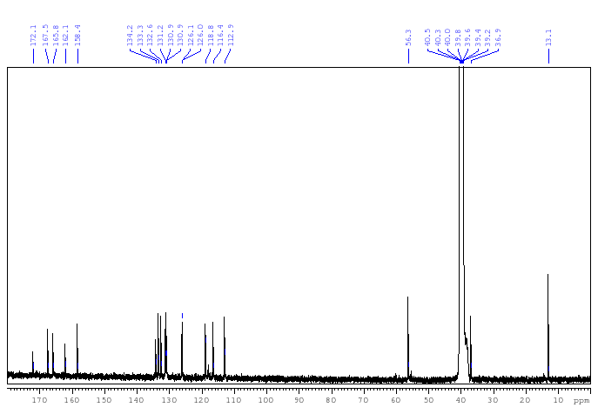
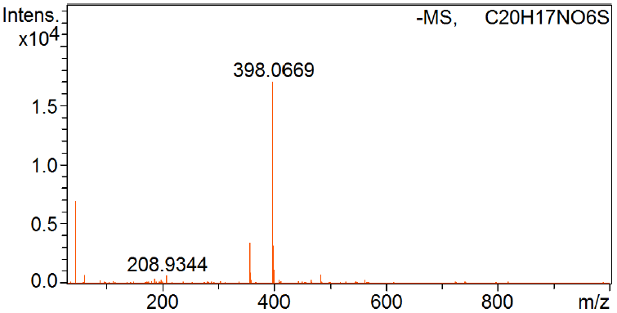

Compound 26
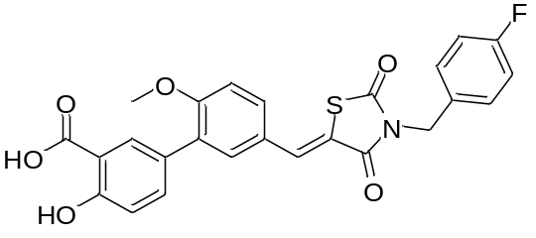
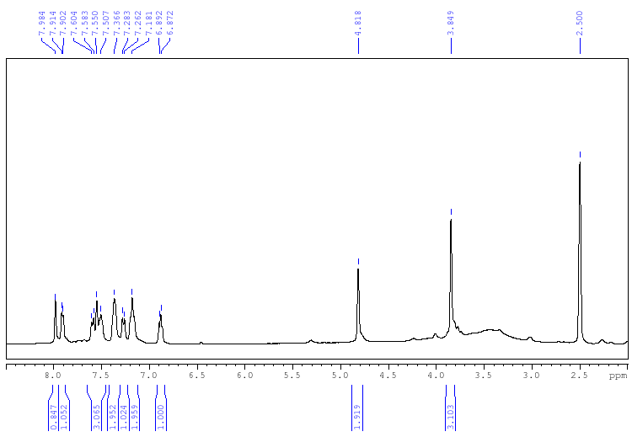

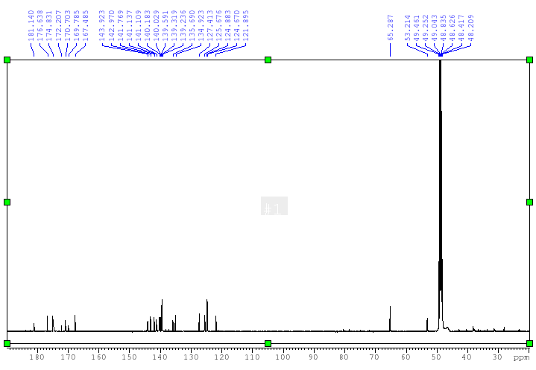

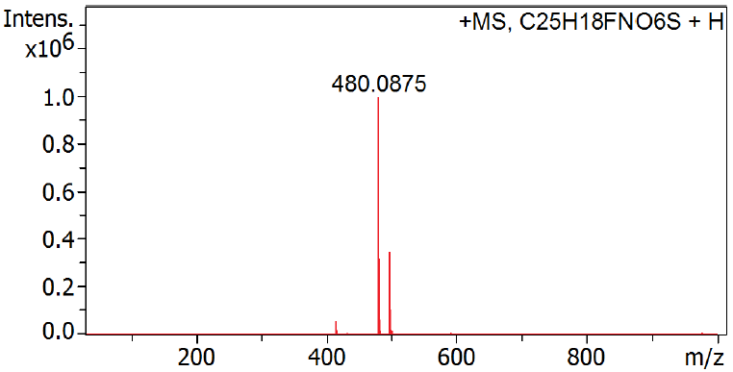

Compound 28
