Supplementary Tables and Figures

Supplementary Table 1 ANOVA of the percentage inhibition of the mycelial growth of Penicillium digitatum
 | Degrees of Freedom | Sum of Squares | Mean of Squares | F-value | Pr(>F) | Significance value
Treatment | 60 | 450555 | 7509 | 76.767 | <2e-16 | < 0.05
Trial | 1 | 339 | 339 | 3.47 | 0.0637 | = 0.05
Treatment:Trial | 60 | 8433 | 141 | 1.437 | 0.0302 | < 0.05
Residuals | 242 | 23672 | 98

Supplementary Table 2 ANOVA of the percentage inhibition of the mycelial growth of Galactomyces citri-aurantii
 | Degrees of Freedom | Sum of Squares | Mean of Squares | F-value | Pr(>F) | Significance value
Treatment | 60 | 626485 | 10441 | 168.183 | <2e-16 | < 0.05
Trial | 1 | 18883 | 18883 | 304.161 | <2e-16 | < 0.05
Treatment:Trial | 60 | 19189 | 320 | 5.151 | <2e-16 | < 0.05
Residuals | 241 | 14962 | 62

Supplementary Table 3 ANOVA of the percentage inhibition of spore germination of Penicillium digitatum as a result of exposure to essential oil volatiles for 3 days
 | Degrees of Freedom | Sum of Squares | Mean of Squares | F-value | Pr(>F) | Significance value
Treatment | 10 | 64690 | 6469 | 42.614 | <2e-16 | < 0.05
Trial | 1 | 69 | 69 | 0.456 | 0.503 | > 0.05
Treatment:Trial | 10 | 639 | 64 | 0.421 | 0.929 | > 0.05
Residuals | 44 | 6679 | 152

Supplementary Table 4 ANOVA of the percentage inhibition of spore germination of Galactomyces citri-aurantii as a result of exposure to essential oil volatiles for 3 days
 | Degrees of Freedom | Sum of Squares | Mean of Squares | F-value | Pr(>F) | Significance value
Treatment | 10 | 56659 | 5666 | 43.583 | <2e-16 | < 0.05
Trial | 1 | 479 | 479 | 3.685 | 0.0614 | = 0.05
Treatment:Trial | 10 | 1401 | 140 | 1.078 | 0.3991 | > 0.05
Residuals | 44 | 5720 | 130

Supplementary Table 5 ANOVA of the percentage inhibition of spore germination of Penicillium digitatum 11 days after a 3-day essential oil volatile exposure period
 | Degrees of Freedom | Sum of Squares | Mean of Squares | F-value | Pr(>F) | Significance value
Treatment | 10 | 64019 | 6402 | 36.475 | <2e-16 | < 0.05
Trial | 1 | 166 | 166 | 0.947 | 0.336 | > 0.05
Treatment:Trial | 10 | 302 | 30 | 0.172 | 0.997 | > 0.05
Residuals | 44 | 7723 | 176

Supplementary Table 6 ANOVA of the percentage inhibition of spore germination of Galactomyces citri-aurantii 11 days after a 3-day essential oil volatile exposure period
 | Degrees of Freedom | Sum of Squares | Mean of Squares | F-value | Pr(>F) | Significance value
Treatment | 10 | 77577 | 7758 | 53.233 | <2.00E-16 | < 0.05
Trial | 1 | 1540 | 1540 | 10.566 | 0.00221 | < 0.05
Treatment:Trial | 10 | 4491 | 449 | 3.082 | 0.00473 | < 0.05
Residuals | 44 | 6412 | 146

Supplementary Table 7 ANOVA of the percentage control of Penicillium digitatum on ‘Valencia’ fruit
 | Degrees of Freedom | Sum of Squares | Mean of Squares | F-value | Pr(>F) | Significance value
Treatment | 2 | 12578 | 6289 | 22.196 | 9.28E-05 | < 0.05
Trial | 1 | 356 | 356 | 1.255 | 0.285 | > 0.05
Treatment:Trial | 2 | 311 | 156 | 0.549 | 0.591 | > 0.05
Residuals | 12 | 3400 | 283
Supplementary Table 8 ANOVA of the extent of degreening of ‘Eureka’ lemons by day 4
 | Degrees of Freedom | Sum of Squares | Mean of Squares | F-value | Pr(>F) | Significance value
Treatment | 5 | 46.85 | 9.371 | 49.376 | 7.47E-12 | < 0.05
Trial | 1 | 1.56 | 1.556 | 8.200 | 0.008562 | < 0.05
Treatment:Trial | 5 | 6.80 | 1.360 | 7.165 | 0.000315 | < 0.05
Residuals | 24 | 4.55 | 0.190

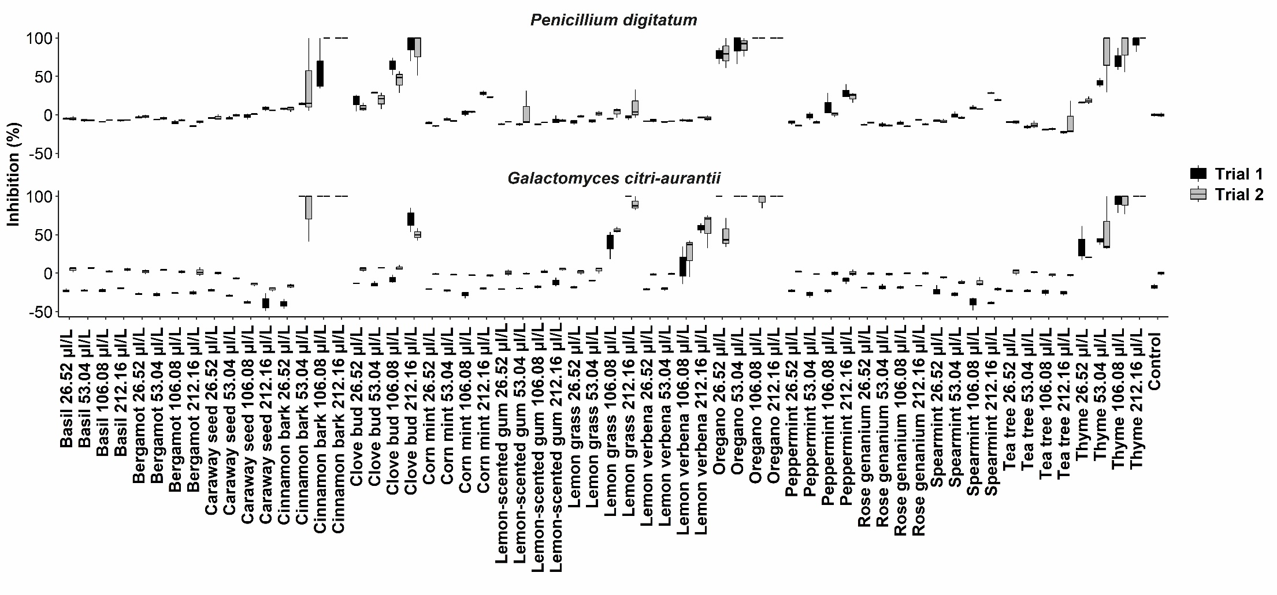
Supplementary Fig. 1 Boxplot of trial 1 and 2 of the mycelial growth inhibition percentage of Penicillium digitatum and Galactomyces citri-aurantii as a result of essential oil volatile exposure

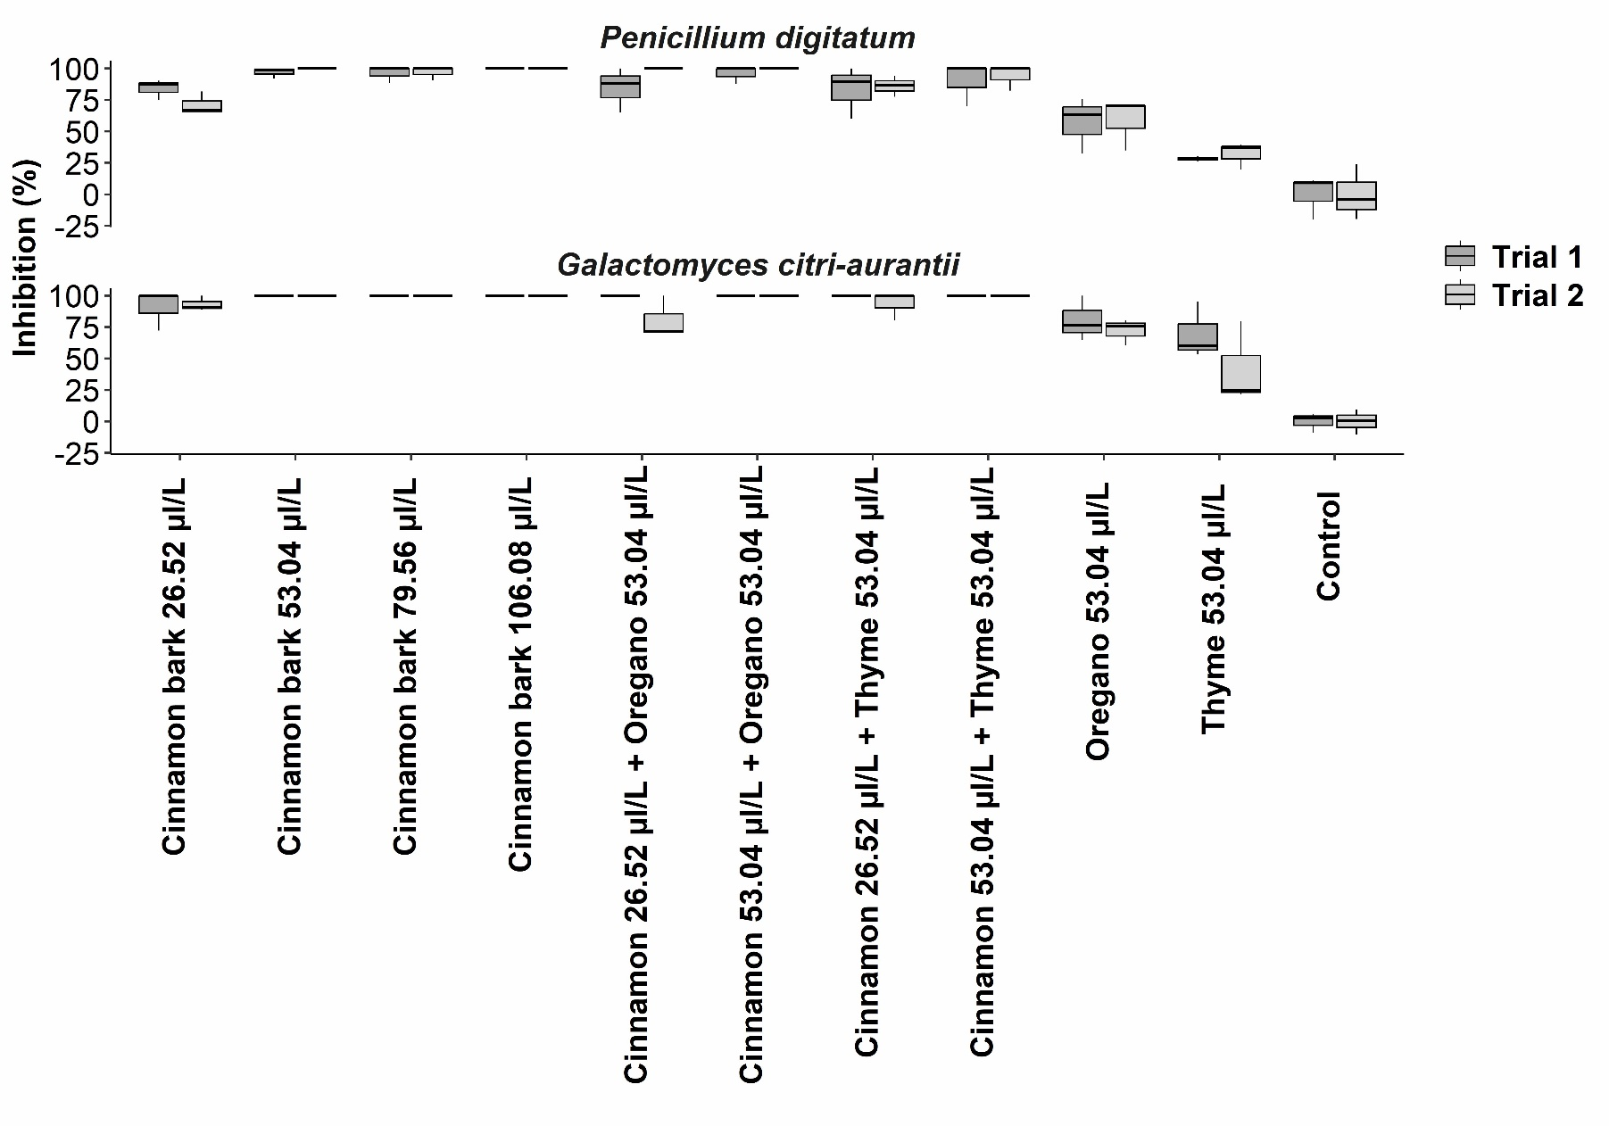 Supplementary Fig. 2 Boxplot of trial 1 and 2 of the spore germination inhibition percentage of Penicillium digitatum and Galactomyces citri-aurantii spores after 3 days of exposure to essential oil volatiles
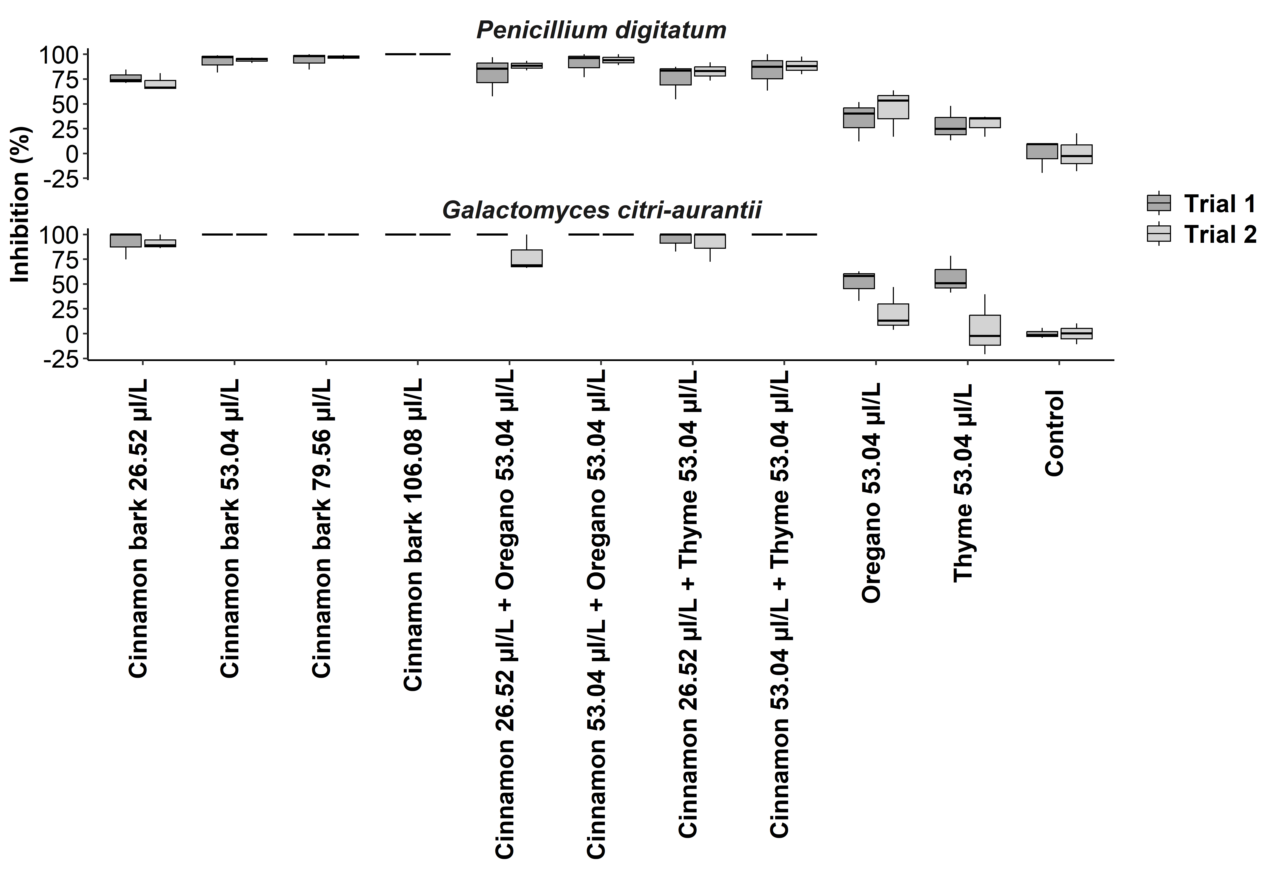Supplementary Fig. 3 Boxplot of trial 1 and 2 of the spore germination inhibition percentage of Penicillium digitatum and Galactomyces citri-aurantii 11 days after spores were exposed to essential oil volatiles for 3 days
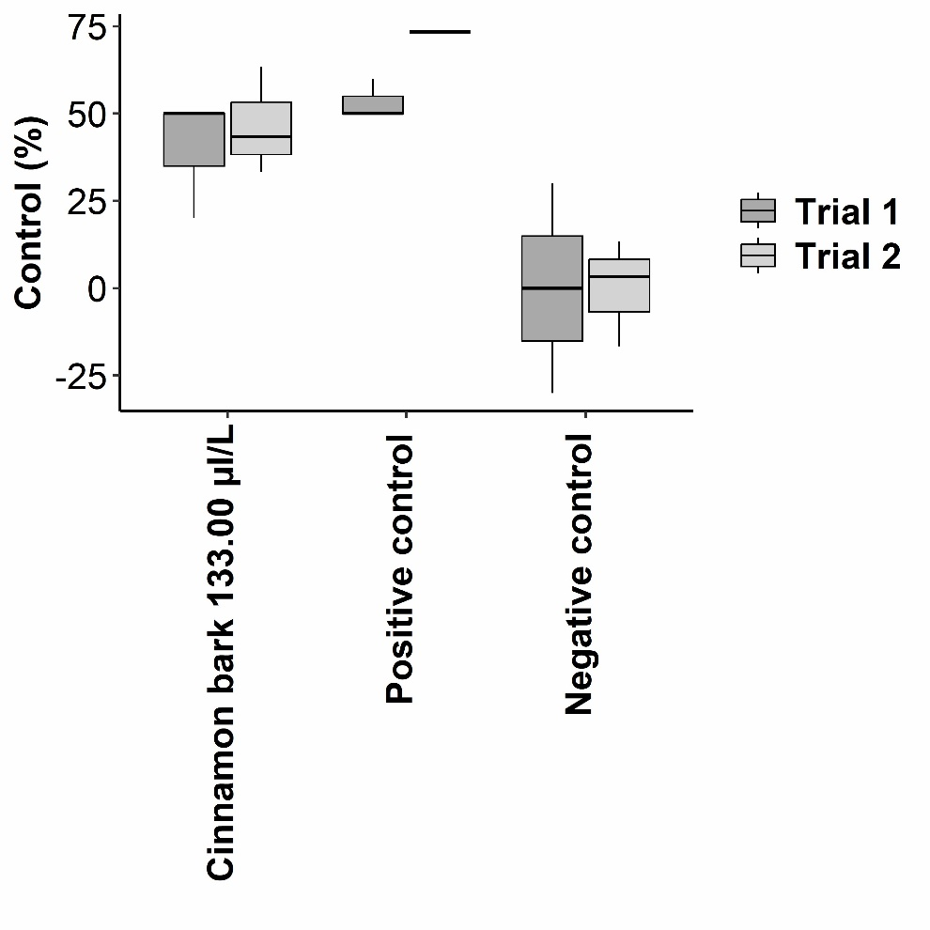
Supplementary Fig. 4 Boxplot of trial 1 and 2 of the percentage control of Penicillium digitatum-infections of wound inoculated ‘Valencia’ fruit

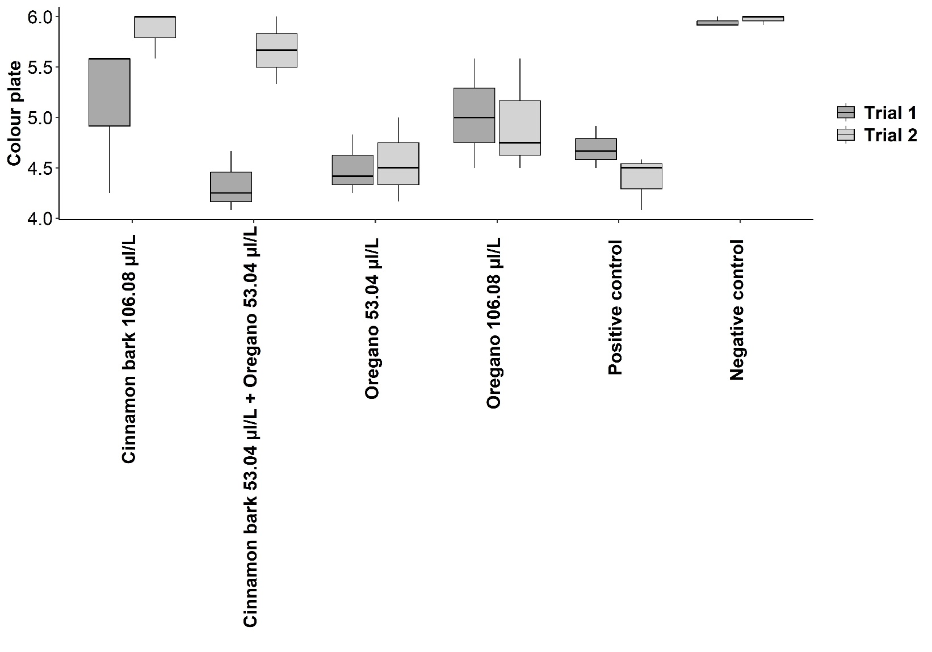
Supplementary Fig. 5 Boxplot of trial 1 and 2 of the extent of degreening of ‘Eureka’ lemons by day 4

