Rapid Gelation from Lipoic Acid/Trometamol Binary Assembling for Realizing 3D Printing in Poly(Lipoic Acid)-based Hydrogel Bandages Production
Jiujiang Zeng ^{1,4,#}, Tao Wang ^{1,#}, Dawei Niu ^{3,#}, Jinyan Li ², Haiyang Pan ², Kunxi Zhang ^{1,2,3}*, Haiyan Cui ^{1,}*

¹ Department of Plastic and Cosmetic Surgery, Tongji Hospital, School of Medicine, Tongji University, Shanghai, 200092, P. R. China.
² Department of Polymer Materials, School of Materials Science and Engineering, Shanghai University, Shanghai, 200444, P.R. China.
³ Department of Orthopaedics, The 971 hospital of CPLA Navy, Qingdao, 266071, P.R.China.
⁴ Department of Emergency, Tongji Hospital of Tongji University, Shanghai 200065, P. R. China.

* Corresponding authors:
Kunxi Zhang, E-mail: zhangkunxi@shu.edu.cn
Haiyan Cui, E-mail: u2beauty1@tongji.edu.cn

# These authors contributed equally to this work.

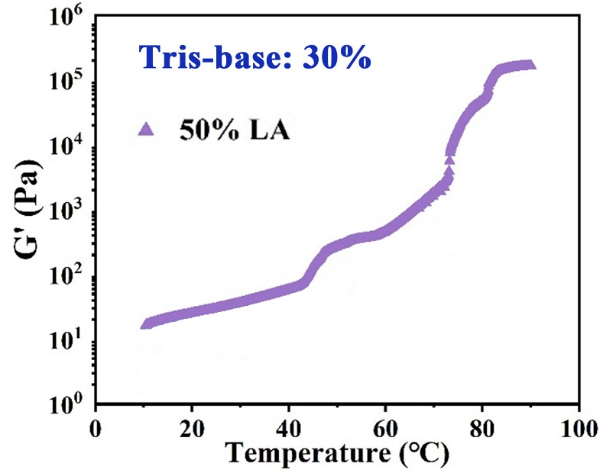
Figure S1. G’ of PLA polymerized form LA solution with the LA concentration of 50% w/v and the Tris-based concentration of 30% w/v during heating.

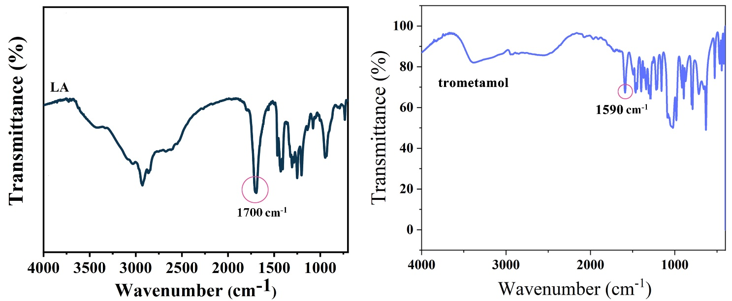
Figure S2. FT-IR spectrum of LA and trometamol.
Table S1. Molecular dynamics simulation results
 | E (a.u.) | E（eV） | ΔE (eV) | kJ·mol ⁻¹
LA | -1259.675126 | -34263.16342
Trometamol | -557.8542744 | -15173.63627
l-t-OH | -1817.541543 | -49437.12997 | -0.3 | -31.867
l-t-N | -1817.544183 | -49437.20177 | -0.4 | -38.795
i | -1817.569883 | -49437.90082 | -1.1 | -106.24
ii | -1817.566996 | -49437.82229 | -1.0 | -98.666

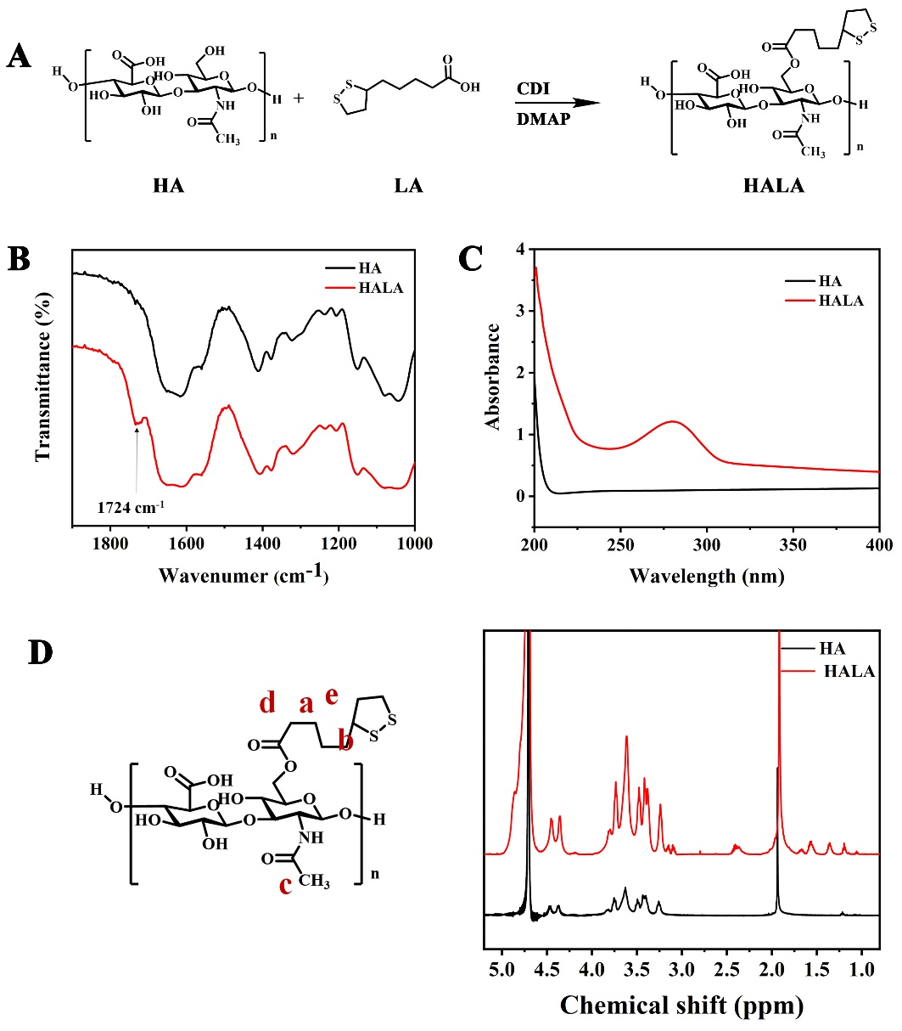
Figure S3. Characterization of HALA. (A) Synthesis of HALA. (B) FT-IR spectrum. (C) UV visible absorption spectrum. (D) ¹H NMR spectrum of HALA.
Discussion: LA was grafted onto HA to synthesize HALA, which was used as a macromolecular crosslinker to co-polymerize with LA to form a crosslinked PLA-HA hydrogel (Figure S3A). The appearance of a typical characteristic peak of ester groups at 1724 cm⁻¹ in FT-IR spectrum, as well as the appearance of a characteristic absorption peak of disulfide bonds at 280 nm in the UV-visible absorption spectrum confirmed the grafting of LA onto HA (Figure S3B,C). ¹H NMR spectrum further confirmed the synthesis of HALA (Figure S3D). The high grafting rate of LA would affect the solubility of HALA in water. Thus, HALA with the LA graft rate calculated from ¹H NMR of 2% was used in the present study.

Figure S4. Molecular weight of HA before and after LA conjugation tested by GPC.

Table S2. Synthesis of HA-LA
 | HA | HA-LA
M_{n} | 3.037 × 10⁴ (±2.068%) | 1.672 × 10⁴ (±1.480%)
M_{w} | 4.458 × 10⁴ (±0.998%) | 2.311 × 10⁴ (±1.079%)
M_{w}/M_{n} | 1.468 (±2.296%) | 1.382 (±1.832%)

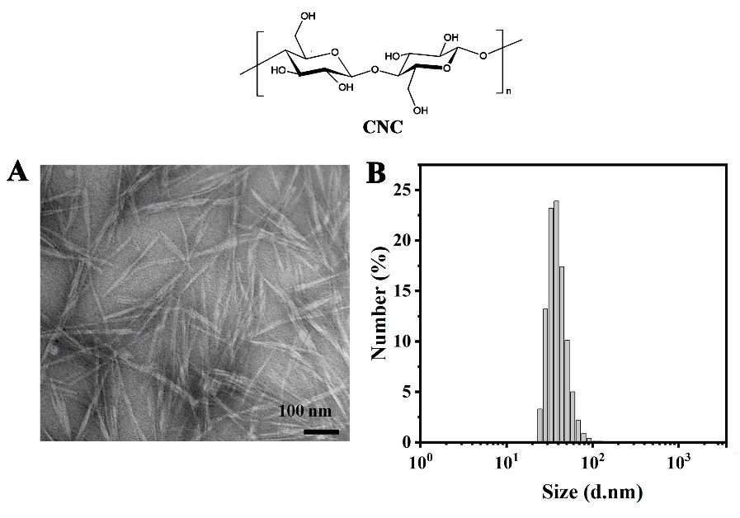
Figure S5. Characterization of CNC. (A) SEM image of CNC (Bar scale=100 μm). (B) Size distribution of CNC in water.
Discussion: CNC was planned to be introduced into the hydrogel bandage to form extensive hydrogen bonds with the PLA-HA network. As shown in Figure S5A,B, the CNC used in the present study was similar to a "needle-like" nanoparticle with a length of ~200 nm and a width of ~10 nm. The particle size of CNC in water measured by DLS showed that the average particle size was ~237.02 nm.

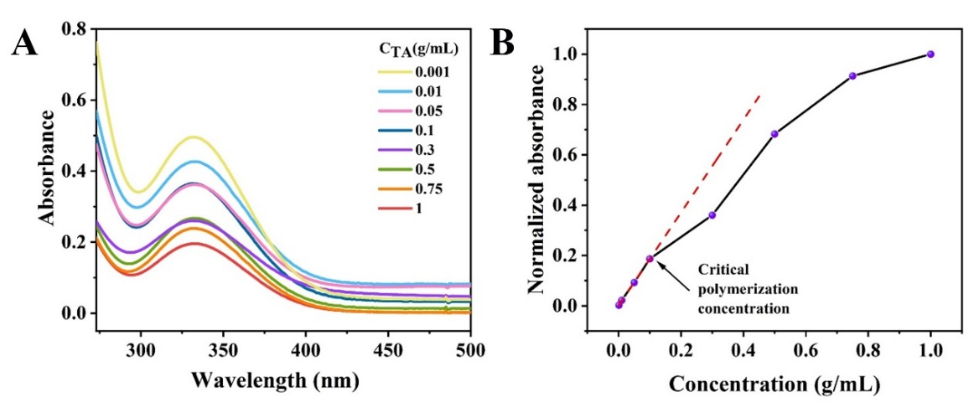
Figure S6. UV visible absorption spectrum for monitoring LA polymerization in solution.
Discussion: The effect of LA concentration on the polymerization process was studied and showed in Figure S6, by monitoring the UV absorption peak of dithiolane, it was found that when the polymerization concentration was ~0.1 g/mL, the relationship between absorbance and concentration deviated from the linear Beer-Lambert line, indicating that the dynamic disulfide bond of LA became close enough to trigger the intermolecular exchange.

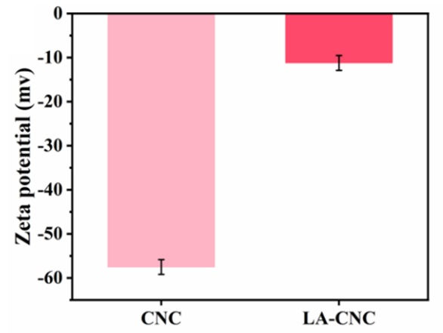
Figure S7. Zeta potential of CNC and LA-CNC.

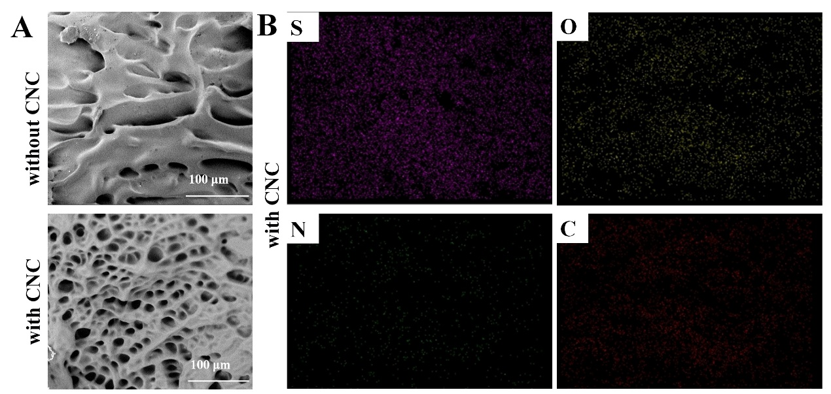
Figure S8. SEM (A) and EDS (B) of hydrogel bandage with and without CNC.

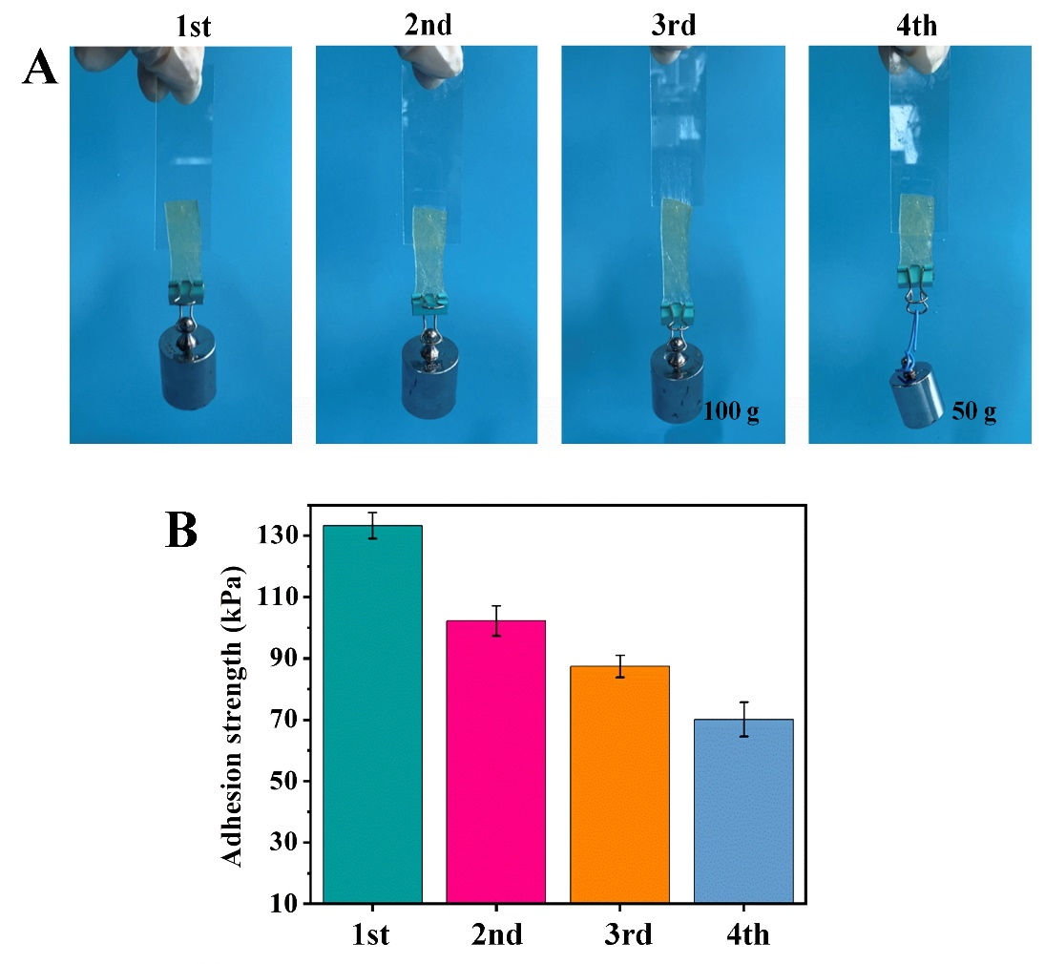
Figure S9. Bandage re-adhesion. (A) Images to show the re-adhesion of the removed hydrogel bandage. (B) Adhesion strength of the re-adhered hydrogel bandage.

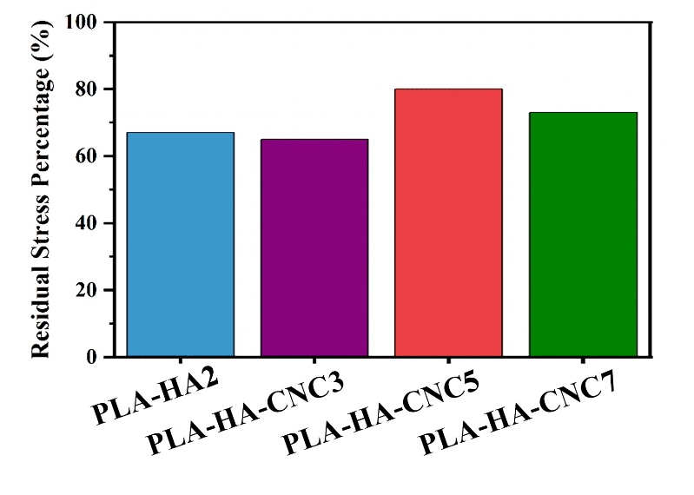
Figure S10. Residual stress percentage of different hydrogels calculated from cyclic compression tests.

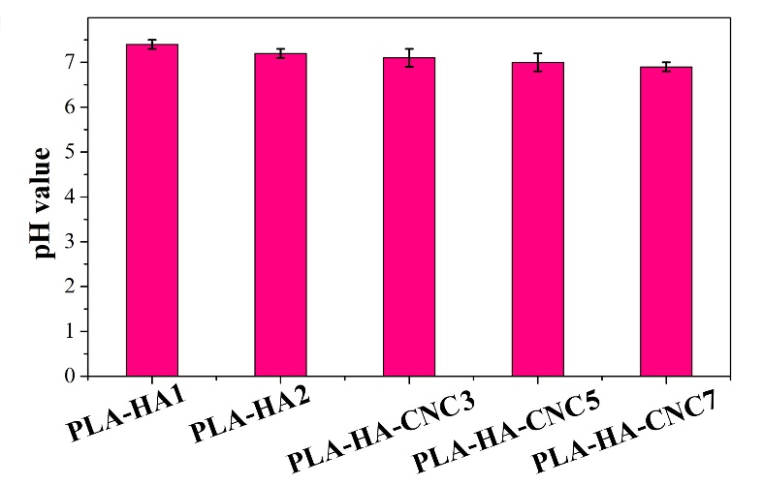
Figure S11. pH value of the hydrogels.

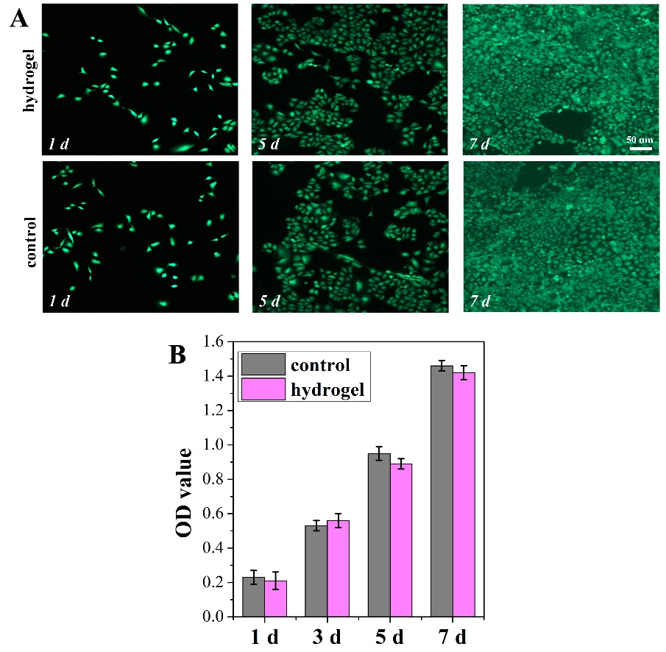
Figure S12. (A) Live/dead staining of fibroblasts co-cultured with hydrogel bandage (PLA-HA-CNC2) (Bar scale=50 μm). (B) OD value to show fibroblasts proliferated after 1, 5, and 7 days culture.

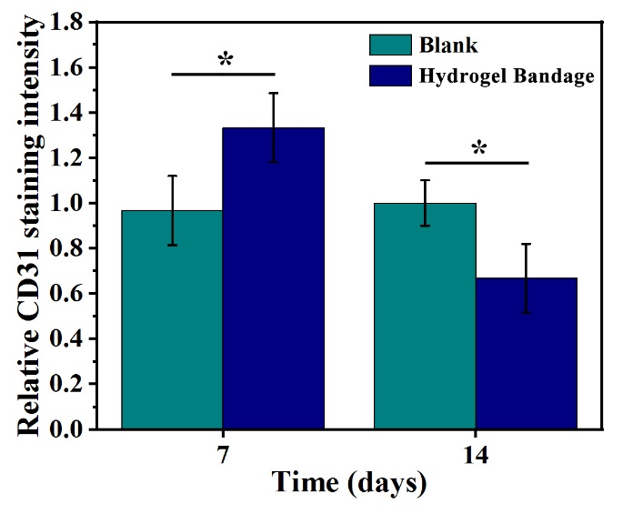
Figure S13. Relative CD31 staining intensity calculated by Image J.

