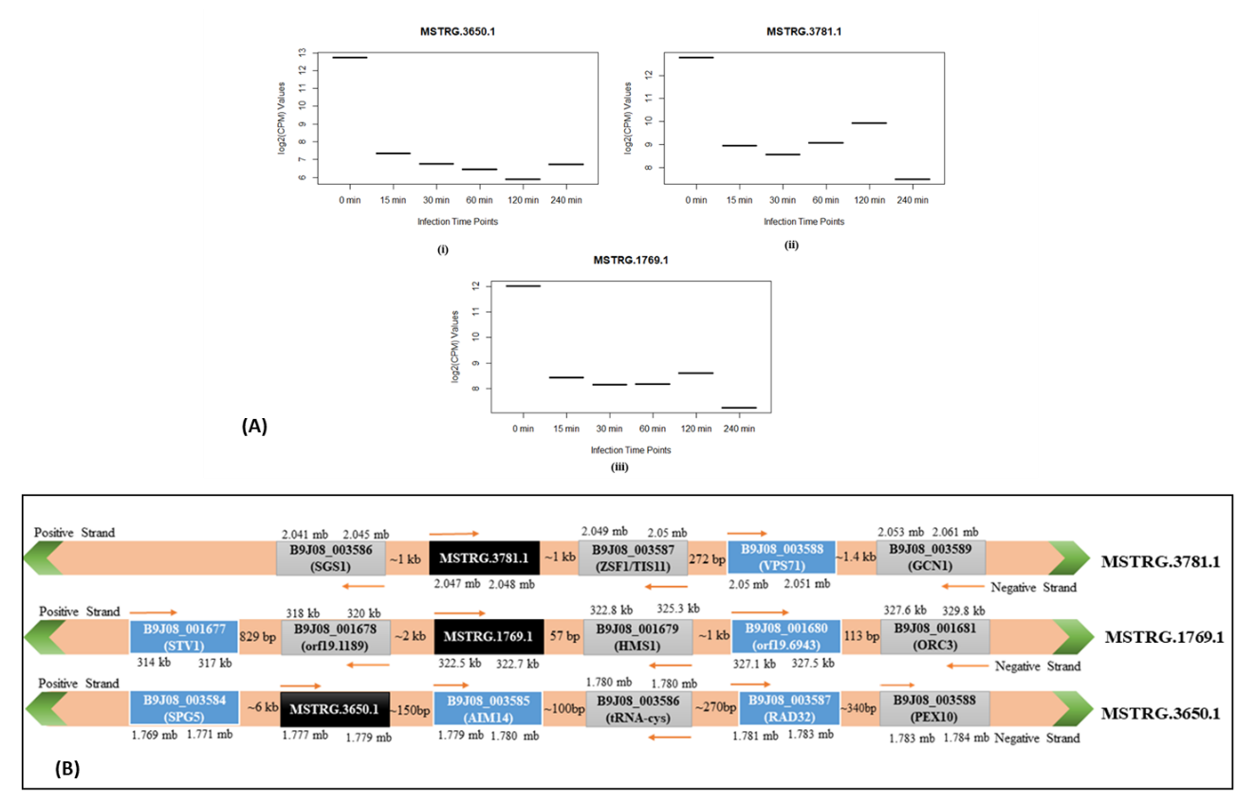
Supplementary Data Figure 1 (A): Boxplot depicts the downregulation of three lncRNAs identified to be common among the all time frames. (i) MSTRG.3650.1, (ii) MSTRG.3781.1 and (iii) MSTRG.1769.1 in C. auris infection. (B) Regulatory map of MSTRG.1769.1, MSTRG.3650.1 and MSTRG.3781.
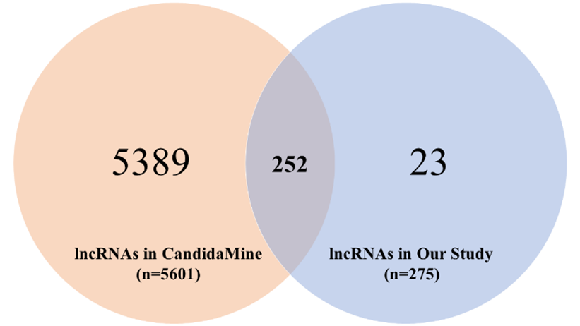
Supplementary Figure 2: Comparison of predicted lncRNAs and lncRNAs deposited in CandidaMine database using Venn Diagram.

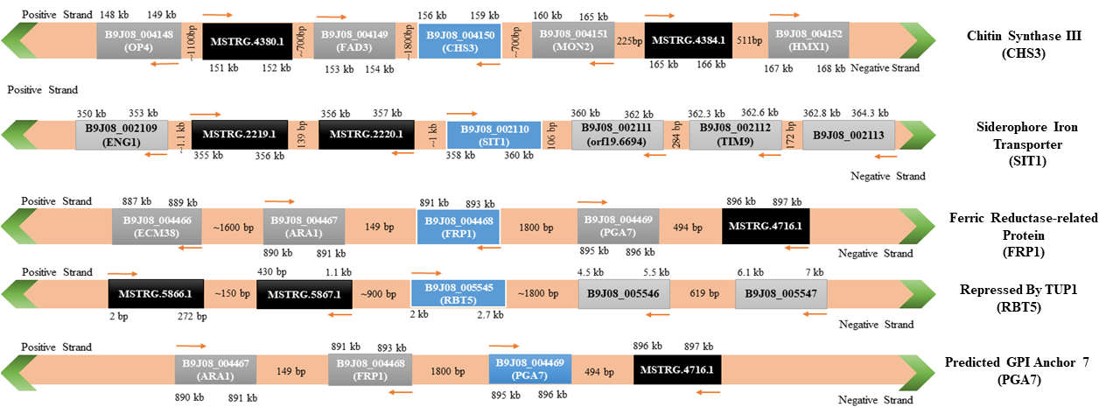

Supplementary Data Figure 3: Regulatory map of five infection related genes CHS3, SIT1, FRP1, RBT5 and PGA7
Supplementary Table 1: Sample details acquired from GSE179000
S. No. | Sample  Accession | Conditions | S. No. | Sample  Accession | Conditions
1 | SRR14926264 | 0 min | 10 | SRR14926273 | 60 min
2 | SRR14926270 | 0 min | 11 | SRR14926279 | 60 min
3 | SRR14926276 | 0 min | 12 | SRR14926267 | 60 min
4 | SRR14926265 | 15 min | 13 | SRR14926274 | 120 min
5 | SRR14926271 | 15 min | 14 | SRR14926280 | 120 min
6 | SRR14926277 | 15 min | 15 | SRR14926268 | 120 min
7 | SRR14926266 | 30 min | 16 | SRR14926275 | 240 min
8 | SRR14926272 | 30 min | 17 | SRR14926263 | 240 min
9 | SRR14926278 | 30 min | 18 | SRR14926269 | - n

Supplementary Table 2: List of identified lncRNAs and their differential regulation during different time frames of infection in host (p < 0.05 and |log2FoldChange| > 1)
S. No. | lncRNA ID | Chromosome ID | Start | End | Strand | Differential Regulation of lncRNAs across different infection time frames (p < 0.05 & |lfc| > 1)
 |  |  |  |  |  | 15 min | 30 min | 60 min | 120 min | 240 min
1 | MSTRG.15.1 | PEKT02000001 | 33653 | 34236 | + | ↓
2 | MSTRG.29.1 | PEKT02000001 | 63934 | 64338 | +
3 | MSTRG.63.1 | PEKT02000001 | 127164 | 127733 | +
4 | MSTRG.78.1 | PEKT02000001 | 153072 | 153475 | +
5 | MSTRG.181.1 | PEKT02000001 | 368011 | 368418 | +
6 | MSTRG.204.1 | PEKT02000001 | 426528 | 426943 | +
7 | MSTRG.216.1 | PEKT02000001 | 451018 | 451580 | -
8 | MSTRG.218.1 | PEKT02000001 | 452620 | 453054 | - |  | ↓ | ↓ |  | ↓
9 | MSTRG.221.1 | PEKT02000001 | 457781 | 458264 | -
10 | MSTRG.242.1 | PEKT02000001 | 495957 | 496215 | -
11 | MSTRG.273.1 | PEKT02000001 | 551583 | 551852 | +
12 | MSTRG.282.1 | PEKT02000001 | 567139 | 567833 | +
13 | MSTRG.295.1 | PEKT02000001 | 586937 | 587565 | -
14 | MSTRG.343.1 | PEKT02000001 | 677013 | 677455 | - | ↑ | ↑ | ↑
15 | MSTRG.351.1 | PEKT02000001 | 695965 | 697647 | -
16 | MSTRG.374.1 | PEKT02000001 | 730266 | 731569 | +
17 | MSTRG.388.1 | PEKT02000001 | 760972 | 761463 | -
18 | MSTRG.400.1 | PEKT02000001 | 791975 | 792299 | +
19 | MSTRG.408.1 | PEKT02000001 | 802491 | 803089 | + |  | ↑
20 | MSTRG.430.1 | PEKT02000001 | 848279 | 850356 | +
21 | MSTRG.437.1 | PEKT02000001 | 869637 | 870847 | -
22 | MSTRG.438.1 | PEKT02000001 | 871582 | 871787 | +
23 | MSTRG.442.1 | PEKT02000001 | 880941 | 882188 | - | ↑
24 | MSTRG.448.1 | PEKT02000001 | 890839 | 891255 | +
25 | MSTRG.450.1 | PEKT02000001 | 893846 | 894228 | -
26 | MSTRG.454.1 | PEKT02000001 | 905342 | 906109 | + |  | ↑ |  | ↑ | ↑
27 | MSTRG.469.1 | PEKT02000001 | 943465 | 947558 | +
28 | MSTRG.472.1 | PEKT02000001 | 954008 | 954486 | -
29 | MSTRG.477.1 | PEKT02000001 | 963267 | 963577 | - | ↑ | ↑ |  |  | ↓
30 | MSTRG.478.1 | PEKT02000001 | 963793 | 964148 | - | ↑ |  | ↑ |  | ↑
31 | MSTRG.494.1 | PEKT02000001 | 986677 | 987275 | +
32 | MSTRG.505.1 | PEKT02000001 | 1014966 | 1015900 | -
33 | MSTRG.528.1 | PEKT02000001 | 1067520 | 1067820 | +
34 | MSTRG.536.1 | PEKT02000001 | 1081976 | 1083522 | -
35 | MSTRG.541.1 | PEKT02000002 | 8650 | 9167 | +
36 | MSTRG.550.1 | PEKT02000002 | 35906 | 37057 | + |  |  |  |  | ↑
37 | MSTRG.606.1 | PEKT02000002 | 130359 | 131291 | - |  |  | ↑ | ↑ | ↑
38 | MSTRG.632.1 | PEKT02000002 | 183077 | 185464 | - |  | ↑
39 | MSTRG.643.1 | PEKT02000002 | 208845 | 209124 | - |  | ↑
40 | MSTRG.683.1 | PEKT02000002 | 291149 | 291697 | + | ↓ | ↓ | ↓ |  | ↓
41 | MSTRG.702.1 | PEKT02000002 | 326589 | 327893 | +
42 | MSTRG.714.1 | PEKT02000002 | 346720 | 347524 | +
43 | MSTRG.745.1 | PEKT02000002 | 426803 | 427627 | -
44 | MSTRG.758.1 | PEKT02000002 | 452626 | 453458 | - |  | ↓
45 | MSTRG.795.1 | PEKT02000002 | 537690 | 538249 | +
46 | MSTRG.826.1 | PEKT02000002 | 608233 | 608528 | +
47 | MSTRG.832.1 | PEKT02000002 | 620392 | 620631 | -
48 | MSTRG.833.1 | PEKT02000002 | 620894 | 621333 | -
49 | MSTRG.836.1 | PEKT02000002 | 629107 | 629656 | + |  |  |  |  | ↓
50 | MSTRG.847.1 | PEKT02000002 | 650857 | 652461 | +
51 | MSTRG.870.1 | PEKT02000002 | 694628 | 694864 | +
52 | MSTRG.891.1 | PEKT02000002 | 739337 | 739730 | +
53 | MSTRG.943.1 | PEKT02000002 | 836592 | 837933 | +
54 | MSTRG.955.1 | PEKT02000002 | 857807 | 858457 | +
55 | MSTRG.958.2 | PEKT02000002 | 866185 | 869187 | + |  |  |  |  | ↑
56 | MSTRG.986.1 | PEKT02000002 | 934409 | 934627 | -
57 | MSTRG.1019.1 | PEKT02000002 | 1009401 | 1011131 | + |  |  |  |  | ↑
58 | MSTRG.1022.1 | PEKT02000002 | 1019120 | 1020377 | +
59 | MSTRG.1033.1 | PEKT02000002 | 1042771 | 1042980 | +
60 | MSTRG.1041.1 | PEKT02000002 | 1057918 | 1058438 | + |  |  |  |  | ↑
61 | MSTRG.1043.1 | PEKT02000002 | 1060226 | 1060691 | - |  | ↑ |  | ↑
62 | MSTRG.1062.1 | PEKT02000002 | 1098595 | 1098906 | -
63 | MSTRG.1074.1 | PEKT02000002 | 1122113 | 1122463 | + |  |  |  | ↑ | ↑
64 | MSTRG.1115.1 | PEKT02000002 | 1218636 | 1218910 | +
65 | MSTRG.1117.1 | PEKT02000002 | 1222620 | 1224397 | - |  |  |  |  | ↓
66 | MSTRG.1131.1 | PEKT02000003 | 12078 | 12507 | - |  | ↓
67 | MSTRG.1144.1 | PEKT02000003 | 39506 | 39722 | -
68 | MSTRG.1149.1 | PEKT02000003 | 49634 | 50937 | +
69 | MSTRG.1194.1 | PEKT02000003 | 133845 | 134612 | +
70 | MSTRG.1264.1 | PEKT02000003 | 274196 | 274550 | -
71 | MSTRG.1289.1 | PEKT02000003 | 327512 | 327935 | +
72 | MSTRG.1299.1 | PEKT02000003 | 346054 | 346397 | -
73 | MSTRG.1314.1 | PEKT02000003 | 376289 | 376845 | -
74 | MSTRG.1397.1 | PEKT02000003 | 556932 | 557886 | +
75 | MSTRG.1449.1 | PEKT02000003 | 674345 | 674894 | + | ↓
76 | MSTRG.1461.1 | PEKT02000003 | 700829 | 701801 | -
77 | MSTRG.1489.1 | PEKT02000003 | 744545 | 744880 | +
78 | MSTRG.1494.1 | PEKT02000003 | 752411 | 752661 | - |  | ↑
79 | MSTRG.1500.1 | PEKT02000003 | 768652 | 769321 | +
80 | MSTRG.1514.1 | PEKT02000003 | 788563 | 789525 | +
81 | MSTRG.1516.1 | PEKT02000003 | 794688 | 794901 | + |  |  |  |  | ↑
82 | MSTRG.1557.1 | PEKT02000003 | 890945 | 891192 | +
83 | MSTRG.1573.1 | PEKT02000003 | 928757 | 929208 | +
84 | MSTRG.1580.1 | PEKT02000003 | 946448 | 947341 | +
85 | MSTRG.1618.1 | PEKT02000003 | 1044876 | 1045520 | +
86 | MSTRG.1660.1 | PEKT02000004 | 93225 | 93651 | -
87 | MSTRG.1732.1 | PEKT02000004 | 241209 | 241813 | -
88 | MSTRG.1749.1 | PEKT02000004 | 274275 | 274570 | -
89 | MSTRG.1763.1 | PEKT02000004 | 304494 | 305095 | - | ↑ | ↑
90 | MSTRG.1769.1 | PEKT02000004 | 322532 | 322755 | + | ↓ | ↓ | ↓ | ↓ | ↓
91 | MSTRG.1786.1 | PEKT02000004 | 355529 | 355986 | -
92 | MSTRG.1832.1 | PEKT02000004 | 450221 | 450525 | +
93 | MSTRG.1835.1 | PEKT02000004 | 456585 | 456979 | +
94 | MSTRG.1842.1 | PEKT02000004 | 472009 | 472454 | +
95 | MSTRG.1881.1 | PEKT02000004 | 556470 | 557478 | -
96 | MSTRG.1928.1 | PEKT02000004 | 648393 | 648694 | +
97 | MSTRG.1950.1 | PEKT02000004 | 685851 | 686400 | - |  |  |  |  | ↓
98 | MSTRG.1973.1 | PEKT02000004 | 726633 | 726891 | +
99 | MSTRG.2007.1 | PEKT02000004 | 794675 | 795470 | + | ↑
100 | MSTRG.2018.1 | PEKT02000004 | 821131 | 824457 | -
101 | MSTRG.2020.1 | PEKT02000004 | 828136 | 828481 | -
102 | MSTRG.2050.1 | PEKT02000005 | 11656 | 13113 | - |  | ↓ |  |  | ↓
103 | MSTRG.2055.1 | PEKT02000005 | 21156 | 23103 | - |  | ↑ |  | ↑
104 | MSTRG.2094.1 | PEKT02000005 | 104936 | 105225 | +
105 | MSTRG.2163.1 | PEKT02000005 | 245280 | 245541 | +
106 | MSTRG.2219.1 | PEKT02000005 | 355085 | 356114 | + |  | ↑
107 | MSTRG.2220.1 | PEKT02000005 | 356253 | 357191 | -
108 | MSTRG.2230.1 | PEKT02000005 | 373436 | 373973 | -
109 | MSTRG.2239.1 | PEKT02000005 | 390335 | 390654 | -
110 | MSTRG.2249.1 | PEKT02000005 | 416906 | 418024 | - | ↓ | ↓
111 | MSTRG.2280.1 | PEKT02000005 | 479024 | 479453 | -
112 | MSTRG.2284.1 | PEKT02000005 | 486955 | 488228 | -
113 | MSTRG.2289.1 | PEKT02000005 | 497277 | 498118 | + |  |  |  |  | ↓
114 | MSTRG.2335.1 | PEKT02000005 | 590401 | 593075 | - |  |  |  |  | ↓
115 | MSTRG.2336.1 | PEKT02000005 | 593448 | 594564 | -
116 | MSTRG.2375.1 | PEKT02000006 | 41444 | 43080 | + |  |  |  |  | ↑
117 | MSTRG.2408.1 | PEKT02000006 | 101978 | 102639 | +
118 | MSTRG.2431.1 | PEKT02000006 | 144677 | 145529 | -
119 | MSTRG.2435.1 | PEKT02000006 | 152473 | 153451 | + |  |  |  |  | ↓
120 | MSTRG.2467.1 | PEKT02000006 | 219949 | 220281 | -
121 | MSTRG.2468.1 | PEKT02000006 | 220497 | 221470 | +
122 | MSTRG.2498.1 | PEKT02000006 | 281886 | 282575 | -
123 | MSTRG.2512.1 | PEKT02000006 | 302270 | 302536 | + |  | ↓
124 | MSTRG.2527.1 | PEKT02000006 | 325632 | 326356 | +
125 | MSTRG.2562.1 | PEKT02000006 | 385761 | 386987 | +
126 | MSTRG.2567.1 | PEKT02000006 | 395199 | 395958 | -
127 | MSTRG.2573.1 | PEKT02000006 | 404331 | 404746 | -
128 | MSTRG.2636.1 | PEKT02000006 | 555635 | 557098 | +
129 | MSTRG.2642.1 | PEKT02000006 | 566929 | 567492 | -
130 | MSTRG.2654.1 | PEKT02000006 | 591612 | 592166 | -
131 | MSTRG.2661.1 | PEKT02000006 | 602087 | 602578 | -
132 | MSTRG.2692.1 | PEKT02000006 | 657711 | 661969 | - |  |  |  |  | ↓
133 | MSTRG.2694.1 | PEKT02000006 | 665317 | 666380 | -
134 | MSTRG.2713.1 | PEKT02000006 | 705734 | 706237 | -
135 | MSTRG.2714.1 | PEKT02000006 | 708000 | 709063 | - | ↓ | ↓ |  |  | ↓
136 | MSTRG.2854.1 | PEKT02000007 | 226782 | 227231 | +
137 | MSTRG.2886.1 | PEKT02000007 | 287963 | 289750 | -
138 | MSTRG.2912.1 | PEKT02000007 | 333725 | 334548 | -
139 | MSTRG.2950.1 | PEKT02000007 | 405936 | 406259 | -
140 | MSTRG.3114.1 | PEKT02000007 | 722859 | 723598 | + | ↓
141 | MSTRG.3138.1 | PEKT02000007 | 766076 | 766555 | - | ↓ |  |  |  | ↓
142 | MSTRG.3151.1 | PEKT02000007 | 797670 | 797932 | -
143 | MSTRG.3219.1 | PEKT02000007 | 917739 | 918295 | +
144 | MSTRG.3274.1 | PEKT02000007 | 1016701 | 1017006 | - | ↓ | ↓
145 | MSTRG.3328.1 | PEKT02000007 | 1114723 | 1115150 | -
146 | MSTRG.3347.1 | PEKT02000007 | 1151687 | 1152014 | + |  |  |  | ↑ | ↑
147 | MSTRG.3417.1 | PEKT02000007 | 1299994 | 1300434 | -
148 | MSTRG.3421.1 | PEKT02000007 | 1307772 | 1308232 | - |  | ↑ | ↑
149 | MSTRG.3437.1 | PEKT02000007 | 1340658 | 1340904 | -
150 | MSTRG.3461.1 | PEKT02000007 | 1382631 | 1382842 | +
151 | MSTRG.3466.1 | PEKT02000007 | 1391284 | 1391973 | +
152 | MSTRG.3492.1 | PEKT02000007 | 1447959 | 1449860 | -
153 | MSTRG.3513.1 | PEKT02000007 | 1494632 | 1494927 | +
154 | MSTRG.3564.1 | PEKT02000007 | 1587016 | 1587239 | - |  |  |  |  | ↓
155 | MSTRG.3588.1 | PEKT02000007 | 1634745 | 1635000 | -
156 | MSTRG.3633.1 | PEKT02000007 | 1741360 | 1742247 | +
157 | MSTRG.3649.1 | PEKT02000007 | 1772697 | 1775162 | +
158 | MSTRG.3650.1 | PEKT02000007 | 1777919 | 1779026 | + | ↓ | ↓ | ↓ | ↓ | ↓
159 | MSTRG.3687.1 | PEKT02000007 | 1853466 | 1854097 | +
160 | MSTRG.3712.1 | PEKT02000007 | 1904320 | 1905019 | +
161 | MSTRG.3736.1 | PEKT02000007 | 1948718 | 1949019 | - |  | ↓
162 | MSTRG.3744.1 | PEKT02000007 | 1963368 | 1965690 | +
163 | MSTRG.3781.1 | PEKT02000007 | 2047186 | 2048467 | + | ↓ | ↓ | ↓ | ↓ | ↓
164 | MSTRG.3784.1 | PEKT02000007 | 2051878 | 2052720 | -
165 | MSTRG.3787.1 | PEKT02000007 | 2064225 | 2064457 | - |  |  |  |  | ↑
166 | MSTRG.3807.1 | PEKT02000007 | 2105902 | 2106658 | -
167 | MSTRG.3820.1 | PEKT02000007 | 2137974 | 2138340 | + | ↑
168 | MSTRG.3831.1 | PEKT02000007 | 2160935 | 2161865 | +
169 | MSTRG.3895.1 | PEKT02000007 | 2273392 | 2273916 | + |  | ↑
170 | MSTRG.4018.1 | PEKT02000007 | 2557537 | 2557888 | -
171 | MSTRG.4030.1 | PEKT02000007 | 2584261 | 2584717 | +
172 | MSTRG.4031.1 | PEKT02000007 | 2584932 | 2586351 | -
173 | MSTRG.4084.1 | PEKT02000007 | 2695684 | 2696055 | -
174 | MSTRG.4097.1 | PEKT02000007 | 2717069 | 2718213 | +
175 | MSTRG.4121.1 | PEKT02000007 | 2771458 | 2772012 | -
176 | MSTRG.4129.1 | PEKT02000007 | 2786179 | 2786848 | +
177 | MSTRG.4169.1 | PEKT02000007 | 2871480 | 2873069 | -
178 | MSTRG.4223.1 | PEKT02000007 | 2981958 | 2983000 | -
179 | MSTRG.4241.1 | PEKT02000007 | 3021148 | 3023904 | + | ↓ |  |  |  | ↓
180 | MSTRG.4279.1 | PEKT02000007 | 3101638 | 3103242 | + |  |  |  |  | ↑
181 | MSTRG.4296.1 | PEKT02000007 | 3125996 | 3127878 | -
182 | MSTRG.4322.1 | PEKT02000007 | 3195253 | 3195932 | -
183 | MSTRG.4325.1 | PEKT02000008 | 10333 | 12671 | -
184 | MSTRG.4334.1 | PEKT02000008 | 49507 | 50419 | - |  | ↑
185 | MSTRG.4335.1 | PEKT02000008 | 50642 | 52677 | + |  |  |  |  | ↓
186 | MSTRG.4353.1 | PEKT02000008 | 86699 | 87325 | -
187 | MSTRG.4357.1 | PEKT02000008 | 100141 | 100417 | + |  |  |  |  | ↑
188 | MSTRG.4358.1 | PEKT02000008 | 100688 | 100907 | +
189 | MSTRG.4361.1 | PEKT02000008 | 104482 | 106916 | +
190 | MSTRG.4362.1 | PEKT02000008 | 108054 | 108500 | -
191 | MSTRG.4363.1 | PEKT02000008 | 109371 | 111795 | +
192 | MSTRG.4364.1 | PEKT02000008 | 111861 | 112231 | + |  |  |  |  | ↓
193 | MSTRG.4376.1 | PEKT02000008 | 141506 | 142154 | - |  | ↑
194 | MSTRG.4380.1 | PEKT02000008 | 151029 | 152414 | +
195 | MSTRG.4384.1 | PEKT02000008 | 165247 | 166806 | +
196 | MSTRG.4392.1 | PEKT02000008 | 179159 | 179669 | +
197 | MSTRG.4395.1 | PEKT02000008 | 181884 | 182144 | + |  |  |  |  | ↑
198 | MSTRG.4412.1 | PEKT02000008 | 225942 | 226443 | -
199 | MSTRG.4421.1 | PEKT02000008 | 246523 | 246877 | +
200 | MSTRG.4430.1 | PEKT02000008 | 266212 | 266689 | + |  |  |  |  | ↑
201 | MSTRG.4449.1 | PEKT02000008 | 307643 | 308923 | +
202 | MSTRG.4501.1 | PEKT02000008 | 414201 | 415141 | +
203 | MSTRG.4521.1 | PEKT02000008 | 456338 | 456566 | -
204 | MSTRG.4528.1 | PEKT02000008 | 472754 | 473666 | - |  |  |  |  | ↓
205 | MSTRG.4552.1 | PEKT02000008 | 528465 | 529992 | +
206 | MSTRG.4632.1 | PEKT02000008 | 708221 | 708422 | -
207 | MSTRG.4686.1 | PEKT02000008 | 822315 | 822831 | -
208 | MSTRG.4690.1 | PEKT02000008 | 830669 | 831478 | +
209 | MSTRG.4716.1 | PEKT02000008 | 896825 | 897330 | -
210 | MSTRG.4719.1 | PEKT02000009 | 9736 | 10430 | -
211 | MSTRG.4720.1 | PEKT02000009 | 10653 | 12434 | +
212 | MSTRG.4721.1 | PEKT02000009 | 13138 | 13814 | +
213 | MSTRG.4729.1 | PEKT02000009 | 30944 | 32218 | +
214 | MSTRG.4752.1 | PEKT02000009 | 83106 | 83718 | -
215 | MSTRG.4778.1 | PEKT02000009 | 134204 | 136271 | +
216 | MSTRG.4810.1 | PEKT02000009 | 212252 | 212572 | -
217 | MSTRG.4816.1 | PEKT02000009 | 223867 | 224633 | -
218 | MSTRG.4823.1 | PEKT02000009 | 246023 | 246773 | - | ↑ | ↑ | ↑
219 | MSTRG.4832.1 | PEKT02000009 | 258782 | 260135 | +
220 | MSTRG.4842.1 | PEKT02000009 | 284977 | 285272 | -
221 | MSTRG.4866.1 | PEKT02000009 | 341494 | 342152 | - | ↓
222 | MSTRG.4879.1 | PEKT02000009 | 368899 | 369369 | -
223 | MSTRG.4894.1 | PEKT02000009 | 400395 | 400602 | +
224 | MSTRG.4899.1 | PEKT02000009 | 414866 | 415176 | +
225 | MSTRG.4912.1 | PEKT02000009 | 439784 | 441559 | - |  |  |  |  | ↑
226 | MSTRG.4920.1 | PEKT02000009 | 457362 | 459657 | -
227 | MSTRG.4959.1 | PEKT02000009 | 534284 | 535816 | +
228 | MSTRG.4969.1 | PEKT02000009 | 549591 | 549793 | + |  |  |  |  | ↑
229 | MSTRG.4991.1 | PEKT02000009 | 591920 | 592231 | -
230 | MSTRG.5003.1 | PEKT02000009 | 620032 | 620327 | +
231 | MSTRG.5027.1 | PEKT02000009 | 658499 | 658933 | + | ↑ | ↑ |  | ↑ | ↑
232 | MSTRG.5058.1 | PEKT02000009 | 735850 | 736127 | .
233 | MSTRG.5059.1 | PEKT02000009 | 736260 | 736643 | +
234 | MSTRG.5061.1 | PEKT02000009 | 745050 | 745277 | + |  |  |  |  | ↓
235 | MSTRG.5099.1 | PEKT02000009 | 822344 | 823204 | +
236 | MSTRG.5161.1 | PEKT02000009 | 947374 | 948765 | +
237 | MSTRG.5176.1 | PEKT02000009 | 983932 | 985838 | +
238 | MSTRG.5182.1 | PEKT02000009 | 995920 | 997730 | -
239 | MSTRG.5183.1 | PEKT02000009 | 1002348 | 1002904 | + |  |  |  |  | ↓
240 | MSTRG.5185.1 | PEKT02000010 | 3297 | 4047 | -
241 | MSTRG.5186.1 | PEKT02000010 | 4270 | 5902 | + |  |  |  |  | ↓
242 | MSTRG.5247.1 | PEKT02000010 | 135983 | 136305 | -
243 | MSTRG.5281.1 | PEKT02000010 | 208189 | 208947 | -
244 | MSTRG.5355.1 | PEKT02000010 | 365832 | 367264 | - |  |  |  |  | ↓
245 | MSTRG.5385.1 | PEKT02000010 | 425611 | 425837 | -
246 | MSTRG.5406.1 | PEKT02000010 | 469102 | 469504 | +
247 | MSTRG.5465.1 | PEKT02000010 | 573635 | 574336 | -
248 | MSTRG.5480.1 | PEKT02000010 | 603340 | 603652 | +
249 | MSTRG.5516.1 | PEKT02000010 | 672905 | 673331 | +
250 | MSTRG.5527.1 | PEKT02000010 | 708145 | 709145 | +
251 | MSTRG.5541.1 | PEKT02000010 | 743773 | 744891 | -
252 | MSTRG.5547.1 | PEKT02000010 | 752763 | 753329 | -
253 | MSTRG.5552.1 | PEKT02000010 | 759548 | 760384 | - | ↑ | ↑
254 | MSTRG.5564.1 | PEKT02000010 | 781346 | 781895 | -
255 | MSTRG.5586.1 | PEKT02000010 | 831709 | 832528 | - | ↓ | ↓
256 | MSTRG.5598.1 | PEKT02000010 | 856292 | 857154 | +
257 | MSTRG.5623.1 | PEKT02000010 | 910938 | 911330 | + |  |  |  |  | ↓
258 | MSTRG.5667.1 | PEKT02000010 | 1010542 | 1011055 | -
259 | MSTRG.5690.1 | PEKT02000010 | 1050845 | 1052036 | + |  |  |  |  | ↑
260 | MSTRG.5739.1 | PEKT02000010 | 1171529 | 1172489 | -
261 | MSTRG.5740.1 | PEKT02000010 | 1172541 | 1173898 | +
262 | MSTRG.5744.1 | PEKT02000010 | 1185636 | 1186642 | -
263 | MSTRG.5786.1 | PEKT02000010 | 1265422 | 1265965 | -
264 | MSTRG.5789.1 | PEKT02000010 | 1268814 | 1270305 | -
265 | MSTRG.5793.1 | PEKT02000010 | 1274566 | 1275369 | + |  |  |  |  | ↑
266 | MSTRG.5807.1 | PEKT02000010 | 1298831 | 1299832 | -
267 | MSTRG.5838.1 | PEKT02000010 | 1369672 | 1369968 | -
268 | MSTRG.5850.1 | PEKT02000010 | 1395406 | 1395972 | -
269 | MSTRG.5853.1 | PEKT02000010 | 1402482 | 1402902 | -
270 | MSTRG.5866.1 | PEKT02000012 | 2 | 272 | +
271 | MSTRG.5867.1 | PEKT02000012 | 430 | 1123 | - |  |  |  | ↑
272 | MSTRG.5875.1 | PEKT02000012 | 13602 | 14446 | +
273 | MSTRG.5877.1 | PEKT02000012 | 21139 | 21788 | - | ↓
274 | MSTRG.5892.1 | PEKT02000012 | 51052 | 51737 | + | ↓
275 | MSTRG.5896.1 | PEKT02000013 | 2 | 882 | -

Supplementary Table 3: List of common differentially expressed protein coding genes identified during different time frame of study (p < 0.05 and |log2FoldChange| > 1)
S. No. | Gene ID | Gene Symbol | Gene Description | Differential Regulation of Genes Across Time Frames  (p < 0.05 ; |lfc| > 1)
 |  |  |  | 15 min | 30 min | 60 min | 120 min | 240 min
1 | B9J08_000026 | URA6 | Bifunctional Uridylate/Adenylate Kinase | ↑ | ↑ | ↑ | ↑ | ↑
2 | B9J08_000060 | LTE1 | Mitotic Regulator | ↑ | ↑ | ↑ | ↑ | ↑
3 | B9J08_000154 | CMC1 |  | ↑ | ↑ | ↑ | ↑ | ↑
4 | B9J08_000172 | ITR2 | myo-inositol transmembrane transporter | ↑ | ↑ | ↑ | ↑ | ↑
5 | B9J08_000290 | HSL1 | Serine/Threonine Protein Kinase | ↑ | ↑ | ↑ | ↑ | ↑
6 | B9J08_000384 | GEL3 | 1,3-beta-glucanosyltransferase | ↑ | ↑ | ↑ | ↑ | ↑
7 | B9J08_000441 |  |  | ↑ | ↑ | ↑ | ↑ | ↑
8 | B9J08_000449 | GAP6 | Amino acid transport, transmembrane transport and membrane localization | ↓ | ↓ | ↓ | ↓ | ↓
9 | B9J08_000484 | GCV3 | Glycine cleavage system H protein | ↓ | ↓ | ↓ | ↓ | ↓
10 | B9J08_000512 |  |  | ↓ | ↓ | ↓ | ↓ | ↓
11 | B9J08_000555 | PXL1 | Rho GDP-dissociation inhibitor | ↑ | ↑ | ↑ | ↑ | ↑
12 | B9J08_000577 |  | Pyridoxal phosphate binding | ↓ | ↓ | ↓ | ↓ | ↓
13 | B9J08_000581 |  | Flavin adenine dinucleotide binding, long chain alcohol oxidase, oxidoreductase | ↓ | ↓ | ↓ | ↓ | ↓
14 | B9J08_000692 | YRB1 | Ran GTPase-binding protein | ↑ | ↑ | ↑ | ↑ | ↑
15 | B9J08_000789 | BNA2 | Indoleamine 2,3-dioxygenase | ↓ | ↓ | ↓ | ↓ | ↓
16 | B9J08_000798 | DFI1 | Cell-surface associated glycoprotein | ↑ | ↑ | ↑ | ↑ | ↑
17 | B9J08_000834 |  |  | ↑ | ↑ | ↑ | ↑ | ↑
18 | B9J08_000938 | HGT10 / STL1 | Glucose-inactivated glycerol proton sympoter | ↓ | ↓ | ↓ | ↓ | ↓
19 | B9J08_001050 |  |  | ↑ | ↑ | ↑ | ↑ | ↑
20 | B9J08_001079 | WSC2 | Transmembrane signaling receptor | ↑ | ↑ | ↑ | ↑ | ↑
21 | B9J08_001080 | PIN2 | Cellular bud, neck, plasma membrane localization | ↑ | ↑ | ↑ | ↑ | ↑
22 | B9J08_001131 | FRK1 | Peroxisome inheritance | ↑ | ↑ | ↑ | ↑ | ↑
23 | B9J08_001171 |  | Oxidoreductase ; zinc ion binding | ↓ | ↓ | ↓ | ↓ | ↓
24 | B9J08_001281 | COQ6 | Ubiquinone biosynthesis monooxygenase COQ6 | ↓ | ↓ | ↓ | ↓ | ↓
25 | B9J08_001313 |  |  | ↓ | ↓ | ↓ | ↓ | ↓
26 | B9J08_001319 |  | Transmembrane transporter | ↑ | ↑ | ↑ | ↑ | ↑
27 | B9J08_001325 |  | Oxidoreductase activity | ↑ | ↑ | ↑ | ↑ | ↑
28 | B9J08_001366 | PGA6 | GPI-anchored cell wall adhesin-like protein | ↑ | ↑ | ↑ | ↑ | ↑
29 | B9J08_001464 | PHO84 | Phosphate H+ sympoter | ↑ | ↑ | ↑ | ↑ | ↑
30 | B9J08_001500 |  |  | ↑ | ↑ | ↑ | ↑ | ↑
31 | B9J08_001518 | SAP1 | Aspartic-type endopeptidase | ↓ | ↓ | ↓ | ↓ | ↓
32 | B9J08_001541 |  |  | ↓ | ↓ | ↓ | ↓ | ↓
33 | B9J08_001679 | CPH2/HMS1 | Pseudohyphal growth | ↓ | ↓ | ↓ | ↓ | ↓
34 | B9J08_001685 |  |  | ↓ | ↓ | ↓ | ↓ | ↓
35 | B9J08_001740 | POX-1 | Fatty acid beta-oxidation | ↓ | ↓ | ↓ | ↓ | ↓
36 | B9J08_001816 | CHS7 | Unfolded Protein-binding activity, role in ER to Golgi vesicle mediated transport | ↑ | ↑ | ↑ | ↑ | ↑
37 | B9J08_001854 | CIA30 |  | ↓ | ↓ | ↓ | ↓ | ↓
38 | B9J08_001863 | COX15 | Cytochrome C oxidase | ↓ | ↓ | ↓ | ↓ | ↓
39 | B9J08_001901 | UTR2 | Chitin Transglycosylase | ↑ | ↑ | ↑ | ↑ | ↑
40 | B9J08_001987 |  | Heme binding, oxidoreductase activity | ↓ | ↓ | ↓ | ↓ | ↓
41 | B9J08_001993 | COX11 | Cytochrome C oxidase | ↓ | ↓ | ↓ | ↓ | ↓
42 | B9J08_002026 | GRX3 | Glutathione-dependent oxidoreductase | ↓ | ↓ | ↓ | ↓ | ↓
43 | B9J08_002141 |  |  | ↑ | ↑ | ↑ | ↑ | ↑
44 | B9J08_002226 | CSO99 |  | ↓ | ↓ | ↓ | ↓ | ↓
45 | B9J08_002246 | MNN47 |  | ↑ | ↑ | ↑ | ↑ | ↑
46 | B9J08_002249 |  | Transmembrane transporter | ↑ | ↑ | ↑ | ↑ | ↑
47 | B9J08_002279 | ZCF23 / GSM1 | DNA-binding transcription factor / Glucose Starvation Modulator | ↓ | ↓ | ↓ | ↓ | ↓
48 | B9J08_002330 |  |  | ↑ | ↑ | ↑ | ↑ | ↑
49 | B9J08_002356 |  |  | ↑ | ↑ | ↑ | ↑ | ↑
50 | B9J08_002600 | SEC53 | Phosphomannomutase | ↑ | ↑ | ↑ | ↑ | ↑
51 | B9J08_002632 | GFA1 | Glutamine-fructose-6-phosphate transaminase | ↑ | ↑ | ↑ | ↑ | ↑
52 | B9J08_002660 | HGT17 | MFS family glucose transporter | ↓ | ↓ | ↓ | ↓ | ↓
53 | B9J08_002666 | AGP2 | high affinity glutamine permease | ↓ | ↓ | ↓ | ↓ | ↓
54 | B9J08_002777 |  |  | ↓ | ↓ | ↓ | ↓ | ↓
55 | B9J08_002781 | FAA21 | Medium chain fatty acid-CoA ligase | ↓ | ↓ | ↓ | ↓ | ↓
56 | B9J08_002932 | PCL1 | Pho85 Cyclin | ↑ | ↑ | ↑ | ↑ | ↑
57 | B9J08_002954 | CNT | Nucleoside transmembrane transporter activity | ↓ | ↓ | ↓ | ↓ | ↓
58 | B9J08_003073 | CSI2 | Chitin Synthesis Involved | ↑ | ↑ | ↑ | ↑ | ↑
59 | B9J08_003374 | ICL1 | Isocitrate lyase | ↓ | ↓ | ↓ | ↓ | ↓
60 | B9J08_003420 | PRM5 | Pheromone Regulated Membrane Protein | ↑ | ↑ | ↑ | ↑ | ↑
61 | B9J08_003609 | GCV2 | Glycine dehydrogenase | ↓ | ↓ | ↓ | ↓ | ↓
62 | B9J08_003611 | SDS24 | Serine/Threonine Phosphatase inhibitor | ↓ | ↓ | ↓ | ↓ | ↓
63 | B9J08_003612 | OLE1 | Stearoyl-CoA 9-desaturase | ↓ | ↓ | ↓ | ↓ | ↓
64 | B9J08_003767 | CDD1 | Cytidine deaminase | ↓ | ↓ | ↓ | ↓ | ↓
65 | B9J08_003799 | SCW10 / MP65 | Soluble cell wall protein | ↑ | ↑ | ↑ | ↑ | ↑
66 | B9J08_003885 | MIT1 / SUR1 | Inositol phosphorylceramide mannosyltransferase | ↑ | ↑ | ↑ | ↑ | ↑
67 | B9J08_004162 | CLB4 | cyclin-dependent protein serine/threonine kinase regulator | ↑ | ↑ | ↑ | ↑ | ↑
68 | B9J08_004271 | CAP4 | DNA-binding transcription factor | ↑ | ↑ | ↑ | ↑ | ↑
69 | B9J08_004357 | DUG1 | Metallodipeptidase | ↓ | ↓ | ↓ | ↓ | ↓
70 | B9J08_004381 | UAP1 / QRI1 | UDP-N-acetylglucosamine diphosphorylase | ↑ | ↑ | ↑ | ↑ | ↑
71 | B9J08_004382 | ECM331 |  | ↑ | ↑ | ↑ | ↑ | ↑
72 | B9J08_004410 | CRH1 | Glycosyltransferase | ↑ | ↑ | ↑ | ↑ | ↑
73 | B9J08_004473 |  | Antiporter activity, xenobiotic transmembrane transporter activity | ↓ | ↓ | ↓ | ↓ | ↓
74 | B9J08_004544 |  | Oligopeptide transmembrane transporter | ↓ | ↓ | ↓ | ↓ | ↓
75 | B9J08_004601 | RNR1 | Ribonucleoside diphosphate reductase | ↑ | ↑ | ↑ | ↑ | ↑
76 | B9J08_004650 | MNN26 | Glycosyltransferase | ↑ | ↑ | ↑ | ↑ | ↑
77 | B9J08_004899 |  |  | ↑ | ↑ | ↑ | ↑ | ↑
78 | B9J08_004918 | HSC82 / HSP90 | HSP82-like protein | ↑ | ↑ | ↑ | ↑ | ↑
79 | B9J08_005078 | AAH1 | Adenosine deaminase | ↑ | ↑ | ↑ | ↑ | ↑
80 | B9J08_005161 | SRB1/VIG9/PSA1 | Mannose-1-phosphate guanylyltransferase | ↓ | ↓ | ↓ | ↑ | ↑
81 | B9J08_005206 |  |  | ↓ | ↓ | ↓ | ↓ | ↓
82 | B9J08_005245 | GAS5 / PGA4 | 1,3-beta-glucanosyltransferase | ↑ | ↑ | ↑ | ↑ | ↑
83 | B9J08_005288 |  |  | ↓ | ↓ | ↓ | ↓ | ↓
84 | B9J08_005328 | GNA1 | Glucosamine 6-phosphate N-acetyltransferase | ↑ | ↑ | ↑ | ↑ | ↑
85 | B9J08_005359 | SUN4/SUN41 | Fungal-type cell wall organization | ↑ | ↑ | ↑ | ↑ | ↑
86 | B9J08_005406 | TRA1 | Histone acetyltransferase activity | ↑ | ↑ | ↑ | ↑ | ↑
87 | B9J08_005424 | KCH1 | Potassium ion transmembrane transporter activity | ↑ | ↑ | ↑ | ↑ | ↑
88 | B9J08_005567 | SKS1 | Serine/Threonine Protein Kinase | ↓ | ↓ | ↓ | ↓ | ↓

