A justice-based framework to determine countries’ fair warming contributions to Paris Agreement
Mingyu Li ^{a,b}, Setu Pelz ^{c}, Robin Lamboll ^{b}, Can Wang ª, Joeri Rogelj ^{b,c,d *}
a School of Environment, Tsinghua University, Beijing, China
b Centre for Environmental Policy, Imperial College London, London, UK
c International Institute for Applied Systems Analysis, Laxenburg, Austria
d Grantham Institute – Climate Change and Environment, Imperial College London, London, UK

* Corresponding author: j.rogelj@imperial.ac.uk

This file includes:
Supplementary notes
Supplementary Fig. 1 to 10
Supplementary Table 1 to 3

Supplementary Notes

Supplementary Note 1: Influence of currency conversion methods on GDP
While GDP is long recognized as a representation of the ability to pay, there are debates on estimation methods of the exchange rates. Estimating GDP using purchasing power parity (PPP) tends to overestimate the capability of developing countries, especially when related to international-sourced products or finance. On the other side, estimating using market exchange rates (MER) may not properly reflect the balance of a country between mitigation and other goods.
In the central case, we adopt GDP in PPP. Here we compare the results of both currency conversion methods on GDP. Our calculation indicates the influence of different GDP conversion methods is generally neglectable on the remaining budget.
b
a
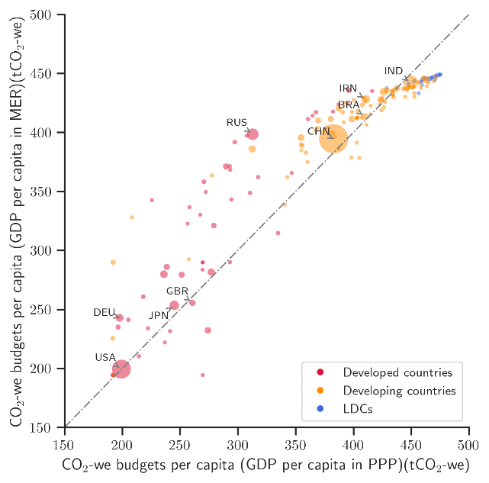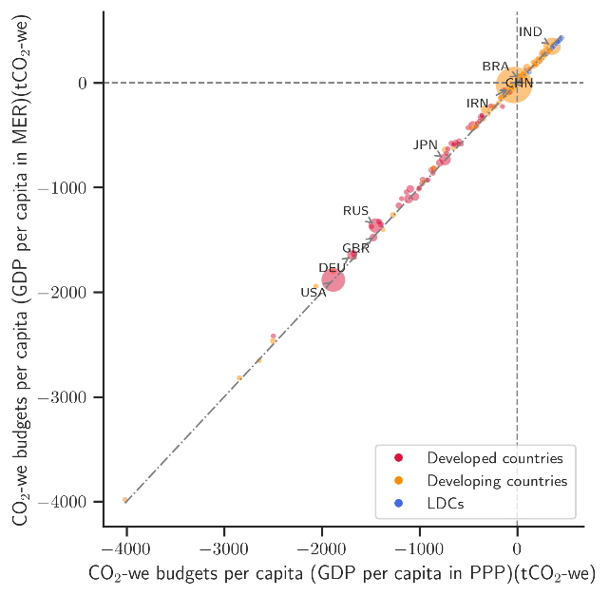
Supplementary Fig. 1 | Total (1850-2050) (a) and remaining (2021-2050) (b) CO₂ warming equivalent budgets per capita, compared between using GDP measured in market exchange rates (MER) and purchasing power parity (PPP). The size of bubbles indicates the amount of national emissions in 2021. Developed countries, developing countries, and least developed countries (LDCs) are marked in different colours.

Supplementary Note 2: Influence of considering colonial powers in calculating the historical fossil fuel sales
In the central case, we take into consideration colonial histories of empires when estimating fossil fuel sales. During colonisation, a colonial country seized the wealth of the colonized country. Here we assign responsibility for the emissions during this period to the colonizing country as it is assumed that all benefits are controlled and enjoyed by the colonizing country. This is a first-order proxy as some assets like railways and roads could have been built and handed over later, which would transfer some of the benefits to the colonized country.
We compare the results when historical fossil fuel sales are redistributed to the colonizers and when they are not. The overall effects remain uncertain. 19 countries have a relative change of fossil fuel sales exceeding 1%, mainly African countries and major European colonial empires, including Madagascar (-82%), Morocco (-41%), Zimbabwe (-35%), Brunei Darussalam (-33%), Portugal (+610%), the UK (+10%), Netherlands (+4%), France (+3%). Yet, the influence on the quantifications of the remaining budgets is nevertheless only minor (see Supplementary Fig. 2).
b
a
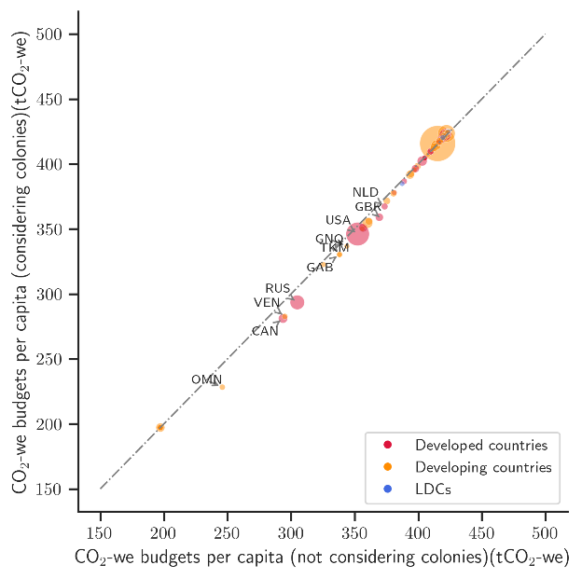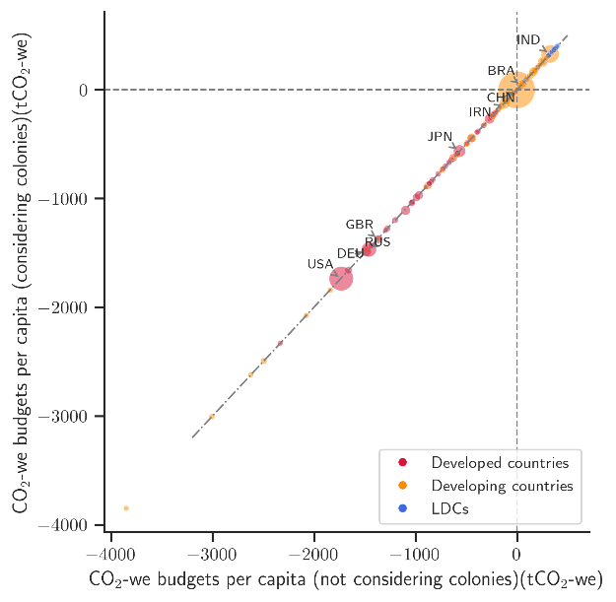
Supplementary Fig. 2 | Total (1850-2050) (a) and remaining (2021-2050) (b) CO₂ warming equivalent budgets per capita, compared between using per capita fossil fuel sales with and without redistribution of the colonies. Both allocations adhere to the third interpretation, which is based on equality, polluter pays and beneficiary pays principles, using fossil fuel sales as the key indicator. They differ in whether fossil fuel sales are redistributed to the colonies (y-axis) or not (x-axis). The size of the bubbles indicates the amount of national emissions in 2021. Developed countries, developing countries, and least developed countries (LDCs) are marked in different colours.

Supplementary Note 3: Influence of different starting year of historical warming contribution
In the central case, we adopt 1850 as the starting year of historical warming contribution. We explore an alternative of 1990.
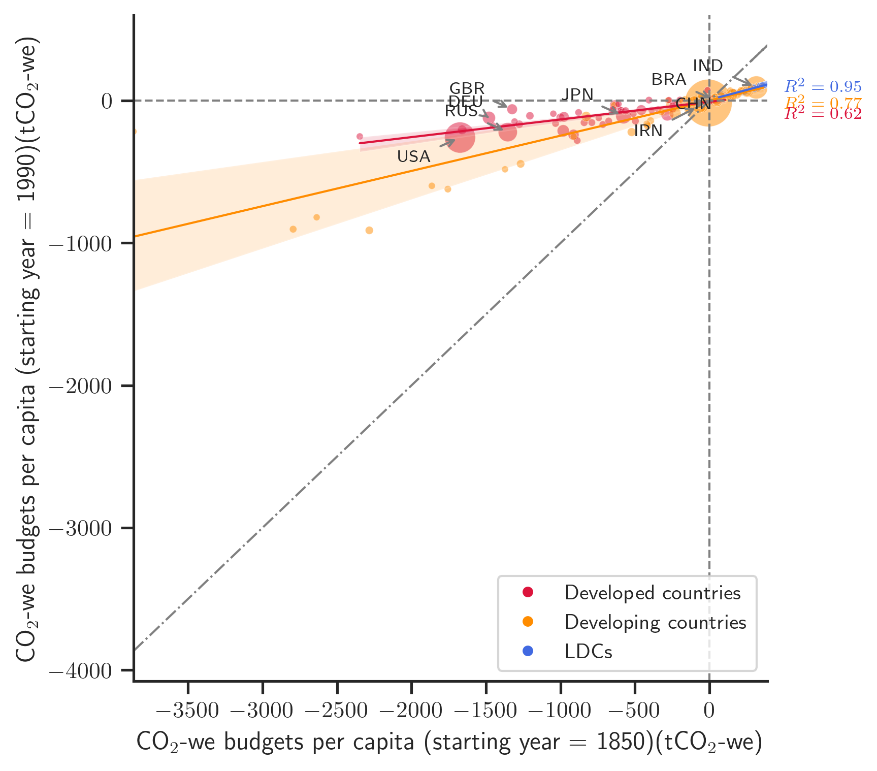
Supplementary Fig. 3 | Remaining (2021-2050) CO₂ warming equivalent budgets per capita, compared between different starting years of historical warming contribution. Both allocations adhere to the first interpretation, which is based on the equality and polluter pays principles. They differ in terms of the starting years for historical warming contributions, 1850 for the x-axis, and 1990 for the y-axis. The size of the bubbles indicates the amount of national emissions in 2021. Developed countries, developing countries, and least developed countries (LDCs) are marked in different colours.
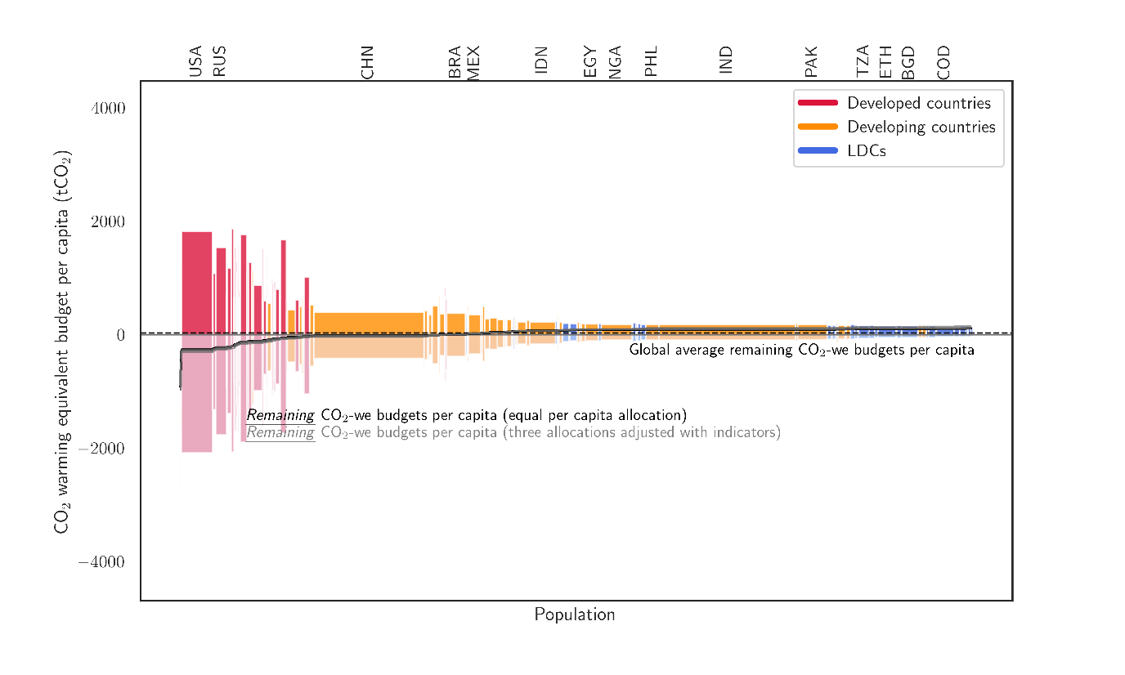
Total CO₂-we budgets per capita (tCO₂-we)
Historical CO₂-we per capita emissions until 2021(tCO₂-we)
Supplementary Fig. 4 | Total (1850-2050), historical (1850-2021), and remaining (2021-2050) CO₂ warming equivalent budgets per capita by country (starting year of historical warming contribution of 1990). Countries are ranked according to their remaining per capita national budgets, under the central case which considers a historical warming contribution starting in 1850 and a global warming target of 1.5°C. The height of bars above the x-axis represents the total CO₂-we budgets per capita under our first interpretation that considers the equality and polluter-pays principles. The height of the bars below the x-axis represents the historical consumed CO₂-we budgets per capita. The width of the bars represents a country’s population. The step lines represent the remaining CO₂-we budgets per capita per country with the black line referring to the interpretation I and the grey lines referring to the other two interpretations. Developed countries, developing countries, and least developed countries (LDCs) are marked in different colours.

Supplementary Note 4: Influence of methodological and physical uncertain factors
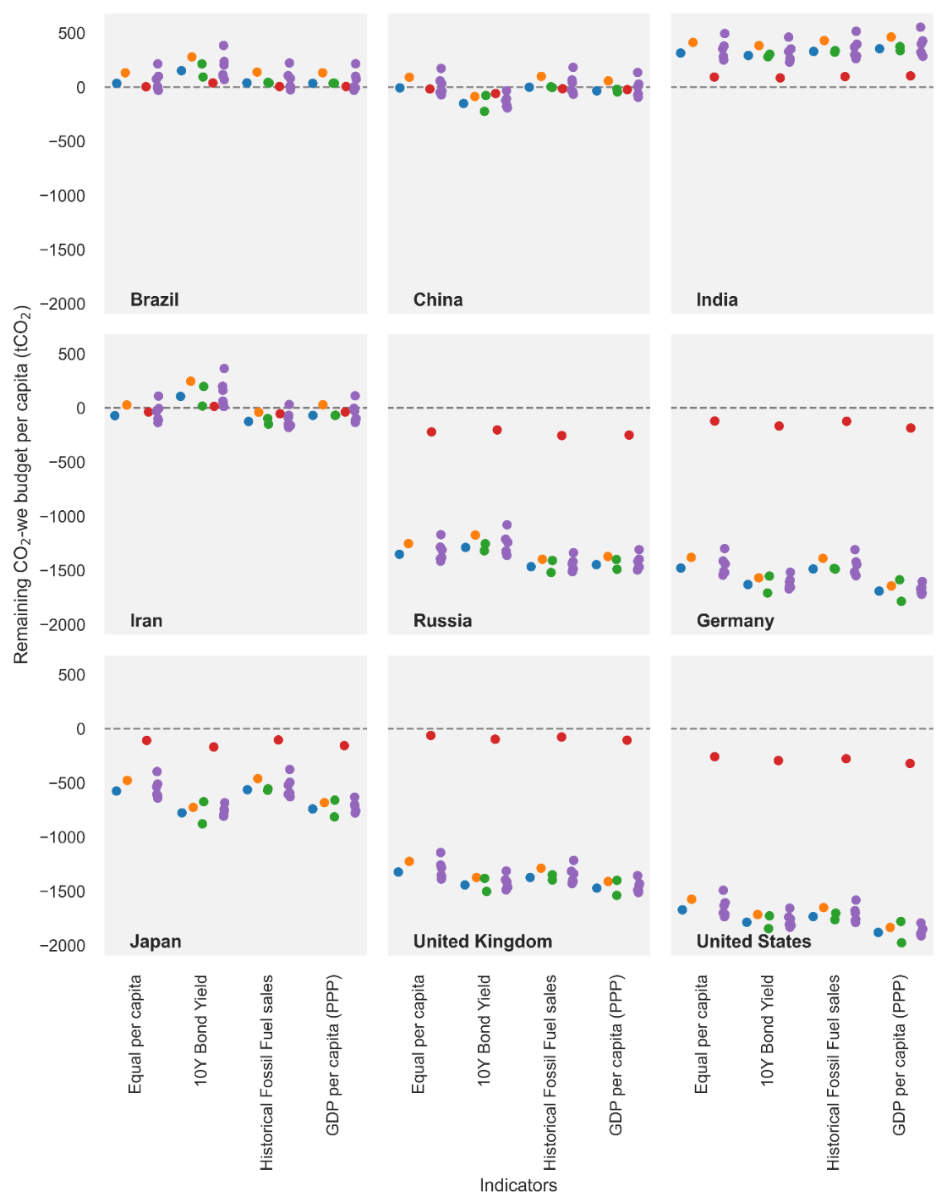
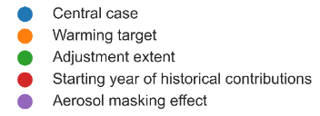
Supplementary Fig. 5 | The uncertainty in remaining (2021-2050) CO₂ warming equivalent budgets for major countries. Each point represents an allocation case. For a specific country and a particular equity interpretation, the central case is performed considering a global warming target of 1.5°C, an indicator adjustment extent of 50%, a historical warming contribution starting in 1850 and an aerosol masking effect under 50% quantile. Alternative scenarios deviate from the central case by one distinct assumption, with each category of assumptions represented by different colours. Points of the same colour denote variations in that specific assumption.

Supplementary Note 5: Influence of different degree to which a country’s allocation is changed as a function of differences in driving indicators
In the central case, we adopt 50% as the maximum degree to which a country’s allocation is changed as a function of differences in driving indicators (adjustment extent). We explore an alternative of 25% and 75%. Assuming a 100% adjustment extent, countries with extreme values will get double or zero allowable total warming budget compared to Interpretation I, which would be a too harsh encouragement or punishment.
The distinction between country groups is normally enlarged with larger adjustment extent. With larger adjustment, country ranking could be reversed. Still, the effect seems to be moderate on reversing the country ranking.
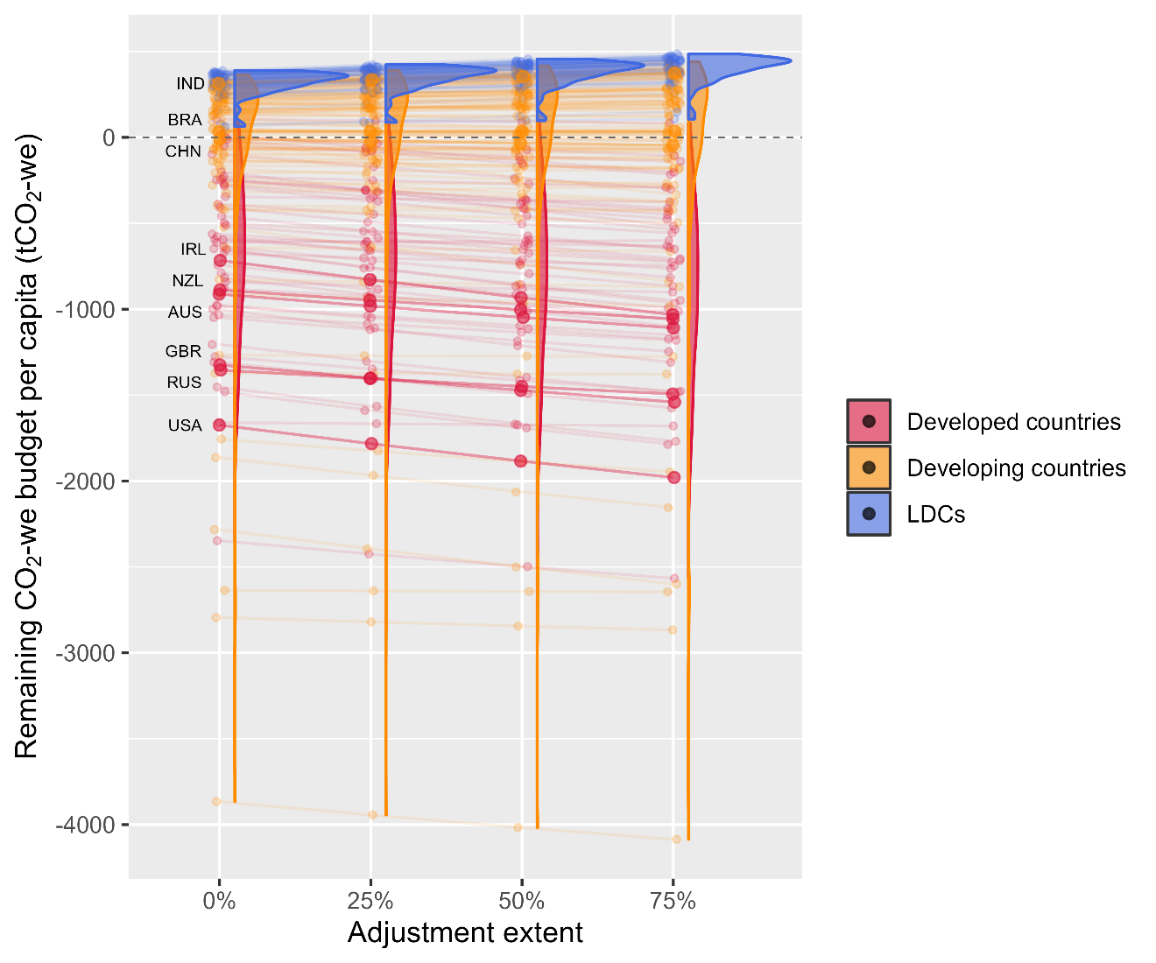
Supplementary Fig. 6 | The uncertainty in remaining (2021-2050) CO₂ warming equivalent budgets for major countries, with various maximum adjustment extent of driving indicators.
Here we present the figures in the main text with an indicator adjustment extent of 75%.

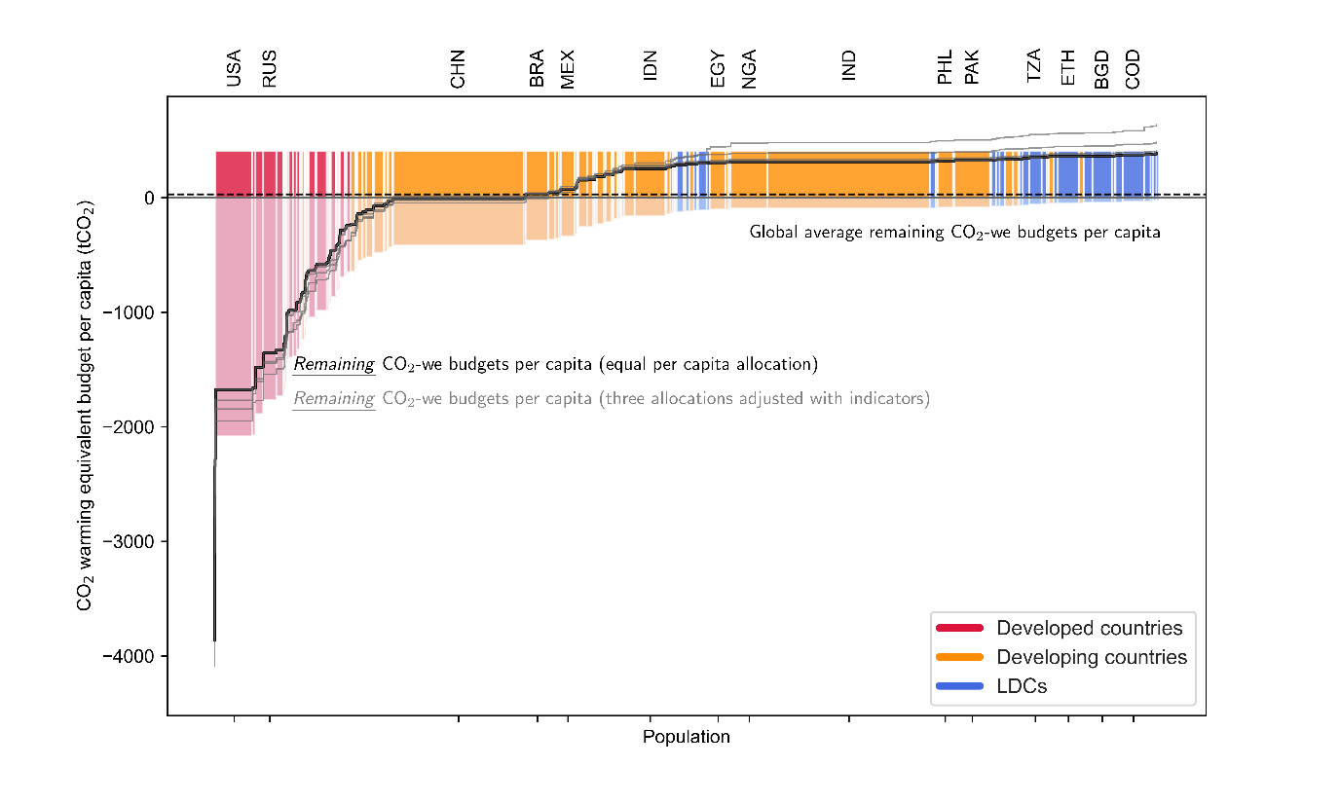
Total CO₂-we budgets per capita (tCO₂-we)
Historical CO₂-we per capita emissions until 2021(tCO₂-we)
Supplementary Fig. 7 | Total (1850-2050), historical (1850-2021), and remaining (2021-2050) CO₂ warming equivalent budgets per capita by country (adjustment extent of 75%). Countries are ranked according to their remaining per capita national budgets, under the central case which considers a historical warming contribution starting in 1850 and a global warming target of 1.5°C. The height of bars above the x-axis represents the total CO₂-we budgets per capita under our first interpretation that considers the equality and polluter-pays principles. The height of the bars below the x-axis represents the historical consumed CO₂-we budgets per capita. The width of the bars represents a country’s population. The step lines represent the remaining CO2-we budgets per capita per country with the black line referring to the interpretation I and the grey lines referring to the other two interpretations. Developed countries, developing countries, and least developed countries (LDCs) are marked in different colours.

Supplementary Note 6: Influence of different desired peak global warming target
In the central case, we adopt 1.5°C as the desired peak global warming target. We explore an alternative of 2°C.
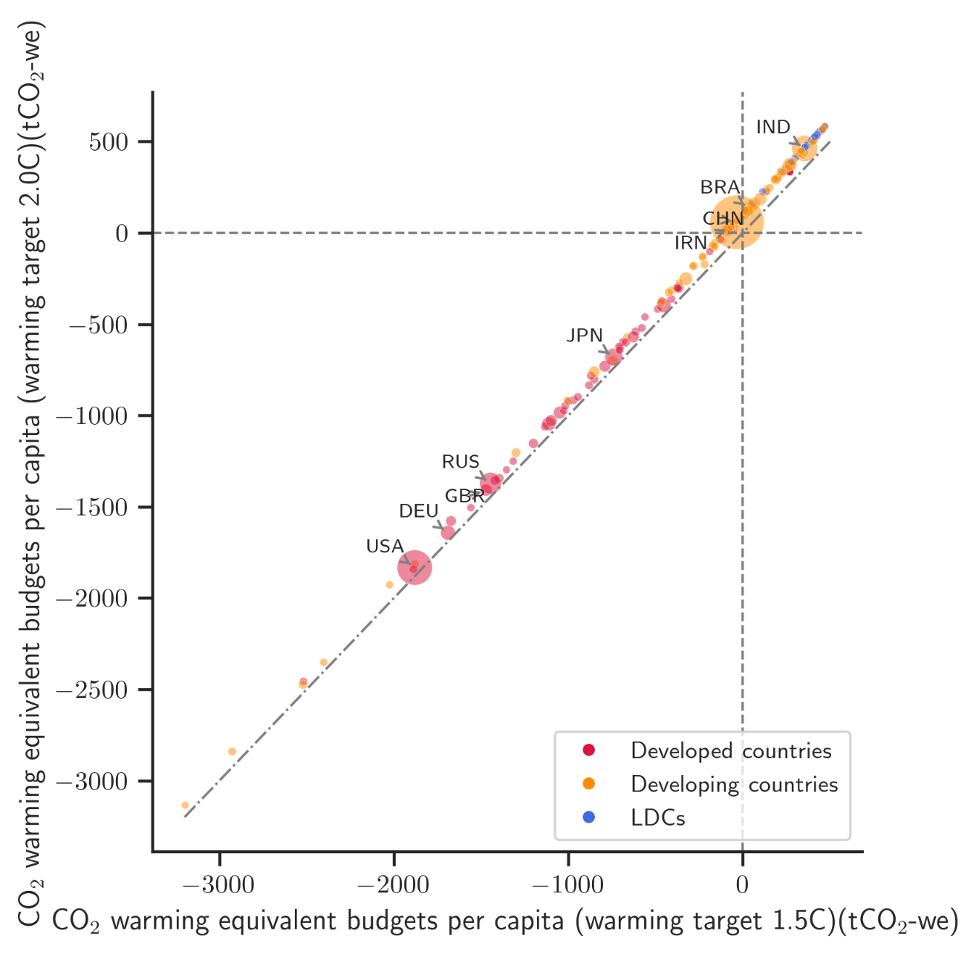
Supplementary Fig. 8 | Remaining (2021-2050) CO₂ warming equivalent budgets per capita, compared between different desired peak global warming target. Both allocations adhere to the equity interpretation II with GDP per capita in PPP. They differ in terms of the desired peak global warming target, 1.5℃ for the x-axis, and 2℃ for the y-axis. The size of the bubbles indicates the amount of national emissions in 2021. Developed countries, developing countries, and least developed countries (LDCs) are marked in different colours.
Here we present the figures in the main text with a desired peak global warming target of 2°C.
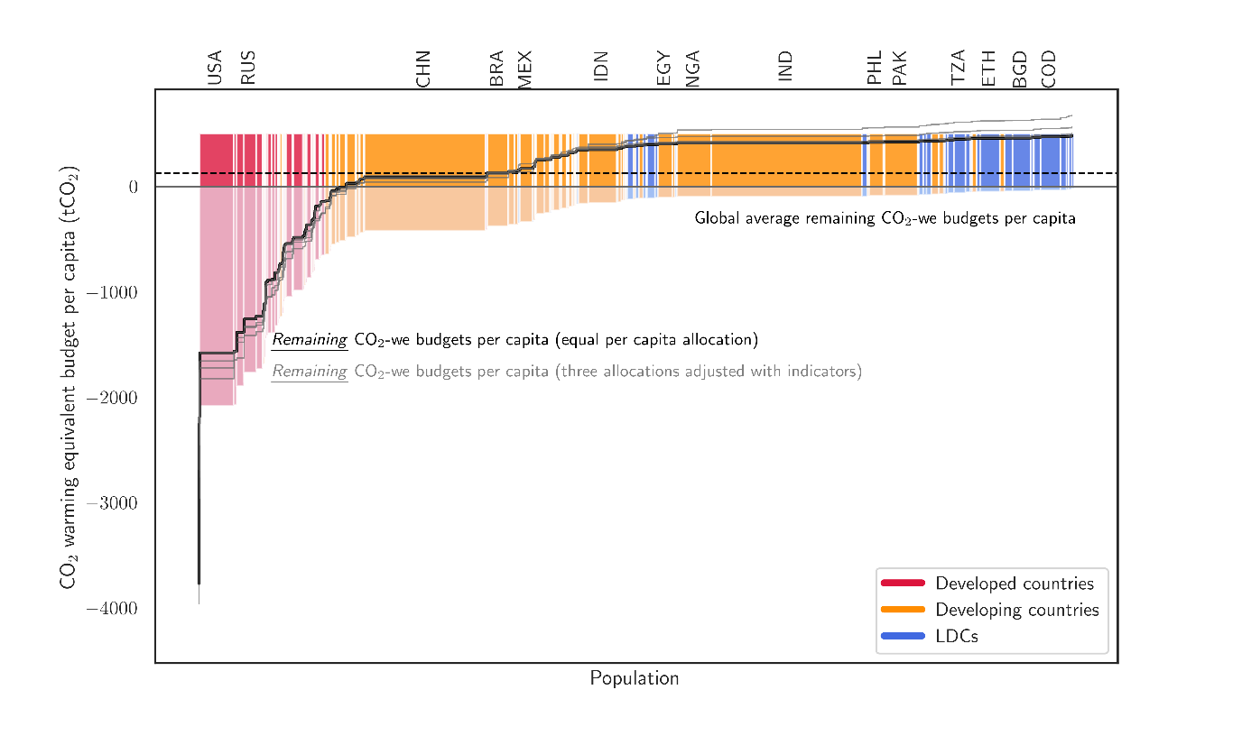
Total CO₂-we budgets per capita (tCO₂-we)
Historical CO₂-we per capita emissions until 2021(tCO₂-we)
Supplementary Fig. 9 | Total (1850-2050), historical (1850-2021), and remaining (2021-2050) CO₂ warming equivalent budgets per capita by country (desired peak global warming target of 2℃). Countries are ranked according to their remaining per capita national budgets, under the central case which considers a historical warming contribution starting in 1850 and a global warming target of 1.5°C. The height of bars above the x-axis represents the total CO₂-we budgets per capita under our first interpretation that considers the equality and polluter-pays principles. The height of the bars below the x-axis represents the historical consumed CO₂-we budgets per capita. The width of the bars represents a country’s population. The step lines represent the remaining CO₂-we budgets per capita per country with the black line referring to the interpretation I and the grey lines referring to the other two interpretations. Developed countries, developing countries, and least developed countries (LDCs) are marked in different colours.

Supplementary Figures

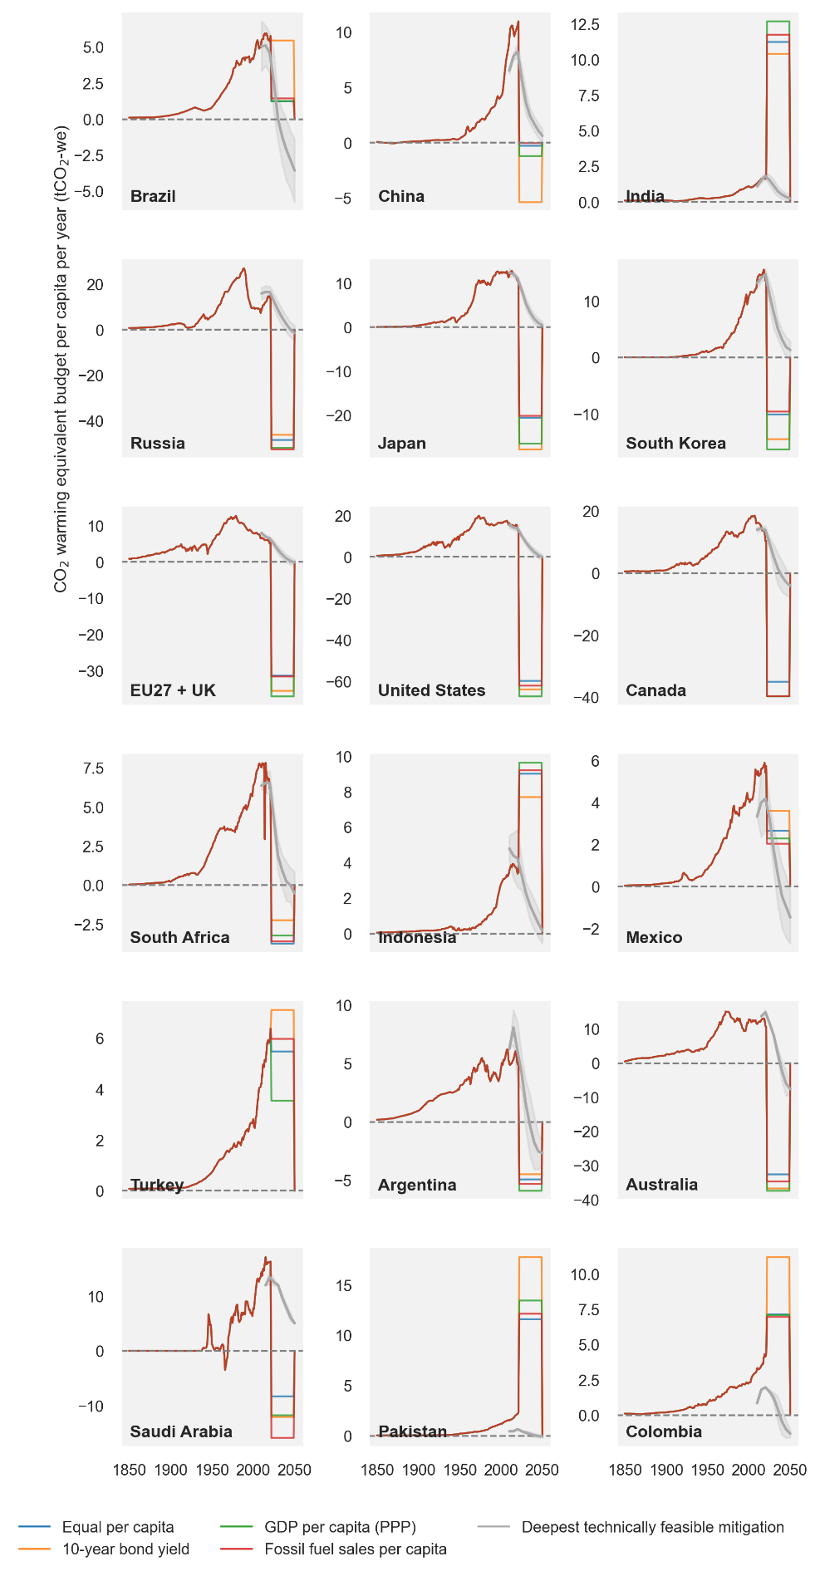
Supplementary Fig. 10 | The annual fair CO₂ warming equivalent emission budgets against the deepest technically feasible mitigation pathways. For the period 1850-2021, the historical CO₂-we GHG emissions per capita data are shown in a single line for each country. For the period 2022-2050, the annual budgets per capita are shown in coloured lines according to the different allocation indicators. The coloured pies behind the indicator labels correspond to the equity principles addressed by the respective allocations; pink stands for the principle of equality, blue for ability to pay, green for beneficiary pays and yellow for polluter pays. For the period 2010-2050, shaded grey areas additionally show the deepest technically feasible mitigation pathways from the global scenario literature for each country or region, including CO₂ emissions only. EU27 + UK is short for the European Union (27 countries) and UK.

Supplementary Tables
Supplementary Table 1 | Methodological and physical uncertain factors considered and their parameter settings
Category | Parameters / metrics | Default setting | Alternative settings
Physical uncertainty | Desired peak global warming target | 1.5℃ | 2℃
Physical uncertainty | Estimation of the aerosol masking effect at the time of peak warming | 50% percentile | 10%, 25%, 33%, 66%, 75%, and 90% percentile
Methodological uncertainty | Maximum degree to which a country’s allocation is changed as a function of differences in driving indicators | 50% | 25%, and 75%

Supplementary Table 2 | Warming unmasked by aerosol reductions at various percentiles and consistent with a set of peak levels of global warming. Negative values indicate a reduction of the remaining allowable warming between today and when the peak warming level is reached.
Peak warming (℃) | Aerosol masking effect (℃)
Peak warming (℃) | 0.1 percentile | 0.25 percentile | 0.33 percentile | 0.5 percentile | 0.66 percentile | 0.75 percentile | 0.9 percentile
1.5 | -1.06862 | -0.56715 | -0.45565 | -0.28514 | -0.15310 | -0.10244 | -0.00151
1.6 | -1.03990 | -0.54500 | -0.43481 | -0.27063 | -0.14729 | -0.09637 | 0.00170
1.7 | -1.01119 | -0.52286 | -0.41398 | -0.25611 | -0.14149 | -0.09030 | 0.00491
1.8 | -0.98247 | -0.50071 | -0.39314 | -0.24159 | -0.13568 | -0.08423 | 0.00812
1.9 | -0.95375 | -0.47857 | -0.37230 | -0.22708 | -0.12987 | -0.07816 | 0.01133
2 | -0.92503 | -0.45642 | -0.35146 | -0.21256 | -0.12407 | -0.07209 | 0.01455

Supplementary Table 3 | Data sources used in this study
Data | Data details | Time | Source
GHG emissions | National historical GHG emissions | 1850-2021 | ^{1, 2}
Aerosol emissions | Global historical aerosol emissions, averaging over all scenarios | 1850-2019 | ³
Population | National population, as of 1 July | 2050 | ⁴
10-year bond yield | 10-year government bond yield | Around 2023 | ^{5, 6}, web search
GDP | GDP, purchasing power parity | 2021 | ⁷
GDP | GDP, market exchange rates | 2021 | ⁸
Fossil fuel sales | National fossil fuel sales | 1900-2021 | ^{9, 10}
Deepest technically feasible mitigation pathways | National emission pathways with below 1.5℃ pathway (C1 category) | 2020-2050 | ³

Supplementary references
1. Gütschow J, Pflüger M. The PRIMAP-hist national historical emissions time series v2.4.1 (1750-2021). 2023 [cited]Available from: https://doi.org/10.5281/zenodo.7585420

2. Gütschow J, Jeffery ML, Gieseke R, Gebel R, Stevens D, Krapp M, et al. The PRIMAP-hist national historical emissions time series. Earth System Science Data 2016, 8(2): 571-603.

3. Byers E, Krey V, Kriegler E, Riahi K, Schaeffer R, Kikstra J, et al. AR6 Scenarios Database hosted by IIASA. 2022 [cited 2023-08-25]Available from: data.ece.iiasa.ac.at/ar6/

4. Economic UNDo, Social Affairs PD. World population prospects 2022: Summary of results. United Nations New York, NY, USA; 2022.

5. World Government Bond. 10Y Bond Yield. 2023 [cited 2023-02-27]Available from: http://www.worldgovernmentbonds.com/

6. Trading Economics. Major10Y. 2023 [cited 2023-03-01]Available from: https://tradingeconomics.com/bonds

7. World Bank. GDP, PPP (current international $). 2023 [cited 2023-03-30]Available from: https://data.worldbank.org/indicator/NY.GDP.MKTP.CD

8. World Bank. GDP (constant 2015 US$). 2023 [cited 2023-03-30]Available from: https://data.worldbank.org/indicator/NY.GDP.MKTP.KD

9. Hannah Ritchie, Pablo Rosado, Roser M. Fossil Fuels. 2023 [cited 2023-06-20]Available from: https://ourworldindata.org/fossil-fuels

10. Feenstra RC, Inklaar R, Timmer MP. The next generation of the Penn World Table. Amer Econ Rev 2015, 105(10): 3150-3182.

