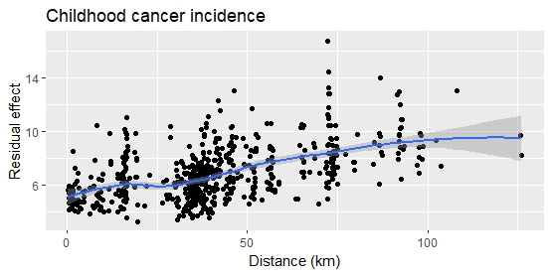
Appendix B. Spatial analysis of childhood cancer incidence in the Region. The clustered distribution of residuals from the fitted models (left) and results of hot-spot analysis (right) indicates potential spatial clustering of cases, particularly in the northern and eastern parts of the Region.

