Supplement

Figure S1

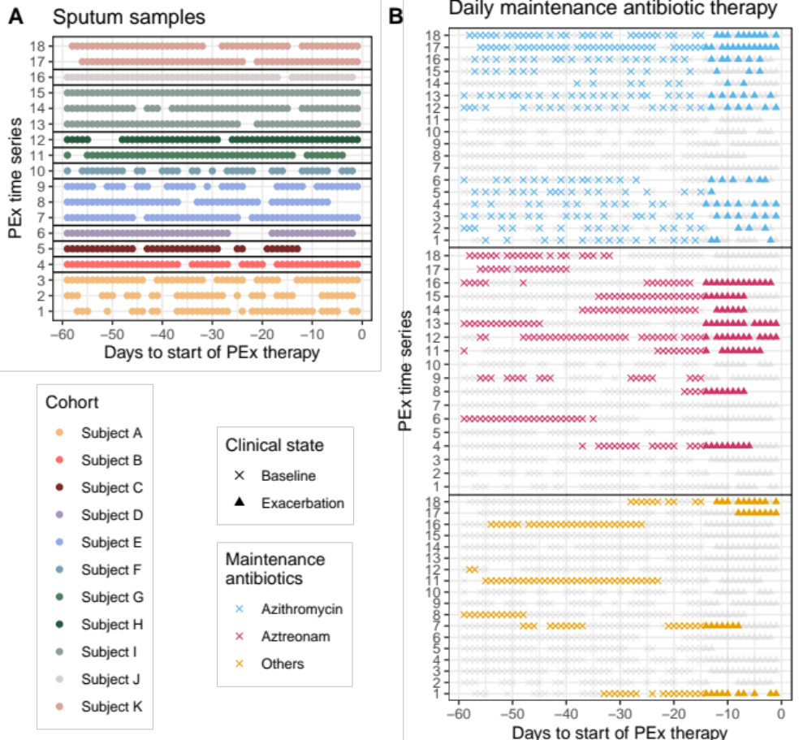

Fig. S1 PEx time series and maintenance antibiotic therapy. a Sputum samples collected during the 60 days prior to the start of antibiotic treatment for PEx are shown by subject for each of the 18 PEx time series. The numbers of samples for each of the 11 study subjects are 126, 53, 38, 50, 143, 37, 51, 51, 168, 56, and 107 for subjects A-K, respectively. b Maintenance antibiotic therapy per day during the PEx time series for each subject is shown. Samples collected after the start of antibiotic therapy for PEx were not included in the analyses.

Figure S2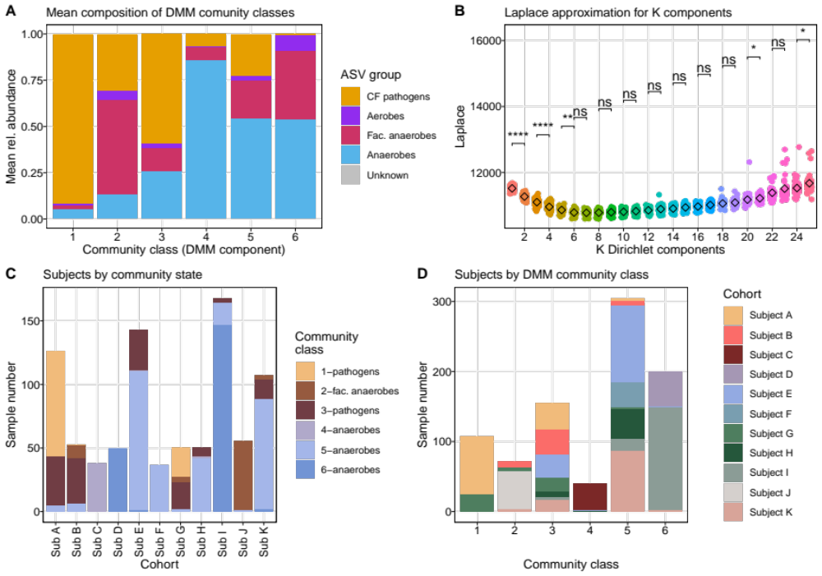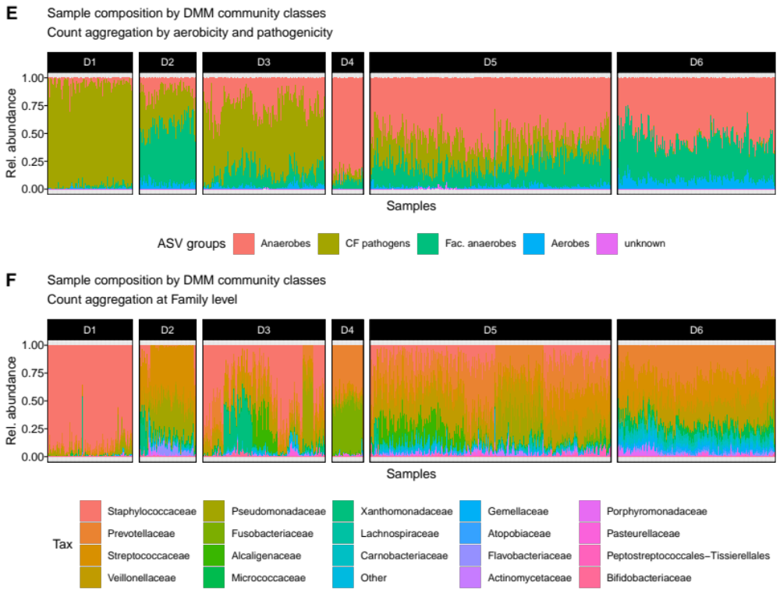

Fig. S2 Identification of microbial community classes. a Composition of six DMM components. DMM was inferred at the level of ASV groups: strictly aerobic, strictly anaerobic, facultatively anaerobic, conventional CF pathogens, and unknown oxygen requirement. b Identification of best DMM model. A total of 36 models, each with one to 25 components, was inferred and the Laplace approximations of each are presented together with stepwise comparison of means among models with k components (Wilcoxon). The first statistically non-significant change of Laplace was used as a cutoff criterion (k=6). c Distribution of DMM community states across the subject cohort. Sample number by subject is depicted. d Distribution of subjects across DMM components. Sample number by DMM is depicted. e Sample-wise community compositions aggregated by ASV groups and presented by DMM community classes (D1-6), as used for downstream analyses. f Original sample-wise community compositions with ASVs aggregated at Family level and grouped by DMM community classes (D1-6). Top 20 taxa are indicated.

Figure S3
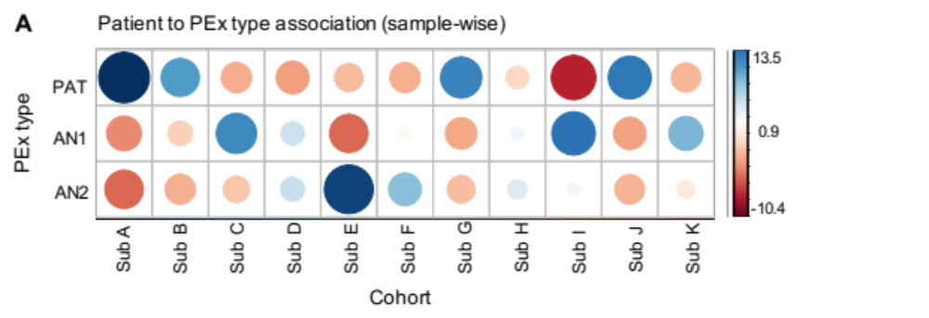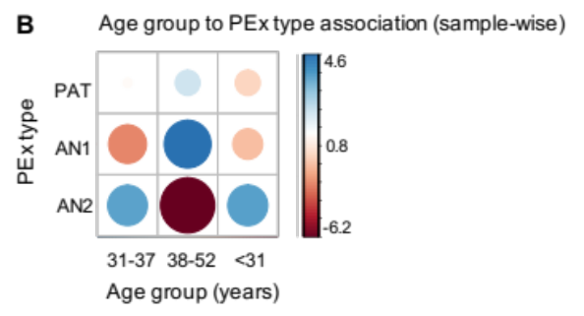
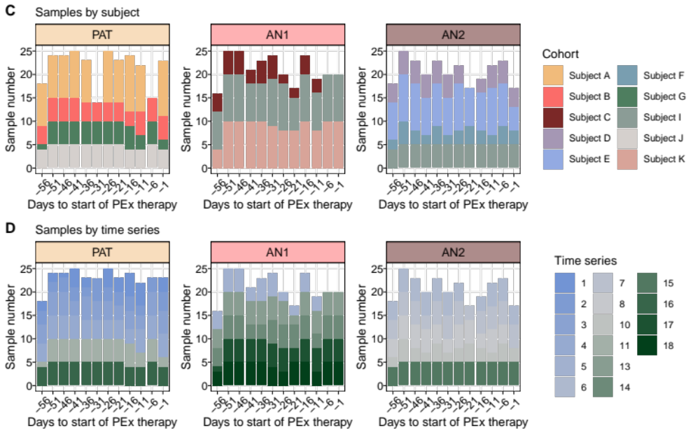
Fig. S3 Sample distributions by PEx types, subjects, age groups and time series. a Spearman rank association of PEx types and subjects (S_{A}-S_{K}). $χ^{2}$testing performed on samples in respective categories, standardized residuals shown ($χ^{2}=700, p<2.2e-16$). b Spearman rank association of PEx types and age groups (<31, 31-37, 38-52 years). $χ^{2}$testing performed on samples in respective categories, standardized residuals shown ($χ^{2}=42.5, p<1.3e-8$). c Sample distribution across PEx types by subjects and time to PEx treatment as used in downstream analyses. Data aggregated by 5 days. d Sample distribution across PEx clusters by time series and time to PEx antibiotic treatment as used in downstream analyses. Data aggregated by 5 days.

Figure S4
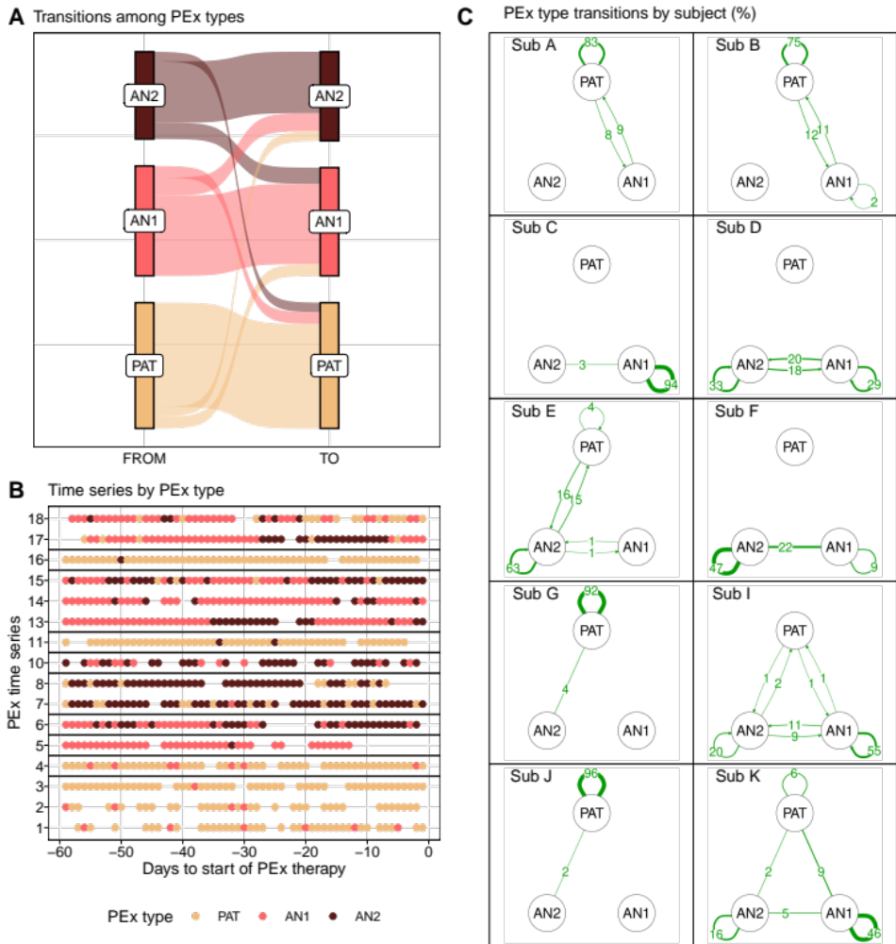
Fig. S4 Transition profiles between PEx types. Used samples distribute to PEx types as $PAT=309, AN1=266, AN2=214$. a Sankey plot depicting transition events between pairs of consecutive samples within individual PEx time series. A particular PEx type can be entered from the previous sample with different or same PEx type and can transition into the PEx type of the subsequent sample. Transition events distribute for AN2: 11% to PAT, 70% within AN2, 19% to AN3; for AN1: 11% to PAT, 16% to AN2, 73% within AN1; for PAT 83% within PAT, 8% to AN2, 9% to AN1. b Samples with respective PEx type classification shown as individual time series. c Transition graphs reporting proportion (%) of PEx type maintenance (self-loops) or switch (edges) by individual subject (Sub A – Sub K). Edges labelled and sized according to transition percentage, undirected edges indicate the same amount of transitions in both directions.

Figure S5
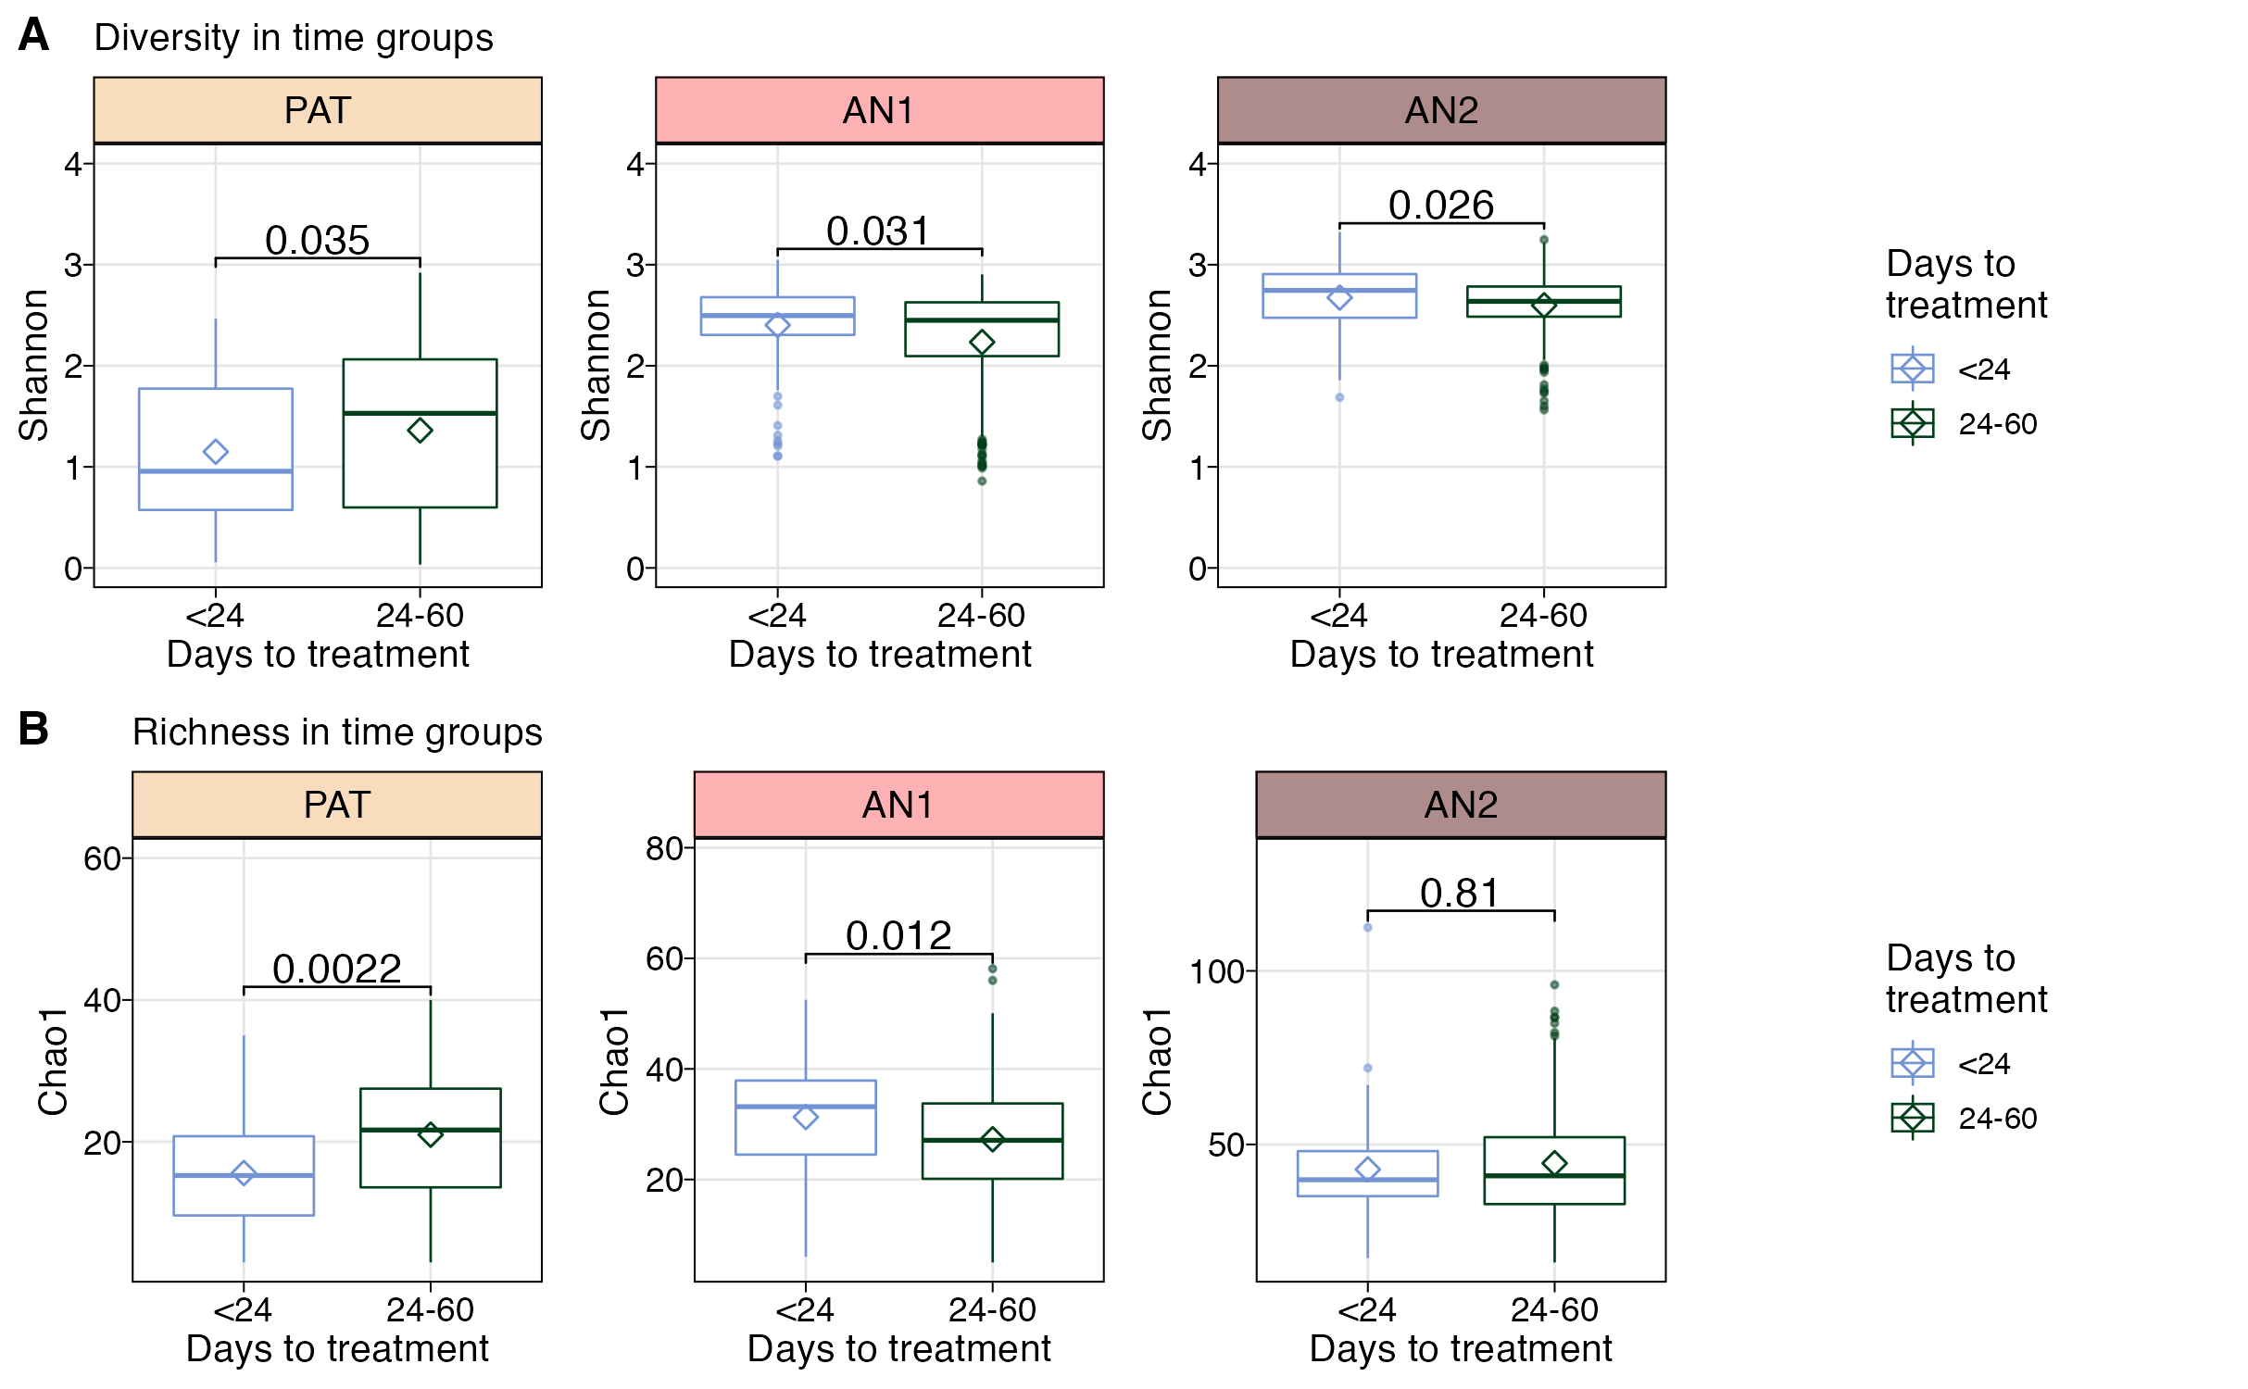
Fig. S5 Time evolution of microbiome diversity and richness by time group and PEx type. a Shannon diversity in microbiomes collected either <24 days or 24-60 days before PEx antibiotic treatment. Significance (p value) of group-wise Wilcoxon tests depicted. b Chao1 richness in microbiomes collected either <24 days or 24-60 days before PEx antibiotic treatment. Significance (p value) of group-wise Wilcoxon tests depicted.
Figure S6
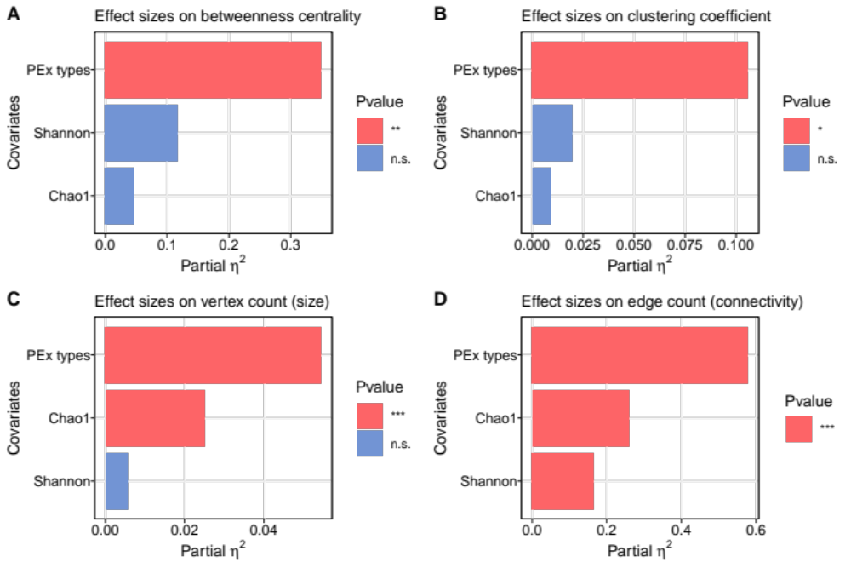
Fig. S6 Effect sizes of PEx types, and covariates Shannon diversity and Chao1 richness on co-occurrence topology. a-d Independent mixed effect models were implemented and the partial effect sizes, as well as p values, of covariates on betweenness centralities (a), clustering coefficients (b), vertex counts (c) and edge counts (d), were assessed and visualized. The analyses were performed on the largest components of co-occurrence networks. Levels of statistical significance displayed by color code in legend.
Figure S7
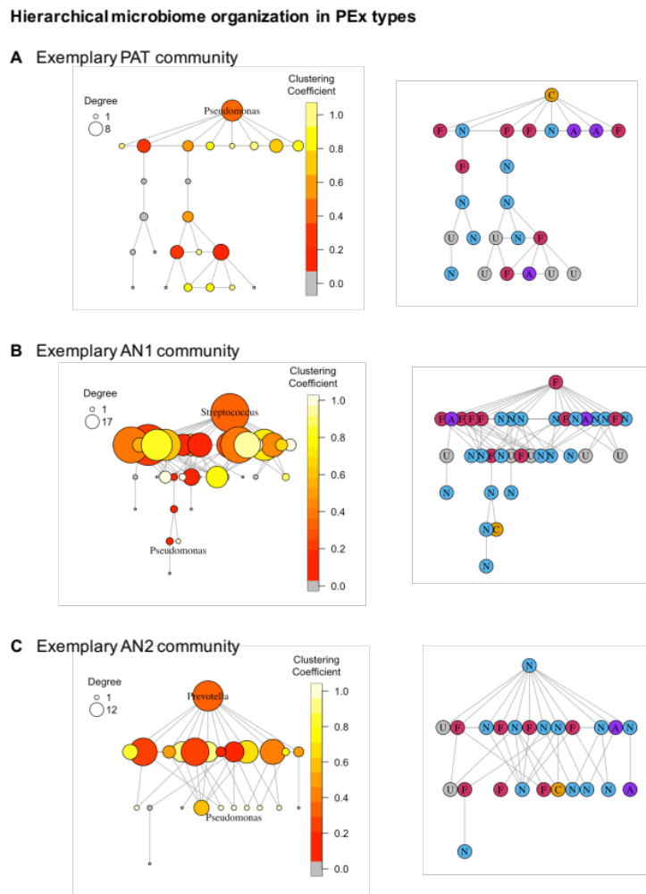
Fig. S7 Hierarchical organization of microbiomes in PEx types reveals different positioning of pathogens in PEx types. (a-c) Co-occurrence network layouts of exemplary PEx type communities were designed with Sugiyama algorithm for hierarchical networks⁴⁷. (left) Node size was scaled according to its degree, node color according to local clustering coefficient. The most hierarchical position of node i in the community was identified by highest degree k_{i} and lowest clustering coefficient (C_{i}>0). Present pathogens (Pseudomonas), as well as ASVs locating to hierarchical positions with highest frequency are indicated by PEx type. (right) Corresponding graphs with node labels according to ASV groups. Pathogens were depicted as C/orange, aerobes as A/purple, facultative anaerobes as F/pink, anaerobes as N/soft blue, ASVs with unknown oxygen requirements as U/light grey.
Table S1 Inclusion criteria and analyses for samples and PEx time series.
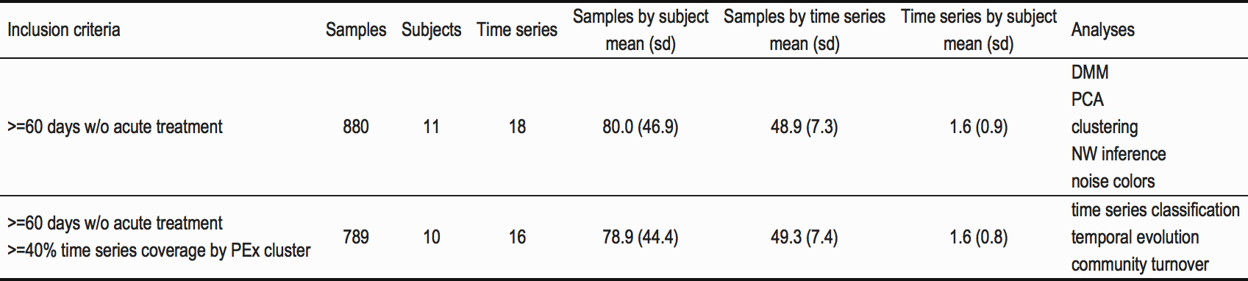

Table S2 Inclusion criteria and analyses for networks (NW).
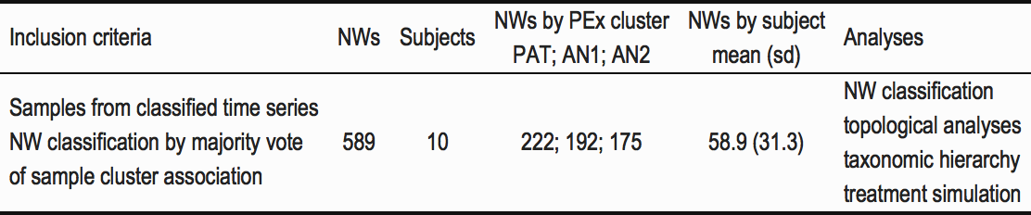

Table S3 Kolmogorov Smirnov test to contrast cumulative distributions of network properties before and after simulated pathogen removal.
