Analysis of solar energetic particle (SEP) event on the geomagnetic environment during 24th solar cycle.
Nirmal Kumar R^{1, 2}, Ranjith Dev Inbaseelan C³, E. Karthikeyan⁴*, Nithyasree⁵, and Johnson Jayakumar⁶
¹ Department of Physics, National Institute of Technology, Tiruchirappalli, Tamil Nadu, India.
²PG and Research, Department of Physics, Srimad Andavan Arts and Science College, Tiruchirappalli, Tamil Nadu, India.
³PG and Research, Department of Physics, Bishop Heber College, Tiruchirappalli, Tamil Nadu, India.
⁴Dr. K.S. Krishnan Geomagnetic Research Laboratory, Indian Institute of Geomagnetism, Jhunsi, Prayagraj (Allahabad), Uttar Pradesh, India.
⁵Department of Physics, Manonmaniam Sundaranar University, Tirunelveli, India.
⁶PG and Department of Physics & Research Centre, Pope’s College, Sawyerpuram, Thoothukudi, affiliated to Manonmaniam Sundaranar University, India

*Corresponding Author
E. Karthikeyan
Dr. K.S. Krishnan Geomagnetic Research Laboratory,
Indian Institute of Geomagnetism,
Jhunsi, Prayagraj (Allahabad),
Uttar Pradesh, India – 211019
Email id: ekarthikeyan2791@gmail.com
Phone No: (+91) 9629800313
Supplementary Figures:
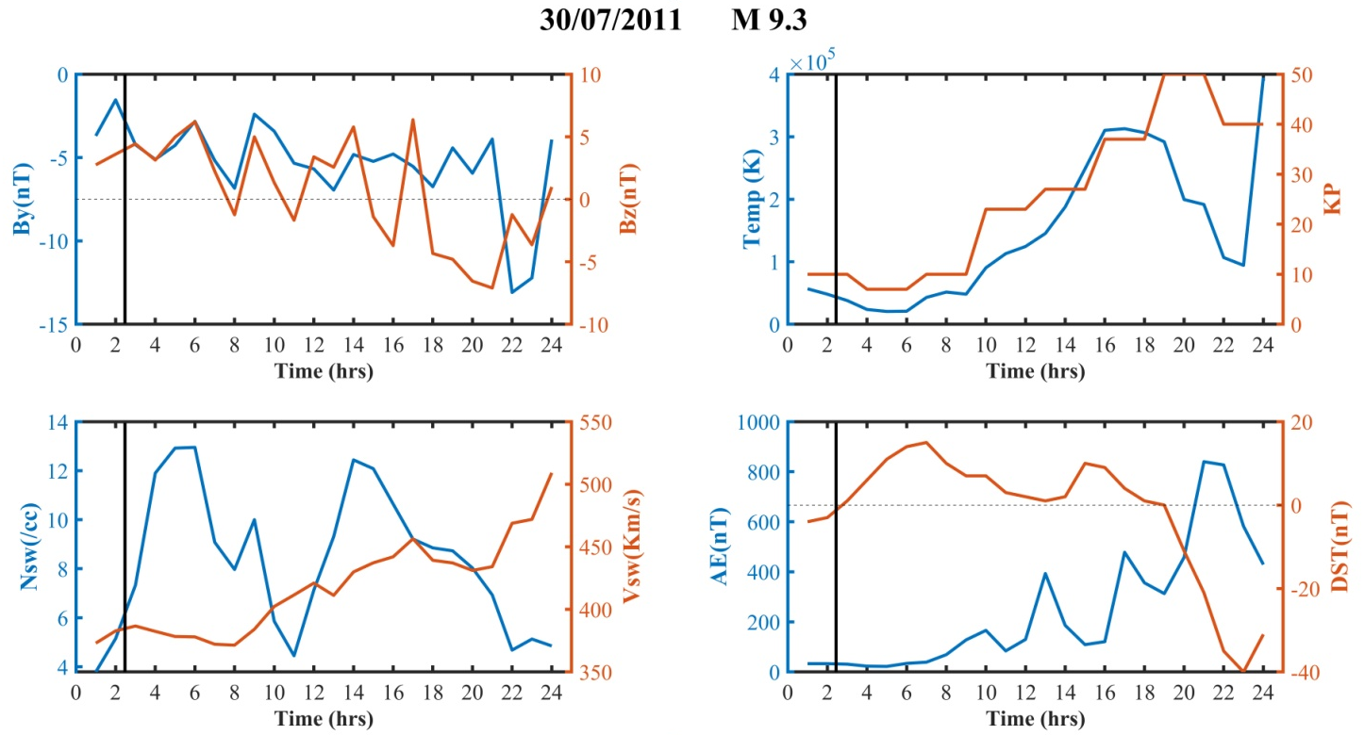
Figure SF1.1: Hourly variation of solar wind, IMF parameters and planetary indices on 30.07.2011, due to flare M9.3.

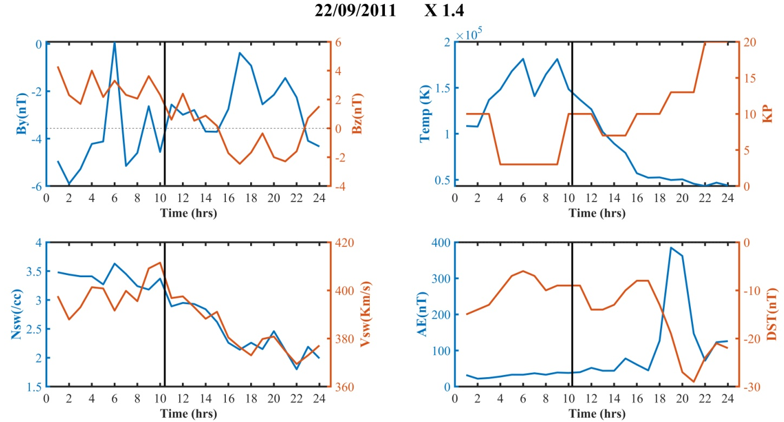
Figure SF1.2: Hourly variation of solar wind, IMF parameters and planetary indices on 22.09.2011, due to flare X1.4.

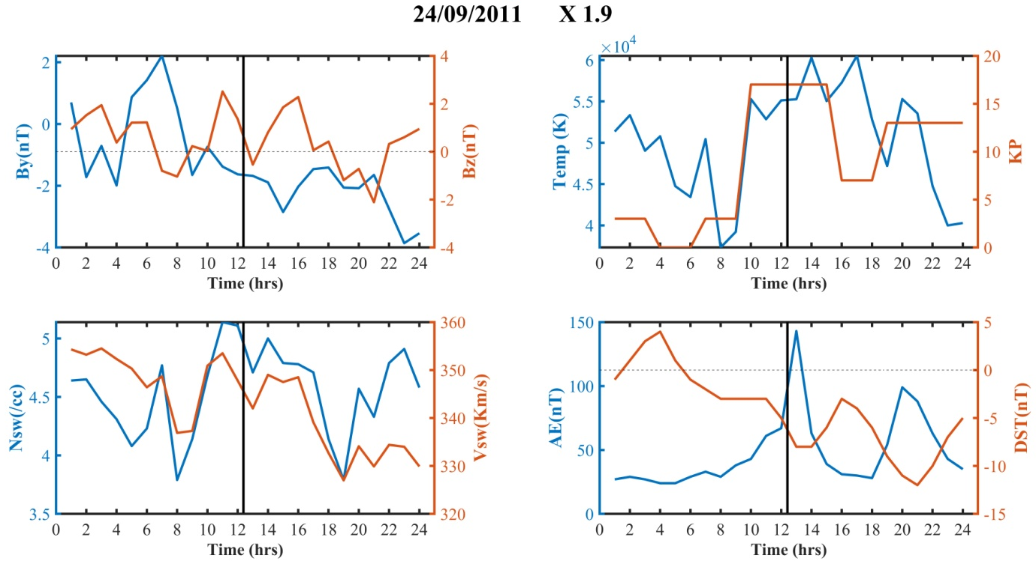

Figure SF1.3: Hourly variation of solar wind, IMF parameters and planetary indices on 24.09.2011, due to flare X1.9.

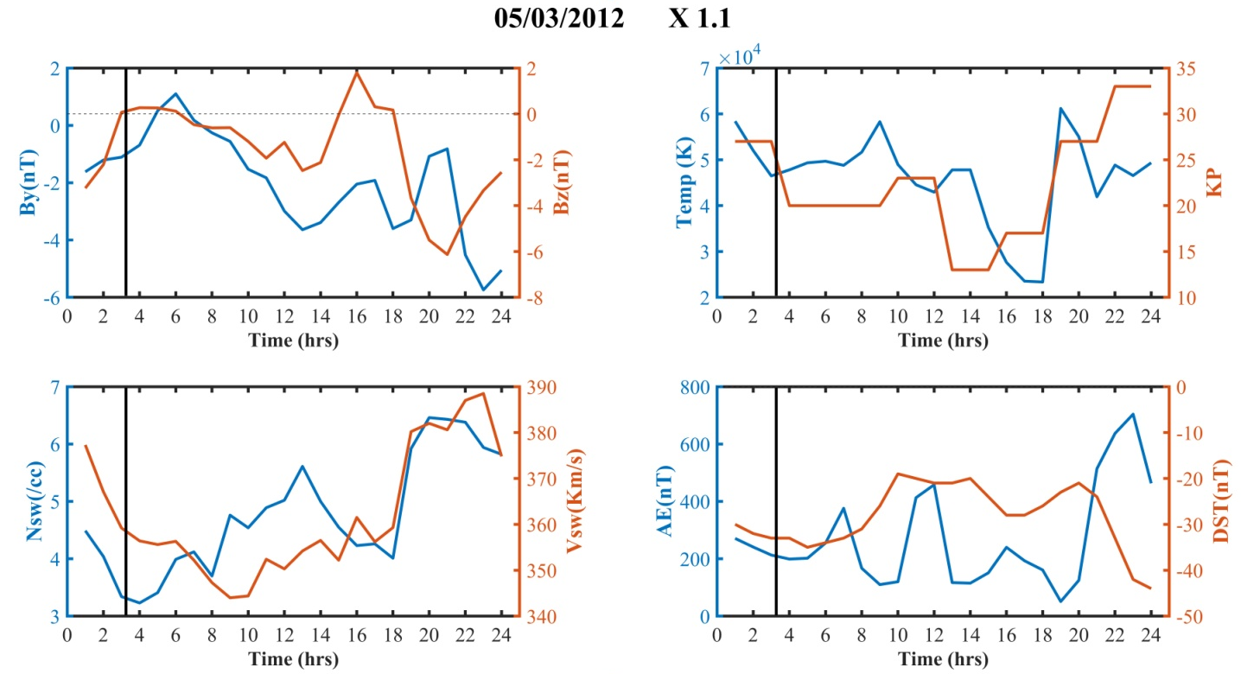
Figure SF1.4: Hourly variation of solar wind, IMF parameters and planetary indices on 05.03.2012, due to flare X1.1.
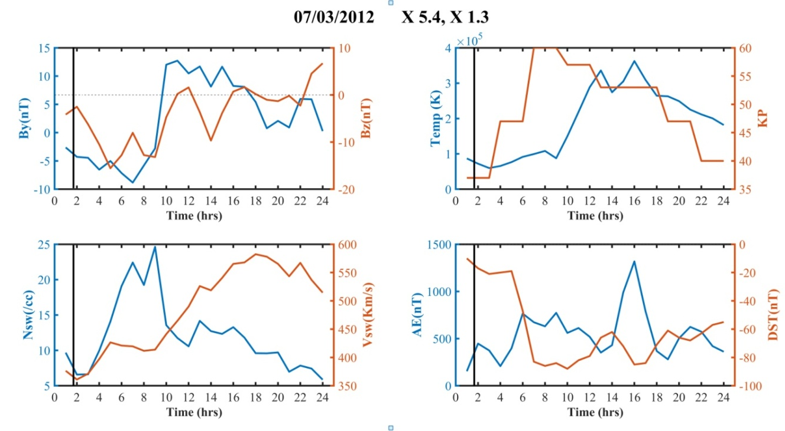
Figure SF1.5: Hourly variation of solar wind, IMF parameters and planetary indices on 07.03.2012, due to flares X5.4 and X1.3.

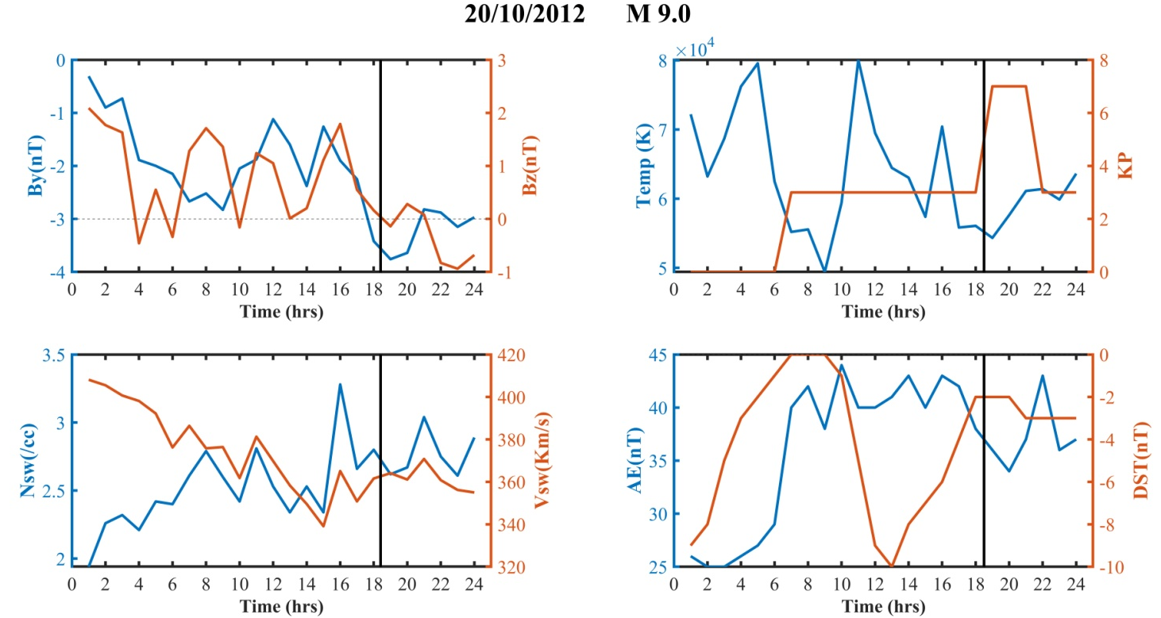
Figure SF1.6: Hourly variation of solar wind, IMF parameters and planetary indices on 20.10.2012, due to flare M9.0.

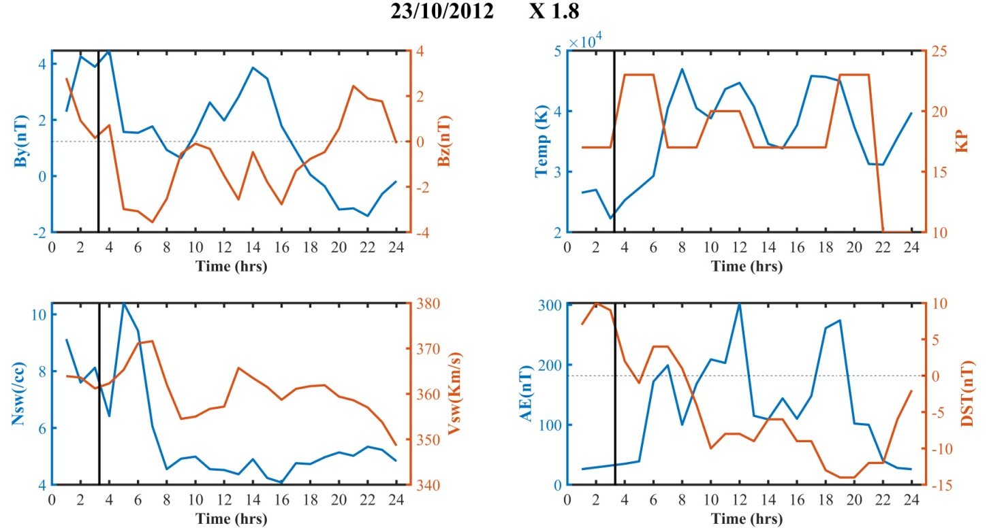
Figure SF1.7: Hourly variation of solar wind, IMF parameters and planetary indices on 23.10.2012, due to flare X1.8.

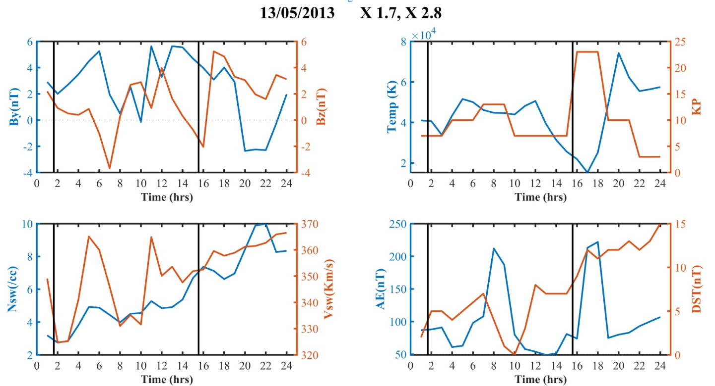
Figure SF1.8: Hourly variation of solar wind, IMF parameters and planetary indices on 13.05.2013, due to flares X1.7 and X2.8.

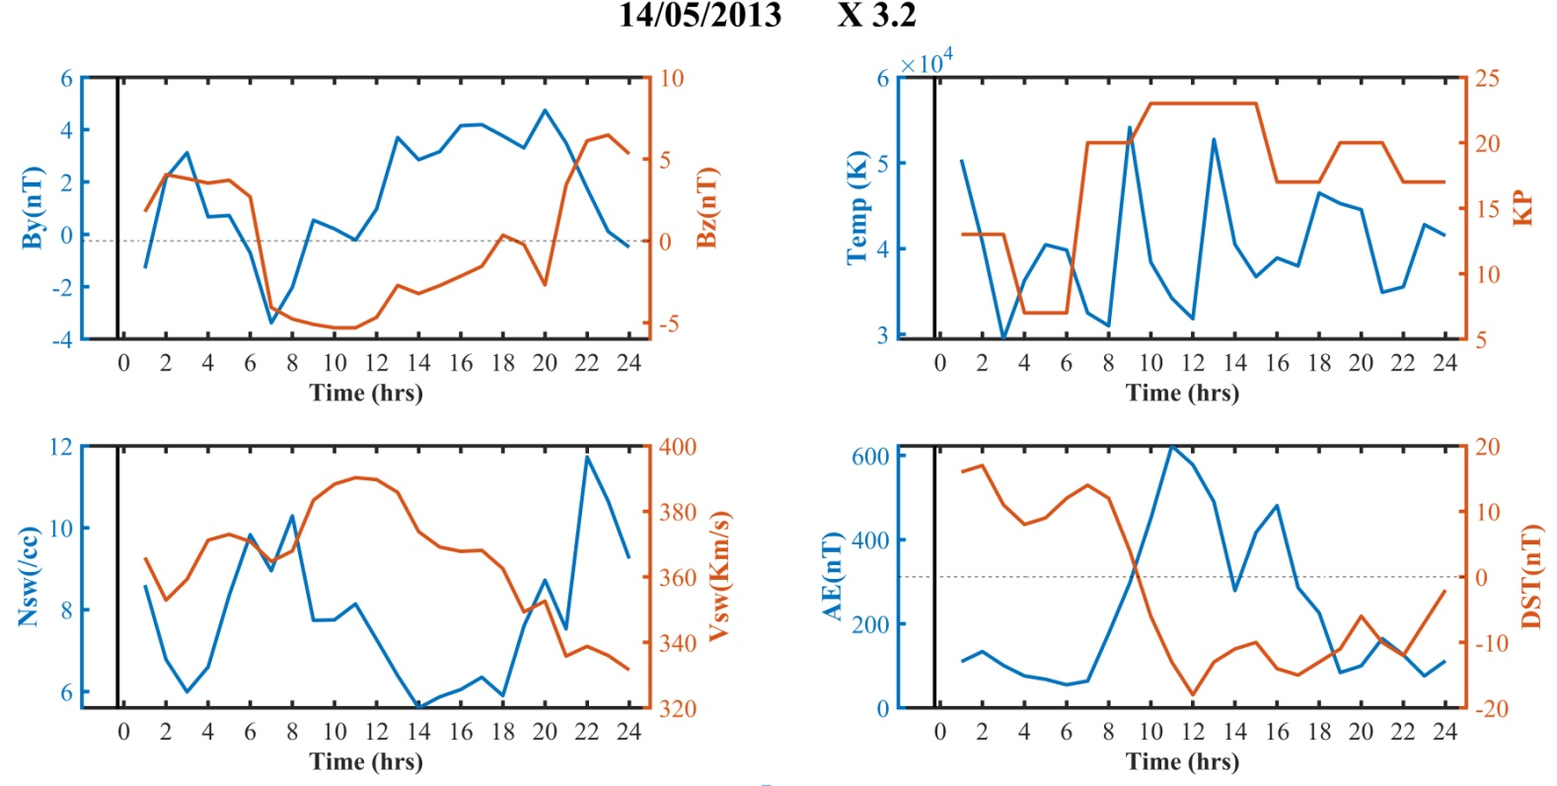
Figure SF1.9:Hourly variation of solar wind, IMF parameters and planetary indices on 14.05.2013, due to flare x3.2.

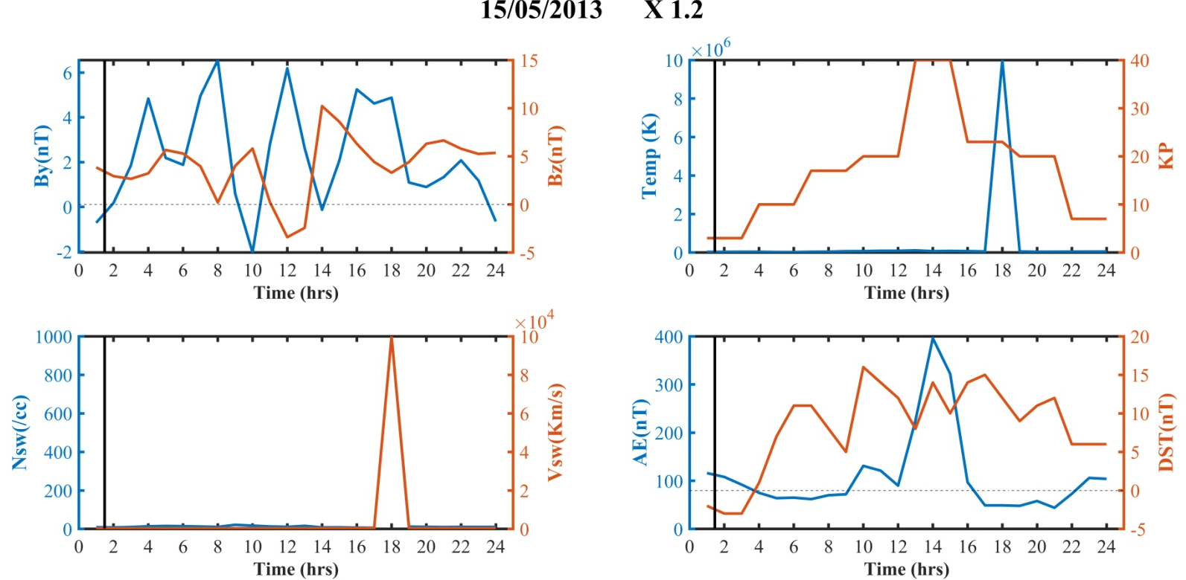
Figure SF1.10: Hourly variation of solar wind, IMF parameters and planetary indices on 15.05.2013, due to flare X1.2.
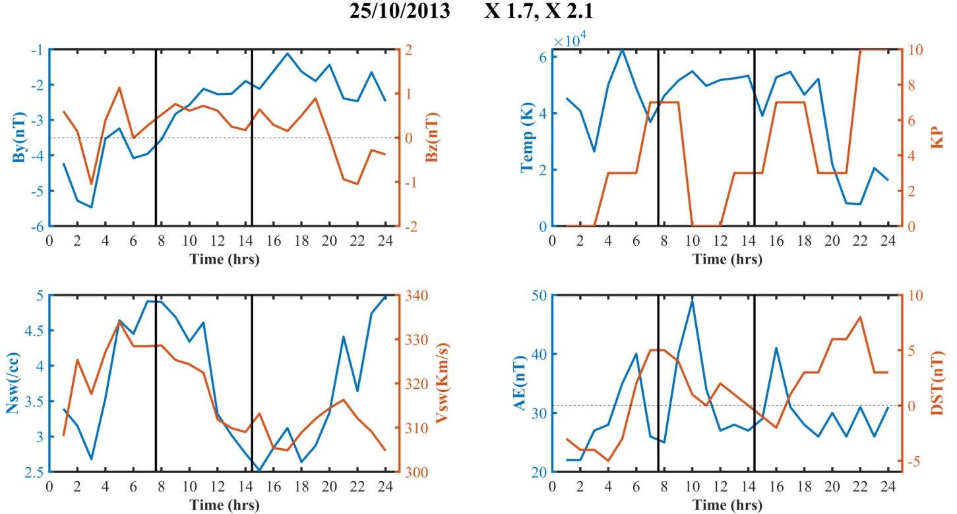

Figure SF 2.1: Hourly variation of solar wind, IMF parameters and planetary indices on 25.10.2013, due to flares X1.7 and X2.1.
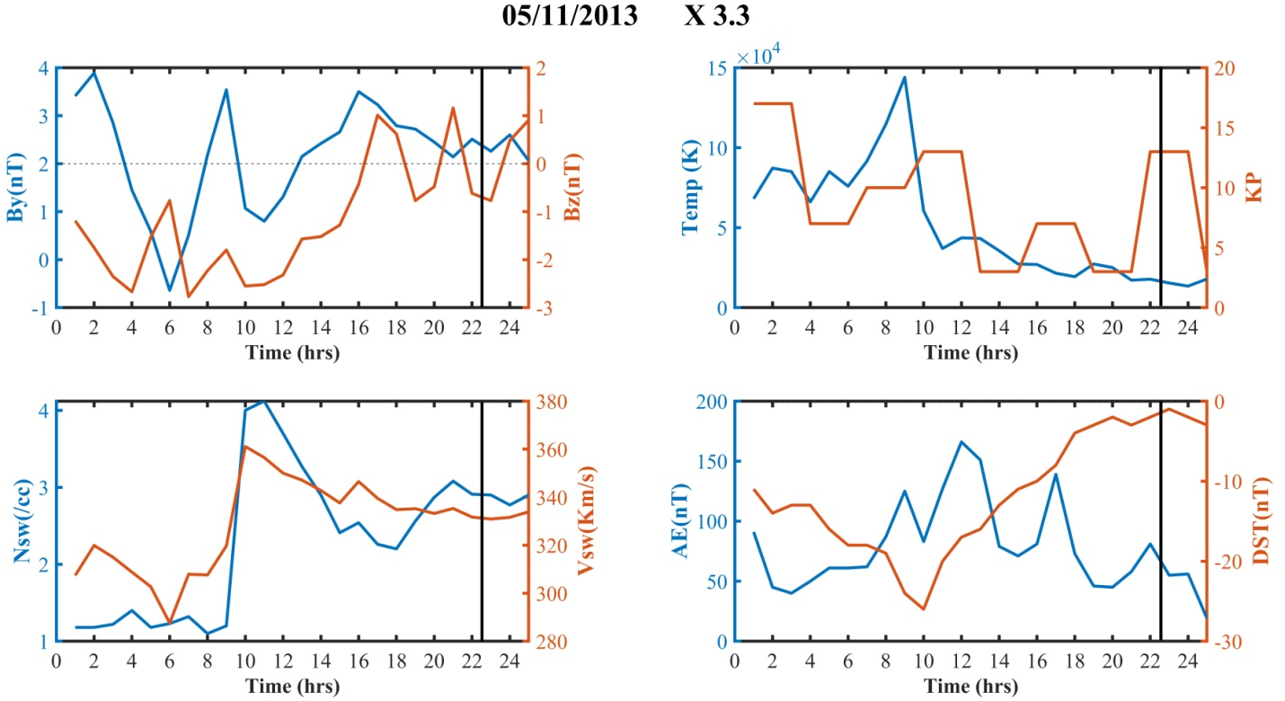
Figure SF2.2: Hourly variation of solar wind, IMF parameters and planetary indices on 05.11.2013, due to flare X3.3.
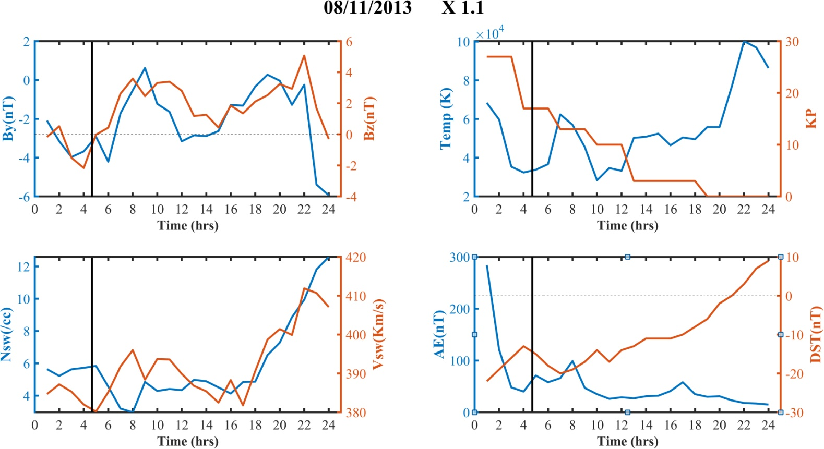
Figure SF2.3: Hourly variation of solar wind, IMF parameters and planetary indices on 08.11.2013, due to flare X1.1.
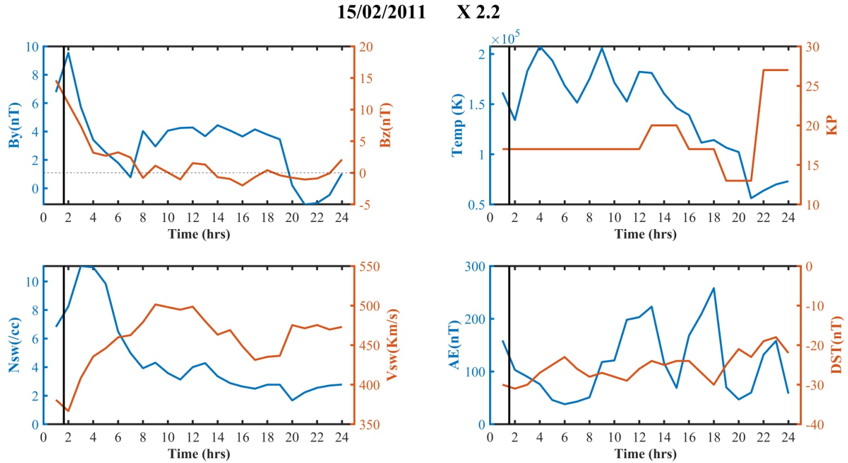
Figure SF2.4: Hourly variation of solar wind, IMF parameters and planetary indices on 15.02.2011, due to flare X2.2.
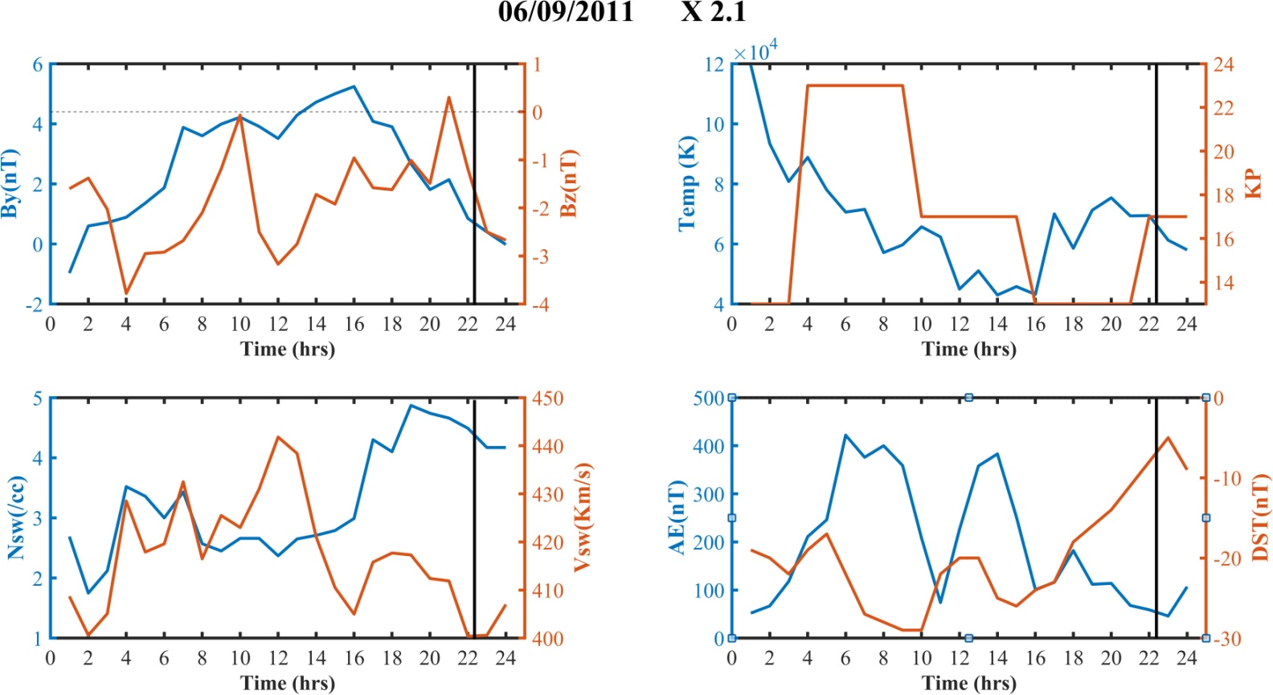
Figure SF2.5: Hourly variation of solar wind, IMF parameters and planetary indices on 06.09.2011, due to flare X2.1.
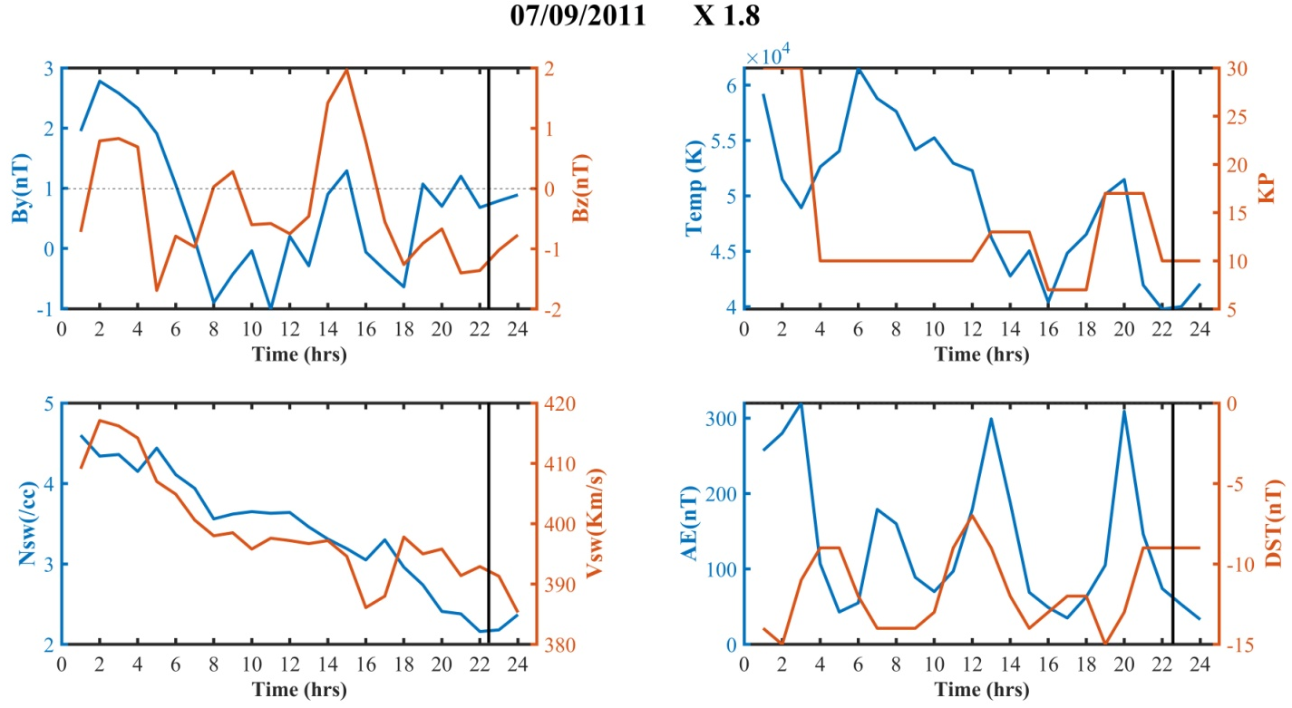
Figure SF2.6: Hourly variation of solar wind, IMF parameters and planetary indices on 07.09.2011, due to flare X1.8.

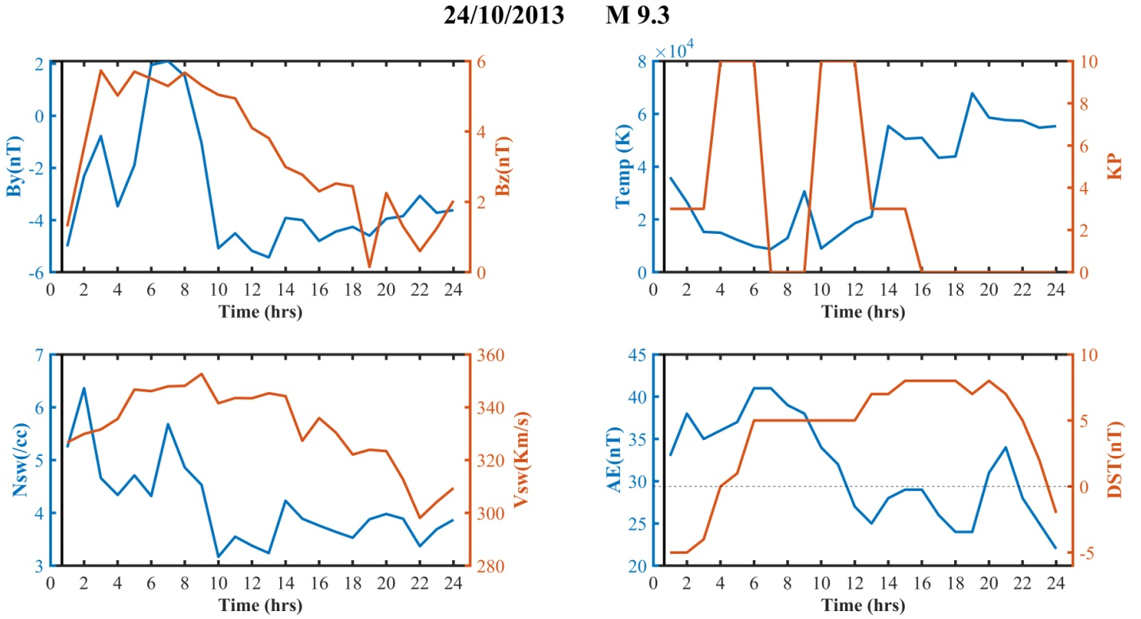
Figure SF2.7: Hourly variation of solar wind, IMF parameters and planetary indices on 24.10.2013, due to flare M9.3.

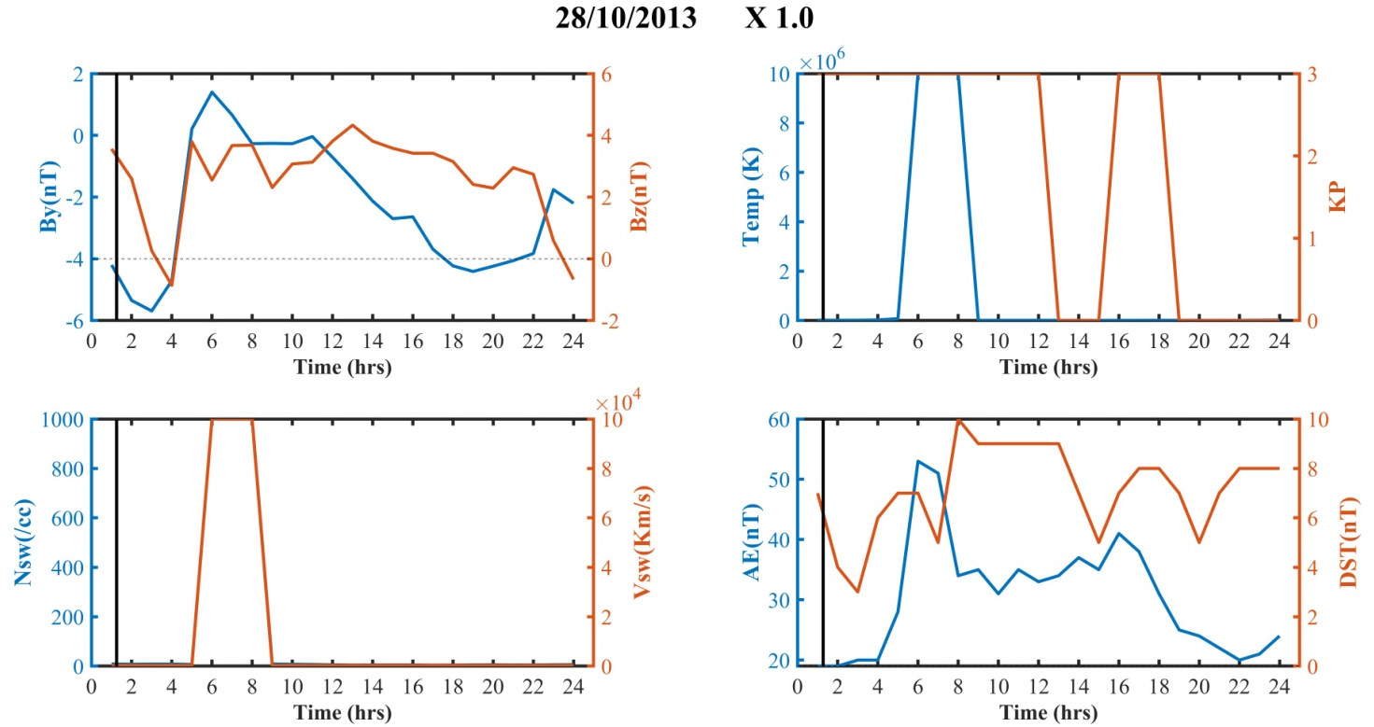
Figure SF2.8: Hourly variation of solar wind, IMF parameters and planetary indices on 28.10.2013, due to flare X1.0.

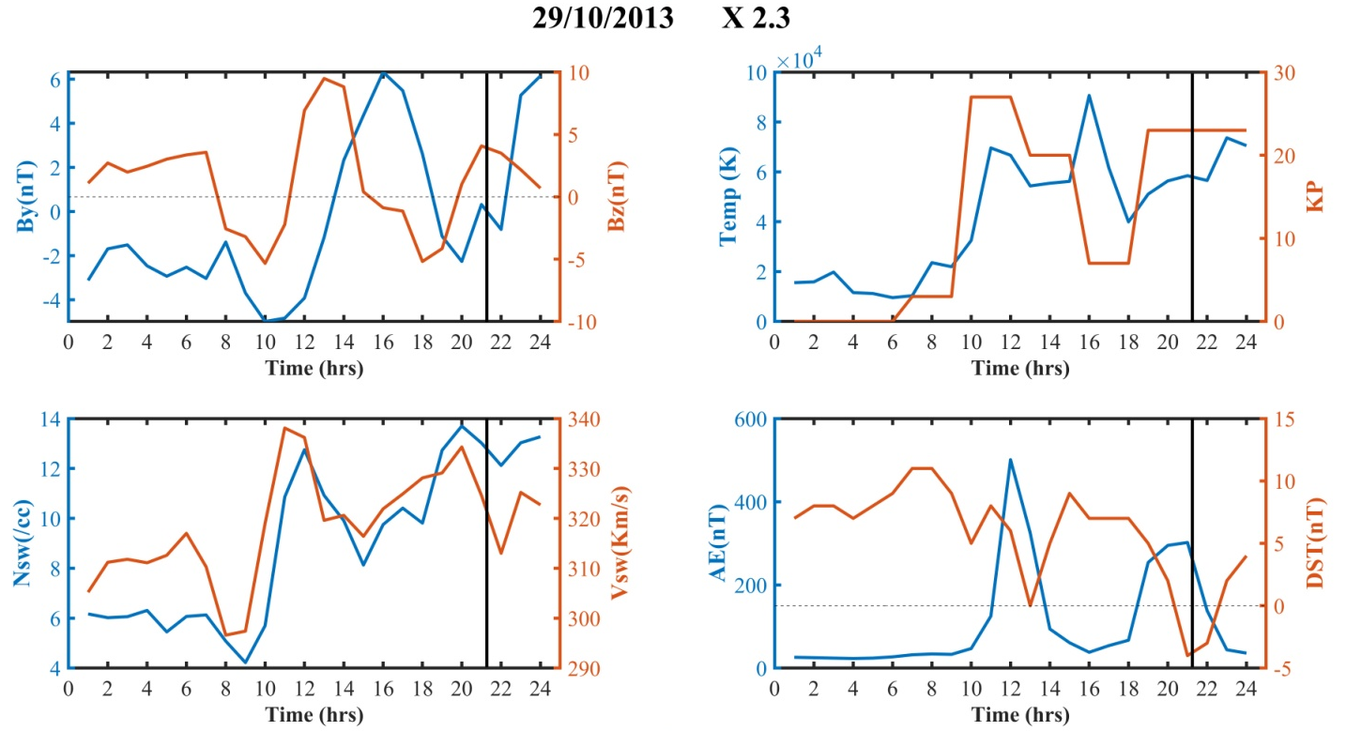
Figure SF2.9: Hourly variation of solar wind, IMF parameters and planetary indices on 29.10.2013, due to flare X2.3.

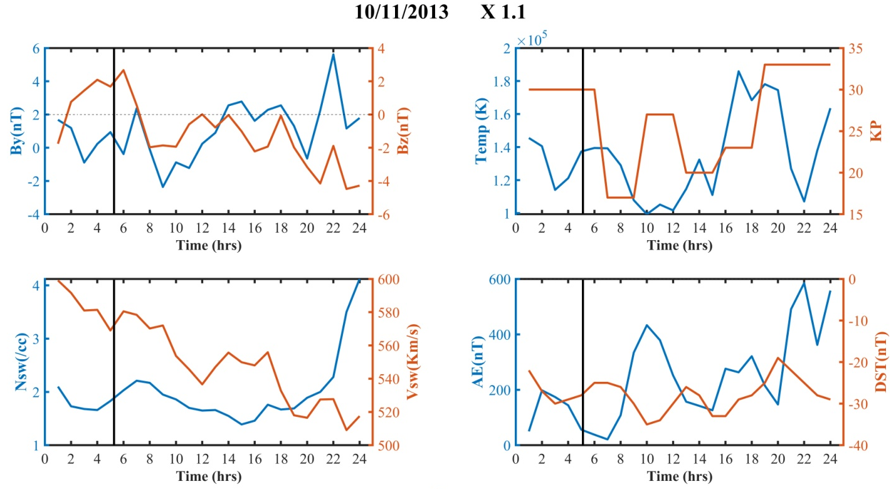
Figure SF2.10: Hourly variation of solar wind, IMF parameters and planetary indices on 10.11.2013, due to flare X1.1.

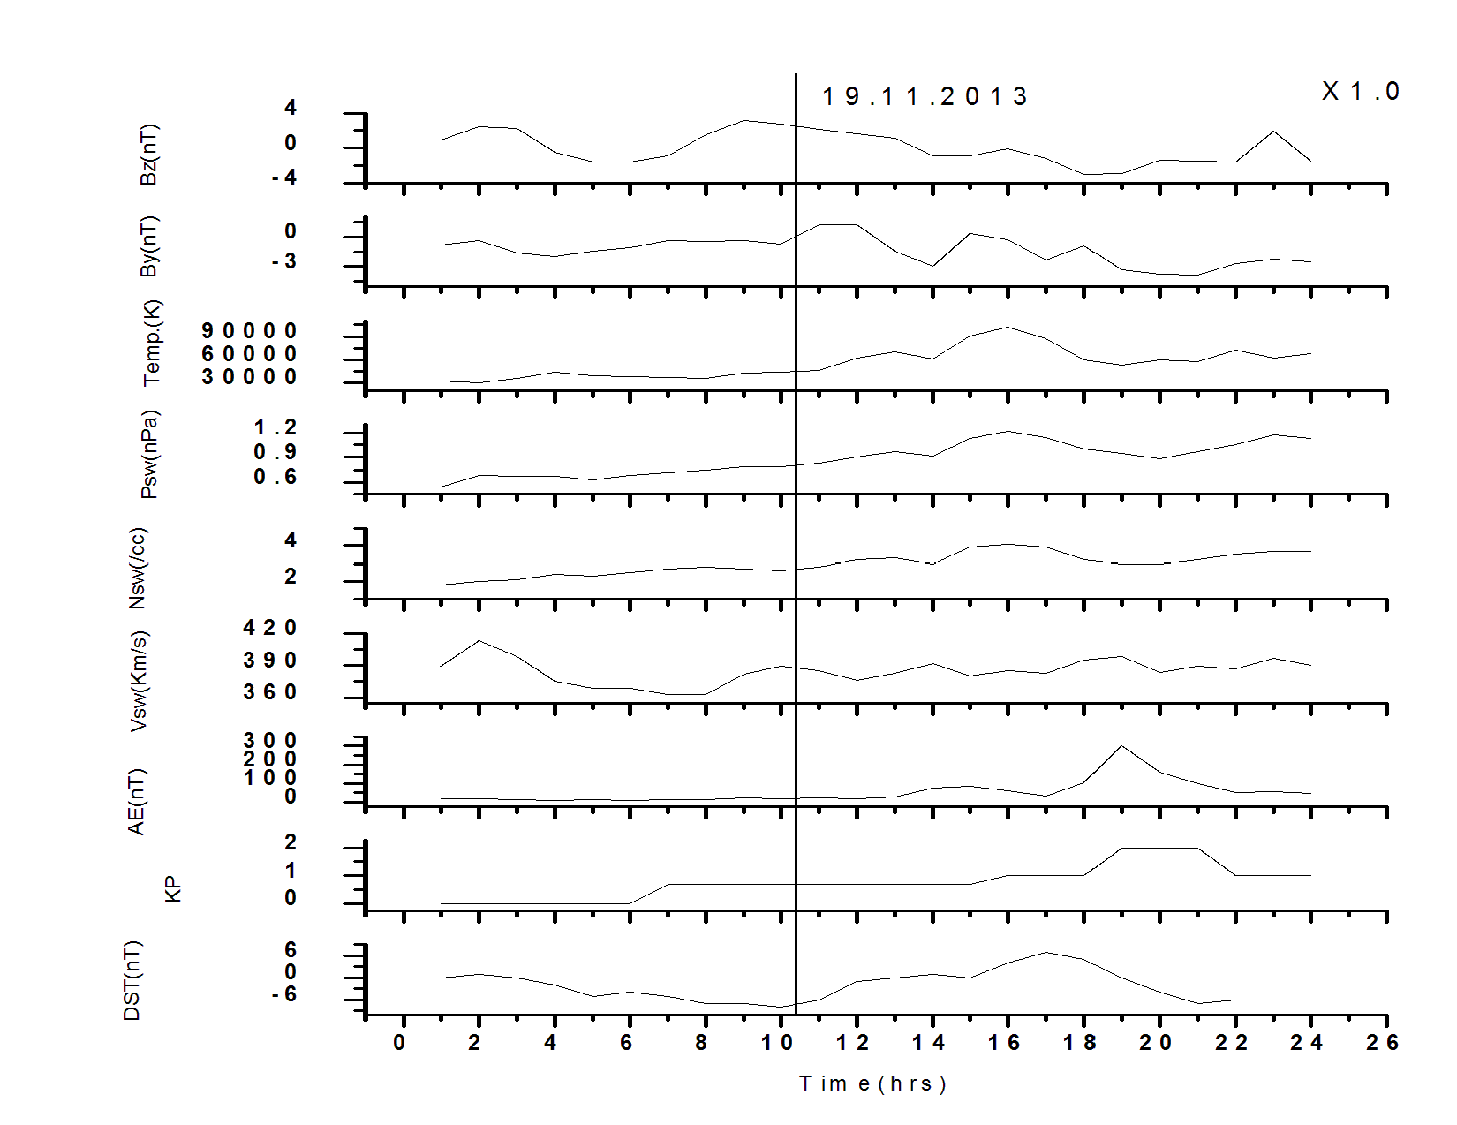
Figure SF3.1: Hourly variation of solar wind, IMF parameters and planetary indices on 19.11.2013, due to flare X1.0.
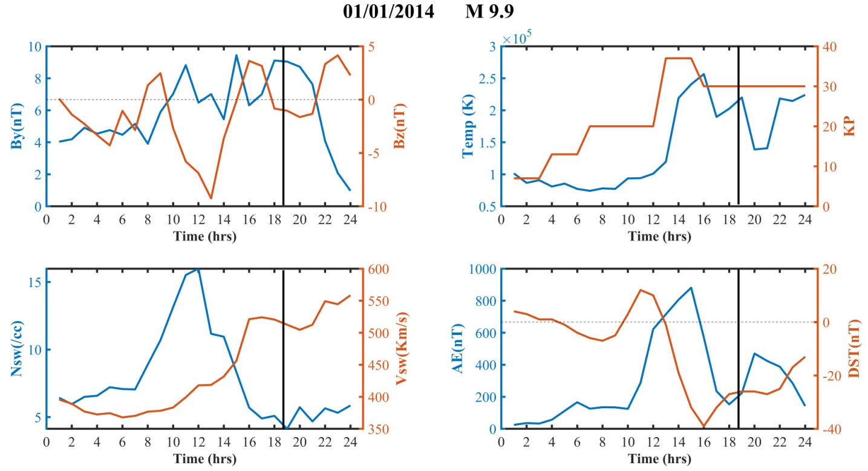
Figure SF3.2: Hourly variation of solar wind, IMF parameters and planetary indices on 01.01.2014, due to flare M9.9.

Figure SF3.3: Time series of Dst index from 30.07.2011 to 08.08.2011

Figure SF3.4: Time series of Dst index from 22.09.2011 to 30.09.2011

Figure SF3.5:Time series of Dst index from 05.03.2012 to 13.03.2012

Figure SF3.6: Time series of Dst index from 20.10.2012 to 29.10.2012

Figure SF3.7: Time series of Dst index from 13.05.2013 to 21.05.2013

Figure SF3.8: Time series of Dst index from 25.10.2013 to 31.10.2013

Figure SF3.9: Time series of Dst index from 05.11.2013 to 14.11.2013

Highly connected

Figure SF4.1.: Time series of Dst index from 15.02.2011 to 21.02.2011

Figure SF4.2:Time series of Dst index from 06.09.2011 to 13.09.2011

Figure SF4.3: Time series of Dst index from 24.10.2013 to 04.11.2013

Figure SF4.4:Time series of Dst index from 10.11.2013 to 16.11.2013

Figure SF4.5: Time series of Dst index from 19.11.2013 to 25.11.2013

